Terminal--Dev Ops Fail (Part 2)

# Solution

This is what the terminal looks like.  
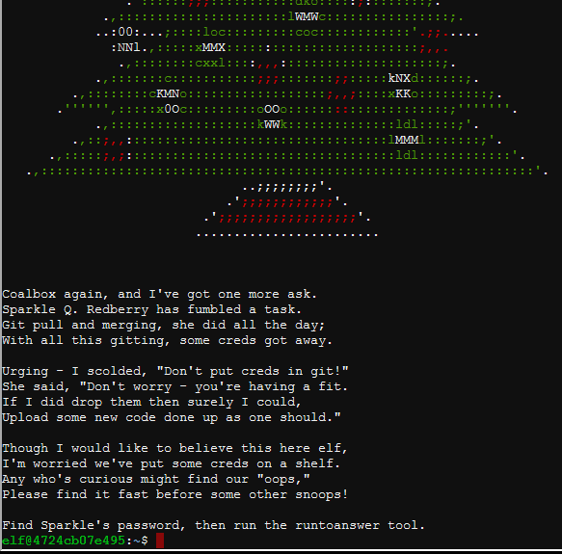

First, let’s find the Git repository.  
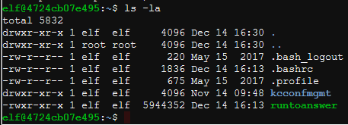

There aren’t many choices other than the kcconfmgmt directory, what’s in there?  
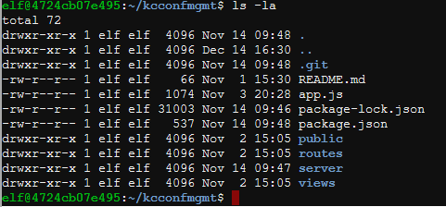

That is a Git repository all right. Examine the logs.  


Nothing on the first page…  
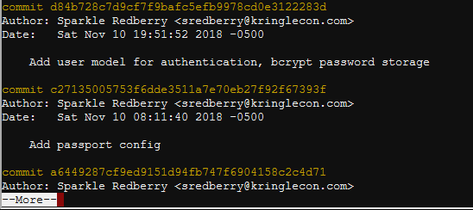

Aha! That was nice of Sparkle to tell us about the password change. Note that the commit hash was 60a2ffea7520ee980a5fc60177ff4d0633f2516b.  
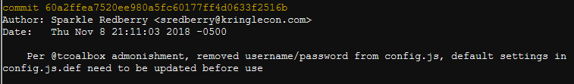

Let’s see what that commit contained, using  
git show 60a2ffea7520ee980a5fc60177ff4d0633f2516b  
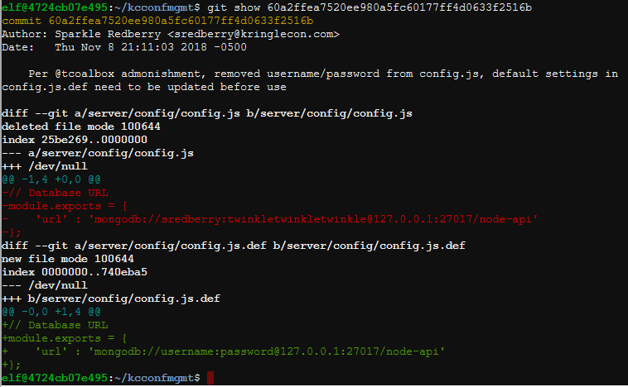

Notice that Git stored a difference (diff) of the changes made in that commit. The red text shows deleted code, which is a connection to the app’s Mongo database with username sredberry and password twinkletwinkletwinkle.

Now, claim credit for the answer.  
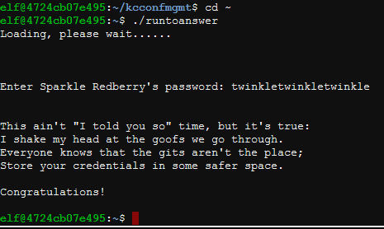

Finally, what should Sparkle have done to correct this? Removing the password from the code was a good first step. The second step should have been to change the password.