Terminal--Python Escape from LA (Part 1)

# What you can learn from this

Python is a popular language among IT security professionals. This challenge gives you some practice and tricks in Python.

# Getting Started

SugerPlum Mary is on the left side of the second floor.  
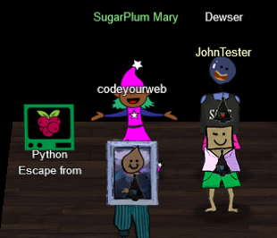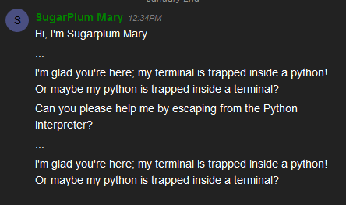

# Hints

Mary gives you a hint that instructs you to watch one of the Kringlecon talks.  
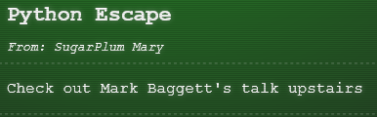

Mark’s talk, [Escaping Python Shells](http://www.youtube.com/watch?v=ZVx2Sxl3B9c), will *almost* walk you through this challenge. Be sure to watch it. Look for the four “dangerous functions” Mark talks about and see if any of them work. One more hint: Don’t name your function “os”.

# A common misconception

Many Kringlecon players thought that “escaping Python” meant that you would be able to get a BASH prompt and get out of Python altogether. It does not. It means you can execute BASH commands from within Python.

# Hand In

1. What “dangerous function” does the terminal allow?
2. What is your code to escape Python?
3. What BASH commands do you need to execute from within Python to get credit for solving the challenge?