Terminal--Python Escape from LA (Part 2)

# Solution

Mary’s terminal really does have a Python shell.   
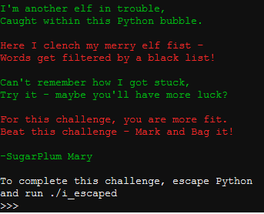

Let’s try the four dangerous functions from Mark’s talk: import, eval, exec, and compile.  
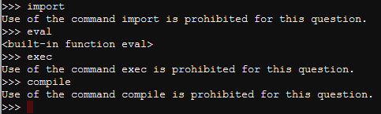

The eval function works, so we will use that. If we follow Mark’s example by rote, this happens.  
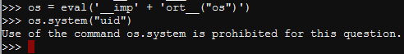

They are also blocking the string “os.system”. We can beat that.  
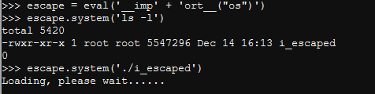

We have a winner!  
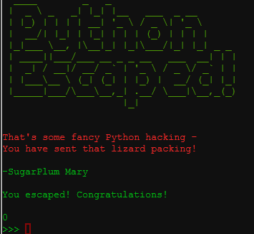

# Up Next

The next objective is Network Traffic Forensics.