Terminal--The Sleigh bell

This terminal followed the method in the hint almost completely. because it is so simple, this lesson will just be a walk through. Feel free to do it on your own with only [Shinny’s hint](https://pen-testing.sans.org/blog/2018/12/11/using-gdb-to-call-random-functions) to help you.

# Getting Started

Shinny Upatree and The Sleighbell terminal are on the right side of the second floor, near the stairs.  
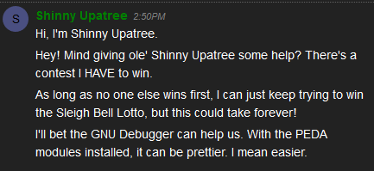

# Hint

Shinny gives you the following link which connects to a SANS Pentest blog. The link to the blog is <https://pen-testing.sans.org/blog/2018/12/11/using-gdb-to-call-random-functions>.   
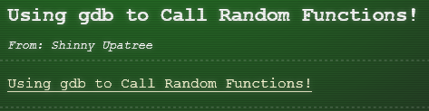

# Solution

Here’s the terminal.  
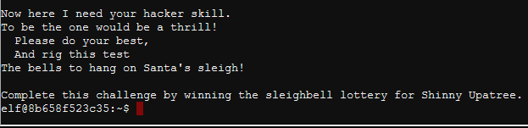

It is always good to look around. It is nice that they left us a link to gdb.  
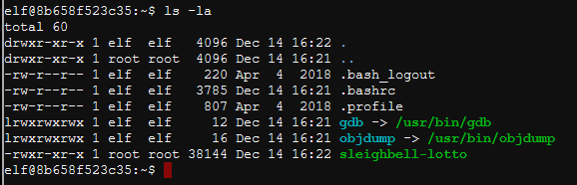

From the hint, first run nm. It had a lot of output, so piping to grep T made it cleaner. Perhaps the function winnerwinner is what we want…  
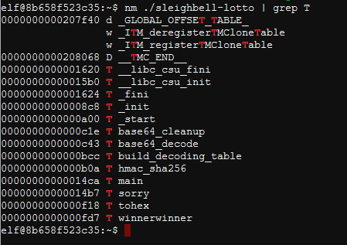

The next step in the blog is to run gdb on the target file, sleighbell-lotto in this case. Then set a break point and run the program. Finally, jump to winnerwinner.  
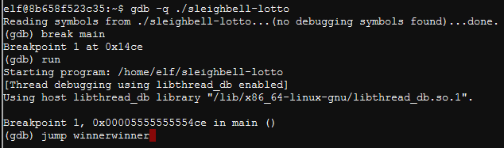

And that’s it!  
