Objective--Recover Alabaster’s Password (Part1)

# What you can learn from this

This objective takes a dive into encryption and decryption. Both symmetric encryption (AES) and asymmetric or public key encryption (RSA) are in play. There are many tools we can use: PowerShell, openssl, and Python were helpful for me. You will probably learn that encryption routines are very fussy about data format, block size, and other details that can be most frustrating.

There will be more reverse-engineering of malware written in PowerShell, probably as much as you will ever want! You will also learn to extract part of the information you need from a memory dump of the PowerShell malware as it was running on Alabaster’s computer.

# The Objective

Alabaster ignored the OPSEC rules we have been talking about and tried to analyzer the WannaCookie malware on his workstation instead of on an encrypted VM. Now his personal password database has been encrypted and he needs our help to decrypt it. The zip file that Alabaster links to [is available here](https://www.holidayhackchallenge.com/2018/challenges/forensic_artifacts.zip).  
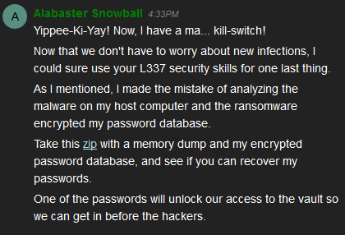 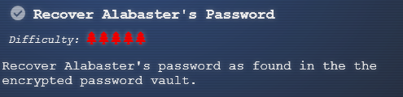

# Hints

This is the end of a conversation with Shinny Upatree after we helped him win the Sleigh Bell Lottery. It describes the job before us very well. We will do well to remember Shinny’s advice.  
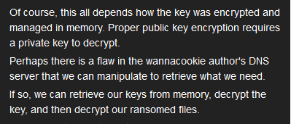

Also, Alabaster reminds us about powerdump. Chris Davis demonstrated its use in his [Analyzing PowerShell Malware](https://www.youtube.com/watch?v=wd12XRq2DNk) talk.  
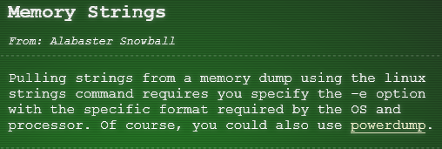

# Get Started

So far, we have analyzed the functions in wannacookie.ps1 that convert data, and the first lines of the wannacookie function that terminate execution. The core of evil in the wannacookie function is in lines 193 through 203. Now is the time to analyze them in detail.

# Hand in

1. Create a flowchart, a discussion, comment the code, or whatever helps you understand the process that wannacookie follows in the 20 lines of evil (193-203). Turn in your flowchart, discussion, commented code, or screenshots of whatever you did.
2. As you document the malware, create a list of interesting variables, their types and their lengths. We will use this later.
3. As you document the malware, keep a list of the command codes and their meanings.