Objective--Who is behind it all? (Part 1)

# The piano lock

The piano lock hovers in space in one corner of Santa’s secret room, and we must unlock it. judging by Alabaster’s comment, the notes must be part of something composed by Rachmaninoff. According to Google, Rachmaninoff’s most famous piece is his Prelude in C sharp minor, Op. 3, No. 2. A music person might know for sure.  
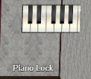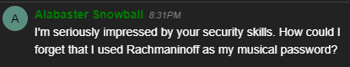

If you enter the password (ED#ED#EED#EF#G#F#G#ABA#BA#B) as is you will get a message that you entered a nice tune, but it is in the wrong key. The hint we need is in the PDF we extracted from the packet capture at the end of the Packalyzer challenge. It tells us how to transpose music to higher or lower keys.

It is easy for a non-musician to make mistakes on a task like this, so this graphic and spreadsheet may help.  
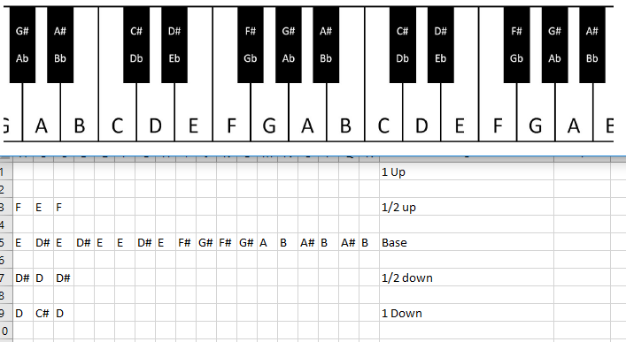

Notice that moving “1/2 step” up or down just involves moving one key up or down. In places where you are moving between two white keys (B - C and E - F), there won’t be any sharps (#) involved.

Hand in

1. What is the sequence that unlocks the door?