Objective--Who is behind it all? (Part 2)

# Solution

The sequence two half steps down (or one whole step) opens the door. Fortunately, there weren’t too many to try. One whole step up runs out of keyboard, as does two whole steps down.

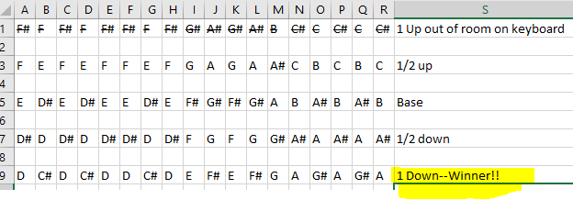

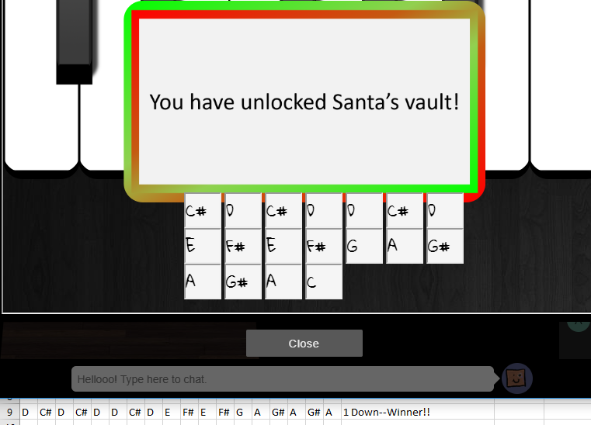

When you enter the vault, Santa tells you that this was all a test to see if you have the skills to work for him. It was a giant employment interview! It was an inside job after all!

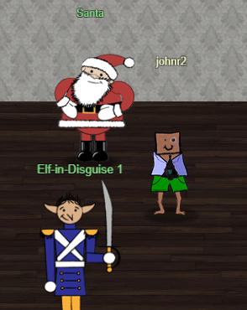 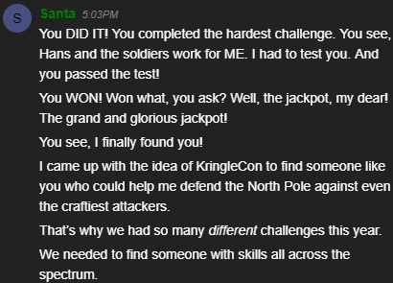

Here is the entire text of Santa’s message:

*“You DID IT! You completed the hardest challenge. You see, Hans and the soldiers work for ME. I had to test you. And you passed the test!*

*You WON! Won what, you ask? Well, the jackpot, my dear! The grand and glorious jackpot!*

*You see, I finally found you!*

*I came up with the idea of KringleCon to find someone like you who could help me defend the North Pole against even the craftiest attackers.*

*That’s why we had so many different challenges this year.*

*We needed to find someone with skills all across the spectrum.*

*I asked my friend Hans to play the role of the bad guy to see if you could solve all those challenges and thwart the plot we devised.*

*And you did!*

*Oh, and those brutish toy soldiers? They are really just some of my elves in disguise.*

*See what happens when they take off those hats?*

*Based on your victory… next year, I’m going to ask for your help in defending my whole operation from evil bad guys.*

*And welcome to my vault room. Where's my treasure? Well, my treasure is Christmas joy and good will.*

*You did such a GREAT job! And remember what happened to the people who suddenly got everything they ever wanted?*

*They lived happily ever after.”*