Probability Stem Lesson Ladder

PROGRESSION
Essential Foundational Knowledge (Roots) | Fractions, fraction operations, percent
Leads to | More probability  Expected value  Statistics: Random sampling
Big Ideas | Probability of an event is a number between 0 and 1. An event with a probability of 0 is impossible. An event with a probability of 1 is certain.
Other Information | Student understanding of chance processes is essential for making inferences.  Long run relative frequency approximates probability.  Empirical and Theoretical are terms we used in E1 and E2. However, these are not CCSS words and they seem to obscure some things for students. Many texts only use the term probability and do not distinguish. I think we should shift this way and focus instead on the relative frequency of events in an experiment and how that is used to approximate probability.  Simple/compound/single-stage/multi-stage are all different ways to determine how “difficult” a problem is. Much like calling an equation a 1-step or 2-step equation when solving. These terms are not  Common core uses the words simple/compound/multi-stage in confusing ways that I think we should avoid. An event is not compound just because it is from a multi-stage experiment

Concept/Skill: Understand probability as a measure of likelihood and describe the probability of an event informally using a probability scale from impossible to certain.

Goal | Develop an informal understanding of probability.
Student-Facing Example | 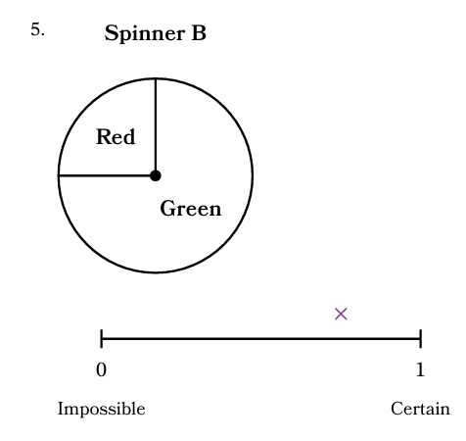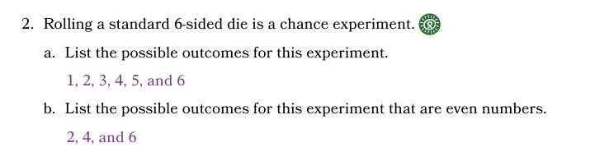
Knowledge Graph Node | Understand that probability is a number between 0 and 1 and informally describe the probability of an event by using terms such as impossible, unlikely, likely, and certain.
Terminology | Chance Experiment: A process where two or more results can occur and the outcome is uncertain.  Probability (of an event): A number between 0 and 1. The number measures the chance that the event will occur.
Mathematical Models | Probability Scale
Strategies
Specifications
Leaves to Include
Considerations | An outcome is one of the possible results of a chance experiment.  An event can be a single outcome or include multiple outcomes (ie- event of rolling an even number includes outcomes 2,4,6)  Students connect informal likelihood language to locations on the probability scale: impossible is 0, unlikely is near 0, neither unlikely nor likely / equally likely is around 1/2, likely is near 1, certain is 1. Formal computation can wait, but the scale should not look binary.  At this stage, the only numbers used are 0 for impossible events and 1 for certain events.  - P(E)=0 means the event is impossible  - P(E)=1 means the event is certain  Don’t use the word probability until we define it.
Required Skills/Cases
Misconceptions
Existing Product Reference, if any | EM2 Grade 7 Module 6 Lesson 1 (focus on spinner activity)
Grade (or Leaf) | 6 or 7
Notes related to Standards, Grade, or Leaf | 7.SP.C.5  MD.6.DS.A.2  NE.6.D.3.c  OK.6.D.2.1  SC.6.DSPR.2.1
Notes for Intervention, Extension, or Optional Activities
Additional Notes | 1 instructional day

Concept/Skill: Define probability and determine the probability of events for single-stage experiments.

Goal | Assign a value between 0 and 1 to an event.
Student-Facing Example | 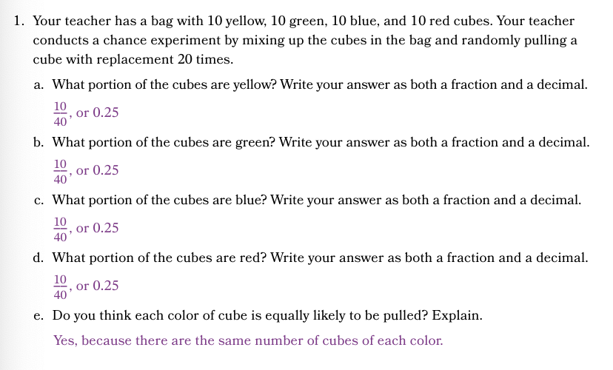
Knowledge Graph Node | For a single-stage chance experiment, determine the sample space and assign probabilities to outcomes to develop a probability model. | Use a probability model to calculate the probabilities of events for a chance experiment.
Terminology | Sample Space: All possible results of a chance experiment.  Outcome: A possible result of a chance experiment  Event: A set of one or more outcomes. | Uniform Probability Model: A probability model where each outcome in the sample space has the equal probability of occurring.  Probability Model: A mathematical representation of a chance experiment that accounts for all outcomes of a sample space and assigns a probability to each outcome.
Mathematical Models | - Probability model | Probability model
Strategies
Specifications
Leaves to Include
Considerations | - Simple events are made of only one outcome. Compound events include multiple outcomes. Not necessary to put too much emphasis on this. It is standard terminology, but is more for describing complexity than actually being useful to students. | - For any probability model, the probabilities of all outcomes sum to 1  - For any probability model, the probability of an event E is the sum of the probabilities of the outcomes in the event  - In a uniform probability model, every outcome is equally likely.  - In a uniform probability model, the probability of any event is given by $P\left(E\right)=n(E)/n(S)$. in words: the probability of any event is the number of outcomes in the sample space for which E occurs divided by the total number of outcomes in the sample space)  - Be sure to make assumptions explicit. We assume a uniform probability model when rolling a die, drawing a marble, whatever. We might choose a different probability model, and a uniform probability model may or may not be in alignment with experimental data. Like all “real world” modeling tasks, the choice of a model is a choice, with advantages and disadvantages, and the choice must be made thoughtfully, and once chosen be made explicit.
Required Skills/Cases | - Write the sample space for a chance experiment.  - Write a uniform probability model.  - Write a non-uniform probability model.  - Given a probability model, calculate $P(\text{not }E)$ from $P(E)$, and interpret complements in context. | - Assign probability to event with one outcome  Example: When a fair six sided die is rolled, what is the probability that the die lands on 1?  - Assign probability to event with >1 outcome  - Example: When a fair six sided die die is rolled, what is the probability that the die lands on an even number?  - Given a probability model, calculate $P(\text{not }E)$ from $P(E)$, and interpret complements in context.
Misconceptions
Existing Product Reference, if any | EM2 Grade 7 Module 6 Lesson 3 problems 2 and 3 (identify sample space, outcomes that make up specific events, e.g., spinning 1, spinning an even number) | EM2 Grade 7 Module 6 Lesson 4 problem 1 (a-e), Learn 2
Grade (or Leaf) | 7 | 7
Notes related to Standards, Grade, or Leaf | 7.SP.C.5  7.SP.C.7.a  FL.7.DP.2.1  TX.7.6A (mentions lists and tree diagrams)  MN.6.1.2.1  NE.6.D.3.a | 7.SP.C.5, 7.SP.C.7.a  SC.6.DPSR.2.2 (limits denominators to 2, 4, 5, 8, 10, 25, 50, 100)  FL.7.DP.2.3  TX.7.6.E (specifies relationship between probability of an event and its complement)  MN.6.1.2.2  NE.6.d.3.b  OK.PA.D.2.1  SC.6.DPSR.2.3
Notes for Intervention, Extension, or Optional Activities
Additional Notes | 1 day  Have students create a table that lists outcomes and corresponding probabilities. | 1-2 days  See considerations cell  Limit to single-stage experiments  Include probability of complement of an event

Concept/Skill: Collect data from a single-stage chance experiment to calculate probability using long run relative frequency.

Goal | Perform experiments and simulations to calculate probability.  Understand long run relative frequency.
Student-Facing Example | 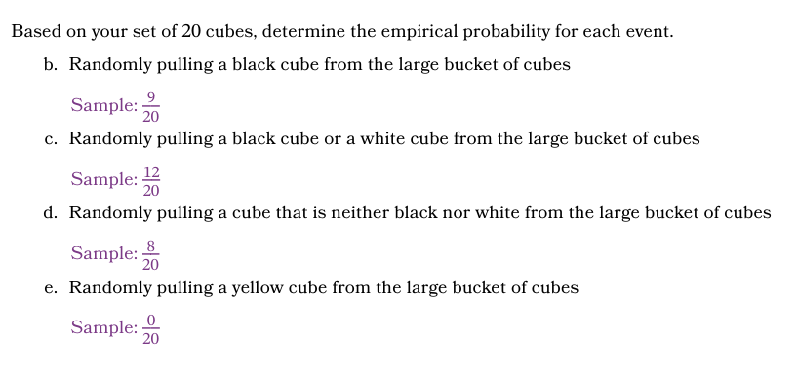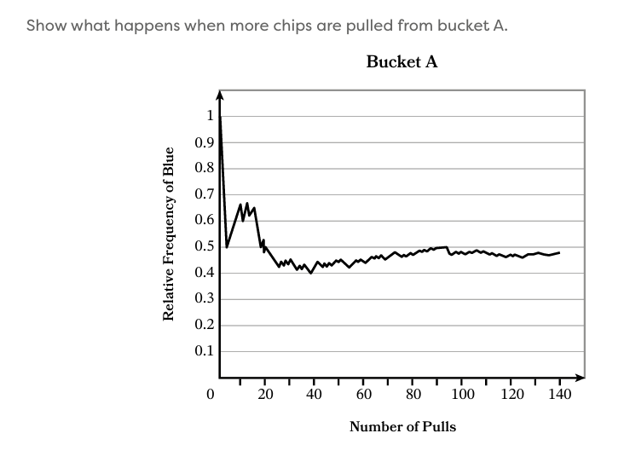
Knowledge Graph Node | Infer the probabilities of events and develop a probability model by using relative frequencies from a chance experiment. | Infer the probabilities of events and develop a probability model by using relative frequencies from a simulation | Use a probability estimate or probability model to predict approximate long-run frequencies, and explain why actual frequencies may differ.
Terminology |  | Simulation: A chance experiment that is conducted to closely resemble a real-world situation of interest. | Uniform Probability Model: A probability model where each outcome in the sample space has the same probability of occurring.  Probability Model: A mathematical representation of a chance experiment that accounts for all outcomes of a sample space and assigns a probability to each outcome.
Mathematical Models
Strategies
Specifications | One-stage chance experiments only | Simulations of one-stage chance experiments only | One-stage chance experiments only
Leaves to Include
Considerations | - Suggest not defining empirical and theoretical separately.  - When performing a single stage chance experiment: Relative frequency of an event= #of successes/#of trials  - Consider both examples where probability model is uniform and non-uniform.  - data give evidence; they do not magically hand us Exact Probability From The Sky™ | data give evidence; they do not magically hand us Exact Probability From The Sky™ | - Long run relative frequency approaches a single number.  - If a chance experiment is repeated multiple times by two people, they will get similar long run relative frequency.  - The relative frequency of events can be used to approximate probability of an event. As the number of trials increases, relative frequency tends to stabilize near the underlying probability; individual runs can still vary.  - Long run relative frequency understanding leads to understanding of importance of random samples for statistical inference.  - data give evidence; they do not magically hand us Exact Probability From The Sky™
Required Skills/Cases | Equally likely outcomes:  - Calculate probability when event includes a single outcome  - Calculate probability when event includes >1 outcome  Calculate probability for nonuniform outcomes (e.g., flipping a cup and noting how it lands; weighted die) | - Calculate probability when event includes a single outcome  - Calculate probability when event includes >1 outcome | Need both directions:  Given a probability and a number of trials, predict the approximate frequency of the event and explain why the exact frequency may differ.  And  Use a probability estimate or probability model to predict approximate long-run frequencies, and explain why actual frequencies may differ
Misconceptions
Existing Product Reference, if any | Grade 7 Module 6 Lesson 2 | Grade 7 Module 6 Lessons 9, 10 | Grade 7 Module 6 Lesson 3 (predictions based on results of experiments)  Grade 7 Module 6 Lesson 6 Learn 3, Lesson 8 (models based on empirical data)  Grade 7 Module 6 Lesson 7 (law of large numbers)
Grade (or Leaf) | 6 or 7 | 6 or 7 | 6 or 7
Notes related to Standards, Grade, or Leaf | Calculating probabilities from results of experiments  7.SP.C.7.b  TX.7.6I  MN.6.1.2.3  NE.6.D.3.d  NY.6.SP.7  OK.6.D.2.3 |  | Comparing model to long-range relative frequencies  7.SP.C.7  FL.7.DP.2.4  TX.7.6H  MN.6.1.2.3  NE.6.D.3.d  NY.6.SP.8  OK.6.D.2.3  Develop probability models based on results from chance experiments  7.SP.C.7.b  NY.6.SP.8  NY.6.SP.8b  Make predictions based off of results of a chance experiment  TX.7.6C  TX.7.6H  OK.PA.D.2.1  Make predictions from probability models  FL.8.DP.2.3  TX.7.6D  TX.7.6H
Notes for Intervention, Extension, or Optional Activities
Additional Notes | 2 days  (1 day equally likely outcomes, 1 day for outcomes that are not equally likely)  Perform repeated trials of single-stage chance experiments, record results  Calculate probability of an event for various numbers of trials, noting relative frequency  Note: We need to be clearer about what a probability model is than we were in EM2. | 2 days:  1 day simulations (general)  1 day simulations (RNT)  Define outcomes for simulation, e.g., using random digit table, 0-4 represents a coin landing on heads, 5-9 represents a coin landing on tails  Calculate probability of an event for various numbers of trials, noting relative frequency | Use results from an experiment to develop a probability model (nonuniform) or to analyze established uniform model (e.g., based on the results, does it appear that a flipped coin is “fair”?)  Use empirical data to develop a probability model  Make predictions based on results of chance experiments and probability models.  3 days:  1 day for long term frequency  1 day for developing uniform models and making predictions  1 day for developing nonuniform models and making predictions (including empirical data)

Concept/Skill: Represent sample spaces and find or estimate probabilities of events in multi-stage chance experiments

Goal | Perform multi-stage experiments.  Find sample space of a multistage experiment.  Understand independent events.  Find probability of events from multi-stage experiment.
Student-Facing Example | 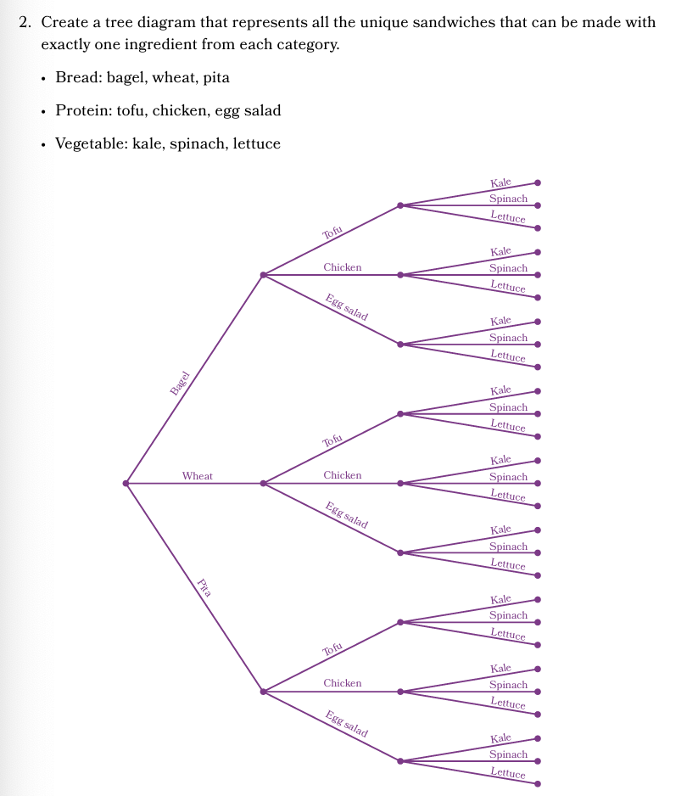  What is the probability that if ingredients are chosen at random that the sandwich will contain tofu?
Knowledge Graph Notes | Represent the sample space of a multi-stage chance experiment using an organized list, table, or tree diagram. | Calculate the probability of an event by using the results of a multi-stage chance experiments. | Infer the probability of an event by using relative frequencies from a simulation of a multi-stage chance experiment.
Terminology
Mathematical Models | Venn Diagrams (optional)  Tree Diagrams  Organized lists/tables | Venn Diagrams (optional)  Tree Diagrams  Organized lists/tables
Strategies
Specifications |  | Based on uniform probability models only  Determine sample space
Leaves to Include
Considerations |  | - Avoid any emphasis on single/multistage and simple/compound. The distinction between simple/compound gets really funky at this level and several states and CCSS make this confusion worse. Only use the words if absolutely necessary.  - For multistage, only consider uniform. They can list the sample space and count, but we are not yet using general multiplication rule.  If the results are given from an experiment, it doesn’t have to be uniform. If we want students to list sample space and outcomes, it does. We aren’t doing multiplication of probabilities here. Just counting. So, if we want to know the probability of getting blue 3 times in a row on a spinner with different size parts and have the results of 100 trials, that’s ok. But we don’t want them to list out the results when it’s not uniform and try to do P(E)/P(S)
Required Skills/Cases |  | Calculate probability based off of results from experiment  Calculating probability from a model:  Stages are identical (e.g., flip a coin 3 times, record results)  Stages are identical, results from stages are combined (e.g., roll a standard die twice, record the total of the two rolls)  Stages are different (e.g., choose a meat, type of bread, cheese for sandwich) | Given empirical data, design a simulation.  Conduct simulation, determine relative frequency.
Misconceptions
Existing Product Reference, if any |  | Grade 7 Module 6 Lesson 2 Launch, Learn 1 (relative frequency)  Grade 7 Module 6 Lesson 4 Learn 2 (using model)  Grade 7 Module 6 Lesson 5 (representing outcomes with tree diagrams) | Grade 7 Module 6 Lessons 9 and 10 (examples with multiple stages)
Grade (or Leaf) |  | 6 or 7 | Leaf
Notes related to Standards, Grade, or Leaf | 7.SP.C.8.b | 7.SP.C.8, 7.SP.C.8.a, 7.SP.C.8.b  FL.8.DP.2.2, TX.7.6I  AK.6.SP.7, AZ.8.SP.B.5ª, AR.8.SP.4  AR.8.SP.5, IN.8.DSP.4  MD.8.DS.C.6.b, NE.7.D.3.a  PA.CC.2.4.HS.B.7, TN.8.SP.B.4, TN.8.SP.B.4a  Focus on representing sample space:  FL.8.DP.2.1, TX.7.6A  AZ.8.SP.B.5b, AR.8.SP.4  IN.8.DSP.3, MD.8.DS.C.6.a  OK.6.D.2.2, SC.8.DPSR.2.1  TN.8.SP.B.4, TN.8.SP.B.4b  Predictions based on relative frequencies:  TX.7.6C  OK.PA.D.2.1  Predictions based on probability models:  FL.8.DP.2.3, TX.7.6D  AR.8.SP.6 | 7.SP.C.8.c  TX.7.6B  AZ.8.SP.B.5c  OK.A1.D.2.3
Notes for Intervention, Extension, or Optional Activities
Additional Notes |  | 3 days total:  Relative frequency (1 day)  Using tables to record sample size and counting (1 day)  Using tree diagrams to represent multiple stages (1 day) | Using RNT (1 day)

