Irrational Numbers and Real Numbers Lesson Ladder

PROGRESSION
Definitions | Real Number: A real number is a number represented by a point on the number line; every point on the number line represents a real number.  Irrational Number: An irrational number is a real number that is not rational.
Essential Foundational Knowledge (Roots) | - Pythagorean theorem  - Rational numbers as foundation:  - Recall that rational numbers are those that can be written as a/b with a, b integers and b ≠ 0.  - Use the properties of operations to show closure of ℚ under addition, subtraction, multiplication, and division (except division by 0).
Leads to | (more) Operations with radicals and rational exponents  Use of real numbers in defining functions and their domains  Introduction of the complex numbers ℂ to preserve closure under roots of negative numbers
Big Ideas | There are numbers that exist that are not rational numbers, called irrational numbers. In this stem we are maturing students’ understanding of the number line.  The real numbers fill the number line; rational numbers can be used to approximate irrational numbers as closely as needed.  The real number system as completion of ℚ:  • Understand ℝ as the extension of ℚ in which every point on the number line corresponds to a number (the completeness property).  • Recognize this as the bridge to reasoning about roots, exponents, and later, complex numbers.  Why do I need to know this?  Irrational numbers are a consequence of things you already know! They’re lurking, mysterious. Lets shine spotlight!  Creating unsatisfied curiosities is an important goal of this stem. If we get a handful of kids curious about stuff, we’ve won! We should inspire some students to dig deeper and go further in math here.
Other Information | • Show √2, π, and e on the number line using rational approximations.  • Compare √2 ≈ 1.414 and 22/7 ≈ 3.142 to illustrate successive refinement.  • Explore examples and counterexamples involving rational and irrational sums/products, such as (1/2 + √2), (√2 + –√2), and (√2)².  architecture is sound and aligned to Grade 8 CCSSM. “completeness” language does not need to be student facing.  avoid the word “verify” for general closure claims based only on examples.  This topic is already ontologically slippery: students are moving from rational numbers, where operations and decimal representations are more familiar, into real numbers, where school mathematics often quietly relies on assumptions that are much deeper than Grade 8 can get into. School mathematics often treats irrational-number operations through the assumption that arithmetic laws and formulas established for rational numbers continue to hold for real numbers, so our language needs to be precise without dragging Grade 8 into Real Analysis.  Recall rational numbers  ↓  Recognize the need for more numbers.  ↓  Define irrational numbers.  ↓  Connect decimals to rationality.  ↓  Approximate irrational numbers with rational numbers.  ↓  Compare and order real numbers.  ↓  -----High-school / extension below-----  Operate with real numbers using properties.  ↓  Deduce properties of rational and irrational sums/products.  ↓  Extend to radicals, rational exponents, and complex numbers.  Writer guidance on the √2 irrationality proof:  Use the diagonal of a unit square as the motivating example for the existence of irrational numbers: by the Pythagorean theorem, the diagonal has length √2. This gives students a concrete reason to believe that the rational numbers are not enough to describe all lengths on the number line, and has stunning historical development. the formal proof that √2 is irrational should not be treated as a required Grade 8 student skill. (illuminate. Not deep, not functional)  The proof should be included as short digital animation or video. A well-scaffolded animation can preserve the mathematical integrity of the idea without requiring every teacher to demonstrate or explain the proof. Do not replace the proof with vague “because the decimal keeps going” language; the decimal behavior is a consequence of irrationality, not the definition of irrationality. The core Grade 8 takeaway is: some real numbers cannot be written as fractions, and we can still reason about them by approximating them with rational numbers.  Are we actually going to do this proof? -Raena  i think yeah. not as something kids need to get good at. but as a little glimpse into the poetry/beauty/fun. if we're going to "go there" with irrationals i can't think of anything that's simpler/more natural than this. and historically, it’s an astonishing thing, that there are irrational numbers. it's important that kids get a glimpse into that astonishment. i know the sqrt 2 proof is by contradiction, which is not at all straight forward. i get that. there are places in curriculum where proof by contradiction is just mathematically unavoidable and glossing over it, or pretending it doesn't exist isn't doing the kids any favors - better to be transparent. -danielle

Concept/Skill: Classify real numbers as rational or irrational.

Goal | Understand irrational numbers as real numbers that cannot be written in the form p/q, where p and q are integers and q ≠ 0.
Student-Facing Example | 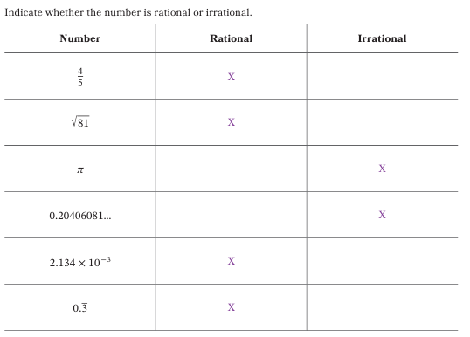
Knowledge Graph Node | Classify real numbers as rational or irrational.
Terminology | Real Number: A real number is a number represented by a point on the number line; every point on the number line represents a real number.  Irrational Number: An irrational number is a real number that is not rational.  (will need to RECALL definition of a rational number here)
Mathematical Models
Strategies | Use the diagonal of a unit square to show that some lengths cannot be expressed as a/b. (proof: sqrt 2 is not rational).  Possible integration of Pythagorean theorem to drive the need.
Specifications | Know that $\sqrt{2}$ and pi are irrational.
Leaves to Include
Considerations | - Why did mathematicians need to extend ℚ at all?  - Bonus motivation: what about decimals that do not repeat and do not terminate?  - Problem types must include justification that reasons from the definition of irrational/rational number  - Kids should see a proof that $\sqrt{2}$ is irrational. See “other information” yellow highlight above for details
Required Skills/Cases | - Identify rational/irrational from decimal form  - Identify rational/irrational from radical form  - Identify rational/irrational from fraction form
Misconceptions | Repeating decimals are irrational.
Existing Product Reference, if any | EM2 G8 M1 L22
Grade (or Leaf) | 8
Notes related to Standards, Grade, or Leaf | 8.NS.A.1  TX.8.2A  NE.8.N.1.a  SC.8.NR.2.2  VA.8.NS.2.a  VA.8.NS.2.c  WY.8.NS.1C
Notes for Intervention, Extension, or Optional Activities | Proof of $√2$ as an extension activity? (Phil: proof of sqrt 2 accessible to g8. Antique diagram and guy with a beard. GREAT opportunity for history of math here. Include in the story the proof. Appreciate the mystery!). [so no, not extension. Seeing it is basic to the understanding for rational/irrational. “illuminate” in prioritization framework language. See “other information” yellow highlight above for details -danielle)
Additional Notes | Number of days depends on how irrational numbers are introduced

Concept/Skill: Use decimal representations to classify any number as rational or irrational

Goal | Know that every real number has a decimal representation. Rational numbers have decimal representations that terminate or eventually repeat; irrational numbers have decimal representations that do not terminate and do not eventually repeat.
Student-Facing Example | 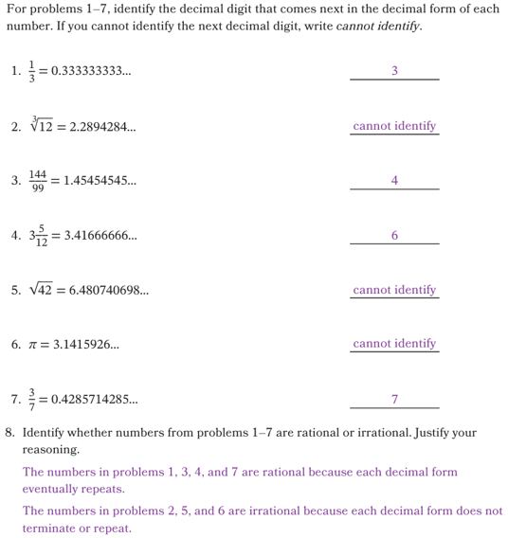
Knowledge Graph Node | Classify a number as rational or irrational by using its decimal representation. | Explain why irrational numbers have decimal representations that do not terminate or repeat
Terminology
Mathematical Models
Strategies
Specifications | Know that rational numbers have decimal representations that terminate or eventually repeat, and that irrational numbers have decimal representations that do not terminate and do not eventually repeat.
Leaves to Include
Considerations | Define irrational as a number that is not rational. So, an irrational number cannot be written in the form p/q with p,q integers and q not 0.  Include problems where kids have to do the long division themselves | The fact that irrational numbers have decimal expansions that are non-terminating and non-repeating is a consequence of the definition of irrational number (not the definition itself)  every real number having a decimal representation is an astonishing mathematical fact. Do not gloss over it. (though we certainly don’t need to prove it in G8)
Required Skills/Cases | terminating decimal → rational;  repeating decimal → rational; nonterminating, nonrepeating decimal → irrational;  repeating decimal written with bar notation
Misconceptions | All square roots are irrational  Irrational numbers are not real numbers  “long decimal” does means irrational.
Existing Product Reference, if any | EM2 G8 M1 L22
Grade (or Leaf) | 8
Notes related to Standards, Grade, or Leaf | 8.NS.A.1  IN.8.NS.1  NE.8.N.1.a  VA.8.NS.2.b
Notes for Intervention, Extension, or Optional Activities | Extension: Cantor’s diagonal proof
Additional Notes | 1 day

Concept/Skill: Use rational approximations to locate, compare, and order rational and irrational numbers on the number line.

Goal | Understand that irrational numbers can be approximated by using rational numbers, and approximations do not change the number’s irrationality.  Understand that every real number corresponds to a unique point on the number line and vice versa.
Student-Facing Example | 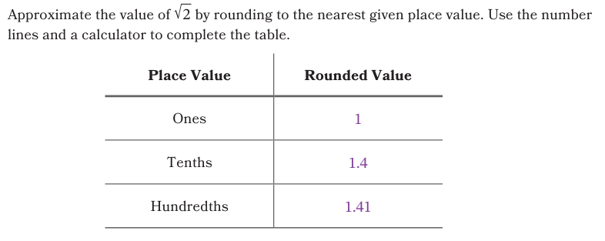  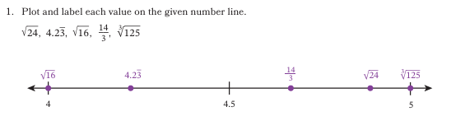  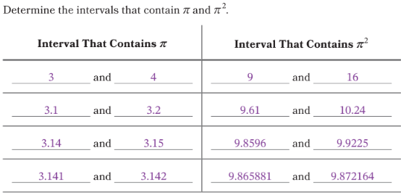
Knowledge Graph Node | Determine rational approximations of irrational numbers. | [Plot/Locate] rational approximations of irrational numbers on the number line | Compare and order rational and irrational numbers.
Terminology
Mathematical Models | Number line | Number line | Number line
Strategies | Use successive rational approximations (fractions or decimals) to locate an irrational number on the number line and to estimate its value to a desired degree of accuracy. Use technology for this process when appropriate.
Specifications
Leaves to Include
Considerations | Be very very careful with = here. And be careful to emphasize that the irrational number doesn’t “lose” its irrationality through approximation | Strong strong connections to geometry: Archimedes method of exhaustion  Strong connections to calculus/analysis too, but that muchhhhhh later.  Don’t turn this node into “stick the number in the calculator” thing. Ground it in the mathematical story: irrational numbers exist, theyre weird and hard to work with, but the can use the rational numbers we know and love to get a handle on them
Required Skills/Cases | Square roots  Cube roots  pi |  | Rational compared to irrational  Irrational compared to irrational
Misconceptions
Existing Product Reference, if any | EM2 G8 M1 L21 | EM2 G8 M1 L23 | EM2 G8 M1 L23
Grade (or Leaf) | 8 | 8 | 8
Notes related to Standards, Grade, or Leaf | 8.NS.A.2  FL.8.NSO.1.1  FL.8.NSO.1.2  TX.8.2B  SC.8.NR.2.1  VA.8.NS.1.c | 8.NS.A.2  FL.8.NSO.1.1  FL.8.NSO.1.2  TX.8.2B  SC.8.NR.2.1  VA.8.NS.1.c | 8.NS.A.2  FL.8.NSO.1.1  FL.8.NSO.1.2  TX.8.2B  SC.8.NR.2.1  VA.8.NS.1.c
Notes for Intervention, Extension, or Optional Activities
Additional Notes | 1 day | 1 day combined with next node to right

Concept/Skill: Perform operations with rational and irrational numbers.
Goal | Extend properties of rational numbers (associative +/x, commutative +/x, distributive) to all real numbers.
Student-Facing Example | 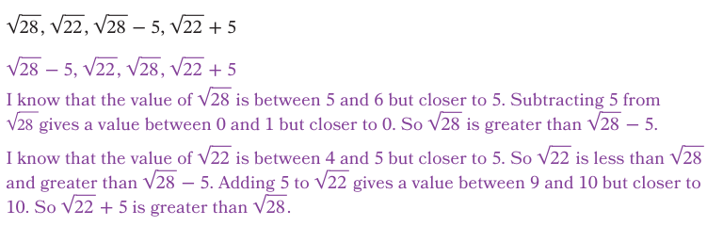  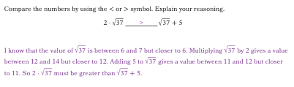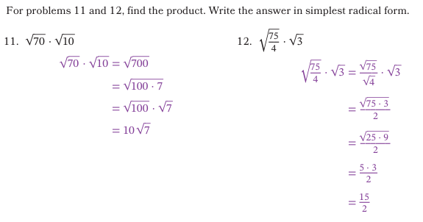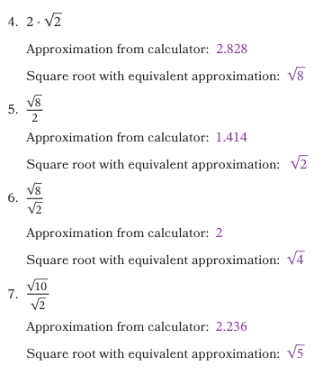
Knowledge Graph Node | Approximate the values of expressions containing irrational numbers. | Compare and order expressions containing irrational numbers. | Find the product or quotient of expressions with radical terms. | Express radicals in simplest radical form. | Find the sum or difference of expressions with radical terms. | Generate equivalent expressions containing irrational numbers and justify the equivalence by using properties or operations.
Terminology
Mathematical Models
Strategies |  | Make use of structure to order expressions with irrational numbers from least to greatest without finding an approximate value for each expression
Specifications |  |  | Multiplication Property of Square Roots | Multiplication Property of Square Roots |  | Sample: $2\left(1+\sqrt{2}\right)=2+2\sqrt{2}$ = $2\sqrt{2}+2$, with justification
Leaves to Include |  |  | Simplify radicals (A1+)  Write equivalent radical expressions (A1+) | Simplify radicals (A1+)  Write equivalent radical expressions (A1+) | Simplify radicals (A1+)  Write equivalent radical expressions (A1+)

Considerations | Make plain the properties of rational numbers extend to all real numbers: We can add and multiply real numbers, and the laws of operations (associative, commutative, distributive) and formulas for complex fractions below continue to be valid when A, B, C, D are real numbers instead of fractions:  - $\frac{AC}{BC}=\frac{A}{B}$ if $C≠0$  - $\frac{A}{B}=\frac{C}{D}$ if and only if $AD=BC$  $\frac{A}{B}<\frac{C}{D}$ if and only if $AD<BC$  - $\frac{A}{B}±\frac{C}{D}=\frac{\left(AD\right)±\left(BC\right)}{BD}$  - $\frac{A}{B}×\frac{C}{D}=\frac{AC}{BD}$ | Make plain the properties of rational numbers extend to all real numbers: We can add and multiply real numbers, and the laws of operations (associative, commutative, distributive) and formulas for complex fractions below continue to be valid when A, B, C, D are real numbers instead of fractions:  - $\frac{AC}{BC}=\frac{A}{B}$ if $C≠0$  - $\frac{A}{B}=\frac{C}{D}$ if and only if $AD=BC$  $\frac{A}{B}<\frac{C}{D}$ if and only if $AD<BC$  - $\frac{A}{B}±\frac{C}{D}=\frac{\left(AD\right)±\left(BC\right)}{BD}$  - $\frac{A}{B}×\frac{C}{D}=\frac{AC}{BD}$ | Unofficial terminology:  simplest radical form, perfect square factor | When asking students to express radicals in simplest form, we will need to be explicit about what that means. |  | Explicitly extend properties of rational numbers (associative +/x, commutative +/x, distributive) to all real numbers. Make connections to algebraic expression manipulation, see similarities between dealing with “x” and dealing with $\sqrt{2}$. Use the properties to manipulate expressions (and solve equations?). require justification of steps in problems.
Required Skills/Cases | Square roots  Cube roots  pi | Square roots  Cube roots  pi | Product  $$\sqrt{2}⋅\sqrt{8}$$  $$\sqrt{2}⋅\sqrt{6}$$  $$2\sqrt{5}⋅3\sqrt{10}$$  Quotient  $$\frac{\sqrt{8}}{\sqrt{2}}$$  $$\frac{\sqrt{24}}{\sqrt{3}}$$  $$\frac{\sqrt{27}}{2}$$ | Simplify by removing perfect square factor.  Rationalize the denominator. | Like radicals  Unlike radicals, one needs to be simplified first  Unlike radicals, two or more need to be simplified first
Misconceptions |  |  |  |  | Common mistake: $\sqrt{a}+\sqrt{b}=\sqrt{a+b}$ | Common mistake: $\sqrt{a}+\sqrt{b}=\sqrt{a+b}$
Existing Product Reference, if any | EM2 G8 M1 L23 | EM2 G8 M1 L23 | EM2 G9 M4 L17 | EM2 G9 M4 L17
Grade (or Leaf) | 8 | 8 | High school | High school | High school | High school
Notes related to Standards, Grade, or Leaf | 8.NS.A.2  FL.8.NSO.1.1  FL.8.NSO.1.2  TX.8.2B  SC.8.NR.2.1  VA.8.NS.1.c | 8.NS.A.2  FL.8.NSO.1.1  FL.8.NSO.1.2  TX.8.2B  SC.8.NR.2.1  VA.8.NS.1.c
Notes for Intervention, Extension, or Optional Activities
Additional Notes | 1 day for the two of these combined

Concept/Skill: Determine whether sums and products of real numbers are rational or irrational and justify the reasoning.
Goal | Understand closure properties within the real numbers: Use results from justifications to emphasize that the set ℝ is closed under addition, subtraction, multiplication, and division (except by 0).
Student-Facing Example | 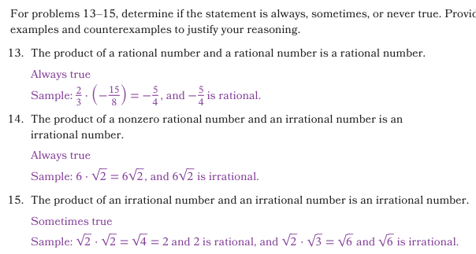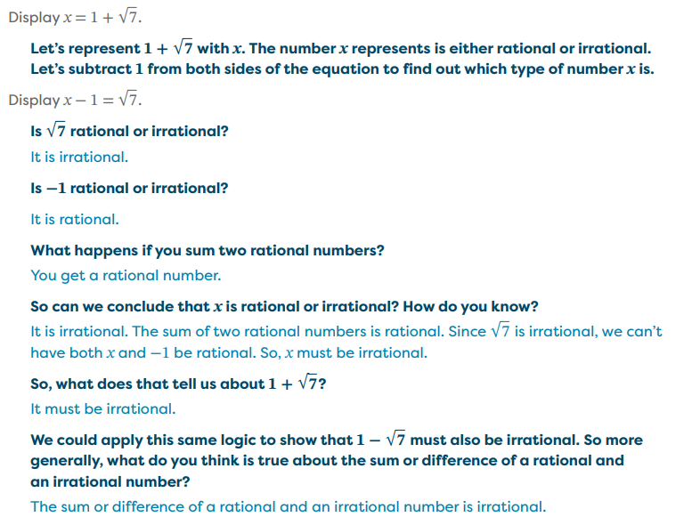
Knowledge Graph Node | Explain why the sum or product of two rational numbers is rational. | Explain why the sum of a rational number and an irrational number is irrational. | Explain why the product of a nonzero rational number and an irrational number is irrational. | Explain why the sum of two irrational numbers may be rational or irrational. | Explain when the product of two irrational numbers may be rational or irrational.
Terminology
Mathematical Models
Strategies | Encourage deductive reasoning, not pattern-spotting | Encourage deductive reasoning, not pattern-spotting | Encourage deductive reasoning, not pattern-spotting | Encourage deductive reasoning, not pattern-spotting | Encourage deductive reasoning, not pattern-spotting
Specifications
Leaves to Include
Considerations | Under what conditions on r and x can r × x or r + x be rational?  avoid the word “verify” for general closure claims based only on examples. | Under what conditions on r and x can r × x or r + x be rational?  avoid the word “verify” for general closure claims based only on examples. | Under what conditions on r and x can r × x or r + x be rational?  avoid the word “verify” for general closure claims based only on examples.
Required Skills/Cases
Misconceptions
Existing Product Reference, if any | EM2 A1 M4 L13 | EM2 A1 M4 L13 | EM2 A1 M4 L17
Grade (or Leaf) | 9 | 9 | 9
Notes related to Standards, Grade, or Leaf | HSN-RN.B.3  NJ.8.NS.A.3 | HSN-RN.B.3  NJ.8.NS.A.3 | HSN-RN.B.3  NJ.8.NS.A.3
Notes for Intervention, Extension, or Optional Activities
Additional Notes | Could be wrapped into a discussion when solving quadratics. | Could be wrapped into a discussion when solving quadratics. | Could be wrapped into lesson for rewriting radicals. | Could be wrapped into lesson for rewriting radicals. | Could be wrapped into lesson for rewriting radicals.

