Number Systems and Structures: Comparing and Ordering Lesson Ladder

PROGRESSION
Essential Foundational Knowledge (Roots) | - Subitizing & structure (0–10): See 1, 2, 5, and 10 as composed units; recognize patterns (dots, five-/ten-frames)  - One-to-one correspondence: Match items without counting; detect leftovers  - Cardinality principle: The last count word names the set size; arrangement does not matter  - Language set: more, fewer, same number, how many more/less, equal
Leads to | - Counting on/successor (n + 1)  - Foundations for place-value comparisons/ordering  - Ordering as a system: sort lists using transitivity; find least/greatest; identify “between” on the line  - Inequalities as statements to solve: represent solution sets on the number line  - Rounding (later): choose the nearest benchmark based on unit size  - Operations connection: comparison as add-on (addition) and take-away (subtraction); distance on the number line
Big Ideas | When we’ve got “stuff” we can assign a number that corresponds to how much stuff we have. These numbers can be ordered can compared, independently of the “stuff”  - Non-symbolic and symbolic comparisons  - Relationships between numbers  - Place value understanding  - Spatial number knowledge  - Magnitude of numbers  - Series position  - Comparison by matchingComparison using numbersComparison involving adding and subtracting  - Relations (not student facing terms, but concepts):  - Exactly one of a<b, a=b, a>b (trichotomy)  - a>b and b>c then a>c (transitivity)
Other Information | - Number range & expected strategies  - To ~5: matching/subitizing  - To 10: counting comparison and number path  - To 20: begin unitizing 10  - Two- and three-digit: place-value comparison  - Line location: “right is greater”  - Common confusions: spacing/size illusions; “longer row means more”; treating < and > as arrows without meaning; ignoring 0  - Zero: 0 is less than every counting number; matching the empty set shows “equal to zero”. Zero isn’t nothing! It’s a very important number! Zero is a number that tells us we have no-things  - Keep ordinal vs cardinal vs numeral distinct; connect deliberately.  - Quietly build the order properties through tasks:  - Trichotomy: for any two whole numbers a and b, exactly one of a<b, a=b, b<a holds.  - Transitivity: if a<b and b<c, then a<c.  - Make connections between representations (don’t use them in isolation): sets ↔ numerals ↔ unitized lengths ↔ positions on number path/line  - LANGUAGE DEVELOPMENT CONSIDERATIONS: squishy real world words, not terms that need to be defined, or assessed! Bigger, smaller, less, more, longer, shorter, taller, before, after, if then, first second, etc etc
  Property | First informal appearance | Later explicit use
  Trichotomy | For two sets/numbers, one has more, fewer, or same | Compare any two numbers: exactly one of (a<b, a=b, a>b)
  Transitivity | If A has fewer than B and B has fewer than C, then A has fewer than C | Order lists; compare through benchmarks; solve inequalities
  Difference | “How many more?” as leftovers | (a=b+k); distance from (b) to (a)

Concept/Skill: Identify and use ordinal numbers.
D+J: First-Second Ordinal Counter

Goal | Use the ordinal numbers to describe positions.
Student-Facing Example | 
Knowledge Graph Node | Use the words first and second to describe objects’ positions in a sequence. | Use the ordinal numbers first through tenth to describe the positions of objects in a sequence.
Terminology
Mathematical Models | Ordered sequences of physical objects, pictures, or people in a line | Ordered sequences of objects or people in a line; numbered positions on a track or path
Strategies | Name the front/beginning of a sequence as "first," then the next as "second" | Count along the sequence from the beginning to reach the named position
Specifications | • Limited to "first" and "second"  • The sequence must have a clear direction or starting point  • Contexts should be familiar and concrete (e.g., who is first in line, which picture comes first in a story)  • Don't conflate ordinal language (position) with cardinal language (how many) | • Sequence must have a clear starting point and direction  • First through tenth only  • Both identifying a position (which one is fifth?) and naming a position (what position is this one?) should be assessed  • Use varied, concrete contexts (lines of people, steps, race results)  • Ordinal language describes position, not amount
Leaves to Include
Considerations | - Use beginning/end language  - Make connections to counting words (e.g., being second means you are number two in line)  - Vary between using ordinal language in reference to time (“first, we’ll eat lunch”) and in reference to objects or people (“the man with the hat is second in line”) | - Name or place objects in a place in a sequence (e.g., third or tenth)  Make connections to counting words (being fifth means you are number 5 in line)
Required Skills/Cases | • Given a line of objects or people, point to or name the "first" one  • Given a line of objects or people, point to or name the "second" one  • Use "first" and "second" correctly in a familiar context (e.g., "I was first in line") | • Given a line of up to 10 objects, identify the one in a named position (e.g., "point to the fifth one")  • Given a line of up to 10 objects, name the position of a indicated object (e.g., "what position is this one?")  • Do the above in varied contexts (people in line, steps on a path, pictures in a sequence)
Misconceptions | • Student uses "first" to mean "the one I like best" or "the biggest" rather than position in a sequence  • Student uses "second" to mean "another one" rather than specifically the one after first  • Student applies ordinal language without a clear reference point (no established starting position) | • Uses ordinal words as cardinal numbers (e.g., "fifth" means "five things")  • Starts counting from the wrong end and gets a different position  • Knows first/second/third but reverts to "number + th" without knowing the correct word (e.g., "fiveth")
Existing Product Reference, if any | EM2 PK M5, Topic D, Lesson 21 | EM2 PK M5, Topic D, Lesson 21  EM2 PK M5
Grade (or Leaf) | PK, K | Pre-K / Kindergarten
Notes related to Standards, Grade, or Leaf | No CCSSM for ordinal numbers  FL.K.NSO.1.3  CO.PK.CC.D.8  IN.PK.M1.3  SD.PK.CD-4.i  AR.K.NPV.3  NY.K.CC.4.d  OK.K.N.1.3  AK.1.CC.2  IN.1.NS.3  VA.1.MG.3.h | FL.K.NSO.1.3  No CCSS standard  AK.1.CC.2, AR.K.NPV.3, CO.PK.CC.D.8, IN.1.NS.3, NY.K.CC.4.d, SD.PK.CD-4.i, VA.1.MG.3.h
Notes for Intervention, Extension, or Optional Activities | • Use physical line-ups with real students; name positions as students stand in line  • Extension: Introduce "third" to bridge toward the Ordinal Counter node  • Use picture books or story sequences where first and second events are explicitly named
Additional Notes | Part of 1 instructional period, woven into other activities | Likely 1 instructional period

Concept/Skill: Compare small sets by matching.
D+J: Matching Comparer

Goal | Use one-to-one matching to determine if one group has more than, fewer than, or the same number as another group.
Student-Facing Example | 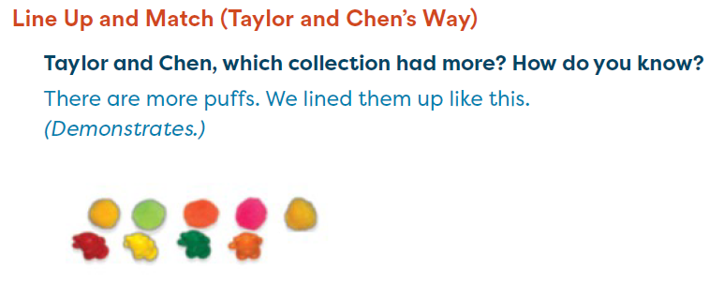
Knowledge Graph Node | Compare groups of objects by matching.
Terminology
Mathematical Models | Physical one-to-one pairing of objects; drawn lines connecting matched items
Strategies | Pair each object from one group with one object from the other; identify which group has leftover objects, or if there are none
Specifications | Learning Trajectories specifies groups up to 6 objects  • Objects can be similar or dissimilar  • Matching must be explicit — student physically pairs or draws lines, not eyeballs  • All three outcomes (more than, fewer than, the same) should be assessed
Leaves to Include
Considerations | - For finite sets A, B: “A has more than B” if a one-to-one match from B into A leaves at least one item of A unmatched; the sets are equal if each item of either set is paired with exactly one item of the other set  - Students may count the collections, but do not rely on the results of counting to compare them  - Up to about 5 objects in each set  - Use matching or subitizing  - To confront spacing and size illusions, student can rearrange the objects to match them  - be careful about is not asking "which set is bigger" instead be very explicit that we are talking about number of objects.
Required Skills/Cases | • Given two groups of objects, pair them and say which has more or fewer  • Given two groups that match exactly, say they have the same number  • Groups of similar objects and dissimilar objects
Misconceptions | • Says the group with bigger objects has more, even after matching  • Matches many-to-one instead of one-to-one  • Skips or doubles up during matching without noticing
Existing Product Reference, if any | - M2 PK M1, Lesson 6  - EM2 PK M4, Topic D, Lessons 14–16  - EM2 K M3, Topic C, Lessons 12–13
Grade (or Leaf) | PK, K
Notes related to Standards, Grade, or Leaf | CA.K.CC.6  FL.K.NSO.1.4  TX.K.2G  IA.PK.7.5.PS.3
Notes for Intervention, Extension, or Optional Activities | • Intervention: Start with very different group sizes (e.g., 1 vs. 5); use physical pairing of objects before drawn lines  • Extension: Introduce counting as an alternative comparison strategy to bridge toward the Counting Comparer node
Additional Notes | Likely 2 instructional periods

Concept/Skill: Compare groups of objects by counting.
D+J: Counting Comparer

Goal | Use counting to compare sets that can’t be organized
Student-Facing Example | 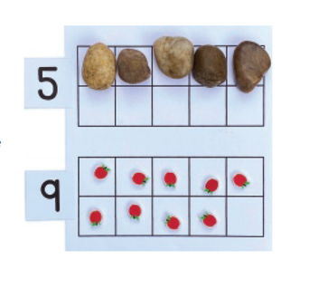
Knowledge Graph Node | Compare groups of objects by counting to determine which has more, fewer, or the same number.
Terminology
Mathematical Models | Counted collections of objects; number line  (Can use number path, grids, or objects to aid in counting)
Strategies | Count each group; compare the last number words to determine which is greater
Specifications | Both groups must be counted, not just one  • All three outcomes (more, fewer, same) should be assessed  • Include cases where the larger group has smaller-sized objects
Leaves to Include | Sizes of sets:  - Up to 5  - Up to 10
Considerations | - The numbers name the set sizes  - Establish each set’s cardinality by correct counting; compare the numbers (not the objects or images of objects)  - Justify: Ask “How do you know?” The number comes later in the counting sequence  show by: (a) recount; (b) show on a number path; (c) compare by matching as a second proof  - Start with similar objects, then dissimilar  - Include problems requiring two representations (e.g., count and number path/line)
Required Skills/Cases | • Count two groups and say which has more or fewer  • Count two groups and say they are the same  • Do the above when the larger group has smaller-sized objects  • Do the above when groups are arranged differently (e.g., one in a line, one scattered)
Misconceptions | • Says the group with larger objects has more, even after counting correctly  • Counts only one group and guesses about the other  • Recounts rather than trusting the last number word as the total
Existing Product Reference, if any | EM2 PK M4, Topic D, Lessons 14–17  EM2 K M3, Topic C, Lessons 13–17
Grade (or Leaf) | PK/K
Notes related to Standards, Grade, or Leaf | K.CC.C.6 / CA.K.CC.6  FL.K.NSO.1.4  TX.K.2G
Notes for Intervention, Extension, or Optional Activities
Additional Notes | Possibly 1 instructional period

Concept/Skill: Order and compare sets, lengths, and numerals.

D+J: Serial Orderer to 5 (comparing number)
Serial Orderer 6+ (comparing number)

Goals | Order lengths marked into units (e.g., cube towers/stairs)  Put numerals in order  Compare numbers without concrete or pictorial sets to match/count
Student-Facing Example | 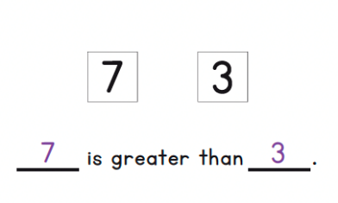  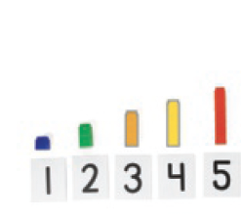
Knowledge Graph Node | Order sets/groups of objects according to the number of objects in each set/groups. | Order lengths marked into units. | Orders numerals up to 10. | Compare two numerals between 1 and 10.
Terminology
Mathematical Models | Dot cards; numeral cards | Lengths marked into units (e.g., cube towers, stair steps) | Number path, numeral cards | Written numerals; number path
Strategies | Use knowledge of number order to place each number  Compare each set/group to find the smallest, place it first, then repeat with what remains | Compare each length to find the shortest, place it first, then repeat with what remains | Use knowledge of the count sequence to identify position and find missing numbers; use the number path as a reference to locate where a number sits in the sequence | (Can use number path, grids, tick marks, or objects to aid in counting. the REASON we can conclude <, >, or =, is location in counting sequence.)
Specifications | Sets shown as objects or dots, up to 10 | • Lengths must be marked into units  • Order a set of 3–5 objects  • Objects must be aligned at one end | • Numerals 0–10  • Include identifying a missing number within the sequence  • Include identifying what comes before and after a given number  • This is about reasoning with the structure of the count sequence | - Use knowledge of number order to determine which numeral is greater or less without counting objects  - Compare numbers without concrete or pictorial sets to match/count  - Compare numbers without concrete or pictorial sets to match/count
Leaves to Include | - Use comparison symbols when ordering  - Number ranges | - Use comparison symbols when ordering  - Number ranges | - Use comparison symbols when ordering  - Number ranges  - Given a partial sequence, identify the missing numeral | • Numerals 1–10 only  • Presented as written numerals, no pictures or objects  • All three outcomes (greater than, less than, equal to) should be assessed
Considerations | - Focus on the order of numbers, increasing the number as students are able  - Trial-and-error strategies can confuse children. That is, they can get stuck with a partial ordering containing a mistake that is more difficult to fix (than it is to build a series from scratch)  - Include questions about ordinality and cardinality (e.g., Which is the seventh step? How many cubes are in it?) | - Initially use perceptually different materials (e.g., lengths that are obviously different in size or sets of 1, 3, and 5)  - Students produce an increasing sequence and explains swaps with “before/after” (e.g., I moved 4 because it comes after 3) | - A significant advance at this level is the ability to correctly determine whether numerals that are not in count-list order (e.g., some are skipped) are in order (e.g., 5, 7, 9, 10) or not (7, 5)  - Students can identify the error in order and restore increasing order with justification | - Light light touch only as appropriate, lives properly below: Exactly one of a<b, a=b, a>b (trichotomy) and a>b and b>c then a>c (transitivity).  - Define numbers as greater than/less than/equal via counting  - Include 0 early—use empty set and place 0 on the number path/line  - Children should be encouraged to generate their own concrete representations to aid in counting. What is important here is that they get used to reading and writing the numerals  More/less vs greater/less
Required Skills/Cases | • Given 3–5 dot cards, put them in order  - Three groups of objects are shown (e.g., a group of 2, a group of 4, a group of 5) in mixed-up positions. Put the groups in order by how many are in each one. | • Given 3–5 cube towers of different heights, order them  • Given a stair-step arrangement with one step out of place, identify and fix it  • Order lengths when presented in random arrangement, not pre-sorted  Given a set of cube towers in random arrangement, order them from shortest to tallest | • Given a partial forward sequence (e.g., 3, 4, __, 6), identify the missing numeral  • Given a partial backward sequence, identify the missing numeral  • Sequence forward from a given starting number within 0–10 | • Given two numerals between 1 and 10, say which is greater  • Given two numerals between 1 and 10, say which is less  • Given two identical numerals, say they are equal  • Include pairs that are close together (e.g., 6 and 7) and far apart (e.g., 2 and 9)
Misconceptions | - Judges "more" by spatial spread, a longer row or larger objects  - Compares only adjacent pairs without holding the whole ordering in mind | • Compares only the tops of towers without checking alignment at the base  • Orders by color, width, or other non-length attribute  • Can order 3 correctly but loses track with 4 or 5  • Compares visually without counting units, leading to errors on close cases  • Misaligns objects at the base and gets incorrect order | • Can recite the count sequence but must start from 1 to find a missing number  • Knows 1-more in the forward direction but not 1-less in the backward direction  • Confuses 1 more with 1 less | • Compares by numeral appearance rather than value (e.g., says 6 is greater than 9 because it "looks bigger")  • Confuses greater than and less than directionality  • Reverts to counting out sets when asked to compare numerals directly
Existing Product Reference, if any | EM2 PK M3, Topic C, Lessons 13–14  EM2 K M1, Topic G, Lesson 29  EM2 K M1, Topic F/G, Lessons 25–26 and Lesson 29  EM2 PK M3, Topic C, Lessons 13–14  EM2 K M1 Lesson 29 "Number Detective" — students use number order to identify a hidden card in a partially ordered sequence | EM2 K M6, Topic D, Lesson 23  EM2 G1 M4, Topic A, Lessons 1–2  Number Stairs:  EM2 PK M3, Topic C, Lesson 13  PK M3, Topic C, Lesson 12  EM2 K M1, Topic G, Lesson 30  EM2 K M1, Topic G, Lesson 32  EM2 K M3, Topic A, Lesson 4  EM2 K M3, Topic C, Lesson 14  EM2 G1 M4, Topic A, Lessons 1–2  EM2 G1 M4, Topic B, Lesson 6 | EM2 PK M3, Topic C, Lesson 12  EM2 PK M3, Topic C, Lesson 13  EM2 PK M3, Topic C, Lesson 14  EM2 K M1, Topic G, Lessons 29–32 | EM2 K M3, Topic D, Lesson 19  EM2 K M3, Topic D, Lesson 20  EM2 PK M4, Topic E
Grade (or Leaf) | Pre-K / Kindergarten | PK-G1 | Pre-K / Kindergarten | Pre-K / Kindergarten
Notes related to Standards, Grade, or Leaf | K.CC.A.2 — Count forward beginning from a given number (foundational)  K.CC.B.4c — Each successive number refers to a total one larger (conceptual basis for ordering) | CA TK PTKLF 3.2  1.MD.A.1 | K.CC.B.4.c  K.CC.A.2 | K.CC.C.7  CA.K.CC.7
Notes for Intervention, Extension, or Optional Activities | • Extension: Introduce gapped sets (e.g., 1, 3, 5) to bridge toward the Serial Orderer 6+ node | • Intervention: Start with 3 objects with very different lengths; emphasize baseline alignment before comparing  • Extension: Order 4–5 objects to bridge toward Serial Orderer 6+ node | • Intervention: Use number stairs as a physical anchor for the 1-more pattern before moving to abstract sequencing; have students count along the stairs while touching each step  • Extension: Introduce missing number tasks with larger gaps (e.g., __, 4, __, 6) to bridge toward place value reasoning
Additional Notes | Likely 1 instructional period | Likely 1 instructional period | Likely 1 instructional period | Likely 2 instructional periods

Concept/Skill: Compare numbers within 10 by using their positions on the number path or number line.
D+J: Mental Number Line to 10

Goal | Use location on the number path/line to compare numbers
Student-Facing Example | 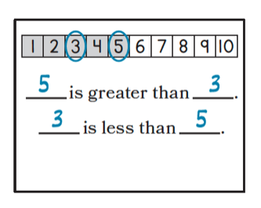
Knowledge Graph Node | Compare two numbers within 10 by using their positions on the number path or number line.
Terminology
Mathematical Models | Number path/line. (Rather than the counting sequence as the REASON we can conclude <, >, or =, we transition to a “position on the number line” understanding here.)  Symbols: >, <, =
Strategies | Locate both numbers on the number line; the number farther to the right is greater
Specifications | • Numbers 0–10 only  • Number line must be the comparison tool — not counting objects or matching  • Both directions assessed: "which is greater?" and "which is less?"  • Include pairs close together (e.g., 4 and 5) and far apart (e.g., 1 and 9)
Leaves to Include
Considerations | - Define order on the number path/line: For whole numbers a and b, a>b if a’s point is to the right of b’s  - Use location claims, rather than matching or counting, to compare  - Introduce <, >, = only after meanings are secured; require a reason (match, count, or path/line)  - Include problems that require two proofs (e.g., number line and match or number line and count)  - Kindergarten: number path (discrete steps); Grades 1+: number line
Required Skills/Cases | • Given two numbers and a number line, say which is greater  • Given two numbers and a number line, say which is less  • Given two numbers and a number line, write a greater than or less than statement  • Given a number line with two numbers marked, explain why one is greater using position
Misconceptions | • Reads the number line right to left (reverses greater/less)  • Confuses distance from zero with the comparison (e.g., thinks numbers that are farther apart are always "more different")  • Can identify position but can't connect position to greater than/less than language
Existing Product Reference, if any | EM2 K M3, Topic C, Lesson 14  EM2 K M3, Topic D, Lesson 19
Grade (or Leaf) | Kindergarten
Notes related to Standards, Grade, or Leaf | K.CC.C.7
Notes for Intervention, Extension, or Optional Activities | Extension: Remove the number line and ask students to compare using only number order knowledge — bridges to the Compare Written Numerals node
Additional Notes | Likely 2 instructional periods

Concept/Skill: Determine how many more or how many less one group has than another.

Goal | Find the difference (how many more/less) between two numbers
Student-Facing Example | Maya has 8 cubes. Leo has 5 cubes. Who has more? How many more?  Show the extra cubes by matching. Then show the distance from 5 to 8 on the number line.
Knowledge Graph Node | Find how many more or less one group has compared to another.
Terminology
Mathematical Models | Number path/line  Symbols: >, <, =  Equations
Strategies | Match two groups and count the leftovers; count up or back on the number line from one number to the other
Specifications | • Numbers within 0–10  • Both "how many more" and "how many fewer" should be assessed  • Concrete and pictorial contexts should be included
Leaves to Include
Considerations | - The difference from b to a is the unique k with a = b + k (later written as a − b)  - On the number line, the difference, k, represents a distance  - Write the equation frame; show the distance on the number path/line.  - Use cubes, line hops, or matched pairs with leftovers  - This is the bridge from addition to subtraction. Very important row. This row is important because it shifts comparison from qualitative to quantitative.
Required Skills/Cases | • Given two groups of objects, match them and count the leftovers to find the difference  • Given two numbers on a number line, count the distance between them to find the difference  • Answer "how many more does X have than Y?"  • Answer "how many fewer does Y have than X?"  • Given the same situation, answer both forms of the question  • Numbers close together (e.g., 6 and 7) and far apart (e.g., 2 and 8)
Misconceptions | • Says which group has more but can't quantify by how much  • Counts both groups rather than counting the difference
Existing Product Reference, if any | EM2 K M3, Topic C, Lesson 17  EM2 G1 M2, Topic E, Lessons 21–22  EM2 G2 M1, Topic D, Lessons 18–19
Grade (or Leaf) | Grade 1 (introduced at K as extension; formalized at G1)
Notes related to Standards, Grade, or Leaf | 1.OA.A.1  2.OA.A.1
Notes for Intervention, Extension, or Optional Activities
Additional Notes | Likely 1-2 instructional periods per grade level

Concept/Skill: Compare and order multi-digit numbers by using a number line.
D+J: Place Value Comparer

Goal | Apply place value understanding to compare numbers
Student-Facing Example | 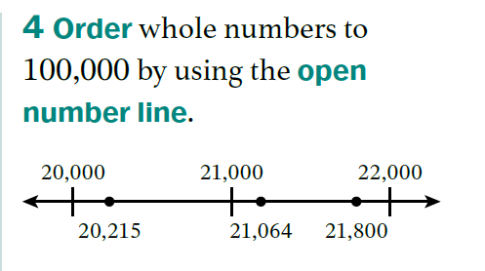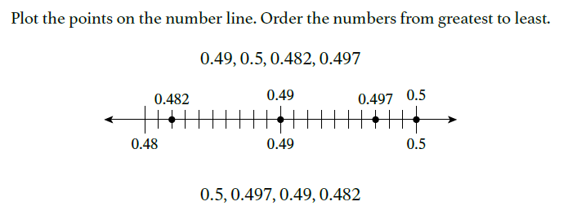
Knowledge Graph Node | Compare two-digit numbers using place value relationships. | Compare multi-digit numbers using place value relationships. | Compare and order multi-digit numbers. | Compare and order decimals.  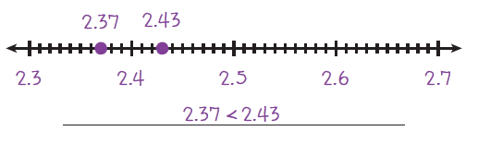
Terminology
Mathematical Models | - Number path/line  - Symbols: >, <, = | - Number path/line  - Symbols: >, <, = | - Number line  - Symbols: >, <, = | - Number line  - Symbols: >, <, =
Strategies
Specifications | - Compare numbers to 100 (or 120, depending on state standards-TX)  - Use tens and ones to justify comparisons  - Compare using a number line  - Compare using base-ten models  - Use >, <, = correctly  - Explain why one number is larger | - Compare whole numbers to 1,000 (or 1,200, depending on state standards-TX)  - Compare using place value reasoning  - Comparing using a number line  - Explain why one number is greater or less  - Use comparison symbols correctly  - Order multiple numbers  - Transition flexibly among standard form, expanded form, place value models, and number lines | - Compare and order numbers to 10,000 (G3)  - Compare and order numbers to 1,000,000 (G4)  - Include comparing and ordering on the number line as one model | - Compare and order decimals to the hundredths (G4)  - Compare and order decimals to the thousandths (G5)  - Include comparing and ordering on the number line as one model
Leaves to Include | Number ranges | Number ranges | Number ranges | Number ranges
Considerations | - use =, <, > with precise meaning of “=”. When comparing numbers, these are the only 3 possibilities. | - Justify via counting array: compare by row (tens) first, then by column (ones) on the array  - connect to expanded form and number line positions  - “=” means the expression on the left of = has the same location on the number line as the expression on the right. Before students have number line: the expression on the left of = is the same number obtained by counting as the expression on the right of “=”; analogous for < and > | - Can (mostly) abandon counting array as expanded form and number line proficiency increases, and as large numbers get more unwieldy in the counting array | - For decimals, rely on number line and expanded form
Required Skills/Cases | - Compare when the greatest place value differs  - Compare when the greatest place value is equal  - Compare when numbers are equal  - Compare using place value representation  - Compare using a number line  - Compare across place value boundaries (e.g., 39 40)  - Compare equivalent representations  - Represent the comparison using >, <, or =.  - Justify the comparison using place value reasoning. | - Compare when the greatest place value differs  - Compare when the greatest place value is equal  - Compare equal sets  - Compare using place value representation  - Compare using a number line  - Compare across place value boundaries (e.g., 399 400)  - Compare equivalent representations  - Represent the comparison using >, <, or =.  - Justify the comparison using place value reasoning. | - Compare numbers with different numbers of digits (all cases apply to G4)  - 3-digit vs 4-digit or 10,000 (G3)  - 4-digit vs 10,000 (G3)  - 3-digit vs 5-digit, 6-digit or 1,000,000  - 4-digit vs 5-digit, 6-digit or 1,000,000  - 5-digit vs 6-digit or 1,000,000  - 6-digit vs 1,000,000  - Compare numbers with the same number of digits  - Different digits in the greatest place value  - Same digit in the greatest place value  - Same digit in multiple places  - Order numbers from least to greatest and greatest to least | - Compare decimals with the same whole number parts  - Compare decimals with different whole number parts  - Compare decimals with a different number of decimal places (all cases apply to G5)  - Tenths vs hundredths (G4)  - Tenths vs. thousandths  - Hundredths vs tenths  - Include cases with trailing zeros (e.g., 0.4 and 0.40)  - Compare decimals with the same number of decimal places  - Different digits in the greatest place value  - Same digit in the greatest place value  - Same digit in multiple places  - Order decimals from least to greatest and greatest to least
Misconceptions | - Comparing ones before tens  - Thinking bigger digits always mean bigger numbers (e.g., comparing individual digits instead of place value) | - Reading left to right without place value (e.g., 398 > 412 because 9 is bigger than 1) | - Comparing by only considering the digit in the greatest place value unit (e.g., thinking 903 is greater than 1,234 because 9 is greater than 1) | - Comparing based only on the number of digits (e.g., thinking 1.23 is greater than 10 because it has more digits)  - Comparing based on the number of digits after the decimal point (e.g., 1.23 is greater than 1.3 because it has more digits after the decimal point)
Existing Product Reference, if any | - D+J: Place Value Comparer  - EM2CA: G1 M1 L2–L4, L6 (1.Mod1.AD8); G1 M5 L7–L9 (1.Mod5.AD4)  - CAT: Place Value—Compare and Order Numbers to 120 | - EM2CA: G2 M1 L35–L38 (2.Mod1.AD16)  - CAT: Place Value—Compare and Order Numbers to 1,000 | - EM2 G4 M1 L9  - Catalyst: Place Value—Compare and Order Numbers to 100,000 | - EM2 G4 M5 L10: Learn 2 and 3  - EM2 G4 M5 L11  - EM2 G5 M4 L6  - Catalyst: Place Value—Compare and Order Decimals to Thousandths
Grade (or Leaf) | G1 | G2 | 3, 4 | 4,5
Notes related to Standards, Grade, or Leaf | 1.NBT.B.3  CA.1.NBT.3  TX.1.2D  TX.1.2F  TX.1.2G  FL.1.NSO.1.4 | 2.NBT.A.4  CA.2.NBT.4  TX.2.2D  FL.2.NSO.1.3 | CCSS.4.NBT.A.2  CA.4.NBT.2  FL.3.NSO.1.3 (to 10,000)  FL.4.NSO.1.3 (to 1,000,000)  TX.3.2D (to 100,000)  TX.4.2C (to 1,000,000,000)  AR.3.NPV.4 (four-digit numbers)  GA.3.NR.1.2 (to 10,000)  KS.4.NBT.2  MD.3.NOS.A.1.d (within 10,000)  MN.3.3.5.3 (to 100,000)  MN.4.3.5.2 (to 1,000,000)  ND.3.NO.NBT.1 (four-digit numbers)  NE.3.N.1.b  OK.3.N.1.4 (to 100,000)  PA.M03.A-T.1.1.4  SC.3.NR.1.3 (to 999,999)  VA.3.NS.2.a (to 9,999)  VA.4.NS.2.a (seven-digit numbers) | CCSS.4.NF.C.7  CCSS.5.NBT.A.3, CCSS.5.NBT.A.3.b  CA.4.NF.C.7  CA.5.NBT.3, CA.5.NBT.3.b  FL.4.NSO.1.5, FL.5.NSO.1.4  TX.4.2F, TX.5.2B  KS.4.NF.7, KS.5.NBT.3b  MN.4.3.5.15, MN.5.3.5.9  MO.5.NBT.A.2  OK.5.N.1.3  VA.5.NS.1.d
Notes for Intervention, Extension, or Optional Activities | - Intervention: build numbers with connecting cubes or base-ten blocks.  - Extension: Order three or four numbers | - Intervention: Have students build numbers using base-ten blocks before comparing.  - Extension: Compare four or five numbers | - Intervention: Use place value disks to represent and compare numbers  - Extension: Compare numbers in different forms | - Intervention: Compare by renaming as a fraction and using an area model (EM2 G4 M5 L10: Learn 1)  - Extension: generate decimals that fit comparison constraints (e.g., a decimal that is greater than 0.3 and less than 0.4)
Additional Notes | Associated concepts from other stems:  - Whole Numbers and Base Ten Structure  - Ordering  Instructional Period:  - Likely 1 instructional period | Associated concepts from other stems:  - Whole Numbers and Base Ten Structure  - Ordering  Instructional Period:  - Likely 1 instructional period | Likely 1 instructional period per grade level | Likely 1 instructional period per grade level

