Estimating Stem Lesson Ladder

PROGRESSION
Essential Foundational Knowledge (Roots) | - Counting to determine “how many”  - Serial order on a number path/line  - Subitizing  - More/less. [reserve “greater than” and “less than” until we define in comparing/ordering stem(s)]
Leads to | - Rounding as distance to a benchmark number on the number line; reasonable sum/difference methods (front-end, compensation); early multiplicative thinking via grouping/arrays. Modeling tasks
Big Ideas | - Numerosity and number location  - Spatial and quantitative reasoning  - Number line reasoning (reason with distance and length)  - Measurement anchoring  - Flexibility with numbers
Other Information | - Justifications cite length on a number line, place-value intervals, benchmarks, composition/scale, or justifications idiosyncratic to the situation/problem. not “it looked like” alone.  - There is no right/wrong here, we don’t need to get fussy with assessment, guess+bounds are for utilitarian human purposes. What are we using our estimate for? That dictates numbers we use. Avoid proceduralizing – we just want to know about how far off we might be, don’t fuss!  - Two important uses of estimation: modeling and error detection when calculating  - Strategy growth visible: quick set → line placement → benchmarks → composition/scale.  - Measurement vs Counting Estimation. Choose a unit, iterate, and anchor to measurement benchmarks (about a foot, about a liter). Prompts mirror bounds/justification above.

Concept/Skill: Make thoughtful guesses about the sizes of sets and about which set has more or less objects. (Katie– DONE)
- D+J: “Perceptual Comparer”. Compare similar collections but only involving very small numbers.
Goal | Make a relatively good guess about “small" numbers of objects
Student-Facing Example | 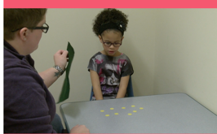  - A child is shown 13 objects spread out for 1 second. The child tries to guess the number of objects. The student guesses a larger number for the same amount of objects when they are more spread out. (Teacher uses a cloth to cover objects between answers)  - Estimating Jar: How many cubes do you think are in this jar?  - How did you come up with your numbers?  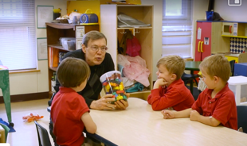  - If this is 10 cubes, how many tens do you think are in this jar?  - “Put objects in a clear plastic jar and secure the lid. Tell the children this is an “estimating jar” and that they will estimate [note: if we’re saying “estimate”, we have to have bounds -ds] how many items are in it, recording their estimates and their names on self-sticking notes to post by the jar. At the end of the week, spill the items out, count them, and compare the counts to the estimates.” - D+J, pg 80
Knowledge Graph Node | Make thoughtful guesses about the sizes of sets and about which set has more or less objects.
Terminology
Mathematical Models | - manipulatives, pictures of objects (on paper vs. on screen), dots and other abstract objects
Strategies | - quick scan that loosely leverages subitizing (no formal grouping yet)
Specifications | - Differences between sets must be clear — one set should cover roughly double the space of the other  - Use brief exposure (~1 second); students should not have time to count  - Start with obvious differences, then gradually reduce the gap as students gain competence  - Objects should be very similar in size. They can be physical, on paper, or on screen
Leaves to Include
Considerations | - Differences between sets must be clear  - One brief look → “About how many?”  - Exposure time  - Configuration of set  - Variables: spread/cluster sense, patterns in space, geometric recognitions from symmetries and groupings  - Do you think this is more or less than 3 objects? More or less than 10 objects? Once they have a more than and a less than can synthesize with "We think it is more than 3 and less than 10" with teacher support.  - “Activities ask children to make simple perceptual estimations about which set has more, including comparison of some larger numbers, but only when comparing sets (e.g., 8) covering a small area to a much larger set (e.g., 16 or more) covering a larger area. Initially these differences can be quite obvious, then decrease them as children gain competence.” -D+J  - Crucial to do this in non-competitive classroom management structure. differences in visual processing speed will create unwanted differentiation issues.
Required Skills/Cases | - Say which of two sets has more when one takes up clearly more space than the other (e.g., one is about double)
Misconceptions | • Student thinks that a spread-out set with fewer objects has more objects than a tightly packed set.
Existing Product Reference, if any | EM2 PreK M4 TD  EM2 GK M1 TD L17  EM2 GK M3 TC L13, L14, L16
Grade (or Leaf) | PreK, GK
Notes related to Standards, Grade, or Leaf | K.CC.C.6  CA.K.CC.6  TX.K.2G
Notes for Intervention, Extension, or Optional Activities | Notes for Intervention, Extension, or Optional Activities:  - The Estimating Jar (Source: Learning Trajectories: Comparing and Order Number: Spatial Extent Estimator)  - Estimate How Many (Source: Learning Trajectories: Comparing and Order Number: Spatial Extent Estimator)
Additional Notes | Launch ideas:  - EM2 GK M1 L9  - EM2 GK M3 L16  - EM2 GK M3 TC L13  Fluency Ideas:  EM2 PreK M4 TD-  - Dot Card Flash- More or Fewer  PreK:  - Using perception to “see” it (e.g., “I can just see there is more.”) (Source: EM2 PreK M4 TD Compare Sets)  - Number comparison is foundational to work with operations. Awareness of more, less, and fewer helps students to reason about story contexts. (EM2 PreK M4 Overview)  GK:  - Young children have an intuitive understanding of size comparison from their daily experiences in the world. This module (M3) develops their ability to talk about their understanding. It also provides tools and encourages behaviors to make more precise comparisons. (EM2 GK M3 Overview)  - UDL: Engagement (EM2 GKM3 TD L18)  Related concepts:  - Comparing numbers  - Comparing measurements  Instructional period:  Likely 1 Instructional period

Concept/Skill: Determine the relative size and position of numbers by using a mental number path or number line. (Megan—DONE)
- D+J: “mental number line to 5”
- D+J: number line placement to 10
- D+J: Number Line Placement to 100
- D+J: number line placement to 1000
Goal | Form a linear representation of numbers
Student-Facing Example | 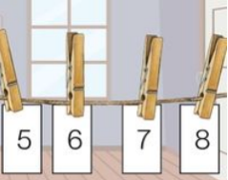  - “Activities ask children to use their mental representation of a number path and the relation between numbers up to 10 to solve a problem such as who is older, or what number is missing in a sequence (e.g., of connecting cubes "stairs" or in a "I'm thinking of a number" game.). Visual mediators (rulers and number lists) scaffold the learning in the earlier phases.” D+J website  - Clothesline number line  - “I have a clothesline of numbers here, but some are missing, could you help me place the missing numbers where they belong?”  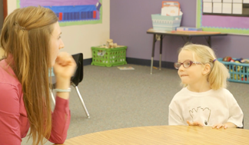  - “Which number is closer to 6; 4 or 9?"  - The child uses a mental number line to answer the following questions: 1) "Which is biggest: 5 or 4?", 2) "Which is biggest: 7 or 9?" and 3) "Which is closer to 6, 9 or 4?"  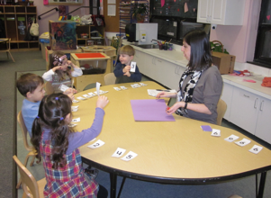  - Secret Number – Child has counting cards 1-10 face up, Teacher hides a number card and students determine the missing number. (Independent version of number detective)  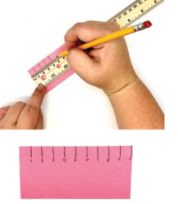  - Make a 10 cm ruler  - Phil: real objects in world, pictures of objects in world, objects on screen (movable vs not movable). These are different. Careful about progression, and we need to do all of them! Students need experience using rulers here too.  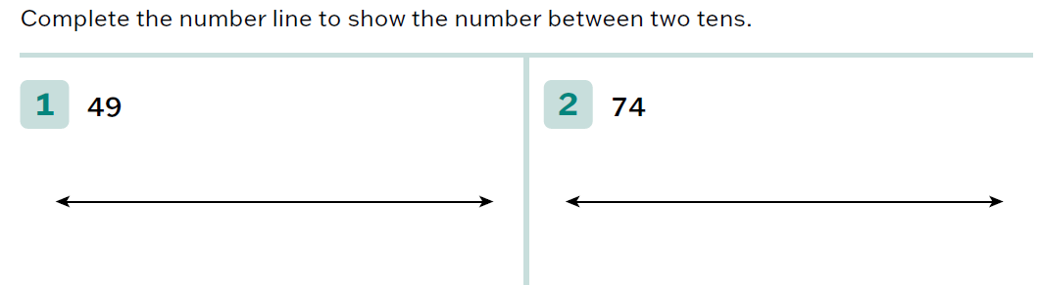  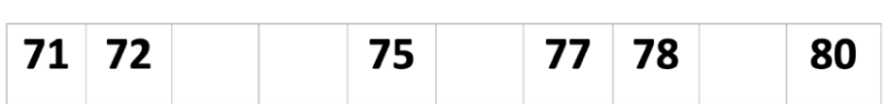  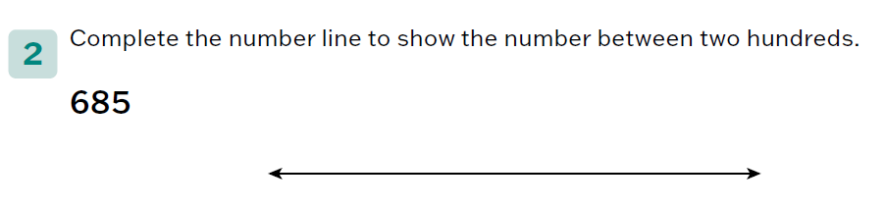
Knowledge Graph Node | Determine the relative size and position of numbers to up 5 by using mental number paths and knowledge of number relationships. | Determine the relative size and position of numbers up to 10 by using mental number paths and knowledge of number relationships. | Determine the relative size and position of numbers up to 100 by using mental number lines and knowledge of number relationships. | Determine the relative size and position of numbers up to 1,000 by using mental number lines and knowledge of number relationships, including place value.
Terminology
Mathematical Models | - Number line  Note: From D&J (pg. 74) “building number sense through number line estimation is not the same as having children work with ‘number lines’ or to solve problems using number lines” | Number line | Number line | - Number line
Strategies |  |  | - Use tens to create interval bounds  decide closer to which endpoint by distance | - Use tens to create interval bounds  decide closer to which endpoint by distance
Specifications | PK and GK:  - Provide perceptual support (i.e., number path, number stairs, counting cards)  - Use 1 more, 1 less activities/number stairs to help students build their understanding of number relationships and visualize the size and position of numbers  - 1 more/1 less counting (“1, 1 more is 2. 2, 1 more is 3.”)  - Remove/omit numbers or number stair “steps” from a sequence and ask students to determine what’s missing  - Offer contextualized problems that encourage students to consider the relative size of numbers (i.e., “Who is older” question)  - Incorporate board games beginning in PK (see “additional notes”)  - See Considerations notes around placing numbers on a line | PK and GK:  - Use 1 more, 1 less activities/number stairs to help students build their understanding of number relationships and visualize the size and position of numbers  - 1 more/1 less counting (“1, 1 more is 2. 2, 1 more is 3.”)  - Remove/omit numbers or number stair “steps” from a sequence and ask students to determine what’s missing or place missing numbers  - Provide two numbers within 10 and determine which is “biggest” or closer to a given number  - Make a 10 cm ruler  - Incorporate board games beginning in PK (see “additional notes”)  See Considerations notes around placing numbers on a line | - Provide two numbers within 100 and determine which is “biggest” or closer to a given number  - Examples:  - When child is asked which of two, two-digit numbers is smaller, correctly answers 27.  - When asked, "Which is closer to 45: 30 or 50?," a child says, " 45 is right next to 50, one five away, but 30 isn't."  - Remove/omit numbers from a sequence and ask students to determine what’s missing or place missing numbers  - See Crack the Code on Learning Trajectories website  - Place numbers on a line between interval bounds (i.e., between two tens)  - Move from bounds providedcreate the bounds  - Decide closer to which endpoint by distance  - Place number on an empty number line labeled with only 0 and 100. Add additional tick marks to support precision and help students refine their estimates.  - Divide the number line in half and quarters to create boundaries that support number placement.  - Use the midpoint of 50 as an anchor/benchmark to support placement. Students can then think about whether the number is greater than or less than 50.  - Incorporate additional benchmarks (25 and 75) to support precision in placement.  - “40 is between 25 and 50. It is only 10 away from 50, but 15 away from 25. 40 should be placed closer to 50 than 25.”  Estimate the placement of a tick mark on an empty number line labeled with only 0 and 100 (determine the unknown number that belongs at that tick mark—see Rocket Blast on Learning Trajectories website) | - Provide two numbers within 1,000 and determine which is “biggest” or closer to a given number  - (Within 1,000) Remove/omit numbers from a sequence and ask students to determine what’s missing or place missing numbers  - See Chip Flip Century on Learning Trajectories website  - (Within 1,000) Place numbers on a line between interval bounds (i.e., between two tens or hundreds)  - Move from bounds providedcreate the bounds  - Decide closer to which endpoint by distance  - Place number on an empty number line labeled with only 0 and 1,000. Add additional tick marks to support precision and help students refine their estimates.  - Divide the number line in half and quarters to create boundaries that support number placement.  - Use the midpoint of 500 as an anchor/benchmark to support placement. Students can then think about whether the number is greater than or less than 500.  - Incorporate additional benchmarks (250 and 750) to support precision in placement.  - “400 is between 250 and 500. It is only 100 away from 500, but 150 away from 250. 400 should be placed closer to 500 than 250.”  - Estimate the placement of a tick mark on an empty number line labeled with only 0 and 1,000 (determine the unknown number that belongs at that tick mark—see Rocket Blast on Learning Trajectories website  Use place value to estimate a number’s position. For example, when placing 383 between 350 and 400, compare the digits in the tens place (“8 is greater than 5”) and determine that 383 should be placed after 350, closer to 400.
Leaves to Include |  | 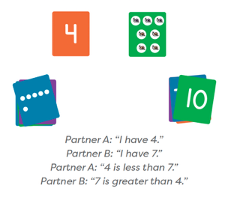  Number Range | Number range (Example: TX standard is 120)
Considerations | THIS STEP IS SUPER IMPORTANT  - Provide perceptual support  - Place a number on a line 0-5; reason with length, not tick-mark counting  - Complexities to dial up or down: open/partially labeled line, distractor placements  - Do not use the word estimate unless we are going to define it and require the thoughtful guess and the bounds. | - Place a number on a line 0-10; reason with length, not tick-mark counting  - “Where does __ go on 0–10? Give bounds first, then your best point. Why there?”  - Variables: open/partially labeled line, distractor placements  Phil says: expect correct order and roughly equal spaced. It’s common for spaces to get smaller as numbers get larger that’s ok… we’re giving them experience to get them equi-spaced. Kids need experience seeing NLs but also DRAWING them. They won’t master it here. That’s ok, they still need to do it | - “On 0–100, bound 74 between hundreds and tens; which ten is it closer to? Explain with distances.”  This is probably the earliest we want to define and get all mathy about “estimate”– a thoughtful guess with bounds. About 7 years old per D+J | - “On 0–1000, bound 374 between hundreds and tens; which hundred is it closer to? Explain with distances.”  Phil: main thing here is - it works the same with big numbers and little numbers. Go ahead and bring place value up and make the connection explicit – ie put 68 in between 0-100, now do 680 between 0-1000
Required Skills/Cases | Up to 5 (PK and GK):  - Orally identify or write the missing number(s) in a sequence OR orally identify the missing number stair “step” in a sequence  - Given two numbers in context, identify the one that is greater (orally, by circling, etc.)  - Place a number on a number path/line  - Example: When shown a 0 at one end of a line segment and a 5 at the other, a child places a "3" approximately in the middle. | Up to 10 (PK and GK):  - Orally identify or write the missing number(s) in a sequence OR orally identify the missing number stair “step” in a sequence  - Given two numbers, identify the one that is greater (orally, by circling, etc.)  - Given two numbers, identify the one that is “closer to” another given number  - “Which is closer to 6, 9 or 4?”  - Place a number on a number path/line  Example: When shown a 0 at one end of a line segment and a 10 at the other, a child places a "5" approximately in the middle. | Up to 100:  - Orally identify or write the missing number(s) in a sequence  - Given two numbers, identify the one that is greater (orally, by circling, etc.)  - Given two numbers, identify the one that is “closer to” another given number  - “Which is closer to 45, 30 or 50?”  - Place number on empty number line labeled with only 0 and 100, with only 0, 50, and 100, or with only 0, 25, 50, 75, and 100  - Accurately place a number between provided bounds on a number line (place 49 between existing bounds of 40 and 50)  - Ex. From TX BB G1 M4 L11 PS:  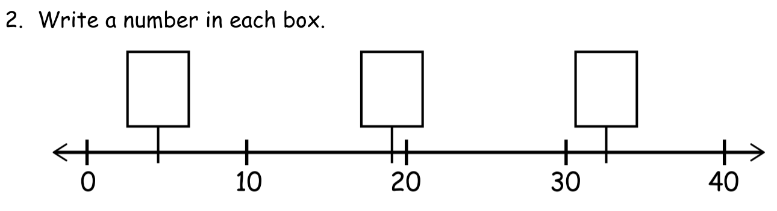  - Create interval bounds (i.e., tens) and accurately place a number within the bounds  Example: Given the number 49, create the bounds of 40 and 50 and place 49 close to 50 | Up to 1,000:  - Orally identify or write the missing number(s) in a sequence  - Given two numbers, identify the one that is greater (orally, by circling, etc.)  - Given two numbers, identify the one that is “closer to” another given number  - “Which is closer to 590, 870 or 240?”  - Place number on empty number line labeled with only 0 and 1,000, with only 0, 500, and 1,000, or with only 0, 250, 500, 750, and 1,000  - Accurately place a number between provided bounds on a number line (i.e., tens, hundreds)  - Create interval bounds (i.e., tens, hundreds) and accurately place a number within the bounds  Example: Given the number 488, create the bounds of 480 and 490 and place 488 close to 490
Misconceptions | - Students may not understand that a set with 5 objects also contains the 1st, 2nd, 3rd and 4th object.  - Issues with number placement when determining relative position (for example, placing the number 3 closer to 1 or to 5 rather than about in the middle)  - Confusing tick marks and interval lengths. They might think of 0 as 1. | - Students may not understand that 5 actually contains 1, 2, 3, and 4 inside of it (concept of hierarchical inclusion)  Issues with number placement when determining relative position (for example, placing the number 5 closer to 0 or to 10 rather than about in the middle) | - Students may crowd numbers at the beginning or the end of the number line due to an inability to visualize distance.  - Students may reverse digits in a number (confusing 23 and 32).  When labeling benchmarks on a number line between multiples of 10 or 100, students do not identify the correct value halfway between the two multiples. This can lead to an incorrect identification of points on the number line. | - Students may crowd numbers at the beginning or the end of the number line due to an inability to visualize distance.  When labeling benchmarks on a number line between multiples of 10 or 100, students do not identify the correct value halfway between the two multiples. This can lead to an incorrect identification of points on the number line.
Existing Product Reference, if any | - EM2 PK M3 Topic C  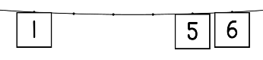  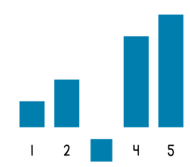  - See Number Stairs—I Can Count and Clothesline Number Path Digital Interactives  - EM2 GK M1 L28 Learn 2 “Number Detective” (goes to 10, could modify to 5)  - EM2 GK M1 Topic G  - EM2 Florida GK M5 L20: Clothesline Math (idea could be adapted—numbers to 5) | - EM2 PK M3 Topic C  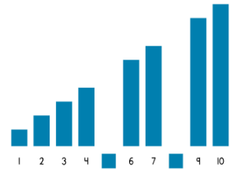  - See Number Stairs—I Can Count and Clothesline Number Path Digital Interactives  - EM2 GK M1 L28 Learn 2 “Number Detective”  - EM2 GK M1 Topic G  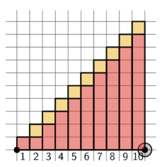  - See The First Number Stair and The Last Number Stair Digital Interactives (L29 & L31)  - Dancing Cats Chant  - EM2 GK M3 Topic D L19  - EM2 Florida GK M6 L5 (lesson focuses on teen numbers but could be modified to 10)  - See Clothesline Math Digital Interactive  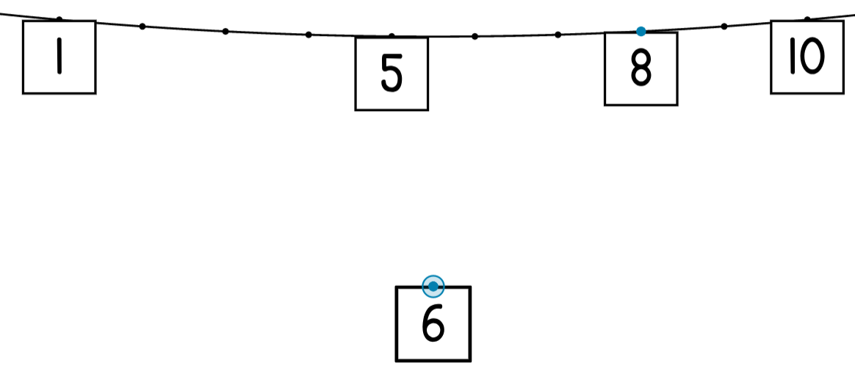  EM2 Florida GK M6 L20 (same note as above) | - EM2 GK M6 L19  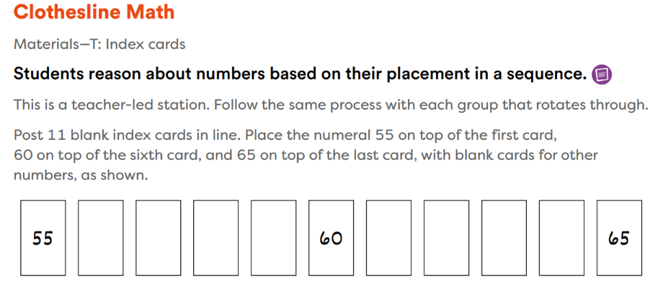  - TX BB G1 M4 Lesson 11  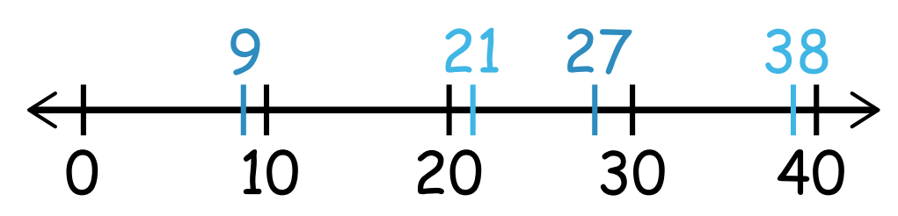  - EM2 G2 M5 Lesson 12  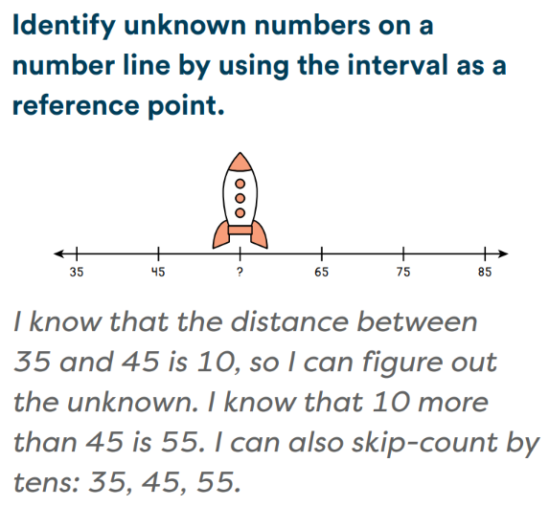  Math Catalyst, Place Value, Locate Numbers on a Number Line | Math Catalyst, Place Value, Locate Numbers on a Number Line
Grade (or Leaf) | PK, GK | PK, GK | G1 | G2
Notes related to Standards, Grade, or Leaf | K.CC.A.2  CA.K.CC.2  K.CC.B.4  K.CC.B.4.c  CA.K.CC.4  CA.K.CC.4.c | K.CC.C.7  K.MD.A.2  K.CC.B.4  K.CC.B.4.c  CA.K.CC.4  CA.K.CC.4.c  CA.K.CC.7  CA.K.MD.2  TX.K.2H  FL.K.NSO.2.3  TX.K.2A | 1.NBT.A.1  CA.1.NBT.1  FL.1.NSO.1.4  FL.2.NSO.1.4  TX.1.2F  MD.1.NOS.B.6  VA.2.NS.2.f | FL.2.NSO.1.3  VA.2.NS.1.g  TX.2.2E  TX.2.2F
Notes for Intervention, Extension, or Optional Activities | Intervention  - Chorally say the number sequence before asking students to identify a missing number.  - Provide a number path or counting cards for students to reference.  Extension  - Place numbers in a decreasing sequence. | Intervention  - Chorally say the number sequence before asking students to identify a missing number.  - Provide a number path or counting cards for students to reference.  - Focus on removing cards with a smaller number (e.g., 2, 3, 4).  Extension  - Place numbers in a decreasing sequence.  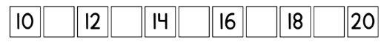  - Determine the relative size and position of numbers to 20 (see EM2 GK M6 L5).  - Remove more than one card and ask students to identify all the missing numbers.  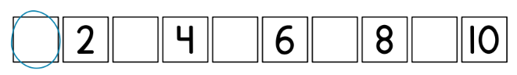 | Intervention  - Pulled from G2 M5 L12 Differentiation Support box: Support students with identifying the unknown (on a number line) by returning to concrete materials, such as yard sticks and inch tiles.  Extension  See Learning Trajectories I’m Thinking of a Number activity | Intervention  - Math Catalyst, Place Value, Locate Numbers on a Number Line  Extension  See Learning Trajectories I’m Thinking of a Number activity
Additional Notes | Fluency Ideas  - Counting the Math Way to 5/Within 5 (EM2 GK M1)  - Choral Response: Which Step is Missing? (EM2 GK M3—modify to 5)  Additional Notes  - From Clements and Sarama, p. 74:  - “Playing board (“racing”) games can develop all children’s ability to do number line estimation, as well as to order magnitudes, count, and recognize numerals.”  - “Even if you use dice or spinners with dots or numerals, mental number lines do not develop well unless there are numerals on the board’s path (as in Chutes and Ladders)…children must read the numerals as they move over them, as in “15, 16, 17!””  - “First graders who estimated the position of target numbers on a 0-100 number line by walking to the estimated position improved in both number line estimation and addition more than those who estimated distances on a screen.”  - “Many competencies help build a mental number line, especially children’s familiarity with numbers in the range considered; for example, their ability to spontaneously subitize or to be a Counter from N.”  Instructional Period  - 2  Associated Concepts from Other Stems  - Comparing and ordering numbers | Fluency Ideas  - Counting the Math Way to 10/Within 10 (EM2 GK M1)  - Choral Response: Which Step is Missing? (EM2 GK M3)  Additional Notes  - From Clements and Sarama, p. 74:  - “Playing board (“racing”) games can develop all children’s ability to do number line estimation, as well as to order magnitudes, count, and recognize numerals.”  - “Even if you use dice or spinners with dots or numerals, mental number lines do not develop well unless there are numerals on the board’s path (as in Chutes and Ladders)…children must read the numerals as they move over them, as in “15, 16, 17!””  - “First graders who estimated the position of target numbers on a 0-100 number line by walking to the estimated position improved in both number line estimation and addition more than those who estimated distances on a screen.”  - “Many competencies help build a mental number line, especially children’s familiarity with numbers in the range considered; for example, their ability to spontaneously subitize or to be a Counter from N.”  Instructional Period  - 2  Associated Concepts from Other Stems  Comparing and ordering numbers | Additional Notes  - “Visual mediators (rulers and number lists) can help children develop the competence initially.” (Source: Learning Trajectories website)  - “Involve children’s whole bodies: First graders who estimated the position of target numbers on a 0-100 number line by walking to the estimated position improved in both number line estimation and addition more than those who estimated distances on a screen.” (Source: Doug and Julie)  - “Many competencies help build a mental number line, especially children’s familiarity with numbers in the range considered.” (Source: Doug and Julie)  - “It may be that solving arithmetic problems in a given range is another, possibly most effective, way of developing number line estimation.” (Source: Doug and Julie)  Instructional Period  - 2-3?  Associated Concepts from Other Stems  - Whole Numbers and Base Ten Structure  - Comparing and ordering numbers  Rounding | Additional Notes  - “Visual mediators (rulers and number lists) can help children develop the competence initially.” (Source: Learning Trajectories website)  - “Involve children’s whole bodies: First graders who estimated the position of target numbers on a 0-100 number line by walking to the estimated position improved in both number line estimation and addition more than those who estimated distances on a screen.” (Source: Doug and Julie)  - “Many competencies help build a mental number line, especially children’s familiarity with numbers in the range considered.” (Source: Doug and Julie)  - “It may be that solving arithmetic problems in a given range is another, possibly most effective, way of developing number line estimation.” (Source: Doug and Julie)  Instructional Period  - 2-3?  Associated Concepts from Other Stems  - Whole Numbers and Base Ten Structure  - Comparing and ordering numbers  Rounding

Concept/Skill: Make a thoughtful guess about the number of objects in a group. (Stella – DONE)
- D+J: Perceptual comparer
- “spatial extent estimator”. Name a "small number" (e.g. from 1-4) for sets that cover little space and a "big number" (10-20 or more) for sets that cover a lot of space

Goal | Make a thoughtful guess about a number of objects
Student-Facing Example | 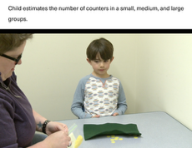  - Shown 9 objects spread out randomly for 1 second and asked, "How many?," the child guesses, "14."  - Other example:  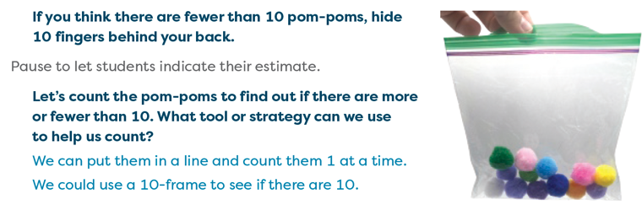  - Measurement  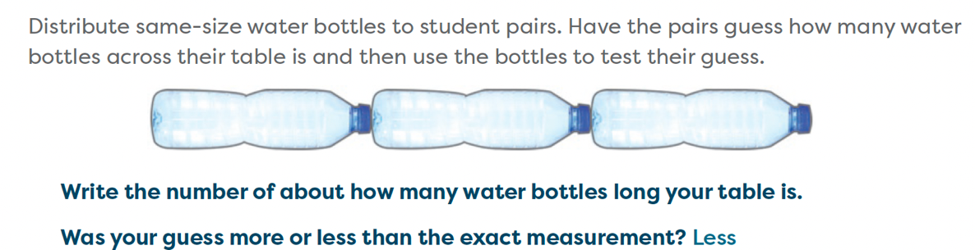
Knowledge Graph Node | Make a thoughtful guess about the number of objects in a group.
Terminology
Mathematical Models | - manipulatives, pictures of objects (on paper vs. on screen), dots and other abstract objects
Strategies | - quick scan that loosely leverages 5s/10s (no formal grouping yet)  - perceptual and conceptual subitizing
Specifications | - Students make reasonable estimate before counting, using “too low” and “too high” bounds to narrow a range.  - Students may use prior sets, visible quantity, grouping, or a number path to support the estimate.
Leaves to Include | - Small numbers (the smallest of which are usually subitized, not estimated)  - Middle-sized numbers (e.g., 10-20)  - Large numbers (e.g., beyond 20)
Considerations | - One brief look → “About how many?”  - Do not say “estimate” unless we want thoughtful guess AND bounds: “You get one quick look to make an estimate. About how many? Give a low and high; what makes that range reasonable?”  - Exposure time  - Configuration of set  - Set size (set leaves)  - Possible measurement to include: length, area, volume, time, perimeter, angles  - Complexities: spread/cluster sense, patterns in space, geometric recognitions from symmetries and groupings  - Estimate increases as the size of the set increases
Required Skills/Cases | - Estimate a single visible collection before counting.  - Size of sets:  - Small set (the smallest of which are usually subitized)  - Medium-sized set (e.g., 10-20)  - Large set (e.g., beyond 20)  - Identify a number that is too low.  - Identify a number that is too high.  - Choose a reasonable estimate between the bounds.  - Organize objects to support counting after estimating.  - Compare estimate to actual count.  - Possible measurement to include: length, area, volume, time, perimeter, angles.
Misconceptions | - Treating spread-out objects as “more” than compact objects. (Source: Learning Trajectory-Spatial Extent Estimator- Small/Big)  - Thinking estimate must be exact. Remind them that an estimate is a good guess where they think about the numbers. (Source: Learning Trajectories-Spatial Extent Estimator)
Existing Product Reference, if any | EM2 PreK M1 L14 & M6 Project C  EM2 GK M6 TA L1  EM2 G1 M1 L5 & L25
Grade (or Leaf) | GK  - Size of groups (small, medium, large)
Notes related to Standards, Grade, or Leaf | K.CC.B.4  K.CC.B.5  CA.K.CC.4  CA.K.CC.5  TX.K.2C  TX.K.2D  FL.K.NSO.1.1  FL.K.NSO.1.3  GA.PK.CD-MA7.4a  MN.PK.M5.7  AK.1.CC.6
Notes for Intervention, Extension, or Optional Activities | Notes for Intervention:  - Use a number path, smaller collections, 5-groups/10-groups.  - Ask: What number is too low? What number is too high? What guess makes sense? (EM2 PreK M1 L14) (EM2 G1 M1 L1)  Extension/Optional Activities:  - Guessing Jar (Volume Quantifier): Children estimate the number of cubes in a clear container  - Adaptation Suggestions: This activity can be used with other large manipulatives; such as toy dinosaurs or plastic eggs of the same size. As children get better at estimating, you can use increasingly smaller objects. (Source: Learning Trajectories-Measurement Volume)
Additional Notes | Additional Notes:  - Kindergarten students are not expected to know the term estimate. In grade 1, estimate is described as making a good guess. A formal description of the term is introduced in grade 2. (EM2 GK M3 TD L18 Teacher Note)  - “Small numbers,” the smallest of which are usually subitized, not estimated; “middle-sized numbers” (e.g., 10-20); and “large numbers.” (e.g., beyond 20) (Source: Learning Trajectories: Spatial Extent Estimator)  Launch ideas:  - EM2 G1 M1 TA L1  - EM2 G1 M1 TC L11  From the Learning Trajectories (Sub Trajectory: Numerosity: Estimation):  - Benchmark Estimator- Counts a portion of the to-be-estimated collection and uses that as a benchmark from which an estimate is made, intuitively or using repeated addition or multiplication. Scanning can be linked to recalled benchmarks.  Related concepts:  - Comparing and ordering numbers  - Comparing measurements  Instructional periods:  - Likely 1 instructional period

Concept/Skill: Estimate the number of objects in a group by using a mental number line. (Stella – DONE)
- D+J: Scanning with intuitive quantification estimator
Goal | Make a relatively good guess about a number of objects by using a mental number line (linear representation of numbers)
Student-Facing Example | 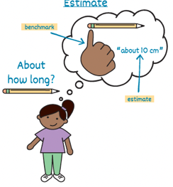  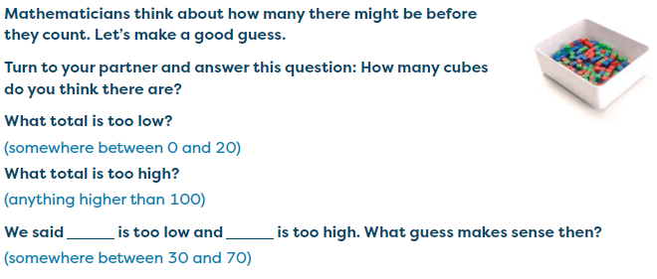  - Student facing example for term
Knowledge Graph Node | Estimate the number of objects in a group by using a mental number line.
Terminology
Mathematical Models | - Number line
Strategies | - manipulatives, pictures of objects (on paper vs. on screen), dots and other abstract objects
Specifications | - Observe a collection without counting every object.  - Use visual magnitude and quantities (e.g., 5, 10, 20)  - Identify numbers that are “too low” and “too high.”  - Place the estimated quantity between known values.  - “It looks more than 20 but less than 30.”  - “It is halfway between 40 and 50.”  - Refine estimates when additional information is provided.  - Recognize that estimation produces a reasonable approximation, not an exact count.  - Verify estimates through counting or organizing.
Leaves to Include
Considerations | - Possible measurement to include: length, area, volume, time, perimeter, angles  - We definitely need “estimate” student facing here.
Required Skills/Cases | - Size of collection  - Small sets (8–15 objects) (GK)  - Medium sets (20–50 objects) (G1)  - Larger sets (50–200 objects) (G2)  - Arrangement  - Organized arrays  - Scattered arrangements  - Clustered groups  - Mixed-density arrangements  - Number-line relationships  - Locating estimated quantities on a number line  - Comparing two estimates  - Different object types  - Identical objects  - Objects with varying sizes  - Real-world collections (buttons, cubes, counters, dots, leaves, etc.)
Misconceptions | - Estimation means guessing randomly.  - Estimation should be based on visual evidence  - “What number are you comparing to?” “How do you know it is more than 20?”  (Source: EM2 G2 M1 TC L11-definition for estimates)  - An estimate must be exact.  - Estimates are reasonable approximations.  - Discuss acceptable ranges rather than a single correct answer. (Source: EM2 G2 M1 TC L11-Teacher Note)
Existing Product Reference, if any | G1 M1 TA L5  G2 M1 TC L11
Grade (or Leaf) | G2
Notes related to Standards, Grade, or Leaf | 2.NBT.A.2  2.MD.B.6  2.MD.A.3  CA.2.NBT.2  CA.2.NBT.7.1  CA.2.MD.6  CA.2.MD.3  TX.2.2D  TX.2.2E  TX.2.2F  FL.2.NSO.1.3  FL.2.NSO.1.4
Notes for Intervention, Extension, or Optional Activities | Notes for Intervention:  - Consider using larger objects (shape tiles or blocks) for children with fine motor delays or a visual impairment (Source: Learning Trajectories: Groupitize!)  Notes for Extension:  - Justify estimates by explaining which visual features were used (e.g., “It looks close to five groups of ten, so I estimated about 50.”)  Optional Activities:  - The Estimating Jar [Scanning with Intuitive Quantification] (Source: Learning Trajectories: Comparing and Ordering Number-Scanning with Intuitive Quantification Estimator)
Additional Notes | Related concepts:  - Comparing and ordering numbers  - Comparing measurements  Launch Ideas:  - EM2 G2 M1 TA L3  - EM2 G2 M1 TD L16  - EM2 G2 M1 TE L20  Fluency Ideas:  - Counting on a Meter Stick by Tens Within 120 (EM2 G2 M1 TD L15)  - Counting on the Meter Stick by Tens Within 150 (EM2 G2 M1 TD L16)  Lesson Ideas:  - EM2 G2 M1 TB L10  - EM2 G2 M1 TC L11  - EM2 G2 M1 TD L15 & 16  - EM2 G2 M1 TE L23  - EM2 G2 M4 TA L1  Instructional periods:  - Likely 1-2 instructional periods

Concept/Skill: Estimate a number of objects or a measurement by using benchmarks. (Megan-DONE)
- D+J: benchmarks estimator
Goal | Compare to-be-estimated collection to benchmarks (e.g., 5, 10, 25, 50, 100)
Student-Facing Example | - Shown 11, a child says "It looked closer to 10 than 20, so I guess 12."  - Shown 45 objects spread out for 1 second and asked, "How many?," a child responds, "About 5 tens - Fifty."  - Children estimate the number of objects in a jar and use those estimations to construct a number line.  - “Count a portion of the to-be-estimated collection and uses that as a benchmark from which an estimate is made, intuitively or using repeated addition or multiplication. Scanning can be linked to recalled benchmarks.” D+J pg 87
Knowledge Graph Node | Estimate a number of objects or a measurement by using benchmarks.
Terminology
Mathematical Models
Strategies | - Count or scan subset to use as benchmark  - Include measurement along with counting here.  - Choose a unit, iterate, and anchor to measurement benchmarks (about a foot, about a liter).  - Prompts mirror bounds/justification with counting.
Specifications | - Using physical objects, help students form benchmarks  - “What would 10 of these look like? 100?”  - Compare a to-be-estimated group to established benchmarks (5, 10, 25, 50, 100)  - Count a small number of the objects and use that group as a benchmark from which an estimate can be made (i.e., by using repeated addition, skip counting, early multiplicative thinking)  - Identify numbers that are “too low” and “too high”  - Verify estimates through counting or organizing  - Incorporate variety in both objects used and their arrangements (arrays, scattered, clustered groups)
Leaves to Include | - Time  - Measurement
Considerations | - Estimate is two things: a thoughtful guess and bounds.  - “Name the benchmark(s) you used. State low/high and your estimate. Why must the true value be in that range?”  - Possible measurement to include: length, area, volume, time, perimeter, angles
Required Skills/Cases | - Estimate the total number of objects in a group of up to 100 objects by using either of the following methods:  - Count a subset and use the number as a benchmark  - Example: Shown 45 objects spread out and asked, "How many?," a child responds, "About 5 tens - Fifty."  - Compare the group to known, established benchmarks  - Example: Shown 11 objects, a child says "it looks like it is between 10 and 20, but closer to 10
Misconceptions | - Estimation means guessing randomly.  - Estimation should be based on visual evidence  - “What number are you comparing to?” “How do you know it is more than 20?” (Source: EM2 G2 M1 TC L11-definition for estimates)  - An estimate must be exact.  - Estimates are reasonable approximations.  - Discuss acceptable ranges rather than a single correct answer. (Source: EM2 G2 M1 TC L11-Teacher Note)
Existing Product Reference, if any | EM2 G1 M1 TA L5  EM2 G2 M1 TC L11 (Measurement focus)  TX BB G2 M2 L5 (Measurement focus)  TX BB G2 M7 L21 (Measurement focus)
Grade (or Leaf) | G2
Notes related to Standards, Grade, or Leaf | CA.2.NBT.7.1  MD.1.NOS.B.6  MD.2.NOS.A.5
Notes for Intervention, Extension, or Optional Activities | Intervention  - Focus on smaller groups of objects and benchmarks of 5 and 10  Extension/Optional  - See Learning Trajectories activity Number Line Estimator [STEMIE]
Additional Notes | Additional Notes  - “In specifically designed instructional situations (e.g., a whole-group lesson in which a large chart is covered with a number of dots) or other settings (e.g., noting a large flock of birds on the playground), ask children to estimate the number.” (Source: Learning Trajectories website)  - “Asking for a number they know is too high and one that is too low early on establishes boundaries for a reasonable answer and encourages accuracy.” (Source: EM2 G1 M1 L5 Teacher Note)  Instructional Period  - 1-2  Associated Concepts from Other Stems  - Whole Numbers and Base Ten Structure  - Comparing and ordering numbers  - Rounding  - Comparing measurements

Concept/Skill: Estimate a number of objects by decomposing and recomposing a set. (Stella – Done)
- D+J: composition estimator
Goal | Partition into convenient groups, then recompose
Student-Facing Example | - When shown 87 objects spread out and asked for an estimate, the child points to a section and says, "That's about 20 - so 20, 40, 60, 80, Eighty!" The use of repeated addition supports estimation after a visual separation of the objects into 4 parts.  - Estimating Game  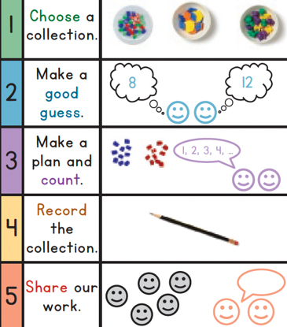  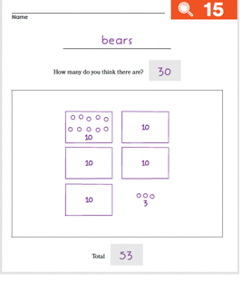  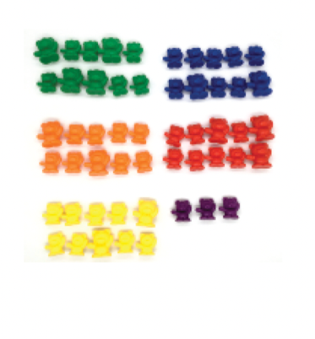
Knowledge Graph Node | Estimate a number of objects by decomposing and recomposing a set.
Terminology
Mathematical Models | - Number line
Strategies | - Repeated addition  - Multiplication  - Include measurement along with counting here, and throughout the rest of the stem.  - Choose a unit, iterate, and anchor to measurement benchmarks (about a foot, about a liter).  - Prompts mirror bounds/justification with counting.
Specifications | - The total set should contain too many objects for immediate subitizing, but not so many that partitioning becomes inaccessible.  - Subsets should be visually or conceptually available through spacing, clustering, rows, columns, color, shape, or student-imposing grouping.  - The task should ask for an estimate, about how many, or a reasonable total, not an exact count.  - Student should not need to count every object one by one.  - The skill should involve both:  - Decomposition: breaking the whole into parts  - Recomposition: combining the approximate parts into a total  - Acceptable reasoning may include additive, skip-counting, or early multiplicative thinking.
Leaves to Include
Considerations | - How did you group the set? Show a lower estimate, a higher estimate, and defend your best.”  - Possible measurement to include: length, area, volume, time, perimeter, angles  - Variables: Arrays, quasi-arrays, irregular clusters; visibility of grouping cues
Required Skills/Cases | - Equal-size partitioning  - The set can be mentally grouped into approximately equal subsets. Example: “This looks like about 4 groups of 5, so about 20.”  - Unequal-size partitioning  - The set is broken into non-equal but meaningful chunks.  Example: “There are about 10 on this side and about 6 on that side, so about 16.”  - Array or structured arrangement  - Objects are arranged in rows, columns, clusters, or repeated groups that support partitioning. Example: “About 3 rows of 6, so about 18.”  - Unstructured collection  - Objects are scattered, requiring the student to impose their own grouping strategy.  - Recomposition with approximation  - Student combines estimated subset quantities and understands the result is approximate, not exact.
Misconceptions
Existing Product Reference, if any | EM2 G1 M3 TD L15  EM2 G2 M1 TE L23, TI L37  EM2 G2 M4 TE L1 & L24  EM2 G2 M5 TE L1  EM2 G2 M6 TA L2
Grade (or Leaf) | G2
Notes related to Standards, Grade, or Leaf | 2.OA.C.4  2.OA.C.3  2.OA.B.2  CA.2.OA.4  CA.2.OA.3  CA.2.NBT.2  TX.2.6A  TX.2.2A  TX.2.4B  FL.2.AR.3.2  FL.2.AR.3.1  FL.2.NSO.1.4
Notes for Intervention, Extension, or Optional Activities | Notes for Intervention:  - Encourage students to physically or mentally draw boundaries around subsets.  - The use of ten-frames and 10-frame cartons support one-to-one correspondence (Source: EM2 GK M1 TB L6 & L17)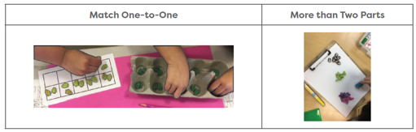  - Use dot collections, cubes, or counters arranged in loose clusters. Ask questions such as:  - What smaller groups do you notice?  - Which part is easiest to estimate first?  - About how many are in each group?  - Allow students to explain multiple growing strategies for the same collection.  - Progress from structural arrangements (rows, arrays, clusters) to irregular scattered collections.  - Students may choose to use organizing tools as they count and record. Cups, bowls, and number paths can support or challenge students. (Source: EM2 PreK M1 Counting Collections)  - Number paths of different lengths are excellent tools to offer. Number paths support one-to-one correspondence and may allow students to stretch into larger collections than they could count alone. Student also use number paths as a way to independently find and copy numerals. (Source: EM2 GK M1 TG L33)  Notes for Extension:  - Students who are proficient can deepen their reasoning by:  - Comparing multiple partitioning strategies for the same collection.  - “I saw four groups of six.”  - “I saw two groups of twelve.”  - “I saw ten and about fourteen more.” (EM2 G1 M6 TD L16 Differentiation: Challenge)  - Estimate larger collections (50–200 objects)  - Use benchmark quantities (5, 10, 25, 50, 100)  - Explain which partitioning strategy produces the most reasonable estimate  - Connect partitioning to:  - Repeated addition  - Skip counting  - Arrays  - Area models  - Multiplication  - Estimate before verifying by counting  Optional Activities:  - Estimating Game (Learning Trajectories website- Composition Estimator Estimating Game)
Additional Notes | Related concepts:  - Addition  - Multiplication and Division  - Fractions  - strong connections to other stems: adding as an extension of counting partitioning that extends to multiplication, division, and fractions  (Source: EM2 G2 M6 Why)  Additional Notes:  - Decomposes or partitions to-be-estimated set into convenient subset sizes then recomposes the numerosity. Initially, this is done with regular arrangements using repeated addition or multiplication. Later, the process can be done with irregular arrangements and children more consistently use multiplication skills to recompose (Source: Learning Trajectories: Composition Estimator)  Launch ideas:  - EM2 G2 M1 TI L37  Lesson ideas:  - EM2 G1 M1 TD L25  - EM2 G2 M1 TE L23  - EM2 G2 M4 TA L1  - EM2 G2 M4 TE L24  Instructional days:  Likely 1-2 days instructional days

