Fractions Stem Lesson Ladder

PROGRESSION
Essential Foundational Knowledge (Roots) | - Units, equal partitions of a unit, and length on the number line  - Meaning of “=” and the basic protocol for symbols (every symbol has a stated meaning)  - Single-digit whole number computation and place value
Leads to | - Operations with fractions  - Proportionality and ratios/rates, percentages, slope as a ratio, similarity/scale factor, and early algebraic manipulation with precise use of symbols  - Advanced concept of number used in middle grades and algebra.
Big Ideas | - Fractions as numbers  - Fractions as extensions of whole number concepts  - Relationships between fractions (comparing, ordering)  - Flexibility with numbers (fraction equivalence)  - Symbolic precision, basic protocol in the use of symbols, the number above the bar has a different meaning entirely than the number below the bar. When we aren’t just talking naked numbers, we need to specify our 1. Not “1/3 of the brownies”, but “1/3 of the area of one pan of brownies” for example.  - Fraction operations as extensions of whole-number operations (laying the groundwork for operations with fractions)
Other Information | - Part-whole is a context, not a definition of fractions; part-whole does not generalize and builds in misconceptions when it is taken as the definition of fractions  - Culminating outcomes (what “ready” looks like at the top of the stem):  - Can define, locate, and compare with explicit reference to the number line and definition(s)/theorem(s)-fraction equivalence.  - Can justify equivalence, comparing, and ordering in clear symbolic language that follows the basic protocol (every symbol has a stated meaning)

*GLOBAL NOTE ABOUT DENOMINATORS: Focus on denominators expected by CCSS for the grade level. Include others to prevent misconceptions, make generalizations, and vary practice. Only assess CCSS.

Concept/Skill: Identify and locate fractions on the number line.

Goal | Understand fractions as numbers
Student-Facing Example | 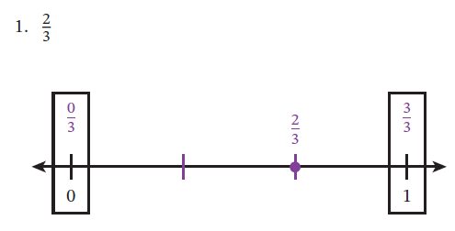
Knowledge Graph Node | Given a unit fraction on a number line, name the fraction. | Partition an interval and locate unit fractions on a number line. | Given a non-unit fraction on a number line, name the fraction. | Partition an interval and locate non-unit fractions on a number line.
Terminology | Unit Fraction: (underlying definition) A unit fraction 1/b (b is a whole number, $b>0$), is a number (point on the number line)- 1st point to the right of 0 when the interval (0,1) is partitioned into b equal lengths.  Student facing: The unit fraction 1/4 is a number that is the first point to the right of 0 when the length from 0 to 1 is partitioned into 4 equal lengths on the number line. |  | Fraction: A fraction a/b (a, b $≥$ 0, b≠0) is a number that is the $a$th point to the right of zero when every unit segment is partitioned into $b$ equal lengths  Student facing: The fraction 5/4 is a number that is the fifth point to the right of 0 when every unit segment is partitioned into 4 equal lengths.  Need definition for decimal fraction
Mathematical Models | Number line | Number line | Number line | Number line
Strategies
Specifications  See Global Note About Denominators | - Unit fractions only  - The intent of the “name” node is that the partitioning is done (number line is given) and students name the indicated point | - Unit fractions only  - The intent of the “locate” nodes is to partition and place a point | - Non-unit fractions  - Include fractions greater than 1  - Include mixed numbers as they are introduced (see Addition and Subtraction ladder) | - Non-unit fractions  - Include fractions greater than 1  - Include mixed numbers as they are introduced (see Addition and Subtraction ladder)
Leaves to Include | - Read and write fractions  - Fraction notation | - Read and write fractions  - Fraction notation | - Read and write fractions  - Fraction notation | - Read and write fractions  - Fraction notation
Considerations | - Interpret unit fractions 1/b as the length of 1 segment when we partition the unit segment into b equal lengths; extend to a/b as a copies of 1/b (unit fractions and non-unit fractions)  - A unit fraction works like a unit in that it can be counted  - Fractions on the number line as a point and length  - Define a fraction a/b (a, b $≥$ 0, b≠0) as a number (point on the number line) – $a$th point to the right of zero in the sequence of $b$ths; locate it on the number line as the point at distance a/b to the right of 0 | - Define a fraction a/b (a, b $≥$ 0, b≠0) as a number (point on the number line) – $a$th point to the right of zero in the sequence of $b$ths; locate it on the number line as the point at distance a/b to the right of 0 | - Interpret unit fractions 1/b as the length of 1 segment when we partition the unit segment into b equal lengths; extend to a/b as a copies of 1/b (unit fractions and non-unit fractions)  - DO NOT add fractions until we define addition of fractions. That means no sum of unit fractions, no mixed numbers. Until we have a definition, (fraction)+(fraction) has NO MEANING.  - Define decimal fraction here, as allowed by state standards. Don’t make a big deal about it.
Required Skills/Cases  See Global Note About Denominators | - Identify/name a unit fraction on a number line | - Plot/locate a unit fraction on a number line | - Identify/name a non-unit fraction on a number line  - < 1  - > 1  - = whole numbers (including 1)  - Mixed numbers (G4) | - Plot/locate a non-unit fraction on a number line  - < 1  - > 1  - = whole numbers (including 1)  - Mixed numbers (G4)
Misconceptions | - Counting/labeling intervals rather than points  - Miscounting tick marks (e.g., including 0 as 1, not including 1) | - Counting/labeling intervals rather than points  - Miscounting tick marks (e.g., including 0 as 1, not including 1) | - From Math Catalyst:  Rather than recognizing that fractions represent quantities relative to the spacing between tick marks, students assume that the numerator in a fraction tells them which tick mark to label. | - Misidentifying the unit or the interval; on a number line that doesn't start at 0, students treat the visible portion as the interval
Existing Product Reference, if any | Math Catalyst, Fractions as Numbers, Representations of Unit Fractions, objective 3  (Consider Fraction Frenzy from Strawman—maybe for lesson content, maybe for fluency, maybe for practice, note that refinement is needed for whatever use is decided) | Math Catalyst, Fractions as Numbers, Representations of Unit Fractions, objective 4 | Bluebonnet Learning, G3 M5 L18, Part 2 | EM2 G3 M5 L11 Learn 2  Math Catalyst, Fractions as Numbers, Representations of Non-Unit Fractions, objectives 2 and 3
Grade (or Leaf) | 3 | 3 | 3, 4 | 3, 4
Notes related to Standards, Grade, or Leaf | CCSS.3.NF.A.1  CCSS.3.NF.A.2a  TX.3.3B (less than or equal to 1)  FL.3.FR.1.1  FL.3.FR.2.1 | CCSS.3.NF.A.1  CCSS.3.NF.A.2a  TX.3.3A (less than or equal to 1)  FL.3.FR.1.1  FL.3.FR.2.1  VA.2.NS.3.e.ii (halves, fourths, eighths, thirds, and sixths)  VA.3.NS.3.a.11 (denominators of 2, 3, 4, 5, 6, 8, and 10) | CCSS.3.NF.A.2b  CCSS.4.NF.A.1  TX.3.3A, B (less than or equal to 1)  TX4.2H  TX.4.3G  FL.3.FR.2.1  FL.4.FR.1.4  IN.4.NS.2  VA.3.NS.3.a.11 (denominators of 2, 3, 4, 5, 6, 8, and 10) | CCSS.3.NF.A.2b  CCSS.4.NF.A.1  TX.3.3A, B (less than or equal to 1)  TX4.2H  TX.4.3G  FL.3.FR.2.1  FL.4.FR.1.4  IN.4.NS.2  VA.3.NS.3.a.11 (denominators of 2, 3, 4, 5, 6, 8, and 10)
Notes for Intervention, Extension, or Optional Activities | - Identify/name a unit fraction represented by a tape diagram/fraction strip (e.g., simple shapes) | - Plot/locate a unit fraction represented by an area model (e.g., simple shapes) | - Identify/name a non-unit fraction represented by an area model (e.g., simple shapes) | - Plot/locate a non-unit fraction represented by an area model (e.g., simple shapes)
Additional Notes | G3: Likely 1 instructional period | Likely 1 instructional period | G3: Likely part of 1 instructional period  G4: Likely part of 1 instructional period | G3: Likely part of 1 instructional period  G4: Likely part of 1 instructional period

Concept/Skill: Identify and generate equivalent fractions.
Goal | Understand that more than one fraction can name the same point on the number line
Student-Facing Example | 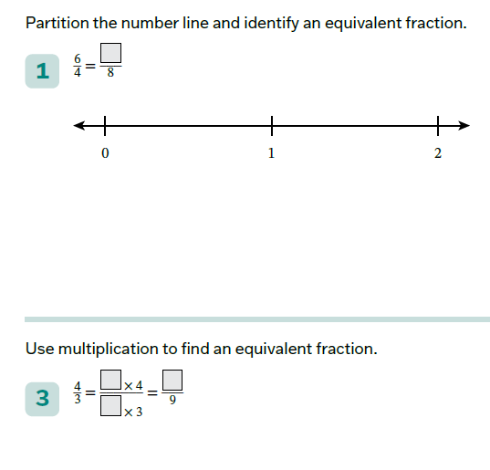
Knowledge Graph Node | Identify and generate equivalent fractions on number lines. | Generate equivalent fractions by using equations. | Identify and generate equivalent fractions by using concrete objects. | Identify and generate equivalent fractions by using area models. | Generate decimals that are equivalent to fractions, and generate fractions that are equivalent to decimals (limited to fractions equivalent to fourths or tenths with denominators 2, 4, 5, 8, 10, and 100).
Terminology | Equivalent Fractions  Equivalent fractions are different ways of writing the same number. a/b is equivalent to c/d if they name the same point on the number line. ¾ is equivalent to 6/8. 3 of ¼ is equivalent to 6 of 1/8.
Mathematical Models | Number line |  | TEKS breakout requires “a variety of objects”—could be counters, etc. | Area model
Strategies |  | Multiplication of whole numbers in the numerator and denominator
Specifications  See Global Note About Denominators | - No mixed numbers  - Include fractions equivalent to whole numbers | - By multiplication only (no division like EM2)  NO AREA MODELS, number lines only  - Include fractions equivalent to whole numbers  - Light touch on decimal fractions  - Inclusion of mixed numbers must be timed with introduction of mixed numbers in addition and subtraction stem |  | To include mixed numbers in G4, must be timed with introduction of mixed numbers in addition and subtraction stem | - Equivalent forms of commonly used fractions and decimals  - Decimals that terminate at tenths, hundredths, or thousandths place
Leaves to Include
Considerations | - Define a/b = c/d when they name the same point on the number line (distance to right of 0) | - (this bullet the most important thing in this node, and possibly even this stem. Possibly even the most mathematically important thing kids will see in G4. I cannot emphasize this enough -danielle s) Equivalent Fraction Theorem & proof: a/b = (ka)/(kb) for any positive integer k  - Use a/b = (ka)/(kb) to generate equivalent fractions and to express fractions in any named denominator that makes sense  - Include problems that have decimal fractions. Point them out. Don’t make a big deal about it. | Be clear what the unit and the measure is. Ie – is it the area of one pizza? The area of two pizzas? Fractions only make sense when we know what the “1” is | Be clear what the unit and the measure is. Ie – is it the area of one pizza? The area of two pizzas? Fractions only make sense when we know what the “1” is | If we do this here, we will need to define what a decimal is here.
Required Skills/Cases  See Global Note About Denominators | - Halves, fourths, and eighths  - Thirds and Sixths  - Halves and Sixths  - Given a unit fraction  - Given a non-unit fraction  - Given the fraction with the smaller denominator  - Given the fraction with the larger denominator  - Fractions <1  - Fractions >1  - Fractions equivalent to whole numbers | - Given a unit fraction  - Given a non-unit fraction  - G3 denominators still fair game, emphasize G4 denominators  - Fifths and tenths  - Tenths and hundredths  - Halves, thirds, fourths, sixths and twelfths  - Fractions <1  - Fractions >1 (no mixed numbers)  - Fractions equal to whole numbers  - Notation a/b = (axk)/(bxk) (Not a/b x k/k)  - Mixed number equivalent to mixed number (same whole number)  - Mixed number equivalent to mixed number (different whole numbers)  - Fraction equivalent to mixed number | - Given a unit fraction  - Given a non-unit fraction | - Given a unit fraction  - Given a non-unit fraction  - Mixed numbers ok in G4 | - Given fraction, generate equivalent decimal  - Given decimal, generate equivalent fraction  - Halves, fourth, eighths  - Fifths, tenths, hundredths
Misconceptions |  | - Multiplying changes the value; because you multiply the numerator and denominator, the fraction must get larger  - Multiplying only the numerator or only the denominator  - Multiplying the numerator by one number and the denominator by another
Existing Product Reference, if any | EM2 G3 M5 L13 Learn 2 and L14  EM2 G3 M5 L22, L23 Learn 2, L24 | EM2 G4 M4 L8, L9—numerical work only, not the area models  EM2 G4 M4 L12 Learn 2 and 3  Math Catalyst, Fractions as Numbers, Represent and Generate Equivalent Fractions Less Than or Equal to 1, Concept Mini Lesson 2  Math Catalyst, Fractions as Numbers, Represent and Generate Equivalent Fractions Greater Than or Equal to 1, Concept Mini Lessons 2 and 4 | - Might also be something concrete in TEKS/Bluebonnet to borrow | EM2 G4 M4 L8, L9  Math Catalyst, Fractions as Numbers, Represent and Generate Equivalent Fractions Less Than or Equal to 1, Concept Mini Lessons 1 (and 3)-uses tape diagrams paired with number lines | G5 M4 L13
Grade (or Leaf) | 3 | 4 | Leaf: state-specific | Leaf: state-specific | Leaf: state-specific
Notes related to Standards, Grade, or Leaf | CCSS.3.NF.A.3a-c  IN.4.NS.2 | CCSS.4.NF.A.1  CCSS.4.NF.5 (just the equivalent fractions part)  MN.5.3.5.5 requires by division | TX.3.3F  (TX breakouts probably require additional models—I didn’t double check; VA.2.NS.3.f also required comparing unit fractions with region/area and length models) | TX.4.3C  TX.3.3F-G  (TX breakouts probably require additional models—I didn’t double check; VA.2.NS.3.f also required comparing unit fractions with region/area and length models) | MO.5.NF.A.3  ND.5.NO.NF.1  NE.5.N.2.b  OK.4.N.3.9  OK.5.N.1.4
Notes for Intervention, Extension, or Optional Activities |  | Division of whole numbers in the numerator and denominator (Math Catalyst, Fractions as Numbers, Represent and Generate Equivalent Fractions Less Than or Equal to 1, Concept Mini Lesson 4)  Math Catalyst, Fractions as Numbers, Represent and Generate Equivalent Fractions Greater Than or Equal to 1, Concept Mini Lesson 3
Additional Notes | Likely 2 instructional periods (0 to 1; >1) | Likely 3 instructional periods (related denominators; any denominators; mixed numbers) | Likely 1 instructional period | Likely 1 instructional period | Likely 1 instructional period

Concept/Skill: Compare and order fractions.
Goal | - Understand that fractions, just like whole numbers, can be compared and ordered  - Apply fraction equivalence to compare and order fractions (without relying on the number line)
Student-Facing Example | 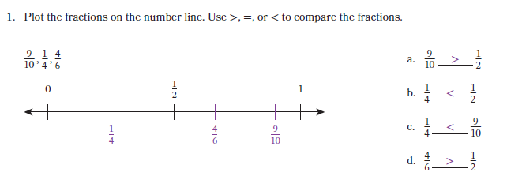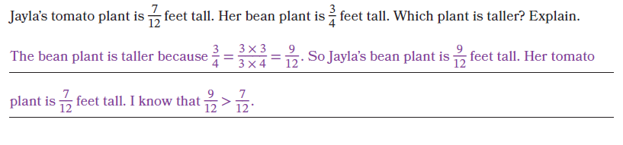
Knowledge Graph Node | Compare and order fractions by using a number line. | Compare and order fractions by using the benchmarks 0, ½, and 1. | Compare and order fractions. | Compare and order fractions and decimals by using benchmarks, place value, or number lines.
Terminology
Mathematical Models | Number line | Number line |  | Some states specify number line, some expect numerical methods
Strategies |  |  | - Fraction equivalence to create common denominators  - Number line (as a tool if needed, rely on reasoning with fractions that have like denominators)
Specifications  See Global Note About Denominators |  |  |  | - Pairs or sets where some numbers are given as fractions and some given as decimals  - Focus on reasoning through the relationships and/or using the number line  - Don’t require students to rename fractions as decimals or vice-versa (except tenths), but if they can figure out how to do it, let them do it
Leaves to Include
Considerations | - Define “greater than/less than” by position on the number line (the same as whole numbers)  - Comparisons based on placement on the number line  - With like denominators, compare a/b and c/b by comparing a and c  - Strategy that always works: generate equivalent fractions with a common denominator | - Include problems that have decimal fractions. Point them out. Don’t make a big deal about it. | - Need equivalent fractions theorem when you can’t “just tell”  - In general, use a common denominator to compare (other strategies as time allows/aspire activities)  - Strategy that always works: generate equivalent fractions with a common denominator  - Don’t emphasize LCD. Any common denominator is fine.  - Explain comparison/ordering by using fraction equivalence  - Include problems that have decimal fractions. Point them out. Don’t make a big deal about it. | If we do this here, we will need to define what a decimal is here.
Required Skills/Cases  See Global Note About Denominators | - Both fractions <1  - Both fractions >1  - One fraction <1, one fraction >1  - <, >, =  - Include fractions equivalent to whole numbers, represented as fractions or as whole numbers  - Sets of 3 fractions, greatest to least  - Sets of 3 fractions, least to greatest  - Like units  - Related units (Halves, fourths, and eighths; thirds and sixths)  - Unrelated units | - Use number line  - Use equivalence to a benchmark (1/2 < 5/6 because ½ = 3/6 and 3/6 < 5/6)  - Sets of 3 fractions, greatest to least  - Sets of 3 fractions, least to greatest  - Include fractions equivalent to whole numbers, represented as fractions or as whole numbers | - Both fractions <1  - Both fractions >1  - One fraction <1, one fraction >1  - Include fractions equivalent to whole numbers, represented as fractions or as whole numbers  - <, >, =  - Sets of 3 fractions, greatest to least  - Sets of 3 fractions, least to greatest  - Related units (Halves, fourths, and eighths; thirds and sixths)  - Unrelated units | - Compare a fraction to a decimal  - Compare a decimal to a fraction  - Both numbers <1  - Both numbers >1  - One number <1, one number >1  - Mixed numbers ok  - Up to 4 numbers in set to order  - No renaming of fractions and decimals or vice-versa required (except tenths)  - Limit to G4 denominators
Misconceptions | - Larger denominator means larger fraction; students apply whole-number reasoning and think 1/8 > 1/4 because 8 > 4
Existing Product Reference, if any | EM2 G3 M5 L18  Math Catalyst, Fractions as Numbers, Compare Fractions with the Same Numerator or Denominator, Concept Mini Lesson 2  EM2 G3 M5 L20 Learn 1  EM2 G3 M5 L21 | EM2 G4 M4 L13  EM2 G5 M2 L6 Fluency Choral Response: Closer to 0, ½, or 1 | G4 Strawman Lessons 2 and 3
Grade (or Leaf) | 3 | 4 | 4 | Leaf, state-specific
Notes related to Standards, Grade, or Leaf | CCSS.3.NF.A.3.d | CCSS.4.NF.A.2  VA.4.NS.3.c (all denominators less than 12) | CCSS.4.NF.A.2 | IN.5.NS.1  MO.5.NF.A.3  OK.4.N.3.9, OK.5.N.1.3  VA.4.NS.5.b, VA.5.NS.1.d  Some states specify number line, some expect equations
Notes for Intervention, Extension, or Optional Activities | - ≠ symbol  - x < y < z notation  - Sets of 4 fractions to order  - Other strategies as time allows/aspire activities  - Common numerator (CCSS, TX expect common numerator) | - x < y < z notation | - Common numerator  - ≠ symbol  - x < y < z notation  - Sets of 4 fractions to order | - x < y < z notation  - 5 or more numbers in set
Additional Notes | Likely 3 instructional days (like units; related units; unrelated units) | Likely 1 instructional period | Likely 2 instructional periods (compare; order) | Likely 2 instructional days (1 for number line, 1 for equivalence)

Concept/Skill: Find a fraction of a number, quantity, or set.
Goal | Understand what a “fraction of” a set, area, etc. means
Student-Facing Example | 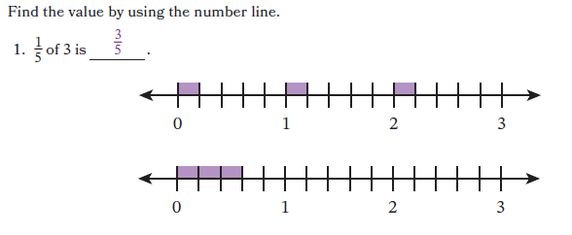
Knowledge Graph Node | Find a fraction of a set where the result is a whole number. | Find a fraction of a whole number by using the number line. | Find a fraction of a set where the result is a fraction. | Find and represent a fraction of a set by using concrete objects. | Find and represent a fraction of a set by using a tape diagram.
Terminology
Mathematical Models | - Number line  - Arrays can be used but only when connected to the work on the number line (as time allows) | - Number line  - Arrays can be used but only when connected to the work on the number line (as time allows) | - Number line | - Fraction tiles | - Tape/strip diagrams
Strategies
Specifications  See Global Note About Denominators | - This lesson needs to work for G5 and G3. The reasoning and computation for non-unit fractions is probably what will need the most attention to nuance.  - The lesson likely needs to start similar to the G3 FL/MD lessons (smaller sets) and build to the G5 visuals.  - Also think about some 1 by x arrays that will bridge to the number line approach in the next lesson/node, but might need to be a little gentle with that because of G3. |  | - This lesson combines the previous two nodes by applying the number line reasoning from the previous node to fraction of a set problems where the result is a fraction.  - Contexts must be considered carefully, can lean heavily on measurement contexts but have some variety
Leaves to Include
Considerations | - Fix a unit; $\frac{a}{b}$ of a quantity of that unit means the totality of $a$ parts when the quantity is partitioned into $b$ equal parts  - Fraction of the area of a shape, fraction of a set  - This can only happen after we have the definition of a fraction  - This lays the groundwork for using ‘of’ to understand multiplying a fraction by a fraction  - Include problems that have decimal fractions. Point them out. Don’t make a big deal about it.
Required Skills/Cases  See Global Note About Denominators | - Find unit fractions of a set  - Find non-unit fractions <1 of a set  - (No find fractions >1 of a set, e.g., 5/4 of the dogs)  - Discrete objects (e.g., ½ of 16 pencils)  - Continuous objects (e.g., ½ of the rug with an area of 24 square feet—1/2 of the area of the rug)  - Result must be a whole number  - Be specific with contextual wording (fraction of the area of a shape, fraction of the length of the board) | - Unit fractions  - Non-unit fractions | - Find unit fractions of a set  - Find non-unit fractions <1 of a set  - (No find fractions >1 of a set, e.g., 5/4 of the height of the building)  - Discrete objects if a fractional answer makes sense in context (e.g., 3/4 of the 15 protein bars, NOT ½ of the 15 dogs)  - Continuous objects (e.g., ¾ of the height of a person)  - Result must be a fraction  - Be specific with contextual wording (fraction of the area of a shape, fraction of the length of the board) | - First/edge part shaded/selected  - Other part shaded/selected  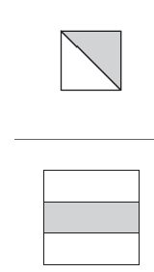  (Note: sample visuals are area models, but do this idea with fraction tiles)  - Connected/consecutive parts shaded/selected  - Non-consecutive parts shaded/selected  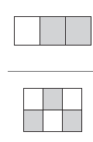  (Note: sample visuals are area models, but do this idea with fraction tiles)
Misconceptions
Existing Product Reference, if any | EM2 G5 M3 L1 Learn 1 (uses arrays, not number lines, could provide a progression to use with number lines, number lines are in L2)  EM2 FL G3 M5 L6  EM2 MD G3 M5 L8-1 | EM2 G5 M3 L2 Learn 1 and 2 | EM2 G5 M3 L2 Learn 1 and 2 for number lines  Problems like EM2 G5 M3 L2 Learn 3 (but don’t use tape diagrams for model) | EM2 G3 M5 L1 Learn 1  EM2 G3 M5 L2 Learn 2  EM2 G3 M5 L5 and L6  Math Catalyst, Fractions as Numbers, Representations of Unit Fractions, Concept Mini Lessons 1 and 2  Math Catalyst, Fractions as Numbers, Representations of Non-Unit Fractions, Concept Mini Lessons 1 and 3 | EM2 G3 M5 L2 Learn 2  EM2 G3 M5 L5 and L6  Math Catalyst, Fractions as Numbers, Representations of Unit Fractions, Concept Mini Lessons 3 and 4  Math Catalyst, Fractions as Numbers, Representations of Non-Unit Fractions, Concept Mini Lessons 1 and 3
Grade (or Leaf) | 5  (Part of stem at G5, leaf for G3) | 5 | 5 | Leaf: state-specific | Leaf: state-specific
Notes related to Standards, Grade, or Leaf | Precursor to CCSS.5.NF.B.4.a  TX.3.3E (breakouts probably require arrays or similar)  MD.3.NOS.F.11  PA.M03.A-F.1.1.1 | Precursor to CCSS.5.NF.B.4.a | Precursor to CCSS.5.NF.B.4.a | TX.3.3A | TX.3.3A
Notes for Intervention, Extension, or Optional Activities
Additional Notes | Likely 1 instructional period | Likely 1 instructional period | Likely 1 instructional period | Likely 2 instructional periods (either split unit fractions and non-unit fractions with concrete objects and strip/tape diagrams in the same lesson OR split concrete objects and strip/tape diagrams with unit and non-unit fractions in the same lesson) | Likely 2 instructional periods (either split unit fractions and non-unit fractions with concrete objects and strip/tape diagrams in the same lesson OR split concrete objects and strip/tape diagrams with unit and non-unit fractions in the same lesson)

Concept/Skill: Interpret a fraction as division of the numerator by the denominator.
Goal | Understand that a fraction is equal to the division of the numerator by the denominator
Student-Facing Example | 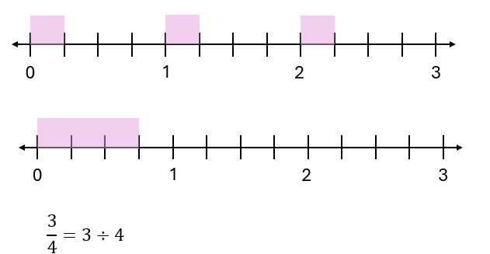
Knowledge Graph Node | Represent and explain that a fraction is equal to the division of the numerator by the denominator.
Terminology
Mathematical Models | - Number line
Strategies
Specifications | - Must get the big idea that a/b is 1 number, a÷b is two numbers and an operator, not just the procedural oh look, the answer is the same  - We need to do this way better than we did in EM2
Leaves to Include
Considerations | - $\frac{a}{b}=a÷b$  - First, define: $a÷b$ for any whole numbers $a$, $b$, $b$ not zero, is the length of one part when a segment of length a is partitioned into $b$ equal parts  - Then prove $\frac{a}{b}$ is the length of one part when a segment of length $a$ is partitioned in $b$ equal lengths  - Include problems that have decimal fractions. Point them out. Don’t make a big deal about it.
Required Skills/Cases | - a = 1  - a > b  - a < b  - include representation/explanation (conceptual) elements in assessment
Misconceptions
Existing Product Reference, if any | (EM2 G5 M2 L1, but might not be very useful with the number line-based approach and students already having fractions of a set understanding)  See Wu 15.1 and 15.2
Grade (or Leaf) | 5
Notes related to Standards, Grade, or Leaf | CCSS.5.NF.B.3  SC.4.PAFR.2.4
Notes for Intervention, Extension, or Optional Activities
Additional Notes | Likely 1 instructional period

