Addition and Subtraction Stem Lesson Ladder

PROGRESSION
Essential Foundational Knowledge (Roots) | - Subitizing  - Counting  - Base Ten Structure
Leads to | - Multiplication and division (definitions parallel to addition/subtraction; standard algorithms)  - Operations with integers. Integers remove the restriction $m≥n$ by introducing additive inverses; subtraction is $a-b :=a+(-b)$
Big Ideas | - Part-total relationships  - Place value  - Renaming and regrouping  - Mental calculations  - The standard algorithms for addition and subtraction – they’re beautiful (they reduce computations, no matter how big the numbers, to single digit facts)! And entirely dependent on our place value system (isn’t it genius that we can represent ANY NUMBER using only ten symbols)!  - Relationship between decimal operations and whole number operations
Other Information | - Meaning of the equal sign pre-number line: two whole numbers are equal if we can verify by counting that they are the same number (have the “same amount” when we can match up and none are leftover). Later we switch to number line: two numbers are equal if they are at the same place on the number line.  - Two numbers are equal if they name the same number; initially verified by one-to-one matching or by counting. Once the number line is in play, two numbers are equal if they occupy the same point and are the same length to the right of zero. Avoid “same amount/quantity” (too loose).  - Number line as model for whole numbers and lengths with a declared unit  - When asking students to “explain,” expect either (a) a number-line/length argument or (b) an expanded-form + laws argument. Avoid imprecisions like ‘I moved numbers because it’s easier’ without naming a law.

Concept/Skill: Compose and decompose whole numbers.
D+J: Composer to 4, then 5; Composer to 7; Composer to 10

Goal | Represent a set of objects by number in many ways
Student-Facing Example | 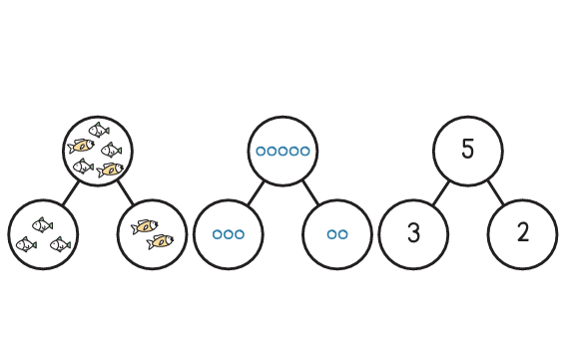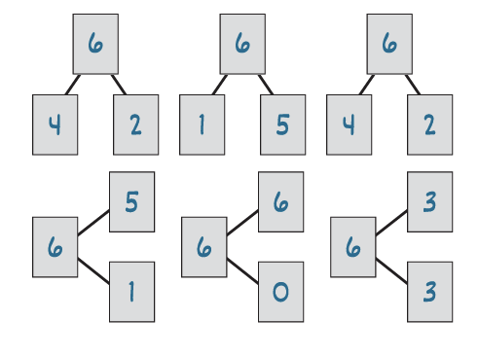
Knowledge Graph Node | Compose and decompose whole numbers in multiple ways.
Terminology
Mathematical Models | Number bond  Number path
Strategies
Specifications | Trajectory:  - Sort in 2 categories  - Sort in different ways  - Sort and count à sort, count, label with numeral  Representations: objects, fingers, mental images, drawings, sounds, acting out situations, verbal explanations, or number bonds.  Range –  - PK - Within 10  - GK – Within 19
Leaves to Include
Considerations | - CAUTION: no addition or subtraction symbols or use of those words until they are defined  - Could potentially pair with composing and decomposing shapes. Shapes aren’t representing numbers – we’re just saying that we can compose/decompose different things
Required Skills/Cases | Trajectory:  - Sort in 2 categories  - Sort in different ways  - Sort and count à sort, count, label with numeral  Representations: objects, fingers, mental images, drawings, sounds, acting out situations, verbal explanations, or number bonds.  Range –  - PK - Within 10  - GK – Within 19  Problem types -  - Given a set of N objects, separate it into two parts in more than one way and describe the parts and total;  - given two parts, combine them to find the total;  - given a total and one part, find the missing part using objects, drawings, fingers, or mental images;  - include 0 as a possible part after students have enough experience with zero;  - coordinate teen-number decompositions with Base Ten
Misconceptions | - Students do not discern between the parts and the total and describe a part as the total or vice versa.  - For example:  - 3 and 4 make 7.  - 3 is 4 and 7.
Existing Product Reference, if any | - PK M3 – Compose/Decompose  - GK M4 – Compose/Decompose  - GK M5 – Introducing Addition/Subtraction  - GK M6 – Teen Numbers
Grade (or Leaf) | Range –  - PK - Within 10  - GK – Within 19  - G1+ – Application
Notes related to Standards, Grade, or Leaf | - K.OA.A.3  - K.OA.A.4  - FL.K.AR.1.1  - FL.K.AR.1.2  - TX.K.2I  - TX.1.3C  - TX.1.3D
Notes for Intervention, Extension, or Optional Activities | - Intervention considerations: set size, representations  - Catalyst – Composition and Decomposition within 10
Additional Notes | Instructional Periods:  PK/GK: Likely 4-5 instructional periods  G1 and G2 begin to decompose based on place value – see Base Ten Stem  Other:  - Consistent language: categories vs groups?  - We will see an overlap with Base Ten structure with teen numbers and conceptual subitizing.

Concept/Skill: Count all in addition and subtraction situations with whole numbers.
D+J: Small Number +/-; Find Result +/-; Find Change +/-

Goal | Directly model addition and subtraction situations with objects, drawings, or fingers and count all, count what remains, or count what was added/removed to answer the question
Student-Facing Example | 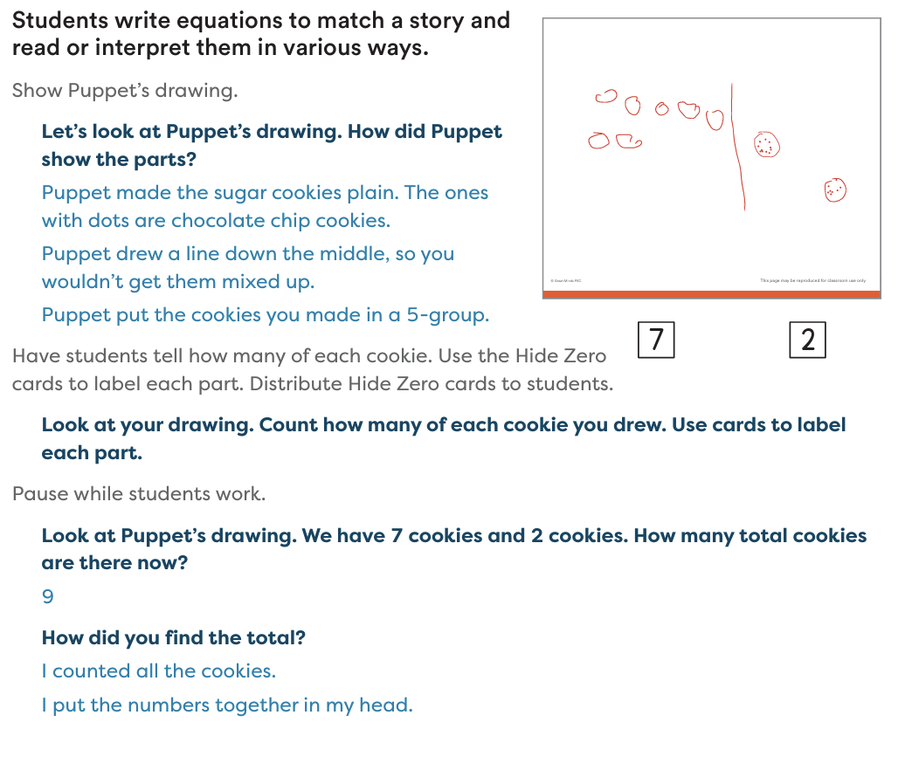  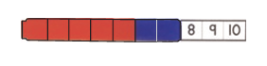
Knowledge Graph Node | Count all to add whole numbers. | Count all to subtract whole numbers.
Terminology | Add: When we put groups together, we add (GPK M5 TB L6)  Subtract: When we take away something (PreK M5 TD L15)  Addition: when we put groups or parts together to find the total (GK M5 TA L1, folio p. 26)  Subtraction: When something gets taken away and we find how many are left (GK M5 TB L8) | Add: When we put groups together, we add (GPK M5 TB L6)  Subtract: When we take away something (PreK M5 TD L15)  Addition: when we put groups or parts together to find the total (GK M5 TA L1, folio p. 26)  Subtraction: When something gets taken away and we find how many are left (GK M5 TB L8)
Mathematical Models | - Number path | - Number path
Strategies | - Count all  - Cubes à number path | - Count all  - Cubes à number path
Specifications | - Match written numbers with sets of up to 5 objects.  - Match written numbers with sets of up to 10 objects.  - Directly model join/result-unknown and part-part-whole/whole-unknown addition by making or seeing both parts and counting all objects;  - directly model simple change-unknown/missing-addend situations by adding or removing objects until the given total/remainder is reached, then counting the changed amount;  - use totals within 5 before totals within 10 | - Match written numbers with sets of up to 5 objects.  - Match written numbers with sets of up to 10 objects.  - directly model separate/result-unknown subtraction by making the whole, taking away a part, and counting what remains;  - directly model simple change-unknown/missing-addend situations by adding or removing objects until the given total/remainder is reached, then counting the changed amount;  - use totals within 5 before totals within 10
Leaves to Include | - Number Ranges  - Problem Types  - +/- one changes the number in a group of objects by exactly one | - Number Ranges  - Problem Types  - +/- one changes the number in a group of objects by exactly one
Considerations | - Can use the words “addition” and “subtraction” and the symbols “+” and “$-$“ once we define what those words/symbols mean here.  - Subtraction as a way to write “take away” and missing addend problems  - Make explicit the relationship between addition and subtraction. Subtraction will be defined as finding a missing addend and should not be treated as unrelated to addition; do not imply that subtraction has the same properties as addition (comm/assoc)  - . Write situations using both addition and subtraction.  - Use pre number line definitions of addition and subtraction here (see definitions)  - Use part-total diagrams (e.g., “number bonds”) sparingly to keep attention on the number path | - Can use the words “addition” and “subtraction” and the symbols “+” and “$-$“ once we define what those words/symbols mean here.  - Subtraction as a way to write “take away” and missing addend problems  - Make explicit the relationship between addition and subtraction. Subtraction will be defined as finding a missing addend and should not be treated as unrelated to addition; do not imply that subtraction has the same properties as addition (comm/assoc)  - Write situations using both addition and subtraction.  - Use pre number line definitions of addition and subtraction here (see definitions)  - Use part-total diagrams (e.g., “number bonds”) sparingly to keep attention on the number path
Required Skills/Cases | PreK:  - count all with concrete objects within 5.  - Join with results unknown  GK:  - combine sets within 10 using objects, drawings, and verbal situations.  - Join with results unknown  - Part-part-whole with whole unknown  G1:  - apply count-all strategies within 20 with visual or concrete support.  - Join with results unknown | PreK:  - count all with concrete objects within 5.  - Separate with results unknown  GK:  - separate sets within 10 using objects, drawings, and verbal situations.  - Separate with results unknown  - part-part-whole with a part unknown  G1:  - apply count-all strategies within 20 with visual or concrete support.  - separate with results unknown
Misconceptions | - Students may say numbers without matching them to objects.  - Students skip objects or count objects more than once. (Source: TX BB GK M1)  - Thinking the arrangement affects the quantity (conservation of numbers) -(Exploring in PK M1 TB).  - Not understanding that each object gets only one number (PK M1 TB).  - Not understanding that the last number word said when counting refers to the total numbers counted (cardinality) (Source: Learning Trajectories-Counting) | - Students memorize the number word list in only a forward direction. (Source: TX BB GK M1)  - Students omit numbers from the counting sequence or count forward out of order. (Source: TX BB GK M1)  - Students repeat the count when asked, “How many?” (e.g., “There are 1, 2, 3, 4, 5.”) (Source: TX BB GK M1)  - Students sometimes treat addition and subtraction as unrelated, not seeing that both can be modeled by counting all objects.
Existing Product Reference, if any | - PreK M1 TE L27, L28  - PreK M5  - GK M1, M4, M5 M6  - G1 M1 TB L7  - Math Catalyst | - PreK M1 TE L27, L28  - PreK M5  - GK M1, M4, M5 M6  - G1 M1 TB L7  - Math Catalyst
Grade (or Leaf) | PreK, K, 1 | PreK, K, 1
Notes related to Standards, Grade, or Leaf | K.OA.A.1  CA.K.OA.1  FL.K.NSO.3.1  FL.K.AR.1.3  TX.1.3F  SD.PK.CD-4.f | K.OA.A.1  CA.K.OA.1  FL.K.NSO.3.1  FL.K.AR.1.3  TX.1.3F  SD.PK.CD-4.f
Notes for Intervention, Extension, or Optional Activities | Intervention  - Concrete-Pictorial-Abstract  - Combining sets  - Counting forward and backwards to 10  - Cardinality  - One-to-one correspondence  - (PK M1-Why section, PK M1 TB- Answer How Many Questions)  Math Catalyst: Count All to Add Within 10  - Numeral Writing- students trace numerals and symbols to support writing addition number sentences.  - Counting Collections- students organize, count, and represent a collection of items to support the development of their understanding of how numbers are composed and decomposed.  - Students count a first set of objects and then a second set of objects to find the total. (Math Catalyst) | Intervention  - Concrete-Pictorial-Abstract  - Extensions: The addition of a third part. Presenting three parts poses a challenge, but the total stays within 10.  - Combining sets  - Count forward by ones from 10 to 20 for the fast-paced counting activity (Teacher Note, GK M5 TA L1)  - Count backward by ones from 20 to 10 for a slow-paced counting activity (Teacher Note, GK M5 TA L1)  - Student may recount only one set instead of all objects.  - Believing the total changes when objects are rearranged.  - Not recognizing the final count as the answer.
Additional Notes | Fluency Ideas  - Ready, Set, Count  - 5 and Tuck  Additional Notes/Ideas:  - Small Number +/-: finds sums for join, results unknown, and separate, result unknown problems with totals up to 5 by “counting all” with objects. (Source: Doug and Julie)  - Join Result Unknown Problem: When asked, “You have 2 balls and get 1 more. How many in all?” a child counts out 2, then counts out 1 more, then counts all 3: “1, 2, 3…3!” (Source: Doug and Julie)  - Part-Part-Whole, Whole Unknown Problem: When asked, “You have 2 red balls and 3 blue balls. How many in all?” counts out 2 red, then counts out 3 blue, then counts all 5. (Source: Doug and Julie)  - Join Result Unknown Problem: When asked, “You have 6 balls and get 2 more. How many in all?” counts out 6 balls, then adds 2, then counts all 8. (Source: Doug and Julie)  - Join to, count-all groups: When asked, “You have 5 balls and then get some more. Now you have 7 in all. How many did you get?”, counts out 5, then counts those 5 again starting at 1, then adds more, counting “6, 7,” then counts the balls added to find the answer, 2. Some children may use their fingers, and attenuate the counting by using finger patterns. (Source: Doug and Julie)  - Likely 2 instructional periods | Fluency Ideas  - Sunrise, Sunset Counting  - Show 1 Less  - Show Me Another Way  Additional Notes/Ideas  - Find Result +/-: find sums for join, result unknown problems, and part-part-whole problems by direct modeling, counting all, with objects. Solves take-away problems by separating with objects. (Source: Doug and Julie)  - Separate, Result Unknown Problem: When asked, “You have 5 balls and give 2 to Tom. How many do you have left?” counts out 5 balls, then takes away 2, and then counts remaining 3. (Source: Doug and Julie)  - Find Change +/-: find the missing addend to solve join and separate, change unknown problems by adding on or taking away objects. Solves compare problems with two small sets by matching objects one-to-one to see how many more or less one set has than the other, or if they are the same- completely matched. (Source: Doug and Julie)  - Separate-to, count-all groups: When asked, “Nita has 8 stickers. She gave some to Carmen. Now, she has 5 stickers. How many did she give the Carmen?”, counts 8 objects, separates until 5 remain, counts those taken away. (Source: Doug and Julie)  - Match, count rest: When asked, “Here are 6 dogs and 4 balls. If we give a ball to each dog, how many dogs won’t get a ball?” counts out 6 dogs, matches 4 balls to 4 of them, then counts the 2 dogs that have no ball. (Source: Doug and Julie)  - Likely 2 instructional periods

Concept/Skill: Count on to add and subtract whole numbers.
D+J: Counting Strategies +/-; Part-Whole +/-; Numbers-in-Number +/-

Goal | Use counting on to increase efficiency when adding and subtracting
Student-Facing Example | 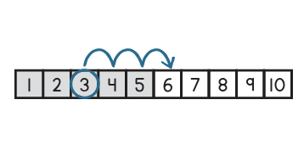
Knowledge Graph Node | Count on to add whole numbers. | Count up/on to find the missing addend in subtraction situations.
Terminology
Mathematical Models
Strategies | - Count on  - cubes à number path à number line | - Count on  - cubes à number path à number line
Specifications | GK:  - Count on within 5  - Count on within 10  - Use fingers, objects, and number paths  - Results unknown, total known  G1:  - Count on within 20  - Change unknown, start unknown, results and total unknown  G2:  - apply counting on within larger numbers and more complex comparison contexts | GK:  - Count on within 5  - Count on within 10  - Use fingers, objects, and number paths  - Results unknown, total known  G1:  - Count on within 20  - Change unknown, start unknown, results and total unknown  G2:  - apply counting on within larger numbers and more complex comparison contexts
Leaves to Include | - Problem Types | - Problem Types
Considerations | - Use part-total diagrams (e.g., “number bonds”) sparingly to keep attention on the number line/path and equations  - Prioritize count-on-from-larger (start counting at the larger addend), a D+J milestone that accelerates the shift away from count-all  - Informally can introduce the commutative property of addition.  - Relationship between addition and subtraction  - Start with counting on from a visible part and transition to seeing a part as a unit to count on from  - Once we have the number line, refine definitions of addition and subtraction (see definitions) | - Use part-total diagrams (e.g., “number bonds”) sparingly to keep attention on the number line/path and equations  - Prioritize count-on-from-larger (start counting at the larger addend), a D+J milestone that accelerates the shift away from count-all  - Informally can introduce the commutative property of addition.  - Relationship between addition and subtraction  - Start with counting on from a visible part and transition to seeing a part as a unit to count on from  - For take-from/compare, use count-up-to (a missing-addend strategy) rather than “counting back” as the default  - Comparison problems: $m-n$ is ‘how much bigger’ when $m≥n$.  - When $m<n$, $m-n$ is not a whole number; this motivates integers later. Avoid saying you “can’t” take n away from m.  - Once we have the number line, refine definitions of addition and subtraction (see definitions)
Required Skills/Cases | GK:  - Count on within 5  - Count on within 10  - Use fingers, objects, and number paths  - Results unknown, total known  G1:  - Count on within 20  - Results and total unknown  G2:  - apply counting on within larger numbers and more complex comparison contexts | GK:  - Count on to find differences within 5  - Count on to find differences within 10  - Use fingers, objects, and number paths  G1:  - Count on to find differences with 20  - Change unknown, start unknown  G2:  - apply counting on to solve subtraction problems, including missing-addened and comparison situations involving larger numbers
Misconceptions | - Double count the starting number (e.g., for 5 +3, saying “5, 6, 7, 8” but counting 5 as one of the three).  - Students may start counting from 1 instead of a given number, reverting to a “count all” strategy rather than counting on. (Source: Math Catalyst Concept Guide) | - Double count the starting number (e.g., for 5 +3, saying “5, 6, 7, 8” but counting 5 as one of the three).  - Students may start counting from 1 instead of a given number, reverting to a “count all” strategy rather than counting on. (Source: Math Catalyst Concept Guide)
Existing Product Reference, if any | - GK M1 TE–H  - GK M4–5  - GK M5 L18 (number path image above)  - GK M6  - G1 M1–3  - G2 M1  - Math Catalyst | - GK M1 TE–H  - GK M4–5  - GK M5 L18 (number path image above)  - GK M6  - G1 M1–3  - G2 M1  - Math Catalyst
Grade (or Leaf) | GK, 1, 2 | GK, 1, 2
Notes related to Standards, Grade, or Leaf | K.CC.A.2  1.OA.C.5  2.OA.C.4  CA.K.CC.2  CA.1.OA.5  CA.2.OA.4  FL.K.NSO.3.1  FL.K.AR.1.3  FL.1.AR.1.2  TX.1.3F  VA.CD3.2e | K.CC.A.2  1.OA.C.5  2.OA.C.4  CA.K.CC.2  CA.1.OA.5  CA.2.OA.4  FL.K.NSO.3.1  FL.K.AR.1.3  FL.1.AR.1.2  TX.1.3F  VA.CD3.2e
Notes for Intervention, Extension, or Optional Activities | Intervention, Extension, or Optional Activities:  - Think-Shout Counting with a brief finger count (GK M5 TC L18 Differentiation: Support)  - Using a number path allows students to interpret information visually (GK M5 TC L18 UDL: Representation)  - Count On: Drawing (G1 M1 TB L7, Differentiation: Support)  - Encourage students to track with their fingers as they count on (G1 M1 TB L9, Teacher Note)  Math Catalyst: Count On to Add Within 10  - Count on from a visible part  - Count on from 5 within a set  - Count on to find the total of an addition expression | Intervention, Extension, or Optional Activities:  - To help students record counting up or back, encourage them to use their fingers to track the numbers as they say the count sequence (G2 M1 TD L18, Teacher Note)  Math Catalyst- Count On to Add Within 10  - Count on from 5 within a set  - Count on from any part in a set
Additional Notes | Fluency Ideas  - Happy Counting Within 15  - 5-Group Hands  - Green Light, Red Light  Additional Notes/Ideas  - Counting Strategies +/-: Find sums for joining and part-part-whole problems with finger patterns and/or by counting on. (Source: Doug and Julie)  - Counting on: When asked, “How much is 4 and 3 more?” “Fourrrrr…five, six, seven [uses rhythmic or finger pattern to keep track]. Seven!” (Source: Doug and Julie)  - Counting-up-to: May solve missing addend (3 + __ = 7) or compare problems by counting up; e.g., counts “4, 5, 6, 7” while putting up fingers, and then counts or recognizes the 4 fingers raised.  When asked, “You have 6 balls. How many more would you need to have 8?”, says, “Six, seven [puts up first finger], eight [puts up second finger]. Two!” (Source: Doug and Julie)  - The formal transition from count all to count on from 5 and eventually count on from a given number to solve addition stories is highlighted GK M5.  - Unitizing: Level 2 counting on strategy (GK M1 Why)  - Likely 2 instructional periods | Fluency Ideas  - Happy Counting by Ones Within 20  - Happy Counting by Ones Within 50  - Counting On with Numerals and 5-Groups  - Green Light, Red Light  Additional Notes/Ideas  - Part-Whole +/-: has initial part-whole understanding and can solve all previous problem types using flexible strategies. May use some known combinations, such as 5+5 is 10. Sometimes can do Start Unknown, e.g., __ + 6 = 11, but only by trial and error. (Source: Doug and Julie)  - Join, Start Unknown Problem, Counting Up to strategy: When asked, “You had some balls. Then you get 6 more. Now, you have 11 balls. How many did you start with?”, lays out 6, then 3 more, counts and gets 9. Puts 1 more with the 3…says, “Ten,” then puts 1 more. Counts up from 6 to 11, then re-counts the group added, and says, “Five!” (Source: Doug and Julie)  - Separate, Result Unknown Problem, Counting up to strategy: When asked, “You have 11 pencils and give 7 away. How many do you still have?, says, “Seven…eight, nine, ten, eleven,” while putting up four fingers, and says, “Four!” (Source: Doug and Julie)  - Formally introduced in G1 M1 as it marks the shift from counting all to counting on to solve addition and subtraction problems. Students use counting on as a more efficient way to find the total or a missing part. GK M5 Overview (After this Module).  - Numbers in Numbers +/-: Recognizes when a number is part of a whole and can keep the part and whole in mind simultaneously; solves Start Unknown, __ + 4 = 9 problems with counting strategies. (Source: Doug and Julie)  - When asked, “You have some balls, then you get 4 more balls, now, you have 9. How many did you start with?”, counts, putting up fingers: “Five, six, seven, eight, nine.” Looks at fingers, and says, “Five!”  - Likely 2 instructional periods

Concept/Skill: Introduce properties of operations to add and subtract whole numbers (Megan-DONE) Combined with the next row—this row no longer exists. MF 6/3

Concept/Skill: Add and Subtract whole numbers by applying properties of operations and place value strategies.
D+J: Deriver +/-; Problem Solver +/-

Goal | - Legally rearrange and add/subtract using associative and commutative laws of addition  - Rewrite to an equivalent, but easier computation  - Bridge from strategies using definitions and properties to using algorithms
Student-Facing Example | 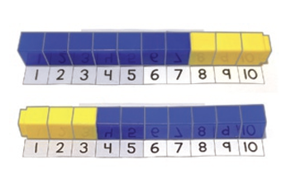  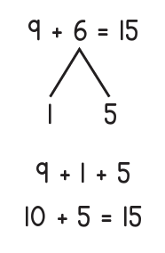  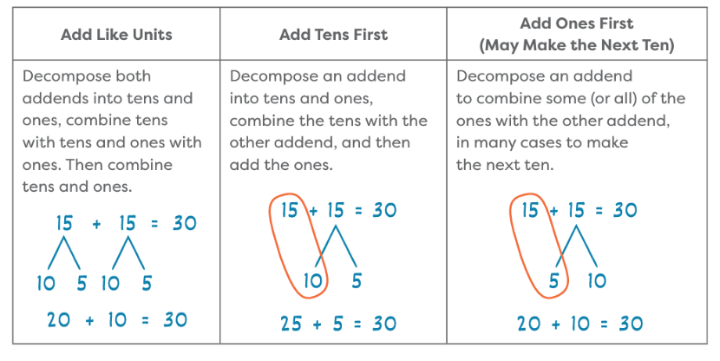 |  | 7+3 and 3+7  Ground work in properties:  9+6  =9+(1+5) Decomposition to write 6 as a sum  =(9+1)+5 Associative property of addition  =10+5  Ground work in the properties (don’t have to write out every time, but this needs to be basis for moves):  Example:  10+5+10+5  10+(5+10)+5 Associative Property of Addition  10+(10+5)+5 Commutative Property of Addition  (10+10)+5+5 Associative Property of Additon  20+5+5  20+(5+5) Associative Property of Addition  20+10  30
Knowledge Graph Node | Add by using strategies based on place value concepts and properties of operations.  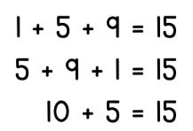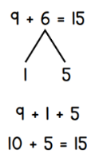  Make ten (G1 M3) | Subtract by using strategies based on place value concepts and properties of operations.  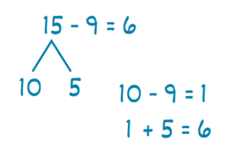  Take from ten (G1 M3)
Terminology | - Commutative Property of Addition: For any numbers (in a given domain) a and b: a+b=b+a  Associative Property of Addition: For any numbers (in a given domain) a, b, and c: a+(b+c)=(a+b)+c. | - Commutative Property of Addition: For any numbers (in a given domain) a and b: a+b=b+a  - Associative Property of Addition: For any numbers (in a given domain) a, b, and c: a+(b+c)=(a+b)+c.
Mathematical Models | - Fade counters/fingers → number path → number line → expanded form; avoid decorative pictures; prefer representations that carry the math
Strategies | - Associative and commutative laws of addition for whole numbers, additive identity  - Theorem: we can add whole numbers up in any order and get equal sums (this is an extension of the commutative property which is only for 2 addends)  - Make ten  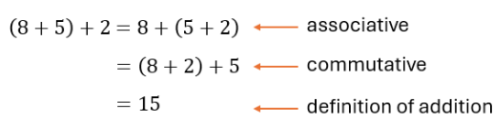  - Example with make ten (note: connect symbolic notation with number path/line to start)  - Compensation (±1, ±2, ±10), break apart and recombine, friendly numbers | - Take from ten, compensation (±1, ±2, ±10)  - Choosing whether to count on or count back when subtracting.  - Tie subtraction facts to missing-addend view, not only ‘take-away’
Specifications | - Observe addends in a different order and understand that the new order does not change the total of an expression.  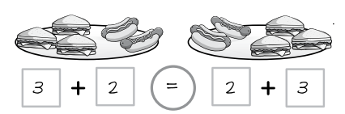  Note: Incorporate multiple commuted pairs, Unifix cubes, number path, objects, and counting (see additional notes)  - Recognize that the total for an expression can be found by grouping addends in any order.  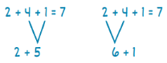  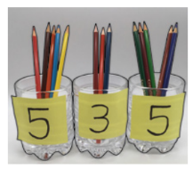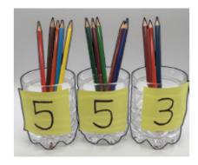  - Sums to 20 (G1)  - Sums to 100 (G1)  - Sums to 200 (G2)  - Sums to 1,000 (G2)  - Include problems that support:  - Counting on from the larger addend:  - Larger addend first  - Larger addend second  - Make Ten:  - Make ten with 3 addends  - Make ten with 2 addends (decompose an addend)  - Make the next ten  - Make a hundred  - Doubles plus one  - Using the relationship between addition and subtraction/related facts  - Adding the ones first and adding the tens first  - Decomposing and adding like units  - Compensation (±1, ±2, ±10) (G2)  - Rename 10 of a smaller unit as 1 of a larger unit. | - Differences within 20 (G1)  - Differences within 100 (G2)  - Differences within 200 (G2)  - Differences within 1,000 (G2)  - Include problems that support:  - Take From Ten  - Count on or count back  - Subtracting like units  - Using the relationship between addition and subtraction/related facts  - Decomposing a number leading to a ten (13 – 4 = 13 – 3 – 1 = 10 – 1 = 9)  - Compensation (±1, ±2, ±10) (G2)  - Rename 1 of a larger unit as 10 of a smaller unit.
Leaves to Include | - Problem types  - Strategies  - Number of addends  - Number ranges  - Add length measurements | - Problem types  - Strategies  - Number ranges  - Subtract length measurements
Considerations | - Use the commutative property of addition to recognize that if I know 2 + 6 = 8, then I also know 6 + 2 = 8  - Use the associative property of addition to add three parts efficiently by grouping addends that make ten (e.g., to find 9 + 7 + 1, I can group the 9 and 1 to make ten)  - Key idea: strategies listed are consequences of the laws and our place value system, not tricks. Use expanded form and associative and commutative laws of addition to justify mental moves (make ten, compensation, etc.) make the connection to the properties explicit for students. Nearly the entire school curriculum rests on these properties. do not lose the forest of the properties for the trees of the particular strategy  - Introduce expanded form here. (Can’t use expanded form until we know what addition means!) Expanded form is a record of place value. We’ll use it later to justify algorithms.  - Always say why it’s legal (associative/commutative, “any order” theorem).  - Connect symbolic notation with number path/line as necessary. Every rewrite must be justified by expanded form and laws  - A put-it-all-together spot before we do the standard algorithms  - Number line usage becomes slightly unwieldy, creating need for other methods  - Use expanded form to connect number line reasoning to written work  - Begin with cases with no regrouping, then include regrouping  - Use relationship between addition and subtraction  - Familiar strategies like make ten can be extended to make a hundred. | - Key idea: strategies listed are consequences of the laws and our place value system, not tricks. Use expanded form and associative and commutative laws of addition to justify mental moves (make ten, compensation, etc.) make the connection to the properties explicit for students. Nearly the entire school curriculum rests on these properties do not lose the forest of the properties for the trees of the particular strategy
Required Skills/Cases | - Sums to 20 (G1)  - Sums to 100 (G1)  - Sums to 200 (G2)  - Sums to 1,000 (G2)  - Include problems that support:  - Counting on from the larger addend:  - Larger addend first  - Larger addend second  - Make Ten:  - Make ten with 3 addends  - Make ten with 2 addends (decompose an addend)  - Make the next ten  - Make a hundred  - Doubles plus one  - Using the relationship between addition and subtraction/related facts  - Adding the ones first and adding the tens first  - Decomposing and adding like units  - Compensation (±1, ±2, ±10) (G2) | - Differences within 20 (G1)  - Differences within 100 (G2)  - Differences within 200 (G2)  - Differences within 1,000 (G2)  - Include problems that support:  - Take From Ten  - Count on or count back  - Subtracting like units  - Using the relationship between addition and subtraction/related facts  - Decomposing a number leading to a ten (13 – 4 = 13 – 3 – 1 = 10 – 1 = 9)  - Compensation (±1, ±2, ±10) (G2)
Misconceptions | - Students think it is more efficient to combine numbers by starting with the least value first and adding it to the greater value, or by adding from left to right when adding two or more addends. (TX BB G1 M2 Overview)  - Students may rely too heavily on counting all or counting on (e.g., I drew 7 dots and 9 dots and counted them all to solve 7 + 9). (TX BB G2 M1 Overview)  - Students see addition and subtraction as unrelated (e.g., “Addition and subtraction are not the same. I can’t  use addition to subtract”). (TX BB G1 M1 Overview)  - Students add unlike units (e.g., 1 plus 2 equals 3 so 16 + 2 = 36"). (TX BB G1 M4 Overview) | - Students rely on counting back to solve problems involving subtraction (e.g., “If I don’t know the subtraction fact, then I have to count back to figure it out”). (TX BB G1 M2 Overview)  - Students may overgeneralize the commutative property to include subtraction (e.g., “I can subtract in any  order. 6 minus 9 equals 3”). (TX BB G2 M4 Overview)  - When using the take from a ten strategy, students might correctly break apart the minuend into two parts and subtract the subtrahend from the benchmark number but then subtract the result from the other part instead of adding.
Existing Product Reference, if any | - EM2 G1 M1  - EM2 G1 M1 TC  - EM2 G1 M2  - EM2 G1 M3 TA  - EM2 G1 M3  - EM2 G1 M5 TC  - TX Bluebonnet G1 M1 Topic E  - TX Bluebonnet G1 M2 Topic A  - EM2 G2 M2 TA  - EM2 G2 M2 | - EM2 G1 M3 TE  - EM2 G2 M2 TC
Grade (or Leaf) | G1, G2 | G1, G2
Notes related to Standards, Grade, or Leaf | 1.OA.B.3  1.OA.C.6  1.OA.D.8  1.NBT.C.4  1.NBT.C.5  2.NBT.B.6  2.NBT.B.8  2.NBT.B.9  CA.1.OA.3  CA.1.OA.6  CA.1.OA.8  CA.1.NBT.4  CA.1.NBT.5  CA.2.NBT.6  CA.2.NBT.8  FL.1.AR.1.1  FL.1.NSO.2.4  FL.2.NSO.2.2  FL.2.NSO.2.4  TX.1.5G  TX.2.4B  OK.3.N.2.5  VA.2.CE.1.h  Add and subtract length measurements | 1.OA.B.3  1.OA.C.6  1.OA.D.8  1.NBT.C.5  1.NBT.C.6  2.NBT.B.8  2.NBT.B.9  CA.1.OA.3  CA.1.OA.6  CA.1.OA.8  CA.1.NBT.5  CA.1.NBT.6  CA.2.NBT.8  FL.1.NOS.2.5  FL.2.NSO.2.2  FL.2.NSO.2.4  TX.1.5G  TX.2.4B  OK.3.N.2.5  VA.2.CE.1.h
Notes for Intervention, Extension, or Optional Activities | Intervention  - See Math Catalyst: Add Within 20, Objective 1 (Count on from the larger part to find the total.)  - Partners to ten  - See Math Catalyst: Add Within 20, Objectives 2 through 4  - See Math Catalyst: Add Within 100 by Using Mental Strategies, Objectives 1 through 4  - See Math Catalyst: Add Within 100 With and Without Making New Tens, Objective 1 | Intervention  - See Math Catalyst: Count on to Find the Unknown Addend Within 10, especially Objective 4  - See Math Catalyst: Subtract Within 20, All Objectives  - See Math Catalyst: Subtract Within 100 by Using Mental Strategies, All Objectives
Additional Notes | Fluency Ideas  - See EM2 G1 M2—Whiteboard Exchange: Commutative Property  - See EM2 G1 M3—Whiteboard Exchange: Three Addends  Additional Notes/Ideas  - Present problems in commuted pairs (6 + 7 and then, immediately after, 7 + 6) (Source: Doug and Julie)  - Relate physical understandings, based on equivalence of groups of objects in various combinations and orders, to the manipulations of them that resulted in this different arrangement, and then to explicit numerical generalizations (Source: Doug and Julie)  - Consider incorporating the student-facing example (use of Unifix cubes and number path) with multiple commuted pairs to help students observe the pattern: each time I switch the order of the cubes (addends), I get the same result. “I keep getting 10!”  (Source: Danielle S. )  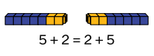  Instructional Periods  G1 – likely 10 instructional periods  G2 – likely 10 instructional periods | Instructional Periods  G1 – likely 10 instructional periods  G2 – likely 10 instructional periods

Concept/Skill: Fluently add and subtract within 18

Goal | Free working memory for algorithms
Student-Facing Example | 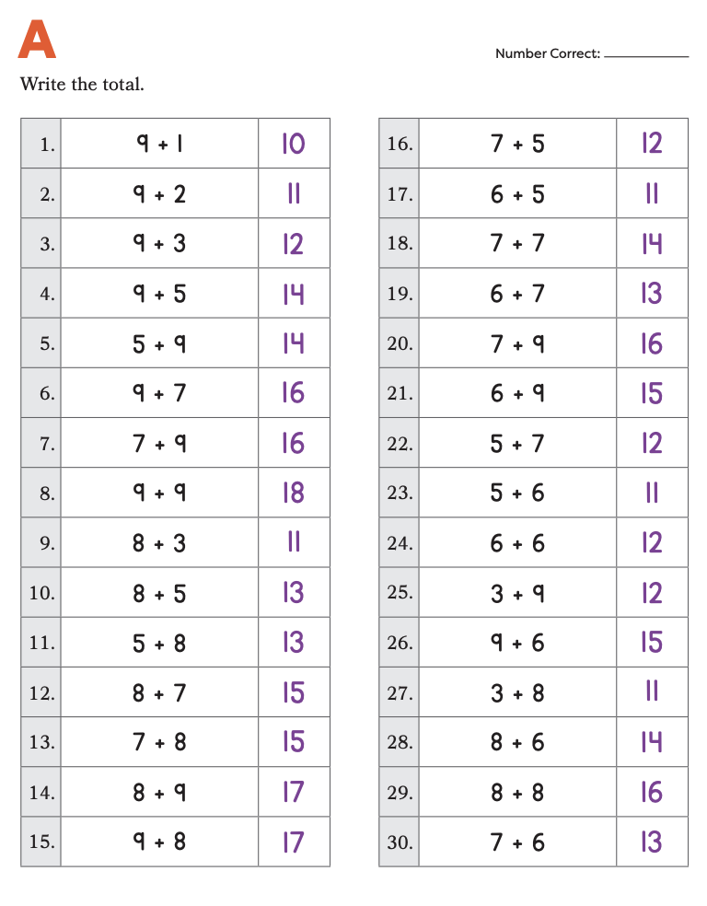
Knowledge Graph Node | Fluently add single-digit numbers with sums up to 5. | Fluently add single-digit numbers with sums up to 10. | Fluently add single-digit numbers with sums up to 18. | Fluently subtract numbers within 5. | Fluently subtract numbers within 10. | Fluently subtract numbers within 18.
Terminology
Mathematical Models
Strategies |  | Required sets:  - All addition facts within 10 |  |  | Required sets:  - All addition facts within 10 and related subtraction facts. | Required sets:  - Teen subtraction facts up to 18 (e.g., $13-5, 14-6,…,18-9$) to support subtracting in the algorithm
Specifications | - Sums up to 5 (GK)  - Subitizing  - Count on from a number | - Sums up to 10 (G1)  - Can students answer 5 + 4 under 3 seconds? If not, what strategy did they use? Doubles? Doubles +1?  - (5 + n) pattern (TX BB GK M4) | - Sums up to 18 (G2)  - Can students answer 6 +7 under 3 seconds? If not, what strategy did they use? Doubles? Making 10?  - (10 + n) (EM2 G1 M3) | - Subtraction facts up to 5 (GK) | - Subtraction facts up to 10 (G1) | - Subtraction facts up to 18 (G2)  - Link addition and subtraction (e.g., “I have 12. I hide some. You see 4. How many am I hiding?”)  - Can they use addition to solve subtraction (e.g., solving 15 – 8 by thinking 8 + ? = 15)?
Leaves to Include
Considerations | - Proficiency (target TBD): $x\%$ accurate and within $x$ seconds per fact on mixed sets. Doesn’t need to be a hard/high gate as students will get more practice when they do standard algorithms, but there should be some kind of a gate  - Practice design: structure by fact families; emphasize make ten and near ten facts as law-backed strategies. Use Sprints heavily here  - Comparison-type practice: Include compare problems in fact practice to force missing-addend reasoning (not only “take away”)  - TREASURE: Pascal’s triangle (generating pascals triangle and variations as a fluency practice tool) | - Proficiency (target TBD): $x\%$ accurate and within $x$ seconds per fact on mixed sets. Doesn’t need to be a hard/high gate as students will get more practice when they do standard algorithms, but there should be some kind of a gate  - Practice design: structure by fact families; emphasize make ten and near ten facts as law-backed strategies. Use Sprints heavily here  - Comparison-type practice: Include compare problems in fact practice to force missing-addend reasoning (not only “take away”)  - TREASURE: Pascal’s triangle (generating pascals triangle and variations as a fluency practice tool) | - Proficiency (target TBD): $x\%$ accurate and within $x$ seconds per fact on mixed sets. Doesn’t need to be a hard/high gate as students will get more practice when they do standard algorithms, but there should be some kind of a gate  - Practice design: structure by fact families; emphasize make ten and near ten facts as law-backed strategies. Use Sprints heavily here  - Comparison-type practice: Include compare problems in fact practice to force missing-addend reasoning (not only “take away”)  - TREASURE: Pascal’s triangle (generating pascals triangle and variations as a fluency practice tool) | - Proficiency (target TBD): $x\%$ accurate and within $x$ seconds per fact on mixed sets. Doesn’t need to be a hard/high gate as students will get more practice when they do standard algorithms, but there should be some kind of a gate  - Practice design: structure by fact families; emphasize make ten and near ten facts as law-backed strategies. Use Sprints heavily here  - Comparison-type practice: Include compare problems in fact practice to force missing-addend reasoning (not only “take away”)  - TREASURE: Pascal’s triangle (generating pascals triangle and variations as a fluency practice tool) | - Proficiency (target TBD): $x\%$ accurate and within $x$ seconds per fact on mixed sets. Doesn’t need to be a hard/high gate as students will get more practice when they do standard algorithms, but there should be some kind of a gate  - Practice design: structure by fact families; emphasize make ten and near ten facts as law-backed strategies. Use Sprints heavily here  - Comparison-type practice: Include compare problems in fact practice to force missing-addend reasoning (not only “take away”)  - TREASURE: Pascal’s triangle (generating pascals triangle and variations as a fluency practice tool) | - Proficiency (target TBD): $x\%$ accurate and within $x$ seconds per fact on mixed sets. Doesn’t need to be a hard/high gate as students will get more practice when they do standard algorithms, but there should be some kind of a gate  - Practice design: structure by fact families; emphasize make ten and near ten facts as law-backed strategies. Use Sprints heavily here  - Comparison-type practice: Include compare problems in fact practice to force missing-addend reasoning (not only “take away”)  TREASURE: Pascal’s triangle (generating pascals triangle and variations as a fluency practice tool)
Required Skills/Cases | - Sums up to 5 (GK)  - Subitizing  - Count on from a number | - Sums up to 10 (G1)  - Can students answer 5 + 4 under 3 seconds? If not, what strategy did they use? Count on? Doubles? Doubles +1?  - (5 + n) pattern (TX BB GK M4) | - Sums up to 18 (G2)  - Can students answer 6 + 7 under 3 seconds? If not, what strategy did they use? Doubles? Making 10?  - (10 + n) (EM2 G1 M3) | - Subtraction facts up to 5 (GK) | - Subtraction facts up to 10 (G1) | - Subtraction facts up to 18 (G2)  - Link addition and subtraction (e.g., “I have 12. I hide some. You see 4. How many am I hiding?”)  - Can they use addition to solve subtraction (e.g., solving 15 – 8 by thinking 8 + ? = 15)?
Misconceptions |  | - Students may rely solely on memorization without understanding, making it hard to apply facts flexibly (e.g., not using known facts like doubles to solve near-doubles).  - Students do not use numerical strategies to develop fact fluency (e.g., “I don’t know this fact, so I am going to just guess.”). (Source: TX BB G1 M1)  - Students rely on counting all (e.g., “I have to count from 1”). (Source: TX BB G1 M1) | - Students might confuse similar facts (e.g., mixing up 6 + 7 and 7 + 8) |  | - Students may treat addition and subtraction facts as unrelated, rather than seeing them as connected (fact families).
Existing Product Reference, if any |  | - EM2 Fluency  - EM2 Sprints (Starts in EM2 G1 M2 L9)  - EM2 CA Contemplate Then Calculate (Starts in EM2 CA G1 M2 L9) | - EM2 Fluency  - EM2 Sprints (Starts in EM2 G1 M2 L9)  - EM2 CA Contemplate Then Calculate (Starts in EM2 CA G1 M2 L9) |  | - EM2 Fluency  - EM2 Sprints (Starts in EM2 G1 M2 L9)  - EM2 CA Contemplate Then Calculate (Starts in EM2 CA G1 M2 L9) | - EM2 Fluency  - EM2 Sprints (Starts in EM2 G1 M2 L9)  EM2 CA Contemplate Then Calculate (Starts in EM2 CA G1 M2 L9)
Grade (or Leaf) | GK | G1 | G2 | GK | G1 | G2
Notes related to Standards, Grade, or Leaf | K.OA.A.5  CA.K.OA.5  FL.K.NSO.3.2  TN.K.OA.A.5 | 1.OA.C.6  CA.1.OA.6  FL.1.NSO.2.2 | 2.OA.B.2  2.NBT.B.5  CA.2.OA.2  CA.2.NBT.5  FL.2.NSO.2.1  TX.2.4A  TN.2.OA.B.2 | K.OA.A.5  CA.K.OA.5  FL.K.NSO.3.2  TN.K.OA.A.5 | 1.OA.C.6  CA.1.OA.6  FL.1.NSO.2.2 | 2.OA.B.2  2.NBT.B.5  CA.2.OA.2  CA.2.NBT.5  FL.2.NSO.2.1  TX.2.4A  TN.2.OA.B.2
Notes for Intervention, Extension, or Optional Activities | Intervention:  - Concrete-Pictorial-Abstract  - Perceptual Subitizing within 5 (Math Catalyst)  Optional Activities:  - Comparison problems (EM2 GK M3) | Intervention:  - Concrete-Pictorial-Abstract  - Conceptual Subitizing within 10 (Math Catalyst)  Optional Activities:  - Plus/Minus 0, 1, 2 (EM2 G1 M1 TD L23)  - Count on/count back (EM2 G1 M1)  - Partners to 10 (EM2 G1 M1)  - Doubles (EM2 G1 M1) | Intervention:  - Concrete-Pictorial-Abstract  - Add within 20 (Math Catalyst) | Intervention:  - Concrete-Pictorial-Abstract  Optional Activities:  - Comparison problems (EM2 GK M3) | Intervention:  - Concrete-Pictorial-Abstract  - Take Away to Subtract within 10 (Math Catalyst)  Optional Activities:  - Reasons About Take From Situations (EM2 G1 M2)  - Plus/Minus 0, 1, 2 (EM2 G1 M1 TD L23) | Intervention:  - Concrete-Pictorial-Abstract  - Subtract within 20 (Math Catalyst)
Additional Notes | Fluency Ideas:  From EM2 GK M3 L7, 8, 12, 13, 18, 19, 20:  - Building Up to the Sprint Routine: What is a Sprint?  - Snap: Partners to 10 (EM2 GK M5)  Additional Notes:  - Associated concepts from other stems: Whole Numbers and Base Ten Structure  - “By fluent we mean students can recall facts without hesitation and can perform routine calculations without thought–similar to speaking a language fluently.” (Source: Fluency without Equivocation by Scott Baldridge, Ben McCarthy, and Robin Ramos)  - “Fluency is designed to promote automaticity by engaging students in practice in ways that get their adrenaline flowing. Automaticity is critical so that students avoid using up too many of their attention resources with lower-level skills when they are addressing higher-level problems. The automaticity prepares students with the computational foundation to enable deep understanding in flexible ways.” (Source: Fluency without Equivocation by Scott Baldridge, Ben McCarthy, and Robin Ramos)  - Three Fluency Categories (Source:The Davidson Group)  - Fluency is not taught in a fixed number of instructional periods; it should be practiced and maintained throughout the school year. | Fluency Ideas:  From EM2 G1 M1, M2, M3:  - Counting on the Rekenrek by Ones Within 5  - Counting on the Rekenrek by Ones Within 10  - 5–Groups to 5  - 5–Groups to 10  - 10–Frame Fill-Up  - Finger Flash: Doubles  - Sprint: +1, +2  - Sprint: 5 + n  - I Say, You Say: Partners to 10  - Sprint: 10+ Facts  - Fluency is not taught in a fixed number of instructional periods; it should be practiced and maintained throughout the school year. | Fluency Ideas:  From EM2 G2 M1:  - Ready, Set, Add  - 5–Groups: Partners to 10  - Fluency is not taught in a fixed number of instructional periods; it should be practiced and maintained throughout the school year. | Fluency Ideas:  From EM2 GK M5:  - Snap: Partners to 10  Additional Notes:  - Associated concepts from other stems: Whole Numbers and Base Ten Structure  - “The Sprints are dealing with ideas that the students will need to use as stepping-stones for understanding later on but the approach is not blind memorization, but rather the achievement of automaticity through understanding numerical relationships...the Sprint provides an opportunity to practice to automaticity the numerical relationships needed to build the students’ number sense.” (Source: Fluency without Equivocation by Scott Baldridge, Ben McCarthy, and Robin Ramos)  - Fluency is not taught in a fixed number of instructional periods; it should be practiced and maintained throughout the school year. | Fluency Ideas:  From EM2 G1 M2, M3:  - 5–Groups: Imagine 1 More, 1 Less  - Choral Response: Disappearing Dots with Totals of 6  - Number Bond Dash: Make 6  - Take Away All at Once  - Happy Counting by Ones Within 20  - Sprint: -1, -2  - Number Path Hop: Get to 10 from a Teen Number  - Fluency is not taught in a fixed number of instructional periods; it should be practiced and maintained throughout the school year. | Fluency Ideas:  From EM2 G2 M1:  - Choral Response: Disappearing Dots with Totals of 10  - Numbers Up!  Fluency is not taught in a fixed number of instructional periods; it should be practiced and maintained throughout the school year.

Concept/Skill: Add and subtract multi-digit whole numbers by using the standard algorithm

Goal | Develop and master addition and subtraction standard algorithms with explanations
Student-Facing Example | 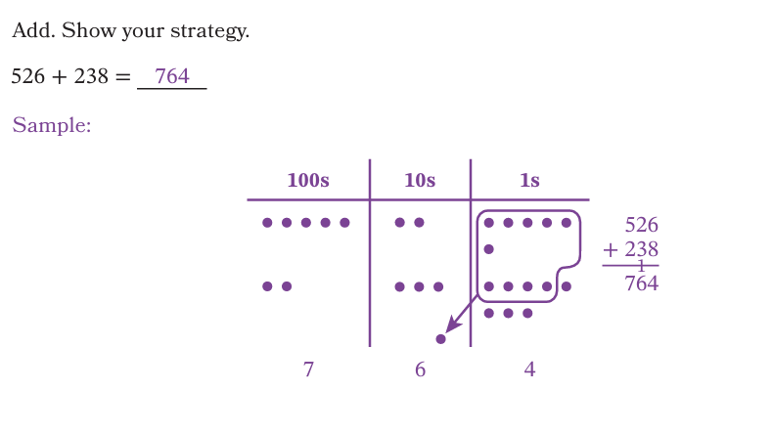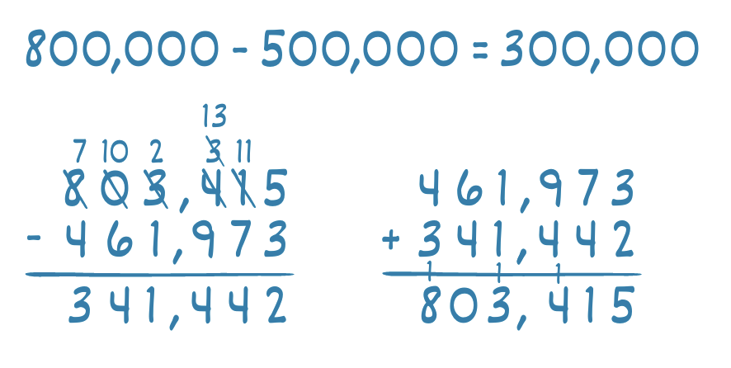
Knowledge Graph Node | Add multi-digit whole numbers by using place-value representations. | Add multi-digit whole numbers by using the standard algorithm. | Subtract multi-digit whole numbers by  by using place-value representations. | Subtract multi-digit whole numbers by using the standard algorithm.
Terminology
Mathematical Models
Strategies | - Addition algorithm: justified by expanded form + associativity/commutativity; explain right-to-left as minimizing backtracking.  - Place value charts ok as initial support of algorithms. Equations and expanded form better!  - Estimate to check reasonableness (see Estimating stem)—more details also in Stem doc |  | - Subtraction algorithm: tie each regrouping to place value and the additive facts.  - Place value charts ok as initial support of algorithms. Equations and expanded form better!  - Estimate to check reasonableness (see Estimating stem)—more details also in Stem doc
Specifications | - Use place value disks, record in vertical form  - Use place value chart, record in vertical form  - Build from/connect to expanded form!!!  - Context/word problems as motivation, not a case | - Algorithm only (place value disks/charts for intervention)  - Context/word problems as motivation, not a case | - Use place value disks, record in vertical form  - Use place value chart, record in vertical form  - Build from/connect to expanded form!!!  - Context/word problems as motivation, not a case | - Algorithm only (place value disks/charts for intervention)  - Context/word problems as motivation, not a case
Leaves to Include | - Number ranges  - Estimate sums | - Number ranges  - Estimate sums | - Number ranges  - Estimate differences | - Number ranges  - Estimate differences
Considerations | - Add and subtract length measurement problems (see length stem)  - Keep the unit explicit; connect to number line.  - Only like units combine; show renaming across compound units (e.g., 1 ft = 12 in) as base-ten-like renaming  - Mental methods may run left-to-right; the standard paper algorithm is right-to-left to minimize backtracking  - Paper-and-pencil steps of the SAs just a convenient bookkeeping method, not explanations; connect each line to place value or properties  - Emphasize that the SAs reduce complicated sums/differences to single digit sums/differences  - Keep manipulatives limited; once the algorithm is introduced, shift to symbolic with brief re-grounding as needed  - For mental arithmetic, allow empty number line jumps (add tens then ones, compensation). No need to fossilize the SAs. | - Optional transitional algorithm: write partial totals by place, regroup at end; then converge to the standard algorithm. | - Build check habit: confirm $a-b$ by verifying $b+(a-b)=a$.
Required Skills/Cases | - Sums within 1,000  - Addends have different numbers of digits  - Addends have same number of digits  - Greater number as first addend  - Greater number as second addend  - Focus on two addends, more addends ok  - Regrouping ones  - Regroup tens  - Regroup ones and tens | - Three-digit addends  - Four-digit addends  - Five-digit addends  - Six-digit addends  - Addends have different numbers of digits  - Addends have same number of digits  - Greater number as first addend  - Greater number as second addend  - Focus on two addends, especially in G3, more addends ok  - Start with 1 regrouping and work up to multiple regroupings in various places | - Totals within 1,000 (G2)  - Minuend and subtrahend have different numbers of digits  - Minuend and subtrahend have same number of digits  - Decompose hundreds  - Decompose tens  - Decompose hundreds and tens  - Decompose across a 0 in tens place | - Three-digit minuend and subtrahend (G3)  - Four-digit minuend and subtrahend  - Five-digit minuend and subtrahend  - Six-digit minuend and subtrahend  - Minuend and subtrahend have same number of digits  - Start with 1 decomposition and work up to multiple decompositions in various places  - Decompose across a 0 in various places  - Decompose across multiple places (EM2 G3 M2 L24, e.g., 508-354, 712-538)
Misconceptions | - Adding without recording the regrouping (e.g., 3 ones + 9 ones = 12 ones and writing 12 below the line)  - Incorrectly aligning the addends (especially when the number of digits in each is different) | - Adding without recording the regrouping (e.g., 3 ones + 9 ones = 12 ones and writing 12 below the line)  - Incorrectly aligning the addends (especially when the number of digits in each is different) | - Subtracting from the bottom up when using the standard algorithm to avoid decomposing  - Incorrectly aligning the minuend and the subtrahend (especially when the number of digits in each is different) | - Subtracting from the bottom up when using the standard algorithm to avoid decomposing  - Incorrectly aligning the minuend and the subtrahend (especially when the number of digits in each is different)
Existing Product Reference, if any | - EM2 G2 M4 L7, L8  - Math Catalyst, Addition, Add Within 1,000 with Regrouping, Concept Mini Lessons 1-4 | - EM2 G3 M2 L20 Learn 2, EM2 G3 M2 L21 Learn 3 (May not need as heavy a measurement emphasis as EM2)  - EM2 G4 M1 L16 (but w/o PV disks or charts)  - Math Catalyst, Addition, Add Whole Numbers Within 1,000,000, Concept Mini Lessons 2-4 | - EM2 G2 M4 L16, L18, L19  - Math Catalyst, Subtraction, Subtract Within 1,000 with Regrouping, Concept Mini Lessons 1–4 | - EM2 G3 M2 L23 (May not need as heavy a measurement emphasis as EM2)  - EM2 G4 M1 L18 (but w/o PV disks or charts), L19 Launch & Learn 2, L20 (but w/o PV disks or charts)  - Math Catalyst, Subtraction, Subtract with Regrouping in Multiple Places to 1,000,000, Concept Mini Lessons 1–3
Grade (or Leaf) | 2 | 3, 4 | 2 | 3, 4
Notes related to Standards, Grade, or Leaf | CCSS.2.NBT.B.7, CCSS.2.NBT.B.9  FL.2.NSO.2.4  TX.2.4B | CCSS.3.NBT.A.2  TX.3.4A (no pure computation standard)  FL.3.NSO.2.1  CCSS.4.NBT.4  TX.4.4A | CCSS.2.NBT.B.7  FL.2.NSO.2.4  TX.2.4B | CCSS.3.NBT.A.2  TX.3.4A (no pure computation standard)  FL.3.NSO.2.1  CCSS.4.NBT.4  TX.4.4A
Notes for Intervention, Extension, or Optional Activities | - Choose an efficient strategy (EM2 G2 M4 L10)  - Math Catalyst, Addition, Add Within 1,000 with Regrouping, Application | - Math Catalyst, Addition, Add Whole Numbers Within 1,000,000, Application  - Optional transitional algorithm: write partial totals by place, regroup at end; then converge to the standard algorithm. (EM2 G3 M2 L21 Learn 1) | - Choose an efficient strategy (EM2 G2 M4 L20, EM2 G3 M2 L24 Learn 2, , EM2 G4 M1 L18 Launch)  - Math Catalyst, Subtraction, Subtract Within 1,000 with Regrouping, Application | - Math Catalyst, Subtraction, Subtract with Regrouping in Multiple Places to 1,000,000, Application (for inspiration, consider number range)
Additional Notes | Likely 2 instructional periods | - G3: Likely 2 or 3 instructional periods, depending on how estimating sums is addressed  - G4: Likely 1 instructional period (consider a combo add & subtract lesson—new learning is more places, not new methods) | Likely 3 instructional periods | - G3: Likely 2 or 3 instructional periods, depending on how estimating differences is addressed  - G4: Likely 1 instructional period (consider a combo add & subtract lesson—new learning is more places, not new methods)

Concept/Skill: Add and subtract fractions.

Goal | Define addition and subtraction of fractions FIRST, then derive formulas from definitions
Student-Facing Example | 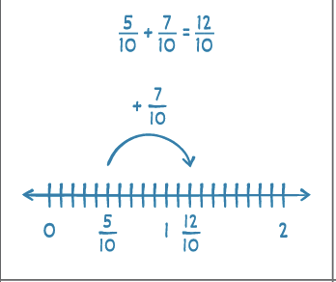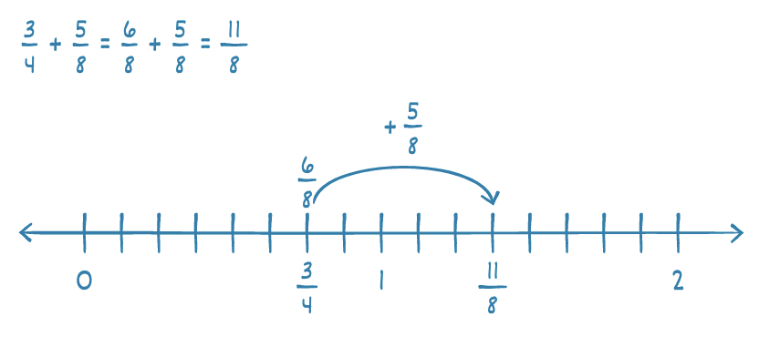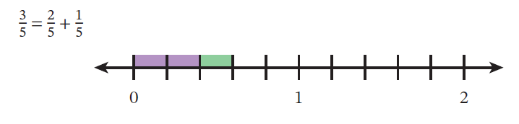  When concatenating the length of segments on the graph, the lines should be straight, not curved to look like “hops”. But this is basically the idea. (Third example was not in the Stem doc—added here because it’s the style that meets Danielle’s specification.)
Knowledge Graph Node | Decompose a fraction into a sum of fractions. | Rename fractions greater than 1 as mixed numbers and mixed numbers as fractions. | Add fractions with like denominators. | Add fractions with unlike denominators. | Subtract fractions with like denominators. | Subtract fractions with unlike denominators.
Terminology
Mathematical Models | Number line | Number line | Number line | Number line | Number line | Number line
Strategies | - Definition: Fractions are numbers on the number line; addition is joining of equal-unit lengths  - Fractions are numbers; $\frac{1}{d}$ is a unit length; $\frac{a}{d}$ is $a$ copies of that unit |  | - Definition: Fractions are numbers on the number line; addition is joining of equal-unit lengths  - Same denominator: prove formula from the definitions | - Different denominators: have to rename to a common unit to figure out where the joining of equal-unit lengths lands; prove from definition the usual formula $\frac{a}{b}+\frac{c}{d}=\frac{ad+bc}{bd}$ | - Definition: Fractions are numbers on the number line; addition is joining of equal-unit lengths, subtraction is a missing addend  - Same denominator: prove formula from the definitions | - Different denominators: have to rename to a common unit to figure out where the joining of equal-unit lengths lands; prove from definition the usual formula $\frac{a}{b}-\frac{c}{d}=\frac{ad-bc}{bd}$
Specifications | - Include estimation and assessing reasonableness of sums  - G4 CCSS denominators  - Word problems to drive motivation | - G4 CCSS denominators  - Include the not completely partitioned number line in EM2 G4 M4 L6 Learn 2—efficiency  - Word problems to drive motivation | - G4 CCSS denominators for fractions and mixed numbers with like units  - Include estimation and assessing reasonableness of sums  - Rename sums as needed (as fraction >1 or mixed as makes sense for context—it’s not “wrong” to leave sum as fraction >1, and so fraction part of mixed number <1)  - Adding with mixed numbers on the number line and numerically (by renaming the whole number as $\frac{a}{a}$)  - Word problems to drive motivation | - For adding tenths and hundredths in G4: Denominators 10 and 100 only, must come after using number line to generate equivalent fractions  - Include related and unrelated denominators but don’t make a big deal of related denominators  - Word problems to drive motivation | - G4 CCSS denominators for fractions and mixed numbers with like units  - Include estimation and assessing reasonableness of differences  - Rename differences as needed (as fraction >1 or mixed as makes sense for context—it’s not “wrong” to leave sum as fraction >1  - Word problems to drive motivation | - Include related and unrelated denominators but don’t make a big deal of related denominators  - Word problems to drive motivation
Leaves to Include
Considerations | - Include fractions with denominators that are powers of 10 (Finite decimals are base-ten fractions; decimal notation represents tenths, hundredths, and, when needed, thousandths)  - Explicitly connect to whole number addition on the number line | - Introduce mixed numbers here.  - Emphasize that mixed numbers ARE addition. 4 1/3 means 4+1/3. | - Include visual proofs on the number line and symbolic derivation proofs  - Problem types: length models, tape diagrams, and “missing addend” equations with fractions all fine. Prioritize and feature number line though  - Convert mixed numbers to fractions greater than 1 to add/subtract; don’t invent a separate rule set  - Explicitly connect to whole number addition on the number line | - Like denominators à unlike denominators. Related denominators can be useful for efficiency or scaffolding, but the mathematical point is renaming to a common unit. | Explicitly connect to whole number subtraction on the number line | Explicitly connect to whole number subtraction on the number line
Required Skills/Cases | - Non-unit fraction <1 as sum of unit fractions  - Non-unit fraction >1 as sum of unit fractions  - Non-unit fraction <1 as sum of unit fraction and non-unit fraction  - Non-unit fraction >1 as sum of unit fraction and non-unit fraction  - Non-unit fraction <1 as sum of two non-unit fractions  - Non-unit fraction >1 as sum of two non-unit fractions | - Include discussion of $0\frac{a}{b}$ from EM2 G4 M4 L5 Learn 2 | - Sum $≤$1  - Sum >1  - Whole + fraction  - Fraction <1 + mixed number (does not make a new whole)  - Fraction <1 + mixed number (makes a new whole)  - Fraction >1 + mixed number  - mixed number + mixed number (fractions do not make a new whole)  - mixed number + mixed number (fractions make a new whole) | - Equivalence with tenths and hundredths:  - $\frac{}{10}+\frac{}{100}$ rename tenths as hundredths  - $\frac{}{10}+\frac{}{100}$ rename hundredths as tenths when possible, recognize equivalent hundredths as tenths, such as 50/100 = 5/10  - Unlike units:  - Sum <1  - Sum >1  - Fraction <1 + mixed number (does not make a new whole)  - Fraction <1 + mixed number (makes a new whole)  - Fraction >1 + mixed number  - mixed number + mixed number (fractions do not make a new whole)  - mixed number + mixed number (fractions make a new whole)  - Some denominators related, some unrelated | - Both fractions <1  - Fraction >1 - fraction <1  - Fraction > 1 - fraction > 1  - 1 – fraction  - Whole – fraction  - Mixed – fraction (fraction is less than the fraction in the mixed number)  - Mixed – fraction (fraction is greater than the fraction in the mixed number)  - Fraction >1 - mixed number  - mixed number - fraction >1  - mixed number - mixed number (fraction in subtrahend is less than the fraction in the minuend)  - mixed number - mixed number (fraction in minuend is less than the fraction in the subtrahend) | - Both fractions <1  - Fraction >1 - fraction <1  - Both fractions > 1  - Mixed – fraction (fraction is less than the fraction in the mixed number)  - Mixed – fraction (fraction is greater than the fraction in the mixed number)  - Fraction >1 - mixed number  - mixed number - fraction >1  - mixed number - mixed number (fraction in subtrahend is less than the fraction in the minuend)  - mixed number - mixed number (fraction in minuend is less than the fraction in the subtrahend)  - 1 − fraction and whole number − fraction  - Some denominators related, some unrelated
Misconceptions |  |  | - Include why $\frac{a}{b}+\frac{c}{b}≠\frac{a+c}{b+b}$, use number line example (required to address: this is in the mathematical models and strategies section of the stem doc) |  | Include why $\frac{a}{b}-\frac{c}{b}≠\frac{a-c}{b-b}$, use number line example (required to address: this is in the mathematical models and strategies section of the stem doc)
Existing Product Reference, if any | - EM2 G4 M4 L2 and L3, don’t use tape diagrams, use number bonds sparingly if at all, use the number line style of L3 Learn 3 | - EM2 G4 M4 L5 Learn 2  - EM2 G4 M4 L6 Learn 1 | - EM2 G4 M4 L19 Learn 3  - EM2 G4 M4 L21 Launch and Learn 1 for estimation  - EM2 G4 M4 L23 and L24, rely more number lines and less on number bonds, arrow way, etc.  - Math Catalyst, Addition, Add Fractions with Like Denominators, Concept Mini Lesson 2  - Math Catalyst, Addition, Add Mixed Numbers, Concept Mini Lesson 1 also has some number line models | - G4 M5 L12 Learn 2 Number Line, Learn 3 Open Number Line  - MH2 Strawman G5 M2 TB Fraction Frenzy (lesson/day 1)  - EM2 G5 M2 L5 Learn 2 (but don’t emphasize related units)  - EM2 G5 M2 L9 Learn 1  - EM2 G5 M2 L10 Learn 2 | - EM2 G4 M4 L19 Learn 3  - EM2 G4 M4 L20 Learn 1 and 2  - Math Catalyst, Subtraction, Subtract Fractions with Like Denominators, Concept Mini Lesson 2  - Math Catalyst, Subtraction, Subtract Mixed Numbers, Concept Mini Lessons 1–2 | - EM2 G5 M2 L9 Learn 1  - Math Catalyst, Subtraction, Subtraction Fractions with Unlike Denominators, Concept Mini Lesson 4  - MH2 Strawman G5 M2 TB Fraction Frenzy (lesson/day 1)  - EM2 G5 M2 L5 Learn 2 (but don’t emphasize related units)  - EM2 G5 M2 L9 Learn 1  - EM2 G5 M2 L13 Learn 1  - Math Catalyst, Subtraction, Subtract Mixed Numbers, Concept Mini Lessons 4
Grade (or Leaf) | 4 | 4 | 4 | 4, 5 | 4 | 5
Notes related to Standards, Grade, or Leaf | CCSS.4.NF.B.3.a, CCSS.4.NF.B.3.b  FL.4.FR.2.1  MA.4.NF.B.3.a (see optional below) | CCSS.4.NF.B.3.a, CCSS.4.NF.B.3.c  FL.4.FR.2.2  TX.4.3.E  OK.5.N.3.2 | CCSS.4.NF.B.3.a, CCSS.4.NF.B.3.c, CCSS.4.NF.B.3.d  FL.4.FR.2.2  TX.4.3.E, TX.4.3.F | CCSS.4.NF.C.5  FL.4.FR.2.3  CCSS.5.NF.A.1  FL.5.FR.2.1  TX.5.3.H  OK.5.N.3.2 | CCSS.4.NF.B.3.a, CCSS.4.NF.B.3.c, CCSS.4.NF.B.3.d  FL.4.FR.2.2,  TX.4.3.E, TX.4.3.F | CCSS.5.NF.A.1  FL.5.FR.2.1  TX.5.3.H  OK.5.N.3.2
Notes for Intervention, Extension, or Optional Activities | - Fraction strips/tiles and/or tape diagrams for intervention  - Non-unit fraction as sum of 3 or more fractions (at least 1 addend not a unit fraction) for extension  - Optional: set of objects as model (for MA.4.NF.B.3.a) |  | - More on estimating using benchmarks (EM2 G4 M4 L18)  - Adding by using unit form (EM2 G4 M4 L19 Learn 1 and 2, EM2 G4 M4 L23 Learn 1, L24 Learn 1)  - By using objects (meets TX breakout)  - Math Catalyst, Addition, Add Fractions with Like Denominators, Application  - Other methods for mixed numbers (EM2 G4 M4 L23 Learn 2, G4 M4 L24 Learn 2) | - Add mixed numbers with tenths and hundredths (EM2 G4 M5 L13)  - Related denominators  - EM2 G5 M2 Math Past (see L9)  - Add more than 2 fractions (G5 M2 L9 Learn 2)  - Math Catalyst, Addition, Add Fractions with Unlike Denominators, Application  - EM2 G5 M2 L11 station prompts  - Math Catalyst, Addition, Add Mixed Numbers, Application  - Other methods for mixed numbers (EM2 G5 M2 L10) | - By using objects (meets TX breakout)  - Math Catalyst, Subtraction, Subtract Fractions with Like Denominators, Application  - Other methods (EM2 G4 M4 L25, L26, and L27) | - Other methods (EM2 G5 M2 L12, L13)  - Math Catalyst, Subtraction, Subtract Mixed Number, Application
Additional Notes | Likely 1 instructional period | Likely 2 instructional periods | Likely 3 instructional periods (fraction + fraction; fraction + mixed number; mixed + mixed) | - G4: Likely 1 instructional period (tenths + hundredths)  - G5: Likely 3 instructional periods (fractions number line—do addition and subtraction together; fractions numerically; mixed numbers) | Likely 3 instructional periods (fraction – fraction; whole – fraction; fraction - mixed) | Likely 2 instructional periods (fractions numerically; mixed numbers)

Concept/Skill: Add and subtract decimals.

Goal | Relate to whole number addition and subtraction (align place value units and then apply the addition/subtraction algorithm)
Student-Facing Example | 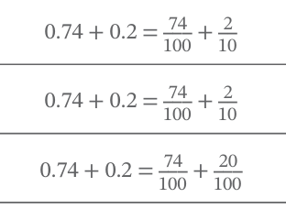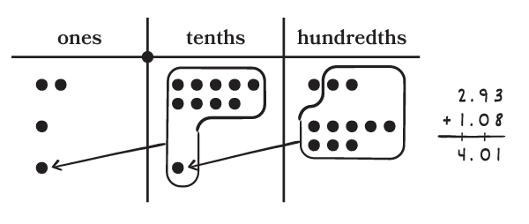
Knowledge Graph Node | Add decimals by using a number line. | Add decimals by using the standard algorithm.  (Currently no decimal computation in a G6+ stem.) | Subtract decimals by using a number line. | Subtract decimals by using the standard algorithm.  (Currently no decimal computation in a G6+ stem.)
Terminology
Mathematical Models | - Number line  - Place value charts ok as initial support of algorithms. Equations and expanded form better! | - Place value charts ok as initial support of algorithms. Equations and expanded form better! | - Number line  - Place value charts ok as initial support of algorithms. Equations and expanded form better!
Strategies |  | - Standard algorithm  - Mastery of the algorithm is not expected in G5 |  | - Standard algorithm  - Mastery of the algorithm is not expected in G5
Specifications | - To the hundredths | - To the hundredths | - To the hundredths | - To the hundredths
Leaves to Include
Considerations | - Appending trailing zeros does not change a decimal’s value (e.g., $3.4=3.40$); it renames the same number in finer units  - Use estimation to check reasonableness (round to a convenient place)  - Recognize decimals as fractions  - Use the number line and fraction equivalence to show tenths and hundredths as units. Do not lose the connection between fractions and decimals (decimals are just fractions written funny) | - Decimals are base-ten fractions; align decimal points is aligning units (tenths with tenths, etc.)  - align decimal points because only like place-value units are combined; appending trailing zeros renames the same number in smaller units | Use the number line and fraction equivalence to show tenths and hundredths as units. Do not lose the connection between fractions and decimals (decimals are just fractions written funny) | - align decimal points because only like place-value units are combined; appending trailing zeros renames the same number in smaller units
Required Skills/Cases | - Total stays within the same whole number interval  - Total crosses a whole number  - Addend is a whole number  - Add decimals with a different number of digits  - Addends with zero (e.g., 2.03) | - No regrouping  - Regrouping from tenths to ones  - Regrouping from hundredths to tenths  - Multiple regroupings  - Addend is a whole number  - Add decimals with a different number of digits  - Addends with zero (e.g., 2.03) | - Difference stays within the same whole number interval  - Difference crosses a whole number  - Minuend or subtrahend is a whole number  - Subtract decimals with a different number of digits  - Subtrahend with zero (e.g., 2.03) | - Subtracting without decomposing  - Subtracting with decomposing in one place value unit (include across one zero)  - Subtracting with decomposing in more than one place value unit (include across zeros)  - Minuend or subtrahend is a whole number  - Subtract decimals with a different number of digits  - Subtrahend with zero (e.g., 2.03)
Misconceptions | - Adding without attending to units (e.g., computing 0.3 + 0.14 by jumping 14 tick marks from 0.3 on a number line partitioned into tenths, landing at 1.7 instead of 0.44) | - Incorrectly aligning the addends (e.g., aligning numbers by the last digit)  - Treating decimal numbers as whole numbers (e.g., 0.9 + 0.3 = 0.12 because 9 + 3 = 12)  - Removing a non-trailing zero (e.g., changing 3.04 to 3.4) | - Subtracting without attending to units (e.g., computing 0.3 - 0.02 by jumping back 2 tick marks from 0.3 on a number line partitioned into tenths, landing at 0.1 instead of 0.28 ) | - Subtracting from the bottom up when using the standard algorithm to avoid decomposing (same misconception with whole number subtraction)  - Incorrectly aligning the minuend and the subtrahend (e.g., aligning numbers by the last digit)  - Removing a non-trailing zero (e.g., changing 3.04 to 3.4)
Existing Product Reference, if any | - G5 M4 L9-Launch (number line) | - G5 M4 L10-Learn 1 (after the PV disks)  - Catalyst, Addition, Add Decimals to the Hundredths, Objectives 2-4 | - G5 M4 L11-Learn 3 (Subtract Decimal Number by Using a Number Line) | - G5 M4 L12-Learn 1 (Subtract Decimal Numbers by Using Place Value Understanding)  - Catalyst, Subtraction, Subtract Decimals to the Hundredths, Objectives 2-4
Grade (or Leaf) | 5 | 5, 6 | 5 | 5, 6
Notes related to Standards, Grade, or Leaf | CCSS.5.NBT.B.7  FL.4.NSO.2.7, FL.4.NSO.2.6, FL.5.NSO.2.3  MO.5.NBT.A.6 | CCSS.5.NBT.B.7  CCSS.6.NS.B.3  FL.4.NSO.2.7, FL.5.NSO.2.3  TX.4.4A  MO.5.NBT.A.6 | CCSS.5.NBT.B.7  FL.4.NSO.2.7, FL.4.NSO.2.6, FL.5.NSO.2.3  MO.5.NBT.A.6 | CCSS.5.NBT.B.7  CCSS.6.NS.B.3  FL.4.NSO.2.7, FL.5.NSO.2.3  TX.4.4A  MO.5.NBT.A.6
Notes for Intervention, Extension, or Optional Activities | - Intervention: add decimals by applying fraction equivalence (Catalyst, Addition, Add Decimals to the Hundredths, Objective 1)  - Optional: simplifying strategies  - Optional: to the thousandths for FL and MO | - Intervention: use place value disks  - Optional: to the thousandths for FL and MO  - Catalyst, Addition, Add Decimals to the Hundredths, Application | - Intervention: subtracting decimals by applying fraction equivalence (Catalyst, Subtraction, Subtract Decimals to the Hundredths, Objective 1)  - Optional: simplifying strategies  - Optional: to the thousandths for FL and MO | - Intervention: use place value disks  - Optional: to the thousandths for FL and MO  - Catalyst, Subtraction, Subtract Decimals to the Hundredths, Application
Additional Notes | - Likely 1 instructional period  - In EM2 we kept the whole number parts small to keep the focus on the decimal part. Include problems with multi-digit whole numbers to satisfy requirement from some states. | - Likely 1 instructional period in G5  - Likely part of an instructional period in G6 (shared with subtraction)  - In EM2 G5 we kept the whole number parts small to keep the focus on the decimal part. Include problems with multi-digit whole numbers to satisfy requirement from some states. | - Likely 1 instructional period  - In EM2 we kept the whole number parts small to keep the focus on the decimal part. Include problems with multi-digit whole numbers to satisfy requirement from some states. | - Likely 1 instructional period in G5  - Likely part of an instructional period in G6 (shared with subtraction)  - In EM2 G5 we kept the whole number parts small to keep the focus on the decimal part. Include problems with multi-digit whole numbers to satisfy requirement from some states.

