Multiplication and Division (Whole Numbers) Lesson Ladder

PROGRESSION
Essential Foundational Knowledge (Roots) | - Counting, cardinality, and the number line  - Addition and subtraction: equal addends, properties of addition (see Addition and Subtraction stem)  - Place value/base-ten decomposition  - Units and measurement language (lengths, “the unit” is declared)  - Equal groups and arrays as contexts (not definitions)  - Comparison and “missing addend” reasoning
Leads to | - Multiplication and division of fractions  - Exponents/powers of 10; scientific notation.  - Early algebra: equations/inequalities solving
Big Ideas | This stem is about building multiplication and division as operations on numbers, not as picture types. Equal groups, arrays, area models, tape diagrams, and contexts are useful, but they serve the definitions and theorems. The through-line is: repeated addition → properties → unknown-factor division → exact division → division with remainder → algorithms (as justified recordings of place-value decomposition and DWR theorem).  - Multiplication and division are operations defined on numbers and governed by the fundamental properties (commutative, associative, distributive)  - Unitizing  - Equal groups  - Place value  - Relationship between multiplication and division  - Exact division vs. division with remainders (and interpreting remainders in context)
Other Information | - CAUTION: Division with remainder is not the same operation as (exact) division; it is a representation theorem for whole numbers and the bookkeeping behind long division  - Multiplication (on whole numbers) is defined as repeated addition  - Division is a missing factor problem  - Division with remainder is a separate representation of whole numbers  - This structure extends coherently from whole numbers to fractions (and decimals as base-10 fractions). Key theorems—Product Formula and Invert-and-Multiply—are proved once and then reused everywhere.  - Properties (commutative/associative/distributive) are stated early and cited when used  - Pictures and contexts illustrate definitions/theorems; they do not define them  - Use the number line for meaning; use arrays/area model to help illustrate distributive structure  Guidance about representations throughout this stem  - Number line / measurement length: use for meaning and future coherence. $4×3$ as 4 copies of an interval of length 3 is excellent  - Arrays / area models: use to illustrate commutativity and especially distributivity; always connect to equations.  - Place-value charts: can use for base-ten decomposition and algorithm development as appropriate. Kids don’t need to “get good” at PV charts  - Tape diagrams: can use for multiplicative comparison when they earn their keep; connect eventually to number lines and ratio/proportion work.  “do not violate” rules:  - Do not define multiplication by arrays or area. Define by repeated addition; use arrays/area to illustrate structure.  - Do not define division by sharing stories. Define exact division by the missing-factor equation; use sharing and measurement stories as contexts and motivation.  - Do not treat $q\text{ R }r$ as a number. Use $a=bq+r$, with $0≤r<b$.

Concept/Skill: Write repeated addition as multiplication, and multiply whole numbers by using repeated addition strategies.
Goal | Build $a × b$as equal addends.
Student-Facing Example | 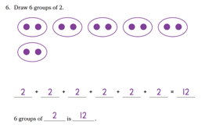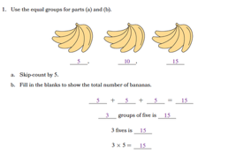
Knowledge Graph Node | Represent equal groups by using repeated addition to find the total. | Translate between models and addition and multiplication expressions to find a product. | Multiply by using repeated addition strategies.
Terminology |  | Underlying:  - Whole-number multiplication. For whole numbers $a$ and $b$, $a×b$ is the sum of $a$ copies of $b$.  Possible Teacher-facing language  - Whole number multiplication: For whole numbers $a,b$, $a×b$ is the sum of $a$ copies of $b$.  Need factor, product?
Mathematical Models | - Equal groups  - Arrays  - Number line  - Equations | - Equal groups  - Arrays  - Number line  - Equations | - Equal groups  - Arrays  - Number line  - Equations
Strategies | - Level 1 strategy: Make groups and count all  - Level 2 strategy: Make groups and skip count | - Level 1 strategy: Make groups and count all  - Level 2 strategy: Make groups and skip count | - Level 2 strategy: Make groups and skip count
Specifications | - When we have copies of the same size group, all of our addends are the same and we can use a repeated addition equation  - When groups are unequal in size, then addends are not all the same and we do not have a repeated addition equation  - Emphasize copies language, don’t emphasize a particular model and its language (e.g., equal groups, rows, columns, hops). Focus is mastering the copies and repeated addition ideas, not mastering particular models  - Up to 5 copies of 5  - Use story situations, but also use non-contextual models (context/word problems as motivation, solving word problems is a node, in the Expressions and Equations stem) | - EM2 emphasized the visual models and how to interpret them as models of multiplication situations, we want to shift the emphasis to multiplication as a shorthand for repeated addition with a variety of models we can use to represent the relationship between the numbers, depending on the situation or what we need to figure out. Might still need to chunk lessons by models, but don’t let the visual model become the emphasis.  - Introduce multiplication as a shorthand for repeated addition  - Formally define multiplication  - Situations that can be represented by repeated addition equations and situations that can be represented by multiplication equations (There is overlap with the Expressions and Equations stem here)  - Want to develop flexibility converting among story situations, equal groups, arrays, number line, a copies of b statements, repeated addition equations, multiplication equations, unit language (e.g., 4 twos)  - Story situations must be paired with a visual model (context/word problems as motivation, solving word problems is a node in the Expressions and Equations stem)  - Skip counting is a strategy we can use to find the total/product, it is not a model/representation  - Every day language, story language, mathematical language | - Skip counting is a strategy we can use to find the total/product, it is not a model/representation  - Skip counting is more efficient than repeated addition  - Initially record the skip count alongside the visual model  - Counting the math way |  | This image is about the types of language note in the second node  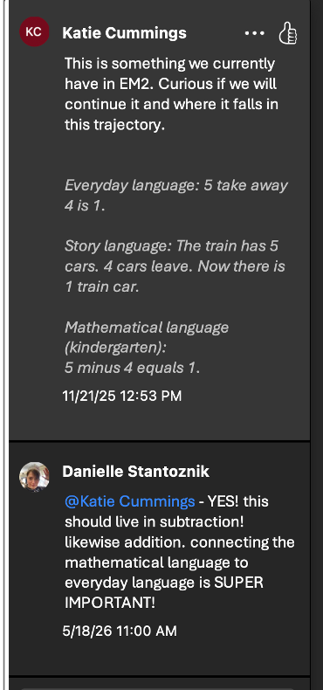
Leaves to Include
Considerations |  | - Can use equal groups but should also connect to length/measurement by using the number line. 4 x 3 can be thought of as 4 copies of an interval of length 3. This connects with later work with multiplication of fractions.  - Do not rely on the word “multiply” as an explanation before the operation has been defined
Required Skills/Cases | - Given a model showing up to 5 copies of 5, write a repeated addition equation  - Given a model or story situation with unequal groups, explain why a repeated addition equation cannot be written  - Given a model showing up to 5 copies of 5, complete an a copies of b statement  - Given a story situation or an a copies of b statement with up to 5 copies of 5, write a repeated addition equation  - Given a repeated addition equation with up to 5 addends up to 5, find the total  - Models: equal groups, array, number line | - Up to 10 copies of 10  - Given one of the following representations, generate another representation (equations will be emphasized further in the Expressions and Equations stem)  - An a copies of b statement  - An equal groups model  - An array  - A number line  - A repeated addition equation  - A multiplication equation  - A story situation (must be paired with a visual model, NOT solving word problems here)  - Unit language (e.g., 4 twos)  - Find a product given (the product needs to be easily identifiable from the representation.  - An equal groups model  - An array  - A number line  - A repeated addition expression (rewrite as multiplication and find the product)  - Identify the factors and product in a multiplication situation | - Up to 10 copies of 10  - Record the skip count alongside a visual model (equal groups, array, number line) and find the product  - Given a copies of b statement or multiplication expression (no visual model), record the skip count and find the product  - Given multiplication expression or equation, find the product (not required to record the skip count)
Misconceptions | - Photocopier interpretation of copies (1 original and y-1 copies instead of y copies)  - Switching the number in each copy and the number of copies (e.g., 3 copies of 4 as 3+3+3+3) |  | Counting 0 as the first count
Existing Product Reference, if any | EM2 G2 M6 L2 Problem Set  EM2 G2 M6 L6  No reference for number lines  Math Catalyst, Multiplication, Represent Contextual Multiplication, Concept Mini Lesson 2 (equal groups) | EM2 G3 M1 L2-L4 (save tape diagrams for word problems lessons)  Math Catalyst, Multiplication, Representations of Multiplication, Concept Mini Lessons 1-4 | EM2 G3 M1 L3 Learn 1 and Learn 3  EM2 G3 Counting the Math Way by… fluencies  EM2 G3 M1 L11 Learn 1  EM2 G3 M1 L13 Learn 1  EM2 G3 M3 L2 Learn 1 and 2  EM2 G3 M3 L3 Learn 1  EM2 G3 M3 L7 Learn 1 (parts)  Math Catalyst, Multiplication, Representations of Multiplication, Concept Mini Lessons 1-4
Grade (or Leaf) | 2 | 3 | 3
Notes related to Standards, Grade, or Leaf | 2.OA.C.4  FL.2.AR.3.2  TX.2.6A | 3.OA.A.1  TX.3.4E  FL.3.NSO.2.2 | 3.OA.A.1  TX.3.4E  FL.3.NSO.2.2
Notes for Intervention, Extension, or Optional Activities | Intervention  - What makes groups equal? (EM2 G2 M6 L1, L5)  - Model equal groups with concrete objects (Math Catalyst, Multiplication, Represent Contextual Multiplication, Concept Mini Lesson 1)  Extension  - Given a repeated addition equation with up to 5 addends up to 5, create another model (array, equal groups, story situation, number line)  - Up to 10 copies and/or up to 10 in each copy  - Math Catalyst, Multiplication, Represent Contextual Multiplication, Application (note: entirely equal groups) | Intervention  - Math Catalyst, Multiplication, Representations of Multiplication, Concept Mini Lessons 1-4 (be careful with lesson 3 “area model” language before area)  Extension  - Math Catalyst, Multiplication, Representations of Multiplication, Application  - Historical multiplication symbols (EM2 G3 M1 Math Past) | Intervention  - Math Catalyst, Multiplication, Representations of Multiplication, Concept Mini Lessons 1-4 (be careful with lesson 3 “area model” language before area)  Extension  - Math Catalyst, Multiplication, Representations of Multiplication, Application
Additional Notes | Likely 1-2 instructional periods | Likely 2 instructional periods, and reinforced in other lessons | Likely 1-2 instructional periods, and reinforced in other lessons

Concept/Skill: Define division with unknown factor equations.
Goal | Use $b×q=a$ to define $a÷b$.
Student-Facing Example | 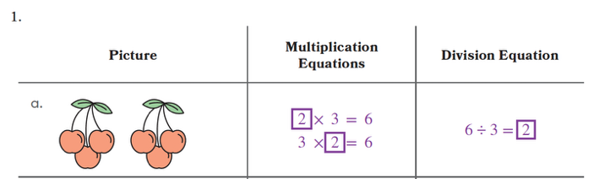
Knowledge Graph Node | Use repeated subtraction to find the number of equal groups when given the total and the size of each group. | Represent and explain division as an unknown factor problem. | Divide by using the relationship between multiplication and division, making equal groups, and skip-counting.
Terminology |  | Exact division of whole numbers. For whole numbers $a$ and $b$, with $b>0$, $a÷b=q$ means $q$ is the whole number such that $a=bq$, when such a whole number $q$ exists.
Mathematical Models | - Equal groups  - Arrays  - Number line  - Equations | - Equal groups  - Arrays  - Number line  - Equations | - Equal groups  - Arrays  - Number line  - Equations
Strategies | - Level 1 strategy: Make groups and count all  - Level 2 strategy: Make groups and skip count | - Level 1 strategy: Make groups and count all  - Level 2 strategy: Make groups and skip count | - Level 1 strategy: Make groups and count all  - Level 2 strategy: Make groups and skip count
Specifications | - When we take away copies of the same size group, we can use a repeated subtraction equation to represent the situation, and count the number of copies that were taken away  - When groups are unequal in size, then we do not have a repeated subtraction equation  - Emphasize copies language, don’t emphasize a particular model and its language (e.g., equal groups, rows, columns, hops). Focus is mastering the copies and repeated subtraction ideas, not mastering particular models  - Up to 5 copies of 5  - Use story situations, but also use non-contextual models (context/word problems as motivation, solving word problems is a node, in the Expressions and Equations stem)  - What is known, what is unknown? | - EM2 emphasized the visual models and how to interpret them as models of the two types of division situations and then introduced division as missing factor, we want to shift the emphasis to lead with division as missing factor that we can represent using the same kinds of models as we use to represent multiplication, depending on the context and what we need to find out  - Might still need to chunk lessons by partitive and measurement contexts or visual models, but don’t let the contexts or visual models become the emphasis  - Formally define division  - (There is overlap with the Expressions and Equations stem here. Relating multiplication and division goes here, finding the unknown in a multiplication or division equation goes there.)  - Want to develop flexibility converting between story situations, a copies of b statements, multiplication equations, division equations, and unit language (e.g., How many twos are in 8?). Can use equal groups, arrays, number line, to visualize and find quotients/missing factors.  - Story situations must be paired with a visual model (context/word problems as motivation, solving word problems is a node in the Expressions and Equations stem)  - Every day language, story language, mathematical language  - What is known, what is unknown? | - Since division is finding an unknown factor, we can make groups and use skip-counting to find quotients  - Our strategy may be different depending on whether the unknown is the number of groups or the size of the group (equally share one group at a time or equally share one thing at a time)
Leaves to Include
Considerations |  | - This definition of division should be analogous to the definition for subtraction (unknown addend).  - Do not use the word “divide” until we have a definition of it.  - Establish the relationship between multiplication and division  - Include partitive and measurement division (teacher-facing terms only) contexts. Include both partitive and measurement contexts, but keep them as contexts. Division is defined by the multiplication equation.  - Partitive context: 42 objects shared equally into 6 groups asks for $q$ such that $6q=42$.  - Measurement context: 42 objects arranged in groups of 6 asks for $q$such that $q×6=42$.  - By commutativity of multiplication, both lead to the same quotient, but the context meaning differs  - Emphasize over and over and over and over (like a monkey with a miniature cymbal) that for exact division $a÷b$ means that we’re looking for some number q that makes the equation $b×q=a$ true. (before we get to fractions, there very well could be no such number!)
Required Skills/Cases | - Given a model showing up to 5 copies of 5, write a repeated subtraction equation to find the number of equal groups  - Given a model or story situation with unequal groups, explain why a repeated subtraction equation cannot be written  - Given a model showing up to 5 copies of 5, complete an a copies of b statement and identify the number of copies, as the number of groups  - Given a story situation or an a copies of b statement with up to 5 copies of 5, write a repeated subtraction equation to find the number of copies, a  - Given a repeated subtraction equation with up to 5 addends up to 5, identify the number of equal groups  - Models: equal groups, array, number line | - Up to 10 copies of 10  - Mixture of partitive and measurement situations  - Given a multiplication situation with one factor and the product, represent and explain the related division as missing factor situation.  - Multiplication situations to be represented one of the following representations, (deemphasize equations in this node, they will be emphasized in the Expressions and Equations stem)  - An a copies of b statement  - An equal groups model  - An array  - A number line  - A multiplication equation  - A story situation (must be paired with a visual model, NOT solving word problems here)  - Unit language (e.g., How many twos are in 6?)  - Identify the factors and product in a division situation | - Up to 10 copies of 10  - Record the skip count alongside a visual model (equal groups, array, number line) and find the product  - Given division expression (no visual model), record the skip count and find the quotient  - Given division expression or equation, find the quotient (not required to record the skip count) [Given unknown factor equation, find the quotient is in the expressions and equations ladder]
Misconceptions | Confusing the number of copies and the number of things that were copied (i.e., size of group, number of groups) | Students think they can write a division equation in any order, instead of starting with the total. (see Math Catalyst, Represent Contextual Division, Concept Guide) | Students do not make connections between equal groups or arrays and a division equation. (see Math Catalyst, Relate Multiplication and Division, Concept Guide)
Existing Product Reference, if any | Math Catalyst, Represent Contextual Division, Concept Mini Lessons 1-3 | EM2 G3 M1 L7, L8, but switch the emphasis to missing factor rather than drawings and equal groups language  Division as missing factor: EM2 G3 M1 L15–L16 (will need adaptation because MH2 puts EM2 TD before TB and L15 assumes some prior knowledge from TB) (save tape diagrams for word problem lessons)  Math Catalyst, Relate Multiplication and Division, Concept Mini Lessons 1-2 | EM2 G3 M1 L15-L17  EM2 G3 M3 L2 Learn 2  EM2 G3 M3 L7 Learn 2  Math Catalyst, Relate Multiplication and Division, Concept Mini Lessons 1-2
Grade (or Leaf) | 2 (possibly just leaf for Texas) | 3 | 3
Notes related to Standards, Grade, or Leaf | Precursor to 3.OA.A.2  TX.2.6B (partially) | 3.OA.2  FL.3.AR.2.1  TX.2.6B (partially)  TX.3.4J (partially)  MD.4.NOS.C.7.d | 3.OA.2  FL.3.AR.2.1  TX.2.6B (partially)  TX.3.4J (partially)  MD.4.NOS.C.7.d  TX.3.4I (odd/even with divisibility)
Notes for Intervention, Extension, or Optional Activities | Extension  - Math Catalyst, Represent Contextual Division, Application | Intervention  - Math Catalyst, Understand Division Concepts, Concept Mini Lessons 1-3, Application  Extension  - Math Catalyst, Relate Multiplication and Division, Application (not great for the MH2 approach, but would work) | Intervention  - Math Catalyst, Understand Division Concepts, Concept Mini Lessons 1-3, Application  Extension  - Math Catalyst, Relate Multiplication and Division, Application (not great for the MH2 approach, but would work)  - Determine whether a whole number is odd or even using divisibility by 2. For TX Grade 3, instruction and assessment should focus on this special case only; frame division as unknown factor problem
Additional Notes | Likely 0 or 1 instructional periods | Likely 1 instructional period, and reinforced in other lessons | Likely 1-2 instructional periods, and reinforced in other lessons

Concept/Skill: Develop and apply properties of operations to multiply and divide (exact division)
Goal | Use properties to develop strategies to multiply and divide efficiently
Student-Facing Example | 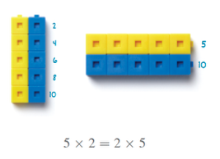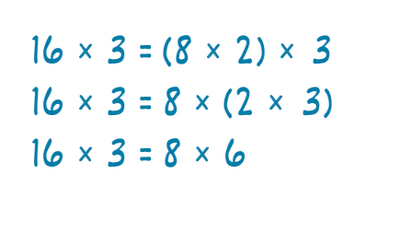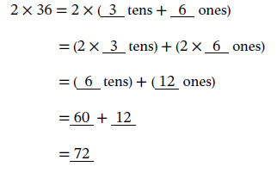
Knowledge Graph Node | Apply properties of operations as multiplication strategies. | Apply properties of operations as division strategies. | Multiply one-digit whole numbers by multiples of 10 less than 100.
Terminology
Mathematical Models | - Commutative, distributive, and associative properties  - Arrays and area models can be used to illustrate the properties  - Equations, esp with expanded form(s) | - Distributive property  - Arrays and area models can be used to illustrate the properties  - Equations | - Place value charts  - Equations and various expanded forms
Strategies | - Level 3 strategy: use the properties to convert to an easier problem (use known facts) | - Don’t be mad Danielle (per OH 6/9/2026): break apart and distribute strategy to divide (we need to call it something else. The word “distribute” as applied to division is the issue. see singapore math for ways to do this well -danielle) | - Unit form: 4 × 70 = 4 × 7 tens = 28 tens = 280  - Associative property: 4 × 70 = 4 × (7 × 10) = (4 × 7) × 10 = 28 × 10 = 280
Specifications | - Commutative property: one-digit factors and 10  - Associative property: one-digit factors  - Distributive property: one-digit factors; factors can extend into teen numbers to demonstrate usefulness of property  - FL and TX: apply the distributive property to multiply a one-digit and two-digit number; stick to teen numbers here  - Always use the full names Commutative Property of Multiplication and Associative Property of Multiplication (not just Commutative and Associative)  - Say we’re using the distributive property (of multiplication over addition) | - Break apart and distribute strategy to divide within 100 by one-digit divisors and quotients (some states to 144)  - Decompose the dividend in a way that makes each part divisible by the divisor | - One-digit factors; multiples of 10 in the range 10–90  - Problems can be presented in both orders: one-digit × multiple of 10 and multiple of 10 × one-digit; students cite commutativity when reordering
Leaves to Include
Considerations | - State and use the properties: commutative, associative, distributive. Cite them when used.  - Can use area models and arrays as support, but these are not the way we define the properties  - Always say why it’s legal (associative/commutative/distributive. Every rewrite must be justified by the properties.  - repeatedly model “because” language:  - 8 × 7 = 8 × (5+2) because 7 = 5 + 2  - 8 × (5 + 2) = 8 × 5 + 8 × 2 by the distributive property  - That “why is this legal?” habit is the thing. | - Emphasize over and over and over and over (like a monkey with a miniature cymbal) that for exact division $a÷b$ means that we’re looking for some number q that makes the equation $b×q=a$ true. (before we get to fractions, there very well could be no such number!)
Required Skills/Cases | - Commutative property of multiplication  - Associative property of multiplication; use parentheses to group factors  - Distributive property; use parentheses in equations  - Watch instructional sequence for which factors are fair game  - Need some items that are structured for a specific property and some that are open ended (do it however you want, and justify what allowed you to do it that way) | - Decomposition of the dividend is given  - Students decide how to decompose the dividend  - Include dividends where decomposing by place value units does not result in both parts being divisible by the divisor | - One-digit x multiple of 10 where the product of the ones and tens is a one-digit number (e.g., 3 x 20; 3 x 2 tens = 6 tens)  - One-digit x multiple of 10 where the product of the ones and tens is two-digit number that does not end in zero (e.g., 4 x 70; 4 x 7 tens = 28 tens)  - One-digit x multiple of 10 where the product of the ones and tens ends in zero (e.g., 4 x 50; 4 x 5 tens = 20 tens)  - Use parentheses with the associative property to show how to group the factors
Misconceptions | - Partial distribution: when decomposing a factor, students multiply one part but forget the other part (e.g., 8 × (5 + 2) = 8 × 5 + 2, dropping the second multiplication) | - Students attempt to apply the commutative property of multiplication to division (e.g., thinking that $a÷b=b÷a$) | - From EM2 G3 M3 L20: When multiplying by 10, avoid teaching tricks such as adding a zero to the product. This misconception does not support a deep understanding of place value and is not sustainable in later grades when students are multiplying decimals by 10.
Existing Product Reference, if any | EM2 G3 M1 Topic C  EM2 G3 M1 L19  EM2 G3 M3 L5, L8, L9 | EM2 G3 M1 L20  EM2 G3 M3 L6 L11 | EM2 G4 M3 L20 Learn 2 (PV chart)  EM2 G3 M3 L21 (associative property)
Grade (or Leaf) | 3 (4 for some states) | 3 (4 for some states) | 3 (4 for SC)
Notes related to Standards, Grade, or Leaf | 3.OA.B.5  FL.3.AR.1.1  TX.3.4G  AK.3.OA.5  IN.4.CA.3 (does not include distributive property)  MD.4.NOS.C.7.c  MN.3.3.6.3 (does not include distributive property) | 3.OA.B.5  FL.3.AR.1.1  TX.3.4G  AK.3.OA.5  MD.4.NOS.C.7.c | 3.NBT.A.3  FL.3.NSO.2.3  SC.4.PAFR.1.2 (1-digit x multiple of 10 (10-90) and 100 (100-900)
Notes for Intervention, Extension, or Optional Activities | Intervention: Use cubes arranged in arrays to represent the properties (if not used in core instruction)  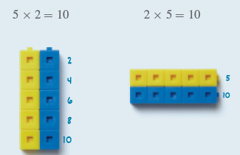  Extension: Make connections between commutative/associate properties of addition and commutative/associative properties of multiplication | Intervention: Use cubes arranged in an array to represent the distributive property  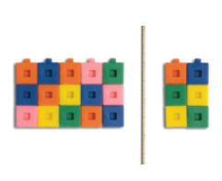  Intervention: Use number bonds to show how to decompose the dividend, if not used in core  Extension: Make connections between why subtraction and division do not have commutative/associative properties | Intervention:  - Place value disks (EM2 G3 M3 L20 Learn 1)  - Unit form (EM2 G3 M3 L20 Learn 3)  Extension:  - Times multiple of 100 (from 100-900) (for SC) (EM2 G4 M3 L2)
Additional Notes | Likely at least 1 instructional period to introduce the commutative property; additional parts of instructional periods with different factors  Likely at least 1 instructional period to introduce the associative property; additional parts of instructional periods (e.g., might be a strategy shared in an instructional routine)  Likely at least 1 instructional period to introduce the distributive property; additional parts of instructional periods with different factors | Likely 2 instructional periods | Likely 2 instructional periods

Concept/Skill: Fluently multiply and divide whole numbers.
Goal | Free working memory for algorithms
Student-Facing Example | 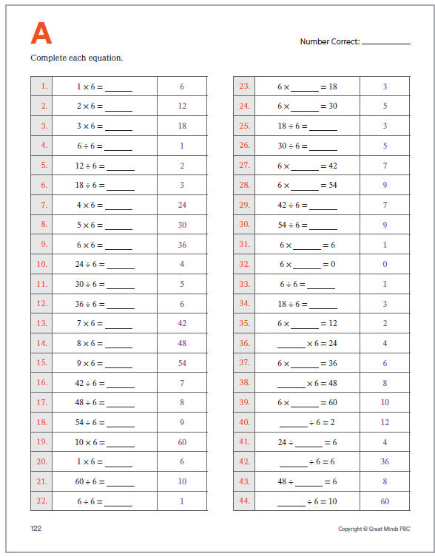
Knowledge Graph Node | Fluently multiply within 100. | Fluently divide within 100. | Fluently multiply within 144. | Fluently divide within 144. | Generate factor pairs for a whole number. | Identify prime and composite numbers. | Determine whether a whole number is a multiple of a given one-digit number.
Terminology |  |  |  |  | factor, multiple, prime, composite
Mathematical Models
Strategies |  |  |  |  | Note: The Progressions describe a systematic search strategy for finding all factor pairs, checking divisors in order (2, 3, 4, ...) until a "reversal" appears (e.g., after finding 6 × 9 for 54, the next pair 9 × 6 signals that all factor pairs have been found). Students need not be fluent in finding all factor pairs. | Classification as prime or composite follows directly from the factor pair work in the previous node  A number with exactly one factor pair (1 and itself) is prime; a number with more than one factor pair is composite | Note: The Progressions are clear that this node is primarily about applying prior knowledge of division rather than introducing new strategies; determining whether a whole number is a multiple of a given one-digit number "is a matter of interpreting prior knowledge of division in terms of the language of multiples and factors."
Specifications | - All one-digit x one-digit products  - One-digit x 10 and 10 x 10 | - Exact quotients where the dividend is any product from the multiplication facts within 100 and the divisor is a one-digit number or 10  - Sequence relative to Node 1: Node 2 is practiced alongside and integrated with Node 1, not strictly after it. Fact families are the organizing structure (e.g., 6 × 7 = 42, 7 × 6 = 42, 42 ÷ 6 = 7, 42 ÷ 7 = 6) | - Extends the range of Node 1 to include all products where both factors are at most 12 | - Extends the range of Node 2 to include all exact quotients where the dividend is any product from the multiplication facts within 144 and the divisor is a one-digit number, 100, 11, or 12  - Sequence relative to Node 3: Node 4 is practiced alongside and integrated with Node 3, not strictly after it. Fact families are the organizing structure (e.g., 12 × 5 = 60, 5 × 12 = 60, 60 ÷ 12 = 5, 60 ÷ 5 = 12) | - Whole numbers to 100  - Whole numbers to 144 (FL) | - Whole numbers to 100  - Whole numbers to 144 (FL)  - classification follows directly from factor pair results: two factors (1 and itself) → prime, more than two factors → composite  - FL includes "neither" for 0 and 1 | - Whole numbers in the range 1–100; one-digit numbers 1–9  - For SC, factors 1-10
Leaves to Include
Considerations | - Fluency means students can retrieve or quickly derive basic products and related exact quotients accurately, flexibly, and without rebuilding each fact from first principles. Use low-stakes, distributed practice organized by fact families and structure. Avoid making timed performance the main evidence of mathematical understanding.  - Doesn’t need to be a hard/high gate as students will get more practice when they do standard algorithms, but there should be some kind of a gate  - Practice design: structure by fact families  - Use brief, low-stakes retrieval routines, including Sprints where appropriate
Required Skills/Cases | - Structure by fact families:  - x2, x3, x4, x5, x10  - x6, x7, x8, x9  - x0 and x1  - Mixed facts  - Known-fact strategies (e.g., double a known x2 product to find a x4 product) [This fact strategy is grounded in the associative property. It works because 4x7= (2x2)x7=2x(2x7). Let's be careful not to call out strategies that are properties without giving them their proper reasoning. -raena (Danielle cosign)]  - Properties of operations (e.g., 5 x 7 = 35, so 7 x 5 = 35) | - Structure by fact families:  - $÷$2, $÷$3, $÷$4, $÷$5, $÷$10  - $÷$6, $÷$7, $÷$8, $÷$9  - $÷$1  - Mixed facts  - Relationship between multiplication and division (e.g., knowing 6 × 8 = 48 supports knowing 48 ÷ 6 = 8 and 48 ÷ 8 = 6)  - Division as an unknown-factor problem | - Fact families beyond Node 1:  - X11, x12  - Mixed facts across the full range  - Known-fact strategies (e.g., 10 x 8 = 80, so 11 x 8 = 80 + 8 = 88)  - Properties of operations (e.g., 5 x 12 = 60, so 12 x 5 = 60) | - Fact families beyond Node 2:  - $÷11$, $÷12$  - Mixed facts across the full range  - Relationship between multiplication and division (e.g., knowing 4 × 12 = 48 supports knowing 48 ÷ 4 = 12 and 48 ÷ 12 = 4)  - Division as an unknown-factor problem | - Given a whole number find all factor pairs  - Numbers with one factor pair  - Numbers with exactly two factor pairs (e.g., 4: 1 × 4, 2 × 2)  - Numbers with many factor pairs (e.g., 12: 1 × 12, 2 × 6, 3 × 4)  - Perfect squares (e.g., 9, 16, 25); one factor pair includes a repeated factor | - Given a whole number, determine whether it is prime or composite using factor pairs as evidence  - Special cases: 0 and 1 are neither prime nor composite; 2 is the only even prime  - Even numbers other than 2 are always composite | - Required, but less emphasized:  - List first ___ multiples of whole number  - Name a specific multiple by its ordinal position in the sequence of multiples (e.g., What is the fifth multiple of 7?)  - Whole number is a multiple of the given one-digit number (e.g., Is 72 a multiple of 8? Yes.)  - Whole number is not a multiple of the given one-digit number (e.g., Is 74 a multiple of 8? No.)  - Whole numbers within the basic facts range  Whole numbers beyond the basic facts range but within 100, requiring reasoning rather than retrieval (e.g., Is 96 a multiple of 8?)
Misconceptions |  |  | Overgeneralizing the x11 digit pattern; students who notice that 11 × 3 = 33 and 11 × 7 = 77 may try to apply the pattern incorrectly (e.g., assuming 11 × 12 follows the same pattern) |  |  | 1 is prime; instruction must make clear that 1 is neither prime nor composite, and that the definition of prime requires exactly two distinct factors | Confusing factors and multiples; students frequently reverse the two terms (e.g., saying "3 is a multiple of 12"). Instruction should consistently pair both statements together (e.g., "3 is a factor of 12, and 12 is a multiple of 3")
Existing Product Reference, if any | - EM2 G3 Sprints (e.g., M2 L15 Multiply and Divide by 5)  - G3 Fluency related to multiplication and division (e.g., EM2 M2 L2 Counting the Math Way by Fives) | - EM2 G3 Sprints (e.g., M2 L15 Multiply and Divide by 5)  - G3 Fluency related to multiplication and division (e.g., EM2 M2 L2 Counting the Math Way by Fives) |  |  | - EM2 G4 M2 L21 and L22 | - EM2 G4 M2 L21 and L25 | - EM2 G4 M2 L23 and L24
Grade (or Leaf) | 3, 4 | 3, 4 | Leaf | Leaf | 4, 5 | 4, 5 | 4 (3 for FL and SC)
Notes related to Standards, Grade, or Leaf | 3.OA.C.7  TX.3.4F  MD.4.NOS.C.7.a-d  ND.4.AR.OA.1  SD.4.OA.A.1.b  VA.3.CE.2  WI.4.OA.D.6 | 3.OA.C.7  TX.3.4F  MD.4.NOS.C.7.a-d  ND.4.AR.OA.1  SD.4.OA.A.1.b  VA.3.CE.2  WI.4.OA.D.6 | FL.4.NSO.2.1  MA.4.OA.A.3.a  MN.4.3.5.5  ND.5.AR.OA.1  OK.4.N.2.1  RI.4.OA.A.3.a  VA.4.CE.2.b | FL.4.NSO.2.1  MA.4.OA.A.3.a  MN.4.3.5.5  ND.5.AR.OA.1  OK.4.N.2.1  RI.4.OA.A.3.a  VA.4.CE.2.b | 4.OA.B.4  FL.4.AR.3.1 (to 144)  TX.5.4A  AZ.5.OA.B.4  ND.5.AR.OA.4 | 4.OA.B.4  FL.4.AR.3.1 (to 144)  TX.5.4A  AZ.5.OA.B.4  ND.5.AR.OA.4 | 4.OA.B.4  FL.3.AR.3.2  SC.3.PAFR.2.4
Notes for Intervention, Extension, or Optional Activities | Intervention: For students who lack conceptual understanding of multiplication as a foundation for fact retrieval, revisit equal-groups and array representations before continuing fluency practice.  Intervention: For students who are fluent with some fact families but not others, use diagnostic practice to identify specific gaps and target those families directly rather than cycling through all facts repeatedly. | Intervention: Prioritize fact family practice that builds division from known multiplication facts before treating division as a separate retrieval task. Use arrays or equal-groups representations to make the relationship between the two operations visible. | Intervention: For students who are fluent with some fact families but not others, use diagnostic practice to identify specific gaps and target those families directly rather than cycling through all facts repeatedly. | Intervention: Prioritize fact family practice that builds division from known multiplication facts before treating division as a separate retrieval task. Use arrays or equal-groups representations to make the relationship between the two operations visible. |  | Extension: Sieve of Eratosthenes (EM2 G4 M2 Math Past and L25) | Extension: Pose questions that combine multiples reasoning across two one-digit numbers (e.g., "Find a number between 50 and 100 that is a multiple of both 6 and 8").
Additional Notes | - Fluency is not taught in a fixed number of instructional periods; it should be practiced and maintained throughout the school year. | - Fluency is not taught in a fixed number of instructional periods; it should be practiced and maintained throughout the school year. | - Fluency is not taught in a fixed number of instructional periods; it should be practiced and maintained throughout the school year. | - Fluency is not taught in a fixed number of instructional periods; it should be practiced and maintained throughout the school year. | Likely 1-2 instructional periods | Likely part of an instructional period | Likely 1 instructional period

Knowledge Graph Node | Express a composite number as the product of its prime factors.
Terminology | Prime number, composite number
Mathematical Models | Equations
Strategies | G5 approach: decomposition via known factor pairs. For example, to express 24 as a product of its prime factors, a student first lists all factor pairs of 24 (1 × 24, 2 × 12, 3 × 8, 4 × 6), then uses that list to identify that 24 = 2 × 2 × 2 × 3.
Specifications | - Whole numbers in the range 2–50 (CA)  - Products are expressed using multiplication equations (e.g., 24 = 2 × 2 × 2 × 3) (No exponential form)  - Recognize that the prime factorization of a number is unique regardless of which factor pair is used as the starting point (e.g., starting with 2 × 12 or 4 × 6 for 24 yields the same result: 2 × 2 × 2 × 3)
Leaves to Include
Considerations
Required Skills/Cases | - Given a composite number express it as a product of its prime factors using multiplication (e.g., 24 = 2 × 2 × 2 × 3)  - Composite numbers with exactly two prime factors, not necessarily distinct (e.g., 6 = 2 × 3; 9 = 3 × 3)  - Composite numbers with three or more prime factors (e.g., 12 = 2 × 2 × 3; 30 = 2 × 3 × 5)  - Powers of a single prime (e.g., 8 = 2 × 2 × 2; 25 = 5 × 5)
Misconceptions | Treating the prime factorization as a multiplication equation that incorporates all factor pair (e.g., writing 24 = 1 × 24 × 2 × 12 × 3 × 8 × 4 × 6 × 2 × 2 × 2 × 3),
Existing Product Reference, if any | - EM2 CA G5 M1 L21
Grade (or Leaf) | Leaf
Notes related to Standards, Grade, or Leaf | CA.5.OA.2.1  AZ.5.OA.B.4
Notes for Intervention, Extension, or Optional Activities | Intervention: use side-by-side examples that make the boundary between listing factor pairs and prime factorization visible; the factor pair list is the tool, the prime factorization is the product of using that tool.  Extension: work with larger numbers beyond 50  Extension: Have students compare the prime factorizations of two numbers and use them to identify shared prime factors (e.g., 24 = 2 × 2 × 2 × 3 and 36 = 2 × 2 × 3 × 3 share factors of 2 × 2 × 3).
Additional Notes | Likely 1 instructional period

Concept/Skill: Interpret a whole-number multiplication equation as a comparison.
Goal | Relate quantities using multiplicative comparisons
Student-Facing Example | 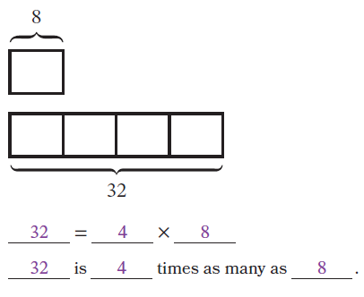
Knowledge Graph Node | Describe a relationship between quantities by using a multiplicative comparison. | Solve problems involving multiplicative comparisons.
Terminology
Mathematical Models | - Tape diagrams  - Number line  - Language (depends on context): times as much, times as many, times as long, etc.  - Modeling/word problems | - Tape diagrams  - Number line  - Language (depends on context): times as much, times as many, times as long, etc.  - Modeling/word problems
Strategies
Specifications | - Begin by writing the multiplication equation with the total first, followed by the equal sign and the multiplicative comparison expression where the first factor indicates how many of the second factor is represented in the relationship to allow students to see the connection between the times as many language and the multiplication equation. Then move to flexibility.  - EM2 does not use number lines to model multiplicative comparison, so will need to incorporate that model  - Emphasis for this node is about representation, not solving for unknowns  - Use varied contexts so students learn to use context-appropriate comparison language | - Unknown in all three positions  - Relate to unknown factor problems  - Mathematical problems (e.g., __ is 5 times as many as 8)  - Word problems (mostly one-step)  - Students use tape diagrams to represent the comparison relationship and identify the unknown before writing and solving an equation.  - Compare and contrast additive relationships and multiplicative relationships by examining rules for patterns  - Not expecting students to say “this is a multiplicative comparison situation”, expecting students to write a multiplicative comparison statement and/or equation and explain why multiplication represents the situation instead of addition
Leaves to Include
Considerations | - Relate to previous understanding of comparing quantities through additive comparison  - Use a variety of contexts, including relationship between place value units  - Lays the foundation for multiplication as scaling  - Find unknown quantities in multiplicative comparison contexts by using multiplication or division  - Do not let this row redefine multiplication. It is a relationship type: “A is $n$times as many as B” means $A=n×B$. (Maybe worth noting: "Times as many" is the preferred language over "as many times more" as the second is ambiguous. Does it mean multiply or multiply and add? This was the standard language in EM2. -raena)
Required Skills/Cases | - Create a multiplicative comparison statement given a multiplication equation  - Given a multiplicative equation, write two multiplicative comparison statements by applying the commutative property of multiplication  - Write multiplicative comparison statements as multiplication equations.  - Given a tape diagram or number line representing a multiplicative comparison relationship, write a multiplicative comparison statement  - Given a tape diagram or number line representing a multiplicative comparison relationship, write a multiplication equation  - Given a multiplicative comparison statement, draw a tape diagram or number line to represent the statement  - No context  - Measurement and money contexts (and corresponding language)  - Other contexts | - Number range will depend on placement in instructional sequence  - Given a multiplicative comparison statement with 2 knowns, find the unknown (factor or product)  - Solve a multiplicative comparison word problem  - No context  - Measurement and money contexts (and corresponding language)  - Other contexts  - Given a context, determine if the relationship is additive or multiplicative and be able to explain their thinking
Misconceptions | (Misconception in Math Catalyst isn’t great as a misconception, listed below as an intervention approach)
Existing Product Reference, if any | EM2 G4 M1 L1–L4  Math Catalyst: Multiplication — Multiplication as Multiplicative Comparison, Concept Mini Lessons 1–4 | EM2 G4 M1 L1–L4  EM2 G4 M2 L20
Grade (or Leaf) | 4 (TX G3) | 4
Notes related to Standards, Grade, or Leaf | 4.OA.A.1  TX.3.5C | 4.OA.A.2  Related to TX.3.5B and TX.3.5C
Notes for Intervention, Extension, or Optional Activities | Intervention  - See Math Catalyst: Multiplication — Multiplication as Multiplicative Comparison, Addressing Student Misconceptions, and relate to a copies of b (definition of multiplication)  Extension  - Math Catalyst: Multiplication — Multiplication as Multiplicative Comparison, Play a Game | Extension  - Math Catalyst: Multiplication — Multiplication as Multiplicative Comparison, Solve a Problem and Solve a Task
Additional Notes | Likely 2–3 instructional periods  Needed prior to G4 place value relationships lessons | Likely part of other instructional periods, could be 1–2 instructional periods (especially due to context-specific comparison language and/or distinguishing between additive and multiplicative contexts)  Will likely come very early in year (as place value prerequisite), reinforce later in year by connecting to practice with multiplication of larger factors

Concept/Skill: Develop the standard algorithm for multiplying multi-digit numbers.
Goal | Use the distributive property and base-ten decompositions to understand and use the standard algorithm for multiplication.
Student-Facing Example | 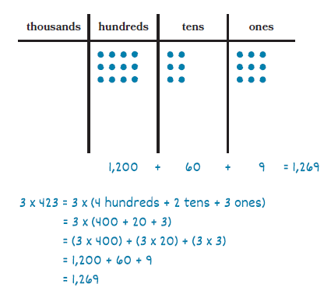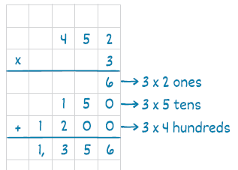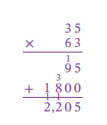  Use $\left(30+4)(20+6\right)$to find $34×26$. Connect each partial product to the standard algorithm. [oh look, distributive property! -ds]
Knowledge Graph Node | Multiply a multi-digit whole number by a single-digit whole number by using strategies based on place value concepts and the properties of operations. | Multiply a multi-digit whole number by a single-digit whole number and record the partial products in vertical form. | Multiply a multi-digit whole number by a two-digit whole number by using strategies based on place value concepts and the properties of operations. | Multiply two multi-digit whole numbers and record in vertical form. | Multiply two multi-digit whole numbers by using the standard algorithm.
Terminology
Mathematical Models | - Place value charts  - Area model  - Distributive property  - Partial products  - Equations and various expanded forms | - Distributive property  - Partial products  - Equations and various expanded forms | - Area model  - Distributive property  - Partial products  - Equations and various expanded forms | - Area model  - Distributive property  - Partial products  - Equations and various expanded forms | - Distributive property
Strategies
Specifications | - Connect area model to distributive property, start with unit form and standard form in equations, then drop the unit form  - Do distributive property without a visual model  - Say we’re using the distributive property (don’t need “break apart and distribute” strategy terminology like EM2)  - Number of “regroupings” is a complexity, but by focusing on the distributive property, that complexity is minimized  - Develop habit of estimation to check reasonableness | - Connect area model and distributive property to vertical form with partial products on their own lines, then with partial production recorded on one line (this is really the standard algorithm, we just don’t call it that yet) (drop area model after connections are made)  - Consider number of regroupings in the multiplication and number of regroupings in the addition of the partial products when thinking about scaffolding complexities  - Develop habit of estimation to check reasonableness | - Start with 10x10, 10x20, 10x30, 20x30, and other multiple of 10 x multiple of 10 like in EM2 G4 M3 L3 Learn 1  - Then 2-digit x 2-digit multiple of 10  - Then 2-digit x 2-digit, 3-digit x 2-digit, etc. (see cases)  - For multiples of 10, use associative property and area model (don’t use place value chart as model)  - Connect area model to distributive property and to each partial product, start with unit form and standard form in equations, then drop the unit form  - Be conscious of placement of factors on sides of area model as compared to order of factors in horizontal and vertical forms, but don’t be rigid (commutative property and efficiency)  - Do distributive property without a visual model  - Number of “regroupings” is a complexity, but by focusing on the distributive property, that complexity is minimized  - Develop habit of estimation to check reasonableness | - Include due to commutative property, we can write either factor first in the algorithm recording in G4, let’s think about preferences and efficiency (EM2 waited until G5, see G5 M1 L9 Learn 2, toward the end)  - Connect area model and distributive property to vertical form with each partial product on their own lines (then drop area model)  - Consider number of regroupings in the multiplication and number of regroupings in the addition of the partial products when thinking about scaffolding complexities  - Develop habit of estimation to check reasonableness  - In G5, this is a light touch, get to the standard algorithm node quickly | - Connect distributive property to SA  - Develop habit of estimation to check reasonableness  - This is a fluency standard for G5
Leaves to Include
Considerations | - Check for reasonableness by using estimation  - The area model can be used to support organizing work but isn’t the definition of multiplication. Area model should always connect to the distributive property.  - NOTE: This row will span over more than one grade level  The area model is a diagram of the distributive property. Students should be able to connect each region to a partial product and each partial product to a line or digit in the written algorithm.
Required Skills/Cases | - Two-digit x one-digit  - Three-digit x one-digit  - Four-digit x one-digit  - Don’t specifically assess place value chart or area models (practice problems ok, but not formal assessment) | - Two-digit x one-digit  - Three-digit x one-digit  - Four-digit x one-digit  - Various numbers of regroupings (in the multiplication and in the addition of partial products) | - Two-digit multiple of 10 x two-digit multiple of 10 (G4)  - Three-digit multiple of 10 x two-digit multiple of 10 (G5)  - Two-digit x two-digit multiple of 10 (G4)  - Three-digit x two-digit multiple of 10 (G5)  - 2-digit x 2-digit (G4)  - 3-digit x 2-digit (G5 and FL G4) | - 2-digit x 2-digit (G4)  - 3-digit x 2-digit (G5 and FL G4)  - 4-digit x 2-digit (G5)  - 5-digit x 2-digit (G5)  - 3-digit x 3-digit (G5)  - 4-digit x 3-digit (G5)  - 5-digit x 3-digit (G5)  - (Beyond 5 by 3 is just mean) | - 2-digit x 2-digit (TX G4)  - 3-digit x 2-digit (G5 and FL G4)  - 4-digit x 2-digit (G5)  - 5-digit x 2-digit (G5)  - 3-digit x 3-digit (G5)  - 4-digit x 3-digit (G5)  - 5-digit x 3-digit (G5)  - Various numbers of regroupings  - (Beyond 5 by 3 is just mean)
Misconceptions | - Not applying place value to digits (Math Catalyst: Multiplication — Multiplication of Two-Digit Numbers by One-Digit Number) | - Not applying place value to digits (Math Catalyst: Multiplication — Multiplication of Two-Digit Numbers by One-Digit Numbers)  - Recording all partial product digits in the product instead of regrouping (Math Catalyst: Multiplication of Multi-Digit Numbers by One-Digit Numbers) | - Not applying place value to digits (Math Catalyst: Multiplication — Multiplication of Two-Digit Numbers by One-Digit Numbers)  - Applying distributive property incorrectly (Math Catalyst: Multiplication, Multiplication of Two-Digit Numbers by Two Digit Numbers) | - Not applying place value to digits (Math Catalyst: Multiplication — Multiplication of Two-Digit Numbers by One-Digit Numbers) | - Not applying place value to digits (Math Catalyst: Multiplication — Multiplication of Two-Digit Numbers by One-Digit Numbers)  - Do not record partial products with the correct units (Math Catalyst: Multiplication — Multiplication of Multi-Digit Numbers by Multi-Digit Numbers)
Existing Product Reference, if any | - EM2 G4 M2 L7-L8 (2-digit x 1-digit)  - EM2 G4 M3 L9-L10  - Math Catalyst: Multiplication — Multiplication of Multi-Digit Numbers by One-Digit Numbers, Concept Mini Lesson 1 | - EM2 G4 M3 L11-L12 but need more explicit connection to distributive property  - Math Catalyst: Multiplication — Multiplication of Two-Digit Numbers by One-Digit Numbers, Concept Mini Lessons 3 and 4  - Math Catalyst: Multiplication — Multiplication of Multi-Digit Numbers by One-Digit Numbers, Concept Mini Lessons 2 and 3 | - EM2 G4 M3 L3, L13-L14 Learn 1  - EM2 G5 M1 L8  - Math Catalyst: Multiplication — Multiplication of Two-Digit Numbers by Two-Digit Numbers, Concept Mini Lessons 1 and 2  - Math Catalyst: Multiplication — Multiplication of Multi-Digit Numbers by Multi-Digit Numbers, Concept Mini Lesson 1 | - EM2 G4 M3 L14 Learn 2 and 3, L15-L17  - EM2 G5 M1 L8  - Math Catalyst: Multiplication — Multiplication of Two-Digit Numbers by Two-Digit Numbers, Concept Mini Lesson 3  - Math Catalyst: Multiplication — Multiplication of Multi-Digit Numbers by Multi-Digit Numbers, Concept Mini Lesson 2 | - EM2 G4 M3 L16 a little bit  - EM2 G5 M1 L9–L11  - Math Catalyst: Multiplication — Multiplication of Two-Digit Numbers by Two-Digit Numbers, Concept Mini Lesson 4  - Math Catalyst: Multiplication — Multiplication of Multi-Digit Numbers by Multi-Digit Numbers, Concept Mini Lessons 3–4
Grade (or Leaf) | 4 | 4 | 4, 5 | 4, 5 | 5
Notes related to Standards, Grade, or Leaf | - 4.NBT.B.5 (up to 4 digits x 1 digit, 2-digit x 2-digit)  - FL.4.NSO.2.2 (up to 3-digit x up to 2-digit, reliability)  - TX.4.4D up to 4-digit x 1-digit, 2-digit x 2-digit  - OK.4.N.2.3 (estimate 3-digit x 1-digit, 2-digit x 2-digit) | - 4.NBT.B.5 (up to 4 digits x 1 digit, 2-digit x 2-digit)  - FL.4.NSO.2.2 (up to 3-digit x up to 2-digit, reliability)  - FL.4.NSO.2.5 explore multi-digit using estimation  - TX.4.4D up to 4-digit x 1-digit, 2-digit x 2-digit  - OK.4.N.2.3 (estimate 3-digit x 1-digit, 2-digit x 2-digit) | - 4.NBT.B.5 (up to 4 digits x 1 digit, 2-digit x 2-digit)  - FL.4.NSO.2.2 (up to 3-digit x up to 2-digit, reliability)  - FL.4.NSO.2.3 (2-digit x 2-digit, fluency)  - FL.5.NSO.2.1 multi-digit SA, fluency  - TX.4.4C (2-digit x 2-digit)  - TX.4.4D up to 4-digit x 1-digit, 2-digit x 2-digit  - OK.4.N.2.3 (estimate 3-digit x 1-digit, 2-digit x 2-digit)  - MD.4.NOS.B.4 (multi-digit x multiple of 10) | - 4.NBT.B.5 (up to 4 digits x 1 digit, 2-digit x 2-digit)  - 5.NBT.B.5 (fluently multi-digit SA)  - FL.4.NSO.2.2 (up to 3-digit x up to 2-digit, reliability)  - FL.4.NSO.2.3 (2-digit x 2-digit, fluency)  - FL.5.NSO.2.1 multi-digit SA, fluency  - TX.4.4C (2-digit x 2-digit)  - TX.4.4D up to 4-digit x 1-digit, 2-digit x 2-digit  - TX.5.3B 3-digit x 2-digit, fluency, SA  - OK.4.N.2.3 (estimate 3-digit x 1-digit, 2-digit x 2-digit) | - 4.NBT.B.5 (up to 4 digits x 1 digit, 2-digit x 2-digit)  - 5.NBT.B.5 (fluently multi-digit SA)  - FL.4.NSO.2.2 (up to 3-digit x up to 2-digit, reliability)  - FL.4.NSO.2.3 (2-digit x 2-digit, fluency)  - FL.5.NSO.2.1 multi-digit SA, fluency  - TX.4.4C (2-digit x 2-digit)  - TX.4.4D up to 4-digit x 1-digit, 2-digit x 2-digit  - TX.5.3B 3-digit x 2-digit, fluency, SA  - OK.4.N.2.3 (estimate 3-digit x 1-digit, 2-digit x 2-digit)
Notes for Intervention, Extension, or Optional Activities | Intervention  - Place value disks (Math Catalyst TEXAS: Multiplication — Multiplication of Two-Digit Numbers by One-Digit Numbers, Concept Mini Lesson 1)  - Place value charts EM2 G4 M2 L5-L6, Math Catalyst: Multiplication — Multiplication of Two-Digit Numbers by One-Digit Numbers), Concept Mini Lesson 2  - Multiply by multiples of 100 and 1000 (G4 M3 L2)  - Vertical form for two-digit x one-digit (EM2 G4 M3 L12 Learn 2, second half)  Optional/Extension  - Two-digit x one-digit with simplifying strategies (EM2 G4 M2 L10)  - Math Catalyst: Multiplication — Multiplication of Two-Digit Numbers by One-Digit Numbers: Application: Solve a Problem, Play a Game, Solve a Task  - Math Catalyst: Multiplication — Multiplication of Multi-Digit Numbers by One-Digit Numbers, Application (Solve a Problem and Solve a Task include 4-digit factors, Play a Game is just 3-digit factors) | Extension  - Could do more digits, just for fun  - Math Catalyst: Multiplication — Multiplication of Two-Digit Numbers by One-Digit Numbers, Application: Solve a Problem, Play a Game, Study a Solution  - Math Catalyst: Multiplication — Multiplication of Multi-Digit Numbers by One-Digit Numbers, Application (Solve a Problem and Solve a Task include 4-digit factors, Play a Game is just 3-digit factors) | Intervention  - Place value chart for multiplying 2-digit x 2-digit multiple of 10 (EM2 G4 M3 L13)  Extension  - Ethiopian Multiplication (EM2 G5 M1 Math Past and L10)  - Math Catalyst: Multiplication — Multiplication of Two-Digit Numbers by Two-Digit Numbers, Application  - Math Catalyst: Multiplication — Multiplication of Multi-Digit Numbers by Multi-Digit Numbers, Application | Intervention  - If not included in core lessons, use color coding in the area model to relate to partial products  Extension  - Could do more digits, just for fun  - Math Catalyst: Multiplication — Multiplication of Two-Digit Numbers by Two-Digit Numbers, Application  - Math Catalyst: Multiplication — Multiplication of Multi-Digit Numbers by Multi-Digit Numbers, Application | Intervention  - Connect to area model, if needed (hopefully the previous node is sufficient on that)  Extension  - Could do more digits, just for fun  - Math Catalyst: Multiplication — Multiplication of Two-Digit Numbers by Two-Digit Numbers, Application  - Math Catalyst: Multiplication — Multiplication of Multi-Digit Numbers by Multi-Digit Numbers, Application
Additional Notes | Likely 4 instructional periods (2-digit area model, 2-digit distributive property only, 3-digit and 4-digit area model, 3-digit and 4-digit distributive property only)  This will need continued practice | Likely 3 instructional periods, including 1 for partial products all on one line  This will need continued practice | G4: Likely 2 instructional periods (at least one factor is multiple of 10, any two-digit factors)  G5: Likely 2 instructional periods (at least one factor is multiple of 10, any three-digit x two-digit factors) | G4: Likely 1–2 instructional periods  Will need continued practice  G5: Likely 1 instructional period | Likely 2 instructional periods (multi-digit x 2-digits, multi-digit x 3-digits)  This will need continued practice (this is a fluency standard for G5)

Concept/Skill: Divide multi-digit whole numbers by single-digit whole numbers in problems with whole-number quotients.
Goal | Apply place value understanding to divide with larger numbers (exact division)
Student-Facing Example | 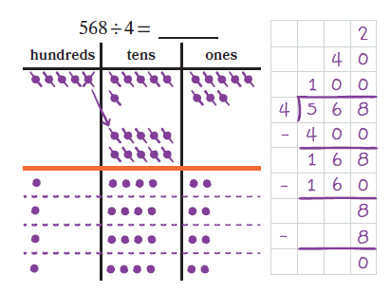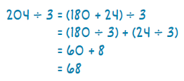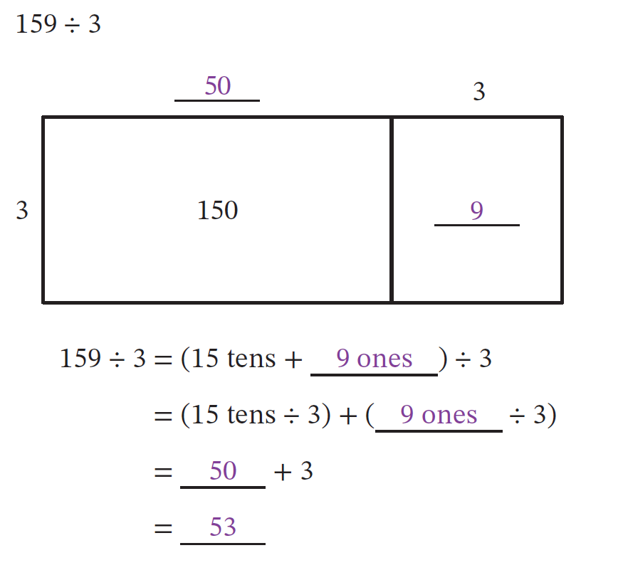
Knowledge Graph Node | Divide multi-digit whole numbers by single-digit whole numbers in problems with whole-number quotients by using strategies based on place value concepts and the properties of operations. | Divide multi-digit whole numbers by single-digit whole numbers by recording partial quotients in vertical form for problems with whole-number quotients.
Terminology | Dividend, divisor, partial quotient
Mathematical Models | - Equations  - Place value chart (intervention)  - Area model | - Equations  - Area Model (as a scaffold)
Strategies | - Partial quotients | - Partial quotients  - Vertical form
Specifications | - Initially pair break apart and distribute strategy with the area model, then drop the visual model, start with unit form and standard form in equations, then drop the unit form  - Develop habit of estimation to check reasonableness and to think about how to break apart  - No remainders!!! | - Vertical form with partial quotients, initially pair vertical form with area model, then drop the visual model  - Connect break apart and distribute to vertical form  - Develop habit of estimation to check reasonableness and to think about how to break apart  - No remainders!!!  - A later row in the stem doc says “Don’t call it looooooong division because looooong division takes too looooong. Also, we use the terminology of standard algorithm for the other operations.”—just call it vertical form until we use the standard algorithm terminology
Leaves to Include
Considerations | - Decompose the dividend to divide  - Use equations and vertical form alongside pictorial representations  - Emphasize over and over and over and over (like a monkey with a miniature cymbal) that for exact division $a÷b$ means that we’re looking for some number q that makes the equation $b×q=a$ true. (before we get to fractions, there very well could be no such number!) | - Use equations and vertical form alongside pictorial representations
Required Skills/Cases | - Two-digit and three-digit multiple of 10 ÷ one-digit (rename three-digit dividend in unit form as some tens)  - Two-digit ÷ one-digit, each digit divisible by divisor (break apart by place value)  - Two-digit ÷ one-digit, tens digit of dividend not divisible by divisor (can’t break apart by place value or must decompose into 10 of smaller place value)  - Three-digit ÷ one-digit, each digit divisible by divisor (break apart by place value)  - Three-digit ÷ one-digit, at least one digit is not divisible by divisor (can’t break apart by place value or must decompose into 10 of smaller place value)  - Four-digit multiple of 100 or 1,000 ÷ one-digit (rename dividend in unit form as some hundreds or thousands)  - Four-digit ÷ one-digit, each digit divisible by divisor (break apart by place value)  - Four-digit ÷ one-digit, at least one digit is not divisible by divisor (can’t break apart by place value or must decompose into 10 of smaller place value)  - Include zeros in various places in dividend | - Two-digit ÷ one-digit, each digit divisible by divisor  - Two-digit ÷ one-digit, tens digit of dividend not divisible by divisor  - Three-digit ÷ one-digit, each digit divisible by divisor  - Three-digit ÷ one-digit, at least one digit is not divisible by divisor  - Four-digit ÷ one-digit, each digit divisible by divisor  - Four-digit ÷ one-digit, at least one digit is not divisible by divisor  - Include zeros in various places in dividend
Misconceptions | Always breaking apart the dividend by place value even when the parts aren't divisible by the divisor (e.g., for 96 $÷$ 4, breaking apart into 90 and 6 and getting stuck because 90 isn't divisible by 4, rather than breaking apart 96 into 80 and 16). | Maybe not a misconception, but at least a common error: Losing track of place value, especially with 0s in the dividend (903 ÷ 3 = 31 because 9 ÷ 3 = 3 and 3 ÷ 3 = 1).
Existing Product Reference, if any | EM2 G4 M2 L2  EM2 G4 M2 L12–L13  EM2 G4 M3 L1, L4-L5  Math Catalyst: Division — Divide Multi-Digit Numbers by One-Digit Numbers, Concept Mini Lesson 3 | EM2 G4 M3 L5-L8
Grade (or Leaf) | 4 | 4
Notes related to Standards, Grade, or Leaf | 4.NBT.B.6  FL.4.NSO.2.4 (up to 4 by 1, procedural reliability, remainder as fraction)  TX 4.4E (up to 4 by 1, using arrays, area models, equations)  OK.5.N.2.2 (no related G4 standard, all in G5 in OK) | 4.NBT.B.6  FL.4.NSO.2.4 (up to 4 by 1, procedural reliability, remainder as fraction)  TX 4.4F (use strategies and algorithms)  OK.5.N.2.2 (no related G4 standard, all in G5 in OK)
Notes for Intervention, Extension, or Optional Activities | Intervention  - Place value disks (EM2 G4 M2 L2, L14, M3 L1, Math Catalyst: Division — Divide Multi-Digit Numbers by One-Digit Numbers, Concept Mini Lesson 1)  - Place value chart (EM2 G4 M2 L14–L16, Math Catalyst: Division — Divide Multi-Digit Numbers by One-Digit Numbers, Concept Mini Lesson 2)  - Number bonds to model break apart (EM2 G4 M2 L12–L13)  Extension  - Math Catalyst: Division — Divide Multi-Digit Numbers by One-Digit Numbers, Application | Intervention  - Place value drawings (EM2 G4 M3 L6)  Extension  - EM2 G4 M3 Math Past (would need to add something to do with it)  - Math Catalyst: Division — Divide Multi-Digit Numbers by One-Digit Numbers, Application
Additional Notes | Likely 2 instructional periods  This will need continued practice | Likely 2 instructional periods  This will need continued practice

Concept/Skill: Find whole-number quotients and remainders with multi-digit dividends and one-digit divisors.
Goal | Understand division with remainder as a separate concept from exact division.
Student-Facing Example | 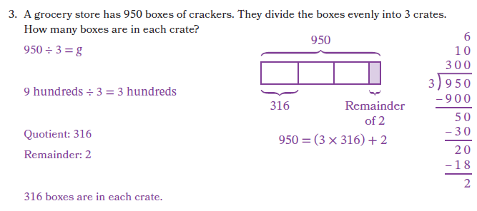
Knowledge Graph Node | Find whole-number quotients and remainders with multi-digit dividends and one-digit divisors by using strategies based on place value concepts and the properties of operations. | Find whole-number quotients and remainders with multi-digit dividends and one-digit divisors by recording the partial quotients in vertical form. | Interpret remainders in context.
Terminology
Mathematical Models | Division with remainder theorem. For whole numbers $a$ and $b$, with $b>0$, there exist unique whole numbers $q$and $r$ such that $a=bq+r \text{and} 0≤r<b.$The numbers $q$and $r$ are called the quotient and remainder.  - Place value chart (intervention)  - Arrays (early and with smaller numbers) and area model  - equations | - Area Model (as a scaffold) | Can use contexts to interpret $r$ in division with remainder theorem
Strategies | - Partial quotients | - Vertical form  - Partial quotients
Specifications | - Connect to division as unknown factor  - Start with arrays and transition to area model  - Be explicit that remainder must be less than divisor and why  - Develop habit of estimation to check reasonableness and to think about how to break apart  - Connect exact division to division with remainder by presenting examples where r = 0 alongside examples where r > 0, making explicit that exact division is a special case of DWR.  - Record quotient and remainder as Quotient: __ Remainder: __ (maybe eventually abbreviate Q: __ R: __) | - Vertical form with partial quotients, initially pair vertical form with area model, then drop the visual model  - Develop habit of estimation to check reasonableness and to think about how to break apart  - Record quotient and remainder as Quotient: __ Remainder: __ (maybe eventually abbreviate Q: __ R: __) | - While this node depends on context/word problems, the emphasis is not about knowing what to divide by what and how to do the division to get the correct quotient and remainder; the emphasis is understanding what the remainder means within the context and how it impacts the answer to the question in the word problem
Leaves to Include
Considerations | - Separate talk and tasks for division (exact) and division with remainder  - In whole-number arithmetic, when exact division is not possible, division with remainder records the quotient and leftover. Later, fractions and decimals allow the same situation to be represented by single number, while the DWR structure still underlies the long-division algorithm and decimal expansions.  - This strategy is connected to the standard algorithm for division.  - Notation hygiene: Avoid writing $27÷6=4\text{ R }3$. This is not an equation between numbers. Write $27=6×4+3$, or say, “When 27 is divided by 6, the quotient is 4 and the remainder is 3.”  Note: when $a$ is a multiple of $b$ (exact) division is a special case of DWR … (exact) division is identical to DWR in this situation, it’s just that r=0. Surfacing this in our materials would be valuable if possible  Possible motivation: if we’ve done this correctly up until this point, kids should be BEGGING to know what to do when there is no such number q that satisfies $b×q=a$. This row is where we (partially) solve that mystery. The complete solution requires fractions
Required Skills/Cases | - Two-digit ÷ one-digit  - Three-digit ÷ one-digit  - Four-digit ÷ one-digit  - Remainder expressed as whole number (not fraction)  - Include problems where r = 0  - Include zeros in various places in dividend | - Two-digit ÷ one-digit  - Three-digit ÷ one-digit  - Four-digit ÷ one-digit  - Remainder expressed as whole number (not fraction)  - Include problems where r = 0  - Include zeros in various places in dividend | - Answer to problem requires leaving the remainder as a whole number remainder (i.e., 24 ÷ 5, there are 4 extra chairs)  - Answer to problem requires ignoring remainder (i.e., 19 ÷ 6, we can make 3 necklaces)  - Answer to problem requires adding 1 to quotient (i.e., 38 ÷ 6, we need 7 tables)  - Remainder expressed as fraction is most reasonable for context (G5)  - Include contexts where the unknown is the number of groups and where the unknown is the size of the group
Misconceptions | - Remainders aren’t possible; getting a remainder means you did something wrong; all division is exact division  - $27÷6=4\text{ R }3$ (see EM2 G4 M3 L21 Learn 1 Teacher Note, EM2 G5 M1 L14 Launch) | - The remainder can be more than the divisor | - Just ignore the remainder  - Overgeneralizing one interpretation (e.g., always rounding the quotient up, always recording the remainder as the answer)
Existing Product Reference, if any | EM2 G4 M3 L21 | EM2 G4 M3 L22–L23 | EM2 G4 M3 L21–L23
Grade (or Leaf) | 4 (5 for OK) | 4 (5 for OK) | 4, 5 (5 only for OK)
Notes related to Standards, Grade, or Leaf | - 4.NBT.B.6  - FL.4.NSO.2.4 (up to 4 by 1, procedural reliability, remainder as fraction)  - TX 4.4E (up to 4 by 1, using arrays, area models, equations)  - OK.5.N.2.2 (no related G4 standard, all in G5 in OK) | - 4.NBT.B.6  - FL.4.NSO.2.4 (up to 4 by 1, procedural reliability, remainder as fraction)  - TX 4.4F (use strategies and algorithms)  - OK.5.N.2.2 (no related G4 standard, all in G5 in OK) | - 4.OA.A.3  - FL.4.AR.1.1 (WP, interpret remainder in context)  - TX.4.4H (WP, include interpreting remainders)  - MN.5.3.5.3  - OK.5.N.2.3
Notes for Intervention, Extension, or Optional Activities | Intervention  - Physical items for building arrays  - Place value charts  - Math Catalyst: Division — Divide Multi-Digit Numbers by One-Digit Numbers with Remainders, Concept Mini Lessons 1-3  Extension  - Math Catalyst: Division — Divide Multi-Digit Numbers by One-Digit Numbers with Remainders, Application | Extension  - Math Catalyst: Division — Divide Multi-Digit Numbers by One-Digit Numbers with Remainders, Application | Intervention  - Give the students the quotient and remainder, ask them to match a context (remove computation entirely)  Extension  - Give students an interpretation (e.g., the remainder is the answer) and have them write word problems for that interpretation
Additional Notes | Likely 1 instructional period  This will need continued practice | Likely 1 instructional period  This will need continued practice | G4: Likely part of other instructional periods  G5: Likely part of other instructional periods

Concept/Skill: Find whole-number quotients and remainders with multi-digit dividends and multi-digit divisors.
Goal | Use division with remainder repeatedly to divide multi-digit numbers
Student-Facing Example | 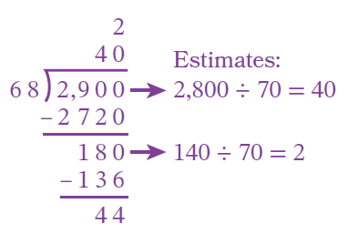
Knowledge Graph Node | Find whole-number quotients and remainders with multi-digit dividends and two-digit divisors by using strategies based on place value concepts and the properties of operations. | Find whole-number quotients and remainders with multi-digit dividends and two-digit divisors by recording the partial quotients in vertical form. | Express the result of division with remainder as a mixed number. | Find mixed-number quotients and remainders with multi-digit dividends and divisors by using the standard algorithm.
Terminology
Mathematical Models | - Area model | - Area model | Area model | Area model
Strategies | - Vertical form  - Partial quotients | - Vertical form  - Partial quotients | - Vertical form  - Partial quotients | - Vertical form  - Partial quotients  - Division with remainder is the recording strategy for the standard algorithm for division
Specifications | - Develop habit of estimation to guide efficiency at each step and check reasonableness  - Use multiplication + remainder to check and connect to division with remainder theorem  - Write quotient and remainder (not mixed number)  - Encourage efficient partial quotients, but don’t require most efficient | - Vertical form with partial quotients, initially pair vertical form with area model, then drop the visual model  - Develop habit of estimation to guide efficiency at each step and check reasonableness  - Use multiplication + remainder to check and connect to division with remainder theorem  - Write quotient and remainder (not mixed number)  - Encourage efficient partial quotients, but don’t require most efficient | - Connect to fractions as division (in Fractions ladder) and to interpreting remainder in context  - Introduce with 1-digit ÷ 1-digit, then 2-digit ÷ 1-digit, both grounded in context, for sense-making  - Focus in this node is renaming the remainder, not on the division itself  - Rename fraction with larger unit not necessary, but can be helpful to interpret in context  - Record the final quotient below the vertical form  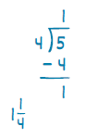 | - Connect to partial quotients  - Develop habit of estimation to guide efficiency at each step and check reasonableness  - Use multiplication + remainder to check and connect to division with remainder theorem  - Write quotients as mixed numbers, not Q _ R _  - This is a fluency standard for G6
Leaves to Include
Considerations | - Don’t call it looooooong division because looooong division takes too looooong. Also, we use the terminology of standard algorithm for the other operations.  - Partial quotients is also a viable strategy. It also uses division with remainder as bookkeeping strategy. Can do this before standard algorithm and connect to place value.  - Use estimation to help with division and check reasonableness  Note: when $a$ is a multiple of $b$ (exact) division is a special case of DWR … (exact) division is identical to DWR in this situation, it’s just that r=0. Surfacing this in our materials would be valuable if possible  - Notation hygiene: Avoid writing $27÷6=4\text{ R }3$. This is not an equation between numbers. Write $27=6×4+3$, or say, “When 27 is divided by 6, the quotient is 4 and the remainder is 3.”
Required Skills/Cases | - Three-digit ÷ two-digit multiple of 10  - Two-digit ÷ two-digit, with and without remainders  - Three-digit ÷ two-digit with one-digit quotient, with and without remainders  - Three-digit ÷ two-digit with two-digit quotient, with and without remainders  - Four-digit ÷ two-digit, with and without remainders  - Include zeroes in various places in the dividend  - Include problems where r = 0 | - Two-digit ÷ two-digit, with and without remainders  - Three-digit ÷ two-digit with one-digit quotient, with and without remainders  - Three-digit ÷ two-digit with two-digit quotient, with and without remainders  - Four-digit ÷ two-digit, with and without remainders  - Include zeroes in various places in the dividend  - Include problems where r = 0 | - Given a quotient and remainder, rename as a mixed number  - (or after finding a quotient and remainder, which is assessed in a different node, rename as a mixed number) | - Three-digit ÷ two-digit, with and without remainders  - Four-digit ÷ two-digit, with and without remainders  - Five-digit ÷ two-digit, with and without remainders  - Four-digit ÷ three-digit, with and without remainders  - Five-digit ÷ three-digit, with and without remainders (don’t overdo it with this problem type)  - Include zeroes in various places in the dividend  - Include problems where r = 0
Misconceptions | Students treat the remainder as a separate, unrelated number rather than understanding it as part of the DWR relationship (e.g., writing $81÷17=4 R 13$, instead of understanding that $81=4×17+13$) | Not recording digits of the quotient in vertical form by place value (see Math Catalyst: Division — Divide Multi-Digit Numbers by Two-Digit Numbers, Concept Guide) | Using the divisor as the whole number part of the mixed number
Existing Product Reference, if any | EM2 G5 M1 L12, L15 | EM2 G5 M1 L13–L14, L16  EM2 G6 M2 L17 (don’t use the extra model, though) | EM2 G5 M2 L2 | EM2 G6 M2 L18
Grade (or Leaf) | 5 | 5 | 5 | 6 (5 for FL, TX, OK)
Notes related to Standards, Grade, or Leaf | - 5.NBT.B.6 (up to 4 by 2, strategies)  - FL.5.NSO.2.2 (5-digit dividend, SA, remainder as fraction)  TX.5.3C (4-digit dividend, SA)  OK.5.N.2.2 (multi-digit dividend, strategies including SA) | - 5.NBT.B.6 (up to 4 by 2, strategies)  - FL.5.NSO.2.2 (5-digit dividend, SA, remainder as fraction)  - TX.5.3C (4-digit dividend, SA)  OK.5.N.2.2 (multi-digit dividend, strategies including SA) | - 5.NBT.B.6 (up to 4 by 2, strategies)  - FL.5.NSO.2.2 (5-digit dividend, SA, remainder as fraction) | - 6.NS.B.2 (std alg, whole numbers)  - FL.5.NSO.2.2 (5-digit dividend, SA)  - TX.5.3C (4-digit dividend, SA)  OK.5.N.2.2 (multi-digit dividend, strategies including SA)
Notes for Intervention, Extension, or Optional Activities | Intervention  - Math Catalyst: Division — Divide Multi-Digit Numbers by Two-Digit Numbers, Concept Mini Lessons 1 and 3  Extension  - See EM2 G5 M1 L16 Launch Differentiation: Challenge  - Math Catalyst: Division — Divide Multi-Digit Numbers by Two-Digit Numbers, Application | Intervention  Extension  - Math Catalyst: Division — Divide Multi-Digit Numbers by Two-Digit Numbers, Application  - Five-digit ÷ two-digit, with and without remainders (required for FL, OK) |  | Intervention  - Math Catalyst: Division — Divide Multi-Digit Numbers by Two-Digit Numbers, Concept Mini Lessons 2 and 4  Extension  - Euclidean algorithm (EM2 G6 M2 Math Past and L18)
Additional Notes | Likely 1–2 instructional periods | G5: Likely 2–3 instructional periods  This will need continued practice  G6: Likely a lesson 0 and intervention | Likely 1 instructional period or part of another instructional period | Likely 1 instructional period  This will need continued practice (will also get more practice through node about continuing to divide and writing remainders as decimals in the fraction multiplication and division ladder)  This is a fluency standard for G6

