The Maths of Predators and Preys

Don’t get Eaten by the Wolf

### No predators

Given a population of 60 Hares and a growth rate of 0.2 what would the population be after three years?

|  |  |
| --- | --- |
| Year | Hare Population |
| 0 | 60 |
| 1 |  |
| 2 |  |
| 3 |  |

**Sketch the Graph**.

**Guess what would happen in 100 years**?

**

### No Prey

Given a population of 30 Lynxes and a death rate of 0.1 what would the population be after three years?

|  |  |
| --- | --- |
| Year | Lynx Population |
| 0 | 30 |
| 1 |  |
| 2 |  |
| 3 |  |

**Sketch the Graph**.

**Guess what would happen in 100 years?**

Label the graph:

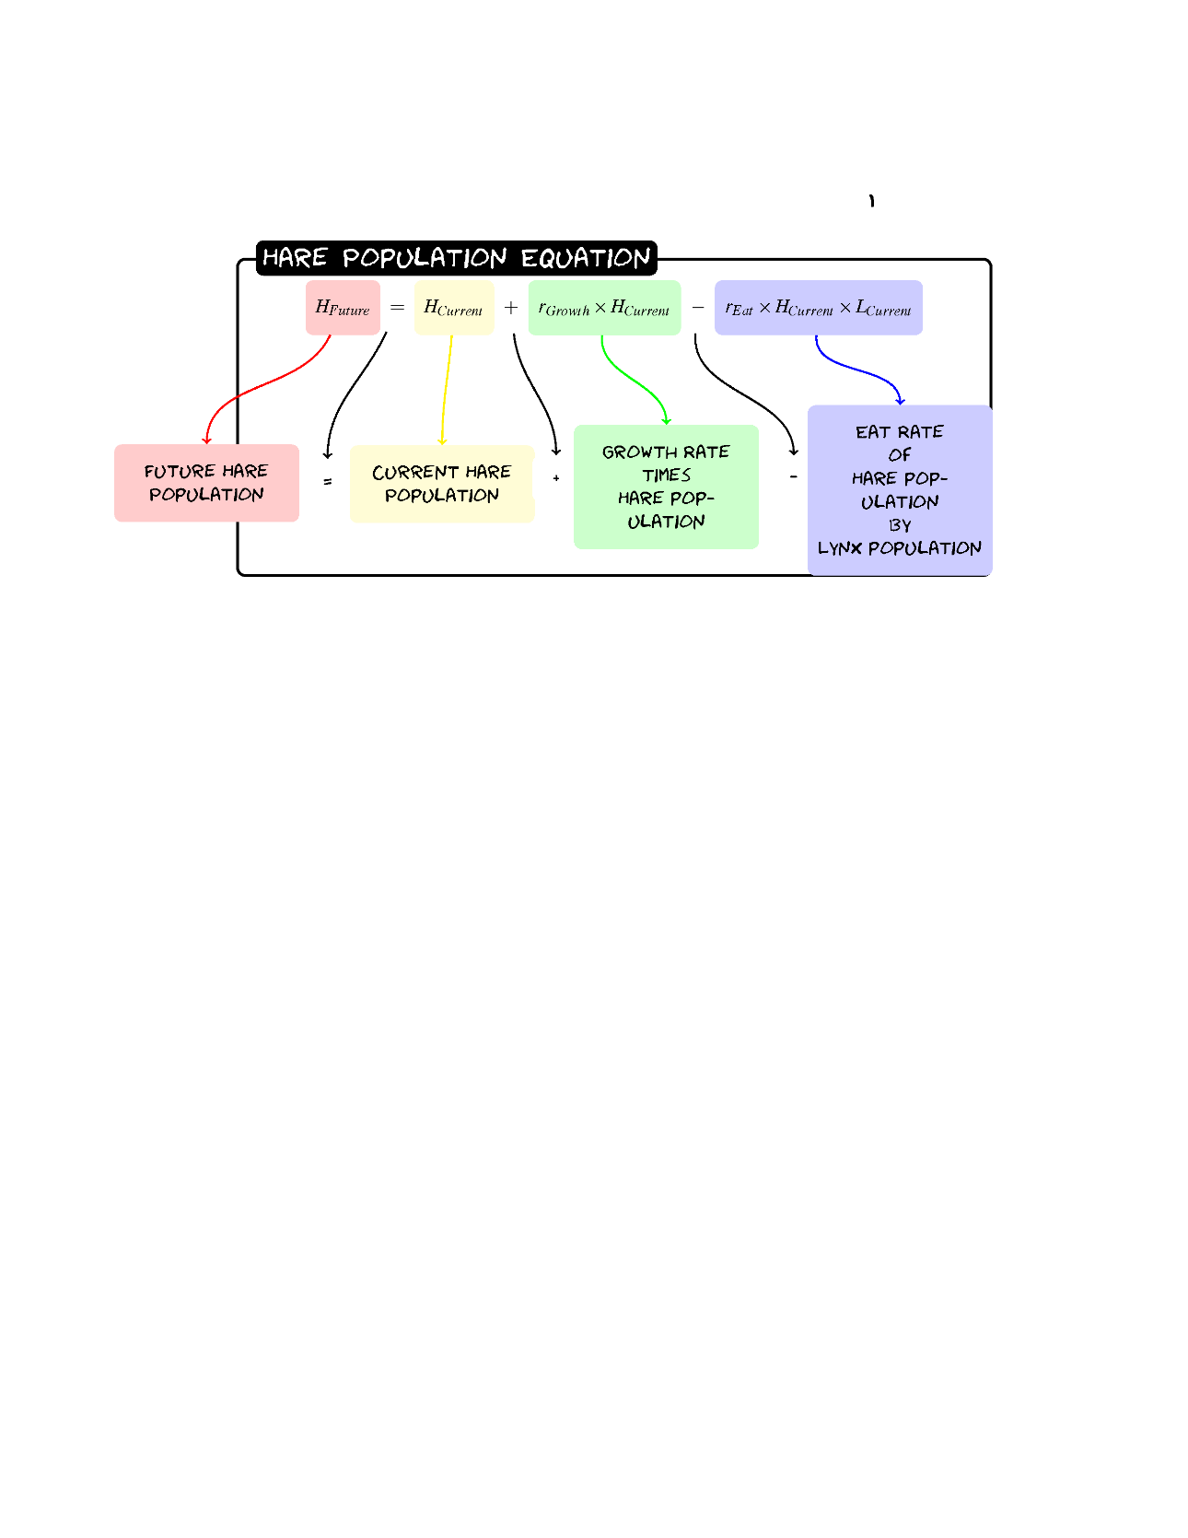

Given a population of 60 Hares and 30 Lynxes with a birth rate of .2, a death rate of 0.1, a eat rate of 0.005 and a food rate of 0.002 what would the populations be after three years?

|  |  |  |  |
| --- | --- | --- | --- |
| Hare | Hare | Lynx | Value |
| Growth | 0.2 | **Death** | 0.1 |
| Eat | 0.005 | **Food** | 0.002 |

|  |  |  |
| --- | --- | --- |
| Year | Hare Population | Lynx Population |
| 0 | 60 | 30 |
| 1 |  |  |
| 2 |  |  |
| 3 |  |  |

Sketch the graph:

Don’t get Eaten by the Wolf

Label the graph

