Connecting Neuroscience and Machine Learning

Don’t get Eaten by the Tiger

## Neuroscience of Decision Making

### The Neuron

What is the basic **unit of information** for a neuron?

How do we **encode** it mathematically?

### Two Populations of Neurons

Label the graph:

### Making Decisions

Label the graph:

Where is the **50-50 chance line**?

Fill in the graph with your answers:

### The Algorithm

What is an **algorithm**? Give an **example**?

What is **Machine Learning**?

### The Node

**Label** the graph:

**Draw** the **functions** could be used in a node and what are they good for?

What does an **Artificial Neural Network learn**?

### An Artificial Neural Network

**Label** the graph:

How are you **smarter than AI**?

The Maths of Predators and Preys

Don’t get Eaten by the Wolf

### No predators

Given a population of 60 Hares and a growth rate of 0.2 what would the population be after three years?

|  |  |
| --- | --- |
| Year | Hare Population |
| 0 | 60 |
| 1 |  |
| 2 |  |
| 3 |  |

**Sketch the Graph**.

**Guess what would happen in 100 years**?

**

### No Prey

Given a population of 30 Lynxes and a death rate of 0.1 what would the population be after three years?

|  |  |
| --- | --- |
| Year | Lynx Population |
| 0 | 30 |
| 1 |  |
| 2 |  |
| 3 |  |

**Sketch the Graph**.

**Guess what would happen in 100 years?**

Label the graph:

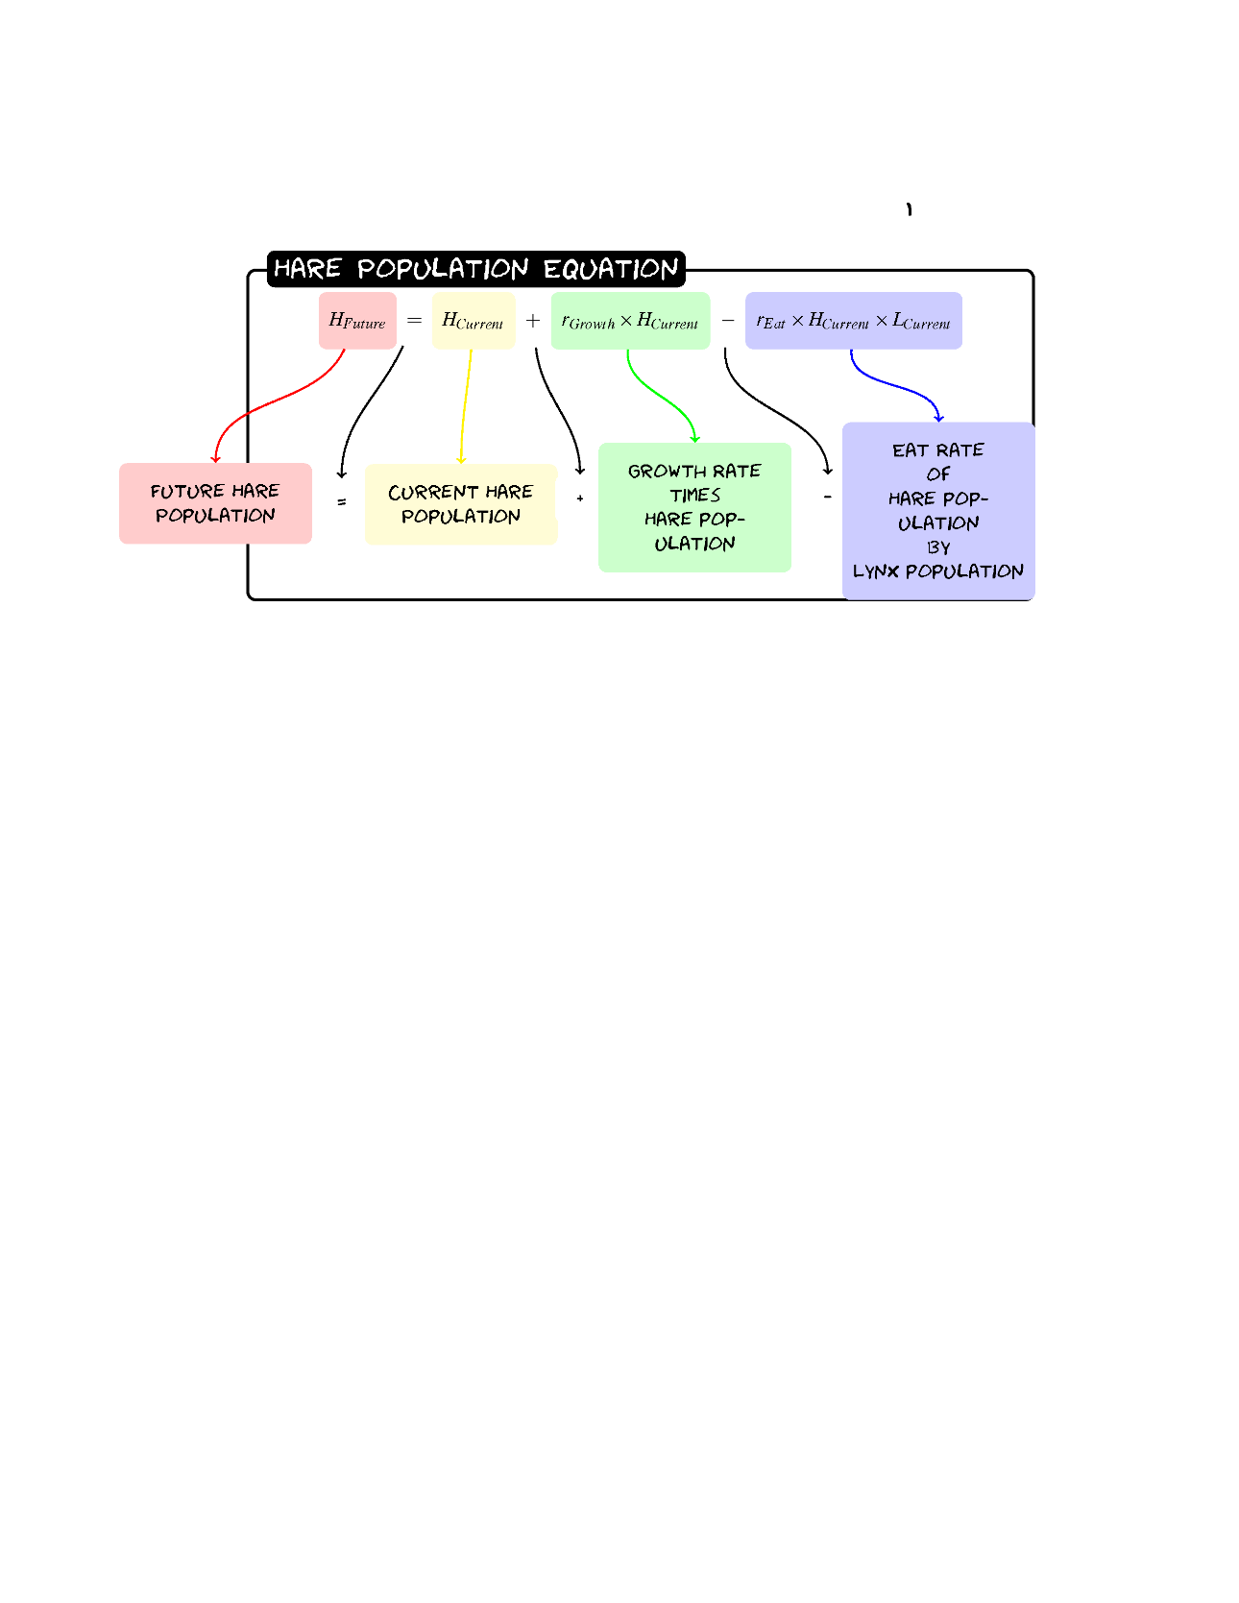

Given a population of 60 Hares and 30 Lynxes with a birth rate of .2, a death rate of 0.1, a eat rate of 0.005 and a food rate of 0.002 what would the populations be after three years?

|  |  |  |  |
| --- | --- | --- | --- |
| Hare | Hare | Lynx | Value |
| Growth | 0.2 | **Death** | 0.1 |
| Eat | 0.005 | **Food** | 0.002 |

|  |  |  |
| --- | --- | --- |
| Year | Hare Population | Lynx Population |
| 0 | 60 | 30 |
| 1 |  |  |
| 2 |  |  |
| 3 |  |  |

Sketch the graph:

Don’t get Eaten by the Wolf

Label the graph

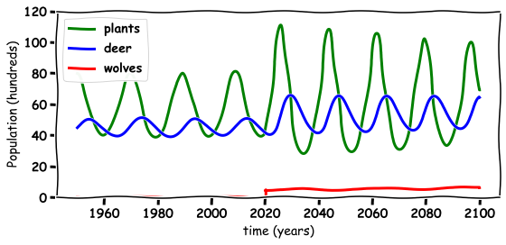

FEEDBACK

## General Experience

What did you enjoy most about the workshop?

Was there anything you found challenging or unclear during the session?

On a scale of 1 to 5, how engaging did you find the workshop? (1 = Not engaging, 5 = Very engaging)

1 2 3 4 5

## Content and Delivery

Were the topics covered relevant and interesting to you? (1 = Not interesting, 5 = Very interesting)

1 2 3 4 5

Was the pace of the workshop appropriate? (1=Too slow,3= Just right, 5=Too fast)

1 2 3 4 5

Did the examples or exercises help you understand the concepts better? (1 = Not helpful, 5 = Very helpful)

1 2 3 4 5

Was the presenter clear and easy to follow? (1 = Not clear, 5 = Very clear)

1 2 3 4 5

## Suggestions for Improvement

What would you like to see more of in future workshops?

Is there any topic you think we should include next time?

How could we improve your overall experience?