Decision Making

Am I Going to Bike or Walk

## Making a Decision

How did you get to here today?

How do you decide?

What helps to a make decision?

Do you sometimes make the wrong decision? Give an example

Are you sometimes unable to decide?

Is it better to decide slowly or quickly?

What would make you change a decision?

What happens when times runs out?

### Making a Decision

### Label the graph:

Put a start point and draw a graph that makes decision to walk and at what time:

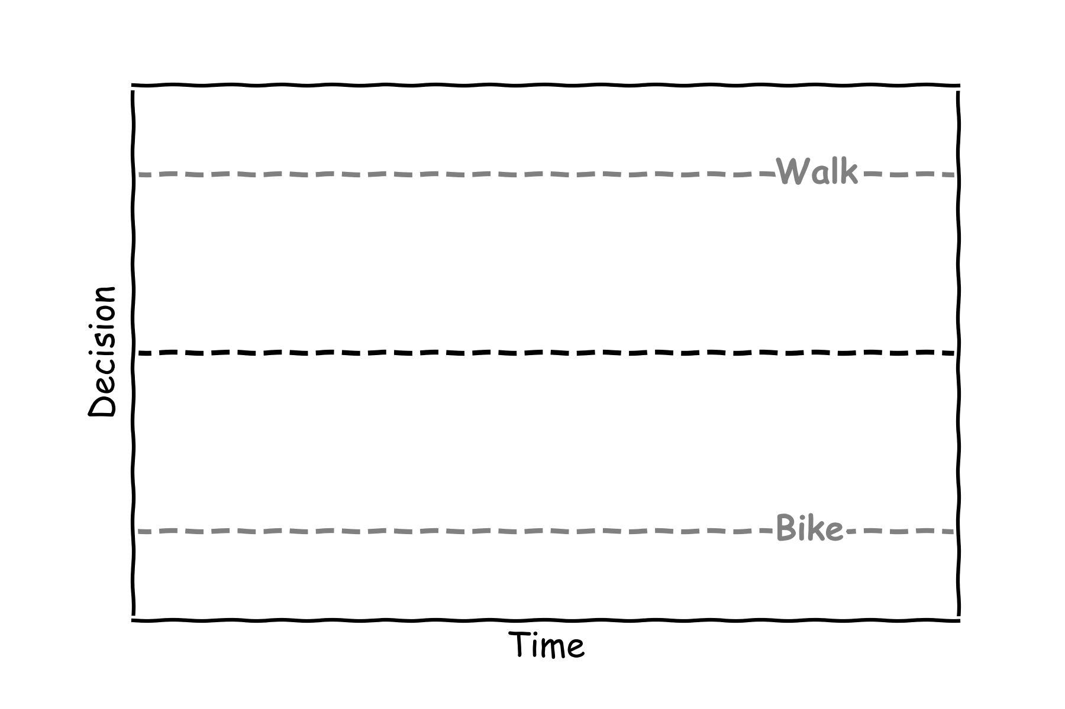

### Which decision was faster?

### What would no decision graph look like:

### What would a bias to bike look like:

### What would a change of mind look like:

### What would happen if time runs out before you make a decision:

### How will the brother and sister get to school?

