Connecting Neuroscience and Machine Learning
Don’t get Eaten by the Tiger

Neuroscience of Decision Making

The Neuron
What is the basic unit of information for a neuron?

Spike

How do we encode it mathematically?

0 or 1

Two Populations of Neurons
Label the graph:
Left told to
calm down
Left told to
calm down
Right Group
Excitement
Left Group
Excitement
Input
Input
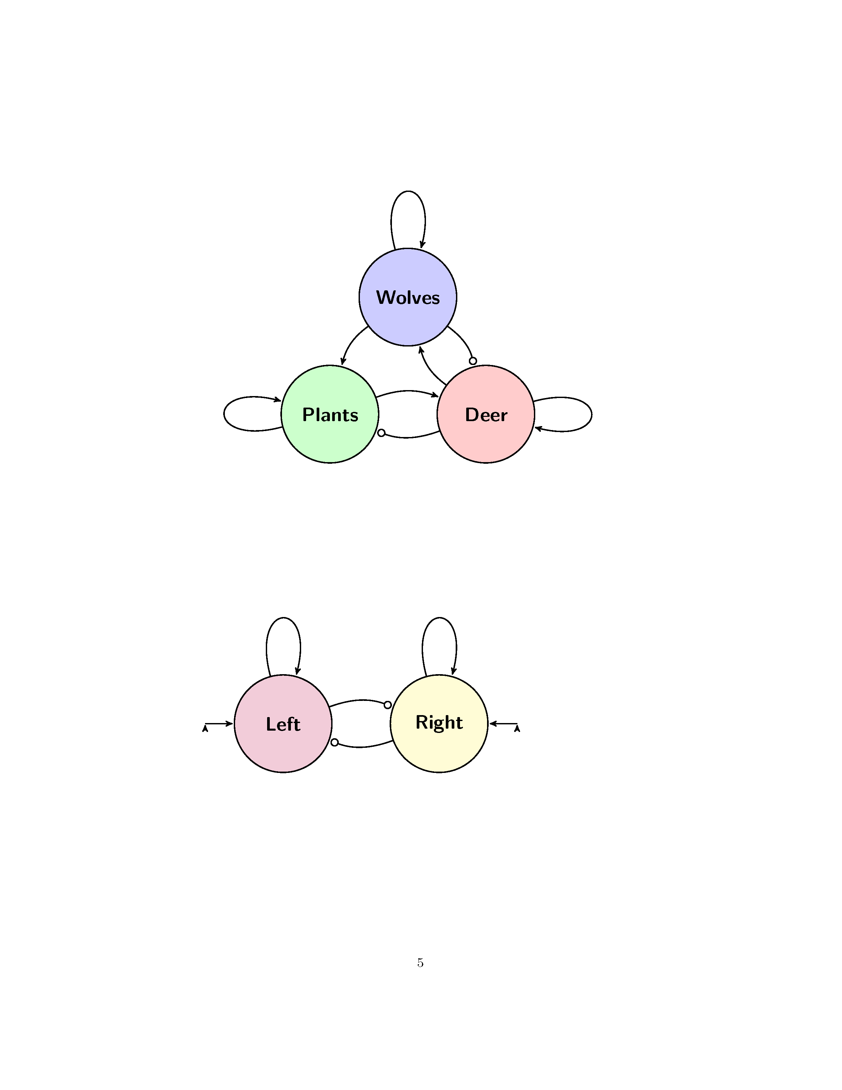
Label the graph:
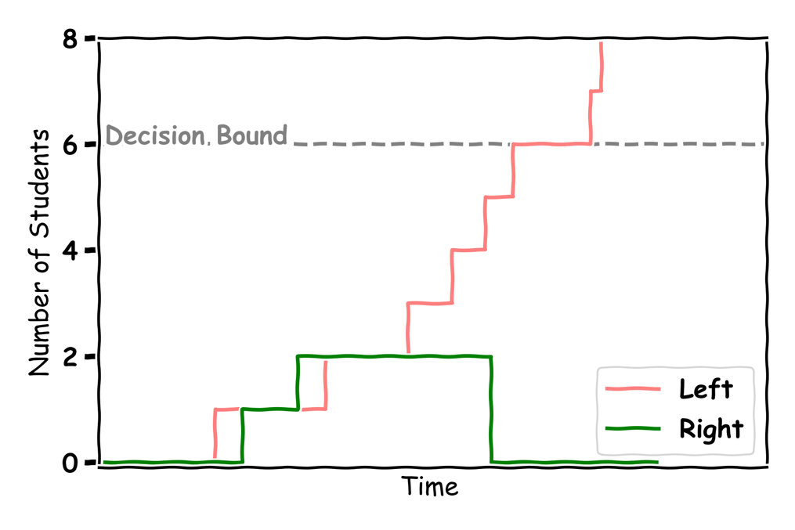

Making Decisions
Label the graph:
Where is the 50-50 chance line?
Fill in the graph with your answers:
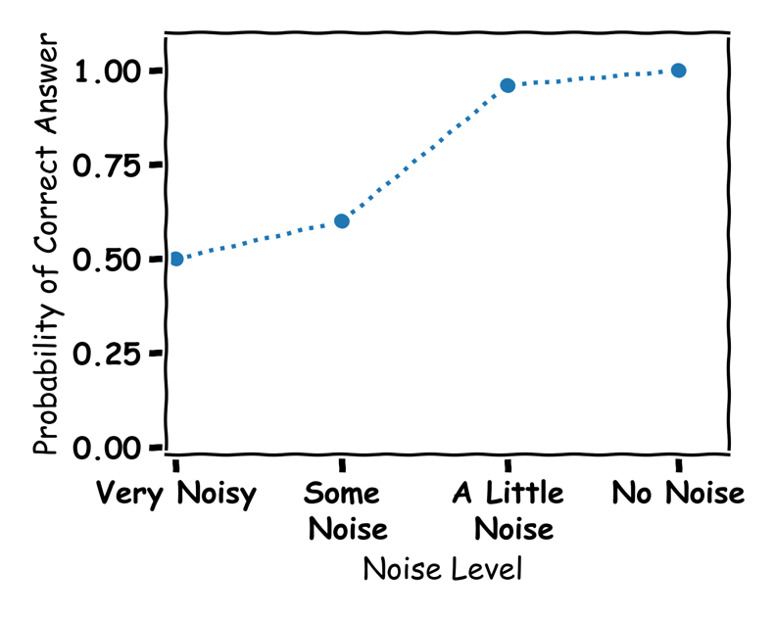

Machine Learning of Decision Making 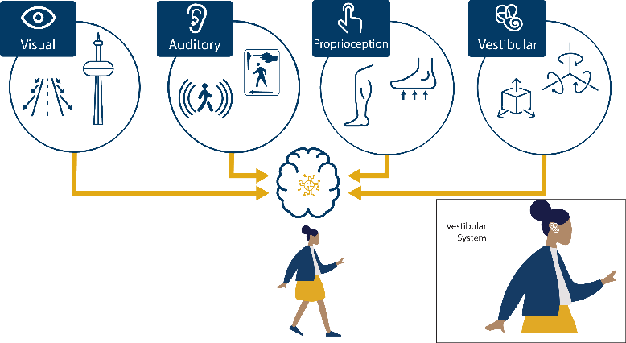

The Algorithm
What is an algorithm (AI)? Give an example?
An algorithm is a step-by-step set of instructions for solving a problem or performing a specific task.
Tik-Tok

The Node
Label the graph:
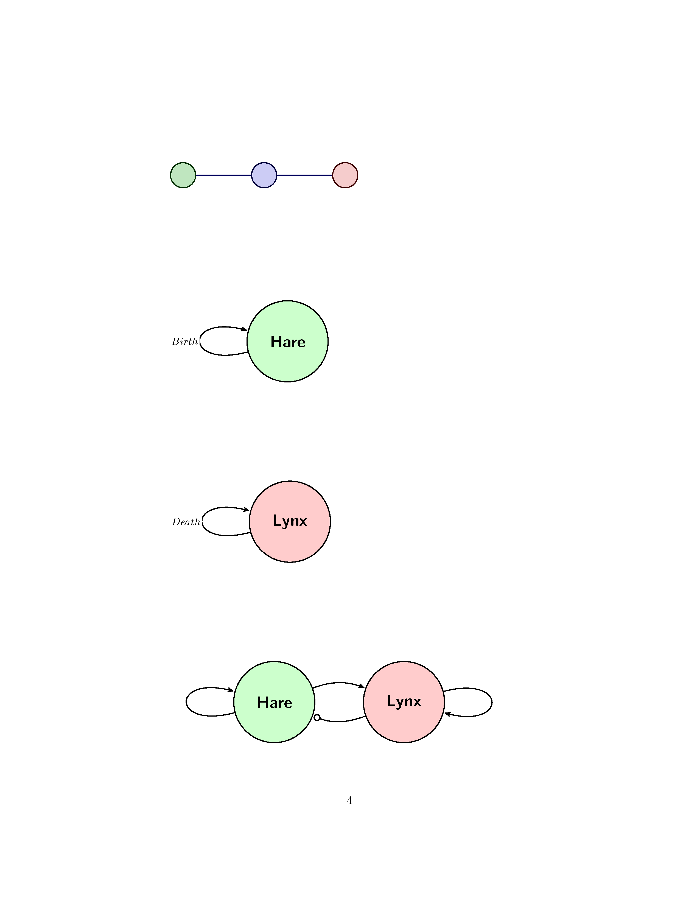
Input
node
output
Connection
Connection
What does an Artificial Neural Network learn?

Weights (Connections) for Patterns

How are you smarter than AI?

I know what upwards motion is

