Connecting Neuroscience and Machine Learning
Don’t get Eaten by the Tiger

Neuroscience of Decision Making

The Neuron
What is the basic unit of information for a neuron?

How do we encode it mathematically?

Two Populations of Neurons
Label the graph:
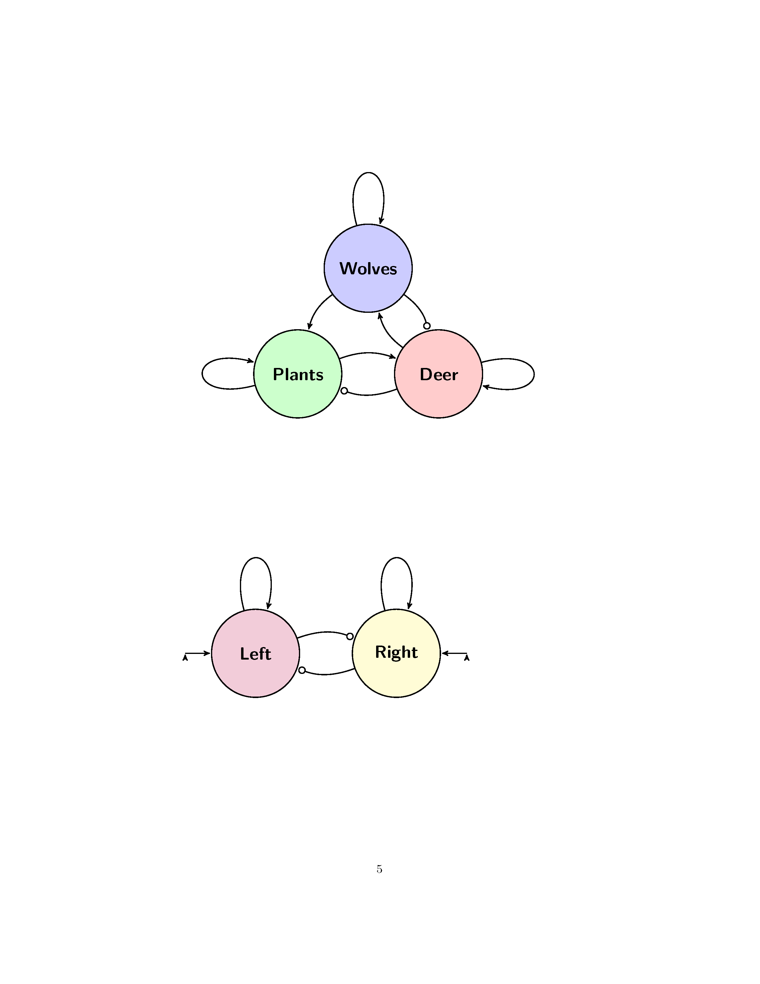
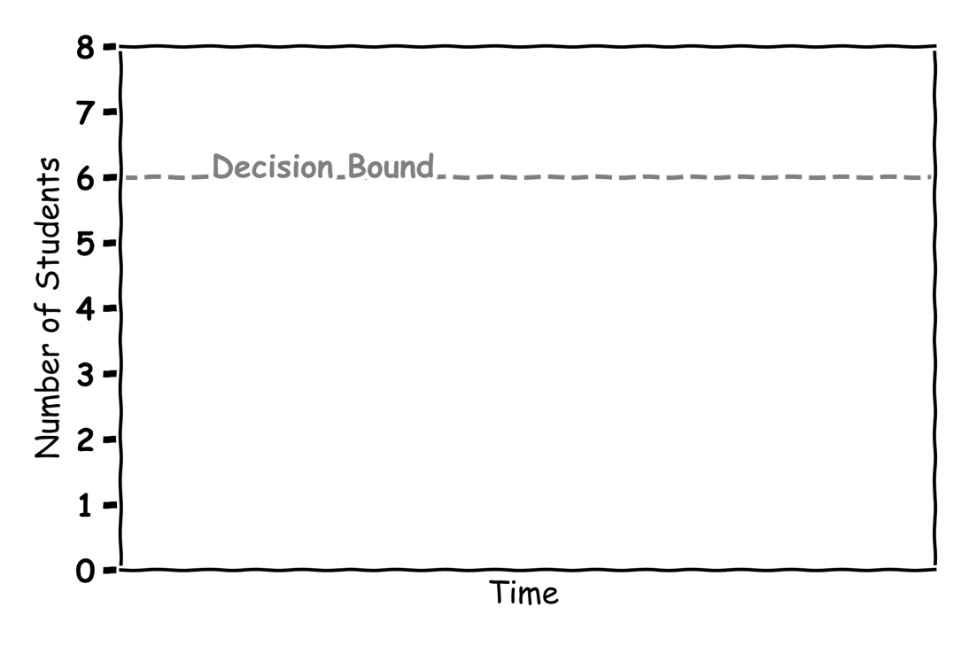

Making Decisions
Label the graph:
Where is the 50-50 chance line?
Fill in the graph with your answers:
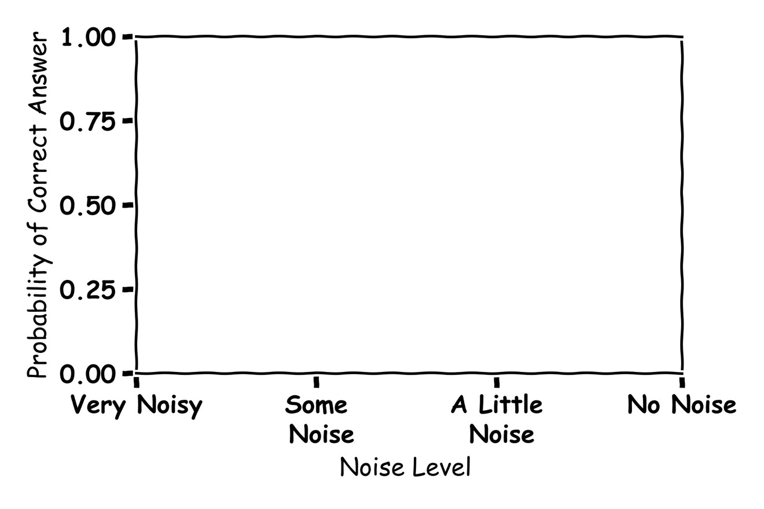

Machine Learning of Decision Making 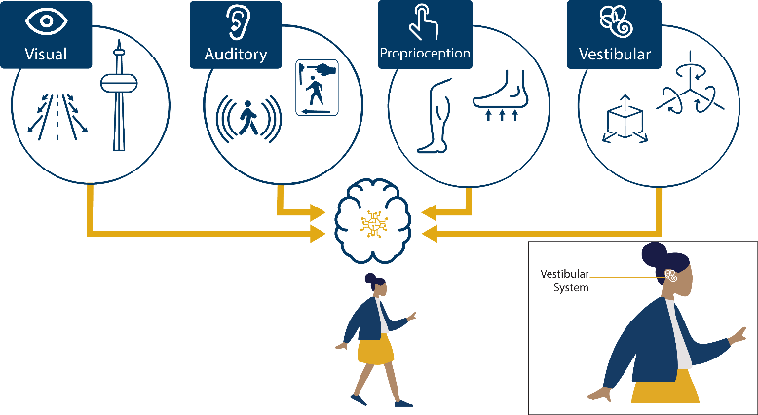

The Algorithm
What is an algorithm? Give an example?

What is Machine Learning?

The Node
Label the graph:
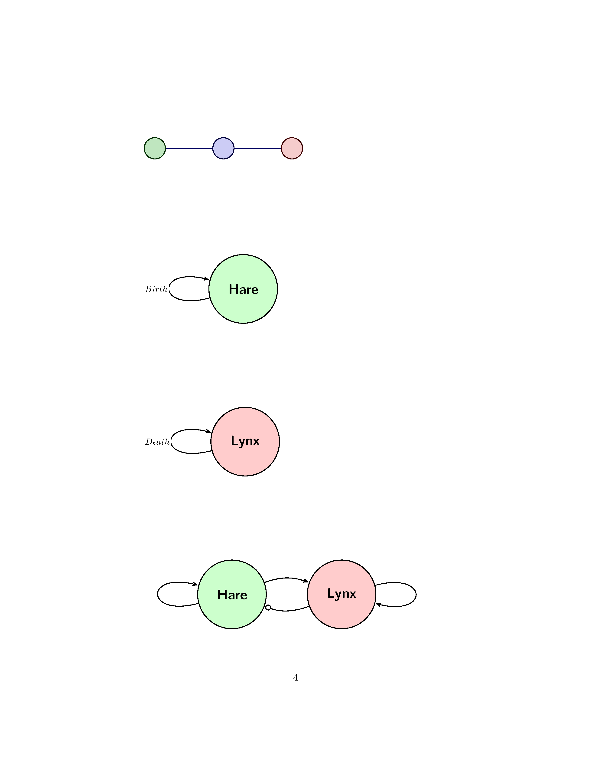

Draw the functions could be used in a node and what are they good for?

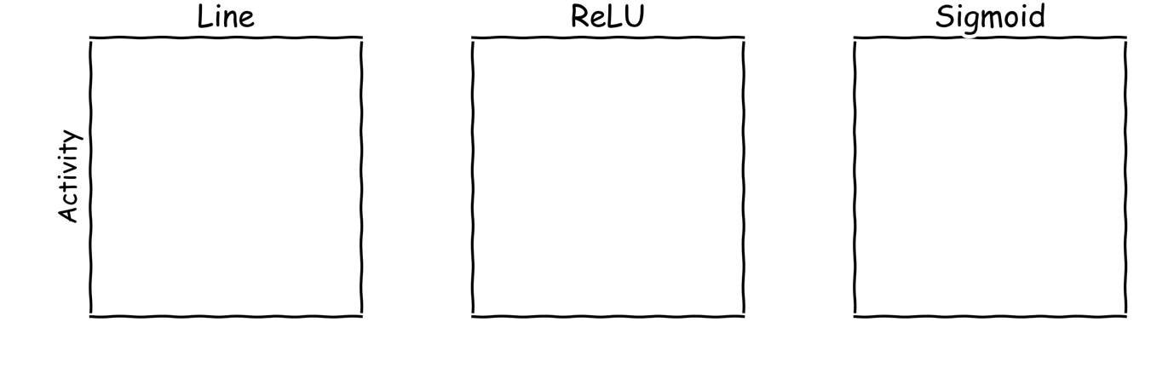

What does an Artificial Neural Network learn?

An Artificial Neural Network
Label the graph:
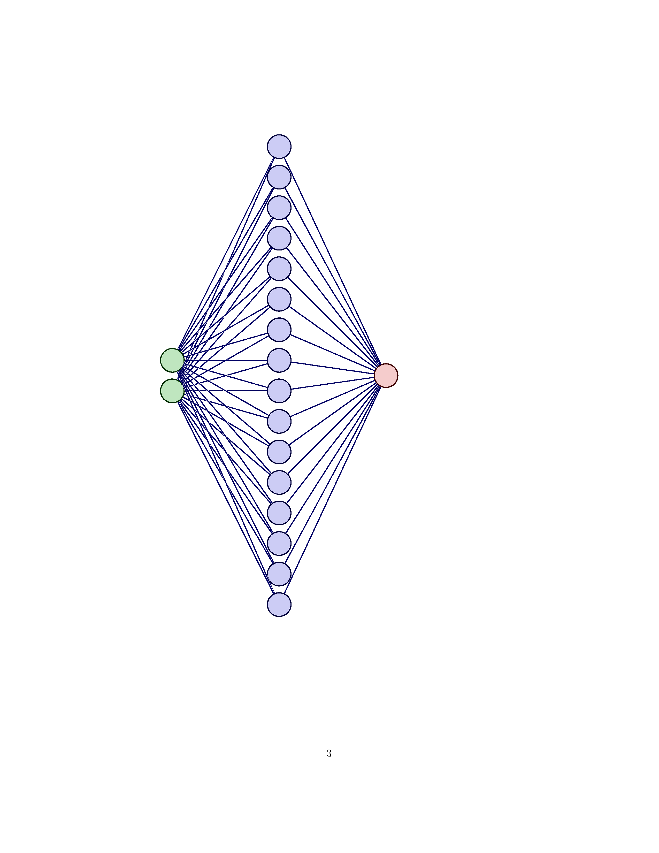
How are you smarter than AI?

