Connecting Neuroscience and Machine Learning
Don’t get Eaten by the Tiger

Neuroscience of Decision Making

The Neuron
What is the basic unit of information for a neuron?
Spike

How do we encode it mathematically?

0 and 1

Two Populations of Neurons
Label the graph:
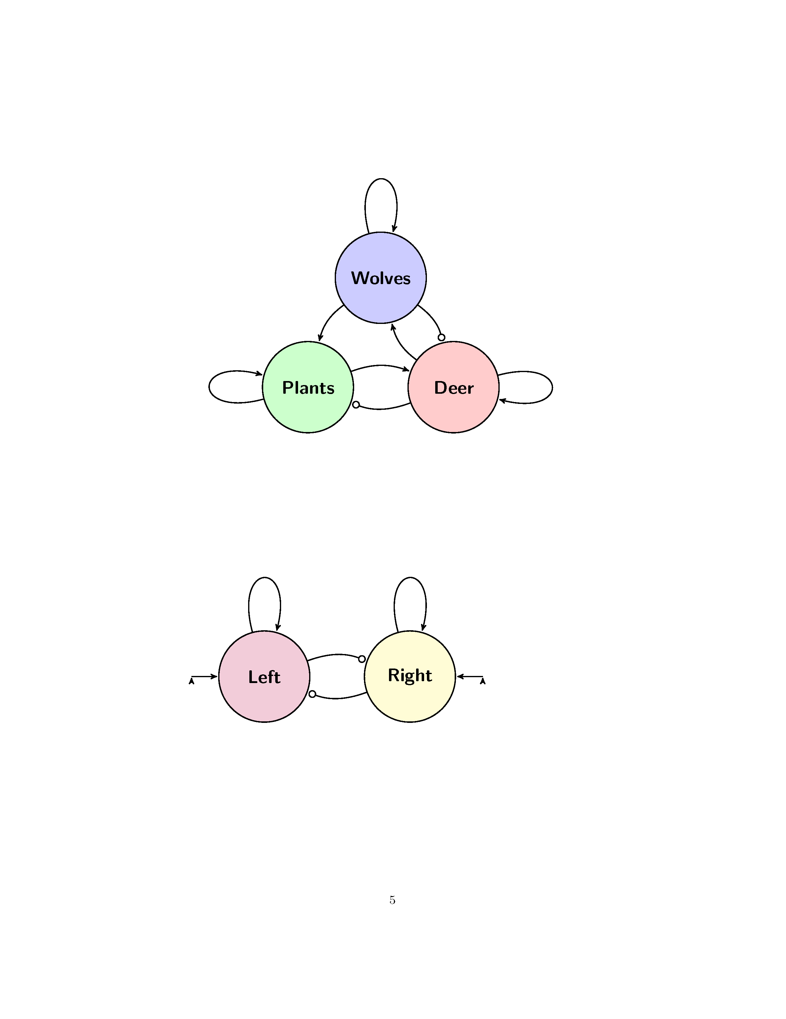
Left told to
calm down
Left told to
calm down
Right Group
Excitement
Left Group
Excitement
Left Group
Excitement
Left Group
Excitement
Input
Input

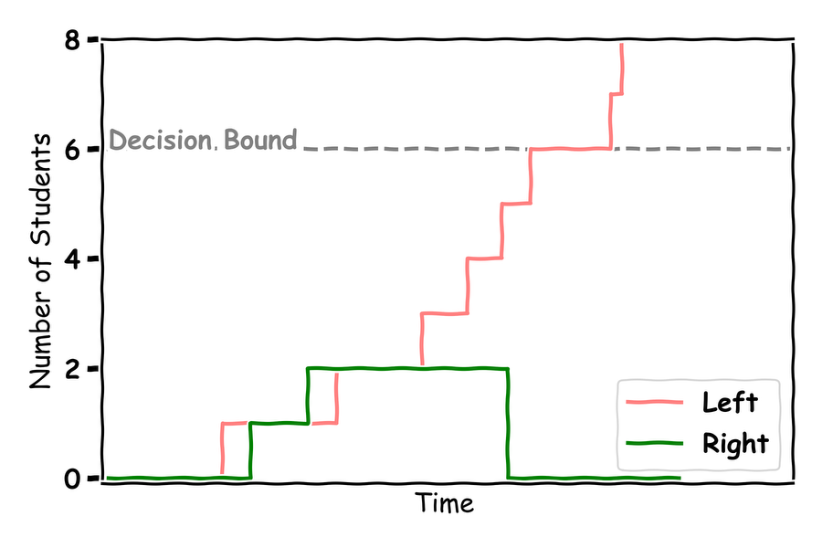

Making Decisions
Label the graph:
Where is the 50-50 chance line?
Fill in the graph with your answers:
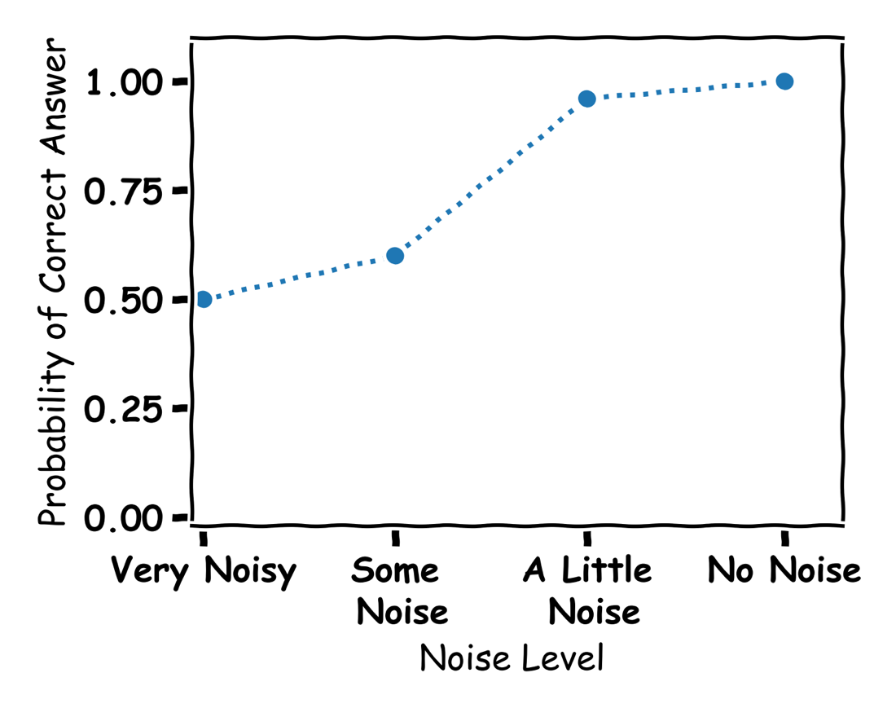

Machine Learning of Decision Making 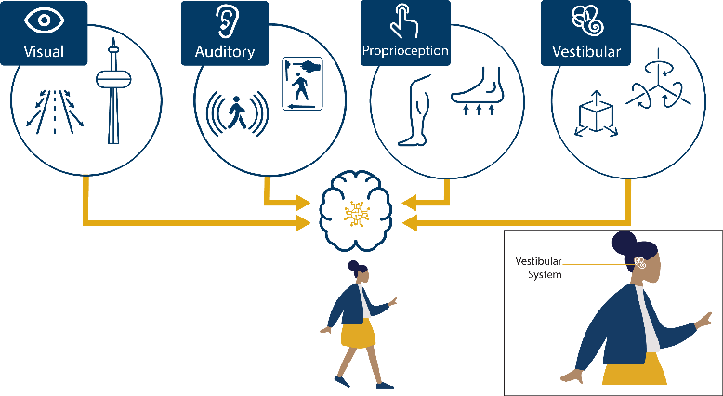

The Algorithm
What is an algorithm? Give an example?

An algorithm is a step-by-step set of instructions for solving a problem or performing a specific task.

Tik-Tok

What is Machine Learning?

The way computers learn from data

The Node
Label the graph:
output
node
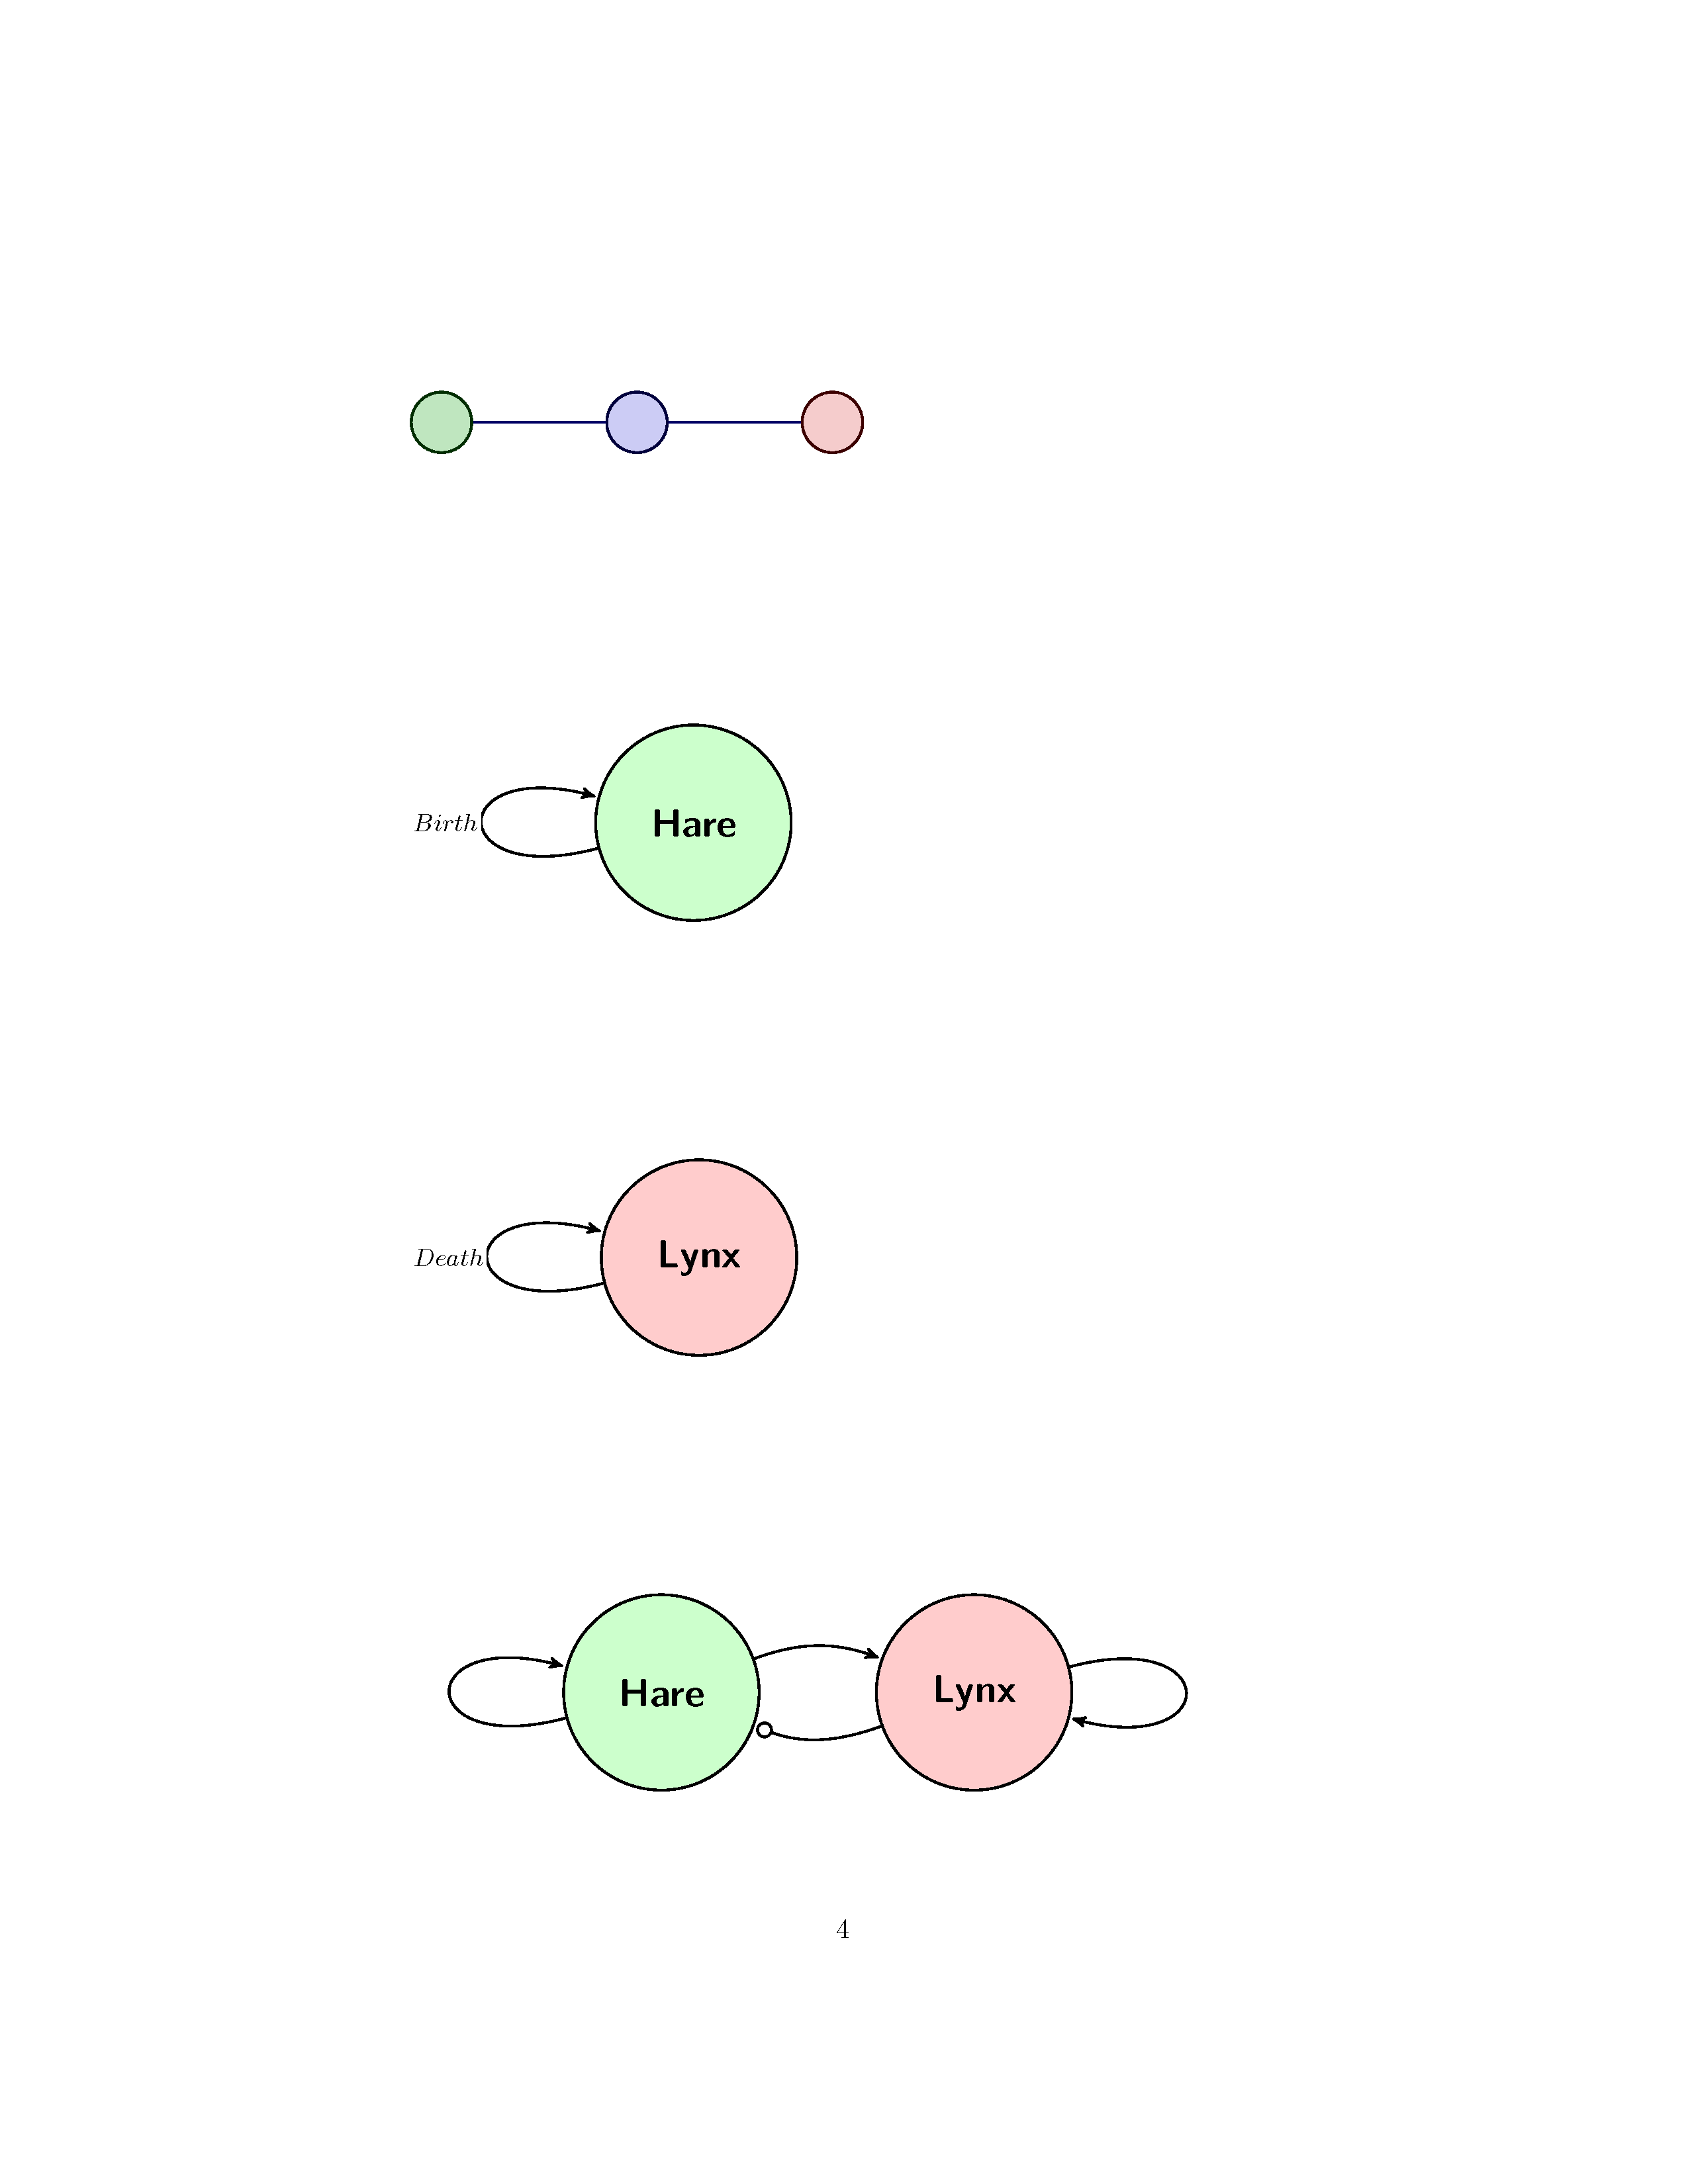
Connection
Connection
Input

Draw the functions could be used in a node and what are they good for?

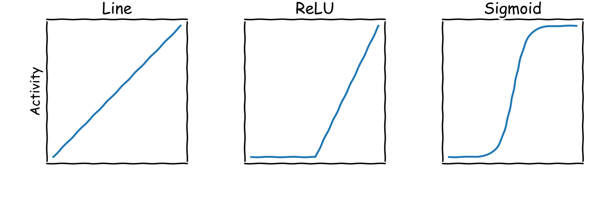

What does an Artificial Neural Network learn?

Weights for Patterns

An Artificial Neural Network
Label the graph:
Node
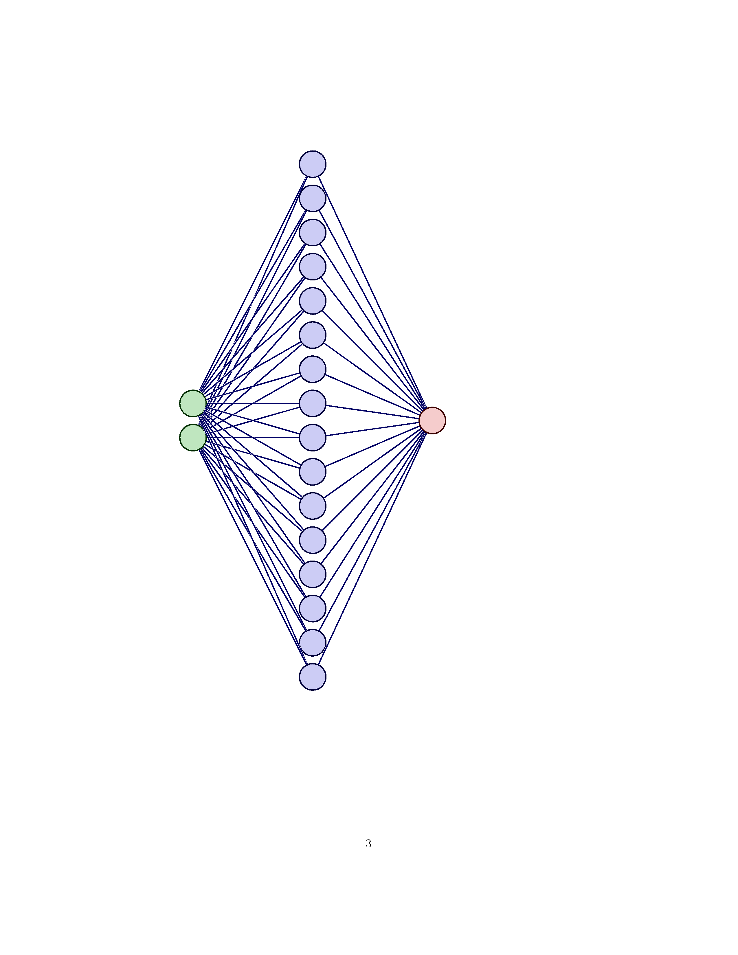
Connection
Weights
output
Input
How are you smarter than AI?

I know what upwards motion is

