The Maths and Neuroscience of Walking
Walking is Not as Easy as You Think

Name: ______________________________________________ Date: ____________

Exercise 1: Sensory Systems
1.1 How many senses are there and name them:

Five classic: Vision, Audio, Taste, Smell and Touch

Two lesser known: Vestibular and Proprioception

1.2 What is Multisensory Integration and give and example

The combination of senses
Watching someone’s lips while they talk (audio-visual)

Exercise 2: Self-motion
2.1 What is Self-motion give an example?

Walking, driving, running

2.2 Why is researching walking important?

Falling reduces quality of life
It is one of the first things we learn

2.3 What is the most important sense for walking?

  - We use vision much more than body cues
  - We use body cues much more than vision
  - We use body cues as much as vision

None of the above and all of the above

2.4 How to study Walking

How would you isolate vision or motion?

Blindfolding

Exercise 3: How Much Do You Remember
Label the graph and add the data:
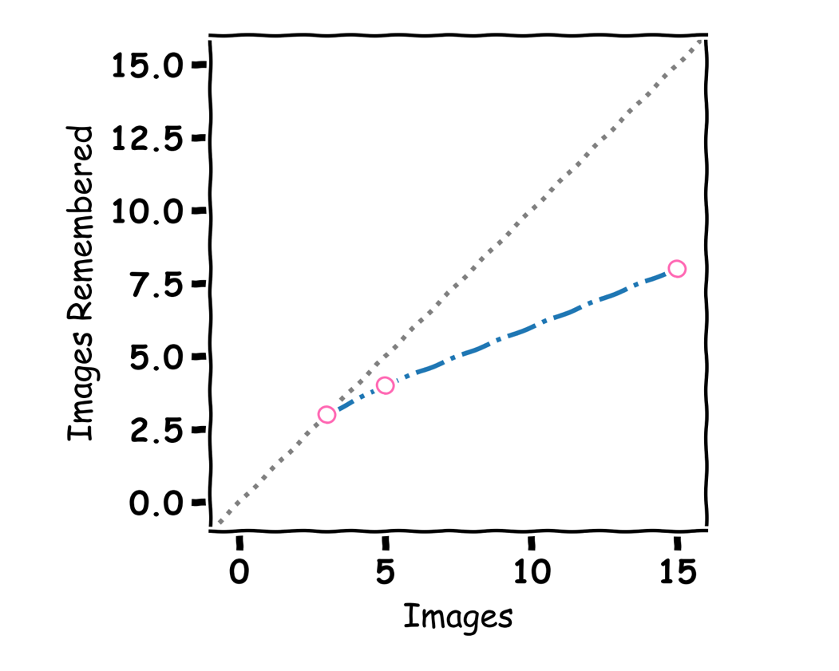
Perfect Memory

Exercise 4: Walking Distance
Label the graph and other lines
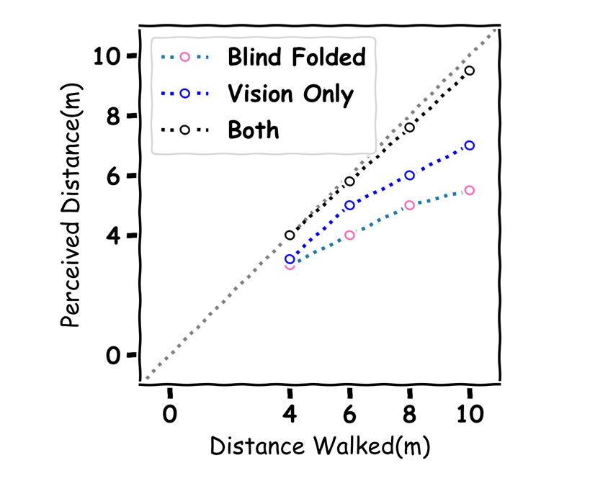

Exercise 5: Left or Right

Exercise 5.1: Fill in the table

Repitition | -20 | -1 | 1 | 20
1 | 0 | 1 | 1 | 1
2 | 0 | 0 | 1 | 1
3 | 0 | 0 | 0 | 1
Average | 0 | .3333 | .6666 | 1

Exercise 5.2: Label the graph and add the data:

Exercise 6: Is A better than B?
Participant A and B did the same heading task from the plots below which participant was better at the task?

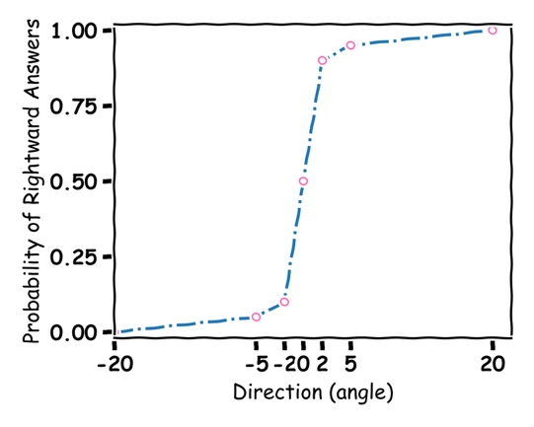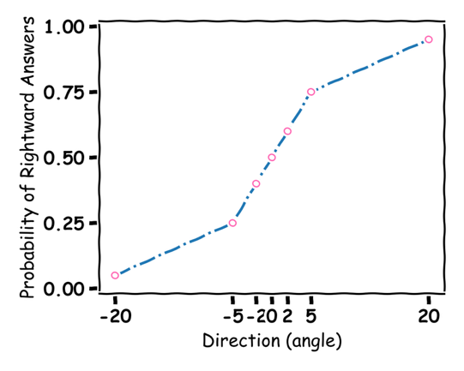
A
B
ANSWER: A

Exercise 7: Multisensory Integration
Exercise 7.1 What are the benefits of Multisensory Integration?

More accurate and faster responses

Exercise 7.2 Sometimes conflict is good

7.2 Fill in the table
 | Vestibular | Visual | Vestibular Weight
Equally | 4 | 4 | 4/8=0.5
Vestibular More | 2 | 6 | 6/8=0.75
Visual More | 8 | 2 | 2/8=.25

Open Question
What research question would you like to do on Multisensory Integration:

