Connecting Neuroscience and Machine Learning
Don’t get Eaten by the Tiger

Neuroscience of Decision Making

The Neuron
What is the basic unit of information for a neuron?

How do we encode it mathematically?

Two Populations of Neurons
Label the graph:
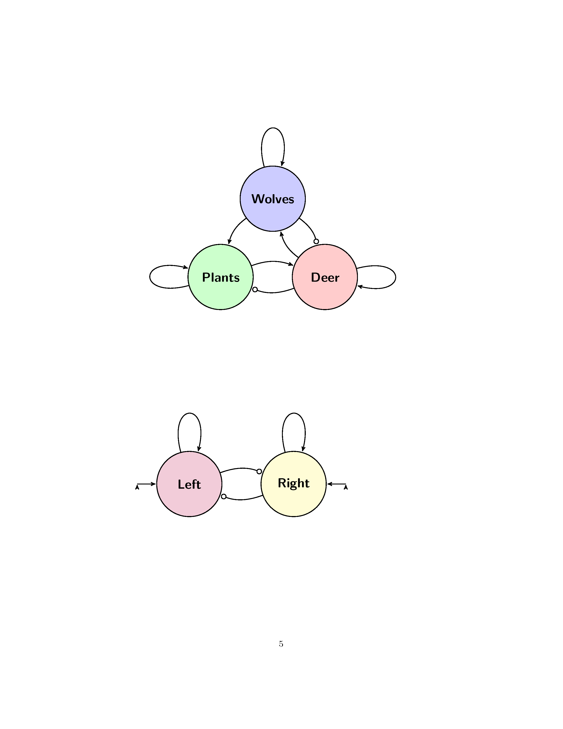
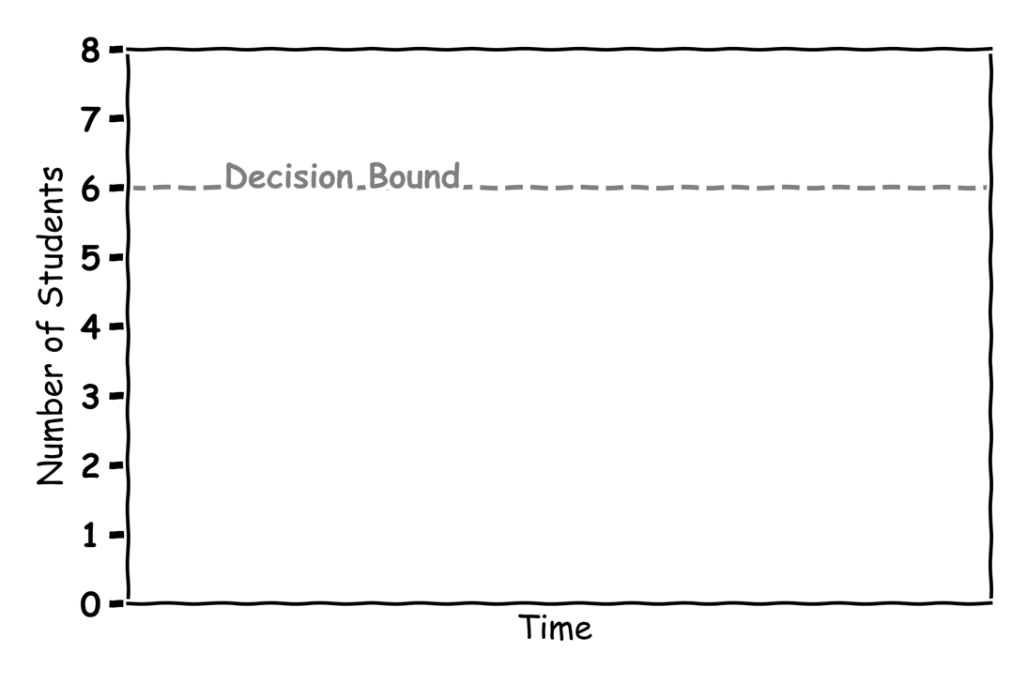

Making Decisions
Label the graph:
Where is the 50-50 chance line?
Fill in the graph with your answers:
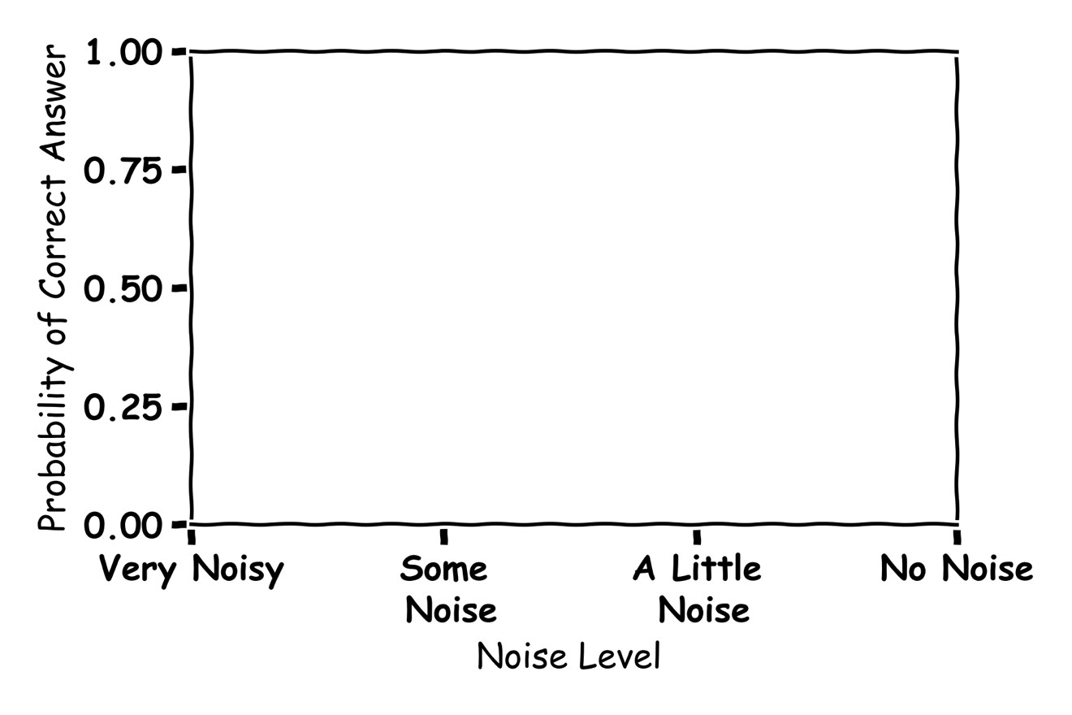

Machine Learning of Decision Making 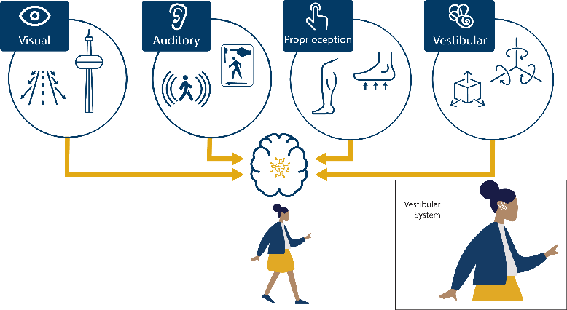

The Algorithm
What is an algorithm? Give an example?

What is Machine Learning?

The Node
Label the graph:
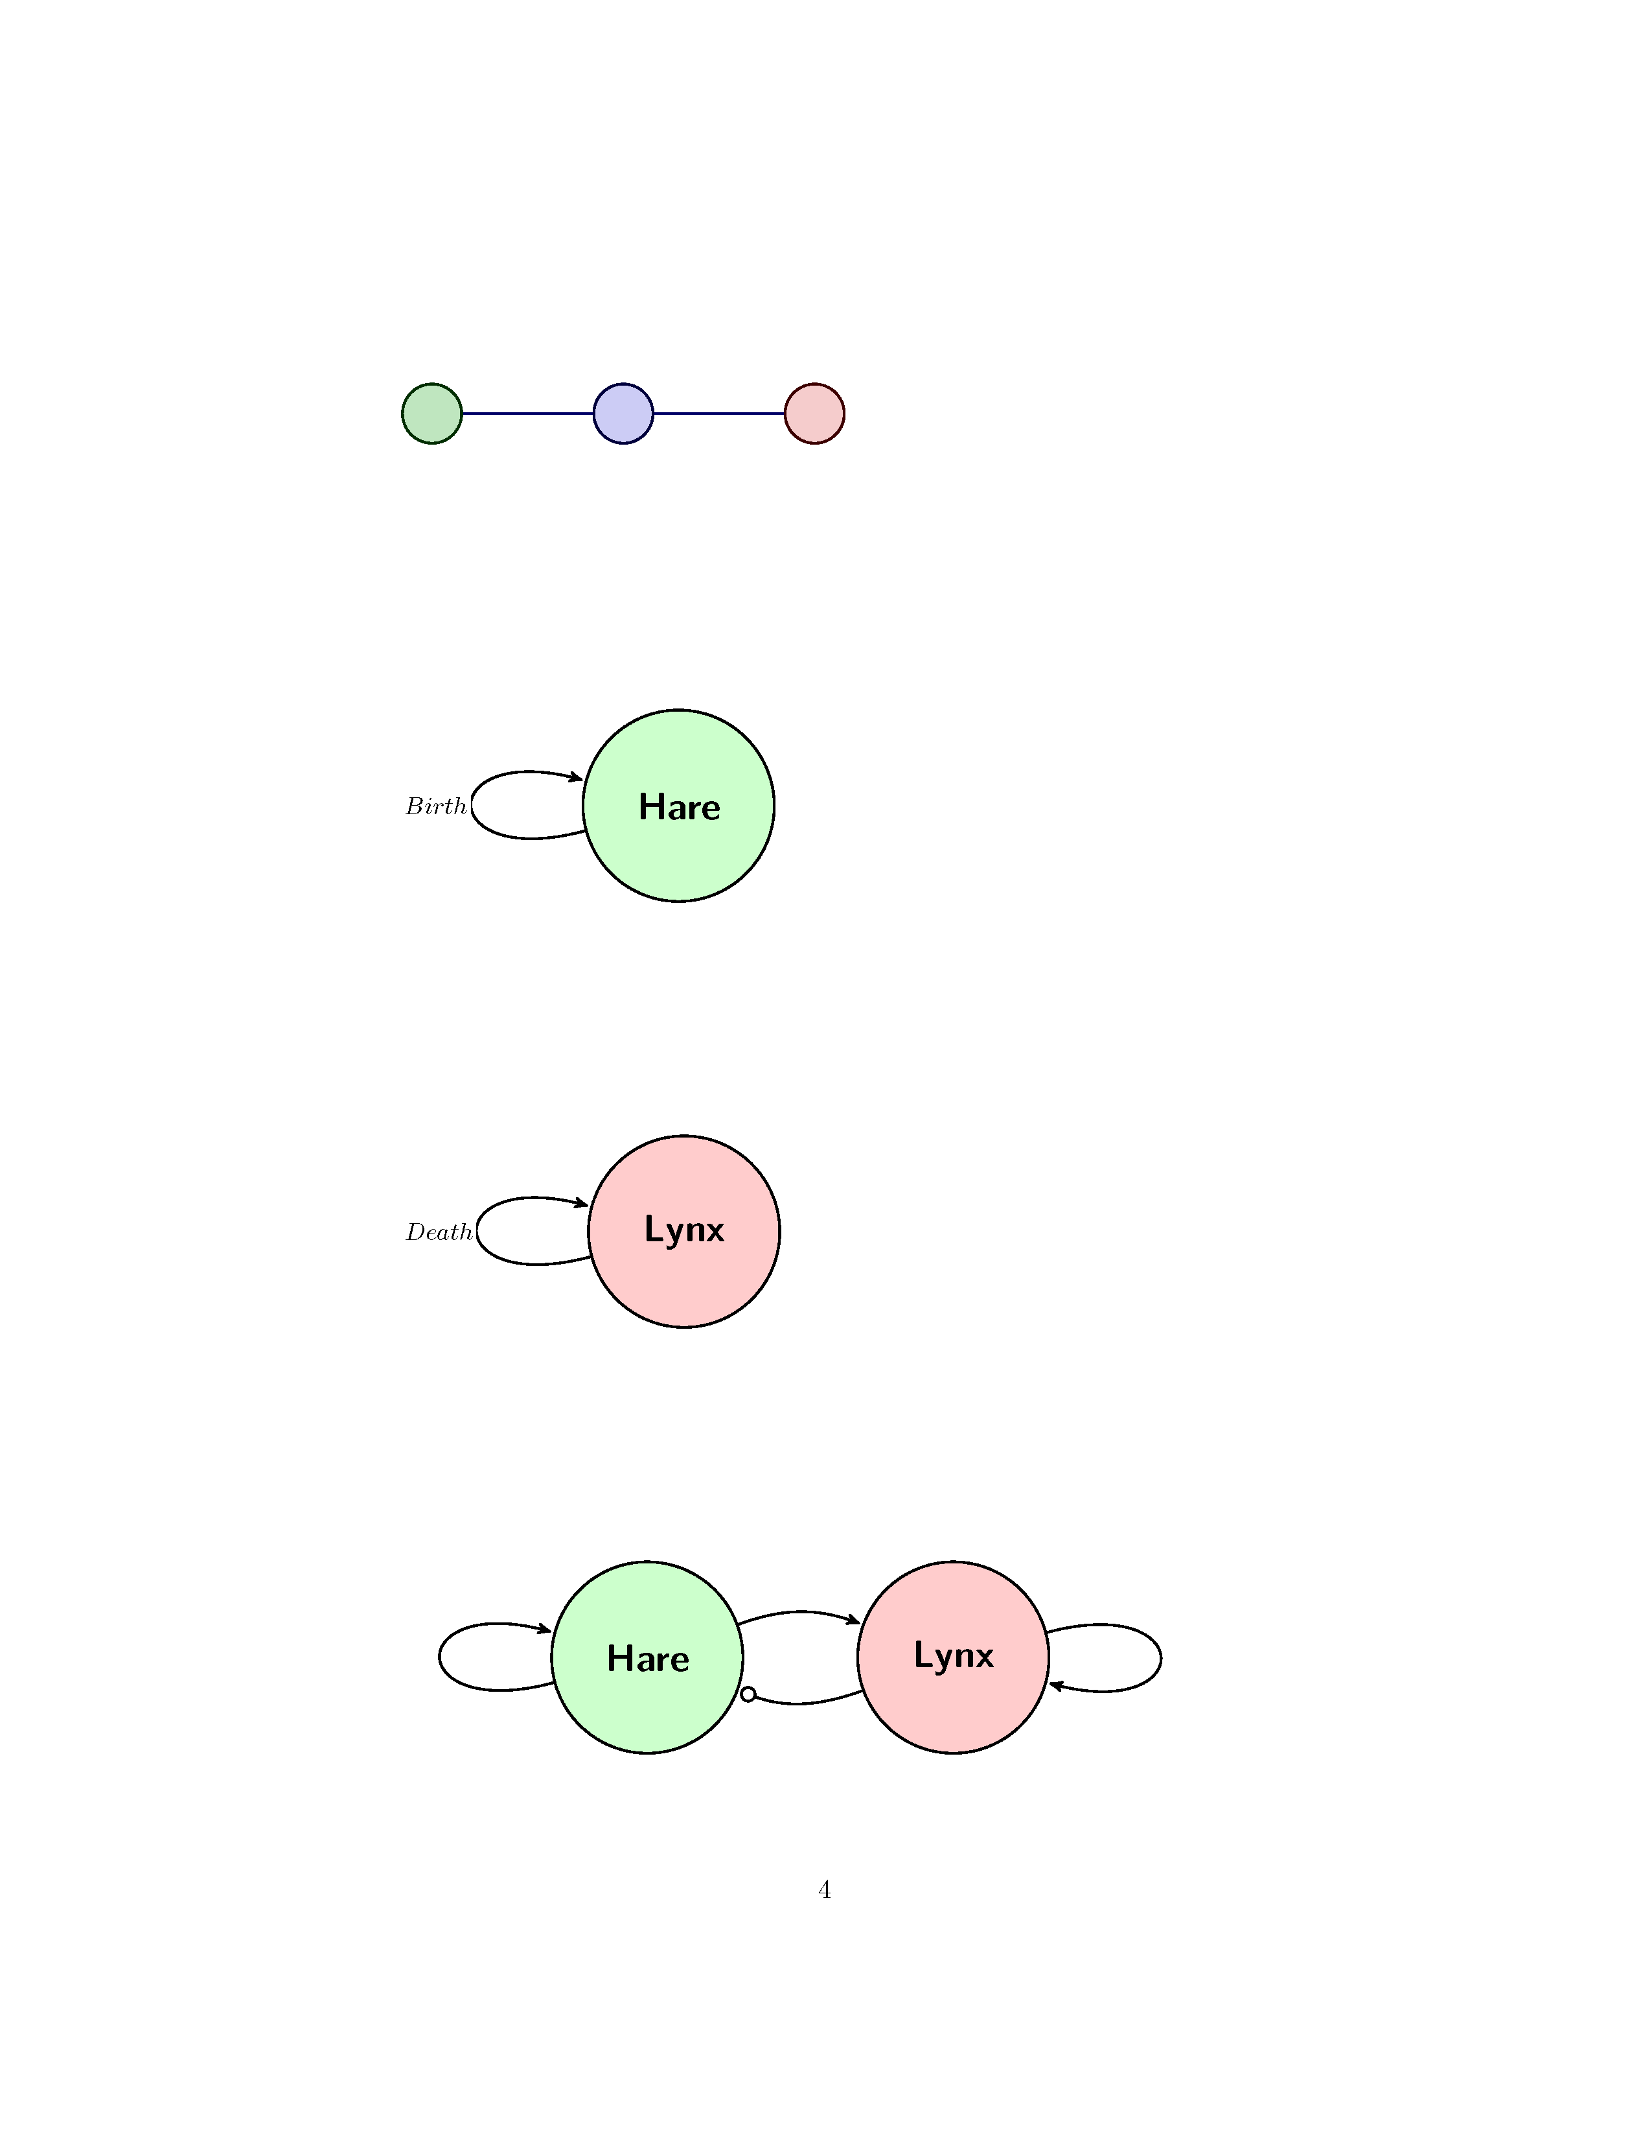

Draw the functions could be used in a node and what are they good for?

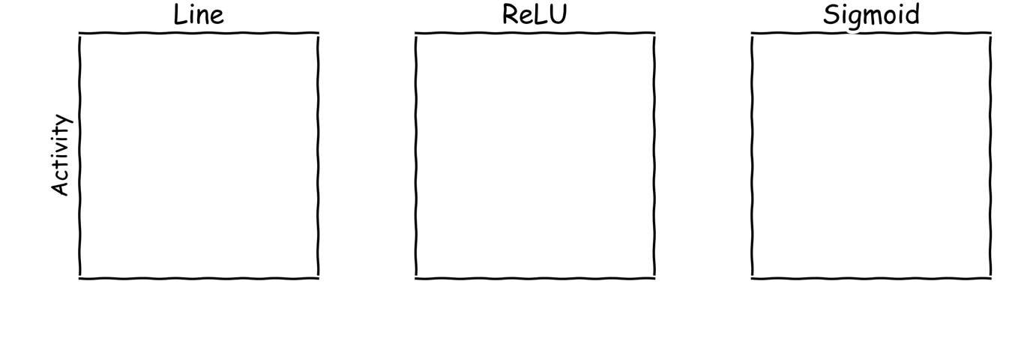

What does an Artificial Neural Network learn?

An Artificial Neural Network
Label the graph:
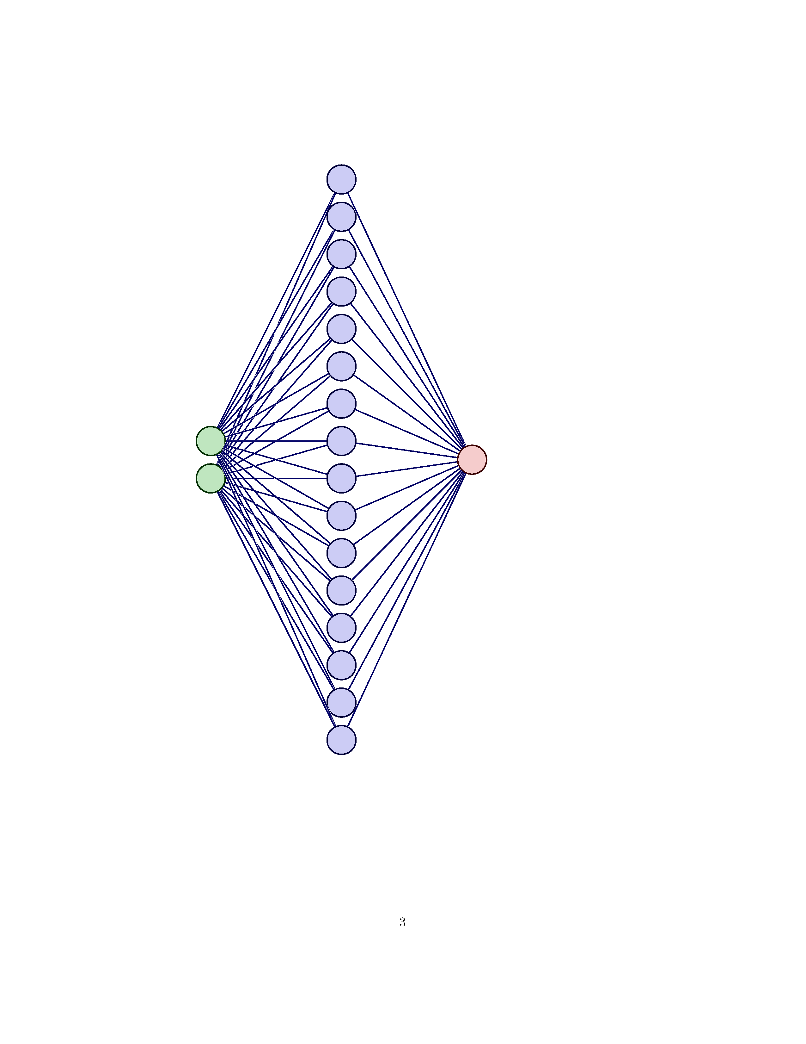
How are you smarter than AI?

The Maths of Predators and Preys
Don’t get Eaten by the Wolf

Hares 

No predators
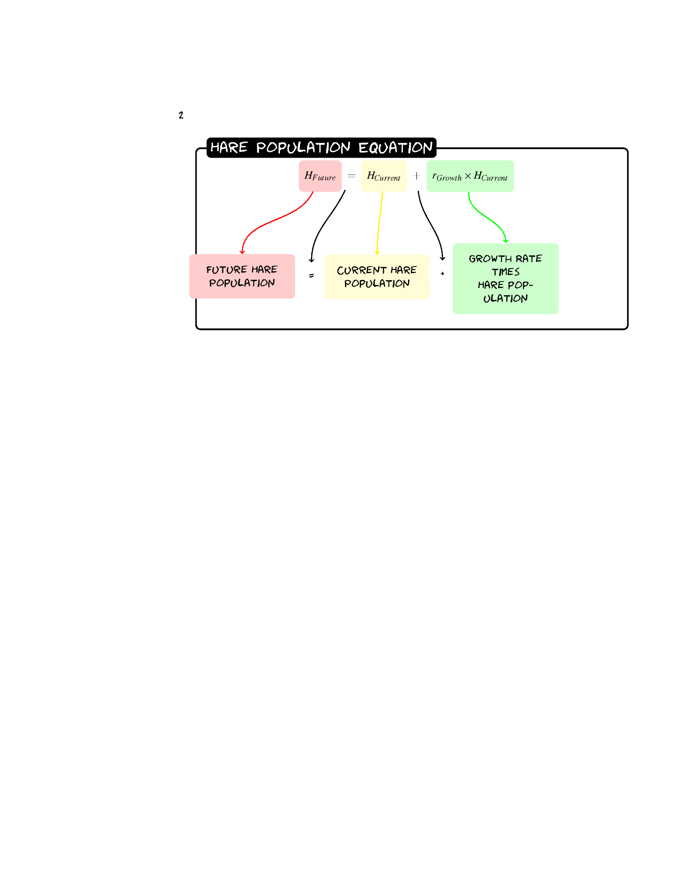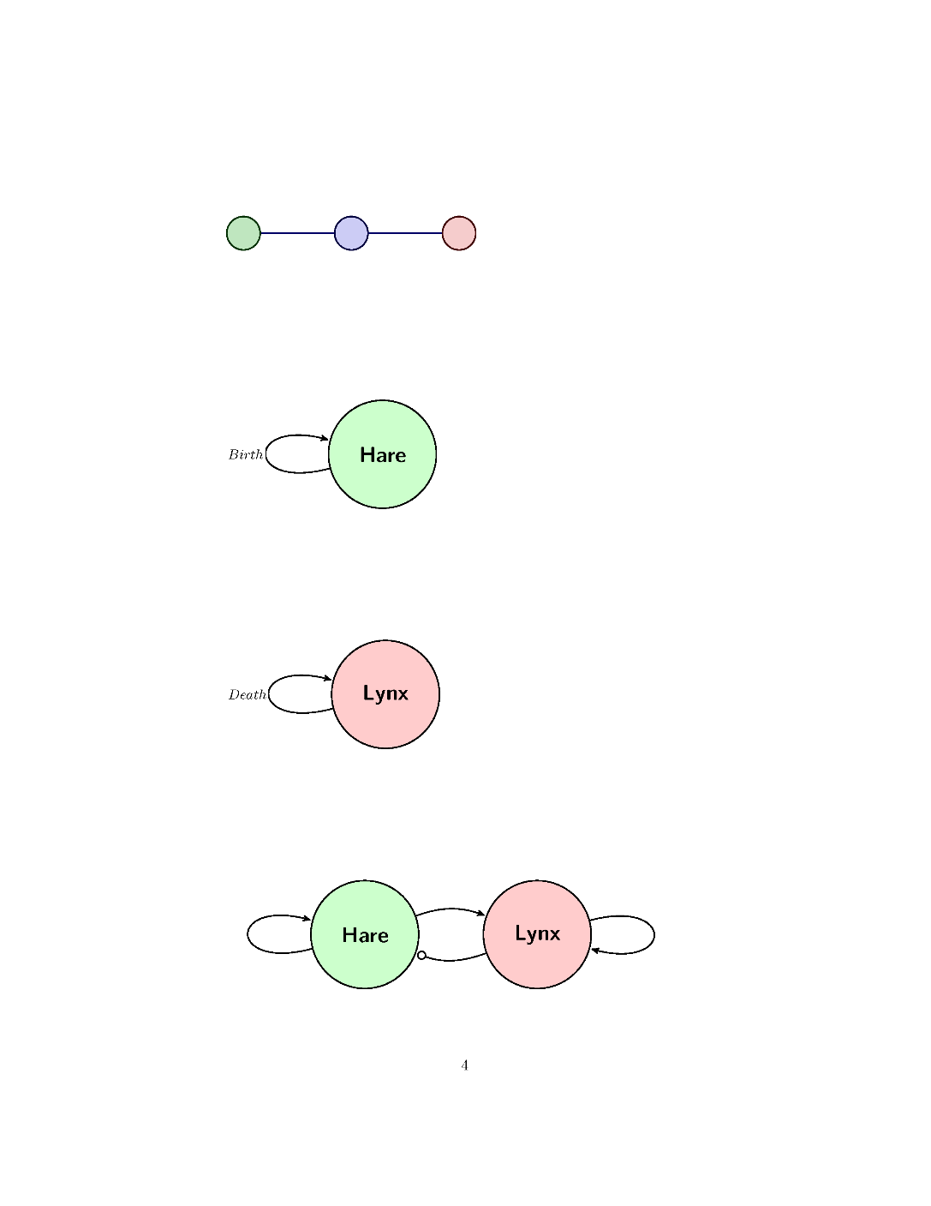
Given a population of 60 Hares and a growth rate of 0.2 what would the population be after three years?
Year | Hare Population
0 | 60
1
2
3
Sketch the Graph.
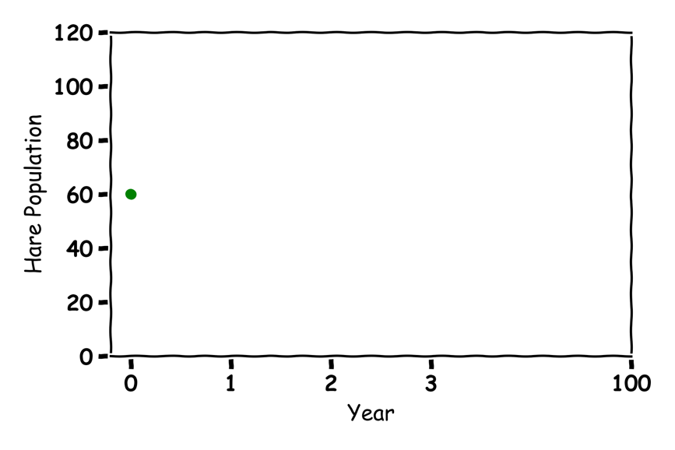
Guess what would happen in 100 years?

Lynx 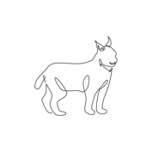

No Prey
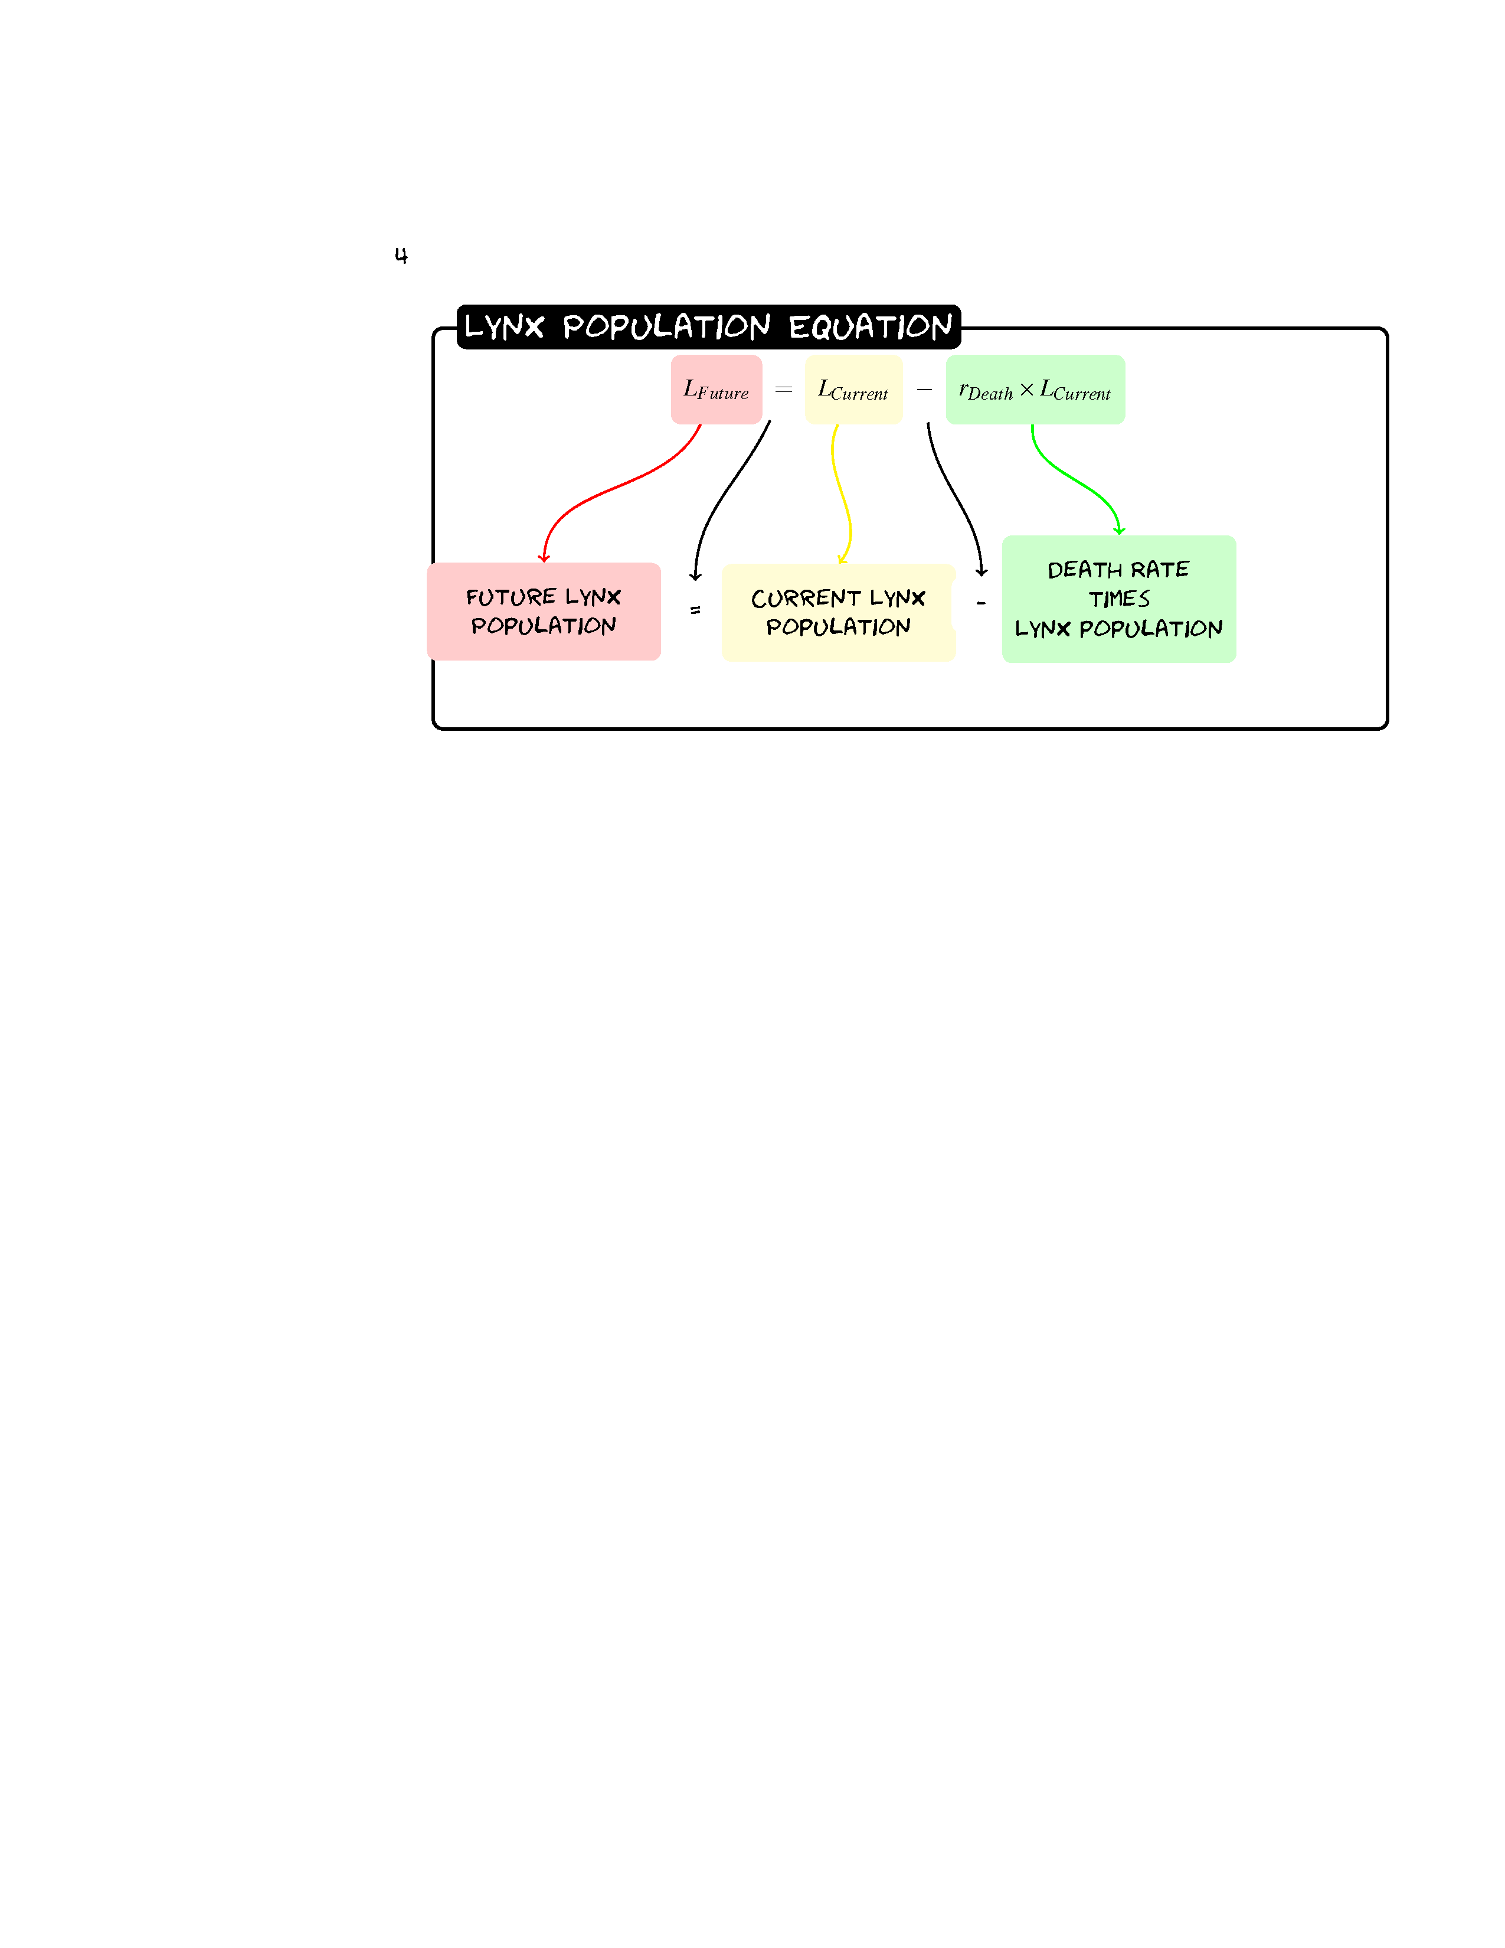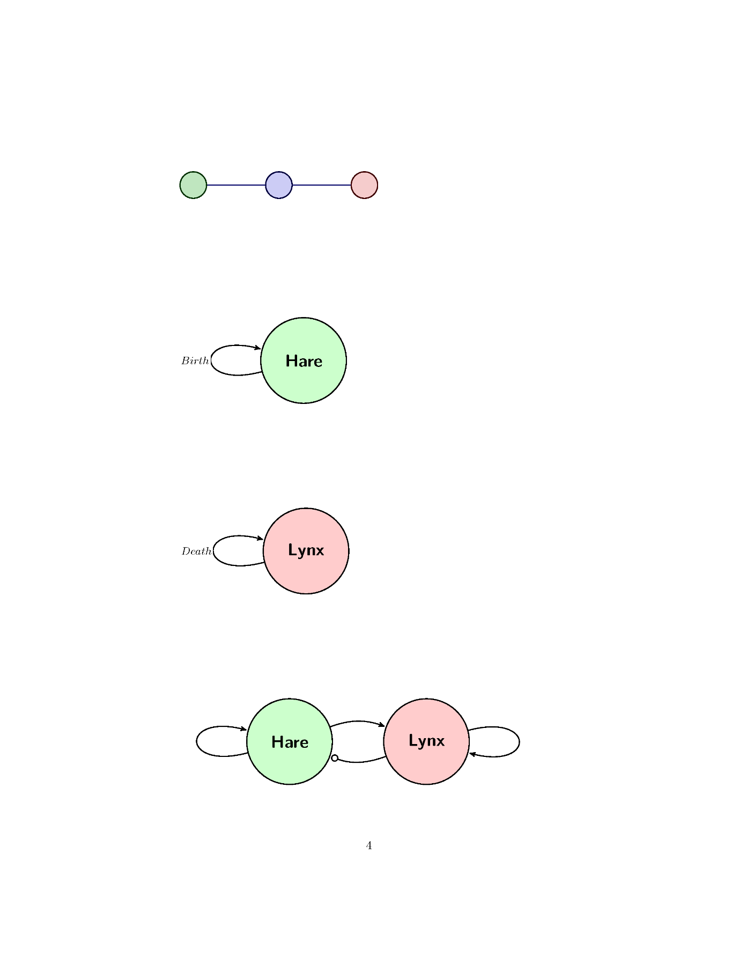
Given a population of 30 Lynxes and a death rate of 0.1 what would the population be after three years?
Year | Lynx Population
0 | 30
1
2
3
Sketch the Graph.
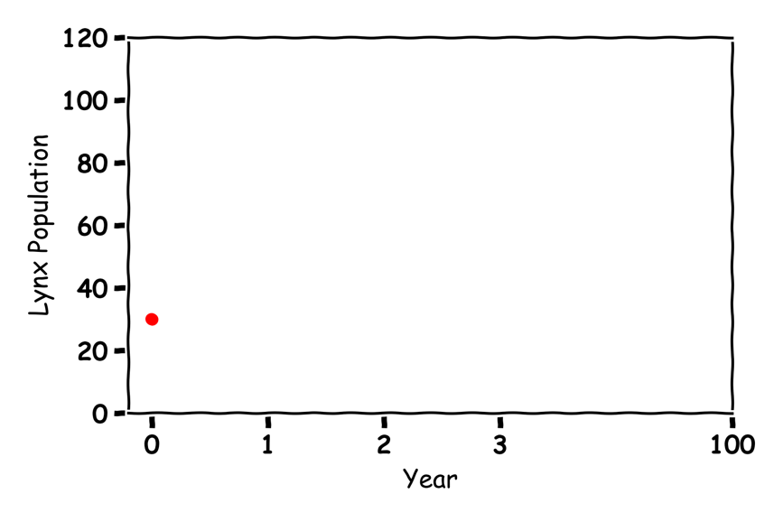
Guess what would happen in 100 years?

Hares and Lynxes  
Label the graph:

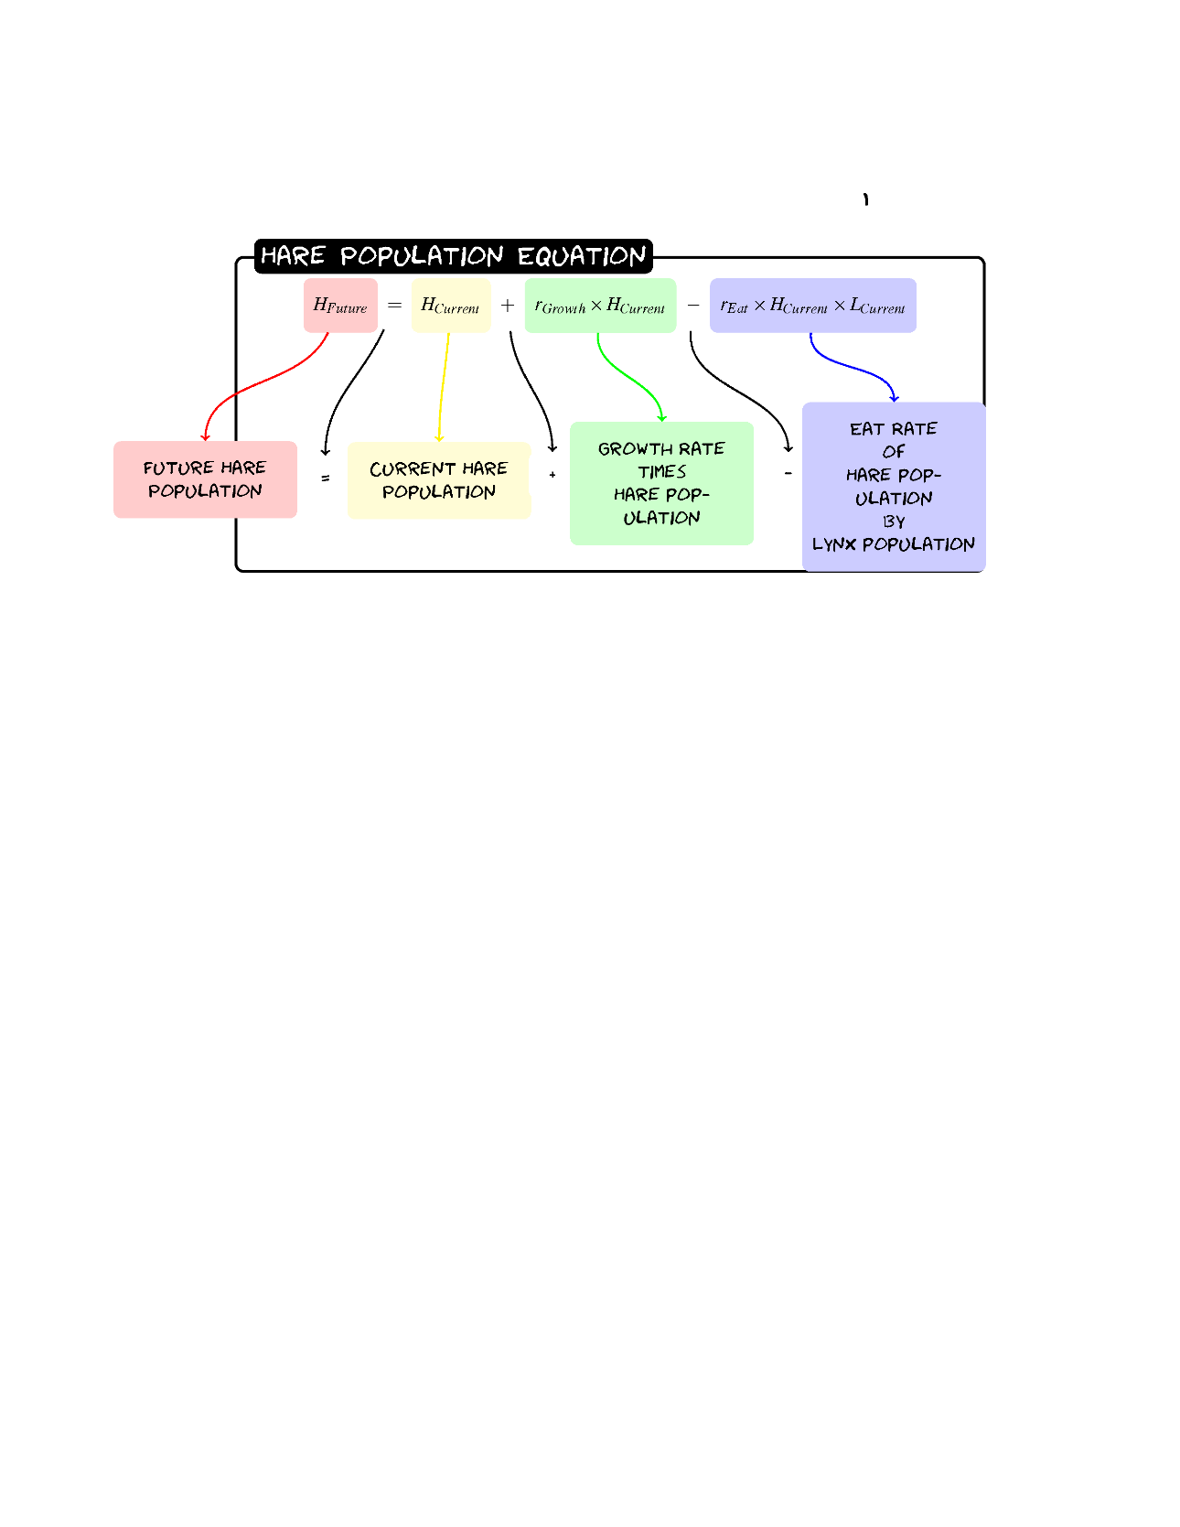
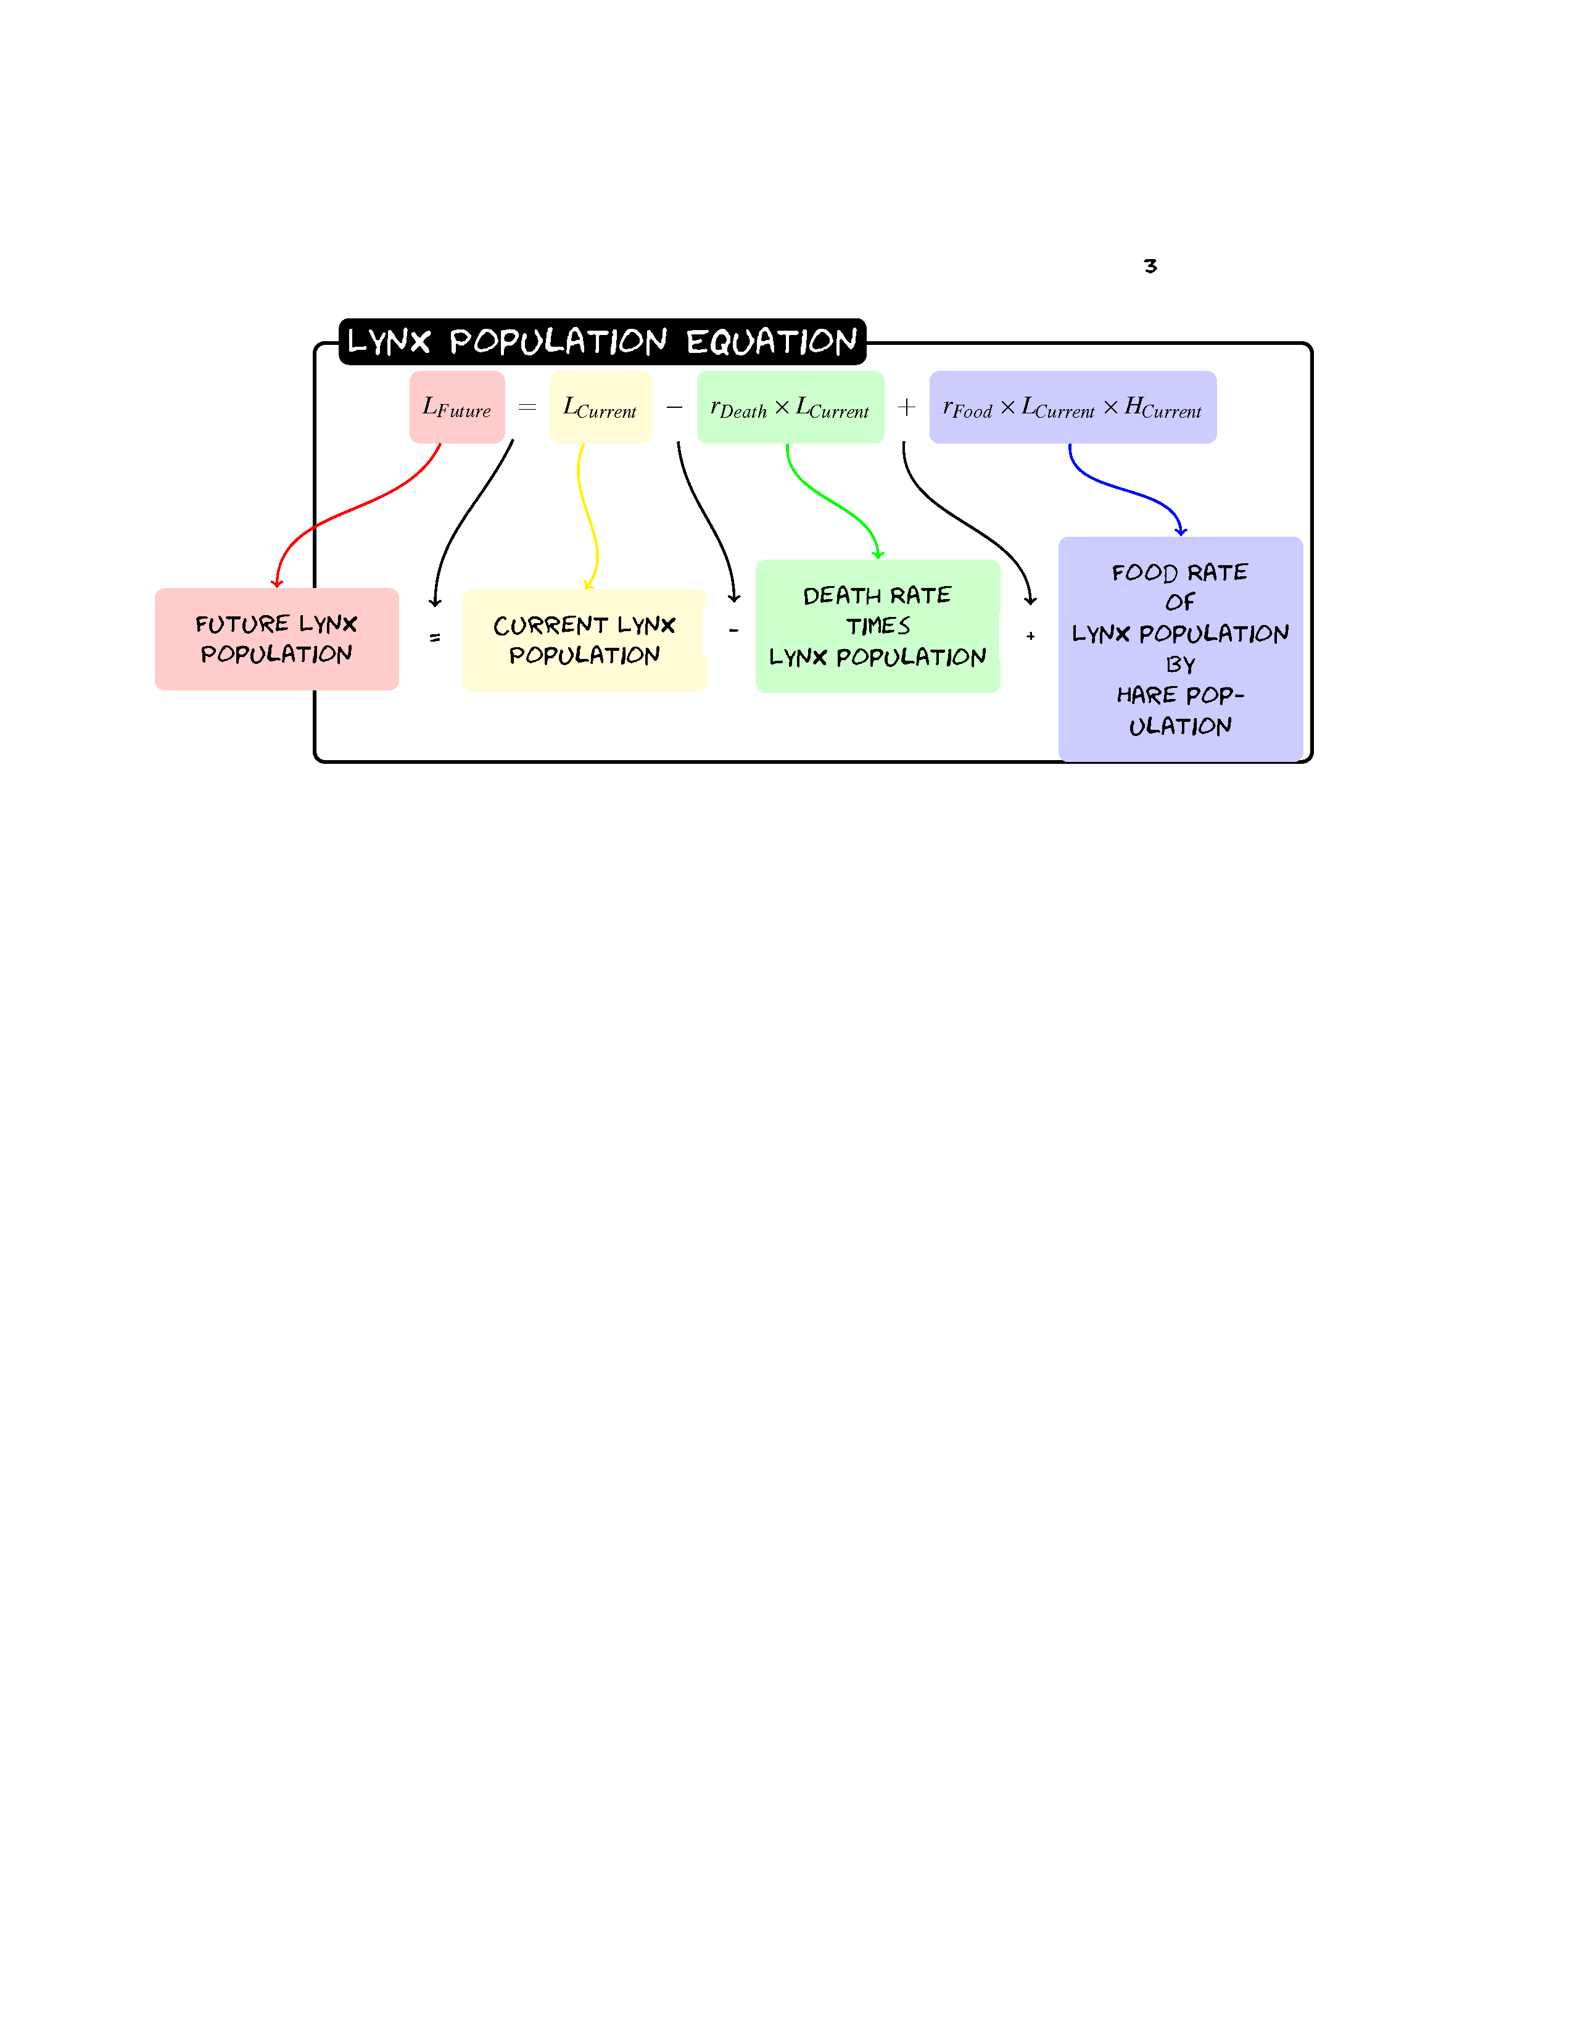

Given a population of 60 Hares and 30 Lynxes with a birth rate of .2, a death rate of 0.1, a eat rate of 0.005 and a food rate of 0.002 what would the populations be after three years?

Hare | Hare | Lynx | Value
Growth | 0.2 | Death | 0.1
Eat | 0.005 | Food | 0.002

Year | Hare Population | Lynx Population
0 | 60 | 30
1
2
3

Sketch the graph:
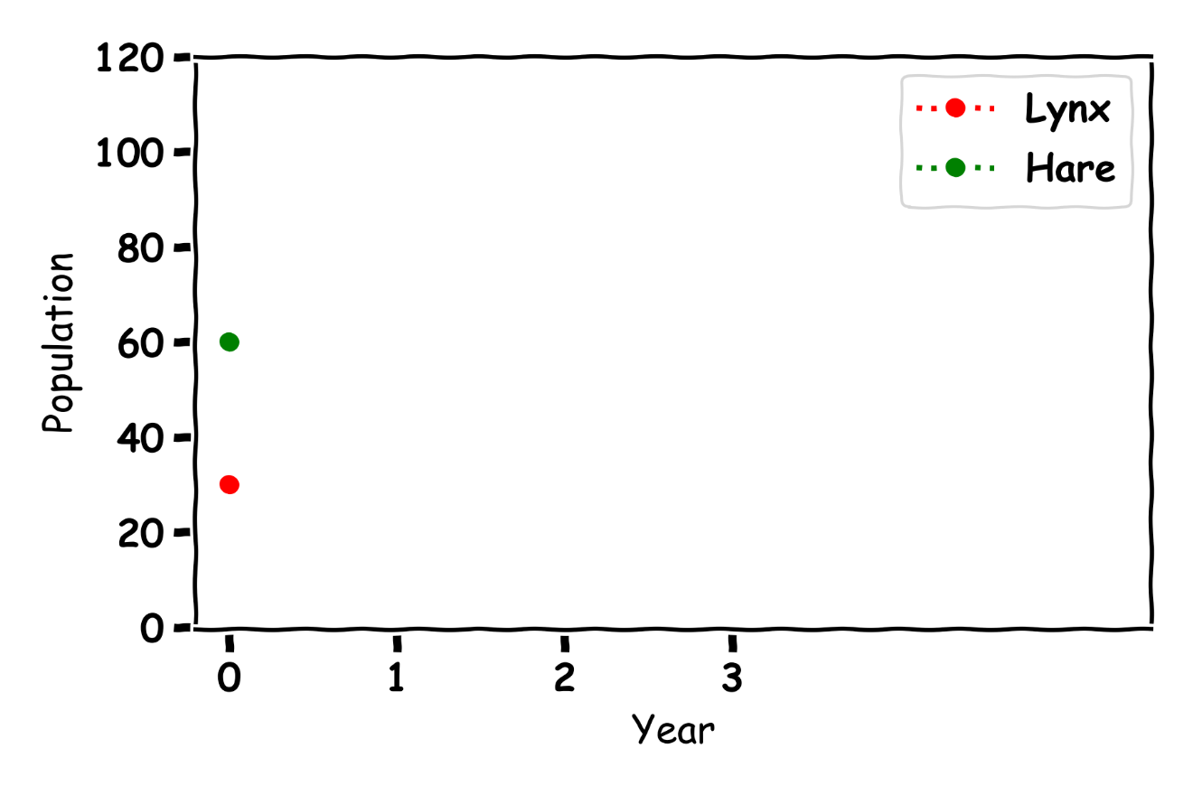
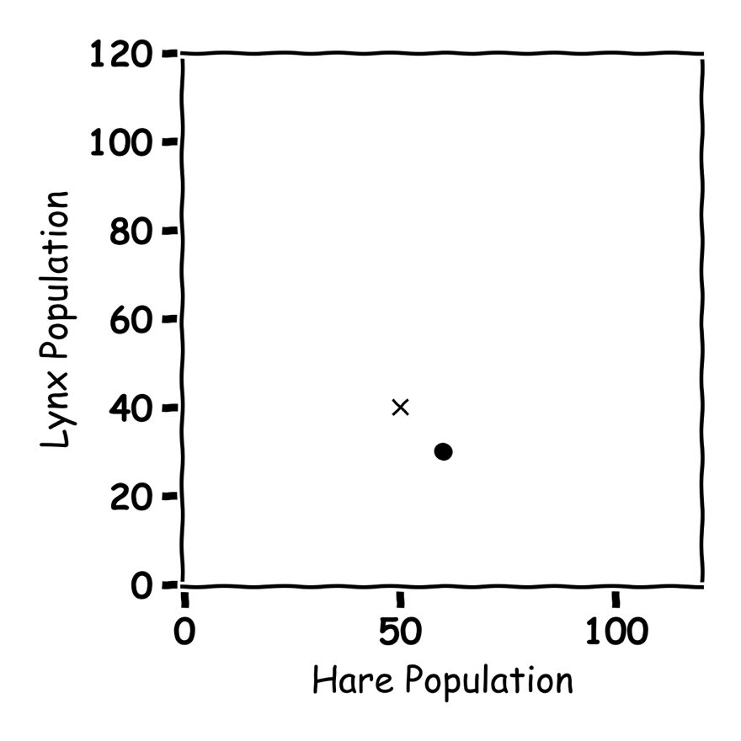

Don’t get Eaten by the Wolf
Label the graph


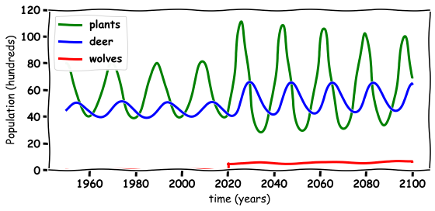

FEEDBACK

General Experience
What did you enjoy most about the workshop?

Was there anything you found challenging or unclear during the session?

On a scale of 1 to 5, how engaging did you find the workshop? (1 = Not engaging, 5 = Very engaging)
1 2 3 4 5

Content and Delivery
Were the topics covered relevant and interesting to you? (1 = Not interesting, 5 = Very interesting)
1 2 3 4 5

Was the pace of the workshop appropriate? (1=Too slow,3= Just right, 5=Too fast)
1 2 3 4 5

Did the examples or exercises help you understand the concepts better? (1 = Not helpful, 5 = Very helpful)
1 2 3 4 5

Was the presenter clear and easy to follow? (1 = Not clear, 5 = Very clear)
1 2 3 4 5

Suggestions for Improvement
What would you like to see more of in future workshops?

Is there any topic you think we should include next time?

How could we improve your overall experience?

