Decision Making
Am I Going to Bike or Walk

Name: ________________________________________________ Date: ____________

Exercise 1: How do you Decide

- How did you get here today?

- Did you decide?

- What helps you make a decision?

- Do you sometimes make the wrong decision? Give an example

- Are you sometimes unable to decide?

- Is it better to decide slowly or quickly?

- What would make you change a decision?

- What happens when time runs out?

Making a Decision

Exercise 2: A Plot Is Worth 1000 Words
Put a start point and explain the different lines on the decision graph:
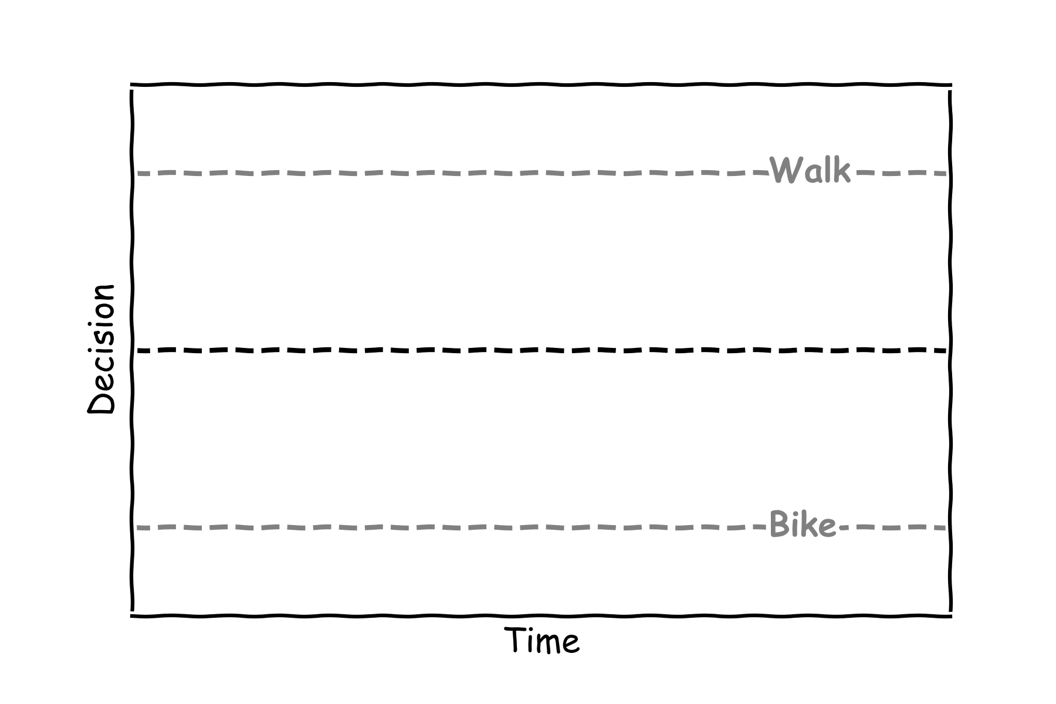

Exercise 3.1: The decision formula?
The simplified decision formula is a version of the formula of a line:

$$x=μt+0.$$
What does the drift rate $μ$ correspond to
- The slope
- The intercept
- The y-variable

Exercise 3.2: Drift to a Decision
If the decision time is 1.5 seconds and the bike threshold is -1 calculate the Drift Rate

$$μ=\frac{Bike Threshold}{Decsion Time}=$$

Exercise 3.3: Evidence in Decision
Given the current decision evidence, x(t), is 0.2 and the drift rate is 0.5 calculate the updated decision using the formula
$$x\left(t+1\right)=x\left(t\right)+0.5x\left(t\right).$$

Answer:

Exercise 4.1: Let’s make a decision
Given the current decision evidence, x(t), is -0.2 and the drift rate is 0.75 calculate the updated decision for two time steps using the formula:
$$x\left(t+1\right)=x\left(t\right)+0.75x(t)$$

Time step | Current Decision x(t) | Updated Decision x(t+1)
0 | -0.2 | -0.2+0.75*(-0.2)

1

2

Exercise 4.2: Let’s make a decision
Sketch the answers in the table on the graph

Exercise 4.3: Deciding Fast, Deciding Slow
Will a large drift, $μ,$ mean you decide?

- Faster
- Slower

Exercise 5: No Decision

Exercise 5.1: Let’s Draw No Decision
Sketch a graph where there is no evidence for the decision:

Exercise 5.2: Let’s Calculate No Decision
Given the current decision evidence, x(t), is -0.2 and the drift rate is 0.5 calculate the updated decision for two time steps using the formula:
$$x\left(t+1\right)=x\left(t\right)+0.5x(t)$$

Time step | Current Decision x(t) | Updated Decision x(t+1)
0 | 0 | 0.0+0.5*(0.0)

1

2

Exercise 5.3: Let’s Make No decision
What would make it hard to decide to bike or walk?

- You only love walking
- You only love biking
- You love both walking and biking the same

Exercise 6: Let’s Bias a Decision

Exercise 6.1: Add a start point to the plot that would be biased to decide to bike:
Exercise 6.2: Let’s Calculate a Bias
Given the current decision evidence, x(t), is -0.6 which is -0.2 and a bias of -0.4, and the drift rate is 0.75 calculate the updated decision for two time steps using the formula:
$$x\left(t+1\right)=x\left(t\right)+0.75x(t)$$

Time step | Current Decision x(t) | Updated Decision x(t+1)
0 | -0.2-0.4=-0.6 | -0.6+0.75*(-0.6)

1

2

Exercise 6.3: Let’s Bias Your Decision

What would make you prefer to walk?

- Better bike paths

- New bike

- A friend is walking

Exercise 7: Let’s Change a Decision
Exercise 7.1: Draw a Change of Decision
Sketch a change of decision going from almost deciding to bike to deciding to walk.

Exercise 7:2: Let’s Change Your Decision
If you were thinking of biking but then you see a “no bike” sign would that change your decision?
- Yes
- No

Exercise 8: There Is Not Enough Time

Given the graph below what decision was made when there was no time left?
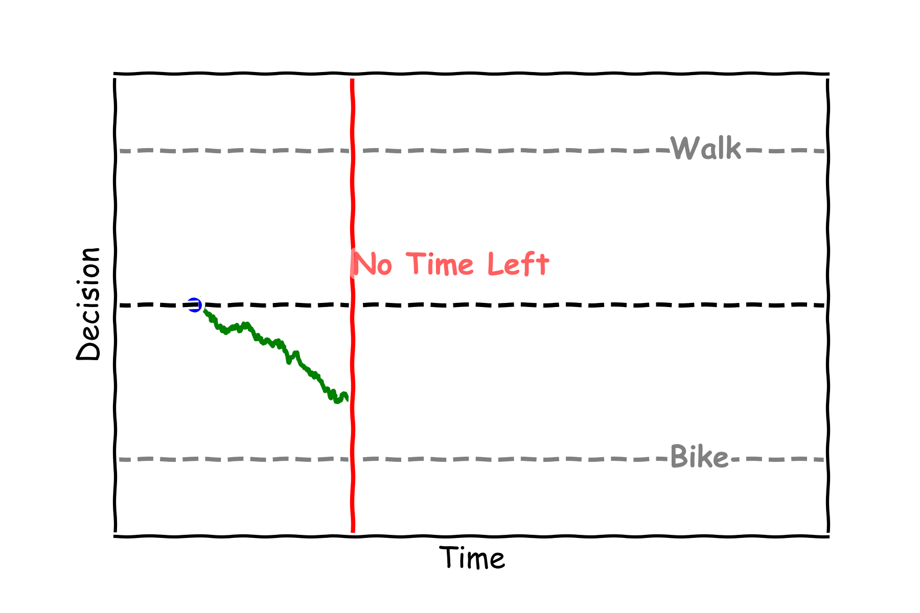
- Bike
- Walk

Was it the correct decision?

Exercise 9: Competing Siblings

Given the graph below which sibling got to decide?
How did they travel to school?
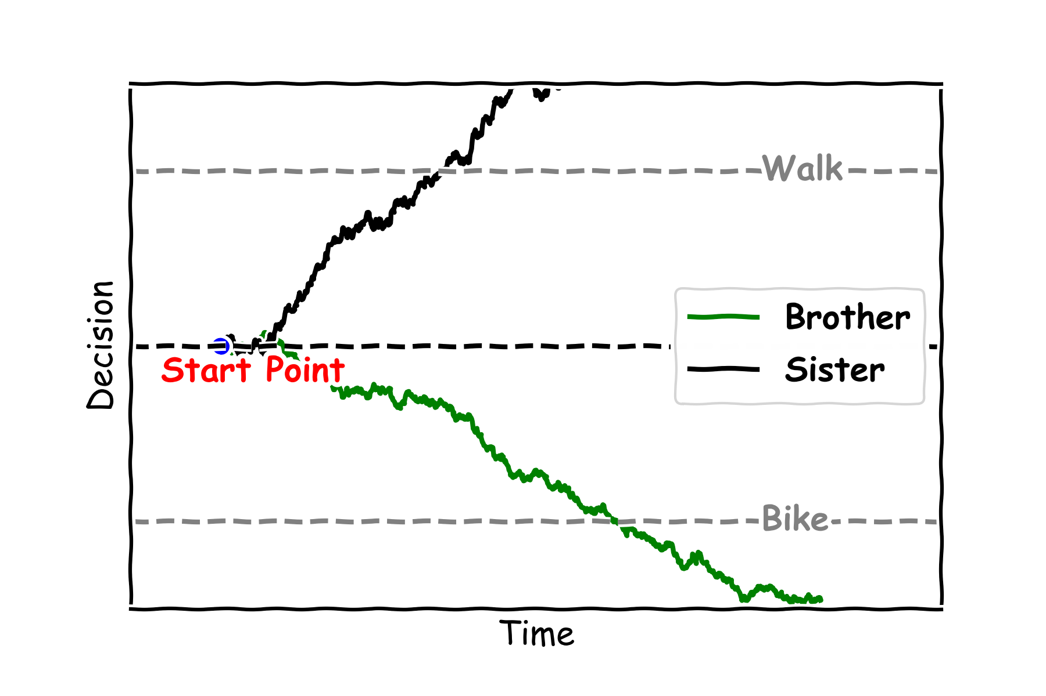

Exercise 10: You Decide

Fill in the table below with your own example of a decision making process that could be modelled like biking or walking to school.

Example | What Is the Decision? | What Is the Evidence? | What Affects Speed?
How to get to School | Bike or Walk | The weather or is someone else walking | How much you like walking or biking

