The Maths of Predators and Preys
Don’t get Eaten by the Wolf

Hares 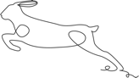

No predators
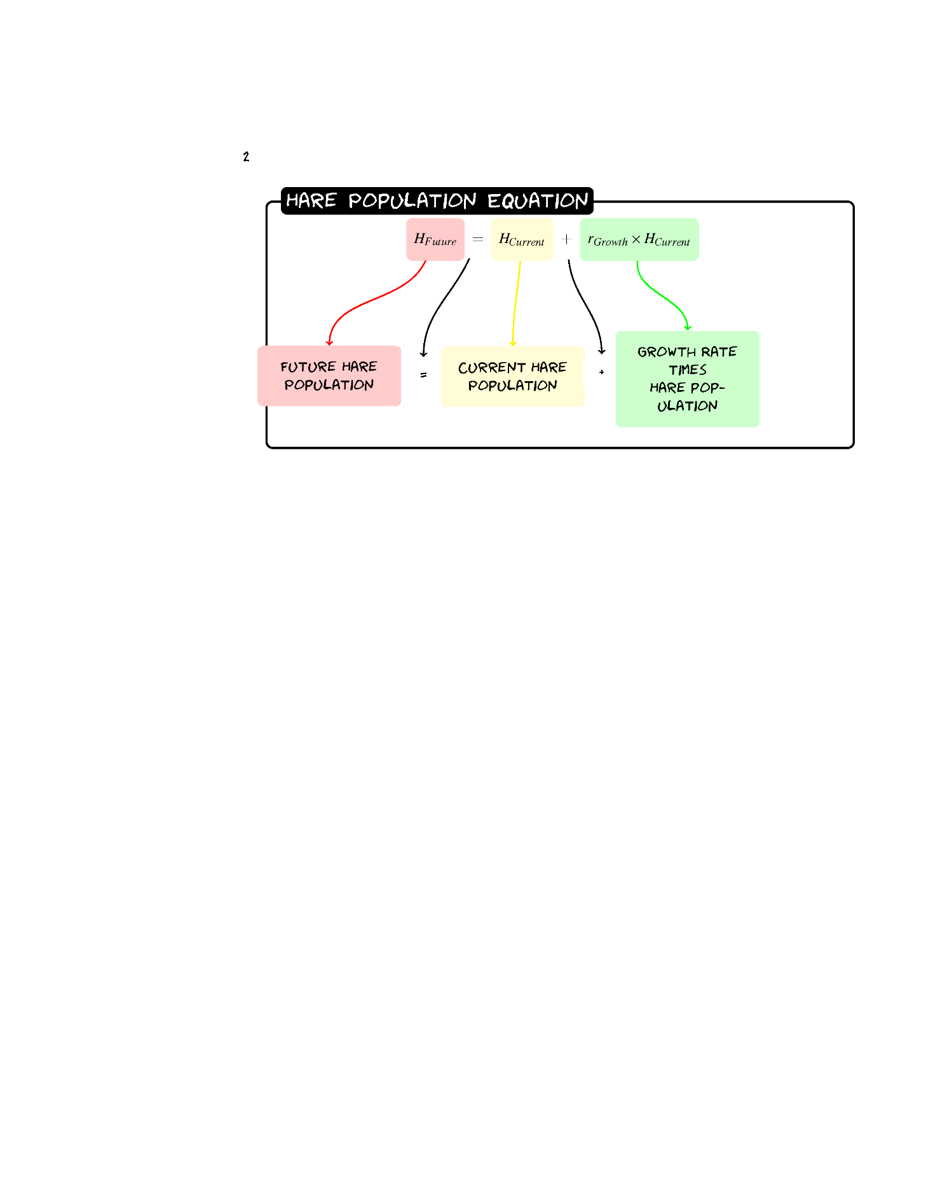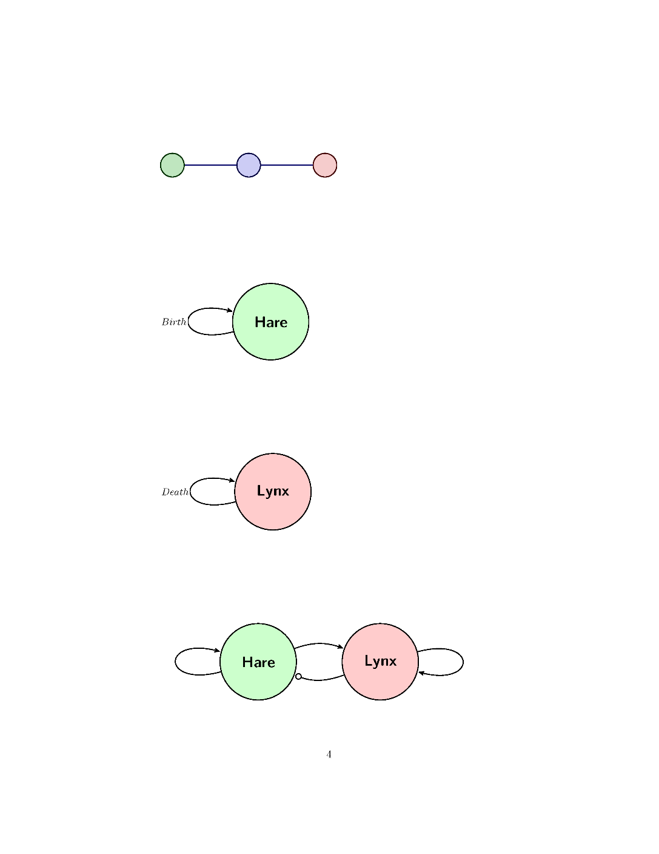
Given a population of 60 Hares and a growth rate of 0.2 what would the population be after three years?
Year | Hare Population
0 | 60
1 | 60+0.2*(60)=72
2 | 72+0.2*(72)=86
3 | 86+0.2*(86)=103
Sketch the Graph.
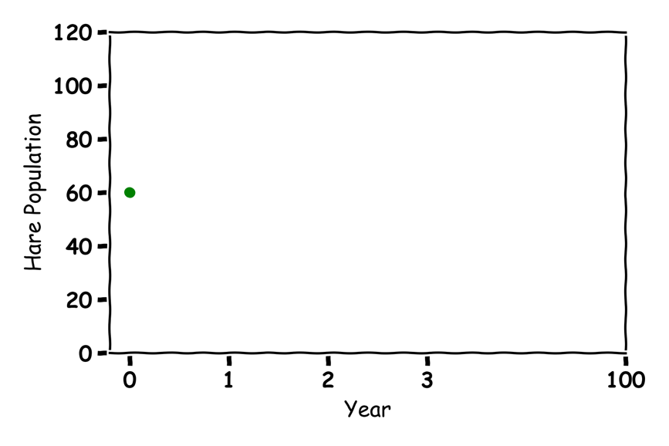
Guess what would happen in 100 years?
Over 4 Billion

Lynx 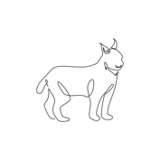

No Prey
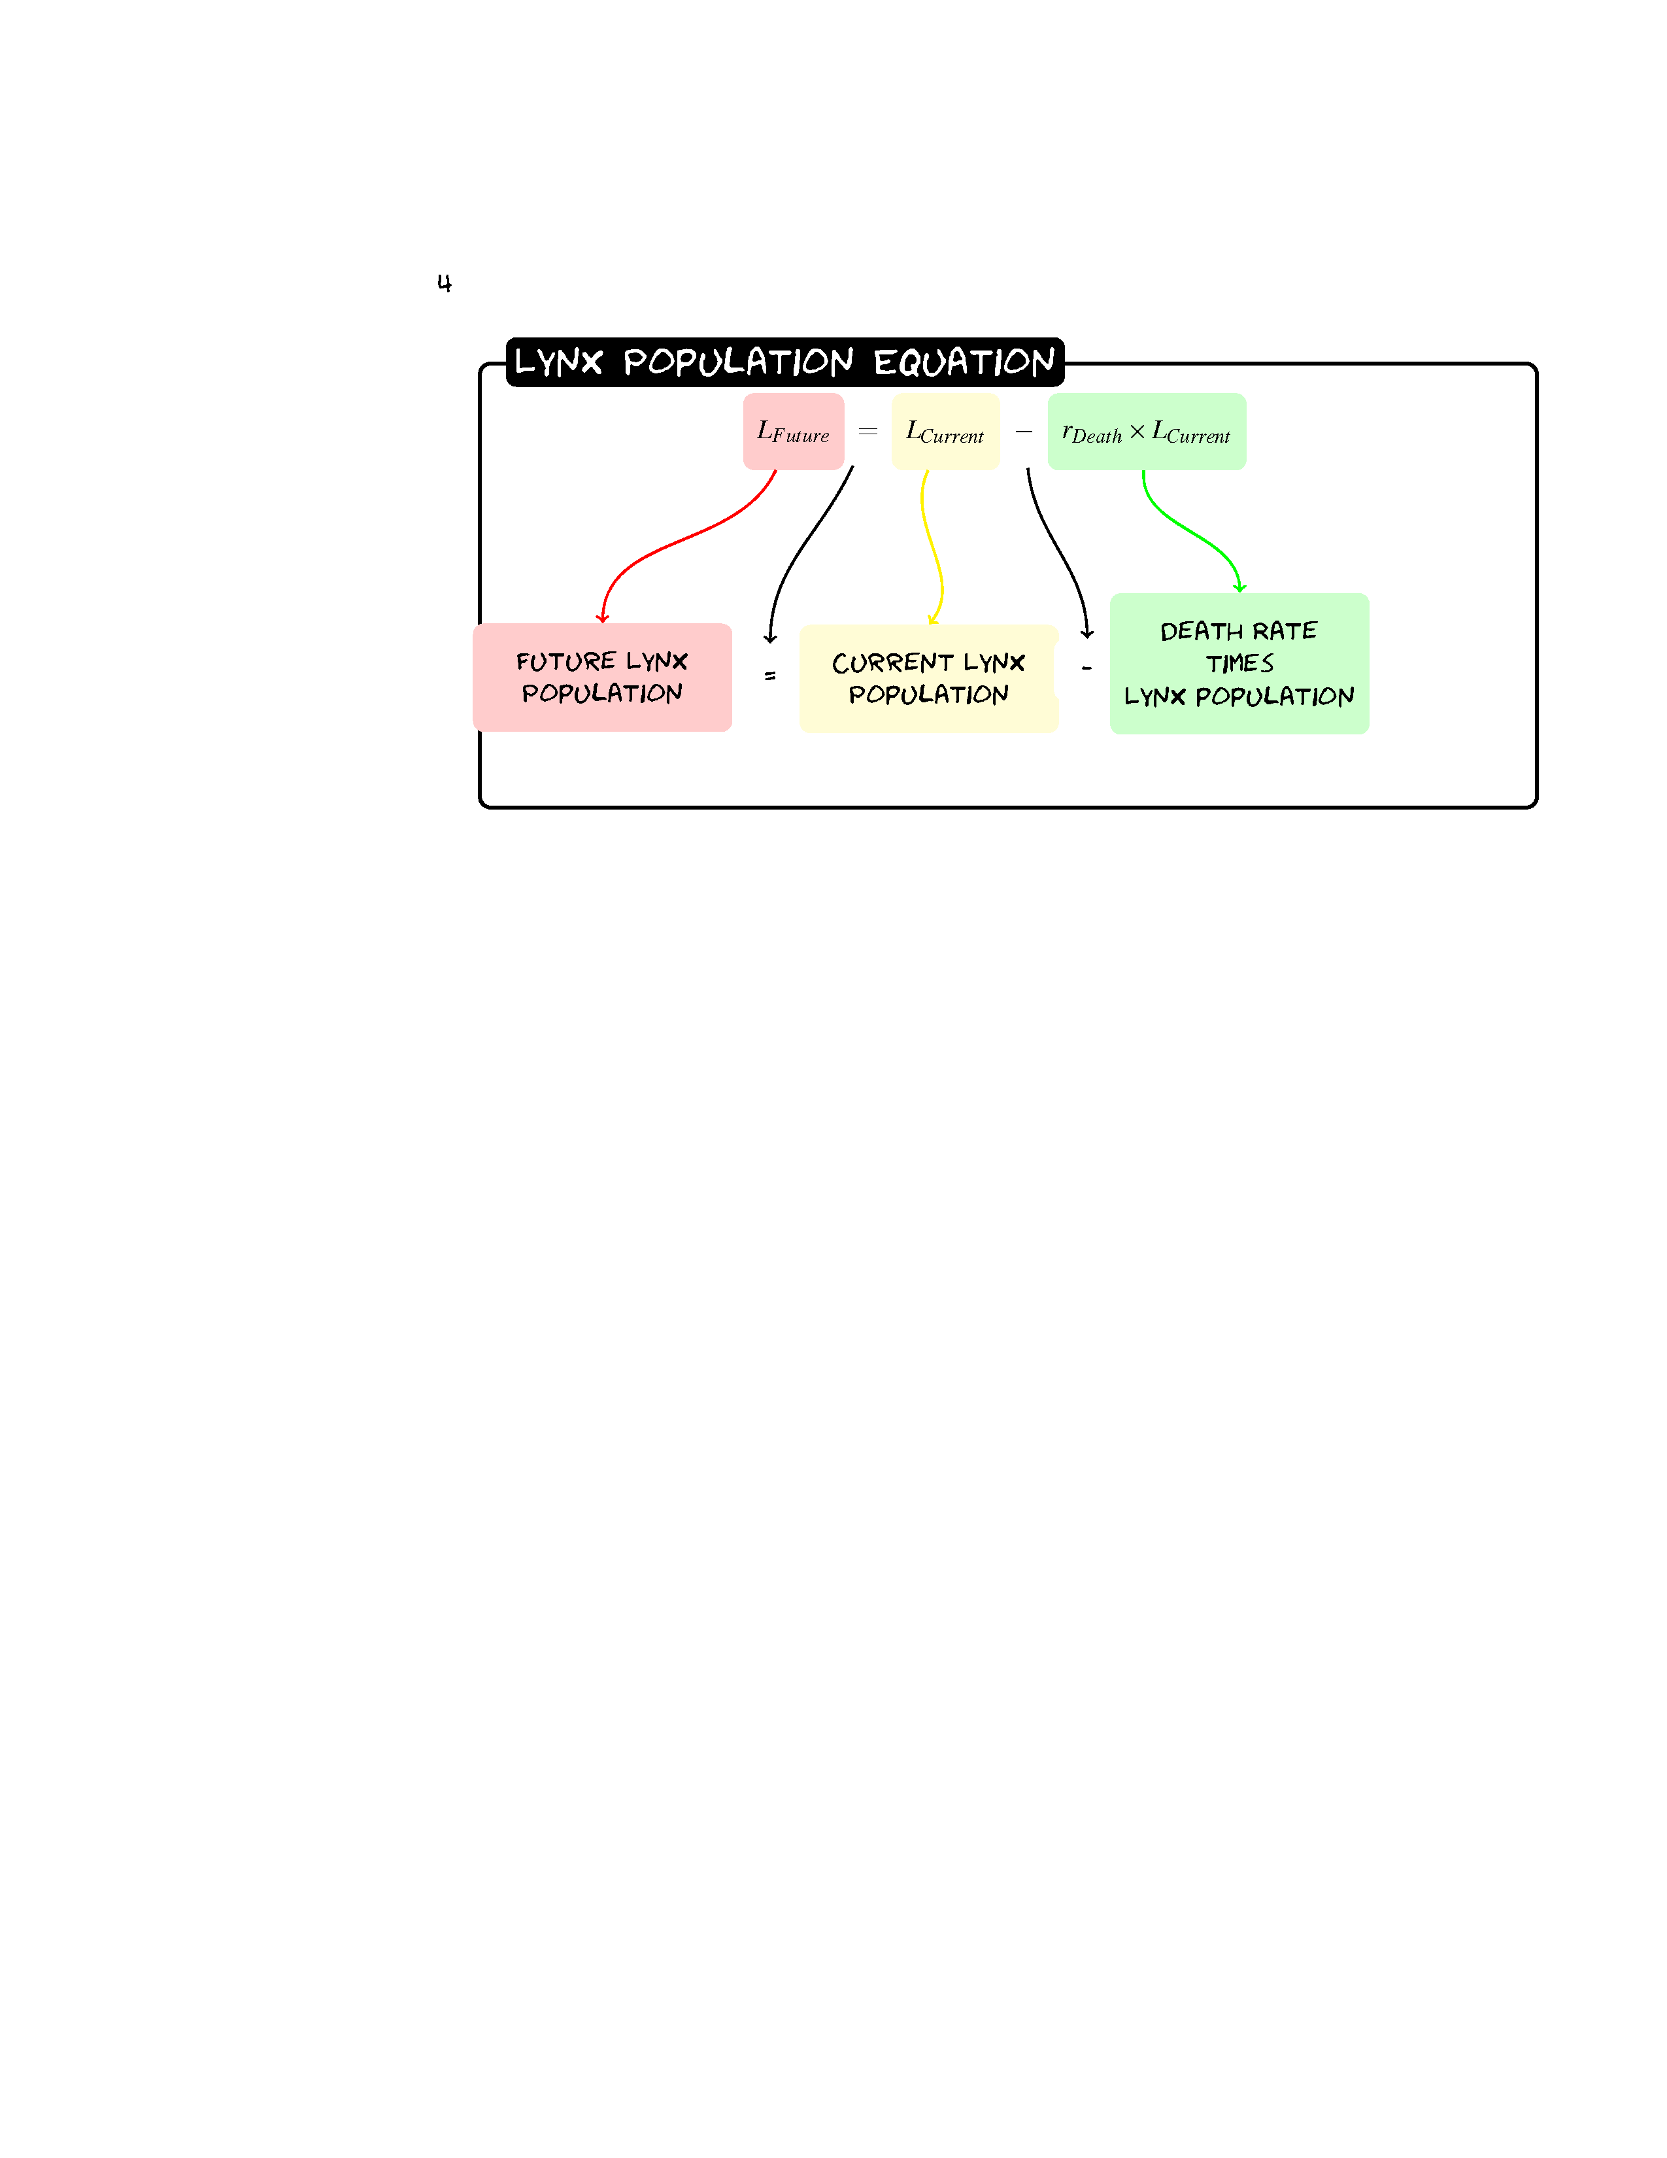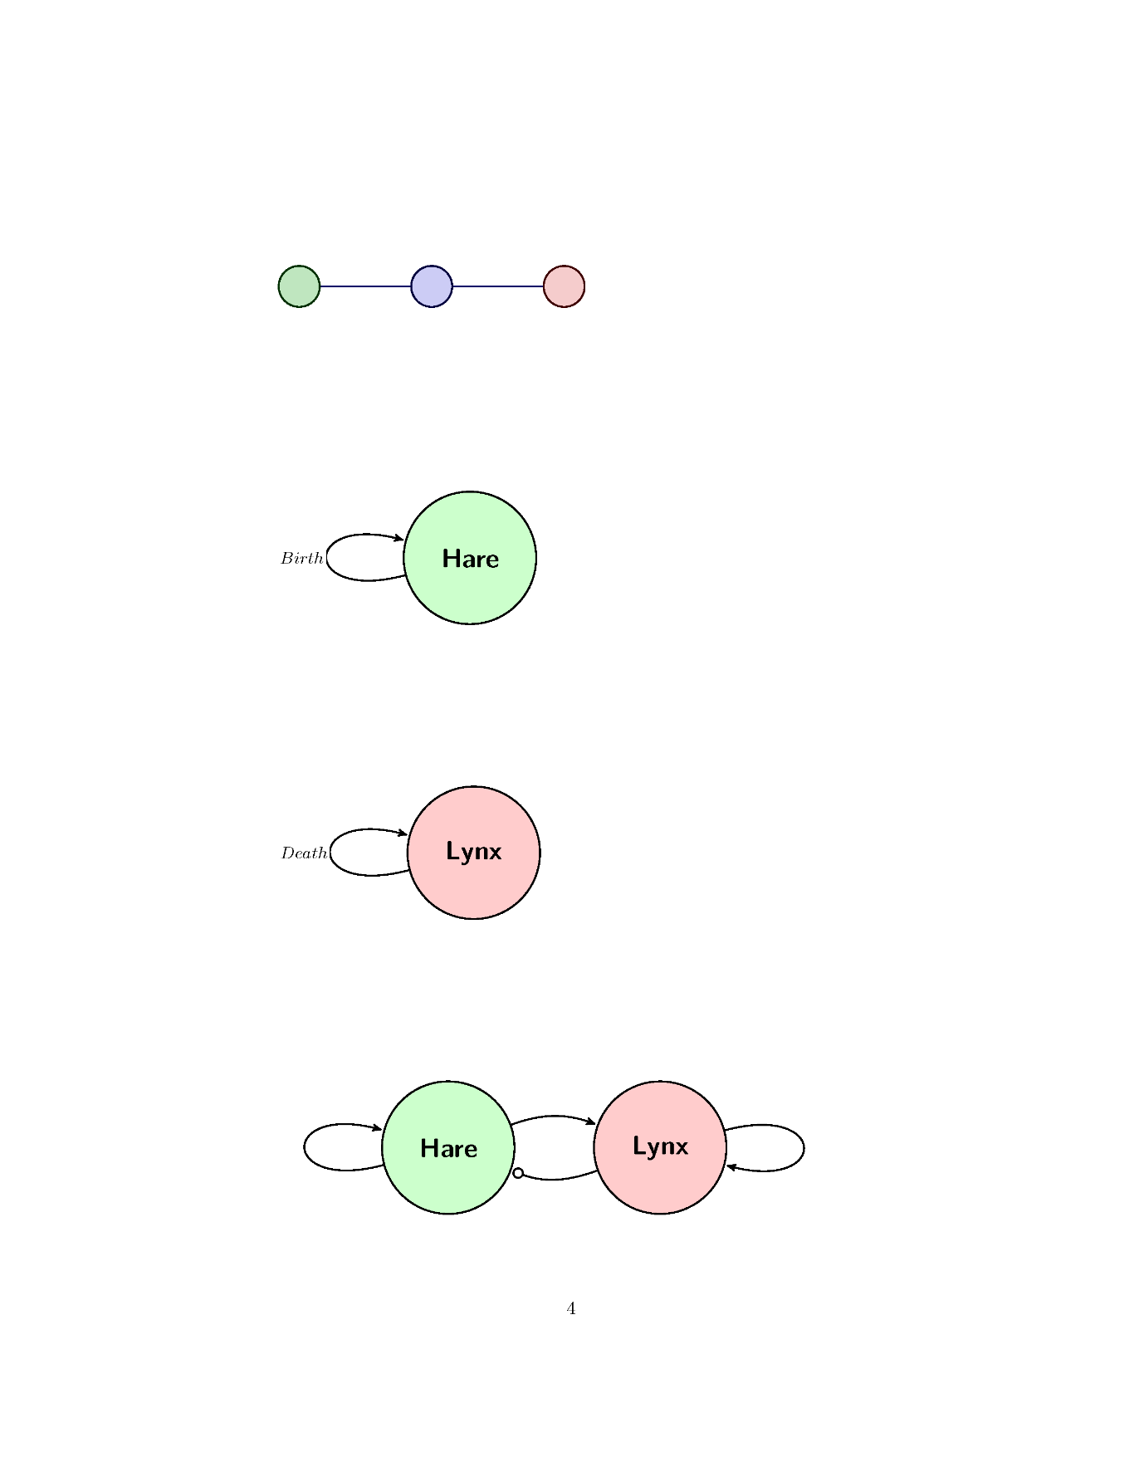
Given a population of 30 Lynxes and a death rate of 0.1 what would the population be after three years?
Year | Lynx Population
0 | 30
1 | 30-0.1*(30)=27
2 | 27-0.1*(27)=24
3 | 24-0.1*(24)=22
Sketch the Graph.
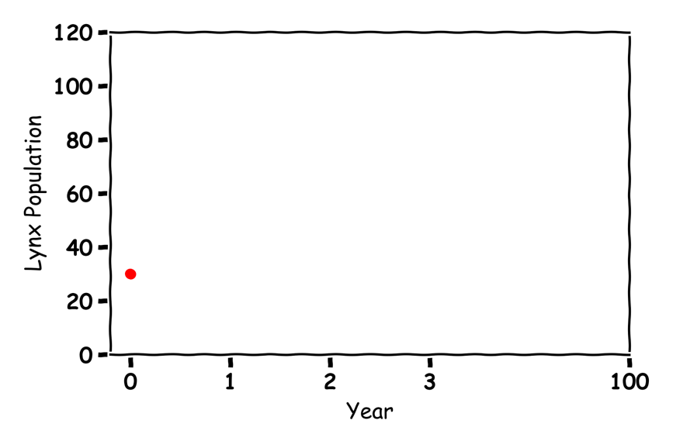
Guess what would happen in 100 years?
All Dead

Hares and Lynxes  
Label the graph:
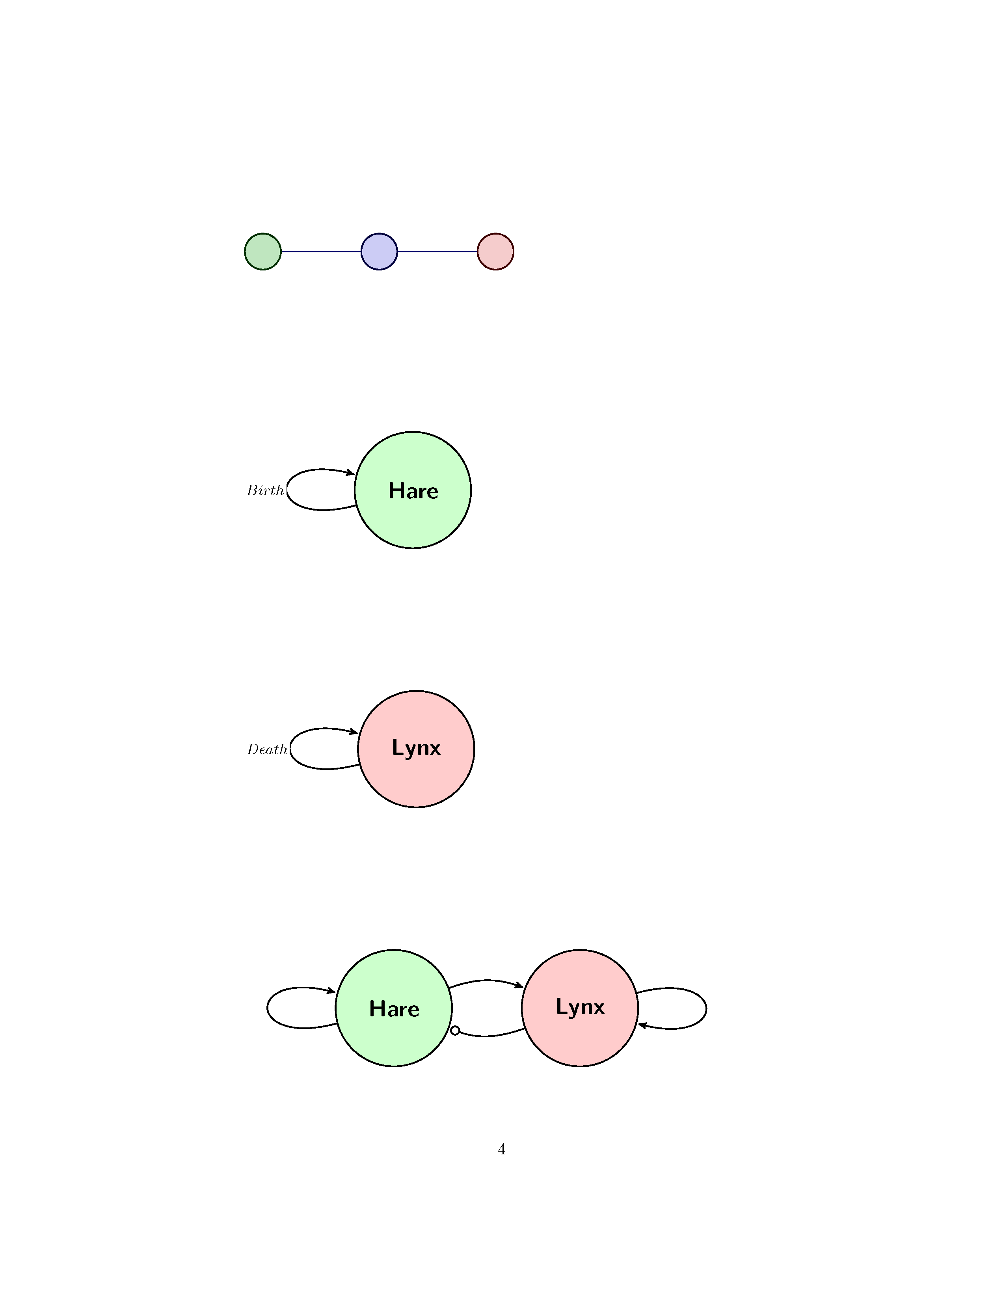
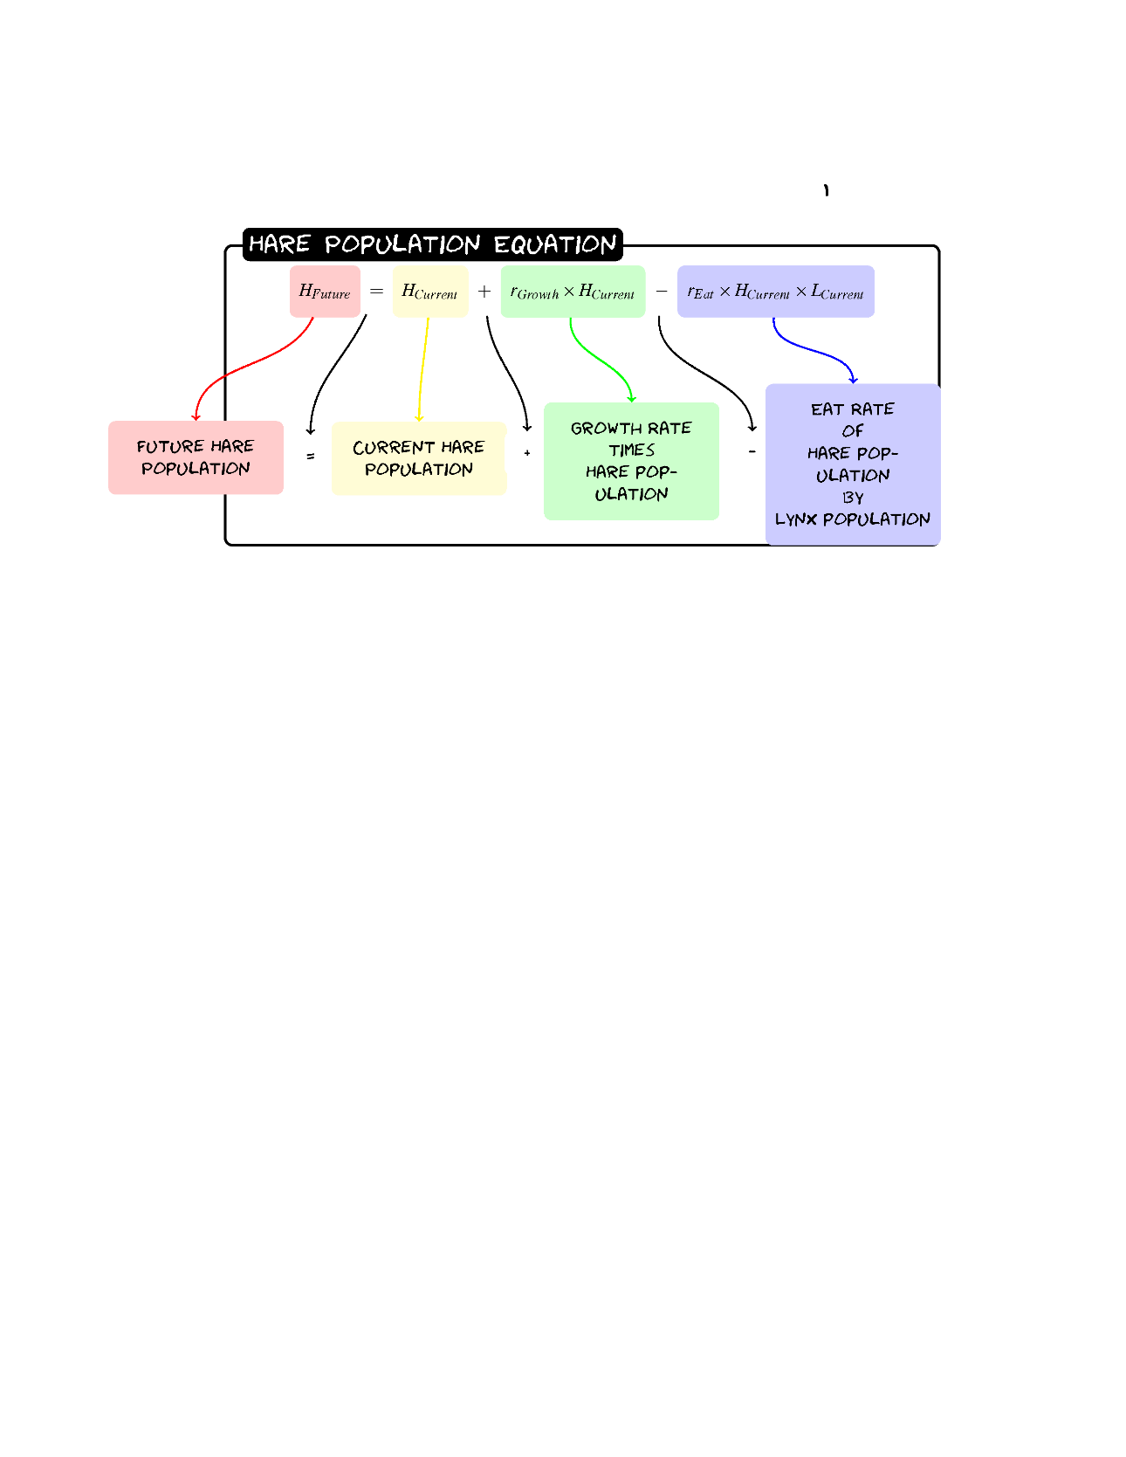
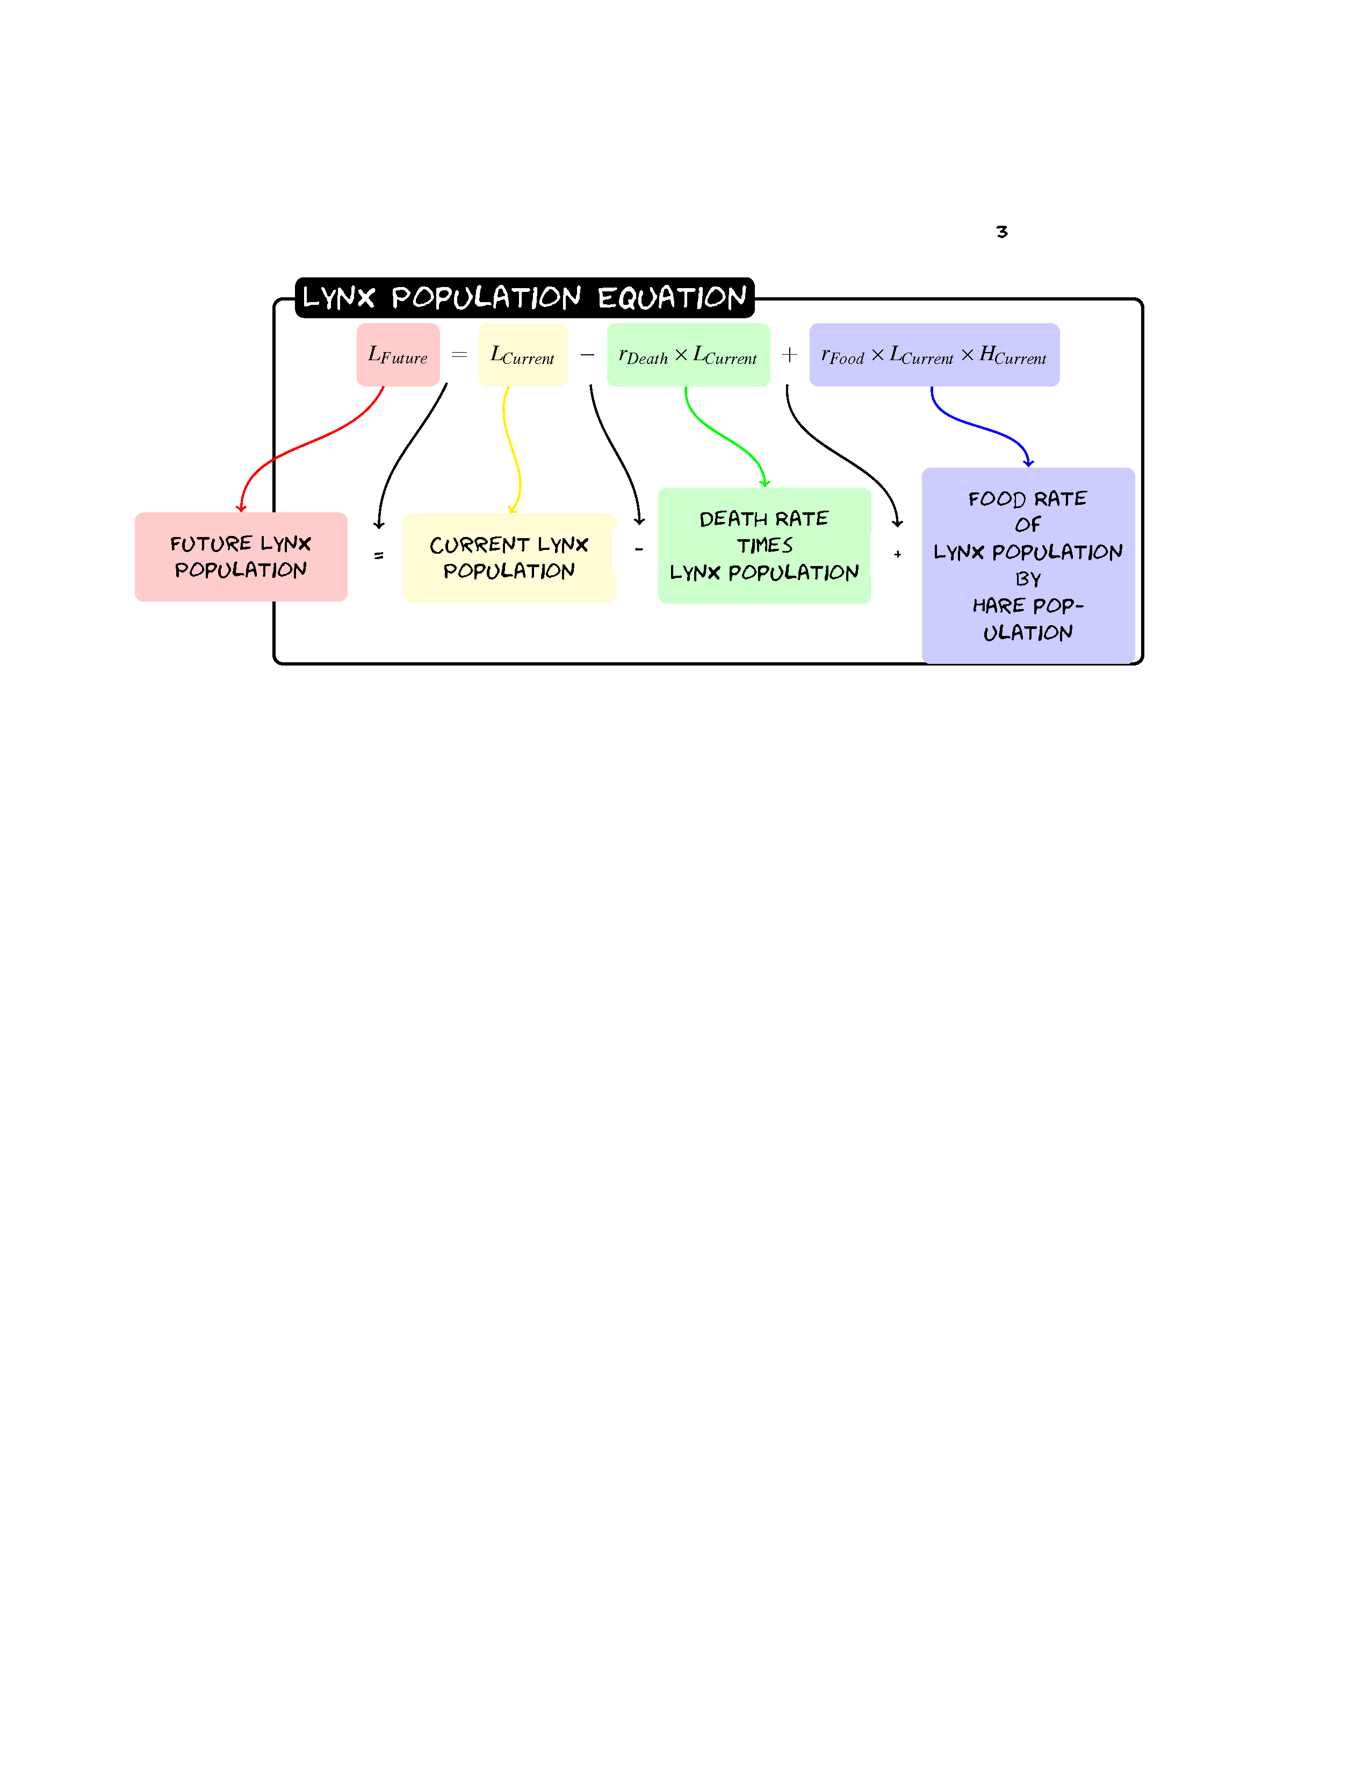

Given a population of 60 Hares and 30 Lynxes with a birth rate of .2, a death rate of 0.1, a eat rate of 0.005 and a food rate of 0.002 what would the populations be after three years?

Hare | Hare | Lynx | Value
Growth | 0.2 | Death | 0.1
Eat | 0.005 | Food | 0.002

Year | Hare Population | Lynx Population
0 | 60 | 30
1 | 60+0.2*(60)-0.005*(60)*(30)=63 | 30-0.1*(30)+0.002*(30)*(60)=31
2 | 63+0.2*(63)-0.005*(63)*(31)=66 | 31-0.1*(31)+0.002*(31)*(63)=31
3 | 66+0.2*(66)-0.005*(66)*(31)=69 | 31-0.1*(31)+0.002*(31)*(66)=32

Sketch the graph:
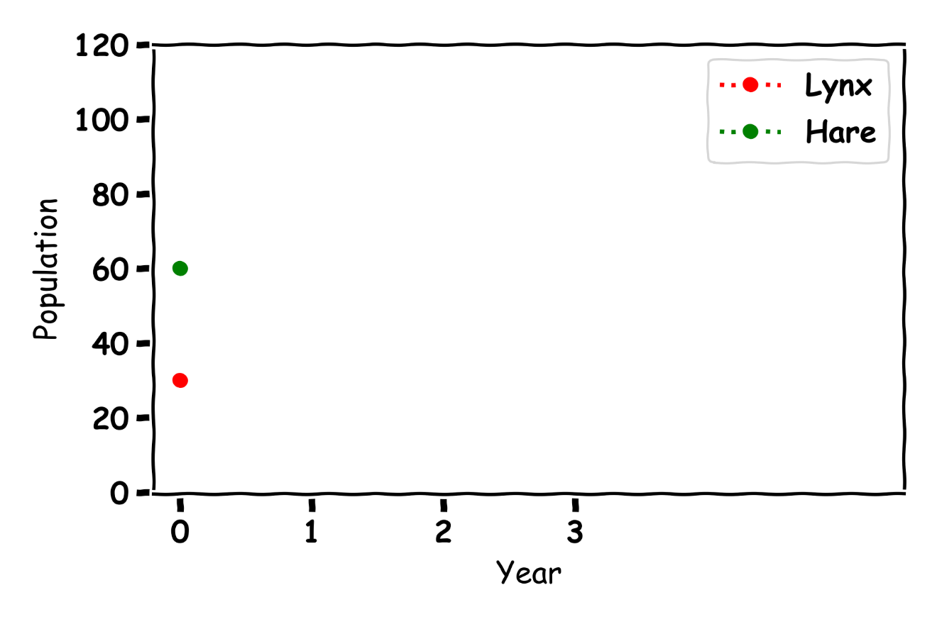
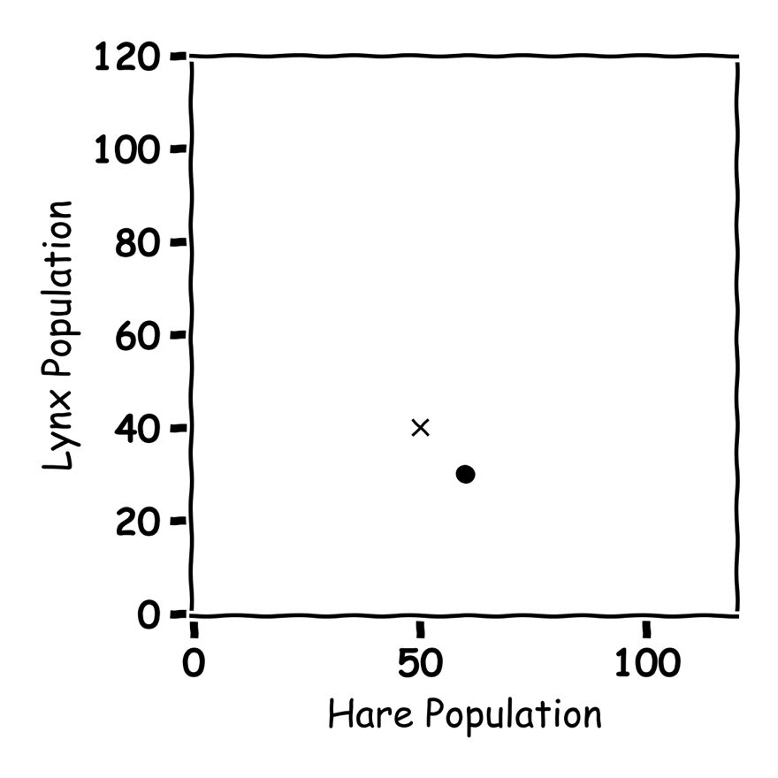

Don’t get Eaten by the Wolf

Label the graph
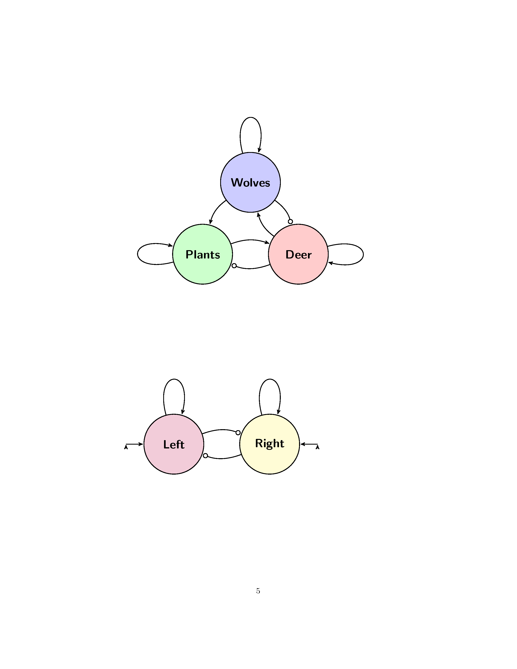
More Plants Grow
More Deer Born
Death rate Wolves
Wolves eat Deer
Deer eat plants
Food for wolves
Wolves project plants

Describe what is happening in the below graph:
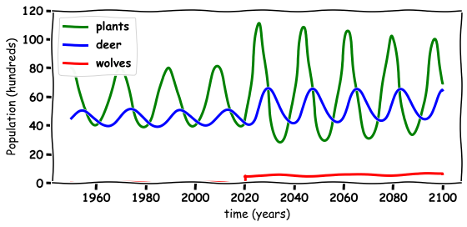

When the Wolves were reintroduced, they scared the deer from the river which helped the plants grow. Thie also made more food for the deer.

Discussion Questions
- What happened to the environment when the wolves are re-introduced?

- What happened to the wolf population when they are re-introduced?

- What happened to the deer population when the wolves are re-introduced?

- Do you think the wolves should have been re-introduced in Ireland?
- What else could you model with these Equations?

