The Maths and Neuroscience of Walking
Walking is Not as Easy as You Think
Name: ______________________________________________ Date: ____________

Sensory Systems
How many senses are there and name them:

What is Multisensory Integration

How Much Do You Remember
Label the graph and add the data:
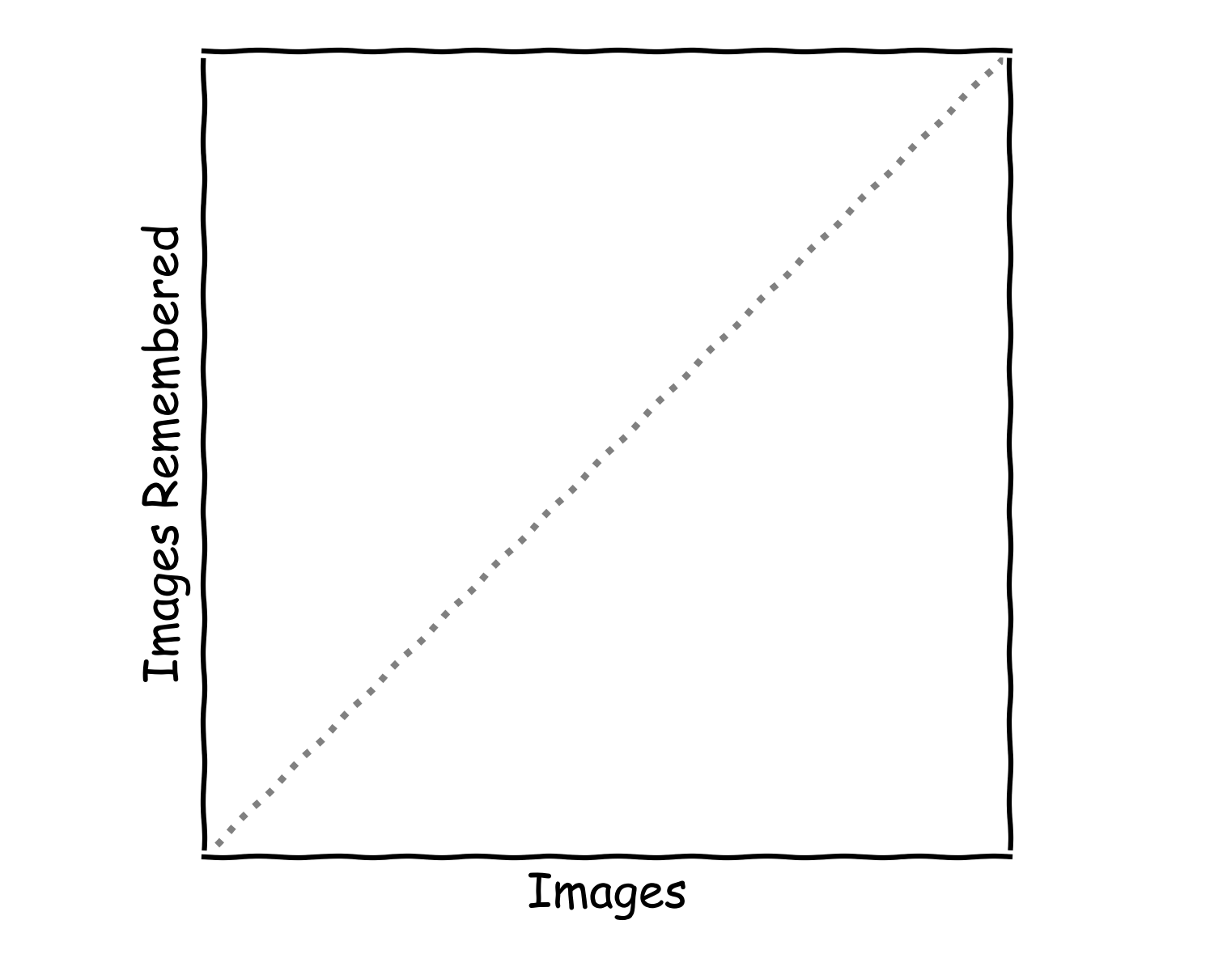

Left or Right
Label the graph and add the data:

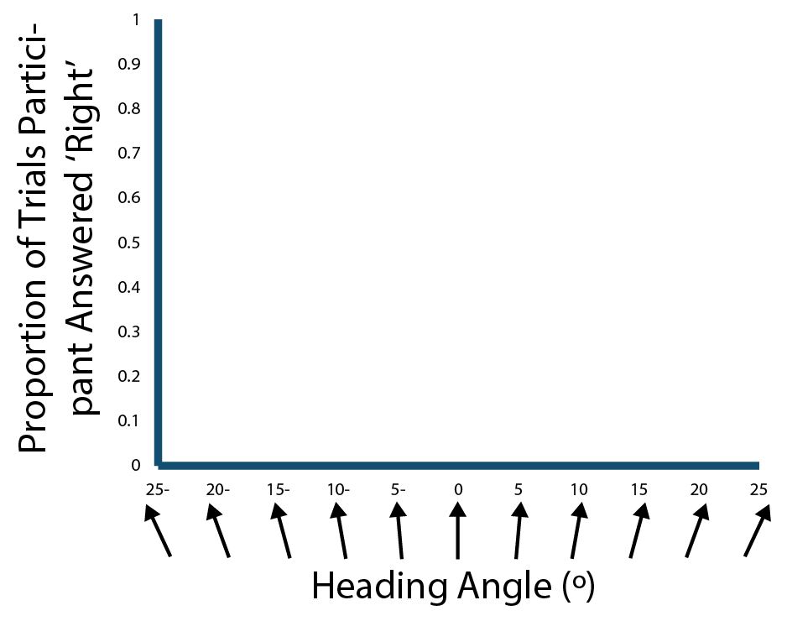

Multisensory Integration
What are the benefits of Multisensory Integration:

What research question would you like to do on Multisensory Integration:

