The Maths of Predators and Preys
Don’t get Eaten by the Wolf
Name: ____________________________________________ Date: ____________

Hares (No Predators) 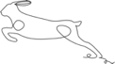
Given a population of 60 Hares and a birth rate of 0.2 what would the population be after three years?
H_{Future}=H+0.2(H)
Year | Hare Population
0 | 60
1
2
3
Sketch the Graph.
Guess what would happen in 100 years?
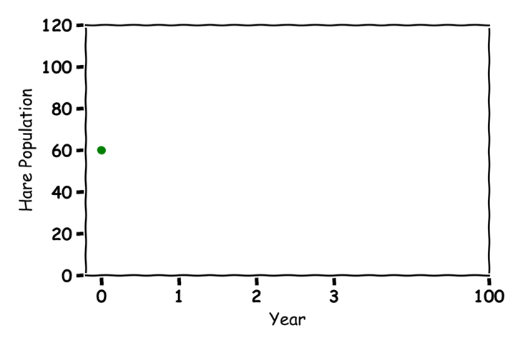
Lynx (No Prey) 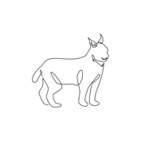
Given a population of 30 Lynxes and a death rate of 0.1 what would the population be after three years?
L_{Future}= L-0.1(L)

Year | Lynx Population
0 | 30
1
2
3
Sketch the Graph.
Guess what would happen in 100 years?
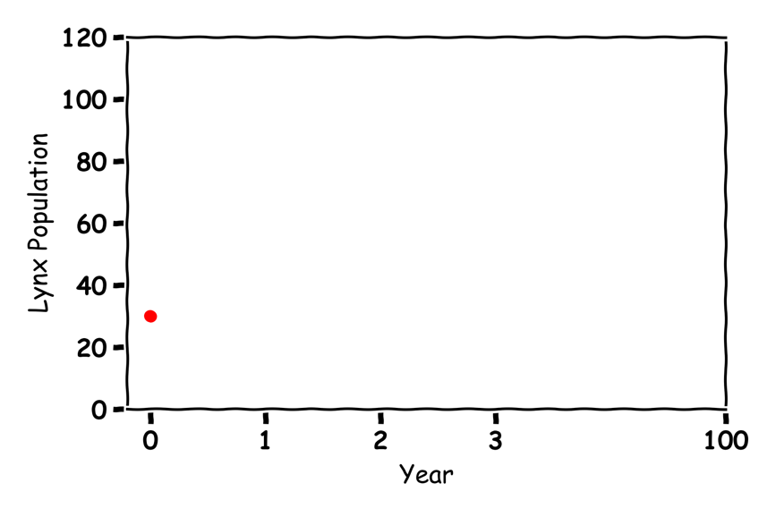

Hares and Lynxes 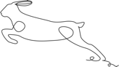 
Label the graph:
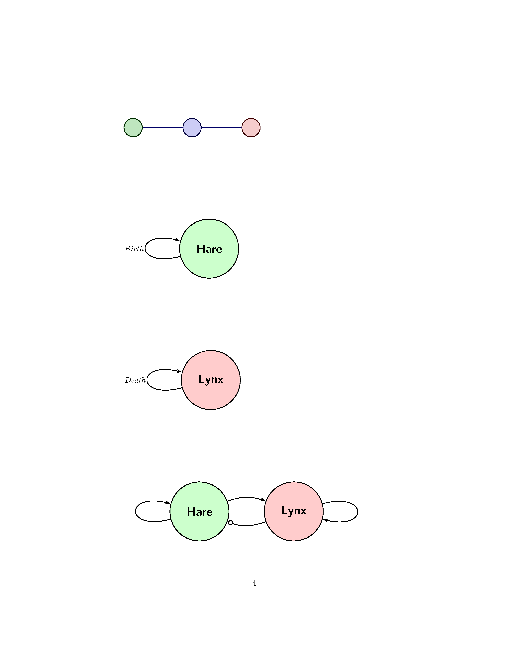
Given a population of 60 Hares and 30 Lynxes in year 0 with a birth rate of 0.2, a death rate of 0.1, a eat rate of 0.005 and a food rate of 0.002 what would the populations be after three years?
Hare | Value | Lynx | Value
Birth | 0.2 | Death | 0.1
Eat | 0.005 | Food | 0.002
H_{Future}=H+0.2(H)-0.005(H)(L)
L_{Future}= L-0.1(L)+0.002(L)(H)
Year | Hare Population | Lynx Population
0 | 60 | 30
1
2
3

