The Maths of Predators and Preys
Don’t get Eaten by the Wolf

Hares (No Predators) 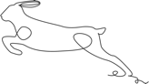
Given a population of 60 Hares and a birth rate of 0.2 what would the population be after three years?
H_{Future}=H+0.2(H)
Year | Hare Population
0 | 60
1 | 60+0.2*(60)=72
2 | 72+0.2*(72)=86
3 | 86+0.2*(86)=103
Sketch the Graph.
Guess what would happen in 100 years?
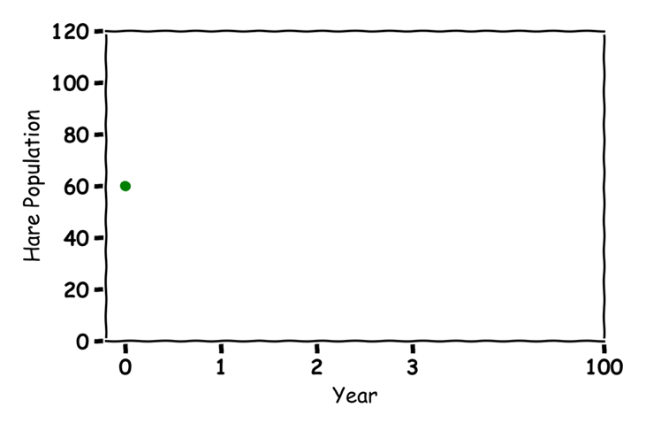
4 billion
Lynx (No Prey) 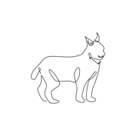
Given a population of 30 Lynxes and a death rate of 0.1 what would the population be after three years?
L_{Future}= L-0.1(L)

Year | Lynx Population
0 | 30
1 | 30-0.1*(30)=27
2 | 27-0.1*(27)=24
3 | 24-0.1*(24)=22
Sketch the Graph.
Guess what would happen in 100 years?
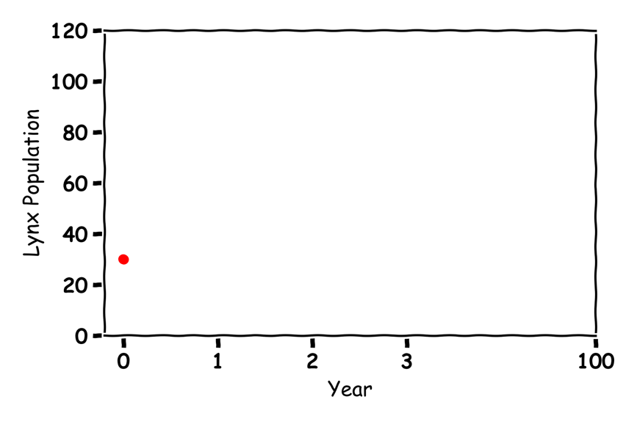
All dead

Hares and Lynxes  
Label the graph:
Food Rate
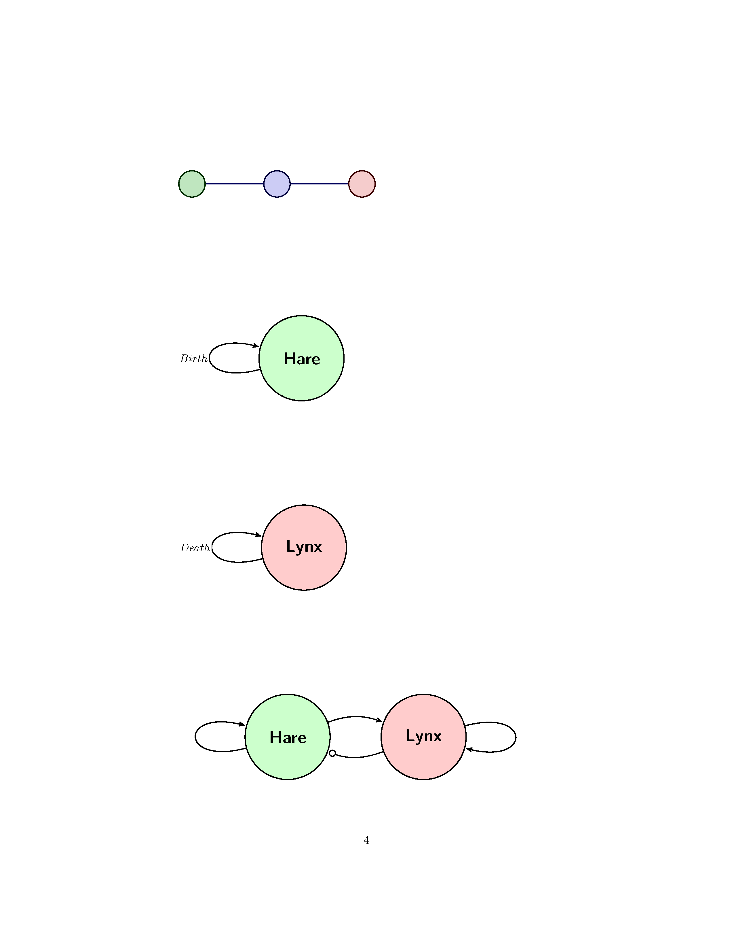
Eat Rate
Birth rate
Death rate
Given a population of 60 Hares and 30 Lynxes with a birth rate of .2, a death rate of 0.1, a eat rate of 0.005 and a food rate of 0.002 what would the populations be after three years?
 | Value |  | Value
Birth | 0.2 | Death | 0.1
Eat | 0.005 | Food | 0.002

H_{Future}=H+0.2(H)-0.005(H)(L)
L_{Future}= L-0.1(L)+0.002(L)(H)

Year | Hare Population | Lynx Population
0 | 60 | 30
1 | 60+0.2*(60)-0.005*(60)*(30)=63 | 30-0.1*(30)+0.002*(30)*(60)=31
2 | 63+0.2*(63)-0.005*(63)*(31)=66 | 31-0.1*(31)+0.002*(31)*(63)=31
3 | 66+0.2*(66)-0.005*(66)*(31)=69 | 31-0.1*(31)+0.002*(31)*(66)=32

