The Maths of Predators and Preys
Don’t get Eaten by the Wolf
Name: _______________________________________________ Date: ____________

Hares 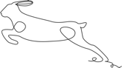

No predators
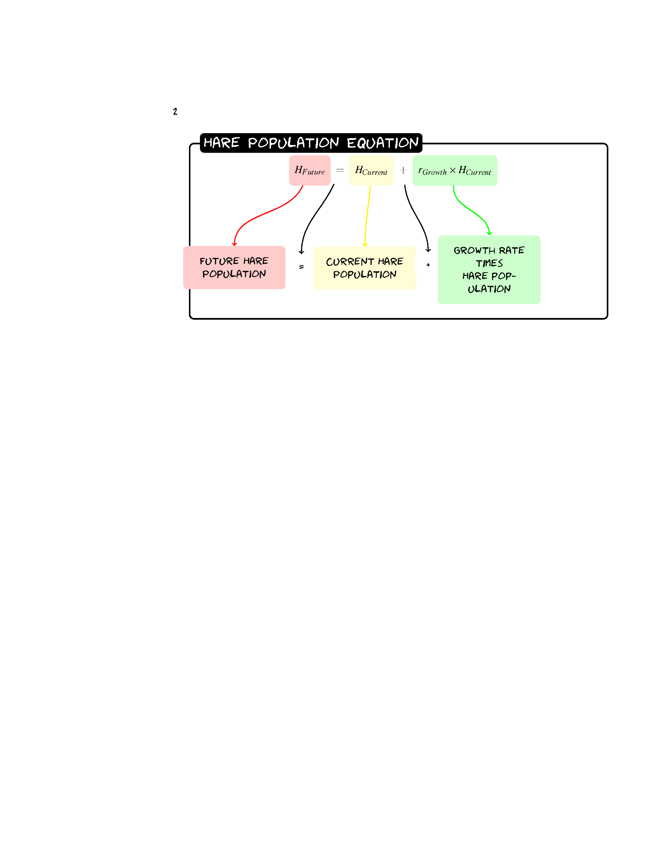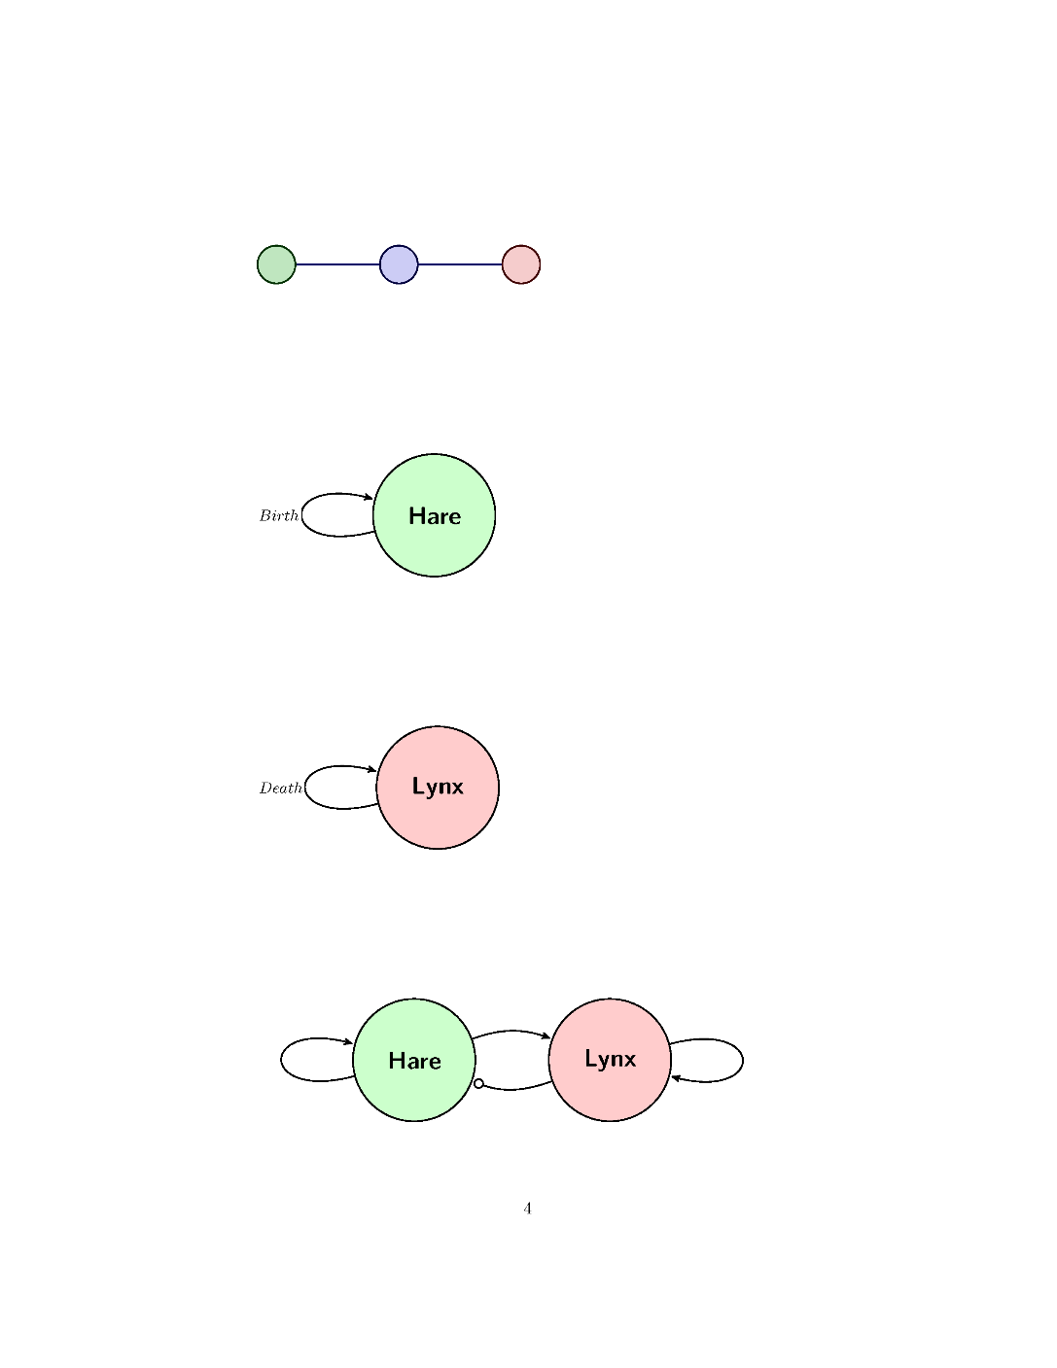
Given a population of 60 Hares and a birth rate of 0.2 what would the population be after three years?
H_{Future}=H+0.2(H)
Year | Hare Population
0 | 60
1
2
3
Sketch the Graph.
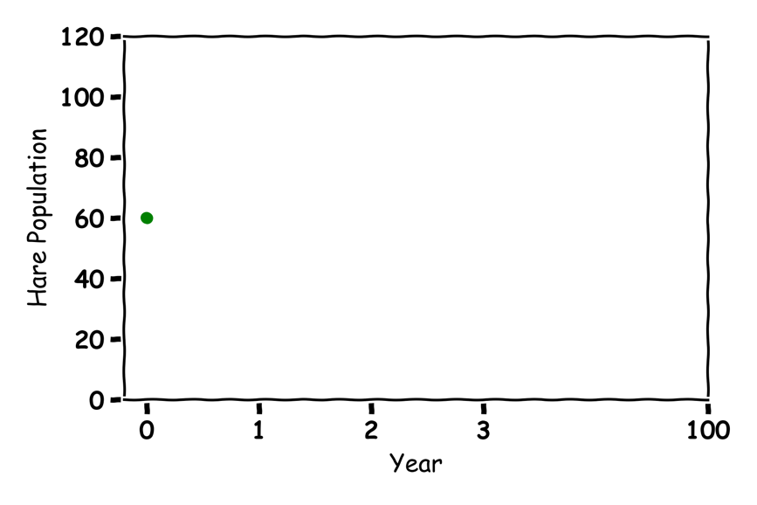
Guess what would happen in 100 years?
Lynx 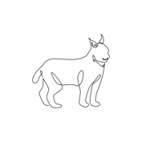

No Prey
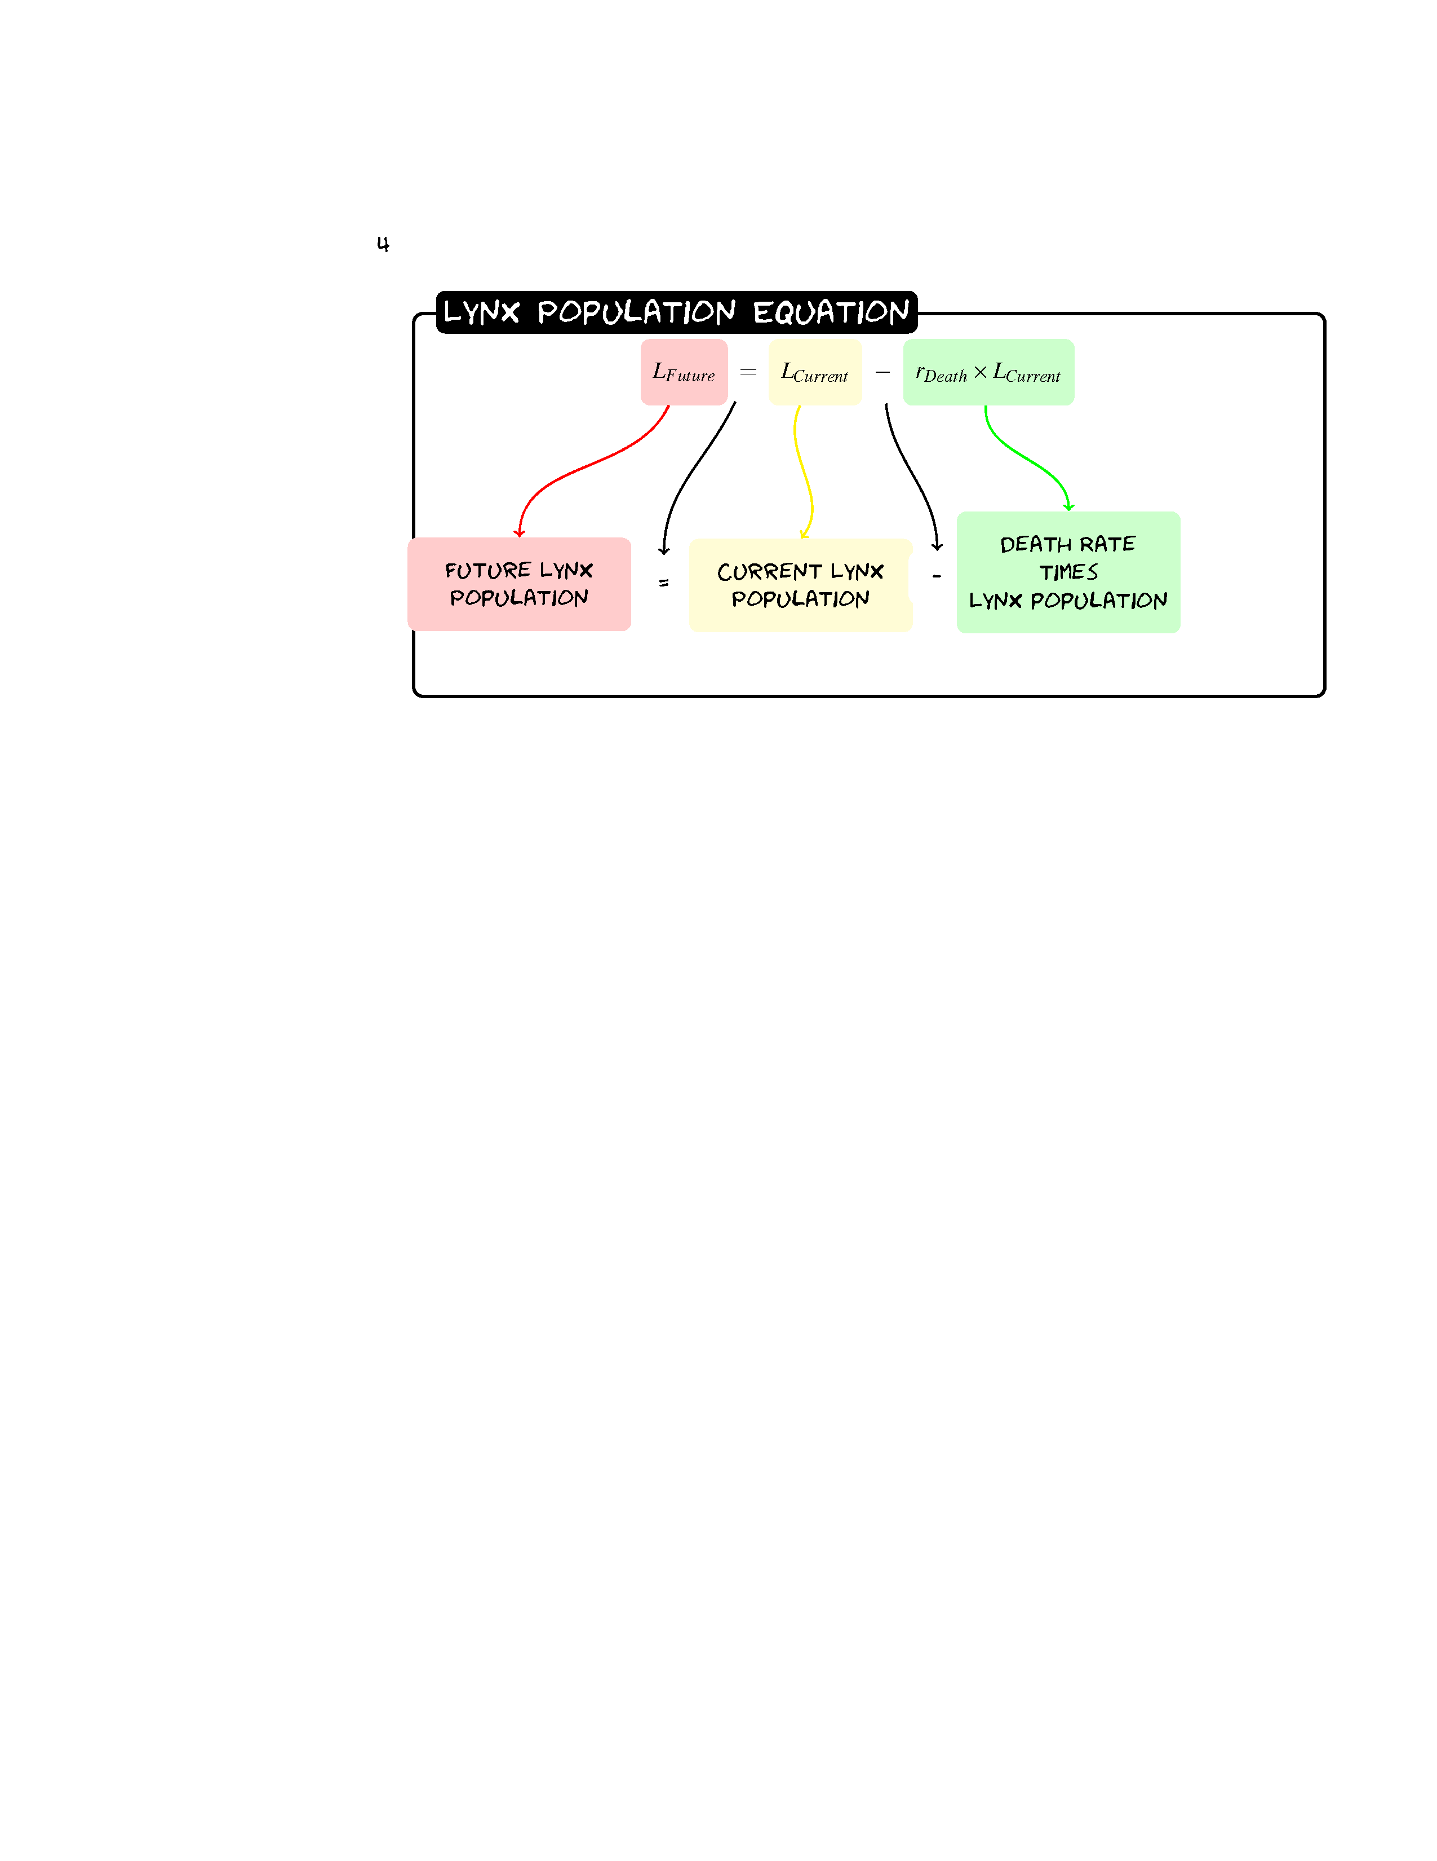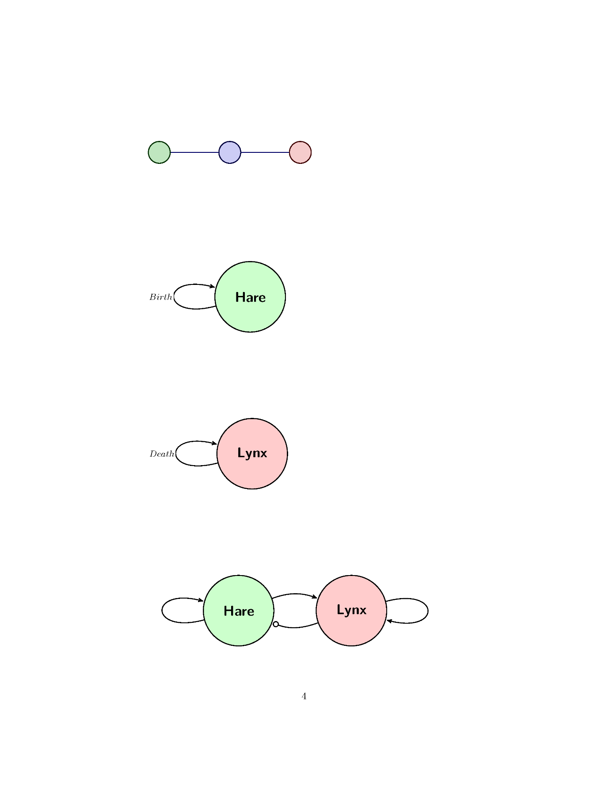
Given a population of 30 Lynxes and a death rate of 0.1 what would the population be after three years?
L_{Future}= L-0.1(L)
Year | Lynx Population
0 | 30
1
2
3
Sketch the Graph.
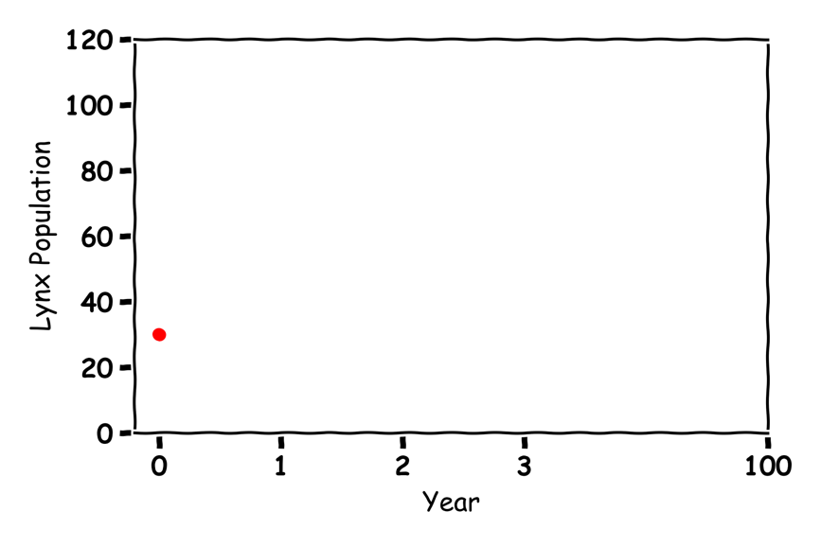
Guess what would happen in 100 years?

Hares and Lynxes  
Label the graph:
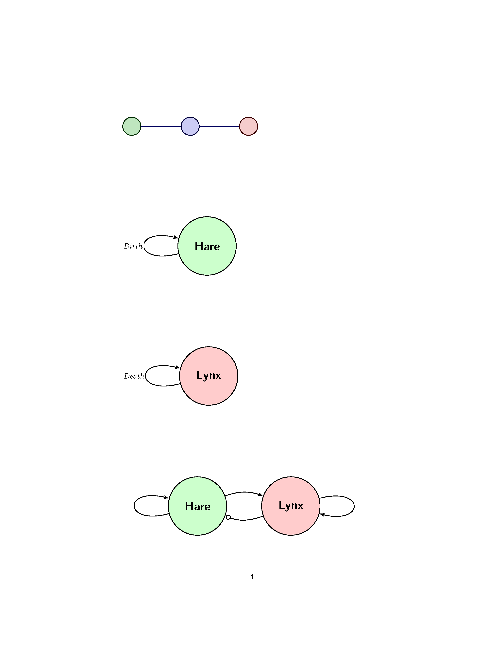
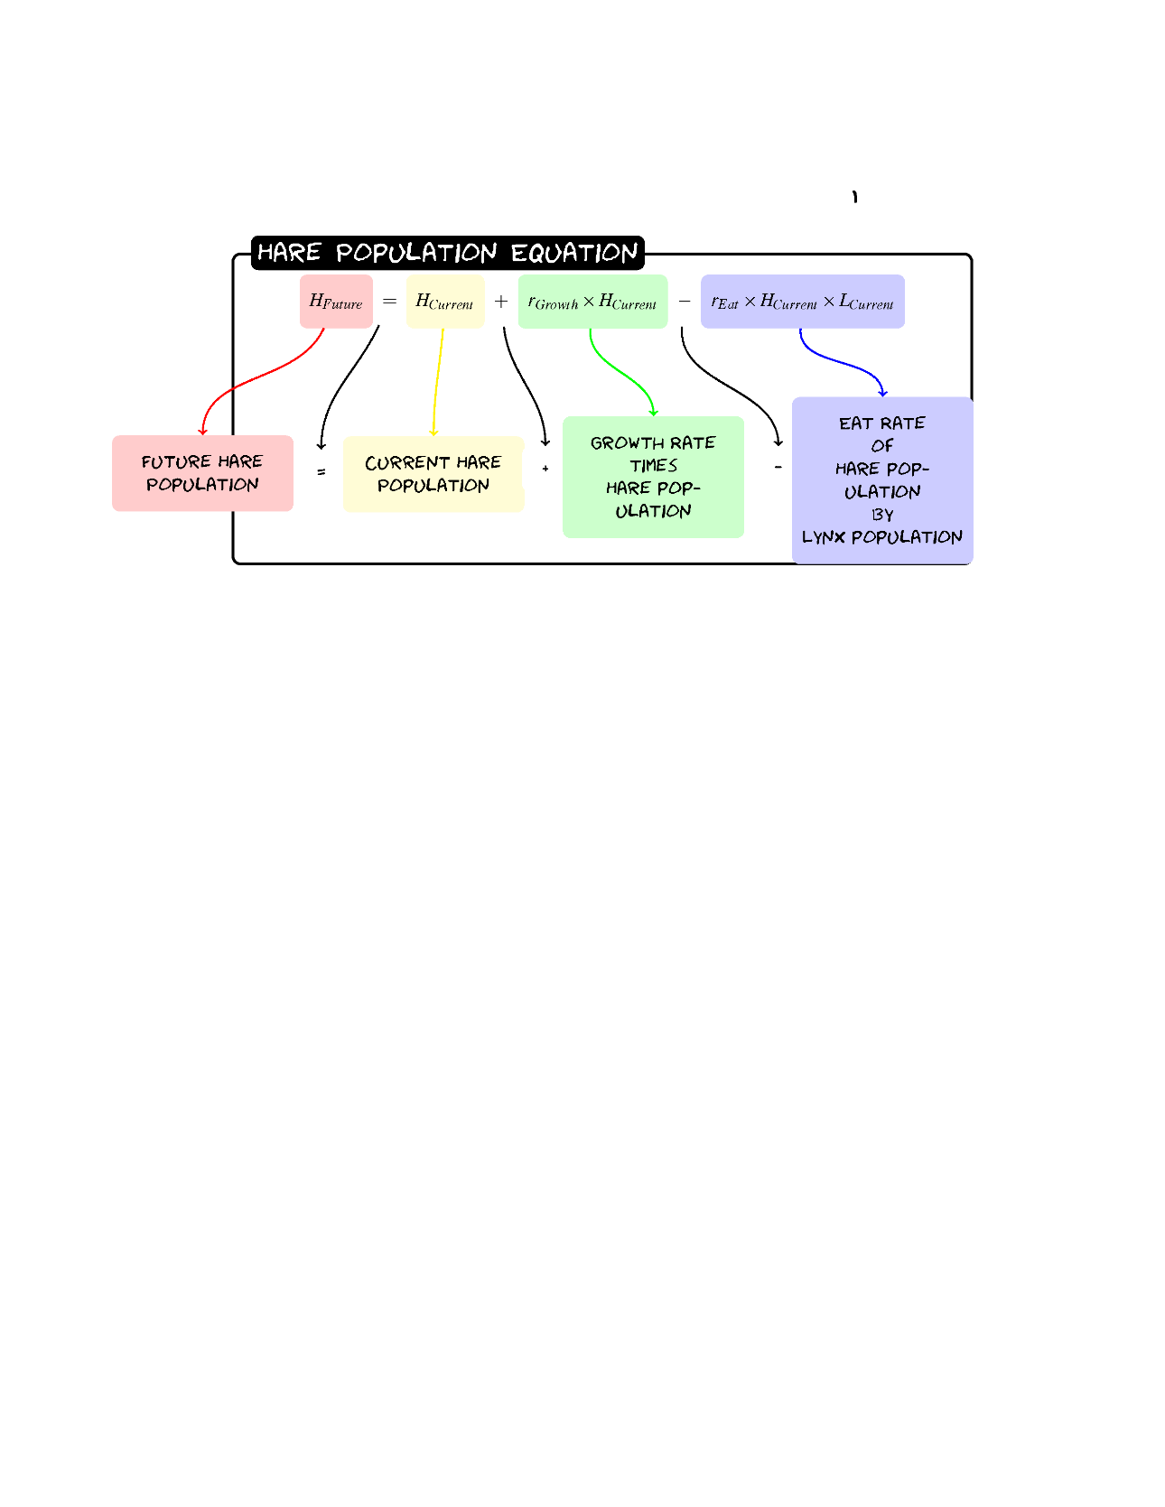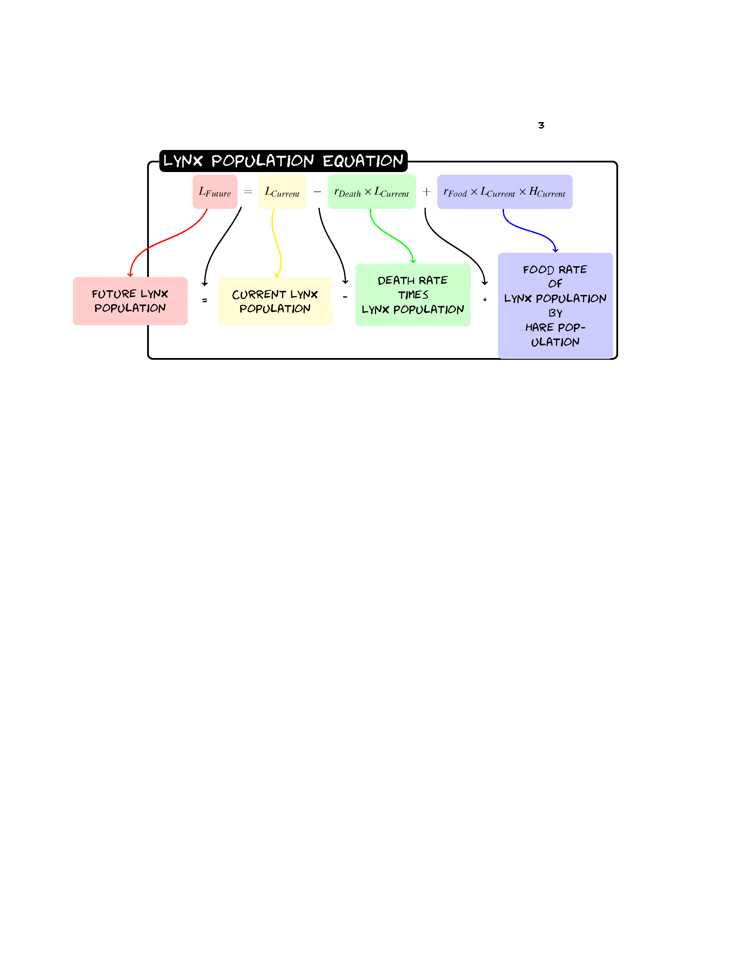

Given a population of 60 Hares and 30 Lynxes with a birth rate of 0.2, a death rate of 0.1, a eat rate of 0.005 and a food rate of 0.002 what would the populations be after three years?
Hare | Value | Lynx | Value
Birth | 0.2 | Death | 0.1
Eat | 0.005 | Food | 0.002
H_{Future}=H+0.2(H)-0.005(H)(L)
L_{Future}= L-0.1(L)+0.002(L)(H)

Year | Hare Population | Lynx Population
0 | 60 | 30
1
2
3

Sketch the graph:
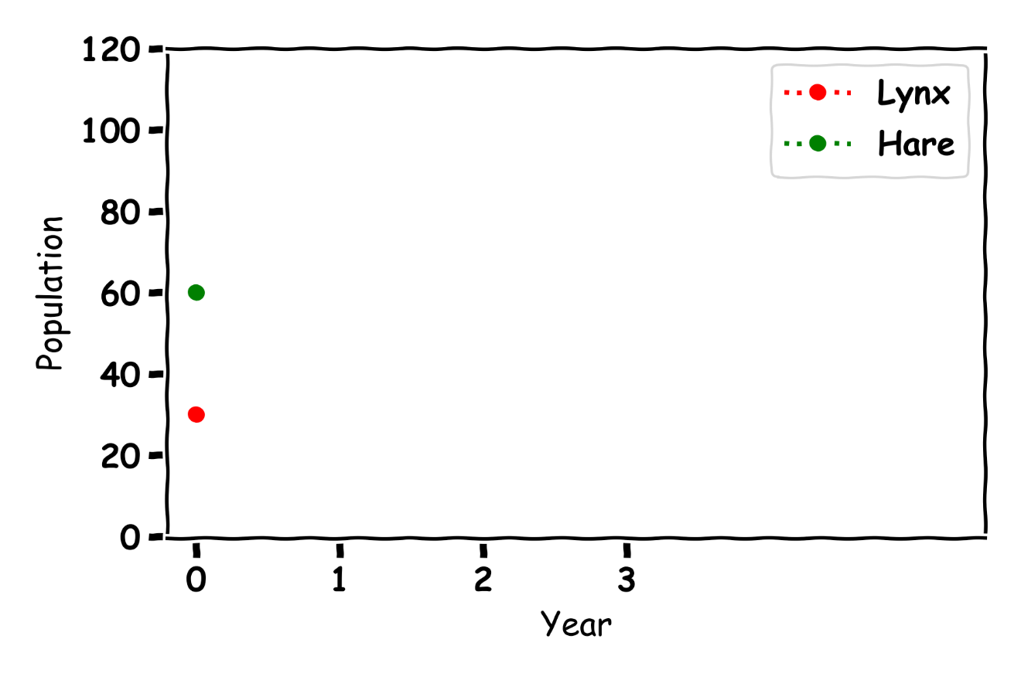
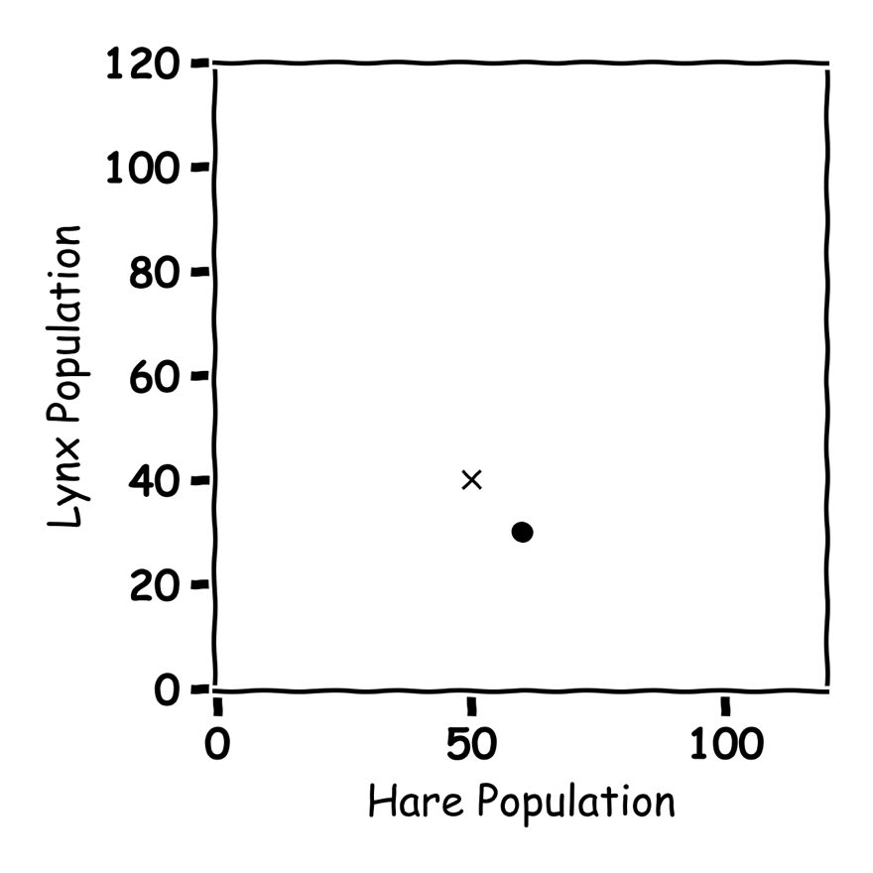

Don’t get Eaten by the Wolf

Label the graph
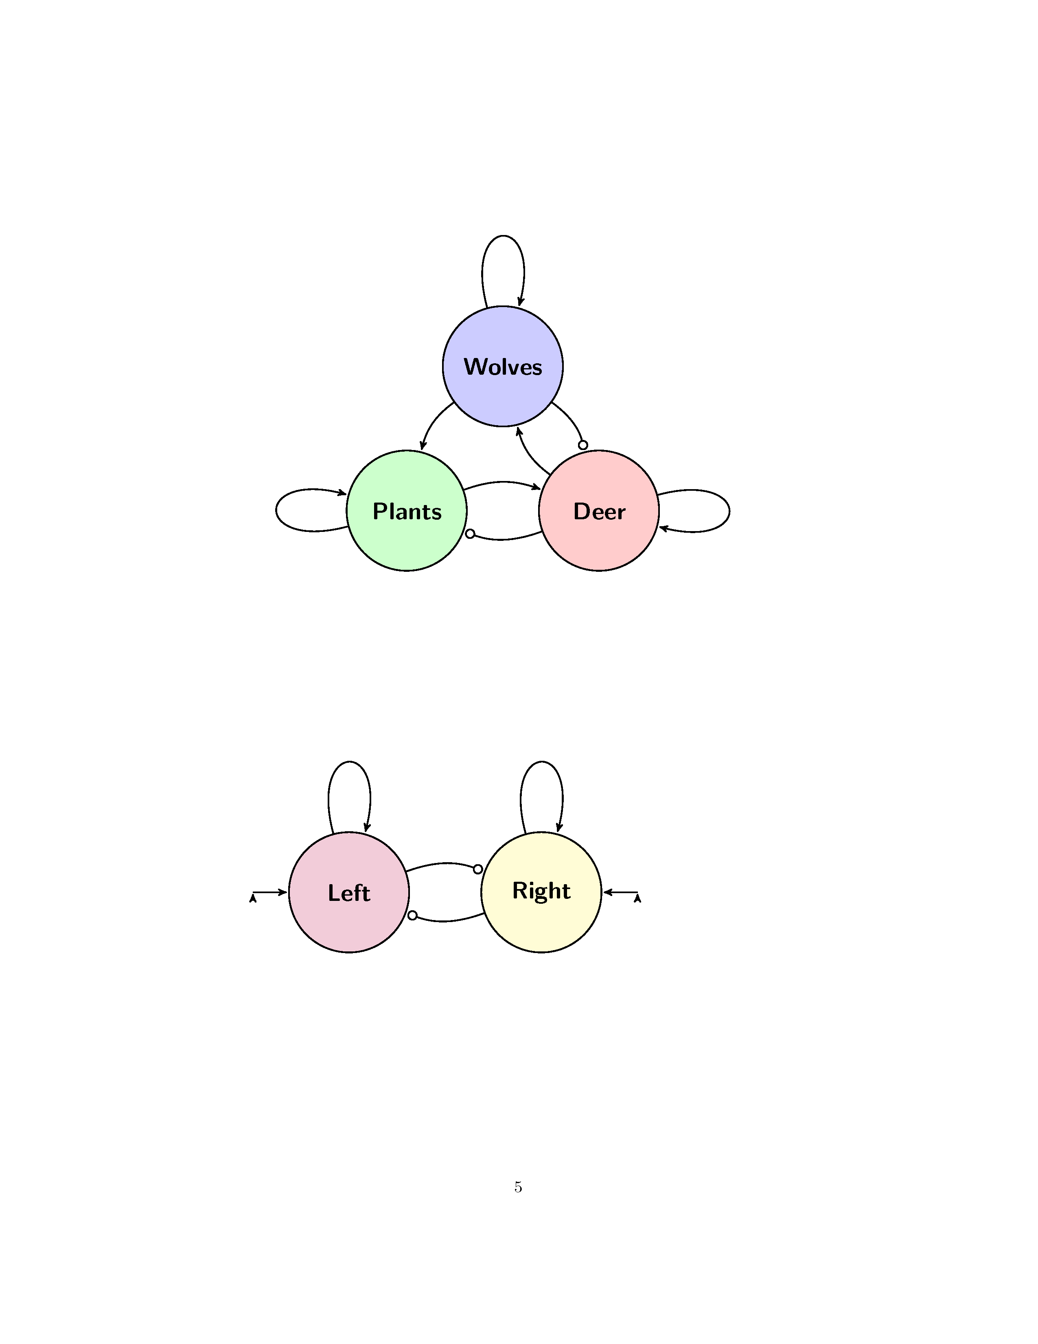

Describe what is happening in the below graph:
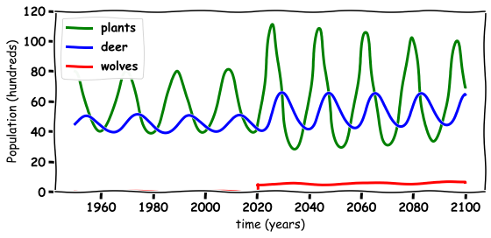

Discussion Questions
- What happened to the environment when the wolves are re-introduced?

- What happened to the wolf population when they are re-introduced?

- What happened to the deer population when the wolves are re-introduced?

- Do you think the wolves should have been re-introduced in Ireland?
- What else could you model with these Equations?

