Connecting Neuroscience and Machine Learning
Don’t get Eaten by the Tiger
Name: ______________________________________________ Date: ____________

Neuroscience of Decision Making

Exercise 1: How does a Neuron Work
What is the basic unit of information for a neuron?

How do we encode it mathematically?

Exercise 2: Two Populations of Neurons
Label the graph:
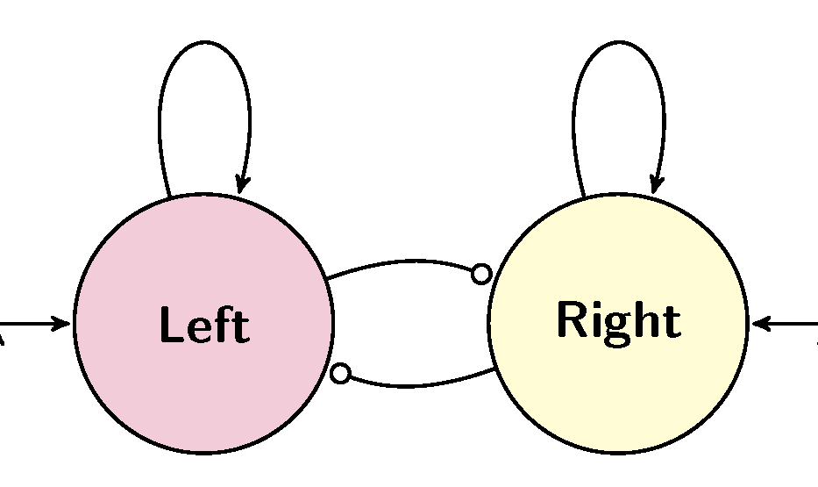

Exercise 3: Two Populations of Neurons (Students)

Count and time the number of students response to over time sketch the left group in red and the right in green.
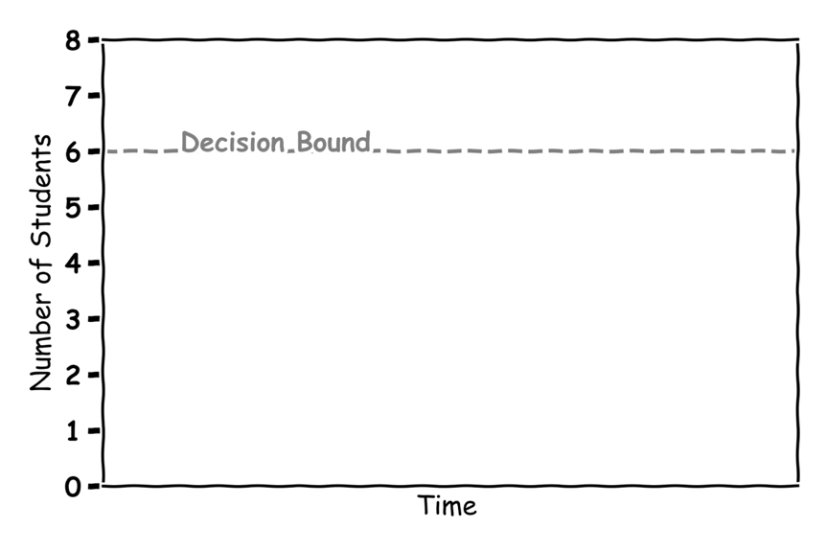

Making Decisions

Exercise 4: Are you Correct
Label the graph:
Where is the 50-50 chance line?
Fill in the graph with your answers:
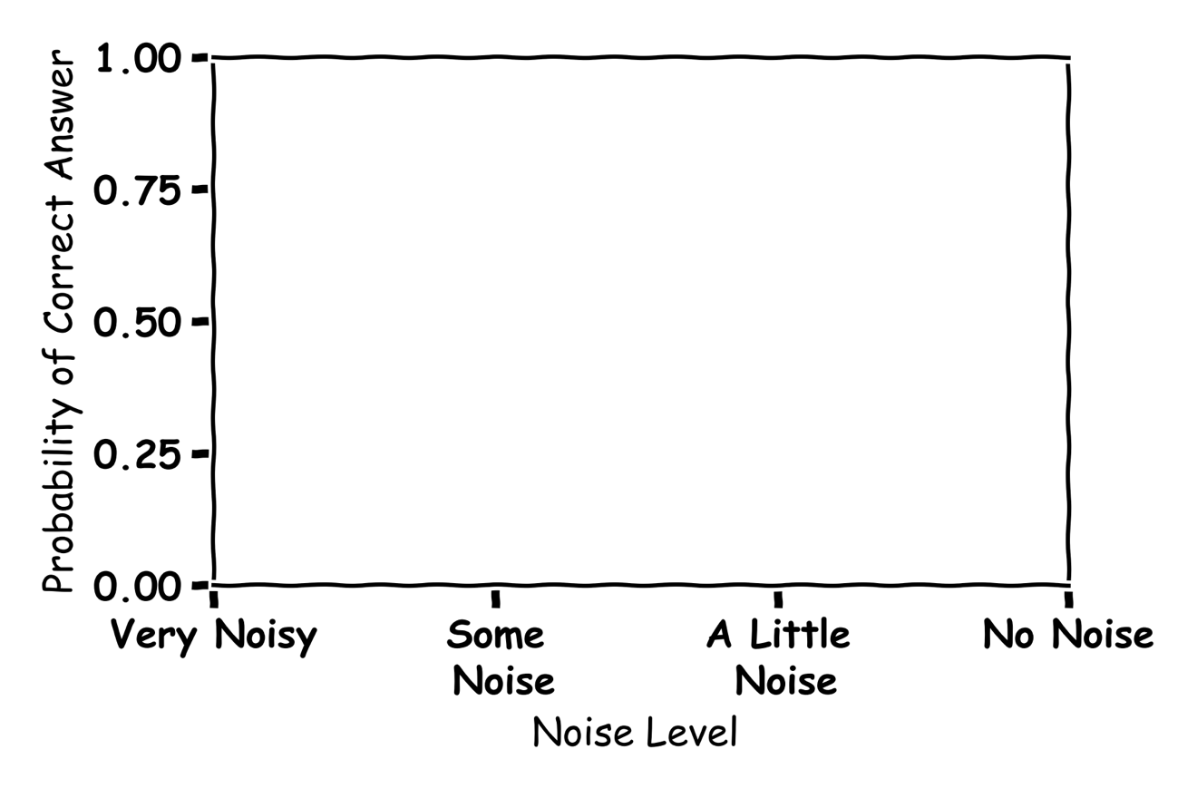

Machine Learning of Decision Making 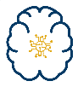

Exercise 5: The Machine Learning Algorithm
What is a Machine Learning algorithm?

Give an example of Machine Learning in your day to day life?

Exercise 6: The Node
Label the graph:
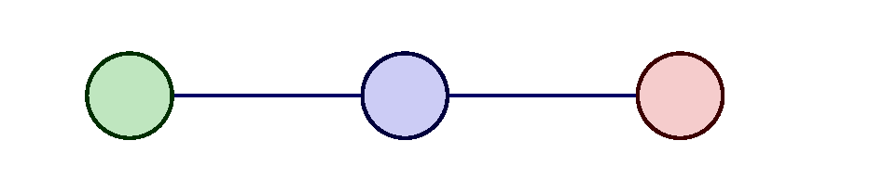

Exercise 7: Activation Functions
7.1 Draw the functions could be used in a node and what are they used for?

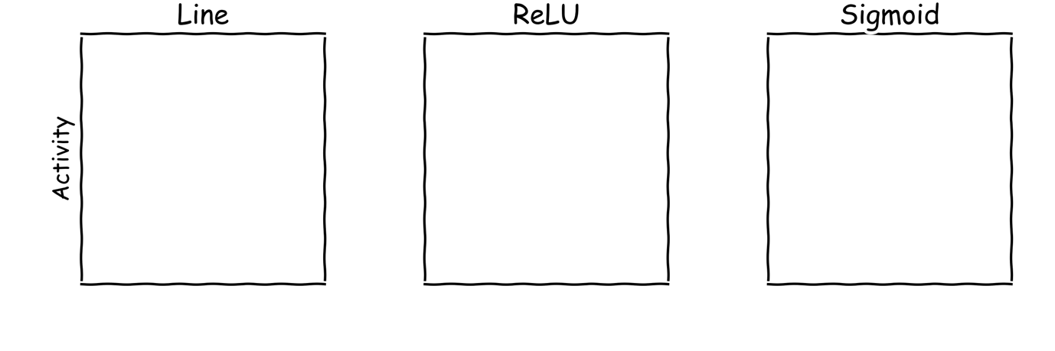

7.2 What does an Artificial Neural Network learn?

Exercise 8: An Artificial Neural Network
Label the graph:
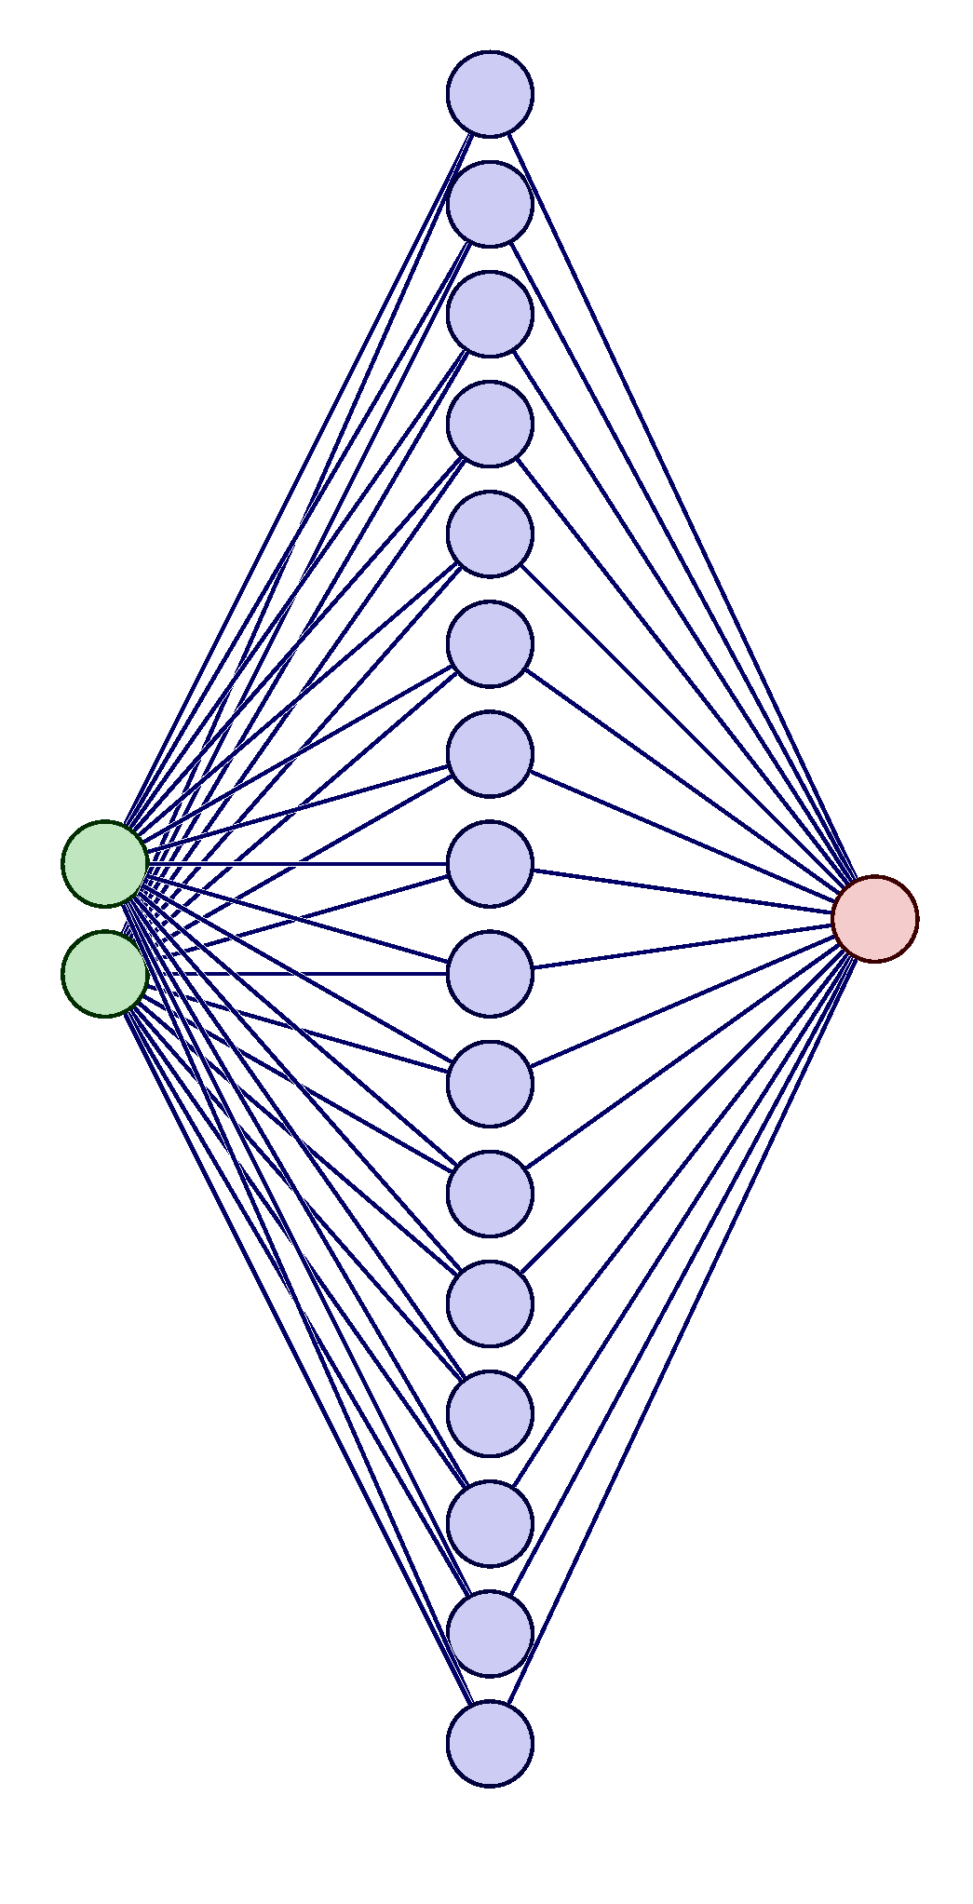

Exercise 9:
How are you smarter than AI?

