The Maths of Predators and Preys
Don’t get Eaten by the Wolf
Name: _______________________________________________ Date: ____________

Hares 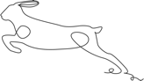

No predators
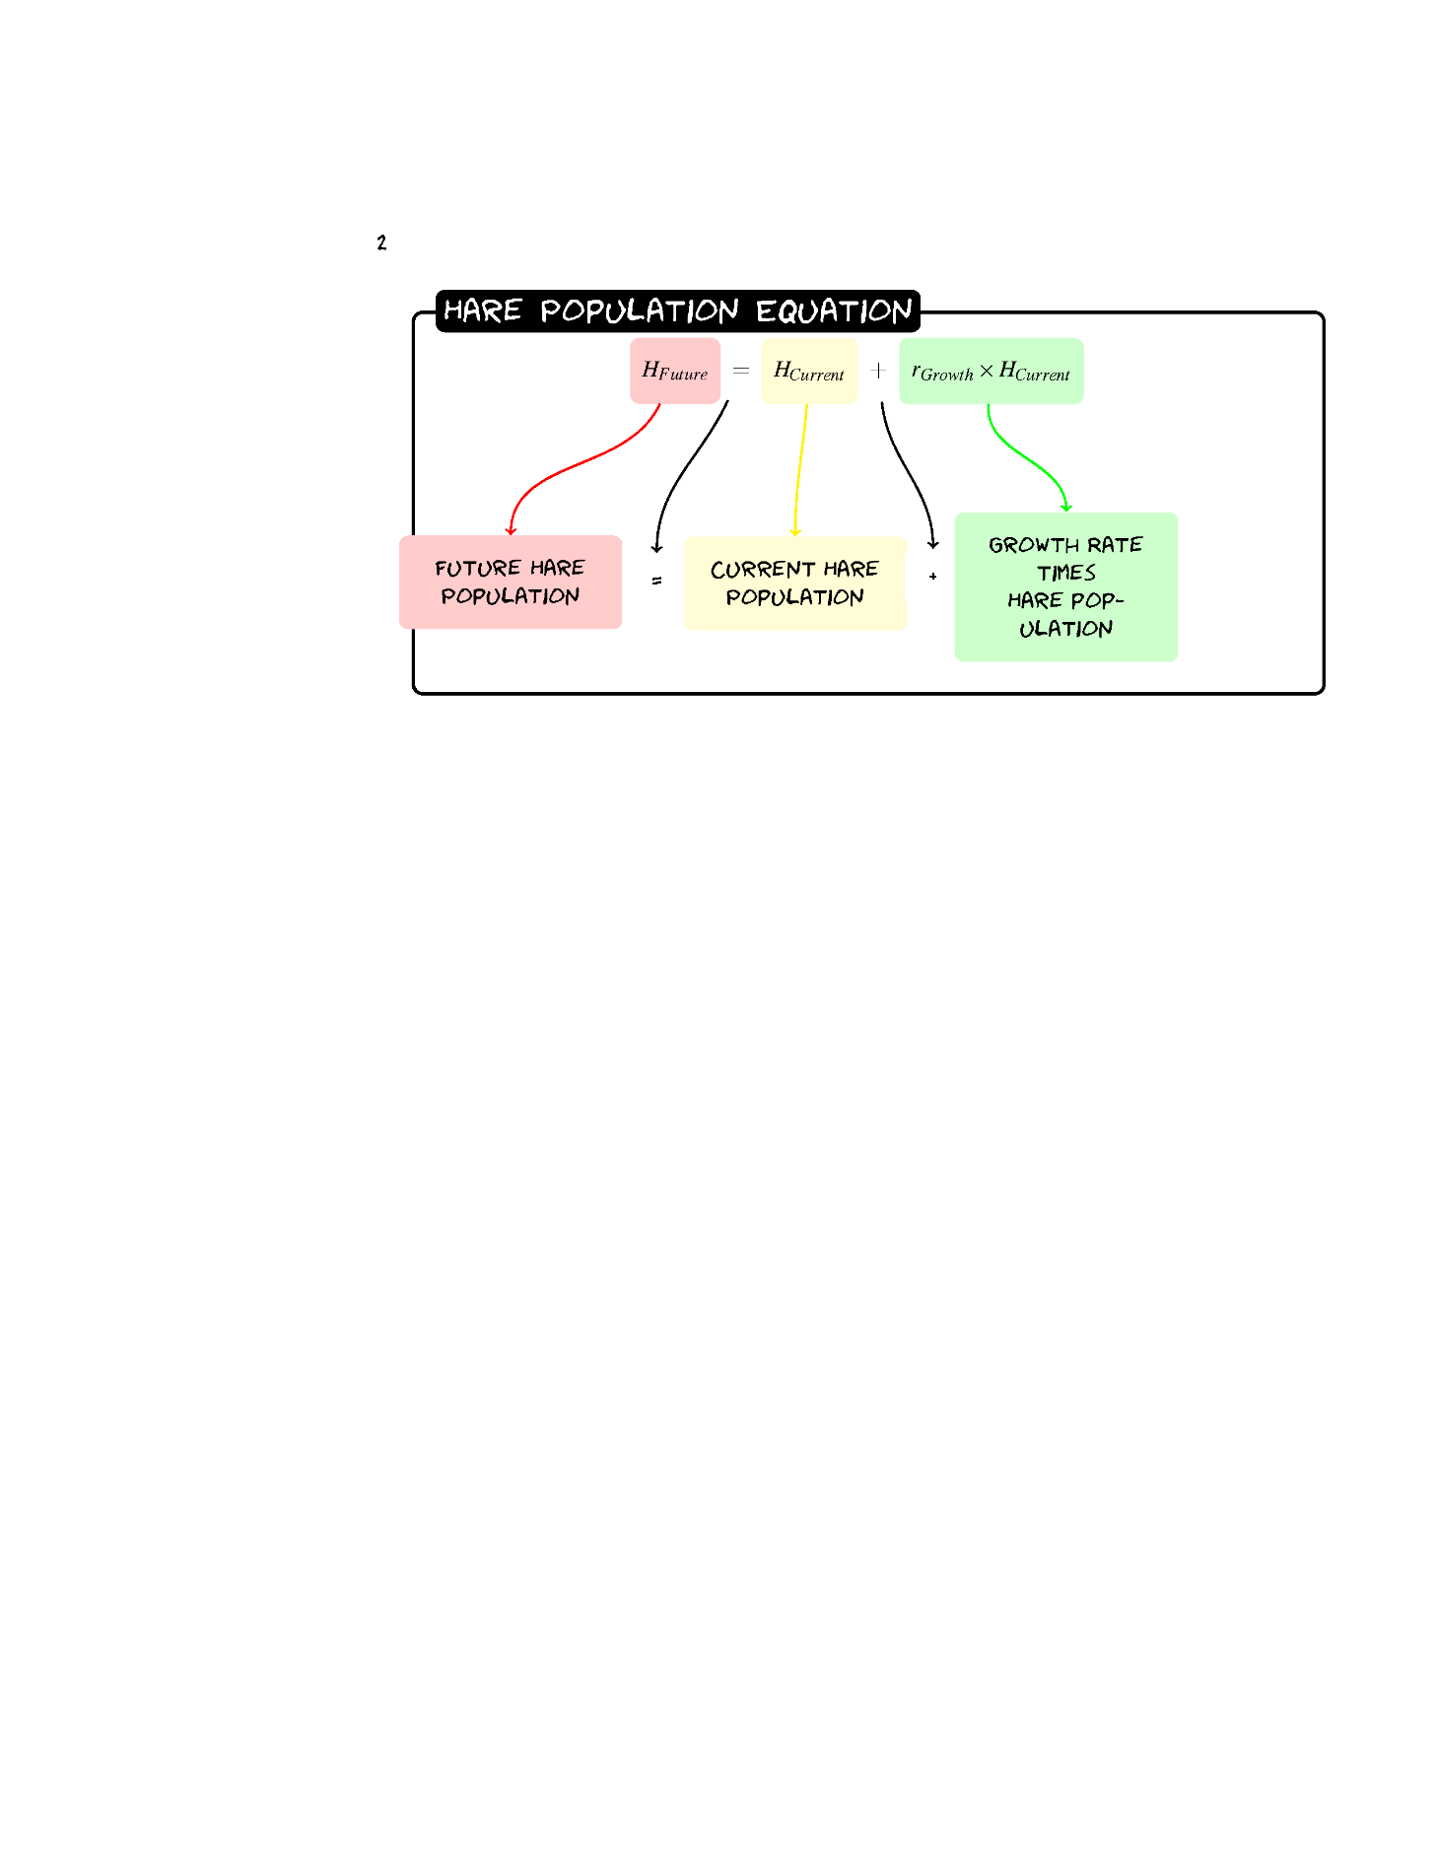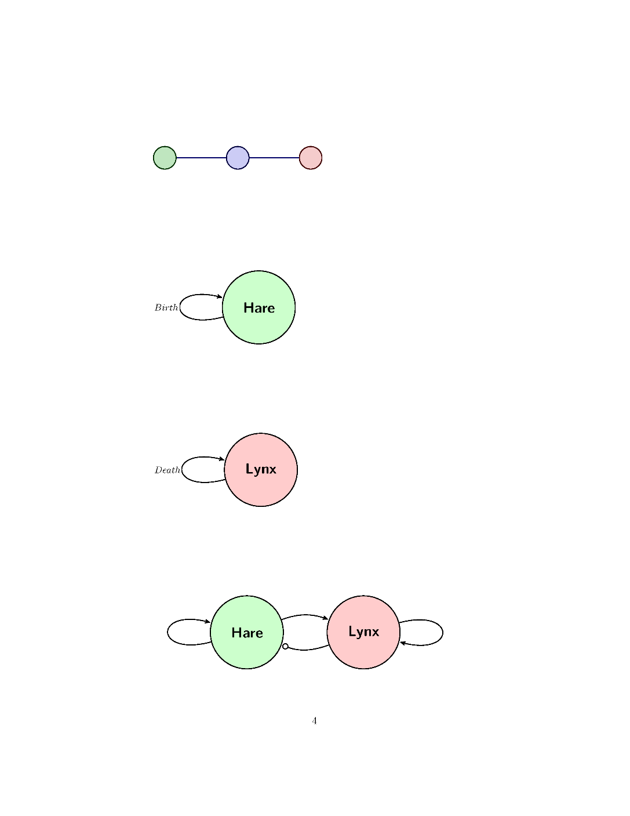

Exercise 1: Calculate the Population
1.1 Given a population of 60 Hares and a birth rate of 0.2 what would the population be after one year using the formula:
H_{Future}=H+0.2(H)
1.2 Now calculate the Hare population for three years
Year | Hare Population
0 | 60
1
2
3

Exercise 2:
Sketch the graph for three years of Hare populations.
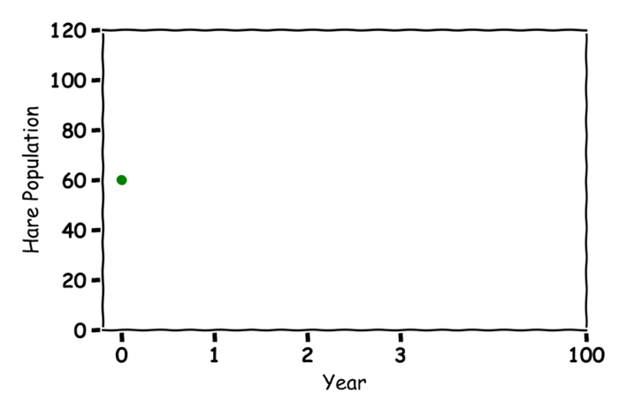

Exercise 3: What would happen in 100 Years
Guess what would happen to the Hare population in 100 years?
Lynx 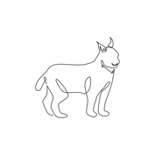

No Prey
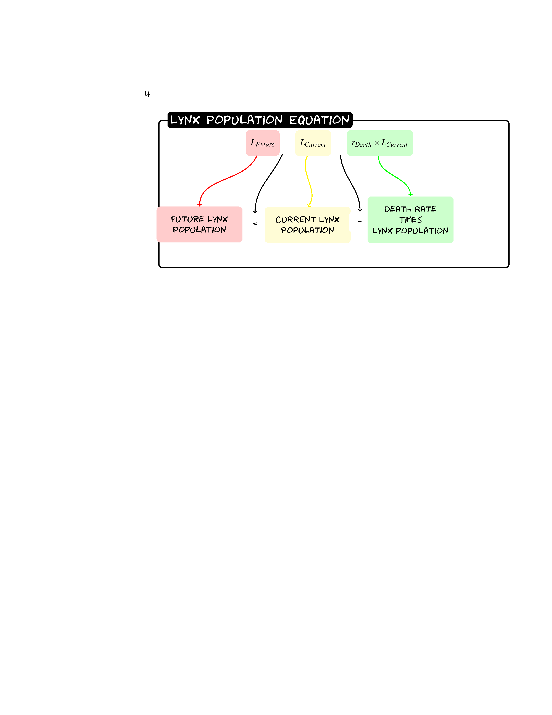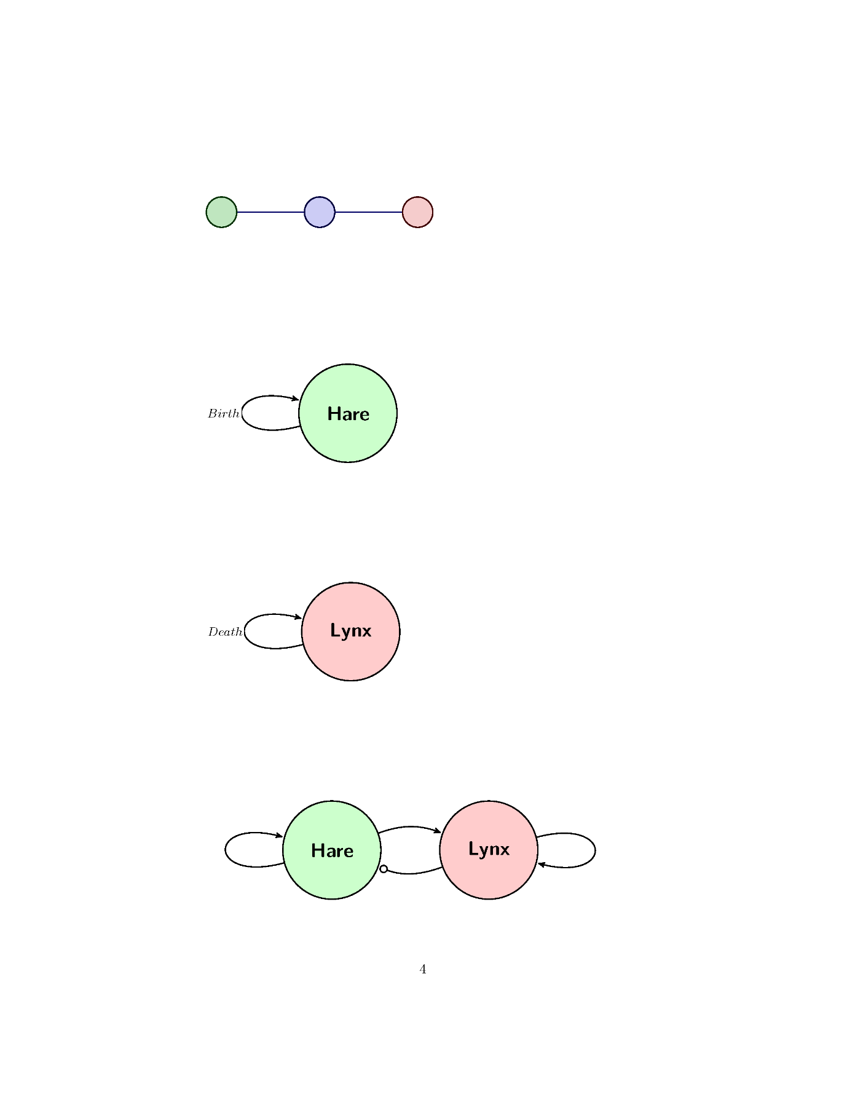

Exercise 4:
4.1 Given a population of 30 Lynxes and a death rate of 0.1 what would the population be after one year?
L_{Future}= L-0.1(L)
4.2 Now calculate the Lynx population for three years
Year | Lynx Population
0 | 30
1
2
3

Exercise 5
Sketch the graph for three years of Hare populations.
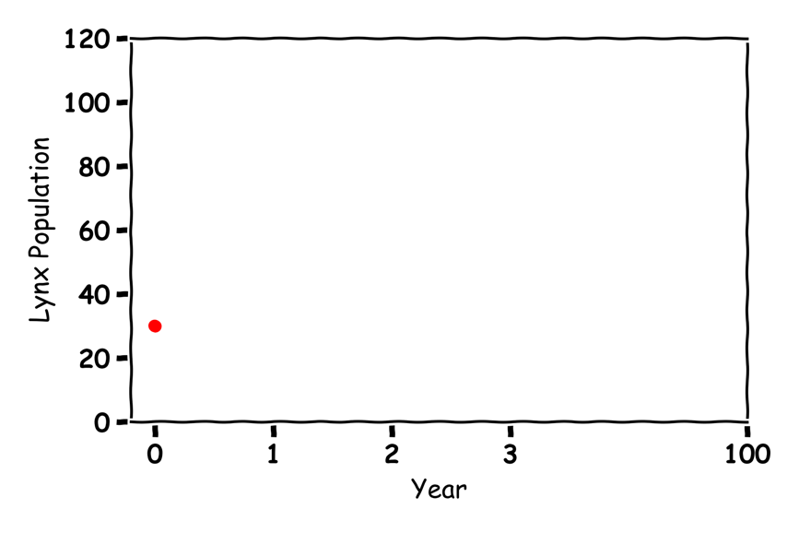

Exercise 6
Guess what would happen to the Lynx population in 100 years?

Hares and Lynxes  

Exercise 7
Label the graph:
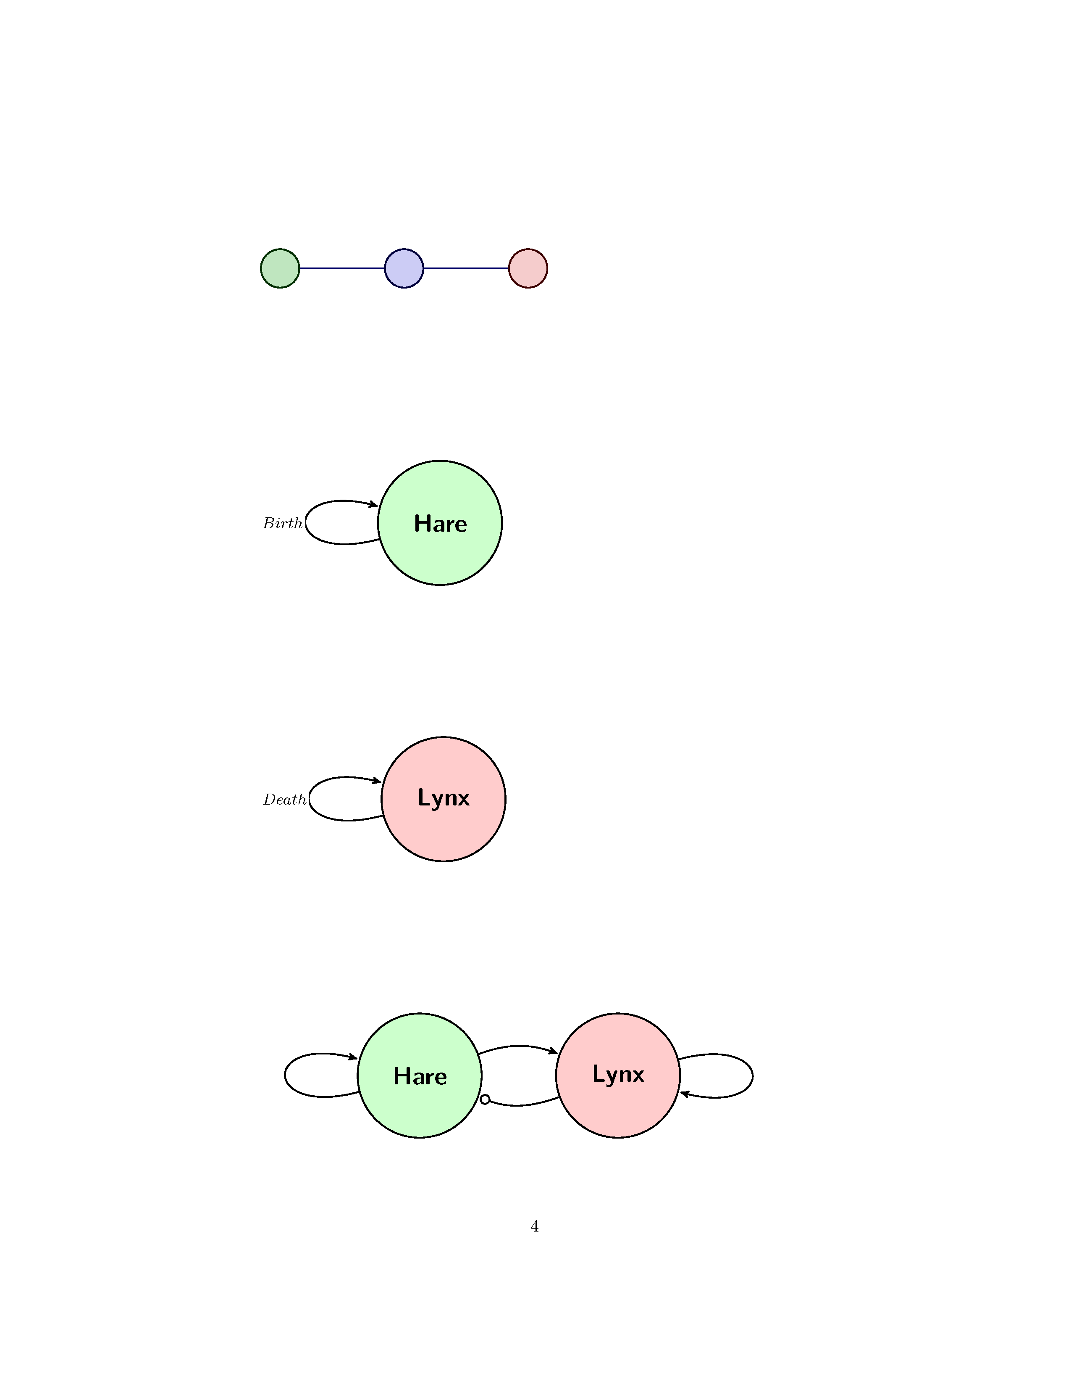
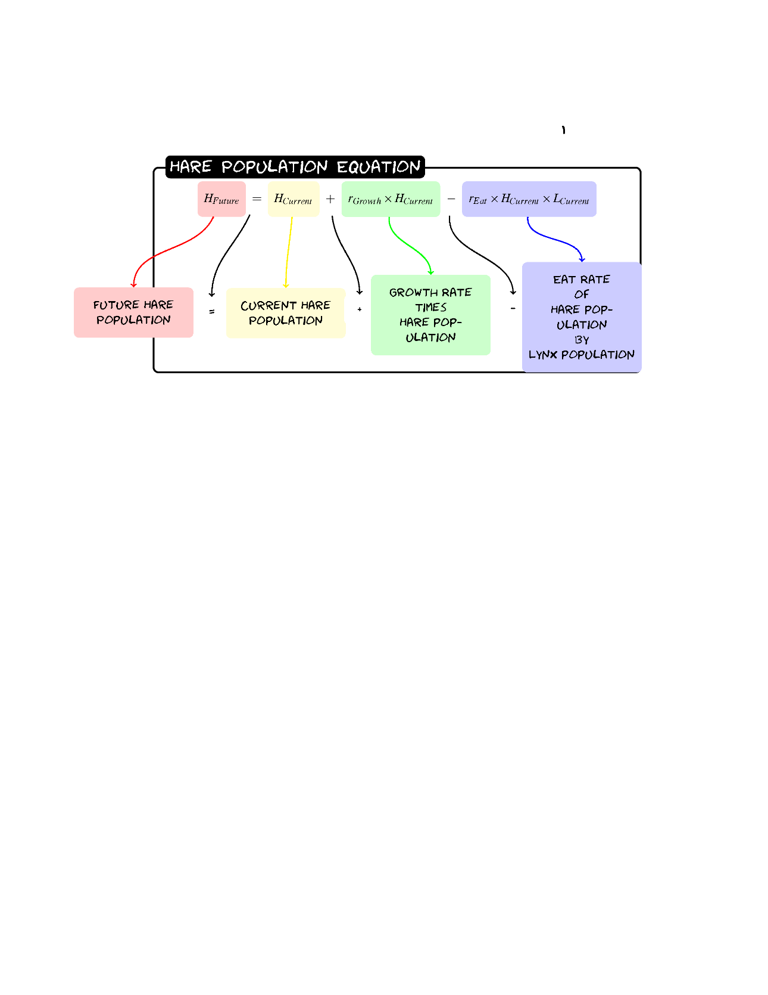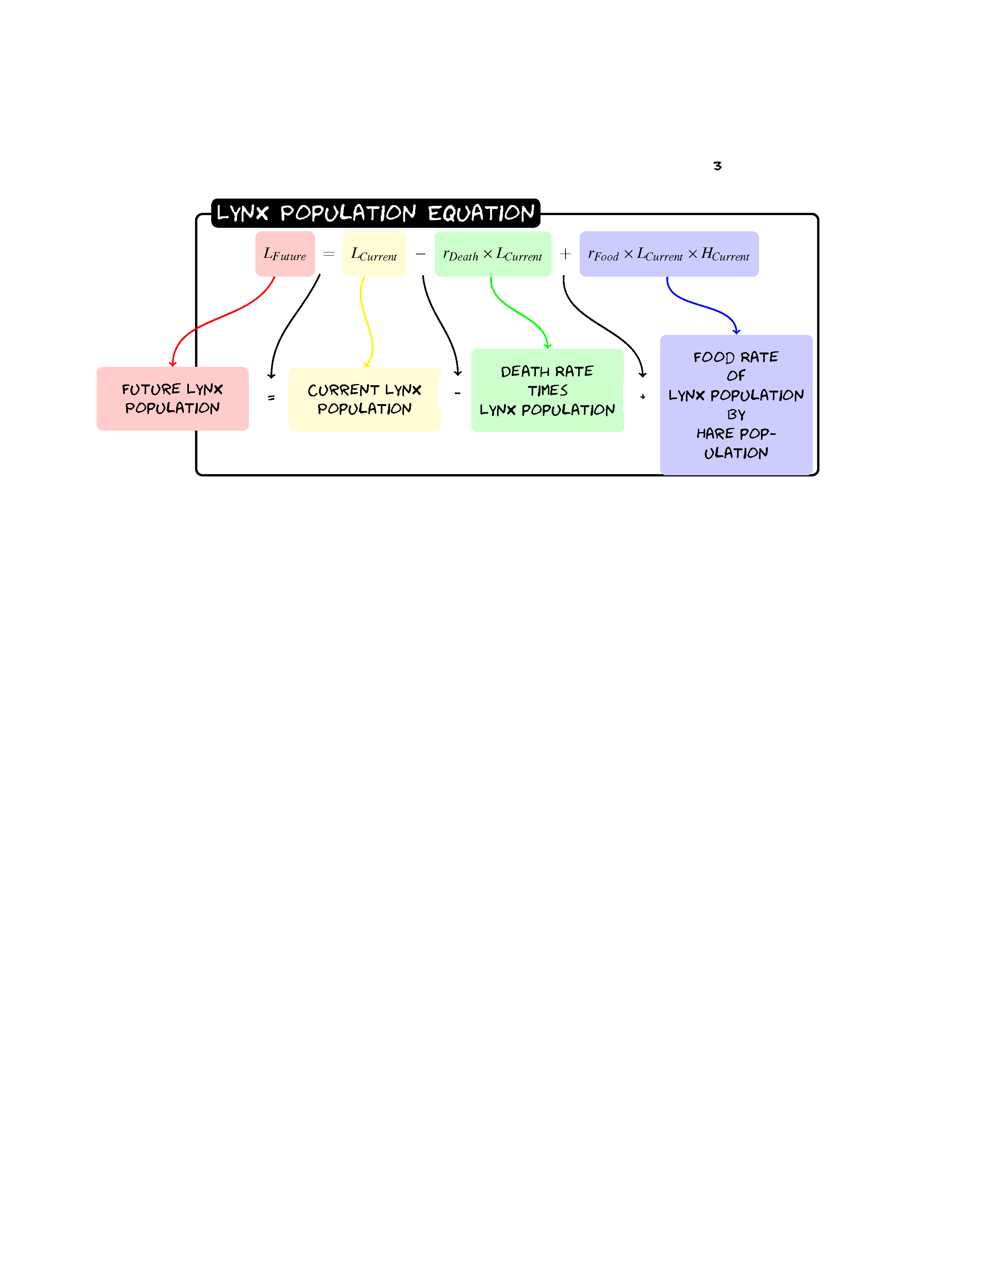

Exercise 8
8.1 Given a population of 60 Hares and 30 Lynxes with a birth rate of 0.2, a death rate of 0.1, a eat rate of 0.005 and a food rate of 0.002 what would the populations be after one year?
Hare | Value | Lynx | Value
Birth | 0.2 | Death | 0.1
Eat | 0.005 | Food | 0.002
H_{Future}=H+0.2(H)-0.005(H)(L)
L_{Future}= L-0.1(L)+0.002(L)(H)
8.2 Now Predict Three Years of Hare and Lynx Populations

Year | Hare Population | Lynx Population
0 | 60 | 30
1
2
3

Exercise 9:
Sketch the graph for the Lynx and Hare populations for three years:

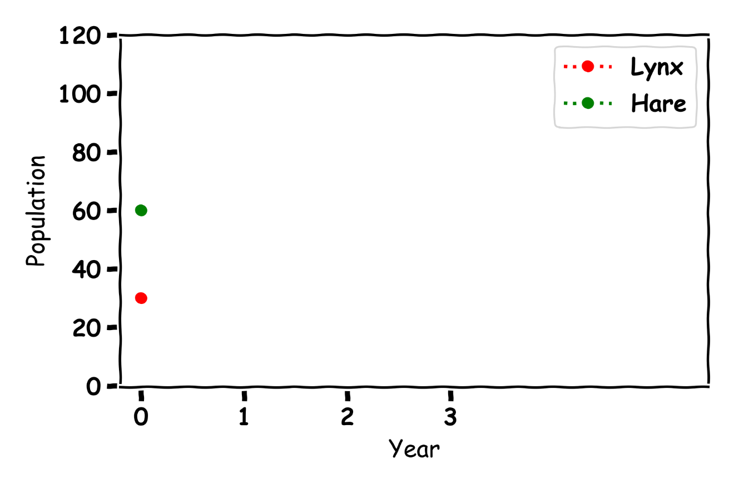

Exercise 10
Sketch the Hare population on the x-axis and the Lynx population on the y-axis
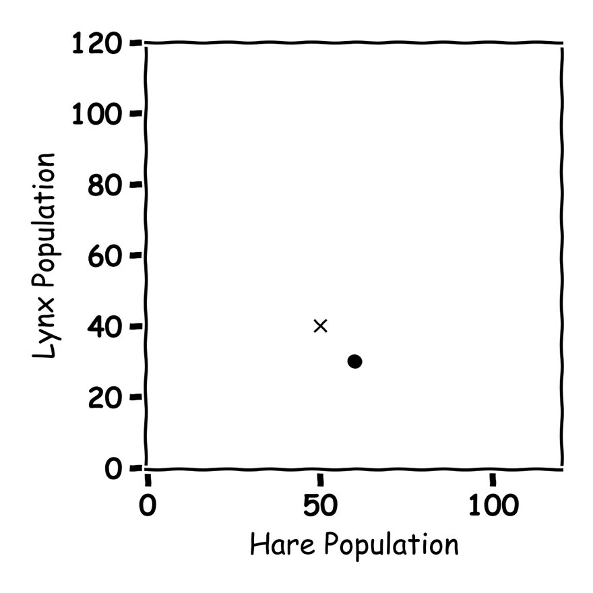
Don’t get Eaten by the Wolf

Exercise 11
Label the graph arrows in the graph.
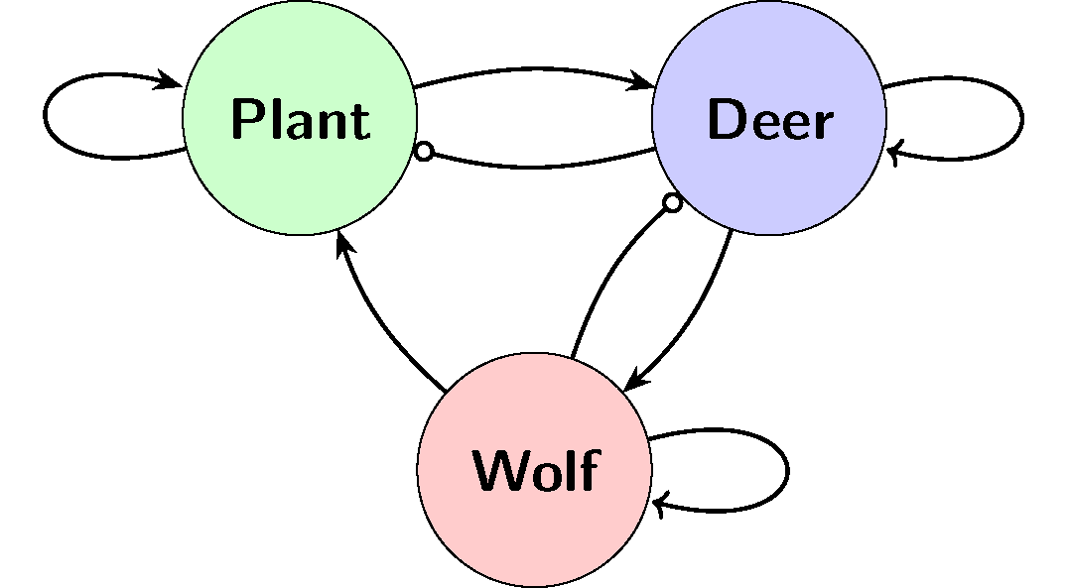

Exercise 12:
Describe what is happening in the below graph:
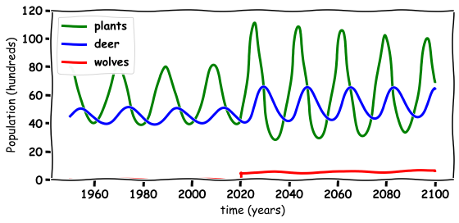

Discussion Questions
- What happened to the environment when the wolves are re-introduced?

- What happened to the wolf population when they are re-introduced?

- What happened to the deer population when the wolves are re-introduced?

- Do you think the wolves should have been re-introduced in Ireland?
- What else could you model with these Equations?

