The Maths of Predators and Preys
Don’t get Eaten by the Wolf

Hares 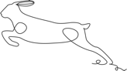

No predators
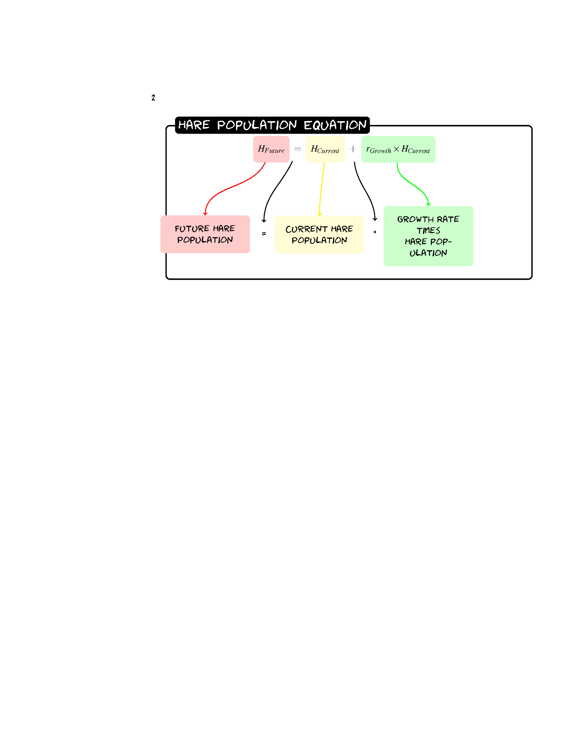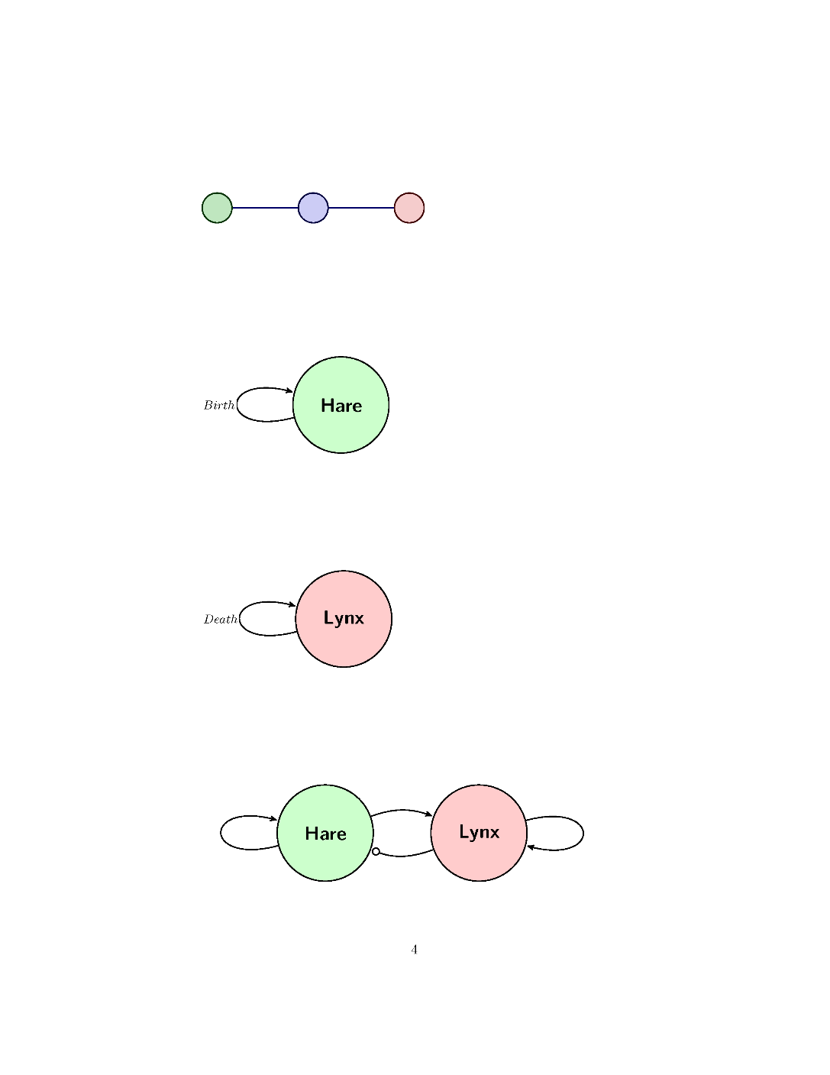

Exercise 1: Calculate the Population
1.1 Given a population of 60 Hares and a birth rate of 0.2 what would the population be after one year using the formula:
H_{Future}=H+0.2(H)
Answer:
72=60+0.2(60)

1.2 Now calculate the Hare population for three years
Answer:
Year | Hare Population
Year | Hare Population
0 | 60
1 | 60+0.2*(60)=72
2 | 72+0.2*(72)=86
3 | 86+0.2*(86)=103

Exercise 2:
Sketch the graph for three years of Hare populations.
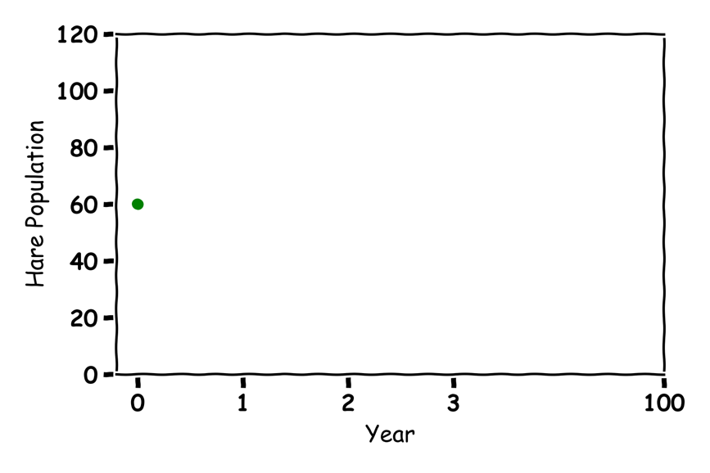

Exercise 3: What would happen in 100 Years
Guess what would happen to the Hare population in 100 years?
Answer:
Over 4 Billion

Lynx 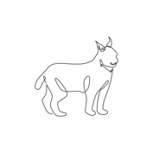

No Prey
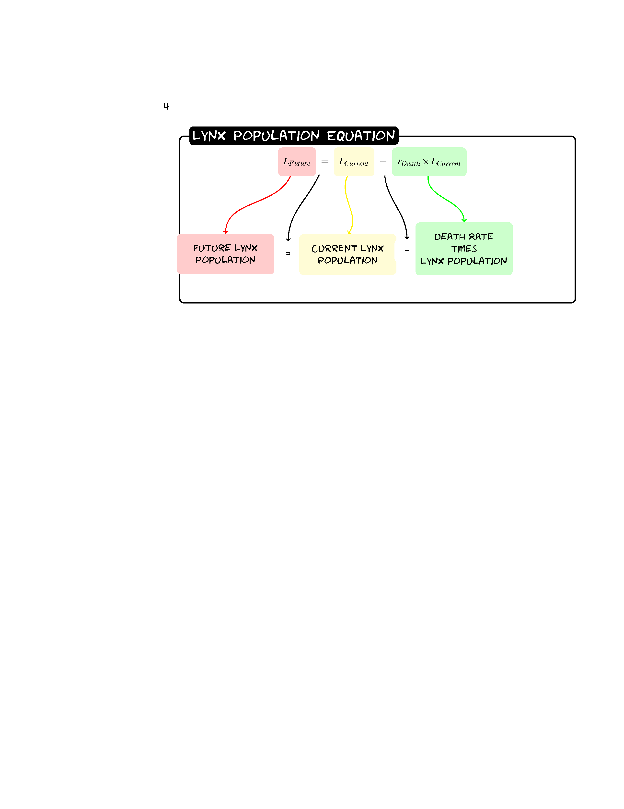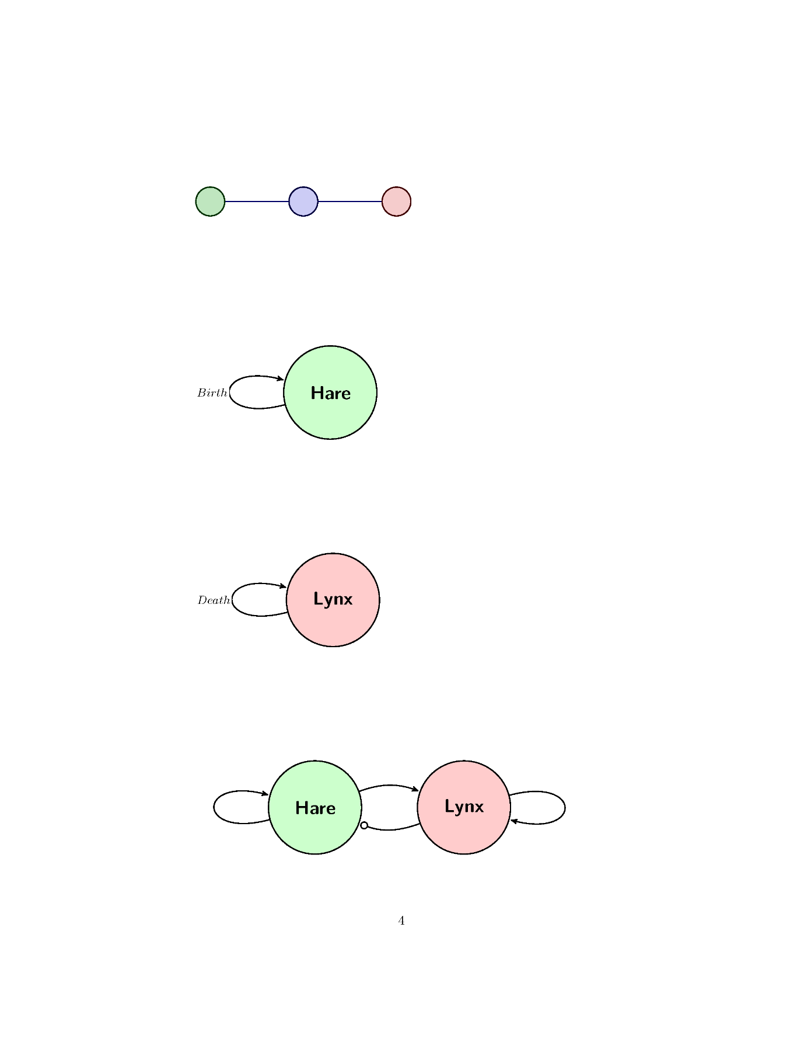
4.1 Given a population of 30 Lynxes and a death rate of 0.1 what would the population be after one year?
L_{Future}= L-0.1(L)
Answer:
30-0.1(30)=27
4.2 Now calculate the Lynx population for three years
Answer:
Year | Lynx Population
0 | 30
1 | 30-0.1*(30)=27
2 | 27-0.1*(27)=24
3 | 24-0.1*(24)=22

Exercise 5
Sketch the graph for three years of Hare populations.
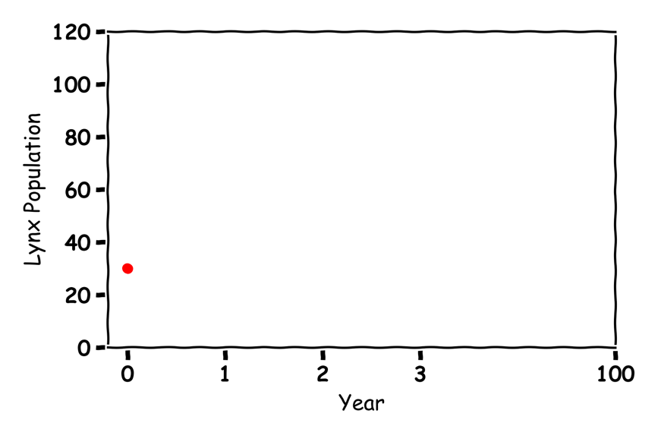

Exercise 6
Guess what would happen to the Lynx population in 100 years?
ANSWER:
All Dead

Hares and Lynxes  
Label the graph:
Food Rate
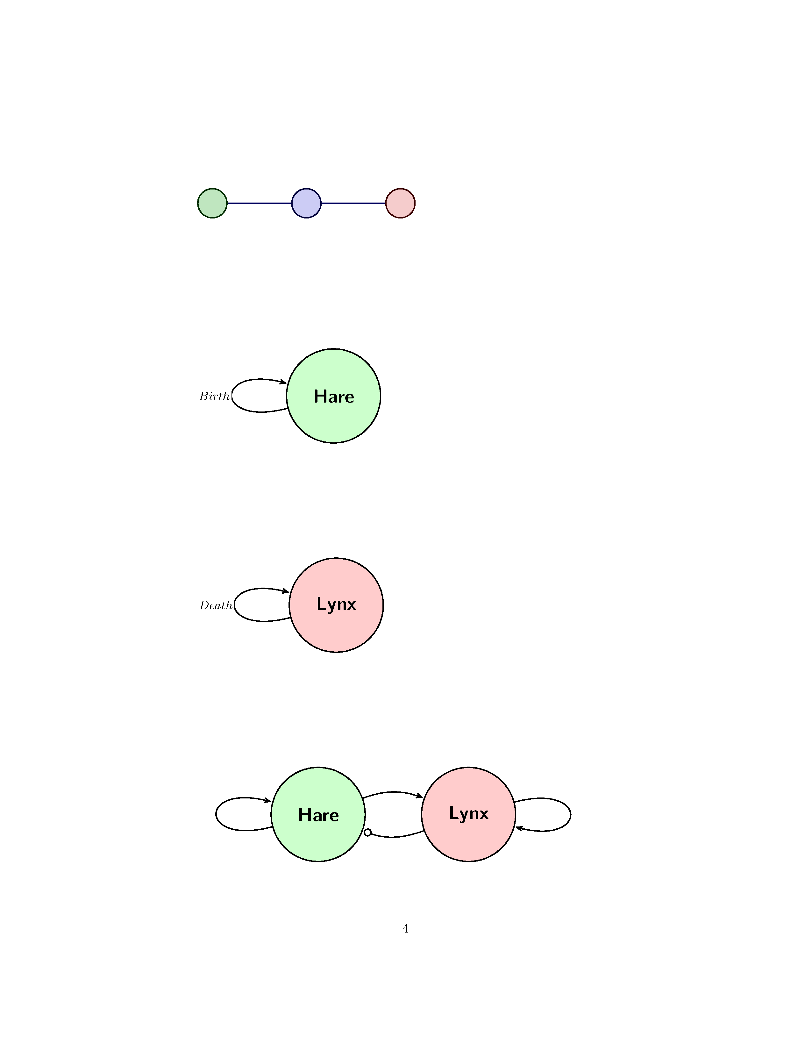
Birth rate
Eat Rate
Death rate
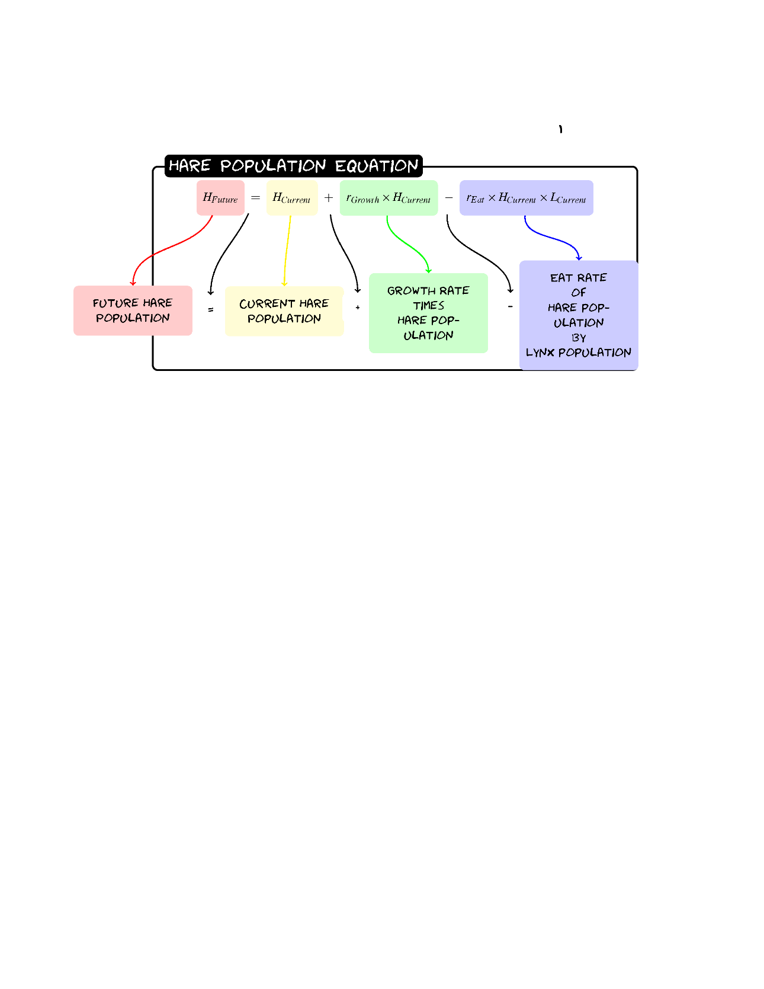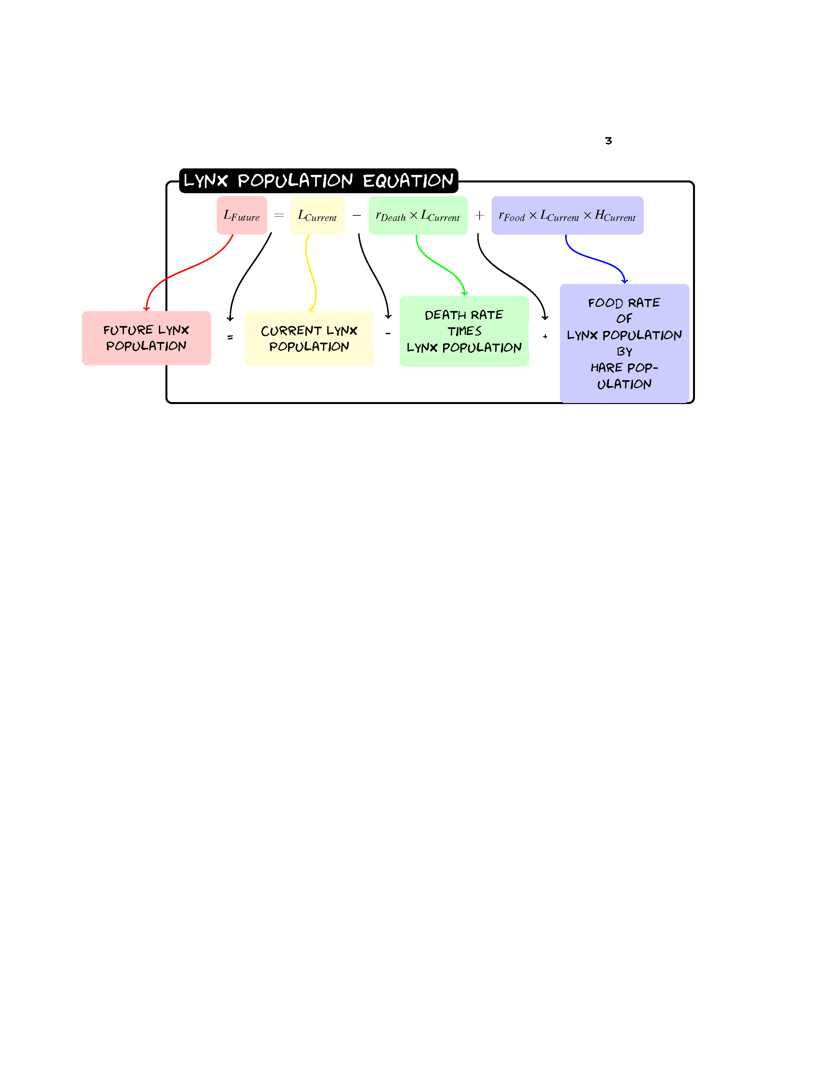

Exercise 8
8.1 Given a population of 60 Hares and 30 Lynxes with a birth rate of 0.2, a death rate of 0.1, a eat rate of 0.005 and a food rate of 0.002 what would the populations be after one year?
Hare | Value | Lynx | Value
Birth | 0.2 | Death | 0.1
Eat | 0.005 | Food | 0.002
H_{Future}=H+0.2(H)-0.005(H)(L)
L_{Future}= L-0.1(L)+0.002(L)(H)
ANSWER:
HARE: 60+0.2*(60)-0.005*(60)*(30)=63
LYNX: 30-0.1*(30)+0.002*(30)*(60)=31
8.2 Now Predict Three Years of Hare and Lynx Populations
ANSWER:
Year | Hare Population | Lynx Population
0 | 60 | 30
1 | 60+0.2*(60)-0.005*(60)*(30)=63 | 30-0.1*(30)+0.002*(30)*(60)=31
2 | 63+0.2*(63)-0.005*(63)*(31)=66 | 31-0.1*(31)+0.002*(31)*(63)=31
3 | 66+0.2*(66)-0.005*(66)*(31)=69 | 31-0.1*(31)+0.002*(31)*(66)=32

Exercise 9:
Sketch the graph for the Lynx and Hare populations for three years:
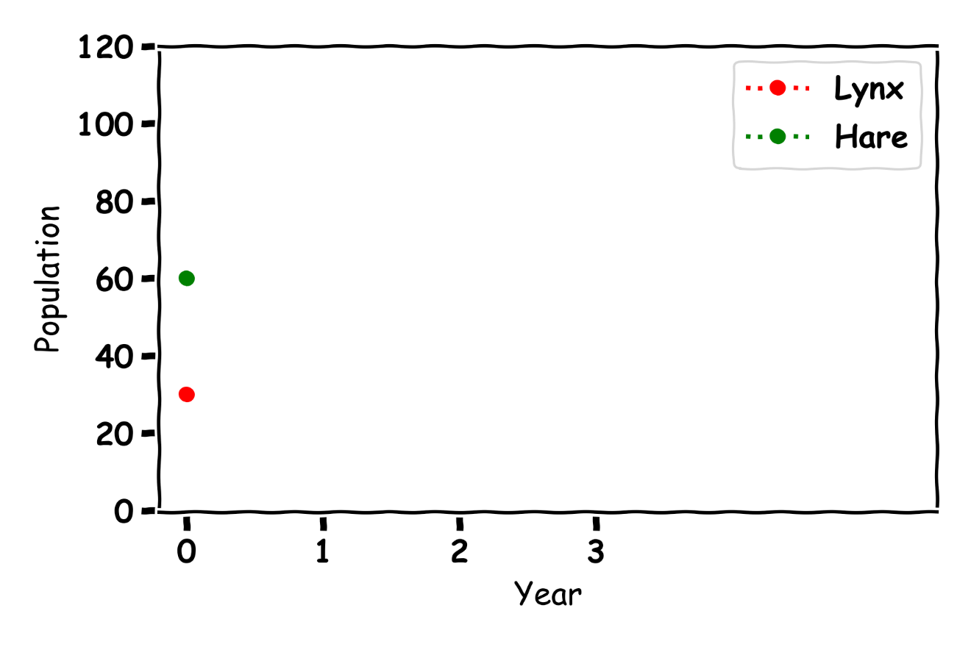

Exercise 10
Sketch the Hare population on the x-axis and the Lynx population on the y-axis

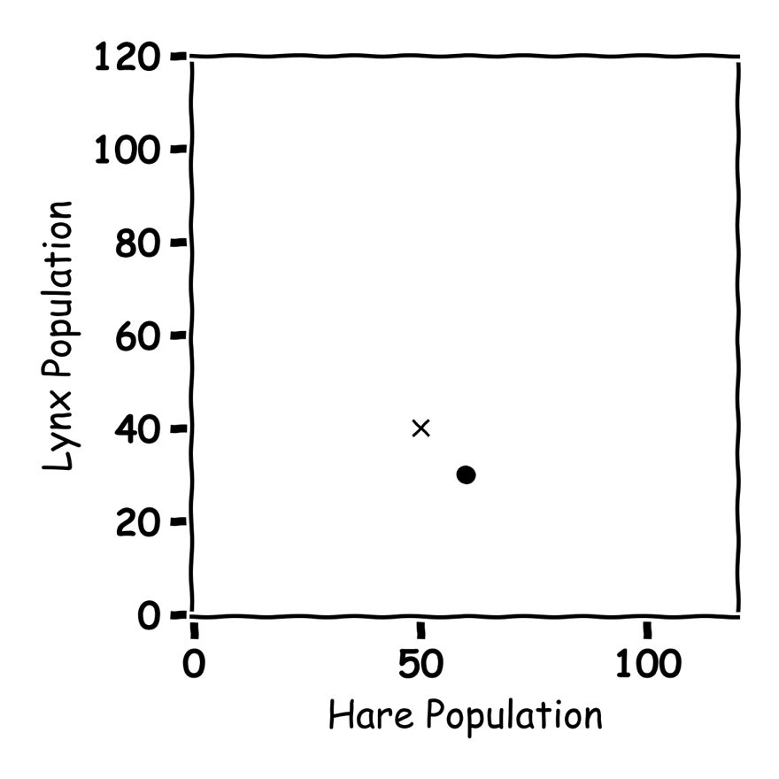

Don’t get Eaten by the Wolf

Exercise 11
Label the graph arrows in the graph.
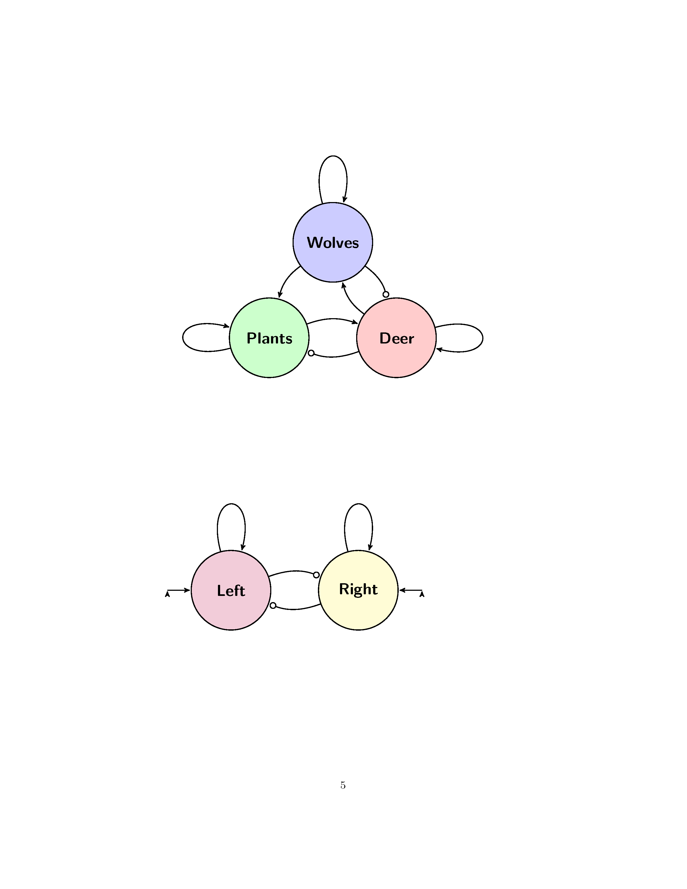
Food for deer
More Plants Grow
More Deer Born
Death rate Wolves
Wolves eat Deer
Deer eat plants
Food for wolves
Wolves project plants

Exercise 12:
Describe what is happening in the below graph:
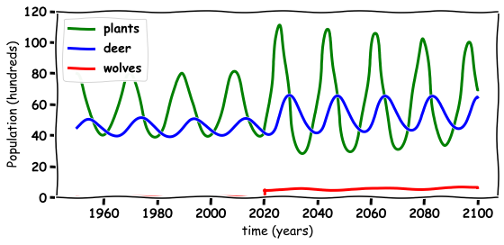
ANSWER:
When the Wolves were reintroduced, they scared the deer from the river which helped the plants grow. Thie also made more food for the deer.

Discussion Questions
- What happened to the environment when the wolves are re-introduced?

- What happened to the wolf population when they are re-introduced?

- What happened to the deer population when the wolves are re-introduced?

- Do you think the wolves should have been re-introduced in Ireland?
- What else could you model with these Equations?

