My First R

2025-10-01

## Question 1

## [1] 2

## Including Plots

You can also embed plots, for example:

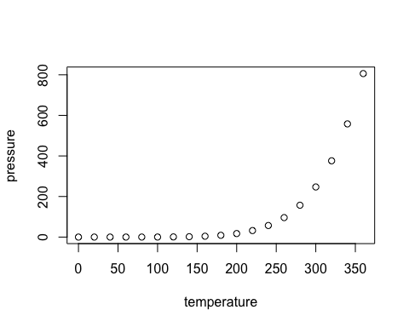

Note that the echo = FALSE parameter was added to the code chunk to prevent printing of the R code that generated the plot.