# Tutorial Sheet 3 Solutions

## Probability Mass Distributions

### Question 1

1. The probability mass function of a discrete random variable X is given in the following table:
2. Find the E[X] and Var [X].

#### **ANSWER**

The formula for the Expected value, E[X] is:

$$E\left[X\right]=x_{1}p_{1}+x_{2}p_{2}+x_{3}p_{3}+x_{4}p_{4}+x_{5}p_{5}=\sum_{i=1}^{5}{x_{i}}p_{i}$$

Doing the E[X] calculation in tabular form:

$$E\left[X\right]=0\left(0.1\right)+1\left(0.2\right)+2\left(0.4\right)+3\left(0.2\right)+4\left(0.1\right)=2$$

The expected value E[X] is 2.

The formula for the Variance value, VAR[X], is:

$$VAR\left[X\right]={\left(x_{1}−E\left[X\right]\right)}^{2}p_{1}+{\left(x_{2}−E\left[X\right]\right)}^{2}p_{2}+$$

$${\left(x_{3}−E\left[X\right]\right)}^{2}p_{3}+{\left(x_{4}−E\left[X\right]\right)}^{2}p_{4}+{\left(x_{5}−E\left[X\right]\right)}^{2}p_{5}=\sum_{i=1}^{5}{{\left(x_{i}−E\left[X\right]\right)}^{2}}p_{i}$$

In tabular form:

$$VAR\left[X\right]={\left(0−2\right)}^{2}0.1+{\left(1−2\right)}^{2}0.2+$$

$${\left(2−2\right)}^{2}0.4+{\left(3−2\right)}^{2}0.2+{\left(4−2\right)}^{2}0.1=1.2.$$

The Variance value VAR[X] is 1.2.

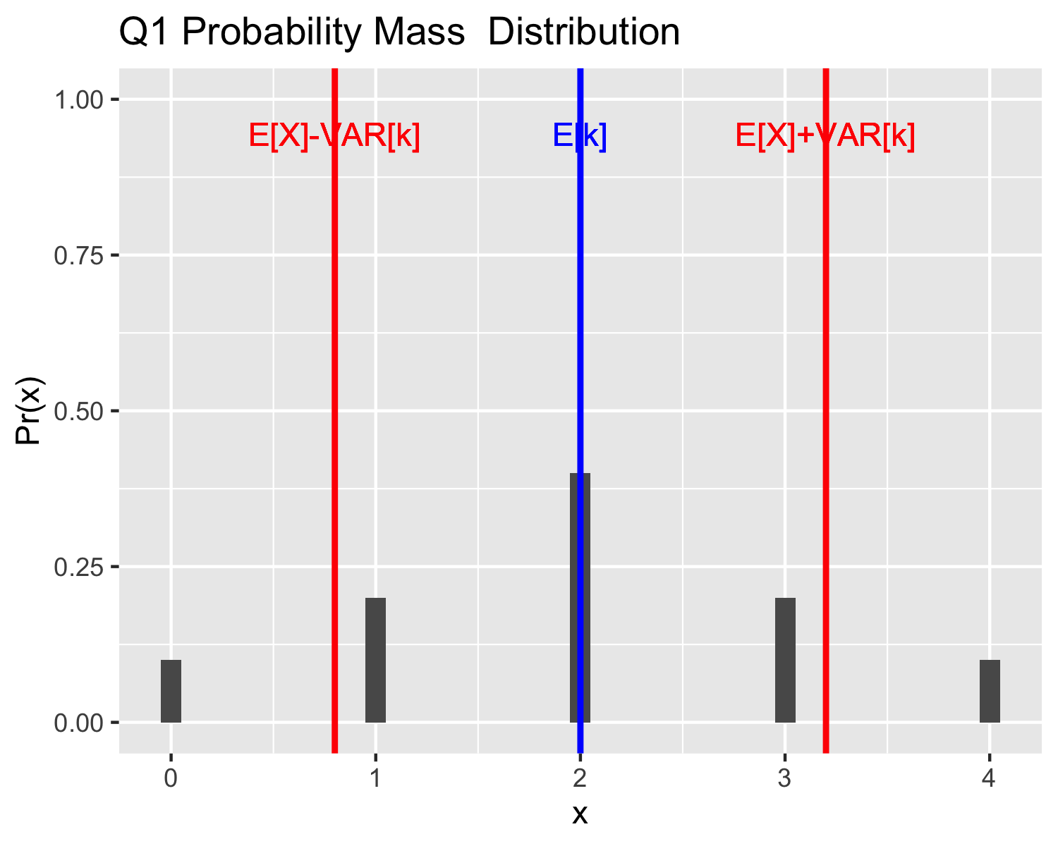

1. The Cumulative probability mass function

The cumulative probability mass function of a discrete random variable X is given in the following table:

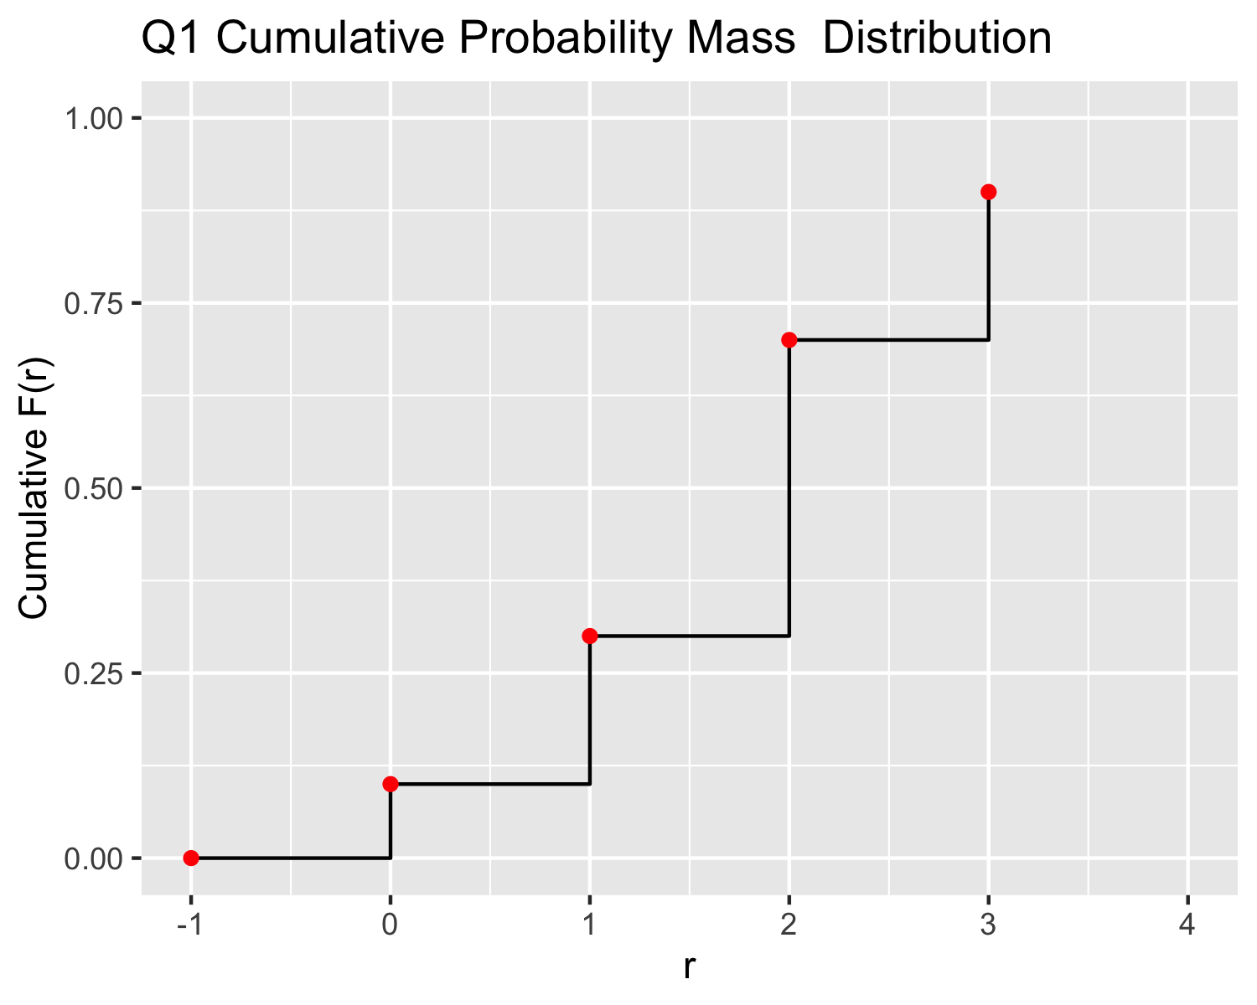

### Question 2

The probability mass function of a discrete random variable X is given in the following table:

1. Show that p3 = 0.2

#### **ANSWER**

$$0.1+0.3+0.3+p_{3}+0.1=1$$

re-arranging

$$p_{3}=1−0.1+0.3+0.3+0.1$$

$$p_{3}=1−0.8=0.2$$

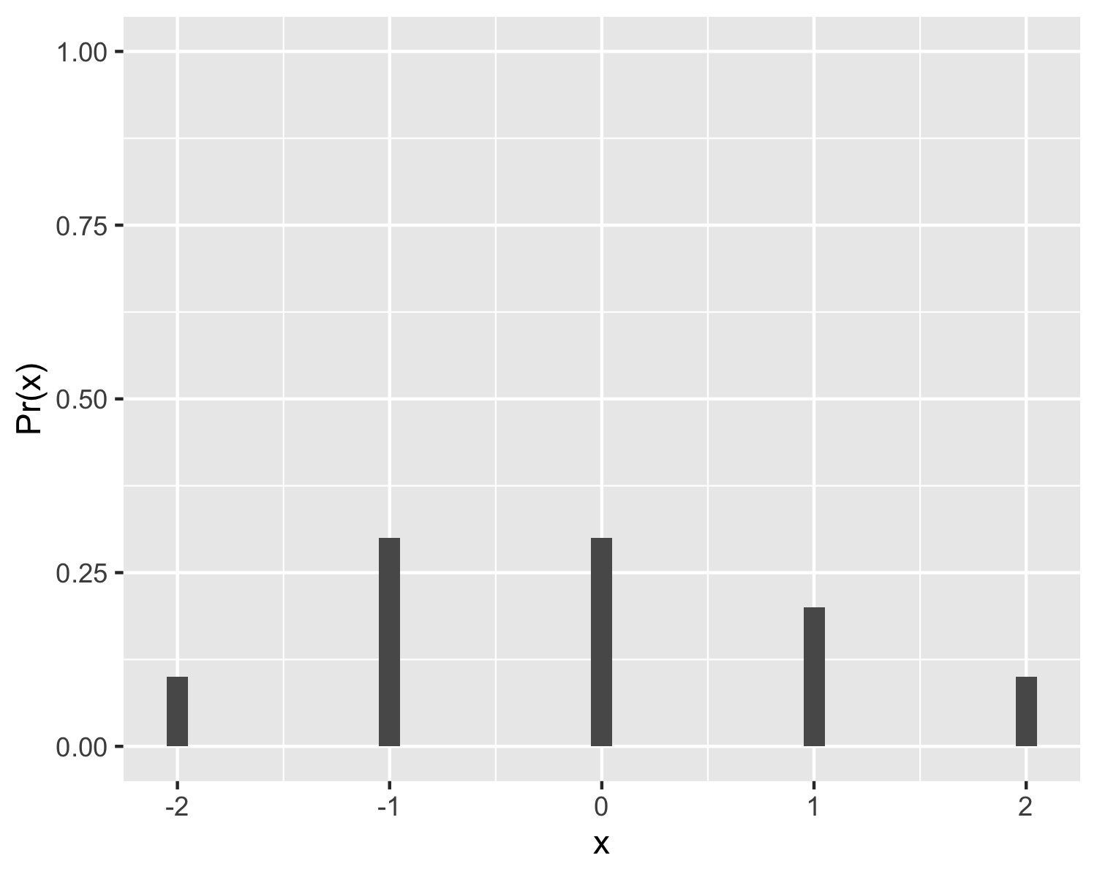

1. Calculate the E[X] and Var[X].

#### **ANSWER**

$$E\left[X\right]=x_{1}p_{1}+x_{2}p_{2}+x_{3}p_{3}+x_{4}p_{4}+x_{5}p_{5}=\sum_{i=1}^{5}{x_{i}}p_{i}$$

$$E\left[X\right]=−2\left(0.1\right)+−1\left(0.3\right)+0\left(0.3\right)+1\left(0.2\right)+2\left(0.1\right)=−0.1$$

The expected value E[X] is -0.1.

Calculating the Var[X] in tabular form:

The formula for the Variance value, VAR[X], is:

$$VAR\left[X\right]=\sum_{i=1}^{5}{{\left(x_{i}−E\left[X\right]\right)}^{2}}p_{i}$$

$$VAR\left[X\right]=1.29.$$

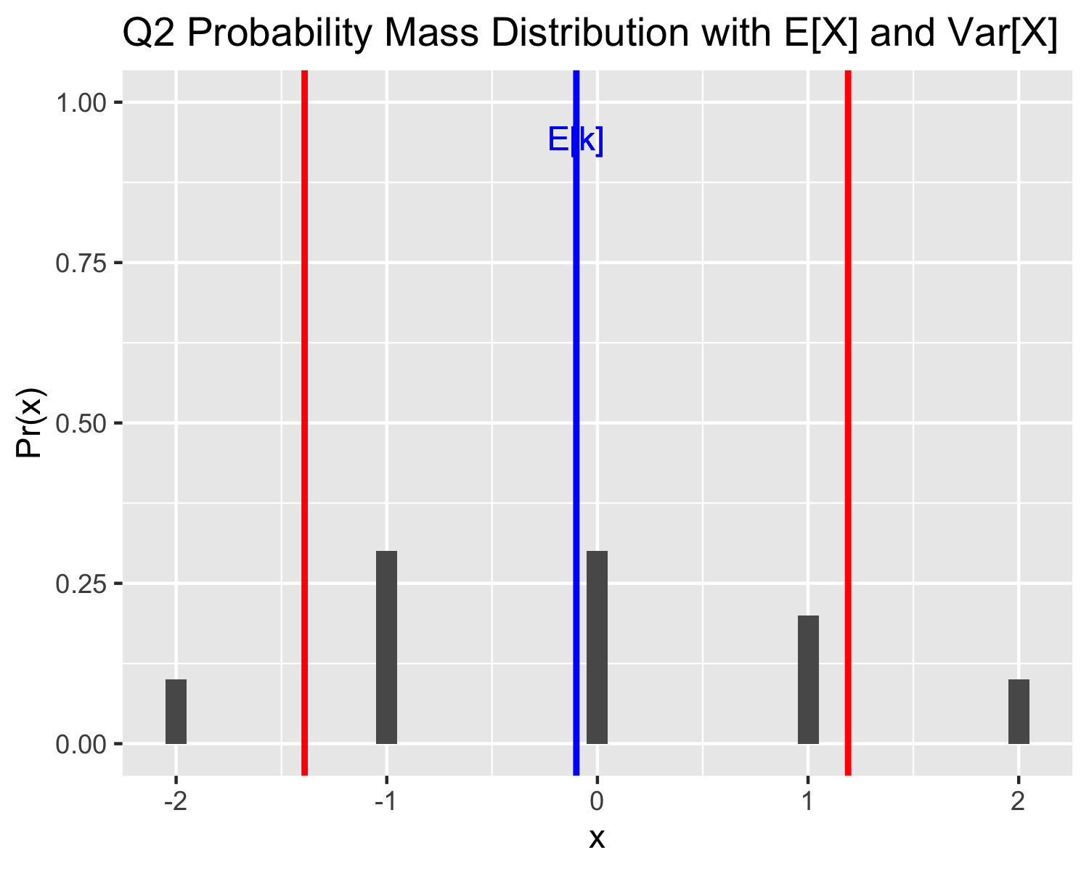

### Question 3

1. 20% of the Irish population watched Ireland beat France in the Rugby World Cup. A representative from TV3 marketing was sent to Grafton Street to ask passersby their opinion of the match coverage. Let X denote the number of people need to be asked til the marketer successfully finds someone who watched the game.

i Give the Geometric probability mass function for X.

**ANSWER**

The probability of “success” is

$$p=0.2,$$

the probability of “failure” is

$$q=1−p=0.8.$$

This gives the general definition of the distribution as:

$$Pr\left(k\right)={0.8}^{\left(k−1\right)}0.2, k=1,2,...$$

where k is the number of people asked by the marketer.

ii Find the probability that the marketer had to ask exactly 2 people.

**ANSWER**

$$Pr\left(2\right)={0.8}^{\left(2−1\right)}0.2=0.8\left(0.2\right)=0.16$$

iii What is the E [X ] and V ar [X ] of the distribution.

**ANSWER**

The expected outcome of,

$$E\left[k\right]=\frac{1}{p}=\frac{1}{0.2}=5,$$

and variance of

$$Var\left[k\right]=\frac{q}{p^{2}}=\frac{0.8}{{0.2}^{2}}=20.$$

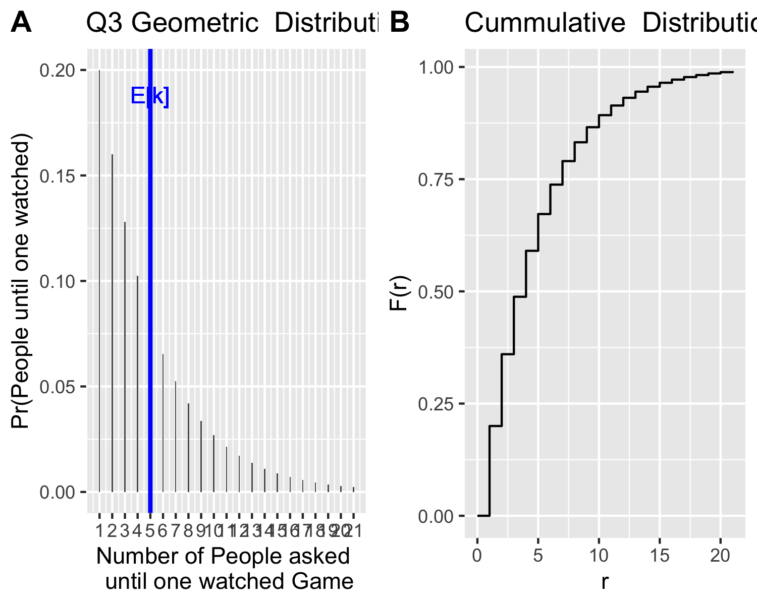

### Very Optional Question 4

1. The probability mass function of a Bernoulli random variable X is given in the following table:
2. Find the mean E[X] and variance Var[X]. **Answer:**

$$q=1−p,p=1−q,1=p+q.$$

$$E\left[X\right]=Σ_{x}xp\left(x\right)=0\left(q\right)+1\left(p\right)=p.$$

$$Var\left[X\right]=Σ_{x}{\left(x−E\left[X\right]\right)}^{2}p\left(x\right)={\left(0−p\right)}^{2}\left(q\right)+{\left(1−q\right)}^{2}\left(p\right)=p^{2}q+q^{2}p$$

$$Var\left[X\right]==p^{2}q+q^{2}p=qp\left(p+q\right)=qp$$

### MCQ Question 5

Which of the following is true about a probability mass function (PMF) of a discrete random variable?

1. The PMF can take any value greater than or equal to 0.
2. The sum of all values of a PMF is 1.
3. The PMF can take negative values.
4. The PMF is defined for continuous random variables.

**Solution**

Correct Answer: B) The sum of all values of a PMF is 1.

### MCQ Question 6

The probability mass function of a discrete random variable $X$ is given in the following table:

What is the probability that X takes a value greater than -2?

1. 0.1
2. 0.2
3. 0.6
4. 0.4
5. 0.7

**Solution**

Answer: C) 0.6

### MCQ Question 7

Which of the following best describes the geometric distribution?

1. It models the number of successes before the first failure in a series of independent Bernoulli trials.
2. It models the number of trials until the first success in a series of independent Bernoulli trials.
3. It models the number of failures before the first success in a series of dependent Bernoulli trials.
4. It models the number of trials until the first success in a series of dependent Bernoulli trials.

**Solution** ANSWER: B

### MCQ Question 8

Spot three reasons why the following table cannot be a probability mass function of a discrete random variable $X$:

**Solution**

1. Negative probability
2. Probabilities do not sum to 1
3. In wrong order (this is a bit of a weak one)

### MCQ Question 9

What is the variance of a Bernoulli random variable with success probability $p=0.6$?

1. 0.24
2. 0.36
3. 0.4
4. 0.6

**Answer**: **A $\text{Var}\left[X\right]=p\left(1−p\right)=0.6⋅0.4=0.24$**

### MCQ Question 10

Which statement best describes a cumulative distribution function (CDF)?

1. It gives the probability of a specific value.
2. It gives the probability that a variable is greater than a value.
3. It gives the probability that a variable is less than or equal to a value.
4. It gives the expected value of a distribution.

**Answer**: **C**

### Question 11

Write your own question for a geometric distribution.