Our Brain in Motion

Self-Motion: A team effort by our sensory systems

Get Moving: How the brain interprets self-motion

Jennifer L. Campos, Maryam Pandi, John S. Butler

Word count (1000-1500)

Figures (2 max)

References (4 max)

**Abstract**

As you walk, bike, or drive down the street, your brain uses and integrates many different sources of information. It uses what you see, what you hear, and how your head and body move to help you judge your own movements through space. As you move, your brain must ensure that the world does not look blurry and that you can judge how fast you are moving, how far you are moving, and in what direction you are heading; and of course, falling should be avoided! This paper provides insight into how our brain achieves the amazing task of perceiving our own movements and how we use this information to help us stay balanced and navigate our world. It also describes what happens when errors in self-motion occur (e.g. due to illness/injury) and how the science of self-motion perception can be exploited to enhance advanced display technologies and entertainment platforms (e.g. video games and Virtual Reality).

## Sensory inputs used to perceive self-motion

Sometimes the movements we make are very small and subtle (e.g. when trying to stand very still) and sometimes they are very large (e.g. when riding our bike). But big or small, we always use several important sensory systems to interpret and guide these movements. Each sensory system plays a unique and important role in our perceptions. These sensory systems include our visual system, proprioceptive system (our muscles and joints), tactile system (touch), and vestibular system Figure 1. Below, we describe how these sensory systems help us estimate our movements and guide our behaviours. Importantly, all of these systems work *together* as a team and get integrated in the brain to make sure that our estimates are precise and that our behaviours are efficient.

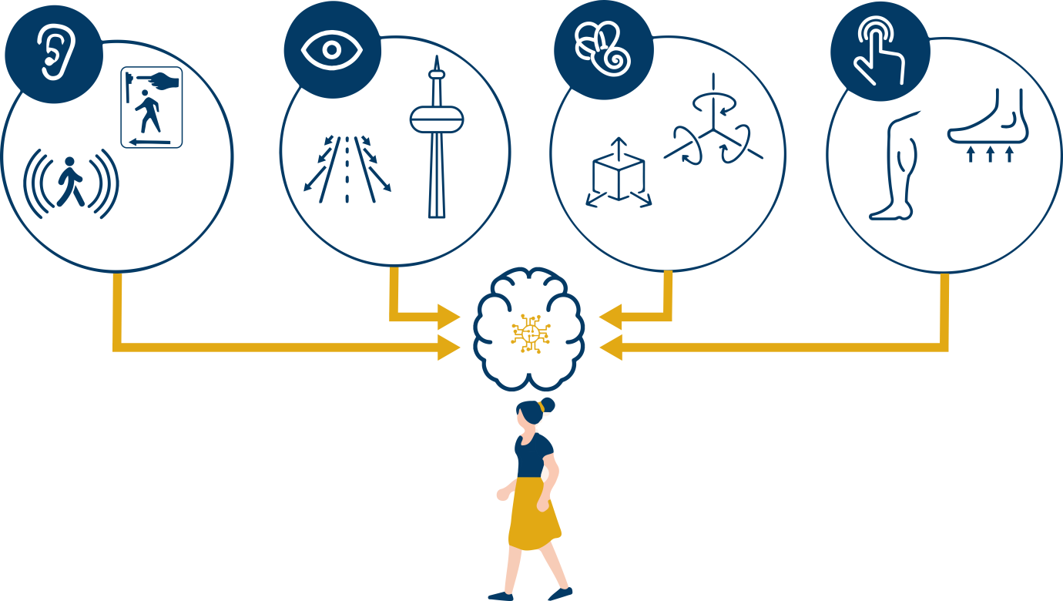

***Figure 1:*** *Our brain uses a combination of sensory inputs, auditory, visual, vestibular and proprioception, to perceive our own movements through space.*

Stand in one place and try to stay still. Even this simple task requires your brain to integrate information from many different sensory sources. Your **visual system** makes use of landmark cues and dynamic visual motion (called optic flow) to know how much your head is moving. Close your eyes and see what happens. It becomes harder to stay stable, which means that vision is used to support balance. Now try lifting one foot off the floor. Information from the sensors in your feet (**tactile** inputs) tells you if the ground is flat, and your muscles and joints provide information about where your body parts are in space and relative to each other; these inputs are referred to as your **proprioceptive system**. Now stand on something soft. This will further challenge your proprioceptive system, but may also generate more head accelerations. Our **vestibular system** is located in our inner ear and it is our brain’s “acceleration detector”; the otolith organs detect straight movements (e.g. forward/backward) and the semicircular canals detect rotations (e.g. nod your head up/down,). Have you fallen over yet? Hopefully not, because once your brain detects that you are off-balance, you can generate motor commands to adjust your body and avoid falling.

Another example of why it is important to coordinate our sensory signals is to keep the image of our external world stable and not jittery or blurry. For instance, as you turn your head left and right, the signals from the vestibular system are processed in milliseconds and tell your eyes to move in the opposite direction; known as the **vestibular-ocular reflex**. This is how you can keep a stable image on your eye even if your head is moving. For example, when you are playing soccer and you are running after the ball, the vestibular inputs help keep your eye stable on the ball while your head bobs up and down, without the image of the ball becoming blurry…. GOAL!

Even though our sensory systems typically work all together to support our perceptions and behaviours , sometimes certain sensory inputs are more reliable than others. For instance, at nighttime, or when it is foggy out, visual information is less reliable, and therefore the brain relies more heavily on other sensory inputs. The brain weights sensory information dynamically and instantaneously. A focus of recent studies has been to understand the extent to which vision, proprioception, audition, and vestibular information each contribute to self-motion perception [1].

## Self-motion experiments

To understand how each sensory input contributes to self-motion perception, it is helpful to systematically remove the brain’s access to individual sensory inputs (e.g. remove vision through blindfolding) and evaluate the effects on behaviour. For example, how does blocking vision affect our ability to judge our distance travelled, our movement speed, or our heading direction? We can actually still perform pretty well! But if we want to know how each input contributes when all inputs are available, as is the case during most everyday interactions, it becomes difficult to manipulate each input independently. Modern Virtual Reality (VR) technologies have made this challenge easier [2].

Using VR John and Jenny studied the contributions of visual and vestibular information for judging **heading** direction (Figure 2A); knowing which way you are going. Participants were seated on a moving platform that moved them forward to the left, or forward to the right at very precise angles [3]. They were also wearing VR goggles (head-mounted display), making it look like they were in space, flying through a cloud of stars. The task for participants was simply to judge whether they moved to the left or to the right. Sometimes the angles moved were very large and obvious and sometimes they were very small and difficult to distinguish. We measured the smallest possible angle that participants could distinguish and how precisely participants could make these judgements. The heading task was performed with vision only, motion only (i.e. vestibular), and with both vision and motion together. The results showed that participants were equally good at the heading task using their visual system or their vestibular system, but that they were significantly better when using both systems together.

To further investigate whether participants relied more on the visual or vestibular estimates when *both* were available, we used a VR experimental trick (very difficult to achieve in the real world). Specifically, participants were presented with a visual heading direction indicating that they were moving 5 degrees to the left, but a vestibular heading direction (motion) that indicated they were moving 5 degrees to the right! This is called introducing a **sensory conflict** (Figure 2B), and most participants are not consciously aware that a conflict has been introduced. By analysing participants’ responses, we can infer whether they were using visual inputs more or vestibular inputs more. If a participant responded “left” more often, this suggests they used vision more, but if they responded “right” more often, this suggests they used vestibular inputs more (Figure 2B). Finally if they say left and right an equal number of times this suggests visual and vestibular inputs are equal. This technique can be used to estimate how each sensory input is “weighted” by the brain. In our study we showed that participants weighted the vestibular cues higher than the visual cues.

## Self-motion illusions

Most of the time we remain completely unaware that our brain is integrating sensory signals seamlessly as we navigate our daily lives. However, self-motion illusions give us a momentary window into the decisions the brain is making about whether to integrate inputs and how to weight them. A good example of this is the **“train illusion”.** This illusion is experienced when you are sitting on a stationary train, and the train beside you begins to move - you are fleetingly tricked into thinking that it is *your* train that is moving. This is because usually, when most of your visual field is moving, it is because you are moving through the world and not because the world is moving past you. The scientific term for illusory, visually-induced self-motion perception is “**vection”.**

Videogame developers and movie producers often exploit vection to enhance the feeling that you are actually moving as you play a first person action adventure video-game, or view a movie while seated. The more of the visual field that the visual motion occupies and the more “immersive” the experience (i.e. the extent to which it stimulates most of your sensory inputs) the greater vection you will feel. However, care must be taken not to unintentionally introduce negative side effects; most notably, a unique kind of motion sickness referred to as “visually induced motion sickness” or simulator/cyber sickness.

### Individual differences in self-motion perception

The way we perceive self-motion changes over the course of development from birth to older adulthood. For example, as we get older, we often experience declines in our sensory systems (e.g. poorer visual acuity, muscle weakness, hearing loss). These declines mean that it may be *even more* important to integrate sensory information. In other words, strong signals may be reliably used to judge movements on their own; however, when signals are weak, they benefit much more from having corresponding evidence from multiple other sensory signals. This is a basic principle of multisensory integration referred to as the **Principle of Inverse Effectiveness**. When people experience age-related declines in their sensory systems, and/or differences in how they are able to integrate sensory inputs, there may be serious consequences including falls and vehicle collisions.

There are other clinical disorders that have significant consequences to self-motion perception and mobility. For instance, Parkinson’s Disease is a disorder of the brain that causes individuals to have difficulties controlling their own movements, such as during walking. It is thought that some of these difficulties are due to problems coordinating sensory inputs to support safe mobility [4].

### Conclusion

Recent research has demonstrated that effective self-motion perception relies on the effective integration of visual, proprioceptive, auditory, and vestibular information to support safe mobility (like walking, biking, driving). Failure to do so could have serious consequences including getting lost, colliding with objects, or falling. By further understanding how the brain integrates and weights these sensory inputs, advances can be made to support healthy aging, treat movement disorders, and develop novel immersive technologies for applications ranging from education to entertainment.

### References

1. Campos, J.L., Bülthoff, H.H. (2012). Multisensory integration during self-motion in virtual reality. Ed. Murray, M.M., Wallace, M. Frontiers in the Neural Bases of Multisensory Processes. CRC Press/Taylor & Francis, Boca Raton, FL: pp. 603-628.
2. Penn R and Hout M (2018) Making Reality Virtual: How VR “Tricks” Your Brain. Front. Young Minds. 6:62. doi: 10.3389/frym.2018.00062
3. Butler, J. S., Smith, S. T., Campos, J. L., & Bülthoff, H. H. (2010). Bayesian integration of visual and vestibular signals for heading. Journal of vision, 10(11), 23-23.
4. Berman T and Bayati A (2018) What Are Neurodegenerative Diseases and  
   How Do They Affect the Brain? Front. Young Minds 6:70. doi: 10.3389/frym.2018.00070

Authors

**Jennifer L Campos**

I am the Associate Director, Academics and Senior Scientist at KITE – Toronto Rehabilitation Institute, University Health Network in Toronto Canada. My research focuses on enhancing safe mobility during walking and driving under realistic and challenging conditions. This includes understanding fundamental changes in multisensory integration with age and how age-related sensory impairments (e.g. vision, hearing) and cognitive impairments can increase the risk of falls and vehicle collisions.

**Maryam Pandi**

**John S Butler**

I am a Mathematics Lecturer in the Technological University Dublin, Ireland. I use my dual backgrounds in math and neuroscience to design experiments and analysis methods to investigate sensory integration, myopia, neuronal modeling and self-motion.