Self-Motion Perception

Jennifer L. Campos, Maryam Pandi, John S. Butler

Word count (1000-1500)

Figures (2 max)

References (4 max)

**Abstract**

As you walk, bike, or drive down the street, Your brain uses and integrates many different sources of information. It uses what you see, what you hear, and how your head and body move to help you judge your own movements through space. As you move, your brain must ensure that the world does not look blurry and that you can judge how fast you are moving, how far you are moving, and in what direction you are heading; and of course, falling should be avoided! This paper provides insight into how our brain achieves the amazing task of perceiving our own movements and how we use this information to help us stay balanced and navigate our world. It also describes what happens when errors in self-motion occur (e.g. due to illness/injury) and how the science of self-motion perception can be exploited to enhance advanced display technologies and entertainment platforms (e.g. video games and Virtual Reality).

## Sensory inputs used to perceive self-motion

Sometimes the movements we make are very small and subtle (e.g. when trying to sit or stand very still) and sometimes they are very large (e.g. when riding our bike to our friend’s house). But big or small, we always use several important sensory systems to interpret and guide these movements. Each sensory system plays a unique and important role in our perceptions. These sensory systems include our visual system, auditory system (hearing), proprioceptive system (our muscles and joints), tactile system (touch), and vestibular system Figure 1. Below, we focus on a few of these sensory systems and describe how they help us estimate our movements and guide our behaviours. Importantly, all of these systems work *together* as a team and get integrated in the brain in order to make sure that our estimates are precise and that our behaviours are efficient.

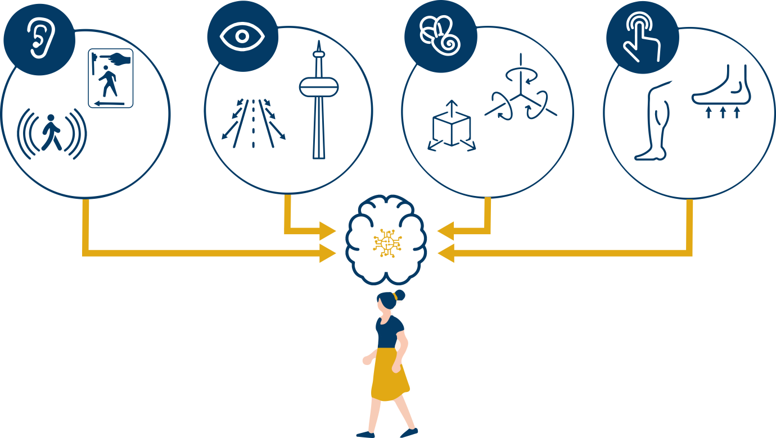

***Figure 1:*** *Our brain uses a combination of sensory inputs, auditory, visual, vestibular and proprioception, to perceive our own movements through space.*

Stand in one place and try to stay still. Even this simple task requires your brain to integrate information from many different sensory sources. Your **visual system** makes use of visual landmark cues and dynamic visual motion (called optic flow) to know how much your head is moving in space. Close your eyes and see what happens. It becomes harder to stay stable, which means that vision is used to support balance. Now try lifting one foot off the floor. Information coming from the sensors in your feet (**tactile** inputs) tells you if the ground is flat, and your muscles and joints provide information about where your body parts are in space and relative to each other; these inputs are referred to as your **proprioceptive system**. Now stand on something soft. This will further challenge your proprioceptive system, but may also generate more head accelerations. Our **vestibular system** is located in our inner ear and it is our brain’s internal “acceleration detector”; the otolith organs detect accelerations when we move straight (up/down, forward/backward, side to side) and the semicircular canals detect accelerations when we rotate/turn (e.g. nod your head up/down, or turn your head right/left). Next, try wearing noise-cancelling headphones or ear plugs. Have you fallen over yet? Hopefully not, because once your brain detects that you are off-balance using information from all of these different sensory inputs, you can generate motor commands to adjust your body to avoid falling.

Another example of why it is important to coordinate our sensory signals is to keep the perception of our external world stable and not jittery or blurry. For instance, as you turn your head left and right the signals from the vestibular system are processed in milliseconds and tell your eyes to move in the opposite direction, this known as the **vestibular-ocular reflex**. This is how you can keep a stable image on your eye even if your head is bobbing up and down while you walk or run. For example, when you are playing soccer and you are running after the ball, the vestibular inputs help keep your eye stable on the ball while your head bobs up and down, without the image of the ball becoming blurry…. GOAL!

Even though our sensory systems typically work all together to support our perceptions and behaviours of movement, sometimes certain sensory inputs are more reliable than others. For instance, at nighttime, or when it is foggy out, visual information is less reliable, and therefore the brain relies more heavily on other sensory inputs. The brain weights sensory information dynamically and instantaneously. A focus of recent research studies has been to understand the extent to which visual, proprioception, audition, and vestibular information each contribute to self-motion perception [1]. Also, researchers want to know how sensory contributions to self-motion perception change depending on the task at hand, the environmental conditions, and on the characteristics of person themselves (e.g. age). In the next section, we will discuss experimental strategies that have been used to quantify the different sensory contributions to self-motion perception.

## Self-motion experiments

In order to understand how each sensory input contributes to self-motion perception, it is very helpful to systematically remove the brain’s access to individual sensory inputs (e.g. remove vision through blindfolding) and evaluate the effects on behaviour. For example, how does blocking vision affect our ability to judge our distance travelled, our movement speed, or our heading direction? The answer is that we can actually still perform pretty well! But if we also want to know how each input is contributing when all inputs are available (as is typically the case during most every day interactions) it becomes more difficult to manipulate each input independently. Modern Virtual Reality (VR) technologies have made this challenge easier [2].

Using VR Johnny and Jenny investigated the contributions of visual and vestibular information for judging **heading** direction (Figure 2A); in other words, knowing which way you are going. Specifically, participants were seated on a motion platform which moved them forward towards the left, or forward towards the right [3], at very precise angles. They were also wearing VR goggles (head-mounted display), which made it look like they were in space, flying through a cloud of stars in leftward and rightward directions. The task for participants was very basic, they were asked to judge whether they perceived themselves to have moved to the left or to the right. Sometimes the angles moved were very large and obvious, and sometimes they were very small and difficult to distinguish left from right. We were interested in knowing the smallest possible angle that participants could distinguish and also how precisely participants could make these judgements across all angles.

The experiment was performed with vision only, with motion only (i.e. vestibular), and with both vision and motion together to investigate how well the visual system, the vestibular system and the combination of visual and vestibular systems were able to estimate self-motion. The results showed that participants were equally good at the heading task using their visual system or their vestibular system, but that they were significantly better when using both systems together.

Importantly, to further investigate whether participants relied more on the visual or vestibular estimates when *both* were available, we used a VR experimental trick (something very difficult to achieve in the real world). Specifically, participants were presented with a visual heading direction indicating that they were moving 5 degrees to the left, but a vestibular heading direction (motions) that indicated they were moving 5 degrees to the right! This is called introducing a **sensory conflict** (Figure 2B), and most participants are not consciously aware that a conflict has been introduced. By analysing participants’ responses, we can infer whether they were using visual inputs more or vestibular inputs more. If a participant responded “left” more often, this suggests that they used vision more. On the other hand if they responded “right” more often, this suggests that they used vestibular inputs more (Figure 2B). Finally if they say left and right an equal number of times this suggests visual and vestibular inputs are equal. This can be used to estimate how each sensory input is “weighted” by the brain. In our study and follow up studies, we showed that participants weighted the vestibular cues higher than the visual cues.

## Self-motion illusions

Most of the time we remain completely unaware of the fact that our brain is integrating sensory signals seamlessly as we move throughout our daily lives. However, self-motion illusions give us a momentary window into the decisions the brain is making about whether to integrate inputs and how to weight them. One good example of this is the **“train illusion”.** This illusion is experienced when you are sitting on a stationary train, and the train beside you begins to move and you are fleetingly tricked into thinking that it is *your* train that is moving. This is because usually, when there is global motion taking up much of your visual field, it is usually because you are moving through the world and not because the world is moving past you. The scientific term for illusory, visually-induced self-motion perception is “**vection”.**

Videogame developers and movie producers often exploit this experience of vection to enhance the feeling that you are actually moving as you play a first person action adventure video-games or view a movie, when really you are physically seated in a stationary chair. The more of the visual field that the visual motion captures and the more “immersive” the experience (i.e. the extent to which it stimulates most of your sensory inputs) the greater vection you will feel. That is one reason why IMAX theatres create such a compelling feeling of movement. However, care must be taken to not unintentionally introduce negative side effects with these experiences; most notably, a unique kind of motion sickness referred to as “visually induced motion sickness” or simulator/cybersickness.

### Individual differences in self-motion perception

The way that we integrate sensory inputs to perceive self-motion changes over the course of typical development from birth to older adulthood. For example, as we get older, we often experience declines in our sensory systems (such as poorer visual acuity, muscle weakness, hearing loss). These declines mean that it may be *even more* important to integrate information than when all of our sensory inputs are strong. In other words, strong signals may be reliably used to make judgements on their own and may therefore benefit less from integrating other sensory signals. However, when signals are weak, they could benefit much more from having corresponding and confirmatory evidence from multiple other signals. This is a basic principle of multisensory integration referred to as the **Principle of Inverse Effectiveness**. When people experience age-related declines in their sensory systems, and/or differences in how they are able to integrate sensory inputs, there may be serious consequences to mobility including falls and vehicle collisions.

There are other clinical disorders that have significant consequences to self-motion perception and mobility. For instance, Parkinson’s Disease is a disorder of the brain that causes individuals to have difficulties controlling their own movements, such as during walking. It is thought that some of these difficulties are due to problems coordinating sensory inputs to support safe mobility [4].

### Conclusion

Recent research has demonstrated that effective self-motion perception relies on the effective integration of visual, proprioceptive, auditory, and vestibular information in the brain to support safe mobility (like walking, biking, driving). Failure to do so could have serious consequences including getting lost, colliding with objects, or falling. By further understanding how the brain integrates and weights these sensory inputs, advances can be made to support healthy aging, treat movement disorders, and develop novel immersive technologies (like VR) for applications ranging from entertainment to education and training.

### References

1. Campos, J.L., Bülthoff, H.H. (2012). Multisensory integration during self-motion in virtual reality. Ed. Murray, M.M., Wallace, M. Frontiers in the Neural Bases of Multisensory Processes. CRC Press/Taylor & Francis, Boca Raton, FL: pp. 603-628.
2. Penn R and Hout M (2018) Making Reality Virtual: How VR “Tricks” Your Brain. Front. Young Minds. 6:62. doi: 10.3389/frym.2018.00062
3. Butler, J. S., Smith, S. T., Campos, J. L., & Bülthoff, H. H. (2010). Bayesian integration of visual and vestibular signals for heading. Journal of vision, 10(11), 23-23.
4. Berman T and Bayati A (2018) What Are Neurodegenerative Diseases and  
   How Do They Affect the Brain? Front. Young Minds 6:70. doi: 10.3389/frym.2018.00070

Authors

**Jennifer L Campos**

I am the Associate Director, Academics and Senior Scientist at KITE – Toronto Rehabilitation Institute, University Health Network in Toronto Canada. My research focuses on enhancing safe mobility during walking and driving under realistic and challenging conditions. This includes understanding fundamental changes in multisensory integration with age and how age-related sensory impairments (e.g. vision, hearing) and cognitive impairments can increase the risk of falls and vehicle collisions.

**Maryam Pandi**

**John S Butler**

I am a Mathematics Lecturer in the Technological University Dublin, Ireland. I use my dual backgrounds in math and neuroscience to design experiments and analysis methods to investigate sensory integration, myopia, neuronal modeling and self-motion.