**Neurophysiological Correlates of Dual Tasking in People with Parkinson’s Disease and Freezing of Gait**

Conor **Fearon\***1,2,3 , John S. **Butler\*** 1,4,5, Saskia M. **Waechter**1,2, Isabelle **Killane**1,2,7

Simon P. **Kelly**6, Richard B. **Reilly**1,2,5 & Timothy **Lynch**3

*1Trinity Centre for Bioengineering, Trinity College, The University of Dublin, Dublin 2, Ireland*

*2School of Engineering, Trinity College, The University of Dublin, Dublin 2, Ireland*

*3 Dublin Neurological Institute at the Mater Misericordiae University Hospital, Dublin 7, Ireland*

*4 School of Mathematical Sciences, Dublin Institute of Technology, Kevin Street, Dublin, Ireland.*

*5School of Medicine, Trinity College, The University of Dublin, Dublin 2, Ireland*

*6School of Electrical & Electronic Engineering, University College Dublin, Dublin 4, Ireland*

*7 School of Mechanical and Design Engineering, Dublin Institute of Technology, Bolton Street, Dublin, Ireland.*

Corresponding authors:

* Timothy Lynch, Centre for Brain Health, Dublin Neurological Institute at the Mater Misericordiae University Hospital, 57 Eccles Street, Dublin 7, tlynch@dni.ie
* Richard B. Reilly, Trinity Centre for Bioengineering, the School of Medicine and the School of Engineering, Trinity College Dublin, Ireland, rbreilly@tcd.ie

* C. Fearon and J.S. Butler contributed equally to the paper

Keywords: Parkinson's Disease, Event Related Potentials, Motor Control, Executive Function

**Abstract:**

Objective: Freezing of gait in people with Parkinson’s disease (PwP) is associated with executive dysfunction and motor preparation deficits. We have recently shown that electrophysiological markers of motor preparation, rather than decision-making, differentiate PwP with freezing of gait (FOG+) and without (FOG-) while sitting. To examine the effect of locomotion on these results, we measured behavioural and electrophysiological responses in PwP with and without FOG during a target response time task while sitting (single-task) and stepping-in-place (dual-task).

Methods: Behavioural and electroencephalographic data were acquired from 18 PwP (eight FOG+) and seven young controls performing the task while sitting and stepping in place.

Results: FOG+ had slower response times while stepping. However, response-times were faster while stepping for FOG- and controls. Electrophysiological responses showed no difference in decision-making potentials (Centroparietal Positivity) between groups or conditions but there were differences in neurophysiological markers of response inhibition (N2) and motor preparation (Lateralized Readiness Potential, LRP) in FOG+ while performing a dual-task.

Conclusion: This suggests that the addition of a second complex motor task (stepping-in-place) impacts automatic allocation of resources in FOG+, resulting in delayed response times. The impact of locomotion on the generation of the N2 and LRP potentials, particularly in freezers, indirectly implies that these functions compete with locomotion for resources.

Significance: In the setting of multiple complex tasks or cognitive impairment, severe motor dysfunction may result, leading to freezing of gait.

**Research Highlights:**

* **Response times to a simple motor task while stepping are significantly slower than while seated for Parkinson’s patients with freezing of gait. However, response times are faster while stepping for non-freezers and controls.**
* **These differences are associated with an attenuation in electrophysiological markers of response inhibition in freezers and the emergence of detectable electrophysiological markers of motor preparation in frontal areas.**
* **These findings suggest that freezers require additional recruitment of frontal resources in order to initiate movement for simple motor tasks compared with non-freezers.**

**1. Introduction:**

The basal ganglia play an important role in the selection of actions in response to stimuli (Friend and Kravitz 2014). Dopamine modulates these neural dynamics for stimulus-response (Vo et al. 2017). The loss of automatic motor control in Parkinson’s disease (due to loss of dopaminergic innervation of the basal ganglia) means that even simple motor tasks require greater reliance on deliberate, cognitively effortful (goal-directed) movement and increased recruitment of cortical areas involved in cognitive control (Wu et al. 2015; Butler et al. 2017). People with Parkinson’s disease (PwP) are vulnerable to interference from other goal-directed tasks which utilize similar neural substrates (Redgrave et al. 2010). This is further exacerbated in PwP with freezing of gait, which is a brief episodic phenomenon, characterised by the “absence or marked reduction in forward progression of the feet despite the intention to walk” (Nutt et al. 2011). Freezing of gait is associated with both executive dysfunction and motor preparations deficits (Amboni et al. 2008; Jacobs et al. 2009; Tard et al. 2014) and leads to an increased risk of falls (Bloem et al. 2004).

Dual-tasking deficits are associated with falls in PwP (Hausdorff et al. 2003; Beck et al. 2015; Heinzel et al. 2016). Problems with dual-tasking are particularly prominent in patients with freezing of gait (FOG+), highlighting difficulties with dividing attention (Spildooren et al. 2010; Pieruccini-Faria et al. 2014). During dual-tasking, FOG+ are more influenced by a second cognitive task (dual-task interference) than patients without freezing of gait (FOG-) (Camicioli et al. 1998). Furthermore, gait parameters in freezing of gait deteriorate when adaptation of movement is required during walking, suggesting that motor planning and preparation is also impaired (Knobl et al. 2012). To date, only diffusion tensor imaging and functional MRI studies have examined the neural substrates of dual-tasking in freezing of gait (Shine et al. 2013a; Shine et al. 2013b; Peterson et al. 2015; Vervoort et al. 2016). These neuroimaging modalities lack the temporal resolution to interrogate the dynamics of processes involved in performing additional cognitive tasks while walking.

Recent studies in younger adults have shown that electroencephalography (EEG) is well suited for the investigation of neural correlates of walking while performing a second response task due to its high temporal (millisecond) resolution (De Sanctis et al. 2012; De Sanctis et al. 2014; De Vos et al. 2014; Malcolm et al. 2017; Malcolm et al. 2018). (Malcolm et al. 2015) showed in healthy older adults that, while behavioural measures can remain stable between single- and dual-tasking, analysis of electrophysiological markers revealed differences in decision making and response conflict processes between single- and dual-task conditions. Recently, the first study examining P3 in PwP during ambulation showed prolongation and attenuation of the P3 in PwP when walking compared with sitting (Maidan et al. 2019). This suggests impaired recruitment of attentional networks during dual-tasking in PwP. However, we have previously shown that standard ERP analysis can erroneously underestimate a P3 signal in PwP due to interference from a frontal lateralized readiness potential (Butler et al. 2017). By employing current source density analysis (CSD, (Kayser and Tenke 2006b; Kayser and Tenke 2006a)), which increases spatial resolution, identification of these discrete potentials demonstrated that the attenuations seen were due to differences in movement-related potentials, rather than cognitive potentials (i.e. P3) (Salisbury et al. 2001).

In this study, using a CSD approach, we examine the behavioural impact of stepping-in-place on a simple response time task and the underlying electrophysiological markers for decision-making (CPP/P3 potentials (Twomey et al. 2015)), response conflict (N2 potential (Eimer 1993)) and motor preparation (Lateralized Readiness Potential, LRP (Shibasaki and Hallett 2006)) in PwP with Freezing of Gait (FOG+), PwP without Freezing of Gait (FOG-) and young controls, to gain insight into the mechanisms of dual-task impairment in FOG.

**2. Methods:**

2.1 Participants:

We recruited 20 PwP (as defined by the UK Brain Bank Criteria (Hughes et al. 1992), Hoehn and Yahr stage II-III) from the Movement Disorder clinic at the Dublin Neurological Institute at the Mater Misericordiae University Hospital and seven control participants. Ethical approval was granted from the hospital ethics committee and informed consent was obtained from all participants. All patients underwent clinical and neuropsychological testing including Montreal Cognitive Assessment (MoCA), Frontal Assessment Battery (FAB) and Unified Parkinson’s Disease Rating Scale III (UPDRS III). freezing of gait status was recorded for all patients based on observation by a movement disorder specialist and Question 1 of the New Freezing of Gait Questionnaire (“Did you experience a freezing episode over the past month?”) (Nieuwboer et al. 2009). All participants had normal or corrected-to-normal vision and were tested in the “on”-state.

2.2 Task:

Participants performed a two-stimulus oddball task in which they watched repeated presentations of a green cross in order to detect 45° rotated targets among vertically-oriented standard stimuli, on a corridor background. Each stimulus was presented for 500 ms on a complex background, in random order on a 55” LCD monitor at eye height. The standard stimulus was presented 80% of the time and the participant was instructed not to respond to this stimulus. For the remaining 20%, the target stimulus was presented and participants were instructed to press the button (Wii remote) with their right hand as soon as they saw the target stimulus. The standard and target stimuli were presented with random interstimulus intervals between 250 and 750 ms. The task was performed both sitting and stepping-in-place (Waechter et al. 2015). The sitting condition was run as a single block of 300 seconds consisting of approximately 60 target trials and 240 standard trials. In the stepping condition participants held on to a walker frame and stepped in place. Sitting and stepping conditions were randomized. To minimize fatigue the condition was divided into three blocks of 20 target and 80 standard trials. Participants were instructed to minimize head movements during the trials.

2.3 Data Acquisition:

Synchronous electroencephalographic (EEG) and button press data were acquired for all participants using a 128-channel BioSemi ActiveTwo EEG acquisition system during the task. Electrodes were placed using a 10-20 montage and amplified at source by an internal pre-amplifier. Data were recorded at a digitization rate of 2048 Hz using DC amplifiers with a low-pass cutoff of 150 Hz. A subset of the sitting data was published previously (Butler et al. 2017). Two FOG+ participant’s data could not be used for analysis due to a technical error resulting in incorrect trigger (button press) labeling during recording.

2.4 Behavioural Data:

Button press responses were processed offline using MATLAB (Mathworks, Natick, MA). Mean response times (time between stimulus presentation and button press response, RT) were calculated for each participant in both conditions. Only target trials with response times falling within 200ms and 1200ms of target presentation were considered valid (Figure 1). The response time data were submitted to mixed-groups factorial ANOVA with the factors condition (STEP, SIT) and group (FOG+, FOG-, controls). Follow up statistical t-tests were also performed.

2.5 EEG Data:

Using custom-MATLAB scripts, EEGLAB (Delorme and Makeig 2004) and CSD toolbox functions (Kayser and Tenke 2006b; Kayser and Tenke 2006a), the continuous data was downsampled to 512Hz and band-pass filtered offline between 0.1 and 30Hz (6 dB/octave). Epochs of 800ms with 100ms pre-stimulus were extracted from the data for standard and correct target trials. An automatic artifact rejection criterion of ±80μV was applied across all electrodes in the array, and suspected “flat” channels with a standard deviation of <0.5μV were rejected. We rejected trials with more than 12 artifact channels. In trials with less than 12 such channels, any remaining bad channels were interpolated using the nearest neighbour spline. Target trials were rejected if there was no response within 1200ms of the stimulus presentation. The epochs were baseline corrected with respect to 100ms pre-stimulus period. Average standard and target-locked responses were calculated as the amplitude of the potentials for each group and the presence of between-group differences was assessed.

To increase spatial resolution and minimize volume conduction, these data were converted using a Laplacian transformation to calculate the second spatial derivative of the potentials known as the current source density (CSD) (Perrin et al. 1989). We have previously shown that this method improves spatial resolution in order to better discriminate between frontocentral motor preparation signals and centroparietal decision-making signals (CPP, equivalent to the P3b) (Butler et al. 2017).

Activity over the central parietal (CPz) area indicated by the three electrode locations (highlighted dots) in the head schematic in Figure 2 was chosen to investigate the decision making responses (CPP) (O'Connell et al. 2012; Kelly and O'Connell 2013; Twomey et al. 2015; Loughnane et al. 2016) and response inhibition potentials (N2) (Malcolm et al. 2015). To illustrate the relationship between the response times and the evoked potentials within groups, individual target trials were sorted by response time and presented as a surface plot (Figure 2C). To investigate unimanual motor preparation, the lateralized readiness potential (LRP) was calculated by subtracting left frontocentral (FC4) scalp from the right frontocentral (FC3) scalp EEG activity. LRP is indicated by the electrode locations in highlighted dots in the head schematic shown in Figure 3 (Shibasaki and Hallett 2006). Each site of interest was represented by an average of the three nearest electrodes to increase the signal-to-noise ratio.

Three mixed-group factorial ANOVAs were performed to examine the effects of group (FOG+, FOG-, controls) and condition (SIT, STEP) on:

1) the average CPP amplitude from 450 to 650ms (Twomey et al. 2015),

2) the average N2 amplitude from 250 to 350ms (Eimer 1993) and

3) the average LRP amplitude from 400-600ms (Shibasaki and Hallett 2006).

ANOVAs were performed in Rstudio version 1.1.456 (Rstudio 2016) using R version 3.3.3 (R Development Core Team 2017). Follow up t-tests were also conducted where appropriate the Rmd analysis script and data are provided as supplementary materials. Unpaired t-tests at each time point were calculated for each condition to test for significant differences in the LRP between FOG- and FOG+ groups (suggesting group differences in motor preparation). To control for Type I errors a period of statistical significance was only considered if an alpha criterion of 0.05 or less was obtained for at least 21ms (11 consecutive time points) (Guthrie and Buchwald 1991).

2.6 Bayes Factor Analysis:

Bayes factor analysis provides a measure of evidence for one model versus another (Dienes 2016). Here it is used to investigate evidence for the null hypothesis (that there is no difference in PwP with and without freezing of gait) or the alternative hypothesis (that there is a difference in Parkinson’s disease with and without freezing of gait). The JZS Bayes factor was computed using the function BayesFactor as part of the R Suite for Statistical Computing using the default effect size of 0.707 (Rouder et al. 2009). A JZS Bayes factor can be interpreted such that a factor greater than 1 favours the null hypothesis over the alternative hypothesis, while a JZS Bayes factor less than 1 favours the alternative hypothesis.

**3. Results:**

3.1 Demographics:

The demographic and neurocognitive data for the participants with Parkinson’s disease cohort categorized by freezing status is given in Table 1 below. There were significant differences between groups with respect to sex, disease duration and Frontal Assessment Battery scores between FOG+ and FOG- but no significant differences in age, Hoehn and Yahr stage, UPDRS III or Montreal Cognitive Assessment scores. The controls were significantly younger than the disease cohorts.

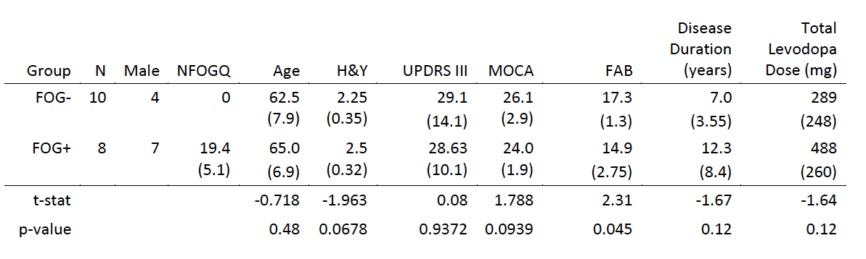

***Table 1.*** *Participant demographics. Means shown with standard deviation in parentheses. * indicates statistically significant difference between groups on an unpaired t-test. FOG+ = People with Parkinson’s disease with freezing of gait, FOG- = People with Parkinson’s disease without; H&Y = Modified Hoehn & Yahr stage; UPDRS III = Unified Parkinson’s Disease Rating Scale III total; MOCA = Montreal Cognitive Assessment total; FAB = Frontal Assessment Battery total.*

3.2 Behavioural Data:

Participants performed a target response time task, responding with a button press to target stimuli while sitting (SIT) or stepping-in-place (STEP.

|  |  |  |  |
| --- | --- | --- | --- |
|  | FOG+ | FOG- | Controls |
| N | 8 | 10 | 7 |
| STEP* | 665.2 (107.38) | 530.2(67.6) | 448.25(48.8) |
| SIT | 571.3 (55.5) | 550.0 (81.8) | 471.0 (48.4) |
| Relative RT (STEP-SIT) * | 93(81.5) | -19. (34.3) | -22.725 |

***Table 2.*** *Behavioural data. Group mean with standard deviation in parentheses Response Times (RT) in milliseconds by freezing of gait status and condition. * indicates statistically significant difference between groups on an unpaired t-test.*

Figure 1 illustrates individual participant mean RT data for the STEP and SIT (line). The FOG+ (circles) participants are on the left side and the FOG- participants (squares) are in the middle and the Control participants (triangles) are on the right of the figure. Table 2 shows the group mean and standard deviation RTs, which were submitted to a repeated measures ANOVA which showed a significant main effect of group (F(2,22)=9.675, MSE=91376 , p<0.001, JZS Bayes Factor= 0.539), and a significant interaction, (*F*(2, 22) = 14.96, MSE=166681 , *p* <0.005, JZS Bayes Factor= 0.043) with no effect of experimental condition (*F*(1, 22) = 1.786, MSE=2386 , *p* =0.195, JZS Bayes Factor= 0.682). Follow up paired t-tests comparison within groups were conducted. For the control group there was a significant difference in RTs between conditions (t(6)=4.02, p<0.01, JZS Bayes Factor= 6.837), with faster RTs in the STEP condition. For the FOG- group there was a no significant difference in RT between conditions (t(9)=1.968, p=0.0806, JZS Bayes Factor= 1.23), but the group average response time in the STEP condition was faster than the RT in the SIT condition, which was in line with the control group. For the FOG+ group there was a significant difference between conditions (t(7)=-3.0638, p<0.025, JZS Bayes Factor= 3.66) with slower RTs in the STEP compared to the SIT condition. These analyses point to the interaction differences being driven by this significantly slower RTs for the FOG+ group in the STEP condition. This is illustrated by the individual data plotted in Figure 1 showing 100% of participants in the control group had a faster RT for STEP than SIT indicating by the downward lines from SIT to STEP. The opposite was the case for the FOG+ group, 100% of participants had slower RT for STEP than SIT indicating by the upward lines from SIT to STEP. While in the FOG- group only four of the ten participants were slower in the STEP condition than the SIT condition.

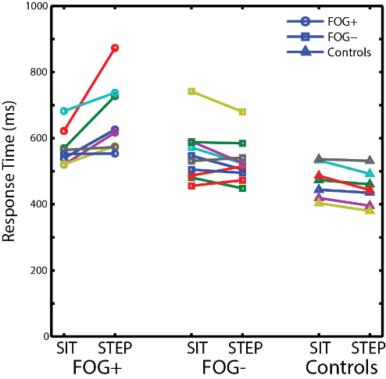

Figure 1 Response times for the FOG+ participants (circles), FOG- participants (squares) and controls (triangles). The lines link each individual response times for the SIT (left) and STEP (right) conditions.

3.3 EEG Analysis: cognitive decision making (CPP):

Figure 2A shows the mean and standard error of the mean (SEM) of the standard (green) and red (target) current source density (CSD) response for both FOG+ (top row) and FOG- (bottom row) for the STEP (left column) and SIT (middle column) over central parietal scalp. The right column of Figure 2B shows the mean and SEM of the subtraction of the target and standard CSD responses for the SIT (orange) and STEP (blue) conditions, the dashed vertical lines indicate response times. To assess differences in the amplitude of the P3/CPP, the mean amplitude of the subtraction (Target-Standard) from 450-650ms were submitted to a mixed repeated measures ANOVA with the factors group (FOG+, FOG-, controls) and condition (STEP, SIT). The analysis revealed no main effect of group (F(2,22)= 0.807, MSE=393.6, p=0.42), condition (F(1,22)= 0.03, MSE=5.6, p=0.865, JZS Bayes Factor=1.8787), or interaction of group and condition (F(2,22)= 2.311, MSE=434.4, p=0.123, JZS Bayes Factor=2.02).

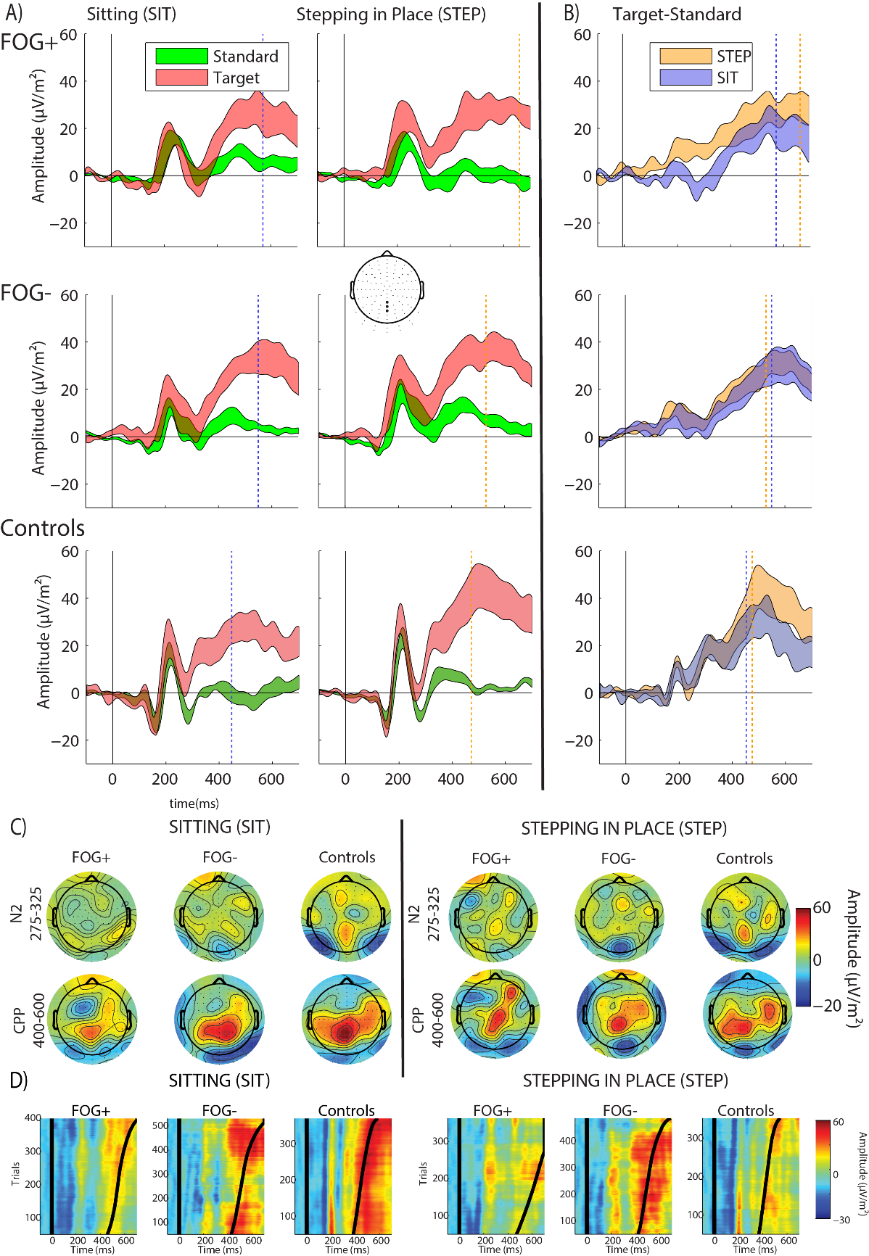

Figure 2 A) The mean and standard error of the mean of the target (red) and standard (green) average CSD response of three electrodes over central parietal scalp (indicated by the large dots in the top down head schematic) for the FOG+ group (top row), the FOG- group (second row) and the control group (bottom row) for the sitting (SIT) condition left column and the stepping-in-place (STEP) condition.

B) Mean and standard error of the mean of the difference between the CSD waveform for the target stimulus and standard stimulus over central parietal scalp for the FOG+ group and FOG- group for the STEP (orange) condition and SIT (blue) condition. The solid black line indicates the stimulus onset, the dashed vertical lines indicate the mean response time for the stepping-in-place (orange) condition and sitting (blue) condition. FOG- = People with Parkinson’s disease without FOG; FOG+ = People with Parkinson’s disease with FOG.

C) Mean scalp Topographic distributions of the difference waveform averaged over the N2 component (top row) and CPP component (bottom row) for each group and the SIT condition (left) and STEP condition (right).

D) Surface plots of the CPP pooled across participants for each group and sorted in ascending order according to response time for each condition SIT (left) and STEP (right), smoothed using a Gaussian moving window of 100 trials. Curved black line represents response times.

3.4 EEG Analysis: automatic response conflict (N2):

The N2 response, is the deflection in the subtraction wave between 250 and 350ms in Figure 2B. To assess differences in the amplitude of the N2, the mean amplitude of the subtraction (Target-Standard) waveform from 275-325ms were submitted to a mixed repeated measures ANOVA with the factors group (FOG+, FOG-, controls) and condition (STEP, SIT). This revealed a significant main effect of group (F(2,22)= 3.638, MSE=686.3, p<0.05 JZS Bayes Factor= 0.355), and a no effect of condition (F(2,22)= 3.778, MSE=389.5, p=0.051, JZS Bayes Factor= 0.719) but no significant interaction effect (F(1,22)= 2.049, MSE=187.8, p=0.1527, JZS Bayes Factor=1.788).

Follow up paired t-test comparisons within groups were conducted. For the control group there was no significant difference in N2 amplitude between conditions (t(6)=-0.19706, p=0.8503, JZS Bayes Factor= 0.379), with faster response times in the stepping condition. For the FOG- group there was no significant difference in N2 amplitude between conditions (t(9)=-0.4887, p=0.6367, JZS Bayes Factor= 0.356). For the FOG+ group there was a significant difference in N2 amplitude between conditions (t(7)=-3.5712, p<0.001, JZS Bayes Factor= 5.92).

3.5 EEG Analysis: motor preparation potentials (LRP):

Figure 3 shows lateralized readiness potential (LRP) CSD waveforms, the subtraction target response over left and right frontal areas indicated by the dots for the FOG+ (dark grey) and FOG- (grey) and control (light grey) group and the STEP (left panel) and SIT (right panel) conditions. To assess differences in the amplitude of the LRP, the mean amplitude of the subtraction (Target-Standard) from 400-600ms were submitted to a mixed repeated measures ANOVA with the factors group (FOG+, FOG-, Control) and condition (STEP, SIT). The analysis revealed a main effect of group (F(2,22)= 7.889, MSE=4137, p<0.005, JZS Bayes Factor= 1.159), with no significant effect of condition (F(2,22)= 0.090, MSE=119.8, p=0.343, JZS Bayes Factor= 0.0881) and no interaction effect of group and condition (F(2,22)= 1.987, MSE=253.4, p=0.161, JZS Bayes Factor= 2.02).

Follow up paired t-tests comparison within groups were conducted. For the control group there was no significant difference in N2 amplitude between conditions (t(6)=-1.052, p=0.333, JZS Bayes Factor= 0.57), with faster response times in the stepping condition. For the FOG- group there was no significant difference in N2 amplitude between conditions (t(9)=--1.7269, p=0.1183, JZS Bayes Factor= 0.95). For the FOG+ group there was a significant difference in N2 amplitude between conditions (t(8)=0.81782, p=0.44, JZS Bayes Factor= 0.46).

To investigate the onset of differences between groups in the LRP for each time point an unpaired t-test was performed. Time points of statistical differences in the LRP between the FOG+ group and the FOG- group are depicted as markers running along the bottom of the plots in Figure 3. The group difference in onset occurs just after ~400ms and continues until the mean response time (indicated by the dashed vertical lines).

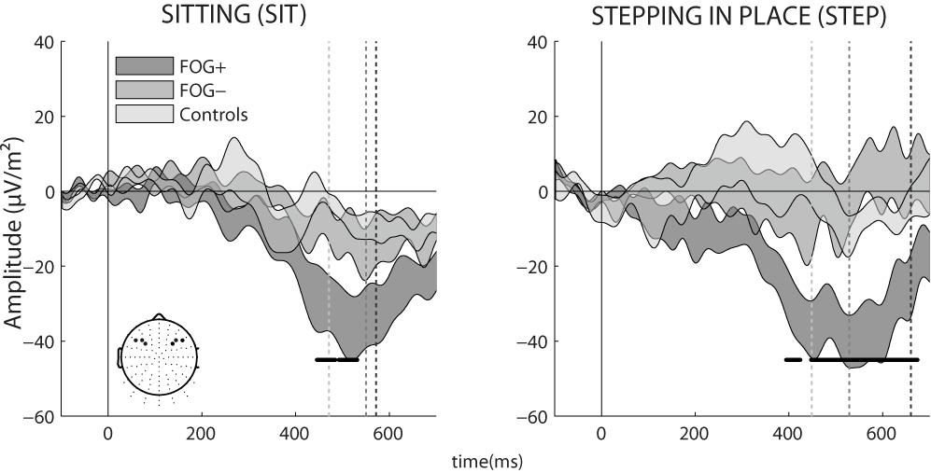

Figure 3 Mean and standard error of the mean of the lateralized readiness potential (LRP) current source density (CSD) calculated by subtracting the average activity of three electrodes over the left frontocentral area (three large electrodes corresponding to D3, D4 and D5 in the 128 Biosemi ABC electrode layout) from the right frontocentral (three large electrodes corresponding to C3, C4 and C5 in the 128 Biosemi ABC electrode layout) area for the FOG+ (dark grey), FOG- (grey) and control (light grey) groups for the STEP (left panel) and SIT (right panel) conditions. The solid black line indicates the stimulus onset, the dashed vertical lines indicate the mean response time, the dots along the time axis indicate significant differences between the FOG+ and FOG- at each time point.

**4. Discussion:**

We have recently shown that electrophysiological markers of motor preparation rather than decision-making differentiate PwP with (FOG+) and without FOG (FOG-) while sitting (Butler et al. 2017). In the current study, we examined the effect of stepping on these results by measuring behavioral and electrophysiological responses in PwP with and without freezing of gait while they performed the same target response time task (oddball task) both sitting (single-task) and stepping-in-place (dual-task). The behavioural results showed slower response times while stepping-in-place (STEP) compared to seated (SIT) for FOG+. However, FOG- had faster response times in the STEP condition compared to the SIT condition. There was no significant difference in response times between the PwP groups while seated but slower response times were seen in the FOG+ group compared to FOG- and control during stepping-in-place, suggesting a dual-task interference which occurs in the freezing group only.

The electrophysiological data enabled the simultaneous analysis of parameters which can contribute to the delayed response times: i) decision making processing (CPP), ii) “automatic” response conflict processing (N2), and iii) motor preparation (LRP). The CPP potential correlates with executive function (Kindermann et al. 2000) and decision making in response to sensory stimuli (Twomey et al. 2015). In line with our previous finding there was no significant difference in CPP amplitude (Butler et al. 2017) between FOG+ and FOG- for the SIT and STEP conditions, suggesting that decision making processes are not the source of the response delay (reduced RT). The N2 potential is present for the sitting condition for both groups which implies that response conflict processing occurs to help perform the task. In the stepping condition FOG+ display a reduction of the N2 potential which suggests reduced allocation of automatic processing resources which could contribute to a delayed response time. The LRP, our measure of motor preparation, is present in the FOG+ group but not in the FOG- group (or control group) for the SIT and STEP conditions. In the FOG+ group the LRP is maintained longer for the STEP condition (dual-task) than the SIT condition (single-task). Overall our findings show that the addition of a second complex motor task (stepping-in-place) impacts the automatic allocation of electrophysiological markers of response conflict and motor preparation (but not decision making) in people with Parkinson’s with freezing of gait, resulting in a delayed response time. Response inhibition and motor preparation have close associations with FOG. These will be dealt with separately below.

***4.1 Response Inhibition***

The N2 potential has a role in monitoring sensory information and selecting relevant information in order to select a response (Malcolm et al. 2015), ultimately determining response time (Loughnane et al. 2016). The reduction of the N2 potential in the FOG+ group for the dual task is remarkable as it points to inflexibility in allocation of automatic resources (Malcolm et al. 2015). The clear presence of an intact N2 potential in the SIT condition for the FOG+ group implies that this is specific to the dual-task condition. On the other hand, there is no significant difference in the N2 potential in the FOG- group across conditions. The N2 potential has been associated with appropriate inhibition of a distracting secondary task or the prioritisation of the primary task (Mazza et al. 2009; Malcolm et al. 2015). Inability to select relevant stimuli (and by extension, suppress irrelevant stimuli) would result in loss or attenuation of the N2 potential. Our findings would suggest that the N2 process is related to an enhancement of the target detection as it is present in single task condition but disappears in the dual task condition, coinciding with a slower response time. This concept is very closely linked with dual tasking as, to decide which task to prioritize and which task to suppress, the unwanted response has to be inhibited. Areas associated with response inhibition in functional imaging studies include the right inferior frontal gyrus (an area central to resolution of dual task interference (Herath et al. 2001), the premotor area and the primary motor cortex. Involvement of the right inferior frontal gyrus is notable as this area is selectively atrophied in volumetric MRI studies in patients with freezing of gait (Kostic et al. 2012; Canu et al. 2015).

Poor inhibitory control is proposed to be central to freezing of gait via a generalized impairment in conflict resolution and response inhibition (Vandenbossche et al. 2011; Vandenbossche et al. 2012). These tasks require suppression of irrelevant information that could interfere with the relevant stimulus. The right inferior frontal gyrus inhibits responses via the hyperdirect pathway to the subthalamic nucleus. Structural and functional neuroimaging has shown that this hyperdirect pathway is deficient in all PwP compared with controls (Shine et al. 2013c; Fling et al. 2014). The reduction of the N2 potential in the current study suggests that dysfunction in this pathway is associated with freezing. The current study provides electrophysiological evidence of impairment in response inhibition in FOG.

***4.2 Motor preparation***

Figure 3 shows no significant LRP for this task in FOG-. However, there is a clear LRP in FOG+ which is remarkable for such a simple motor task. The presence of the LRP in both conditions for the FOG+ group, but not the FOG- group, suggests that FOG+ require additional resources in order to initiate movement for simple motor tasks (possibly via lateral premotor areas (Wu and Hallett 2008)). As these frontal networks become overloaded during a second task such as locomotion, FOG+ compensate by recruiting more resources and initiating movement even earlier. Indeed, there is some evidence to support this idea: functional MRI studies have shown extensive cortical activation both during freezing episodes and normal locomotion in patients with freezing of gait (Shine et al. 2013a).

The differential impact of locomotion on the generation of the N2 and LRP potentials may be the result of differences in cognitive reserve between FOG+ and FOG-/controls or a greater use of cognitive resources in FOG+, even for simple motor tasks, resulting in earlier depletion of these resources. When stress is placed on these resources (in terms of cognitive and motor loads), these premotor differences are amplified in FOG+, ultimately resulting in clinically detectable deterioration of task performance. This suggests a maladaptive system which is prone to overload in stressful situations, which could result in motor breakdown and freezing of gait.

***4.3 Future Directions and Limitations***

Since 2010 there have been a number of studies investigating ambulatory ERP analysis in healthy controls (Gramann et al. 2010; Gwin et al. 2010; Debener et al. 2012; De Vos et al. 2014) and a number of studies looking at power spectral density in people with Parkinson’s while walking (Handojoseno et al. 2012; Handojoseno et al. 2013; Shine et al. 2014; Handojoseno et al. 2015).

Maiden et al. were the first group to examine ERPs in PwP while walking In particular, they demonstrated prolongation and attenuation of the P3 in PwP when walking compared with sitting (Cite Maiden et al Clin Neurophys, Feb 2019). They therefore hypothesised impaired recruitment of attentional networks during dual-tasking in PwP. As mentioned above, we have previously shown that standard ERP analysis can erroneously underestimate a P3 signal in PwP due to interference from the lateralized readiness potential. The higher spatial resolution of the CSD approach utilized here allows separation of the P3/CPP and LRP facilitating simultaneous analysis of these discrete potentials. We have demonstrated that the changes in event-related potentials seen between sitting and stepping conditions are due to differences in response inhibition potentials and movement-related potentials, rather than cognitive potentials (i.e. CPP/P3).

This is, therefore, the first study to employ a CSD analysis to simultaneously examine evoked response related to decision making, response inhibition and motor preparation in people with Parkinson’s disease while stepping. In future studies, a larger sample size would allow correlation of electrophysiological measures with clinical markers of the disease (such as disease duration and severity) and standard neurocognitive tests. Another avenue of interest would be to examine the impact of dopaminergic therapy (or deep brain stimulation) on the above findings, as all patients were tested in the “on”-medication state. Although there were no differences in medication doses or timings between groups, it would be necessary to confirm that these findings can be replicated off medication and in patients with deep brain stimulators. There were differences in baseline characteristics between FOG+ and FOG- (including gender, disease duration and FAB scores) which may have impacted on the results here. Future studies with an age-matched control group would enable the distinction between age-related response delays and those related to Parkinson’s disease (Fearon et al. 2015). Finally, since dual-tasking has been shown to have an effect on gait parameters as well as secondary task performance (Killane et al. 2015), investigating the interaction between electrophysiological correlates of the gait cycle with clinical gait parameters would allow a more ecological study of these processes on gait itself, rather than a simple motor task during stepping shown here.

***5. Conclusion:***

This is the first study to analyse ambulatory event-related potentials in PwP with and without FOG and the first study to employ a CSD analysis to simultaneously examine evoked response related to decision making, response inhibition and motor preparation in people with Parkinson’s disease while stepping. FOG+ had slower response times while stepping, however response times were faster while stepping for FOG- and controls. In association with this, FOG+ displayed neurophysiological evidence of premotor cortical dysfunction (reduction of the N2 potential and prominence of the lateralized readiness potential) while performing the dual-task. In contrast, our measure of executive function, the CPP response, is robust in the face of dual-task interference for all groups. This suggests that the behavioural differences seen in response times between FOG+ and FOG- by motor and response conflict impairments rather than decision making impairments. The impact of locomotion on the generation of the N2 and LRP potentials indirectly implies that these functions compete with locomotion for resources. In the setting of multiple complex tasks or cognitive impairment, severe motor dysfunction may result, leading to freezing of gait (Lewis and Shine 2016).

References

Amboni M, Cozzolino A, Longo K, Picillo M, Barone P (2008) Freezing of gait and executive functions in patients with Parkinson's disease. Mov Disord 23:395-400 doi: 10.1002/mds.21850

Beck EN, Ehgoetz Martens KA, Almeida QJ (2015) Freezing of Gait in Parkinson's Disease: An Overload Problem? PLoS One 10:e0144986 doi: 10.1371/journal.pone.0144986

Bloem BR, Hausdorff JM, Visser JE, Giladi N (2004) Falls and freezing of gait in Parkinson's disease: a review of two interconnected, episodic phenomena. Mov Disord 19:871-884 doi: 10.1002/mds.20115

Butler JS, Fearon C, Killane I, Waechter SM, Reilly RB, Lynch T (2017) Motor preparation rather than decision-making differentiates Parkinson's disease patients with and without freezing of gait. Clin Neurophysiol 128:463-471 doi: 10.1016/j.clinph.2016.12.019

Camicioli R, Oken BS, Sexton G, Kaye JA, Nutt JG (1998) Verbal fluency task affects gait in Parkinson's disease with motor freezing. J Geriatr Psychiatry Neurol 11:181-185 doi: 10.1177/089198879901100403

Canu E, Agosta F, Sarasso E, et al. (2015) Brain structural and functional connectivity in Parkinson's disease with freezing of gait. Hum Brain Mapp 36:5064-5078 doi: 10.1002/hbm.22994

De Sanctis P, Butler JS, Green JM, Snyder AC, Foxe JJ (2012) Mobile brain/body imaging (MoBI): High-density electrical mapping of inhibitory processes during walking. Conf Proc IEEE Eng Med Biol Soc 2012:1542-1545 doi: 10.1109/EMBC.2012.6346236

De Sanctis P, Butler JS, Malcolm BR, Foxe JJ (2014) Recalibration of inhibitory control systems during walking-related dual-task interference: a mobile brain-body imaging (MOBI) study. Neuroimage 94:55-64 doi: 10.1016/j.neuroimage.2014.03.016

De Vos M, Gandras K, Debener S (2014) Towards a truly mobile auditory brain-computer interface: exploring the P300 to take away. Int J Psychophysiol 91:46-53 doi: 10.1016/j.ijpsycho.2013.08.010

Debener S, Minow F, Emkes R, Gandras K, de Vos M (2012) How about taking a low-cost, small, and wireless EEG for a walk? Psychophysiology 49:1617-1621 doi: 10.1111/j.1469-8986.2012.01471.x

Delorme A, Makeig S (2004) EEGLAB: an open source toolbox for analysis of single-trial EEG dynamics including independent component analysis. J Neurosci Methods 134:9-21 doi: 10.1016/j.jneumeth.2003.10.009

Dienes Z (2016) How Bayes factors change scientific practice. Journal of Mathematical Psychology

Eimer M (1993) Effects of Attention and Stimulus Probability on Erps in a Go/Nogo Task. Biological Psychology 35:123-138

Fearon C, Butler JS, Newman L, Lynch T, Reilly RB (2015) Audiovisual Processing is Abnormal in Parkinson's Disease and Correlates with Freezing of Gait and Disease Duration. J Parkinsons Dis 5:925-936 doi: 10.3233/JPD-150655

Fling BW, Cohen RG, Mancini M, Carpenter SD, Fair DA, Nutt JG, Horak FB (2014) Functional reorganization of the locomotor network in Parkinson patients with freezing of gait. PLoS One 9:e100291 doi: 10.1371/journal.pone.0100291

Friend DM, Kravitz AV (2014) Working together: basal ganglia pathways in action selection. Trends Neurosci 37:301-303 doi: 10.1016/j.tins.2014.04.004

Gramann K, Gwin JT, Bigdely-Shamlo N, Ferris DP, Makeig S (2010) Visual evoked responses during standing and walking. Front Hum Neurosci 4:202 doi: 10.3389/fnhum.2010.00202

Guthrie D, Buchwald JS (1991) Significance testing of difference potentials. Psychophysiology 28:240-244

Gwin JT, Gramann K, Makeig S, Ferris DP (2010) Removal of movement artifact from high-density EEG recorded during walking and running. J Neurophysiol 103:3526-3534 doi: 10.1152/jn.00105.2010

Handojoseno AM, Shine JM, Nguyen TN, Tran Y, Lewis SJ, Nguyen HT (2012) The detection of Freezing of Gait in Parkinson's disease patients using EEG signals based on Wavelet decomposition. Conf Proc IEEE Eng Med Biol Soc 2012:69-72 doi: 10.1109/EMBC.2012.6345873

Handojoseno AM, Shine JM, Nguyen TN, Tran Y, Lewis SJ, Nguyen HT (2013) Using EEG spatial correlation, cross frequency energy, and wavelet coefficients for the prediction of Freezing of Gait in Parkinson's Disease patients. Conf Proc IEEE Eng Med Biol Soc 2013:4263-4266 doi: 10.1109/EMBC.2013.6610487

Handojoseno AM, Shine JM, Nguyen TN, Tran Y, Lewis SJ, Nguyen HT (2015) Analysis and Prediction of the Freezing of Gait Using EEG Brain Dynamics. IEEE Trans Neural Syst Rehabil Eng 23:887-896 doi: 10.1109/TNSRE.2014.2381254

Hausdorff JM, Balash J, Giladi N (2003) Effects of cognitive challenge on gait variability in patients with Parkinson's disease. J Geriatr Psychiatry Neurol 16:53-58 doi: 10.1177/0891988702250580

Heinzel S, Maechtel M, Hasmann SE, Hobert MA, Heger T, Berg D, Maetzler W (2016) Motor dual-tasking deficits predict falls in Parkinson's disease: A prospective study. Parkinsonism Relat Disord 26:73-77 doi: 10.1016/j.parkreldis.2016.03.007

Herath P, Klingberg T, Young J, Amunts K, Roland P (2001) Neural correlates of dual task interference can be dissociated from those of divided attention: an fMRI study. Cereb Cortex 11:796-805

Hughes AJ, Daniel SE, Kilford L, Lees AJ (1992) Accuracy of clinical diagnosis of idiopathic Parkinson's disease: a clinico-pathological study of 100 cases. J Neurol Neurosurg Psychiatry 55:181-184

Jacobs JV, Nutt JG, Carlson-Kuhta P, Stephens M, Horak FB (2009) Knee trembling during freezing of gait represents multiple anticipatory postural adjustments. Exp Neurol 215:334-341 doi: 10.1016/j.expneurol.2008.10.019

Kayser J, Tenke CE (2006a) Principal components analysis of Laplacian waveforms as a generic method for identifying ERP generator patterns: I. Evaluation with auditory oddball tasks. Clin Neurophysiol 117:348-368 doi: 10.1016/j.clinph.2005.08.034

Kayser J, Tenke CE (2006b) Principal components analysis of Laplacian waveforms as a generic method for identifying ERP generator patterns: II. Adequacy of low-density estimates. Clin Neurophysiol 117:369-380 doi: 10.1016/j.clinph.2005.08.033

Kelly SP, O'Connell RG (2013) Internal and external influences on the rate of sensory evidence accumulation in the human brain. J Neurosci 33:19434-19441 doi: 10.1523/JNEUROSCI.3355-13.2013

Killane I, Fearon C, Newman L, et al. (2015) Dual Motor-Cognitive Virtual Reality Training Impacts Dual-Task Performance in Freezing of Gait. IEEE J Biomed Health Inform 19:1855-1861 doi: 10.1109/JBHI.2015.2479625

Kindermann SS, Kalayam B, Brown GG, Burdick KE, Alexopoulos GS (2000) Executive functions and P300 latency in elderly depressed patients and control subjects. Am J Geriatr Psychiatry 8:57-65

Knobl P, Kielstra L, Almeida Q (2012) The relationship between motor planning and freezing of gait in Parkinson's disease. J Neurol Neurosurg Psychiatry 83:98-101 doi: 10.1136/jnnp-2011-300869

Kostic VS, Agosta F, Pievani M, et al. (2012) Pattern of brain tissue loss associated with freezing of gait in Parkinson disease. Neurology 78:409-416 doi: 10.1212/WNL.0b013e318245d23c

Lewis SJ, Shine JM (2016) The Next Step: A Common Neural Mechanism for Freezing of Gait. Neuroscientist 22:72-82 doi: 10.1177/1073858414559101

Loughnane GM, Newman DP, Bellgrove MA, Lalor EC, Kelly SP, O'Connell RG (2016) Target Selection Signals Influence Perceptual Decisions by Modulating the Onset and Rate of Evidence Accumulation. Curr Biol 26:496-502 doi: 10.1016/j.cub.2015.12.049

Maidan I, Fahoum F, Shustak S, et al. (2019) Changes in event-related potentials during dual task walking in aging and Parkinson's disease. Clin Neurophysiol 130:224-230 doi: 10.1016/j.clinph.2018.11.019

Malcolm BR, Foxe JJ, Butler JS, De Sanctis P (2015) The aging brain shows less flexible reallocation of cognitive resources during dual-task walking: A mobile brain/body imaging (MoBI) study. Neuroimage 117:230-242 doi: 10.1016/j.neuroimage.2015.05.028

Malcolm BR, Foxe JJ, Butler JS, Molholm S, De Sanctis P (2018) Cognitive load reduces the effects of optic flow on gait and electrocortical dynamics during treadmill walking. J Neurophysiol

Malcolm BR, Foxe JJ, Butler JS, Mowrey WB, Molholm S, De Sanctis P (2017) Long-term test-retest reliability of event-related potential (ERP) recordings during treadmill walking using the mobile brain/body imaging (MoBI) approach. Brain Res doi: 10.1016/j.brainres.2017.05.021

Mazza V, Turatto M, Caramazza A (2009) Attention selection, distractor suppression and N2pc. Cortex 45:879-890 doi: 10.1016/j.cortex.2008.10.009

Nieuwboer A, Rochester L, Herman T, Vandenberghe W, Emil GE, Thomaes T, Giladi N (2009) Reliability of the new freezing of gait questionnaire: agreement between patients with Parkinson's disease and their carers. Gait Posture 30:459-463 doi: 10.1016/j.gaitpost.2009.07.108

Nutt JG, Bloem BR, Giladi N, Hallett M, Horak FB, Nieuwboer A (2011) Freezing of gait: moving forward on a mysterious clinical phenomenon. Lancet Neurol 10:734-744 doi: 10.1016/S1474-4422(11)70143-0

O'Connell RG, Dockree PM, Kelly SP (2012) A supramodal accumulation-to-bound signal that determines perceptual decisions in humans. Nature Neuroscience 15:1729-1735 doi: 10.1038/nn.3248

Perrin F, Pernier J, Bertrand O, Echallier JF (1989) Spherical Splines for Scalp Potential and Current-Density Mapping. Electroencephalography and Clinical Neurophysiology 72:184-187

Peterson DS, Fling BW, Mancini M, Cohen RG, Nutt JG, Horak FB (2015) Dual-task interference and brain structural connectivity in people with Parkinson's disease who freeze. J Neurol Neurosurg Psychiatry 86:786-792 doi: 10.1136/jnnp-2014-308840

Pieruccini-Faria F, Jones JA, Almeida QJ (2014) Motor planning in Parkinson's disease patients experiencing freezing of gait: the influence of cognitive load when approaching obstacles. Brain Cogn 87:76-85 doi: 10.1016/j.bandc.2014.03.005

R Development Core Team (2017) R: A Language and Environment for Statistical Computing. In, vol 2017

Redgrave P, Rodriguez M, Smith Y, et al. (2010) Goal-directed and habitual control in the basal ganglia: implications for Parkinson's disease. Nat Rev Neurosci 11:760-772 doi: 10.1038/nrn2915

Rouder JN, Speckman PL, Sun D, Morey RD, Iverson G (2009) Bayesian t tests for accepting and rejecting the null hypothesis. Psychon Bull Rev 16:225-237 doi: 10.3758/PBR.16.2.225

Rstudio (2016) RStudio: Integrated Development Environment for R. In. RStudio, Inc.

Salisbury DF, Rutherford B, Shenton ME, McCarley RW (2001) Button-pressing affects P300 amplitude and scalp topography. Clin Neurophysiol 112:1676-1684

Shibasaki H, Hallett M (2006) What is the Bereitschaftspotential? Clin Neurophysiol 117:2341-2356 doi: 10.1016/j.clinph.2006.04.025

Shine JM, Handojoseno AM, Nguyen TN, Tran Y, Naismith SL, Nguyen H, Lewis SJ (2014) Abnormal patterns of theta frequency oscillations during the temporal evolution of freezing of gait in Parkinson's disease. Clin Neurophysiol 125:569-576 doi: 10.1016/j.clinph.2013.09.006

Shine JM, Matar E, Ward PB, et al. (2013a) Exploring the cortical and subcortical functional magnetic resonance imaging changes associated with freezing in Parkinson's disease. Brain 136:1204-1215 doi: 10.1093/brain/awt049

Shine JM, Matar E, Ward PB, Bolitho SJ, Pearson M, Naismith SL, Lewis SJ (2013b) Differential neural activation patterns in patients with Parkinson's disease and freezing of gait in response to concurrent cognitive and motor load. PLoS One 8:e52602 doi: 10.1371/journal.pone.0052602

Shine JM, Moustafa AA, Matar E, Frank MJ, Lewis SJ (2013c) The role of frontostriatal impairment in freezing of gait in Parkinson's disease. Front Syst Neurosci 7:61 doi: 10.3389/fnsys.2013.00061

Spildooren J, Vercruysse S, Desloovere K, Vandenberghe W, Kerckhofs E, Nieuwboer A (2010) Freezing of gait in Parkinson's disease: the impact of dual-tasking and turning. Mov Disord 25:2563-2570 doi: 10.1002/mds.23327

Tard C, Dujardin K, Bourriez JL, Destee A, Derambure P, Defebvre L, Delval A (2014) Attention modulates step initiation postural adjustments in Parkinson freezers. Parkinsonism Relat Disord 20:284-289 doi: 10.1016/j.parkreldis.2013.11.016

Twomey DM, Murphy PR, Kelly SP, O'Connell RG (2015) The classic P300 encodes a build-to-threshold decision variable. Eur J Neurosci 42:1636-1643 doi: 10.1111/ejn.12936

Vandenbossche J, Deroost N, Soetens E, Spildooren J, Vercruysse S, Nieuwboer A, Kerckhofs E (2011) Freezing of gait in Parkinson disease is associated with impaired conflict resolution. Neurorehabil Neural Repair 25:765-773 doi: 10.1177/1545968311403493

Vandenbossche J, Deroost N, Soetens E, et al. (2012) Conflict and freezing of gait in Parkinson's disease: support for a response control deficit. Neuroscience 206:144-154 doi: 10.1016/j.neuroscience.2011.12.048

Vervoort G, Heremans E, Bengevoord A, Strouwen C, Nackaerts E, Vandenberghe W, Nieuwboer A (2016) Dual-task-related neural connectivity changes in patients with Parkinson' disease. Neuroscience 317:36-46 doi: 10.1016/j.neuroscience.2015.12.056

Vo A, Seergobin KN, MacDonald PA (2017) Effects of levodopa on stimulus-response learning versus response selection in healthy young adults. Behav Brain Res 317:553-561 doi: 10.1016/j.bbr.2016.10.019

Waechter S, Fearon C, McDonnell C, et al. (2015) The impact of dual tasking on cognitive performance in a Parkinson's disease cohort with and without freezing of gait: An EEG and behavioral based approach. In: Neural Engineering (NER), 2015 7th International IEEE/EMBS Conference on. IEEE, pp 1072-1075

Wu T, Hallett M (2008) Neural correlates of dual task performance in patients with Parkinson's disease. J Neurol Neurosurg Psychiatry 79:760-766 doi: 10.1136/jnnp.2007.126599

Wu T, Hallett M, Chan P (2015) Motor automaticity in Parkinson's disease. Neurobiol Dis 82:226-234 doi: 10.1016/j.nbd.2015.06.014