ECES 435

Professor Matthew Stamm

Assignment 5

Wanyu Li and John R Seitz IV

Part 1: Detecting Image Contrast Enhancement

**Based off your knowledge of contrast enhancement fingerprints, which of these images are likely to have been contrast enhanced?**

After performing contrast enhancement on an image, certain fingerprints are left behind. To determine if an image has previously experienced contrast enhancement, the pixel value histogram is inspected. Normally, the pixel value histogram of an unaltered digital image will appear smooth. In an altered image, the fingerprints appear as impulsive peaks and gaps in its pixel value histogram. After inspecting the PVH of the 4 images below, the following results were determined:

*Image 1:* Likely contrast enhanced, has sharp peaks in the left half of the histogram and gaps in the right half.

*Image 2:* Likely not contrast enhanced, PVH is generally smooth but possibly altered because the PVH is no values past 220.

*Image 3:* Unsure but likely contrast enhanced, even though there are some gaps and peaks, the PVH is generally smooth. The weird PVH is likely due to the image content - the middle parts of the building are very very bright, leading to a high right side peak.

*Image 4:* Likely not contrast enhanced, the PVH is very smooth with no fingerprints.

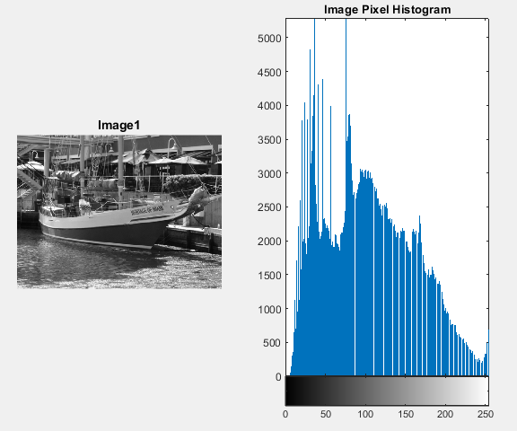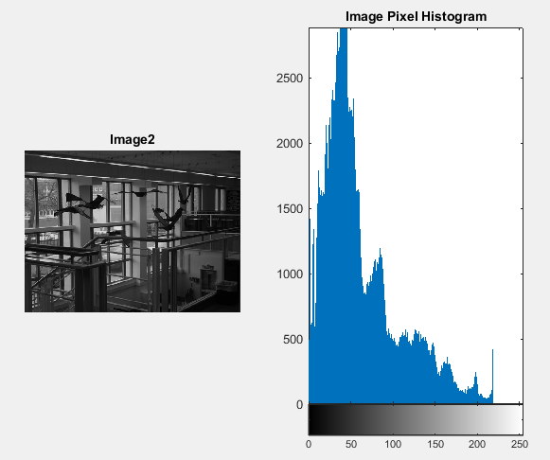

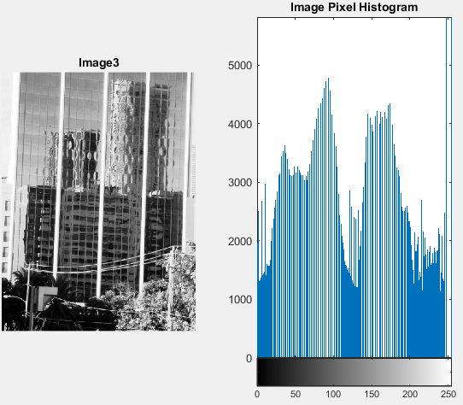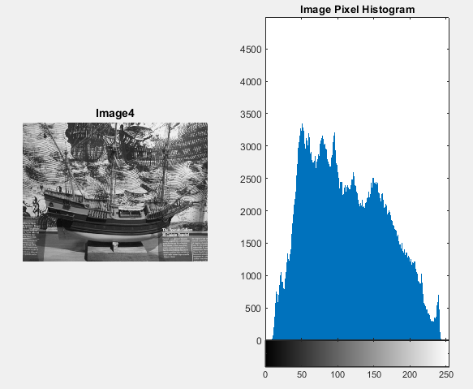

**What influence does the unaltered image's pixel value histogram have on the location and amplitude of the contrast enhancement fingerprints in each of the gamma corrected images? What influence does the contrast enhancement mapping (in this case specified by the value of gamma) have on the location and amplitude of the contrast enhancement fingerprints in each of the gamma corrected images?**

The unaltered image’s PVH keeps its shape after gamma correction, but either shifted left or right depending on gamma. After gamma correction, gaps appear on one side of the PVH and peaks appear on the opposite side, centered around the average of the PVH. These fingerprints changed location depending on the contrast enhancement mapping, or the gamma value.

When gamma is less than 1, gaps appear on the left (0) side, and peaks appear on the right (255) side. Since values are taken from the dark side and added to the light side, the image appears lighter. The opposite is true when gamma is greater than 1, gaps appear on the right (255) side, and peaks appear on the left (0) side. Since values are taken from the light side and added to the dark side, the image appears darker.

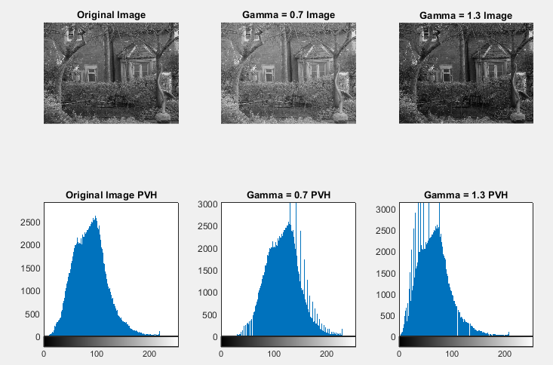

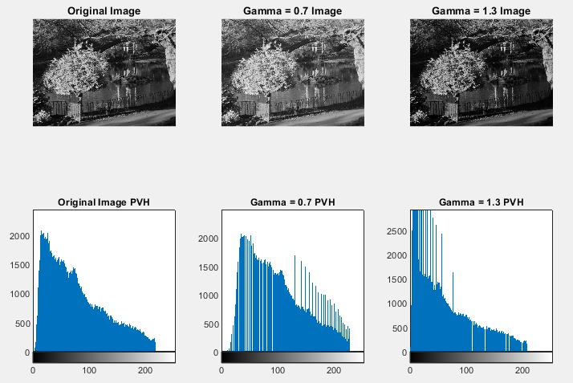

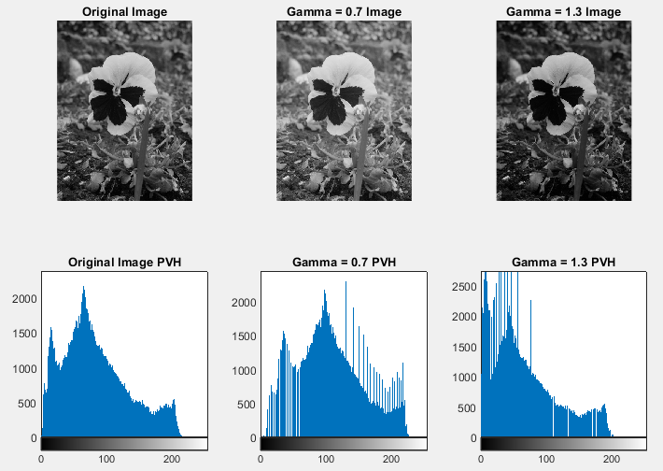

**Examine its pixel value histogram and identify which regions of the contrast enhancement mapping are locally expansive and which are locally contractive. Based on this information, is gamma greater than 1 or less than 1?**

As discovered in the previous question, gamma correction fingerprints appear in the PVH as gaps and peaks, separated around the average of the PVH. In this image, the PVH has gaps in the left (0, dark) side, and has peaks in the right (255, light) side. This means the regions of gamma correction that are locally expansive are the right side, and locally contractive are the left side. By expanding the light values and contracting the dark values, the entire image appears lighter. This effect is consistent with gamma correction where gamma is less than 1.

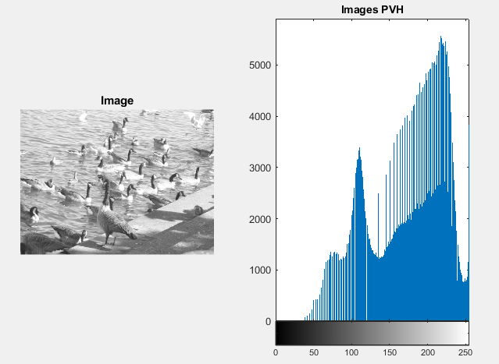

Part 2: Detecting Image Resampling and Resizing

**Which of these p-maps exhibit periodic properties that are indicative of image resampling?**

After performing resampling operations, very obvious artifacts are left in the image’s p-map. Periodic patterns are left throughout the p-map that often look like a grid. From inspecting the p-maps of the 4 images below (second row), the following results were determined:

*Image 1:* Likely not resampled, p-map only has noise, no periodic resampling artifacts

*Image 2:* Likely resampled, p-map only shows clear periodic resampling artifacts

*Image 3:* Likely resampled, p-map only shows very obvious periodic resampling artifacts

*Image 4:* Likely not resampled, p-map only has noise, no periodic resampling artifacts

**Which of these plots contain resampling fingerprints? Include the plot of the magnitude of the Fourier transform of each image's p-map in your report. If contrast enhancement fingerprints are present in an image, clearly label these fingerprints.**

Resampling fingerprints become most evident after transforming into the frequency domain using the discrete fourier transform. In the frequency domain, the artifacts lead to characteristic peaks in the spectrum that appear as 4 adjacent dots.

From inspecting the frequency p-maps of the 4 images below (third row), the following results were determined:

*Image 1:* No fingerprints in magnitude of DFT, likely not resampled

*Image 2:* Clear fingerprints in magnitude of DFT, likely resampled

*Image 3:* Clear fingerprints in magnitude of DFT, likely resampled

*Image 4:* Unsure, no clear fingerprints, but weird noise that could resemble the artifacts of resampling in magnitude of DFT