**Creating the database**

1. **Creating applicants**

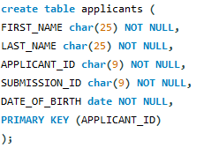

1. **Creating submissions**

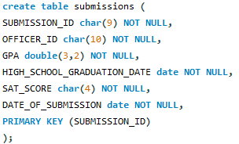

1. **Creating officers**

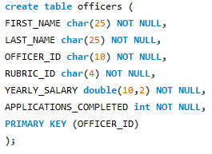

1. **Creating department**

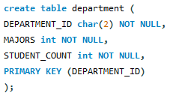

1. **Creating rubric**

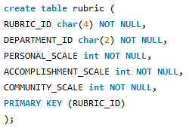

1. **Creating conclusion**

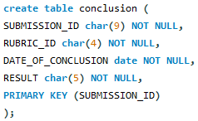

**Making the relationships**

1. **Adding foreign key to applicants**

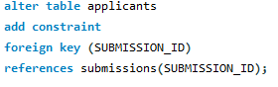

1. **Adding foreign key to submissions**

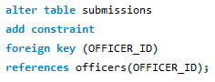

1. **Adding foreign key to officers**

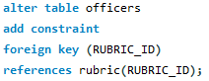

1. **Adding foreign key to rubric**

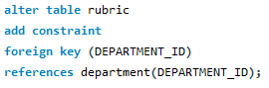

1. **Adding foreign key to conclusion**

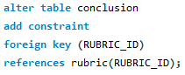

**Queries**

1. **What departments have more than 500 students?**



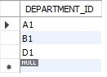

1. **Which submissions have a SAT score higher than 1250?**

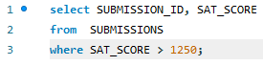

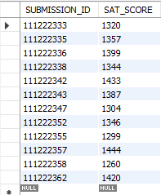

1. **Which officers have a yearly salary greater than $50,000**

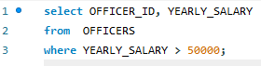

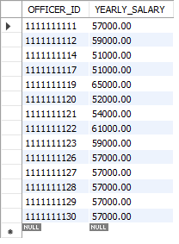

1. **Which officers make less than the average of all officers?**

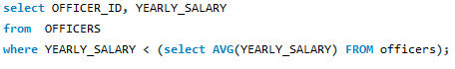

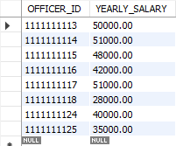

1. **Which rubrics contain an accomplishment scale that is less than 50% weight.**

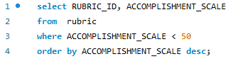

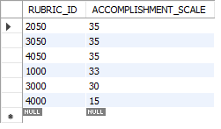

1. **Which rubrics contain a personal scale > 15% weight AND a community scale > 15% weight?**

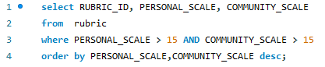

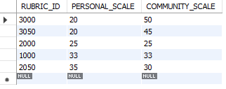

1. **Which applicants were born in the 1990s?**

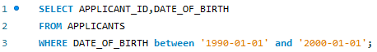

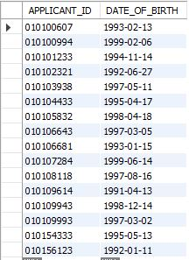

1. **How many conclusions are Passes? How many are Fails?**





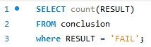



1. **Join tables to show department ID’s along with each scale?**

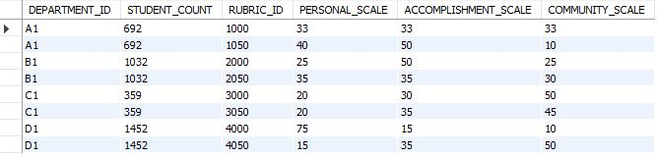

1. **Show the corresponding officer to every ‘PASS’ conclusion.**

