Related to Exp – 2

WEKA is a powerful open-source toolkit for machine learning and data mining
🧠 What Is WEKA?
WEKA (Waikato Environment for Knowledge Analysis) is a GUI-based toolkit developed by the University of Waikato, New Zealand. It supports:
- Classification, clustering, regression, association rules
- Data preprocessing and visualization
- Multiple interfaces: GUI, command line, Java API
💾 Downloading and Installing WEKA
- Visit the official WEKA site
- Download the latest version for your OS (Windows, macOS, Linux)
- Run the installer and launch the WEKA GUI Chooser
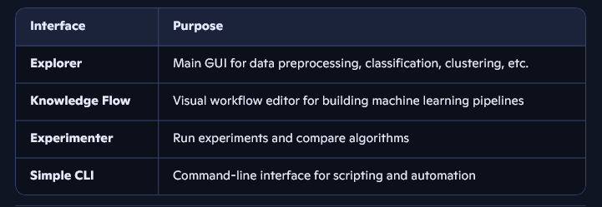
🧭 WEKA Interfaces Overview

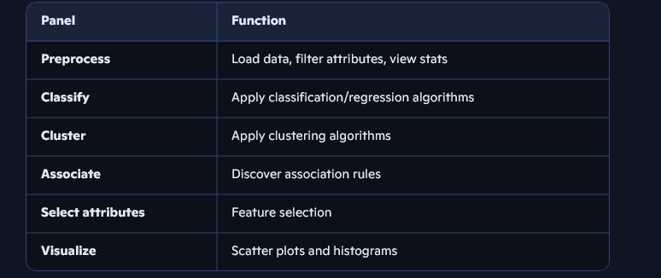
🧪 Navigating WEKA Panels (Explorer)

📂 ARFF File Format
ARFF (Attribute-Relation File Format) is WEKA’s native format:
- Starts with @relation (dataset name)
- Lists attributes with @attribute (name and type)
- Contains data under @data section
Example (Weather dataset):
@relation weather @attribute outlook {sunny, overcast, rainy} @attribute temperature numeric @attribute humidity numeric @attribute windy {true, false} @attribute play {yes, no} @data sunny,85,85,false,no sunny,80,90,true,no ...
📊 Exploring Iris and Weather Datasets in WEKA
1. Load Dataset
- Open WEKA Explorer → Preprocess tab
- Click Open file → Choose iris.arff or weather.arff
2. List Attributes and Types
- Attributes are listed on the left
- Types shown as numeric or nominal
Iris Dataset:
- Attributes: sepallength, sepalwidth, petallength, petalwidth, class
- Types: First four are numeric; class is nominal
Weather Dataset:
- Attributes: outlook, temperature, humidity, windy, play
- Types: Mix of nominal and numeric
3. Number of Records
- Shown at top of Preprocess tab (e.g., 150 for Iris, 14 for Weather)
4. Identify Class Attribute
- Usually the last attribute (e.g., class in Iris, play in Weather)
- Confirm via dropdown at bottom of Preprocess tab
5. Plot Histogram
- Click Visualize All → View histograms for each attribute
- Color-coded by class
6. Records per Class
- Go to Classify tab → Use ZeroR classifier → Click Start
- Output shows class distribution
7. Visualize in Multiple Dimensions
- Go to Visualize tab
- Choose X and Y axes to explore relationships (e.g., petalwidth vs petallength)
- Points are color-coded by class
Would you like a cheat sheet or a guided walkthrough for a specific dataset or panel? I can also help you replicate these steps in Python or compare WEKA with other tools like Scikit-learn.

Related to Exp – 3

I.
1. Discretize (Attribute Filter)
- Function: Converts numeric attributes into categorical (nominal) bins.
- 📍 Path: weka → filters → unsupervised → attribute → Discretize
- 🔧 Options:
  - bins: Number of intervals to divide the data into.
  - useEqualFrequency: Splits bins so each has roughly equal number of instances.
- ✅ Use Case:
  - Some algorithms (like Naive Bayes, Decision Trees) perform better with categorical input.
  - Useful for transforming continuous data into intervals (e.g., age groups: 0–20, 21–40, etc.).

2. Resample (Instance Filter)
- Function: Randomly samples instances from the dataset to create subsets.
- 📍 Path: weka → filters → unsupervised → instance → Resample
- 🔧 Options:
  - sampleSizePercent: % of dataset to sample (e.g., 70% for training, 30% for testing).
  - noReplacement: Ensures no duplicate instances if true.
  - biasToUniformClass: Helps balance class distribution (especially in imbalanced datasets).
- ✅ Use Case:
  - Creating training/testing partitions.
  - Balancing skewed datasets (class imbalance).
  - Bootstrapping for ensemble learning.

II,III,IV

🔹 Step 1: Load Dataset(Try to prefer weather data set)
- Open Weka → Explorer.
- Click Open file… and load one of the datasets (e.g., weather.nominal.arff, iris.arff, glass.arff).
  - These datasets are available in Weka’s data/ folder.

🔹 Step 2: Select Apriori Algorithm
- Go to the Associate tab.
- Click Choose → weka.associations.Apriori.
  - This will apply the Apriori association rule mining algorithm.

🔹 Step 3: Set Parameters
- Apriori has two main options:
  - minMetric → Minimum Confidence (default: 0.9).
  - lowerBoundMinSupport → Minimum Support (default: 0.1).
📌 Example settings you can try:
- Case 1 (default): support = 0.1, confidence = 0.9
- Case 2 (looser rules): support = 0.05, confidence = 0.6
- Case 3 (stricter rules): support = 0.2, confidence = 0.95

🔹 Step 4: Run and Observe
- Click Start.
- Weka will output rules in the Result list.
- You’ll see association rules like:
- outlook=sunny → play=no (0.6)
- petal-length<2.5 → class=Iris-setosa (1.0)
- RI<1.52 → Type=1 (0.72)
- The number and strength of rules will change depending on support and confidence.

🔹 Step 5: Compare Datasets
- weather.nominal → small dataset, you’ll get only a few rules.
- Iris → strong rules appear (e.g., petal-length strongly determines class).
- Glass → larger, more attributes → more complex rules but sometimes weaker support.

✅ Summary Table (for your notes/reports):
Dataset | Support | Confidence | Observation
weather.nominal | 0.1 | 0.9 | Few strong rules (e.g., outlook, humidity).
weather.nominal | 0.05 | 0.6 | More rules, but some weaker.
Iris | 0.1 | 0.9 | Clear separation rules (Setosa vs others).
Iris | 0.05 | 0.7 | Many more rules, but redundancy increases.
Glass | 0.1 | 0.9 | Some rules with moderate support.
Glass | 0.05 | 0.6 | Larger set of rules, weaker but covers more instances.

🔍 Key Parameters
- Minimum support: 0.2 (3 instances)
→ A rule must apply to at least 3 instances (20% of the dataset) to be considered.
- Minimum confidence: 0.95
→ Rules must be correct at least 95% of the time to be accepted.
- Number of cycles performed: 16
→ Apriori iteratively builds larger itemsets; 16 cycles means it explored combinations up to size 3.
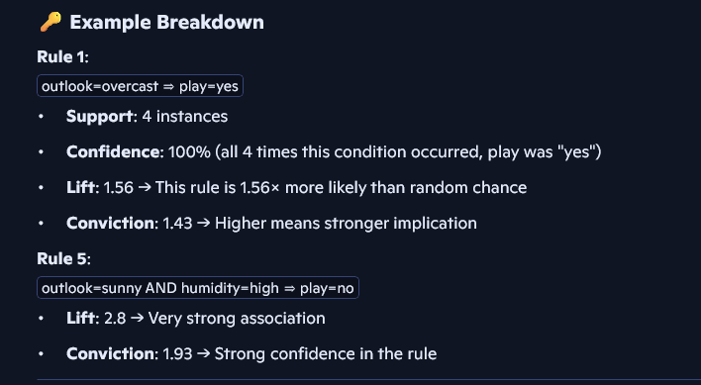

🧠 Why Discretization Is Required
Apriori works with nominal (categorical) data, not continuous numeric values. Since the Iris and glass datasets are numerical , you must convert them into bins using the Discretize filter

- Weather.nominal.arff: Already discretized; all attributes are nominal.
- Iris.arff: Contains numeric attributes (sepal/petal length/width).
- Glass.arff: Contains multiple numeric attributes (e.g., refractive index, element concentrations).

Generated sets of large itemsets: means frequent itemsets
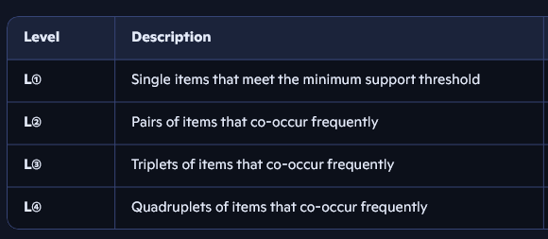
Exp – 4
I,ii
🔹 Step 1: Load Dataset
- Open Weka → Explorer → Preprocess tab.
- Load weather.nominal.arff, iris.arff, and glass.arff (all found in Weka’s data/ folder).

🔹 Step 2: Choose Classifier
- Go to the Classify tab.
- Under Choose, pick:
  - weka.classifiers.trees.Id3 (classic ID3 implementation – note: works only with nominal attributes).
  - weka.classifiers.trees.J48 (C4.5 algorithm, more advanced, handles numeric & pruning).
👉 Run both ID3 and J48 separately on each dataset.

🔹 Step 3: Classification Output (What to Study)
When you click Start, Weka shows several important results:
1. Entropy values (Information Gain)
- ID3/J48 split attributes based on information gain (reduction in entropy).
- In the tree, the first split (root node) is the attribute with maximum information gain.
Example (Iris):
  - Root might be petal-length ≤ 2.45 because it perfectly separates Iris-setosa.
2. Decision Tree → If-Then Rules
- In the Classifier output, click Visualize tree.
- You can extract rules:
  - Example (weather.nominal with J48):
  - outlook = sunny AND humidity = high → play = no
  - outlook = sunny AND humidity = normal → play = yes
  - outlook = overcast → play = yes
  - outlook = rainy AND windy = true → play = no
  - outlook = rainy AND windy = false → play = yes
  - Example (Iris with J48):
  - petal-length ≤ 2.45 → Iris-setosa
  - petal-length > 2.45 AND petal-width ≤ 1.75 → Iris-versicolor
  - petal-length > 2.45 AND petal-width > 1.75 → Iris-virginica
3. Confusion Matrix
- Found at the bottom of the output.
- Example (Iris with J48, 10-fold cross-validation):
- a b c <-- classified as
- 50 0 0 | a = Iris-setosa
- 0 47 3 | b = Iris-versicolor
- 0 2 48 | c = Iris-virginica
  - Meaning: 97% accuracy, only 5 misclassifications.
4. Kappa Statistic
- Found in Classifier output summary.
- Measures agreement between predicted and actual classes, correcting for chance.
- Range: 0 → no agreement, 1 → perfect agreement.
  - For Iris, expect ~0.95–1.0 (very high).
  - For Glass, usually lower (~0.6–0.7) because Glass dataset is harder to classify.

🔹 Step 4: Compute Entropy (Optional Manual Check)
Example (weather.nominal, target = play):
- Yes = 9, No = 5 → Total = 14
- Entropy(Play) = −(9/14) log2(9/14) − (5/14) log2(5/14) ≈ 0.94 bits.
- ID3/J48 compare entropy reductions for attributes (Outlook, Humidity, Windy) to pick best split.

🔹 Step 5: Compare ID3 vs J48
- ID3:
  - Builds a simple tree.
  - No pruning (can overfit).
  - Works only with categorical data.
- J48 (C4.5):
  - Handles numeric + categorical attributes.
  - Includes pruning (reduces overfitting).
  - More robust and usually better accuracy.
Note :
In newer versions of Weka (>=3.8), the ID3 algorithm is not included by default in the main package — only J48 (C4.5) is available. That’s why you’re not seeing weka.classifiers.trees.Id3 in the Choose menu.
But you still have options 👇

🔹 Option 1: Install ID3 Package in Weka
- Open Weka → Tools → Package Manager.
- In the search bar, type “Id3”.
- If available, click Install.
- Restart Weka → Now under trees, you should see Id3.

🔹 1. What is Entropy?
- Entropy measures impurity / disorder in a dataset.
- Formula (for binary classification):
Entropy(S)=−p+log⁡2(p+)−p−log⁡2(p−)Entropy(S) = -p_{+} \log_2 (p_{+}) - p_{-} \log_2 (p_{-})Entropy(S)=−p+​log2​(p+​)−p−​log2​(p−​)
where:
- p+p_{+}p+​ = proportion of positive examples
- p−p_{-}p−​ = proportion of negative examples
👉 If all examples are of one class → entropy = 0 (pure set).
👉 If classes are equally mixed → entropy = 1 (maximum impurity).

🔹 2. Entropy in Decision Trees
- ID3/J48 use entropy to decide which attribute to split on at each node.
- The goal: reduce uncertainty by splitting on the attribute that gives the highest Information Gain.

🔹 3. Information Gain (IG)
- IG(A) = Entropy(before split) − Weighted Entropy(after split on attribute A).
IG(S,A)=Entropy(S)−∑v∈Values(A)∣Sv∣∣S∣Entropy(Sv)IG(S, A) = Entropy(S) - \sum_{v \in Values(A)} \frac{|S_v|}{|S|} Entropy(S_v)IG(S,A)=Entropy(S)−v∈Values(A)∑​∣S∣∣Sv​∣​Entropy(Sv​)
where SvS_vSv​ = subset of dataset where attribute A = v.
👉 Attribute with maximum IG becomes the root or next split.

🔹 4. Example (Weather Dataset)
Target: Play = {Yes, No}
- 9 Yes, 5 No → Total 14.
Entropy(Play)=−914log⁡2914−514log⁡2514≈0.94Entropy(Play) = -\frac{9}{14}\log_2 \frac{9}{14} - \frac{5}{14}\log_2 \frac{5}{14} ≈ 0.94Entropy(Play)=−149​log2​149​−145​log2​145​≈0.94
Now check attribute Outlook:
- Sunny (5 records): 2 Yes, 3 No → Entropy = 0.971
- Overcast (4 records): 4 Yes, 0 No → Entropy = 0
- Rainy (5 records): 3 Yes, 2 No → Entropy = 0.971
Weighted Entropy(Outlook) =
514(0.971)+414(0)+514(0.971)=0.693\frac{5}{14}(0.971) + \frac{4}{14}(0) + \frac{5}{14}(0.971) = 0.693145​(0.971)+144​(0)+145​(0.971)=0.693
So,
IG(Outlook)=0.94−0.693=0.247IG(Outlook) = 0.94 - 0.693 = 0.247IG(Outlook)=0.94−0.693=0.247
📌 If this IG is higher than other attributes, Outlook is chosen as the root split.

🔹 5. Entropy in J48 vs ID3
- ID3 → Uses entropy + information gain.
- J48 (C4.5) → Uses entropy + Gain Ratio (modification to handle many-valued attributes).

🔹 6. Why Entropy is Important
- Helps quantify uncertainty in data.
- Drives the splitting decisions in trees.
- Ensures that the model moves towards purer subsets (less disorder) at each step.

✅ In your practical report you can write:
- “Entropy is used to measure impurity of a dataset. The attribute with the maximum information gain (entropy reduction) is selected for splitting. For example, in the weather dataset, Outlook is chosen as the root node because it yields the highest entropy reduction.”

ExP – 4 – III,IV,V

🔹 Step 1: Load Dataset
- Open Weka → Explorer → Preprocess tab.
- Load weather.nominal.arff, iris.arff, and glass.arff from Weka’s data/ folder.

🔹 Step 2: Select Classifiers
Go to the Classify tab. Run each classifier separately with 10-fold cross-validation (standard evaluation method).
- Naïve Bayes → weka.classifiers.bayes.NaiveBayes
- k-NN → weka.classifiers.lazy.IBk (default k=1, you can try k=3,5 as well)
- ID3 → may need package install (else use J48)
- J48 → weka.classifiers.trees.J48

🔹 Step 3: Plot ROC Curves
- After training a classifier → check Result list.
- Right-click → Visualize threshold curve.
- ROC curve will be shown (True Positive Rate vs False Positive Rate).
  - Area Under Curve (AUC) closer to 1.0 = better classifier.

🔹 Step 4: Interpretation Points

1. Weather.nominal dataset (small, categorical)
- Naïve Bayes: Works well because attributes are categorical and independent. Expect ~70–80% accuracy.
- J48: Performs very well (close to 100%) because dataset is small and tree rules fit nicely.
- k-NN: Not great for small datasets; may overfit.
- ID3: Similar to J48 but no pruning → possible overfitting.
✅ Likely best = J48, poor = k-NN.

2. Iris dataset (numeric, 3 balanced classes)
- Naïve Bayes: Performs okay (~95%) but independence assumption limits it.
- J48: Very strong (~96–97%). Simple rules like petal-length split classes clearly.
- k-NN: Usually best (~97–99%), since Iris has natural clusters.
- ID3: Works only on nominal, so it struggles unless discretized.
✅ Likely best = k-NN, poor = ID3 (without discretization).

3. Glass dataset (numeric, 6 unbalanced classes)
- Naïve Bayes: Moderate (~50–60%) due to independence assumption not holding.
- J48: Okay but not very high (~60–65%), since many overlapping classes.
- k-NN: Often performs better (~65–70%), but sensitive to k choice.
- ID3: Weak because of numeric/imbalanced data.
✅ Likely best = k-NN, poor = ID3.

🔹 Step 5: Comparative Table (Sample for Report)
Dataset | ID3 Accuracy | J48 Accuracy | Naïve Bayes Accuracy | k-NN Accuracy | Best Classifier | Worst Classifier
Weather.nominal | ~100% (overfit risk) | ~100% | ~75–80% | ~60% | J48 | k-NN
Iris | low (needs discretization) | ~96–97% | ~95% | ~97–99% | k-NN | ID3
Glass | ~45–55% | ~60–65% | ~55–60% | ~65–70% | k-NN | ID3

🔹 Step 6: Justification
- J48 → best on small categorical datasets like weather.
- k-NN → best on numeric, well-separated datasets (Iris, Glass).
- Naïve Bayes → simple and efficient, but weaker when attributes are dependent (Glass).
- ID3 → weakest because no pruning and difficulty handling numeric/imbalanced data.

✅ For your report:
- Include confusion matrices and ROC curves for each classifier & dataset.
- Fill a comparison table like above.
- Conclude which classifier is most suitable depending on dataset type.

In RoC
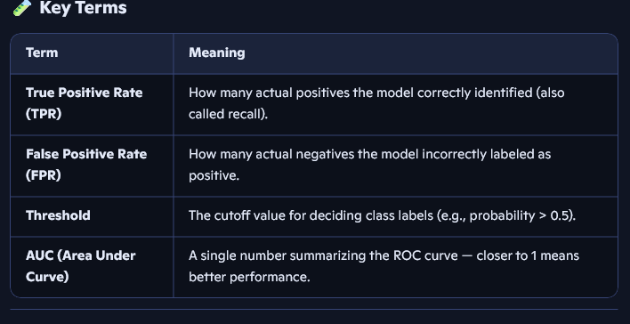

ID3, J48, and KNN are popular machine learning algorithms used for classification tasks, each with a different approach: ID3 and J48 build decision trees, while KNN classifies based on similarity to nearby data points.

🌳 ID3 (Iterative Dichotomiser 3)
• Type: Decision Tree algorithm
• How it works: ID3 builds a tree by choosing the attribute that gives the highest information gain (i.e., reduces uncertainty the most) at each step.
• Splitting criterion: Uses entropy and information gain to decide which feature to split on.
• Output: A decision tree where each internal node is a feature, and each leaf is a class label.
• Limitation: Works only with categorical data and can overfit if not pruned.
🔗 Learn more about ID3

🌲 J48 (C4.5 Implementation in Weka)
• Type: Decision Tree algorithm (an improvement over ID3)
• How it works: Like ID3, but with enhancements:
• Handles both categorical and continuous data
• Prunes the tree to avoid overfitting
• Deals with missing values
• Splitting criterion: Uses gain ratio, a refined version of information gain.
• Output: A more robust and generalizable decision tree.
🔗 Explore J48 in Weka

📍 KNN (K-Nearest Neighbors)
• Type: Instance-based, lazy learning algorithm
• How it works:
• Stores the entire training dataset.
• To classify a new point, it finds the ‘k’ closest data points (neighbors) using a distance metric (like Euclidean distance).
• Assigns the class that is most common among those neighbors.
• No training phase: All computation happens during prediction.
• Best for: Simple problems with small to medium datasets.
• Limitation: Can be slow with large datasets and sensitive to irrelevant features.
🔗 More on KNN

EXP -5

🔹 Step 1: Load Dataset
- Open Weka → Explorer → Preprocess tab.
- Load each dataset: weather.nominal.arff, iris.arff, glass.arff.
- Note: For clustering, the class attribute is ignored by default (unsupervised).

🔹 Step 2: Run K-Means (SimpleKMeans in Weka)
- Go to the Cluster tab.
- Choose → weka.clusterers.SimpleKMeans.
- Set Number of clusters (k) (e.g., 2, 3, 4, …).
- Click Start.
Output will show:
- Cluster centroids (mean values of attributes per cluster).
- Cluster sizes (number of instances per cluster).
- Sum of Squared Errors (SSE) → measures compactness of clusters (lower = better).

🔹 Step 3: Interpret Results

📌 Weather.nominal (small dataset)
- If k=2 → groups into 2 clusters (e.g., play=yes vs play=no).
- If k=3 → may separate based on Outlook (Sunny/Rainy/Overcast).
- SSE is small because dataset is tiny.
- Centroids show average humidity/wind in clusters.
Insight: K-Means here indirectly rediscovers the PlayTennis classes.

📌 Iris (famous clustering dataset)
- If k=2 → usually Setosa in one cluster, Versicolor+Virginica in another.
- If k=3 → often matches the 3 species almost perfectly.
- SSE decreases as k increases.
- Centroids give average petal length/width → shows clear separation.
Insight: Iris is a “natural clustering” dataset; K-Means recovers true species quite well.

📌 Glass (hard dataset)
- With k=2 → rough separation, SSE is high.
- With k=6 (true number of classes) → clusters overlap; misclassifications are common.
- Centroids show mixtures (not pure).
Insight: Glass dataset is complex with overlapping attributes → K-Means struggles.

🔹 Step 4: Observe SSE and Centroids
- SSE trend: As k increases → SSE decreases (clusters get tighter).
- But too high k → overfitting (each instance nearly its own cluster).
- Centroids: Look at values of numeric attributes → they represent the “typical” object in each cluster.

🔹 Step 5: Visualize Clusters
In Weka:
- After clustering, go to Visualize → Visualize cluster assignments.
- Pick 2 attributes (e.g., petal length vs petal width for Iris).
- Instances are plotted with colors for cluster IDs.
👉 You’ll notice:
- Iris → clear separation between clusters.
- Glass → lots of overlap.
- Weather → small dataset, clusters are obvious.
In R:
# Example for Iris
data(iris)
library(cluster)
km <- kmeans(iris[,1:4], centers=3)
plot(iris[,3:4], col=km$cluster, pch=19, xlab="Petal Length", ylab="Petal Width")
points(km$centers[,3:4], col=1:3, pch=8, cex=2) # plot centroids

🔹 Step 6: Explore Other Clustering Techniques
Besides K-Means, Weka/R provide:
- EM (Expectation Maximization): probabilistic clustering, assigns probability of membership.
- Hierarchical Clustering: builds dendrogram, useful for small datasets.
- DBSCAN (in R): density-based clustering, good for irregular shapes.
Comparison:
- K-Means → simple, works well for spherical clusters.
- EM → handles overlapping clusters better.
- Hierarchical → shows hierarchy but not scalable.
- DBSCAN → can find arbitrary-shaped clusters, but parameter sensitive.

🔹 Step 7: Report Insights (what to write)
- Weather.nominal: K-Means discovers play=yes/no groups; SSE low.
- Iris: With k=3, clustering closely matches real species; strong separation in petal attributes.
- Glass: K-Means struggles, SSE high, centroids overlap; dataset is not well-clustered.
- Visualization: Scatter plots show clear clustering in Iris, but overlap in Glass.
- Other methods: EM may better capture overlapping data; hierarchical clustering useful for understanding relationships.

✅ In your practical report, you should include:
- SSE values for different k.
- Cluster centroids (table).
- Screenshots of cluster visualizations.
- Comparison of clustering techniques.
- Final conclusion (which dataset is easy/hard to cluster, which method works best).
EXP - 6
i.
🧠 Knowledge Flow in Weka: Association Rules with Apriori & FP-Growth
To find strong association rules using Weka’s Knowledge Flow:
📌 Layout Setup:
- Start Weka Knowledge Flow Interface.
- Drag and drop the following components:
- ArffLoader → Load your dataset (e.g., weather.nominal.arff)
- Associator → Choose either:
  - Apriori → Set min support/confidence
  - FPGrowth → Configure itemset size and support
- TextViewer → To view the rules
🔗 Connections:
- Connect ArffLoader → Associator
- Connect Associator → TextViewer
🧪 Output:
- Apriori and FP-Growth will generate rules like Outlook=Sunny ⇒ Play=No with confidence and support metrics.
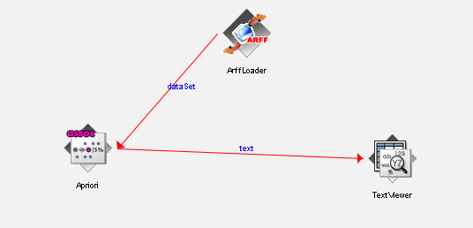
Using Apriori:

To view results right click on text view -> view results
Using FPGrowth:
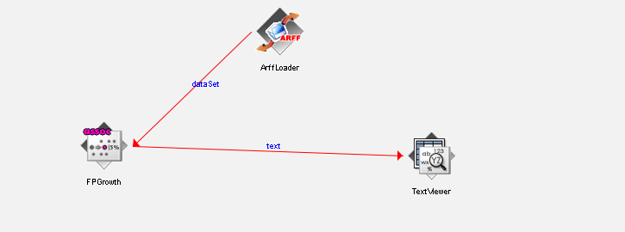

FP growth directly does n’t works on weather.nominial.arff file
1. Convert Nominal Attributes to Binary Format
Use Weka’s NominalToBinary Filter
- Open Weka Explorer.
- Load your ARFF file.
- Go to the Preprocess tab.
- Choose Filter → unsupervised → attribute → NominalToBinary.
- Apply the filter.
- Save the transformed dataset as a new ARFF file (e.g., weather_binary.arff).
- Use this binary ARFF in your Knowledge Flow with FP-Growth.
2..Again convert that weather_binary_.arff
• Open Weka Explorer
- Load your ARFF file (u_weather_binary.arff)
- Go to Preprocess tab
- Apply this filter:
  - unsupervised → attribute → NumericToNominal
  - Configure it to apply to all numeric attributes (e.g., first-last)
- Click Apply
- Save the result as a new ARFF file (e.g., weather_binary_nominal.arff)
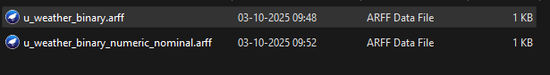
- Use this new file in Knowledge Flow with FP-Growt

Finally load that u_weather_binary_numeric_nominal.arff into arff loader.
Now the result will be obtained in view result of text viewer.
ii.
🧠 Knowledge Flow Setup in Weka (J48 Classifier)
1. Launch Weka Knowledge Flow
Open Weka and switch to the Knowledge Flow environment.
2. Add Required Components
Drag and drop the following components onto the canvas:
- ArffLoader (from DataSources) – Loads your dataset(weather.nominal.arff)
- ClassAssigner (from Filters → Unsupervised → Attribute) – Explicitly sets the class attribute
- CrossValidationFoldMaker (from Evaluation) – Generates cross-validation folds
- Classifier (from Classifiers → trees → J48) – Builds the decision tree
- ClassifierPerformanceEvaluator (from Evaluation) – Evaluates model performance
- TextViewer (from Visualization) – Displays the evaluation results
3. Configure Each Component
🔹 ArffLoader
- Set the path to your .arff file
- Batch mode is enabled by default — no need to change it
🔹 ClassAssigner
- Set class index to last (this ensures the target attribute is correctly assigned)
🔹 CrossValidationFoldMaker
- Set the number of folds (typically 10)
- This component will split your dataset for training and testing
🔹 Classifier (J48)
- Double-click to configure parameters like:
  - -C 0.25 (confidence factor)
  - -M 2 (minimum number of instances per leaf)
- You can also try -U for an unpruned tree
🔹 ClassifierPerformanceEvaluator
- Enable options like:
- Output per-class stats: True
- Output confusion matrix: True
- Collect test data for visualization: True
🔹 TextViewer
- No special configuration needed — it will display the evaluation output
4. 🔗 Connect the Flow
Make the following connections exactly in this order:
- ArffLoader → ClassAssigner (dataSet)
- ClassAssigner → CrossValidationFoldMaker (dataSet)
- CrossValidationFoldMaker → Classifier (J48) (trainingSet ,testSet)
- Classifier (J48) → ClassifierPerformanceEvaluator (batchClassifier)
- ClassifierPerformanceEvaluator → TextViewer (text)
5. Run the Flow
Click the green play button to execute the flow.
Once complete, right-click on TextViewer → Show results to view:
- ✅ Accuracy
- ✅ Precision & Recall
- ✅ Confusion Matrix
- ✅ ROC & PRC metrics
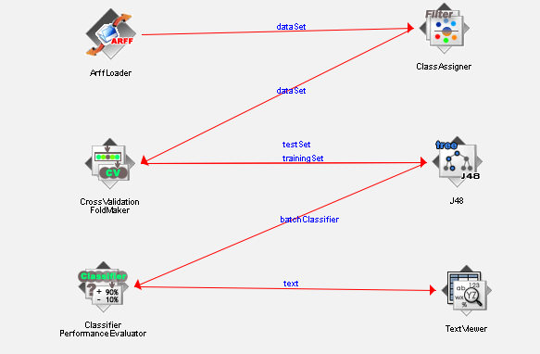

iii. Once refer ii, before seeing this
🧠 Plotting Multiple ROC Curves in Weka Knowledge Flow
1. Launch Knowledge Flow
Open Weka and switch to the Knowledge Flow environment.
2. Add Components
Drag these onto the canvas:
- ArffLoader – Load your dataset
- ClassAssigner – Set class index to last
- CrossValidationFoldMaker – Create folds
- J48 and RandomForest – Two classifiers
- ClassifierPerformanceEvaluator ×2 – One per cla
- ModelPerformanceChart – Plot ROC curves
3. Configure
- Set folds to 10
- Configure J48 (-C 0.25 -M 2) and RandomForest (default is fine)
- Enable ROC output in both evaluators:
- Output per-class stats: True
- Collect test data: True
4. 🔗 Connect the Flow
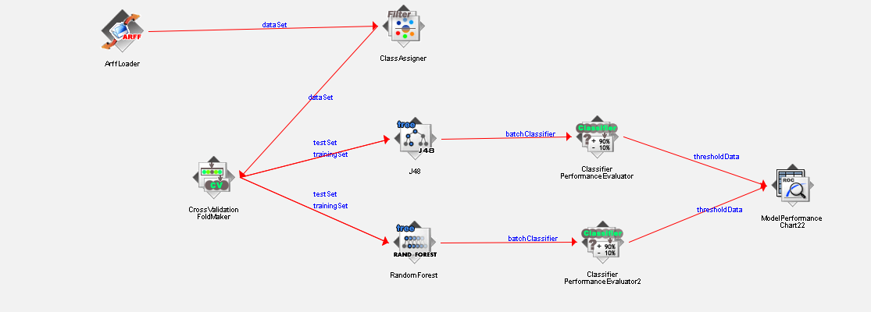

5. Run and View
Click Run, then open ModelPerformanceChart to compare ROC curves for J48 and RandomForest.

EXP – 7
🧪 Step-by-Step: Applying ZeroR on the Iris Dataset
1. Load the Dataset
- Use the built-in iris.arff file in Weka.
- This dataset contains 150 instances with 4 numeric attributes:
- Sepal length
- Sepal width
- Petal length
- Petal width
- Class label: Iris-setosa, Iris-versicolor, Iris-virginica
2. Preprocessing
- Check for missing values: The Iris dataset typically has none.
- Ensure class attribute is set: In Weka, go to “Classify” tab → set class to the last attribute (species).
- No normalization or scaling needed for ZeroR since it doesn’t use features.
3. Apply ZeroR Classifier
- In Weka:
- Go to Classify tab
- Choose ZeroR under rules classifiers
- Click Start
4. Results & Output
You’ll see something like:
ZeroR predicts class value: Iris-setosa
Correctly Classified Instances: 50 (33.33%)
Incorrectly Classified Instances: 100 (66.67%)
Kappa statistic: 0
Mean absolute error: 0.6667

🔍 Observations
✅ Strengths
- Simplicity: ZeroR is extremely fast and easy to implement.
- Baseline: It sets a benchmark for evaluating other classifiers. Any model performing worse than ZeroR is likely flawed.
❌ Limitations
- No predictive power: It doesn’t use input features at all.
- Poor accuracy: In multi-class datasets like Iris, it only predicts the majority class (e.g., Iris-setosa) and ignores the rest.
📊 Interpretation
- Accuracy: 33.33% (since each class has 50 instances, predicting one class only gets 50/150 correct).
- Kappa = 0: Indicates no agreement beyond chance.
- Use case: Only for comparison—not suitable for real-world prediction.

ZeroR (Zero Rule) is the simplest classification algorithm in Weka. It ignores all input features and simply predicts the majority class (for classification) or the mean value (for regression).

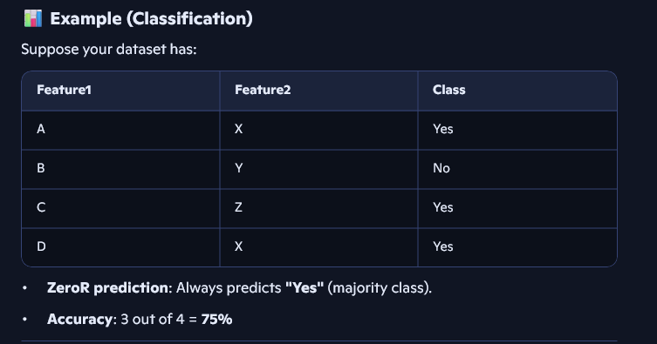

EXP - 8

Write a java program to prepare a simulated data set with unique instances.
import java.util.*;
import java.io.*;

public class SimulatedDatasetGeneratorARFF {
public static void main(String[] args) {
int numInstances = 100;
String[] categories = {"Red", "Green", "Blue"};

Set<String> uniqueInstances = new HashSet<>();
Random rand = new Random();

try (PrintWriter writer = new PrintWriter(new File("simulated_dataset.arff"))) {
// ARFF Header
writer.println("@RELATION simulated_data");
writer.println("@ATTRIBUTE ID STRING");
writer.println("@ATTRIBUTE Feature1 NUMERIC");
writer.println("@ATTRIBUTE Feature2 NUMERIC");
writer.println("@ATTRIBUTE Label {" + String.join(",", categories) + "}");
writer.println();
writer.println("@DATA");

int count = 0;
while (count < numInstances) {
String id = "ID" + (count + 1);
double feature1 = Math.round(rand.nextDouble() * 1000.0) / 10.0;
double feature2 = Math.round(rand.nextDouble() * 1000.0) / 10.0;
String label = categories[rand.nextInt(categories.length)];

String instance = "\"" + id + "\"," + feature1 + "," + feature2 + "," + label;
// "\"" \" – to add double quote , it is enclosed in string " "
if (!uniqueInstances.contains(instance)) {
uniqueInstances.add(instance);
writer.println(instance);
count++;
}
}

System.out.println("ARFF dataset created with " + numInstances + " unique instances.");
} catch (IOException e) {
System.err.println("Error writing ARFF file: " + e.getMessage());
}
}
}
Output :
PS D:\CODING\DWDM\EXP - 7> java SimulatedDatasetGeneratorARFF
PS D:\CODING\DWDM\EXP - 7> java SimulatedDatasetGeneratorARFF
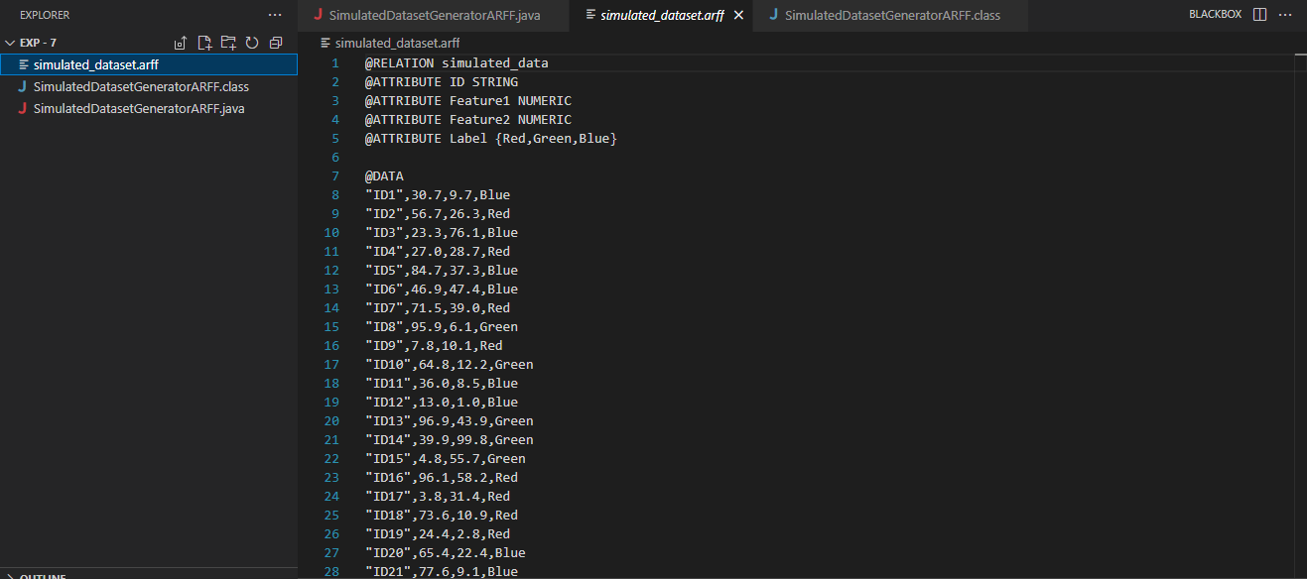
ARFF dataset created with 100 unique instances.

Note :
1.PrinterWriter is similar to FileWriter but allows more formatting options
-- Direct use of printf(),println()
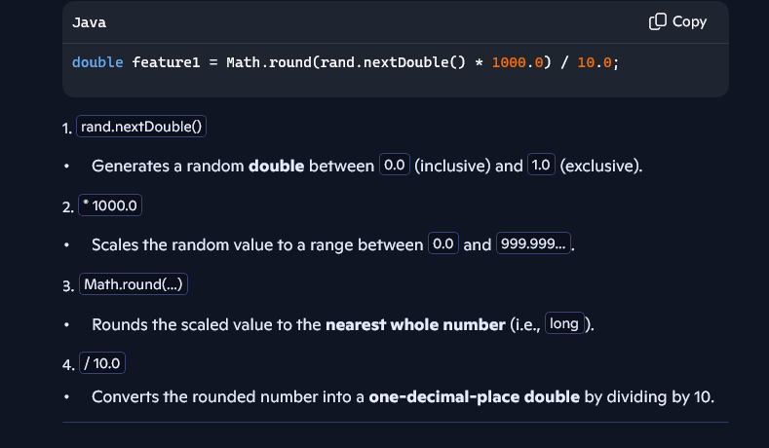
2.

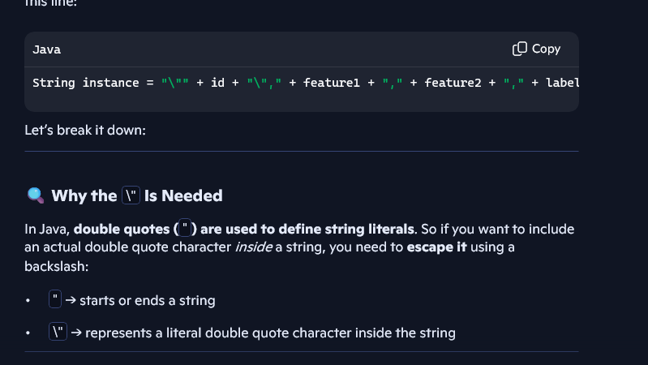
3.

EXP – 9 Simplified(Colab) Manual Calculation
🧮 Step-by-Step Manual Apriori Calculation
We'll use your original transaction list:
T1: milk, bread, eggs
T2: milk, bread
T3: milk, eggs
T4: bread, eggs
T5: milk, bread, eggs, butter
T6: bread, butter
🔢 Step 1: Count Support for Individual Items (1-itemsets)
Support = (Number of transactions containing the item) / (Total transactions = 6)
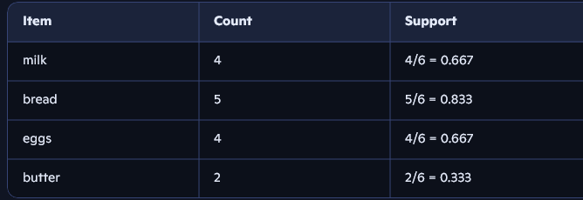

✅ Keep items with support ≥ 0.5 → milk, bread, eggs
🔗 Step 2: Generate 2-itemsets and Count Support
Possible combinations:
- milk & bread → in T1, T2, T5 → 3/6 = 0.5
- milk & eggs → in T1, T3, T5 → 3/6 = 0.5
- bread & eggs → in T1, T4, T5 → 3/6 = 0.5
- milk & butter → in T5 → 1/6 = 0.167 ❌
- bread & butter → in T5, T6 → 2/6 = 0.333 ❌
- eggs & butter → in T5 → 1/6 = 0.167 ❌
✅ Keep:
- (milk, bread), (milk, eggs), (bread, eggs)
🔗 Step 3: Generate 3-itemsets and Count Support
Only one valid 3-itemset from frequent 2-itemsets:
- milk, bread, eggs → in T1, T5 → 2/6 = 0.333 ❌ (below threshold)
✅ No 3-itemsets meet support ≥ 0.5

After Step – 3 Final Frequent Item Sets with their support values are :
Frequent Itemsets:
support itemsets
0 0.833333 (bread)
1 0.666667 (eggs)
2 0.666667 (milk)
3 0.500000 (eggs, bread)
4 0.500000 (bread, milk)
5 0.500000 (eggs, milk)
📐 Step 4: Generate Association Rules
From frequent 2-itemsets:
Example: Rule from (milk, bread)
- Antecedent: milk → Consequent: bread
- Support = 3/6 = 0.5
- Confidence = P(bread milk) = Support(milk & bread) / Support(milk) = 0.5 / 0.667 ≈ 0.75
- Lift = Confidence / Support(bread) = 0.75 / 0.833 ≈ 0.90
✅ Rule: milk → bread (confidence = 0.75, lift = 0.90)
Repeat this for other combinations:
- eggs → bread
- milk → eggs
- bread → milk
- etc.
✅ Keep rules with confidence ≥ 0.7

🧠 Summary Table
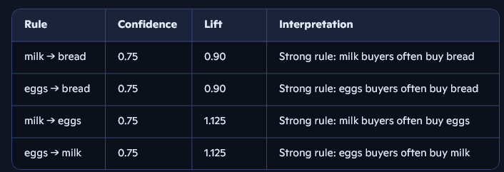
EXP – 9 MANUAL CALCULATION OF CHI SQUARE
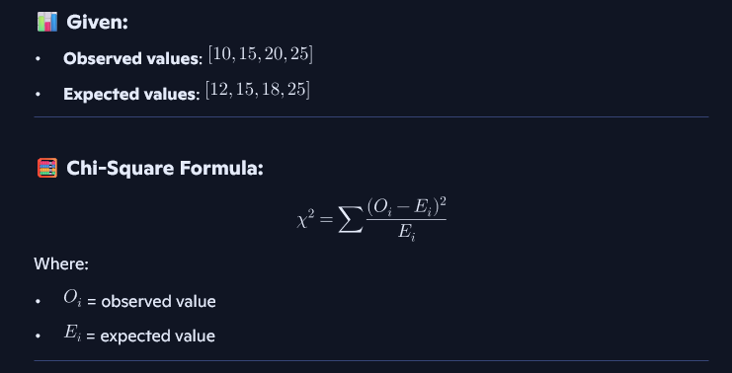

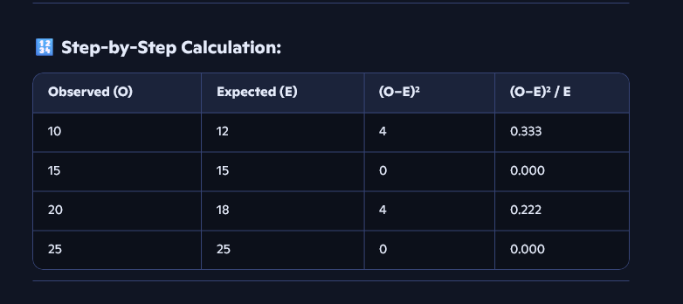

Adding 0.33+0.22 = 0.55 Final Chi-square value

EXP – 12

Implement a Java/R program to perform Apriori algorithm
import java.util.*;

public class SimpleApriori {
private List<Set<String>> transactions;
private double minSupport;
private double minConfidence;

public SimpleApriori(List<Set<String>> transactions, double minSupport, double minConfidence) {
this.transactions = transactions;
this.minSupport = minSupport;
this.minConfidence = minConfidence;
}

public Map<Set<String>, Integer> getFrequentItemsets() {
// Final map to store all frequent itemsets and their counts
Map<Set<String>, Integer> frequentItemsets = new LinkedHashMap<>();

// Step 1: Collect all unique items from the transactions
Set<String> allItems = new HashSet<>();
// For your example:
// Transactions:
// T1: [milk, bread]
// T2: [milk, diaper]
// T3: [bread, diaper]
// T4: [milk, bread, diaper]
// Output: allItems = [milk, bread, diaper]
for (Set<String> t : transactions) allItems.addAll(t);

// Step 2: Generate initial candidate itemsets of size 1
List<Set<String>> candidates = new ArrayList<>();
// Output: candidates = [[milk], [bread], [diaper]]
for (String item : allItems) candidates.add(Set.of(item));

// Step 3: Iteratively find frequent itemsets
while (!candidates.isEmpty()) {
// Map to count support of each candidate
Map<Set<String>, Integer> counts = new HashMap<>();

// Count how many transactions contain each candidate
for (Set<String> candidate : candidates) {
for (Set<String> t : transactions) {
if (t.containsAll(candidate)) {
counts.put(candidate, counts.getOrDefault(candidate, 0) + 1);
}
}
}
// Example output after first pass:
// counts = [[milk]:3, [bread]:3, [diaper]:3]

candidates.clear(); // Prepare for next level

// Filter candidates by support threshold
//We cannot use counts.forEach loop as it requires candidates to be a final variable
for (Map.Entry<Set<String>, Integer> entry : counts.entrySet()) {
double support = entry.getValue() / (double) transactions.size();
// For minSupport = 0.5 and 4 transactions, threshold = 2
if (support >= minSupport) {
// Add to final frequent itemsets
frequentItemsets.put(entry.getKey(), entry.getValue());
// Add to next-level candidates
candidates.add(entry.getKey());
}
}

// After filtering:
// frequentItemsets = [[milk]:3, [bread]:3, [diaper]:3]
// candidates = same as above

// Step 4: Generate next-level candidates (size k+1)
candidates = generateNextCandidates(candidates);
// Output: candidates = [[milk, bread], [milk, diaper], [bread, diaper]]
}

// Final output:
// frequentItemsets =
// [[milk]:3, [bread]:3, [diaper]:3, [milk, bread]:2, [milk, diaper]:2, [bread, diaper]:2]
return frequentItemsets;
}

private List<Set<String>> generateNextCandidates(List<Set<String>> prevLevel) {
// Use a Set to avoid duplicate candidates
Set<Set<String>> nextLevel = new HashSet<>();

// Join step: combine each pair of itemsets
for (int i = 0; i < prevLevel.size(); i++) {
for (int j = i + 1; j < prevLevel.size(); j++) {
Set<String> union = new HashSet<>(prevLevel.get(i)); //Creates a hashSet that has elements of ith index of prevLevel
union.addAll(prevLevel.get(j));

// Only keep itemsets that grow by one item
if (union.size() == prevLevel.get(i).size() + 1) {
nextLevel.add(union); // e.g., [milk, bread], [milk, diaper], [bread, diaper]
}
}
}

// Convert to list and return
return new ArrayList<>(nextLevel);
}

public List<String> generateAssociationRules(Map<Set<String>, Integer> freqItemsets) {
List<String> rules = new ArrayList<>();
int total = transactions.size();

for (Set<String> itemset : freqItemsets.keySet()) {
if (itemset.size() < 2) continue;

List<Set<String>> subsets = getSubsets(itemset);
for (Set<String> antecedent : subsets) {
Set<String> consequent = new HashSet<>(itemset);
consequent.removeAll(antecedent);
if (consequent.isEmpty()) continue;

Integer itemsetCount = freqItemsets.get(itemset);
Integer antecedentCount = freqItemsets.get(antecedent);
Integer consequentCount = freqItemsets.get(consequent);
if (antecedentCount == null || consequentCount == null) continue;

double confidence = itemsetCount / (double) antecedentCount;
double lift = confidence / (consequentCount / (double) total);

if (confidence >= minConfidence) {
double support = itemsetCount / (double) total;
rules.add(String.format("%s -> %s (Support: %.2f, Confidence: %.2f, Lift: %.2f)",
antecedent, consequent, support, confidence, lift));
}
}
}

return rules;
}

private List<Set<String>> getSubsets(Set<String> set) {
List<Set<String>> subsets = new ArrayList<>();
List<String> items = new ArrayList<>(set);
int n = items.size();

// Generate subsets of size 1 to n-1 (proper subsets) -- excludes emptyset and fullset
for (int size = 1; size < n; size++) {
generateCombinations(items, size, 0, new LinkedList<>(), subsets);
}

return subsets;

}

private void generateCombinations(List<String> items, int size, int index,
LinkedList<String> current, List<Set<String>> result) {
if (current.size() == size) {
result.add(new HashSet<>(current));
return;
}

for (int i = index; i < items.size(); i++) {
current.add(items.get(i)); // Choose item
generateCombinations(items, size, i + 1, current, result); // Recurse
current.removeLast(); // Backtrack

}
}
/**
* Generates all proper subsets (excluding empty set and full set) of a given Set<String>.
*
* Logic:
* - Convert the input Set to a List for index-based access.
* - For each subset size from 1 to n-1:
* - Use recursive backtracking to generate all combinations of that size.
* - Store each valid subset in the result list.
*
* Example Trace: Input Set = {"milk", "bread", "diaper"}
*
* Generating subsets of size 1:
* - Start with empty list []
* - Add "milk" → ["milk"] → ✅ Save this
* - Backtrack: remove "milk"
* - Add "bread" → ["bread"] → ✅ Save this
* - Backtrack: remove "bread"
* - Add "diaper" → ["diaper"] → ✅ Save this
* - Backtrack: remove "diaper"
*
* Final subsets of size 1: [milk], [bread], [diaper]
*
* Generating subsets of size 2:
* - Start with empty list []
* - Add "milk" → ["milk"]
* - Add "bread" → ["milk", "bread"] → ✅ Save this
* - Backtrack: remove "bread" → ["milk"]
* - Add "diaper" → ["milk", "diaper"] → ✅ Save this
* - Backtrack: remove "diaper", remove "milk"
* - Add "bread" → ["bread"]
* - Add "diaper" → ["bread", "diaper"] → ✅ Save this
* - Backtrack: remove "diaper", remove "bread"
*
* Final subsets of size 2: [milk, bread], [milk, diaper], [bread, diaper]
*
* Note:
* - These subsets are useful for association rule mining (e.g., Apriori algorithm).
* - This method can be applied to each transaction to extract candidate itemsets.
*/

public static void main(String[] args) {
List<Set<String>> transactions = Arrays.asList(
Set.of("milk", "bread"),
Set.of("milk", "diaper"),
Set.of("bread", "diaper"),
Set.of("milk", "bread", "diaper")
);

//EXP - 9 Example
// List<Set<String>> transactions = Arrays.asList(
// Set.of("milk", "bread", "eggs"),
// Set.of("milk", "bread"),
// Set.of("milk", "eggs"),
// Set.of("bread", "eggs"),
// Set.of("milk", "bread", "eggs", "butter"),
// Set.of("bread", "butter")
// );

SimpleApriori apriori = new SimpleApriori(transactions, 0.5, 0.6);
Map<Set<String>, Integer> itemsets = apriori.getFrequentItemsets();

//Set - Is nothing but current item set
System.out.println("Frequent Itemsets:");
itemsets.forEach((set, count) -> {
double support = count / (double) transactions.size();
System.out.printf("%s : %d (Support: %.2f)\n", set, count, support);
});

System.out.println("\nAssociation Rules:");
List<String> rules = apriori.generateAssociationRules(itemsets);
rules.forEach(System.out::println);
}
}
Ouput:
PS D:\CODING\DWDM\EXP - 12> javac SimpleApriori.java
PS D:\CODING\DWDM\EXP - 12> java SimpleApriori
Frequent Itemsets:
[milk, diaper] : 2 (Support: 0.50)
[bread] : 3 (Support: 0.75)
[milk] : 3 (Support: 0.75)
[diaper] : 3 (Support: 0.75)
[bread, diaper] : 2 (Support: 0.50)
[bread, milk] : 2 (Support: 0.50)

Association Rules:
[milk] -> [diaper] (Support: 0.50, Confidence: 0.67, Lift: 0.89)
[diaper] -> [milk] (Support: 0.50, Confidence: 0.67, Lift: 0.89)
[bread] -> [diaper] (Support: 0.50, Confidence: 0.67, Lift: 0.89)
[diaper] -> [bread] (Support: 0.50, Confidence: 0.67, Lift: 0.89)
[bread] -> [milk] (Support: 0.50, Confidence: 0.67, Lift: 0.89)
[milk] -> [bread] (Support: 0.50, Confidence: 0.67, Lift: 0.89)

Output Explanation:

🧮 Step-by-Step Apriori Walkthrough (using your dataset)

🧱 Transaction Dataset (T1–T4)
Transaction | Items
T1 | milk, bread
T2 | milk, diaper
T3 | bread, diaper
T4 | milk, bread, diaper
Total transactions = 4

🧩 Step 1: Count Itemsets

🔹 Single Items
Item | Count | Support (Count / 4)
milk | 3 | 0.75
bread | 3 | 0.75
diaper | 3 | 0.75
✅ All ≥ 0.5 → Frequent

🔹 Pairs
Itemset | Count | Support
{milk, bread} | 2 | 0.50
{milk, diaper} | 2 | 0.50
{bread, diaper} | 2 | 0.50
✅ All ≥ 0.5 → Frequent

🔹 Triplet
Itemset | Count | Support
{milk, bread, diaper} | 1 | 0.25
❌ Not frequent (support < 0.5)

✅ Frequent Itemsets (minSupport ≥ 0.5)
Frequent Itemset | Count | Support
[milk] | 3 | 0.75
[bread] | 3 | 0.75
[diaper] | 3 | 0.75
[milk, bread] | 2 | 0.50
[milk, diaper] | 2 | 0.50
[bread, diaper] | 2 | 0.50

🔍 Step 2: Generate Association Rules (minConfidence ≥ 0.6)
Confidence = Support(A ∪ B) / Support(A)
Lift = Confidence / Support(B)
Rule | Confidence | Lift | Result
milk → diaper | 2/3 = 0.67 | 0.67 / 0.75 = 0.89 | ✅
diaper → milk | 2/3 = 0.67 | 0.89 | ✅
bread → diaper | 2/3 = 0.67 | 0.89 | ✅
diaper → bread | 2/3 = 0.67 | 0.89 | ✅
milk → bread | 2/3 = 0.67 | 0.89 | ✅
bread → milk | 2/3 = 0.67 | 0.89 | ✅

📊 Final Output Summary

✅ Frequent Itemsets
Itemset | Support
[milk] | 0.75
[bread] | 0.75
[diaper] | 0.75
[milk, bread] | 0.50
[milk, diaper] | 0.50
[bread, diaper] | 0.50

🔗 Association Rules (Confidence ≥ 0.6)
Rule | Confidence | Lift
[milk] → [diaper] | 0.67 | 0.89
[diaper] → [milk] | 0.67 | 0.89
[bread] → [diaper] | 0.67 | 0.89
[diaper] → [bread] | 0.67 | 0.89
[milk] → [bread] | 0.67 | 0.89
[bread] → [milk] | 0.67 | 0.89

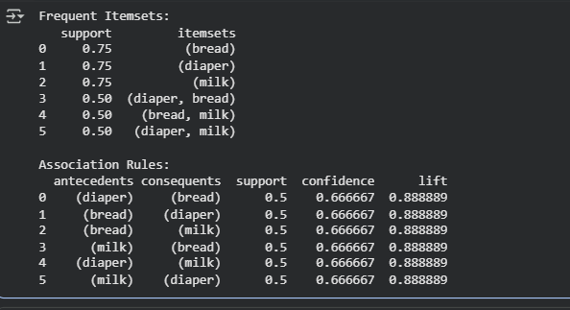
Verified Exp-12 example using Apriori Python Program

Verified Exp-9 example using java program
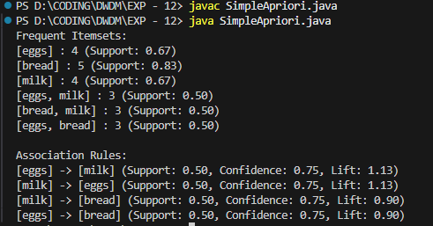

EXP – 13,14
- We can write the same program in DWDMExp14.ipynb , if python
EXP – 13 , If Java
SimpleKMeans.java
import java.util.*;

public class SimpleKMeans {
public static void main(String[] args) {
// Step 1: Define your data points (2D)
double[][] data = {
{1.0, 1.0},
{1.5, 2.0},
{3.0, 4.0},
{5.0, 7.0},
{3.5, 5.0},
{4.5, 5.0},
{3.5, 4.5}
};

int k = 2; // Number of clusters
int maxIterations = 100;
int n = data.length;

// Step 2: Randomly initialize centroids
double[][] centroids = new double[k][2];
Random rand = new Random();
for (int i = 0; i < k; i++) {
centroids[i] = data[rand.nextInt(n)]; // Assigning reference to the entire row (not copying values)
}

// labels[i] stores the index of the cluster assigned to data point i
int[] labels = new int[n];

// Step 3: K-Means loop
for (int iter = 0; iter < maxIterations; iter++) {
// Assign each point to the nearest centroid
for (int i = 0; i < n; i++) {
double minDist = Double.MAX_VALUE;
int cluster = 0;
for (int j = 0; j < k; j++) {
double dist = distance(data[i], centroids[j]); // Passing references to 1D arrays (rows) for distance calculation
if (dist < minDist) {
minDist = dist;
cluster = j;
}
}
labels[i] = cluster;
}

// Update centroids
double[][] newCentroids = new double[k][2];
int[] counts = new int[k]; //Count of points assigned to each cluster

//This loop is mainly used to compute the sum of each feature(e.g., x and y) in a particular cluster.
//If we take iris, x-> sepal Length , y->Sepal Width
for (int i = 0; i < n; i++) {
int cluster = labels[i];
newCentroids[cluster][0] += data[i][0];
newCentroids[cluster][1] += data[i][1];
counts[cluster]++;
}

//Compute the mean (new centroid) for each cluster
for (int j = 0; j < k; j++) {
if (counts[j] > 0) {
newCentroids[j][0] /= counts[j];
newCentroids[j][1] /= counts[j];
}
}

centroids = newCentroids;

//The above two loops helps to reposition the centriods of the cluster , so that the centroids lie exactly center of all assigned points.
}

// Step 4: Print results
System.out.println("Cluster assignments:");
for (int i = 0; i < n; i++) {
System.out.printf("Point (%.1f, %.1f) -> Cluster %d%n", data[i][0], data[i][1], labels[i]);
}

System.out.println("\nFinal centroids:");
for (int j = 0; j < k; j++) {
System.out.printf("Centroid %d: (%.2f, %.2f)%n", j, centroids[j][0], centroids[j][1]);
}
}

// Helper method to compute Euclidean distance
public static double distance(double[] a, double[] b) {
double dx = a[0] - b[0];
double dy = a[1] - b[1];
return Math.sqrt(dx * dx + dy * dy);
}
}

/*
Why K-Means runs for multiple iterations (e.g., 100):

- K-Means is an iterative algorithm that refines cluster assignments and centroids.
- Each iteration:
1. Assigns points to the nearest centroid.
2. Updates centroids based on the mean of assigned points.
- Initial centroids are random, so convergence takes time.
- Multiple iterations help centroids stabilize and reduce assignment changes.
- 100 iterations is a safe upper bound to ensure convergence, especially for complex datasets.
- In practice, convergence often happens earlier, and early stopping can be used to exit sooner.
*/
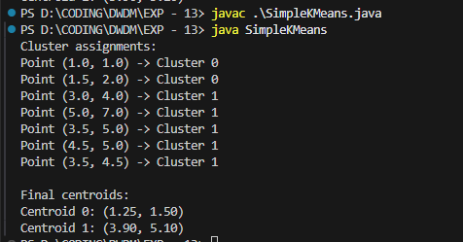

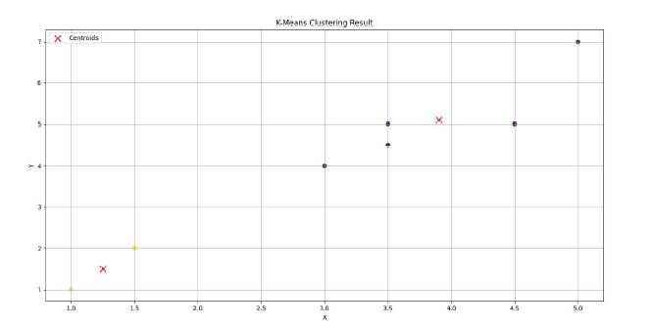
The below image is from mam record pdf(python program – exp13), same data is used both the results are same.

EXP – 9,12 Practice example
Frequent Itemsets:
support itemsets
0 0.50 (bread)
1 1.00 (diaper)
2 0.75 (milk)
3 0.50 (diaper, bread)
4 0.75 (milk, diaper)

Association Rules:
antecedents consequents support confidence lift
0 (bread) (diaper) 0.50 1.00 1.0
1 (milk) (diaper) 0.75 1.00 1.0
2 (diaper) (milk) 0.75 0.75 1.0

