Project: Smart City

Course: Seminar

Prof. Assem Badr Al-deen

ID | Name | Section
4240102 | John Emil Ramzy | TH-4
4240624 | Abdullah Mohamed Ahmed | TH-6
4240622 | Hazem Mohamed Abd Elhaseb | TH-4
4240223 | Belal Ahmed Mahmoud | TH-4
4240233 | Mohamed Abd ElNasser Galal | TH-6
4240063 | John George | TH-6
4240399 | Mohamed Essam Zaki | TH-4
4240260 | Mina Adel Shaker | TH-5
4250315 | Adham Ahmed Sanad | TH-4

Level: Level 2 Computer
Term: Second Term: 2025–2026

Smart City: Integrated IoT Ecosystem for Smart Home, Garage, and Healthcare

Abstract

This project proposes a comprehensive Smart City framework that integrates three core urban modules: the Smart Home, the Smart Garage, and the Smart Hospital. The garage features an automated gate control system, utilizing Radio-Frequency Identification (RFID) for secure garage access and infrared (IR) proximity sensors for general entry. The system leverages Internet of Things (IoT) technology to monitor environmental conditions (temperature and humidity). The proposed architecture employs low-power microcontrollers (e.g., ESP32) and a centralized web-based monitoring platform to enhance urban living, security, and healthcare eﬃciency. This document details the system’s design, hardware and software implementation, and potential societal impact.

Chapter 1: Introduction

Background
The rapid urbanization of the 21st century has necessitated more eﬃcient and
sustainable ways to manage resources and provide services within urban environments. The concept of a Smart City has emerged as a paradigm to address these challenges, utilizing advanced technologies such as the Internet of Things (IoT),
sensor networks, and data analytics to improve the quality of life for its citizens. These technologies enable real-time data collection, intelligent decision-making, and automated control across various urban sectors, including infrastructure, transportation, and public services.

Objectives
The primary objective of this project is to design and document an integrated smart city model, focusing on three critical interconnected modules:
    - Smart Home: To provide an automated living environment with intelligent climate monitoring and secure, touchless access control.
    - Smart Garage: To implement an RFID-based secure entry system for authorized vehicles, enhancing parking management and security.
    - Smart Hospital: To develop a real-time patient vital sign monitoring system (specifically heart rate and temperature) and an automated emergency access
gate, thereby improving healthcare response times and operational eﬃciency.
    - Automated Gates: To integrate universal auto-gate mechanisms across garage modules, controlled by appropriate sensors (RFID, IR).

Scope
The scope of this academic documentation encompasses the conceptual design, detailed system architecture, hardware component selection, and software logic for sensor data acquisition and actuator control. It also includes a discussion on the methodology for system integration and potential future enhancements. This document does not cover the physical construction or deployment of the system, but rather provides a comprehensive blueprint for its development.

Chapter 2: Literature Review

Smart Home Technologies
Modern smart homes extensively utilize IoT devices for automation and monitoring. Environmental sensors such as the DHT series (DHT11/DHT22) are commonly employed for accurate temperature and humidity measurements, enabling intelligent climate control systems, facilitating automated lighting, security alerts, and energy conservation. The integration of microcontrollers like ESP32 allows for seamless data processing and connectivity to cloud platforms, enabling remote monitoring and control of home appliances and security systems.

RFID in Urban Mobility and Access Control
Radio Frequency Identification (RFID) technology offers a robust and eﬃcient method for automated identification and tracking, making it highly suitable for urban mobility and access control applications. In smart garages, RFID systems can replace traditional manual ticketing or key-based entry, providing secure and seamless access for authorized vehicles. The use of RFID tags aﬃxed to vehicles, coupled with RFID
readers at entry/exit points, allows for rapid identification and automated gate operation, significantly improving traﬃc flow and security in parking facilities.

IoT in Healthcare (Smart Hospitals)
The application of IoT in healthcare has led to the emergence of Smart Hospitals, which leverage connected devices to enhance patient care, operational eﬃciency, and resource management. Wearable or bedside sensors, such as pulse oximeters and heartbeat sensors (e.g., MAX30102), enable continuous and real-time monitoring of patient vital signs. This data can be transmitted wirelessly to a central nursing
station, allowing healthcare professionals to monitor patients remotely and respond promptly to critical changes in their condition.

Chapter 3: System Design and Architecture

Overall System Architecture
The proposed Smart City system follows a layered architecture, integrating various sensors and actuators into a cohesive network, all communicating with a central IoT Cloud Platform. This architecture ensures scalability, modularity, and eﬃcient data management.
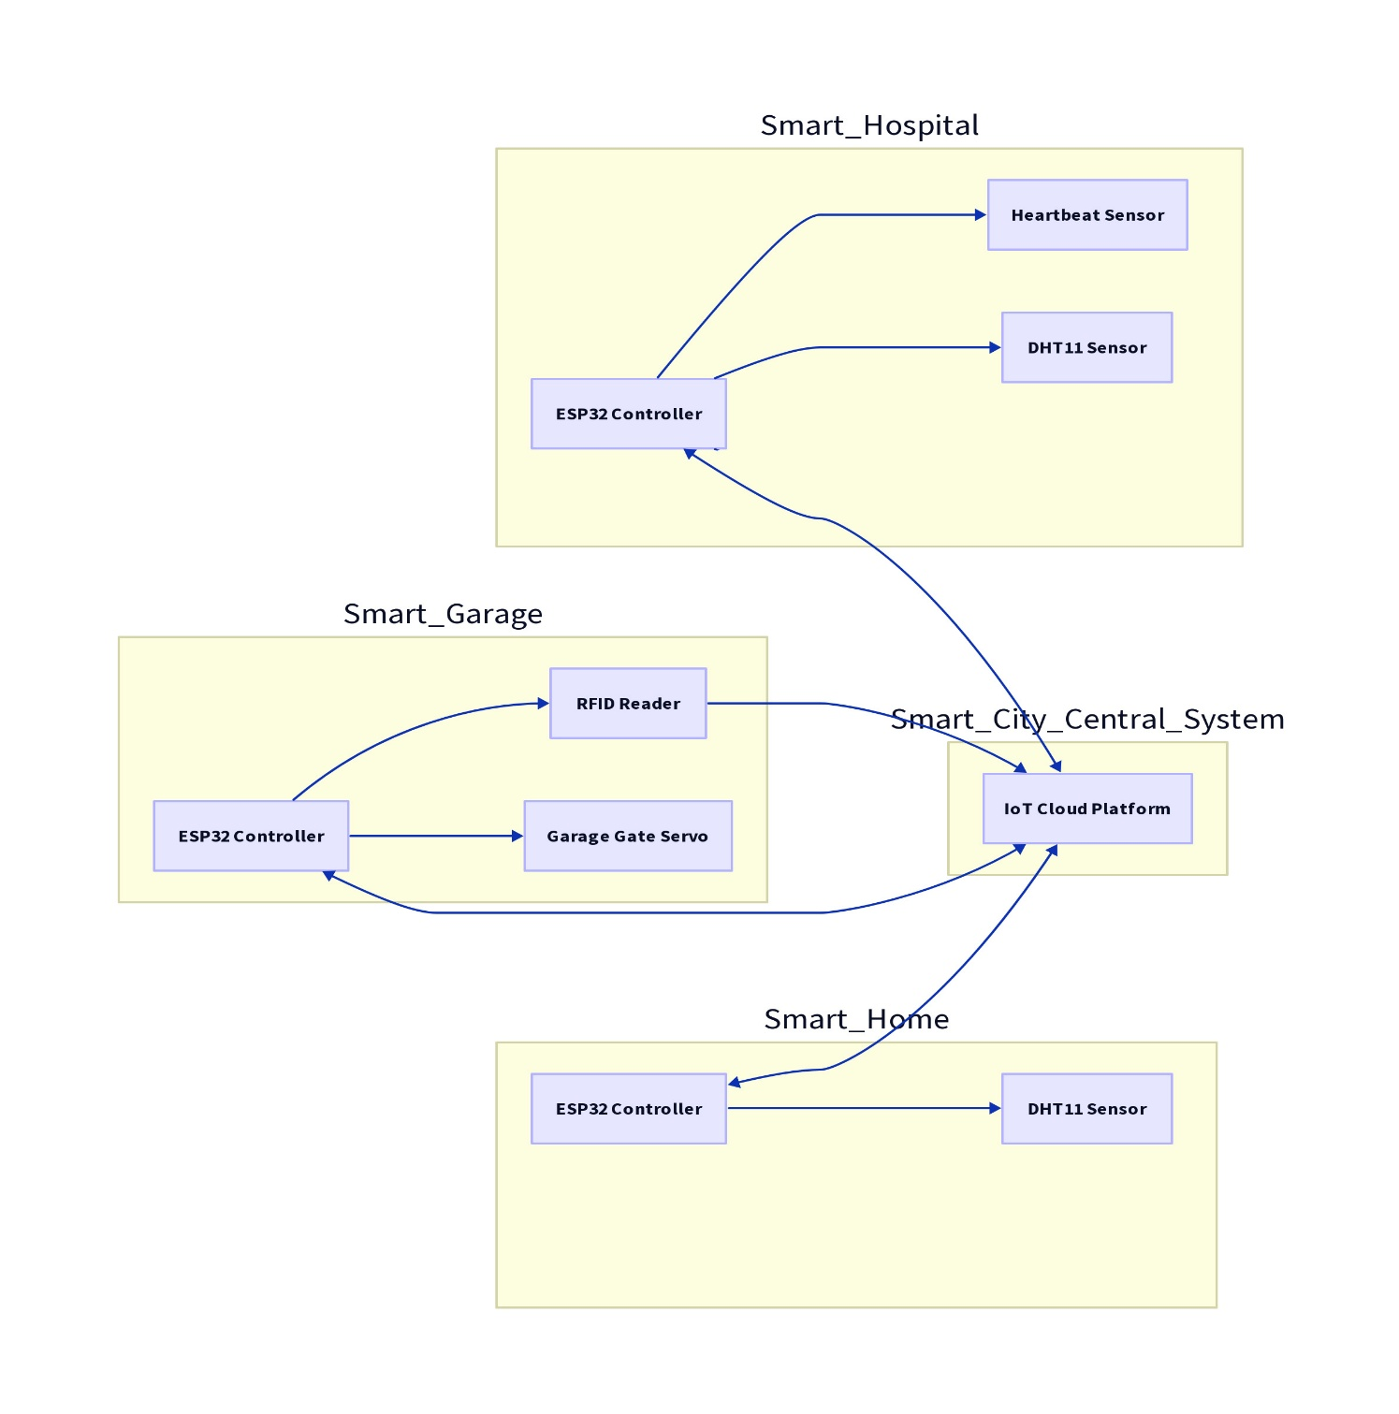

    - Perception Layer: This layer comprises various sensors (DHT11, Heartbeat, RFID, IR) responsible for collecting data from the physical environment and actuators
(servo motors) that perform physical actions based on system commands.
    - Network Layer: This layer handles data transmission from the perception layer to the application layer. It utilizes wireless communication protocols such as Wi-
Fi for local data transfer and potentially LoRaWAN for wider area coverage, ensuring reliable and eﬃcient data flow.
    - Application Layer: This layer consists of a web-based dashboard for real-time monitoring, data analytics, and remote control of the Smart City modules. It provides a user-friendly interface for administrators and relevant personnel to manage the system.

Smart Home Module
The Smart Home module focuses on creating an intelligent and responsive living environment. It integrates environmental monitoring with automated access control.
- Sensors: DHT11 (Temperature & Humidity) for indoor climate monitoring.
- Actuators: A servo motor controls the auto gate for touchless entry.
- Functionality: Continuously monitors indoor temperature and humidity, and provides secure, automated entry for residents.

Smart Garage Module
The Smart Garage module is designed to provide secure and eﬃcient vehicle access control.
- Sensors: MFRC522 RFID Reader for vehicle identification and an IR Proximity Sensor to detect vehicle presence.
- Actuators: A high-torque servo motor operates the garage gate.
- Functionality: Grants access only to vehicles equipped with registered RFID tags. The IR sensor acts as a safety mechanism and can also trigger gate opening for authorized vehicles upon approach.

Smart Hospital Module
The Smart Hospital module prioritizes patient well-being and emergency response eﬃciency.

- Sensors: Pulse Oximeter/Heartbeat Sensor (e.g., MAX30102) for continuous patient vital sign monitoring, and a DHT11 sensor for ambient temperature and humidity in patient rooms.
- Functionality: Monitors patient vitals in real-time, alerts medical staff to anomalies, and facilitates rapid, automated access during emergencies.

Chapter 4: Hardware and Software Implementation

Hardware Components
The core hardware components selected for this project are chosen for their reliability, cost-effectiveness, and ease of integration within an IoT ecosystem. The ESP32 microcontroller serves as the central processing unit for each module due to its integrated Wi-Fi and Bluetooth capabilities, making it ideal for IoT applications.

Component | Description | Purpose
ESP32/Arduino | Central Microcontroller | Processing sensor data, controlling actuators, and providing network connectivity
DHT11/22 | Temp & Humidity Sensor | Environmental monitoring in Smart Home and Smart Hospital modules
MAX3O1O2 | Heartbeat & SpO2 Sensor | Real-time patient health monitoring in the Smart Hospital module
RC522 | RFID Reader | Secure access control and vehicle identification in the Smart Garage module
Servo Motor | Gate Actuator | Physical movement of automated gates across all modules
IR Sensor | Proximity Sensor | Object detection for gate automation and safety mechanisms

Circuit Design and Pin Configuration
The sensors and actuators are interfaced with the ESP32 microcontroller using standard communication protocols. The conceptual circuit diagram illustrates the interconnections.
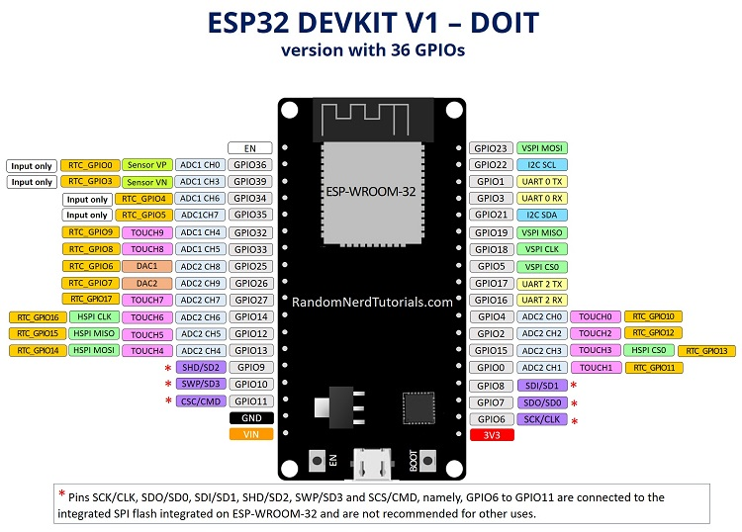
Hospital Circuit

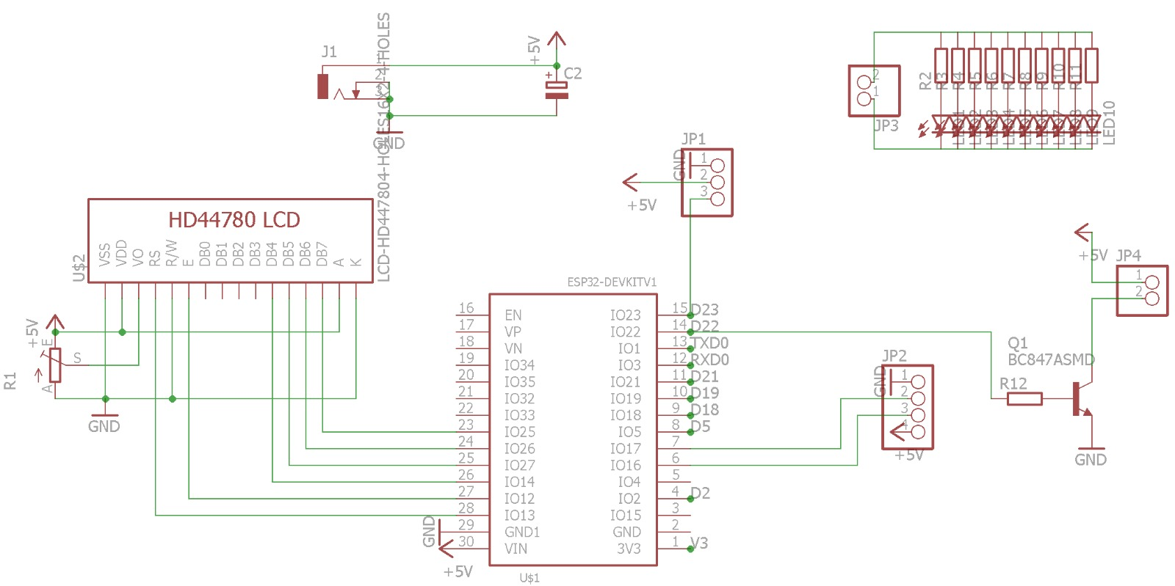
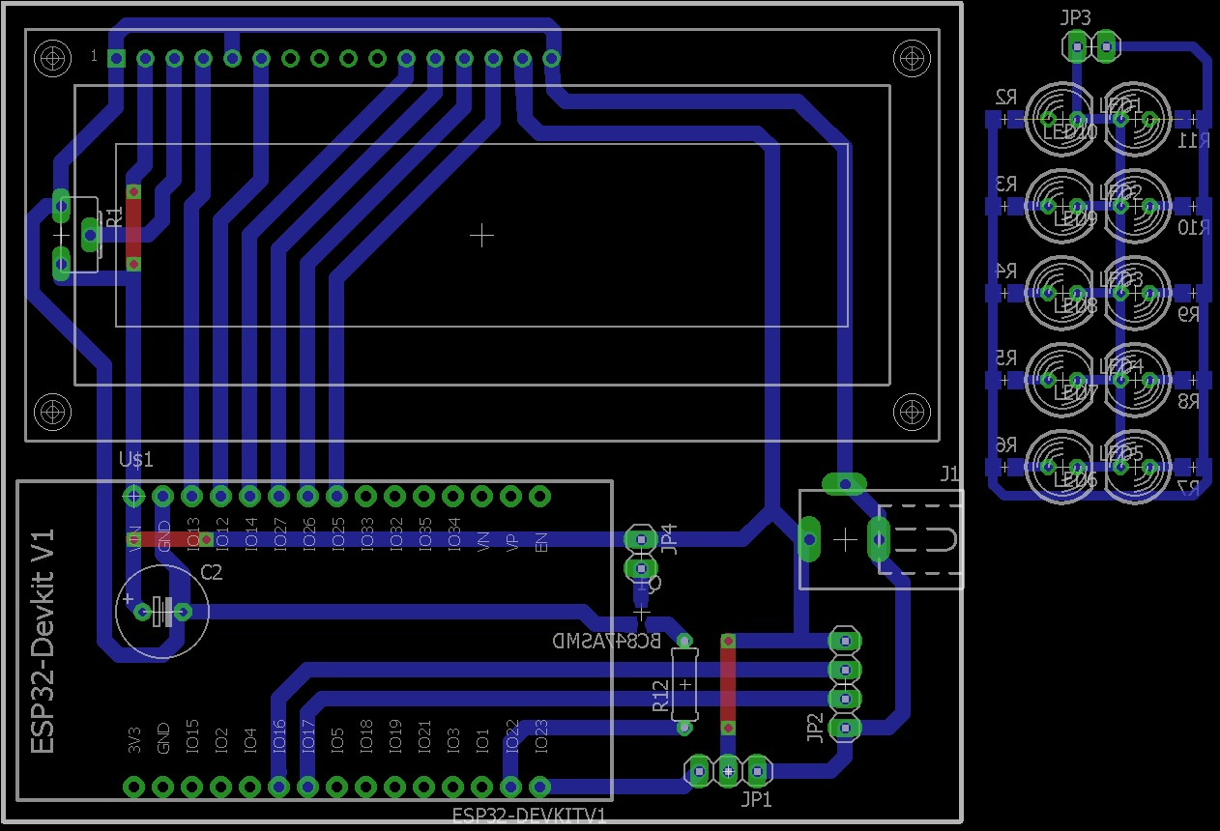

ESP 32 (Hospital Code):
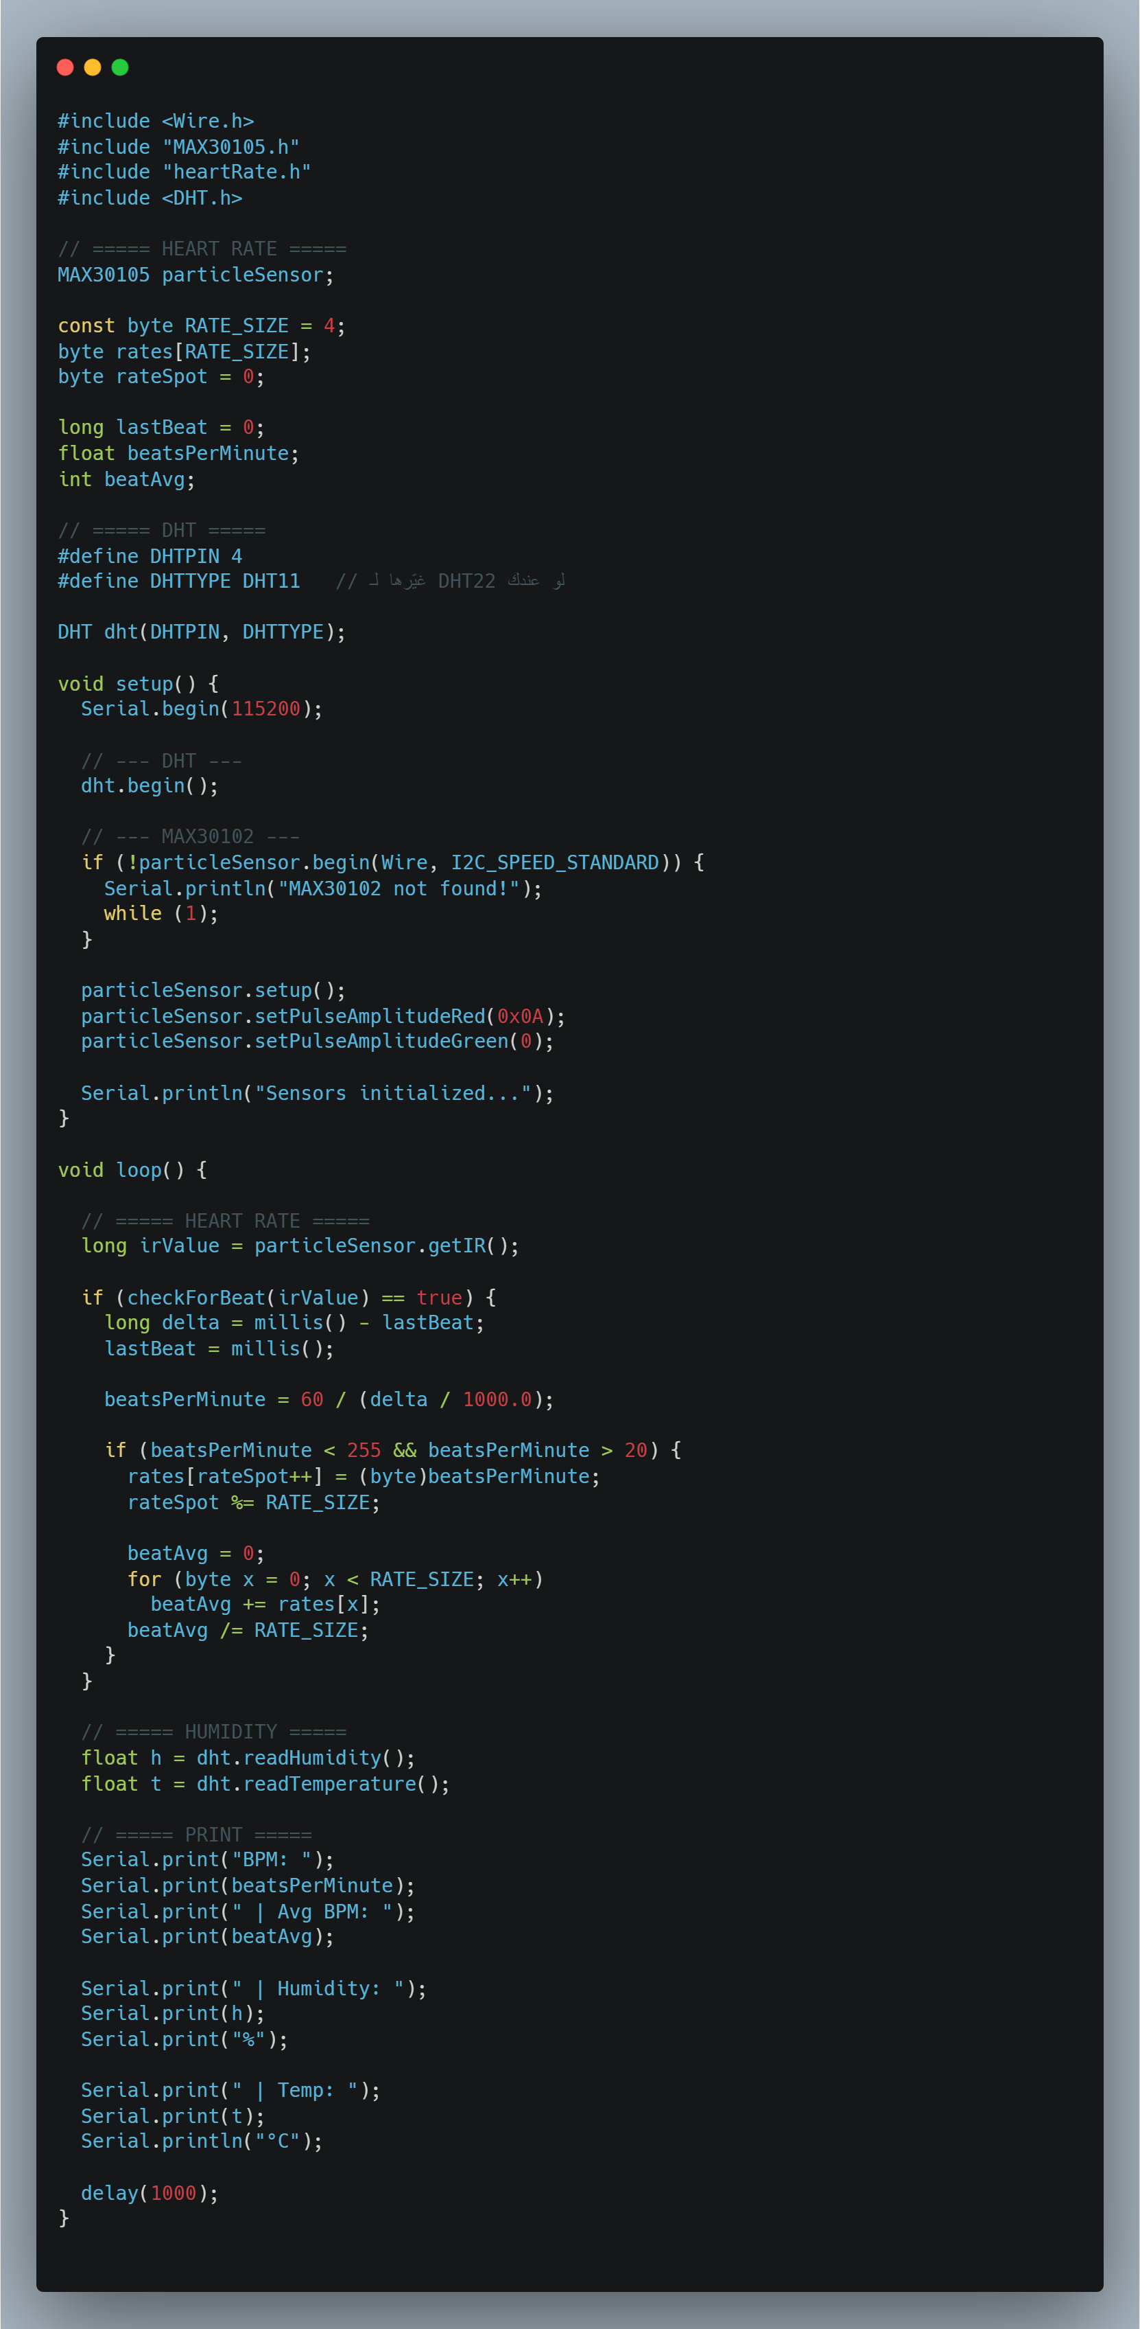

Home Circuit:
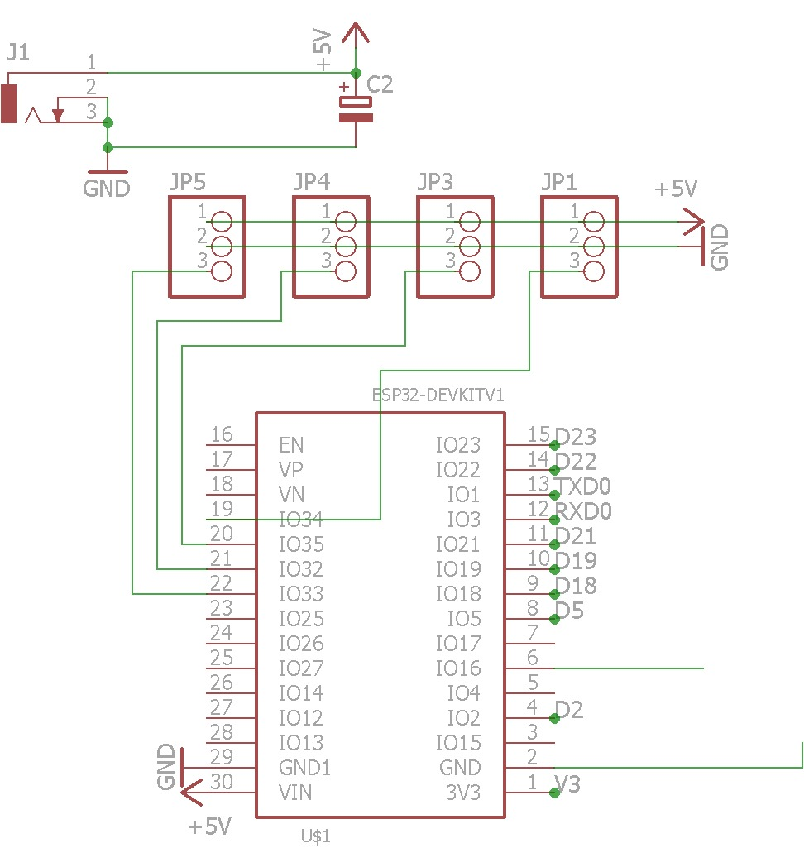

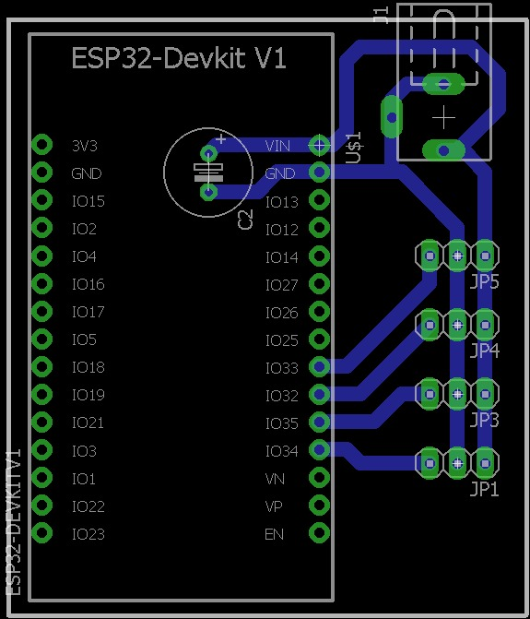

Garage Circuit
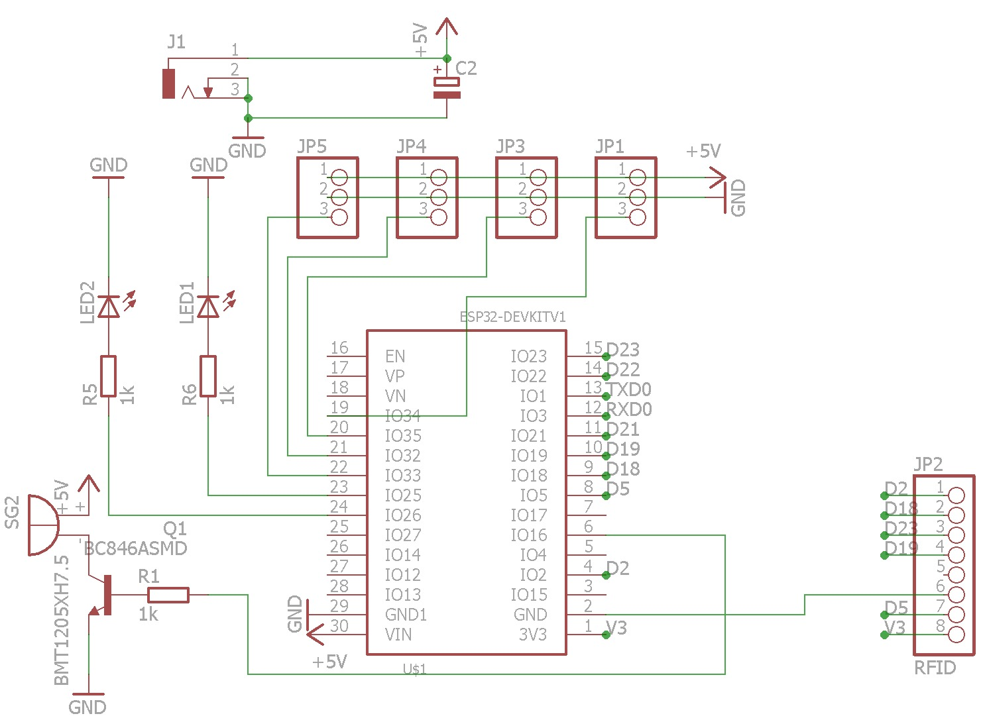

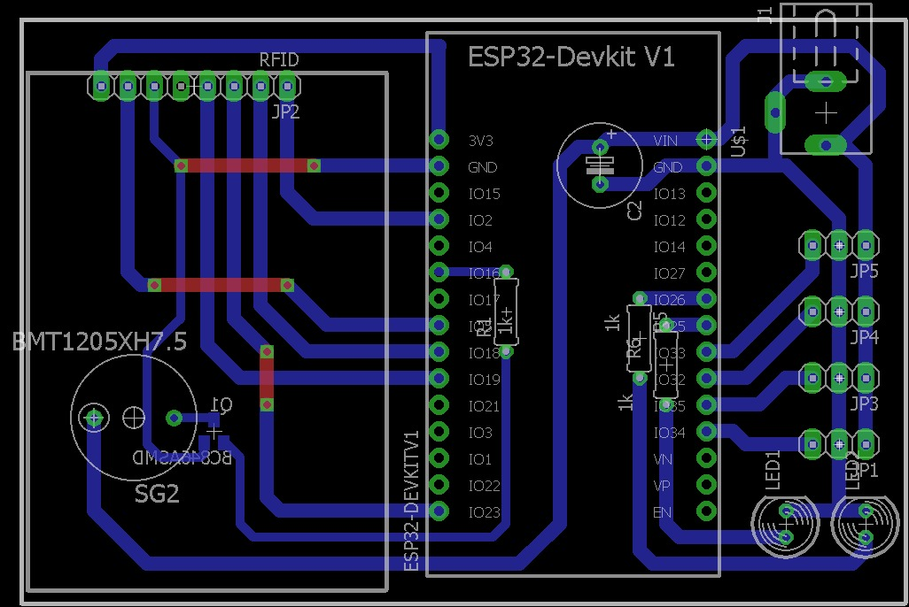

📘 4.3 Software Logic (Updated with System Architecture)
The software logic of the Smart City system is designed using a modular and event-driven architecture, ensuring scalability, flexibility, and efficient real-time interaction between system components.
The system is divided into two main layers:

🧩 1. Backend Layer (Spring Boot)
The backend is implemented using Java Spring Boot, responsible for handling all core system logic and data processing.
🔹 Core Responsibilities:
- Receiving sensor data from ESP32 devices
- Processing and storing sensor readings
- Managing actuator control logic (e.g., LED, gate control)
- Providing RESTful APIs for the frontend
- Handling RFID access validation (garage module)
- Maintaining historical data (logs, readings, states)
🔹 Architecture:
- Controller Layer → handles API requests
- Service Layer → contains business logic
- Repository Layer → database interaction
- DTO + Mapper → clean data transfer

🎨 2. Frontend Layer (Angular)
The frontend is developed using Angular framework, providing a dynamic and interactive dashboard interface for monitoring and control.
🔹 Structure:
The frontend is modular and divided into feature-based dashboards:
- General Dashboard
  - System overview
  - Summary of sensors, devices, and alerts
- Home Dashboard
  - Humidity, Rain, CO2 readings
  - LED control panel
- Hospital Dashboard
  - Heartbeat monitoring
  - Patient status visualization
- Garage Dashboard
  - RFID access logs
  - Gate control system

🔹 Frontend Architecture:
The Angular application follows a clean architecture:
- Core Layer
  - API service (centralized HTTP calls)
  - Models (data structures)
- Feature Modules
  - Each dashboard is isolated (Home, Hospital, Garage)
- State Management
  - Centralized state (NgRx or Signals)
  - Handles:
    - sensor data
    - actuator states
    - dashboard data

🔄 3. System Data Flow
The system follows an event-driven data flow:
ESP32 Sensors → Spring Boot API → Database
↓
Angular Frontend
↓
User Actions (Control)
↓
Spring Boot API → Actuators

⚙️ 4. Event-Driven Logic
Each module operates based on events:
(Garage Gate Control):
- RFID card is scanned
- ESP32 sends data to backend
- Backend validates card
- Decision is made:
  - Allowed → open gate
  - Denied → keep gate closed
- Result is logged and sent to frontend dashboard

📡 5. Communication Strategy
- Protocol: REST APIs (HTTP)
- Future Enhancement:
  - WebSocket for real-time updates

🎯 6. Key Design Advantages
- Modular design (each module)
- Scalable architecture
- Separation of concerns (Frontend ≠ Backend)
- Centralized API management
- Clean and maintainable codebase
Database Schema
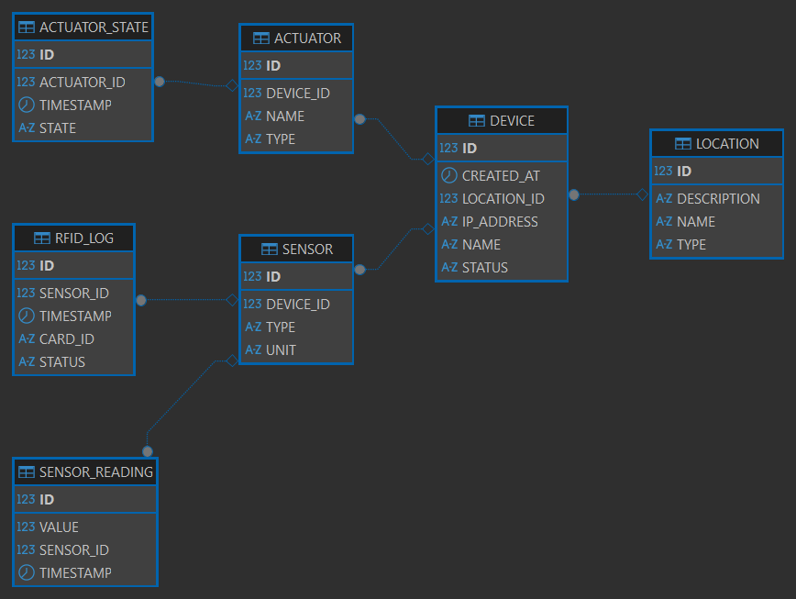

ESP 32 (Garage Code):
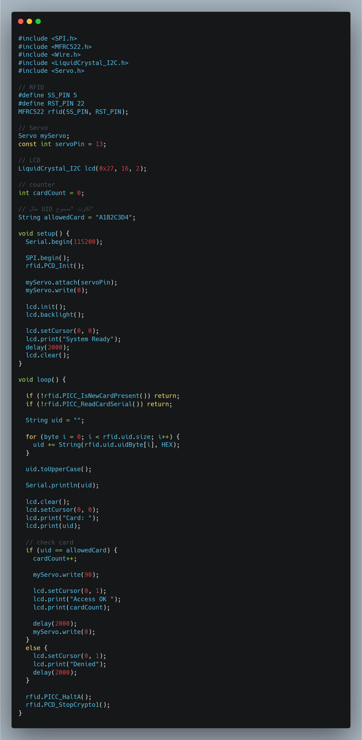

ESP 32 (Home Code):

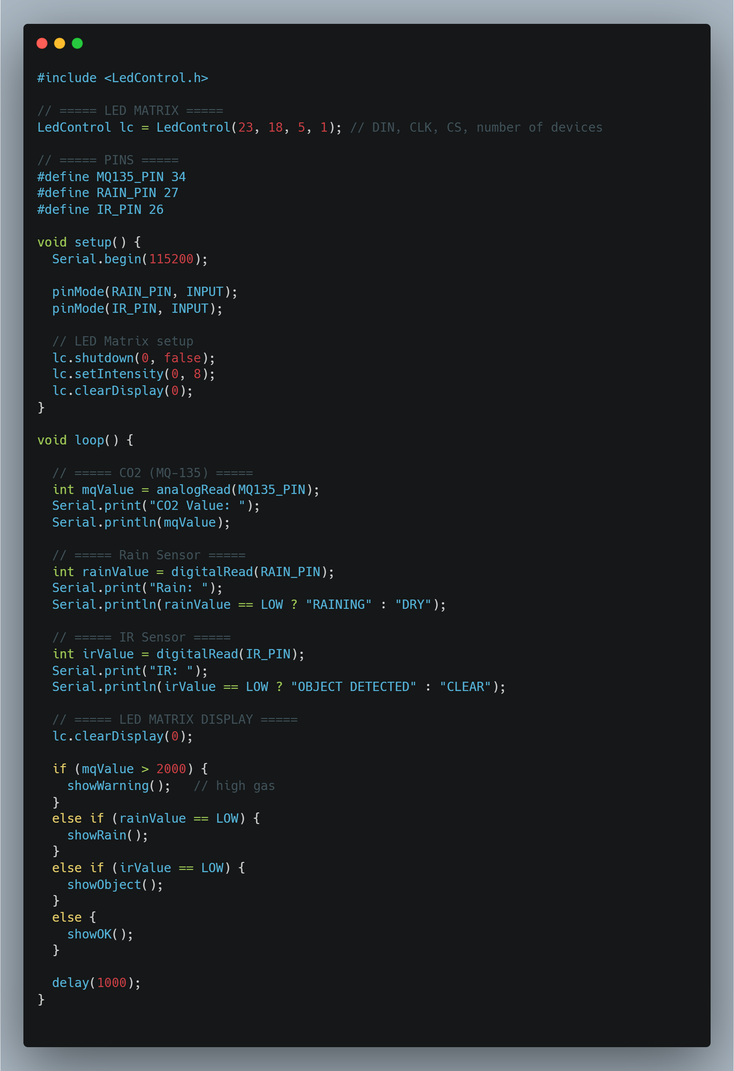

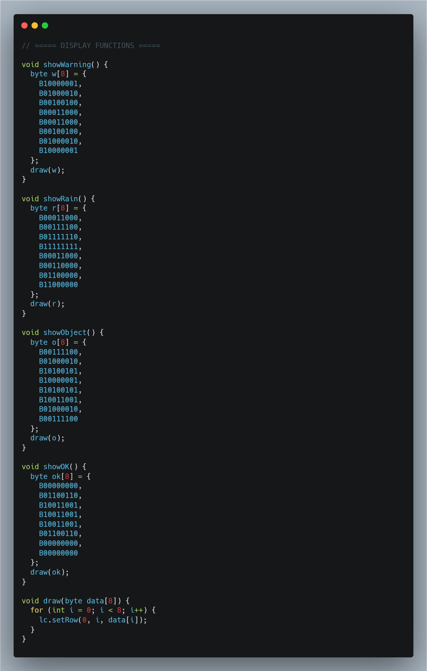

ESP 32 (Hospital Code):


    - Gate Logic: The gate control system operates based on conditional logic. If a valid RFID tag is detected (for the Smart Garage) or an IR sensor is triggered (for general proximity-based access), the gate is commanded to open. Otherwise, the gate remains closed, ensuring security and controlled access.
    - Monitoring Logic: Sensor data from DHT11 and Heartbeat sensors are periodically read and processed by the ESP32. This data is then uploaded to the centralized IoT cloud platform via Wi-Fi for storage, analysis, and visualization.

Chapter 5: Methodology

The project adopts a modular development approach, allowing for independent testing and validation of each subsystem (Smart Home, Smart Garage, and Smart Hospital) before their integration into the overarching Smart City ecosystem. This methodology ensures robustness and simplifies debugging. The development process involves:
- Requirements Analysis: Defining the functional and non-functional requirements for each module.
- System Design: Developing the architectural blueprint, including hardware selection and communication protocols.
- Module Development: Independent implementation and testing of each Smart Home, Smart Garage, and Smart Hospital module.
- Integration: Combining the modules and establishing communication with the central cloud platform.
- Testing and Validation: Comprehensive testing of the integrated system to ensure all functionalities meet the defined objectives.

Chapter 6: Conclusion and Future Work

The proposed Smart City integrated IoT ecosystem demonstrates a scalable, secure, and eﬃcient model for enhancing urban living, particularly in the domains of residential automation, urban mobility, and healthcare. By integrating Smart Home, RFID-enabled Smart Garage, and Smart Hospital modules, the system addresses

critical aspects of modern urban challenges through intelligent automation and real-time monitoring.
Future work could involve several enhancements:

- AI Integration: Implementing artificial intelligence algorithms for predictive maintenance of infrastructure, anomaly detection in patient vitals, and optimized
resource allocation within the city.
- Blockchain for Data Security: Exploring the use of blockchain technology to ensure the integrity and security of sensitive data, especially within the Smart
Hospital module, enhancing patient privacy and data trust.
- Energy Harvesting: Integrating sustainable energy harvesting solutions to power remote sensors, reducing reliance on traditional power sources and promoting environmental sustainability.
- Advanced Sensor Integration: Incorporating additional sensors such as air quality monitors, noise sensors, and smart waste management sensors to further expand the Smart City’s monitoring capabilities.

