NFARL Field Day GOTA 80–10 m Loop Antenna Analysis
NeoMoM and NEC5 — Real Ground

John Shaeffer | KZ4TS
July 2026

1. Overview
The NFARL Field Day Get On The Air (GOTA) 80-meter loop antenna is analyzed using two independent antenna modeling codes: NeoMoM and NEC5. Both codes use real ground parameters. Results presented include: (1) a frequency sweep from 2 to 32 MHz showing input impedance, input admittance, and SWR; (2) elevation and azimuth radiation patterns on the 80, 40, 20, 15, and 10 m amateur bands; and (3) a geographic map overlay of the 10 m pattern on world and CONUS maps. Agreement between the two codes serves as mutual validation.

1.1 Purpose and Scope
This report is primarily about validating NeoMoM against a nationally recognized antenna modeling standard — NEC5 — rather than performing a detailed engineering analysis of a specific antenna. The NFARL Field Day GOTA loop was chosen for this comparison not because it is a particularly complex or unusual antenna, but because it is a real, multiband HF antenna that club members know and have operated. It provides physically meaningful results in a context the audience can relate to.
The technical contribution of this work is the demonstration that NeoMoM — a newly developed, open-source antenna modeling suite — produces results in good agreement with NEC5 across a wide frequency range and for multiple output types: impedance, admittance, SWR, and far-field radiation patterns. This is the central finding. The specific antenna is the vehicle, not the destination.

1.2 NeoMoM — Ease of Use as a Design Objective
A key motivation for developing NeoMoM is to provide amateur radio operators with a modern, easy-to-use antenna modeling tool that does not require the steep learning curve of existing software. NEC5 and EZNEC are powerful and accurate, but their input formats — rooted in 1970s batch computing card decks — present a significant barrier to new users. EZNEC improves on the raw NEC experience but remains an older-generation tool with limitations in visualization and workflow integration.
NeoMoM takes a fundamentally different approach: graphical geometry input from the start, integrated visualization of patterns, impedance, and current distribution, and a modern workflow where input, solve, and visualize are part of a single seamless experience. The first version of NeoMoM is specifically designed for new users — hams who want to understand their antennas without the friction of learning legacy software. NeoMoM captures the same physics as NEC5 and, as this report demonstrates, produces results in close agreement with that gold standard.
For hams who need detailed engineering accuracy — precise ground modeling, exact as-built dimensions, feed system analysis — tools like EZNEC remain available and appropriate. But for the large majority of amateur antenna modeling tasks, NeoMoM provides an accessible, accurate, and modern alternative that lowers the barrier to entry substantially. The goal is to make antenna modeling something any ham can do, not just those willing to invest days learning legacy tools.

2. Antenna Geometry
The GOTA loop is a 70-foot square with the feed point located 55 feet from one corner. Antenna height above ground is 45 feet. The geometry is shown in Figs. 1 and 2 with node coordinates in the NeoMoM input format.
Feed is via ladder line with a characteristic impedance of 400–450 Ω, connected to a 4:1 balun, which in turn connects to the 50 Ω transceiver coaxial cable. The ladder line and balun are not included in the electromagnetic model; only the loop element itself is modeled with a 1-volt source at the feed point. The feed impedance Zin presented in this report is therefore the impedance at the loop feed point, not at the transceiver.
Real ground parameters are used in both NeoMoM and NEC5: relative permittivity εr = 13, conductivity σ = 0.005 S/m (average soil).
The antenna dimensions and ground parameters used in this model are nominal values based on available information from the Field Day setup. No precise field measurements of the as-built antenna were taken. The primary objective of this analysis is to demonstrate NeoMoM's capabilities and validate its results against NEC5 — not to characterize the antenna to engineering accuracy. For that purpose, nominal dimensions and standard average soil parameters are entirely appropriate, since both codes model identical geometry and any parametric uncertainties affect both results equally.

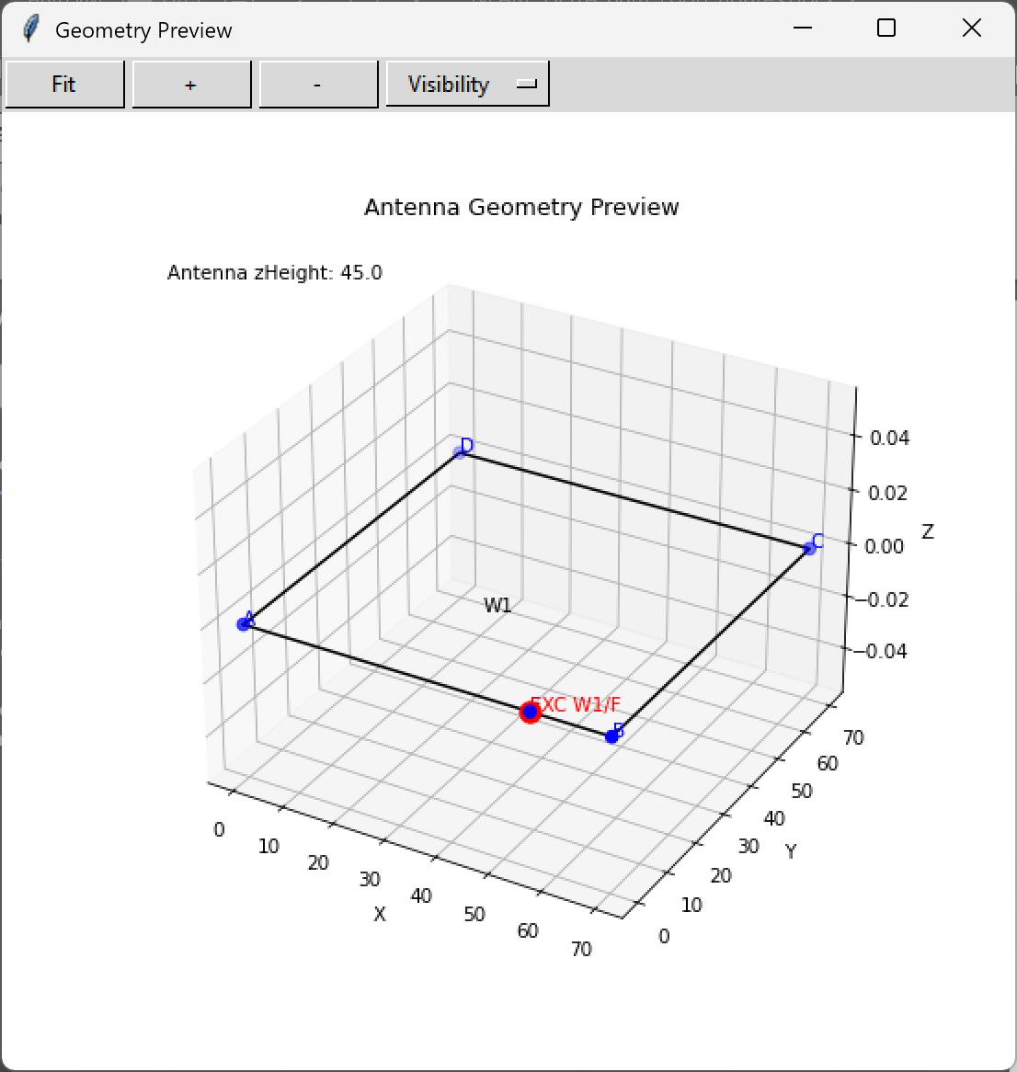
Figure 1. NeoMoM input geometry — GOTA loop wire layout and node positions.
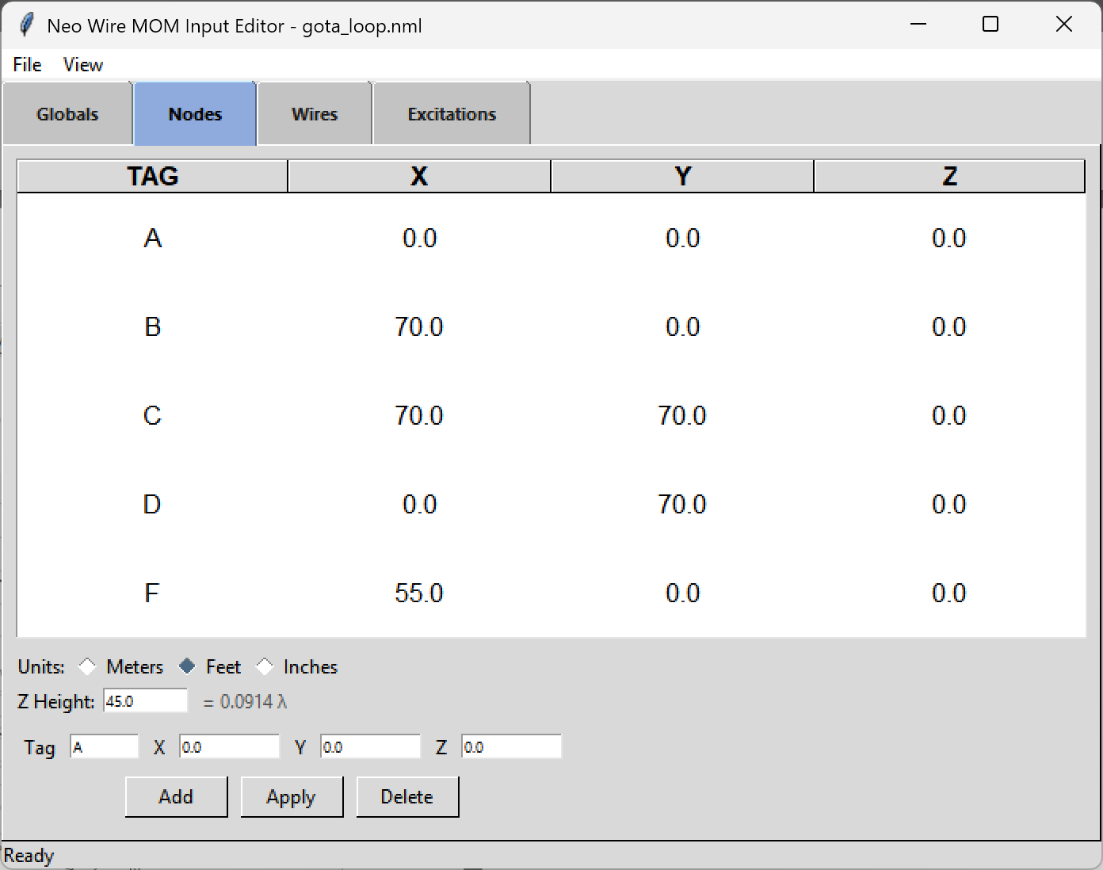
Figure 2. Node coordinates for the GOTA loop in NeoMoM input format.

3. Analysis Codes
NeoMoM is a wire Method of Moments (MoM) solver developed by the author. The engine is written in modern Fortran and uses Rao–Wilton–Glisson (RWG) rooftop basis functions on wire segments. The mesh is adaptive: the number of segments per wire is recomputed at every frequency step to maintain 40 segments per wavelength. Real ground is modeled via Fresnel reflection coefficients. All graphical output — impedance sweeps, radiation patterns, map overlays, and current distribution — is produced by companion Python GUI applications.
NEC5 (Numerical Electromagnetics Code, version 5) is the current release of the Lawrence Livermore wire MoM code. It also uses RWG basis functions and models real ground via the Sommerfeld–Norton method, generally considered the most accurate approach for antennas near lossy ground. For this analysis NEC5 is run via EZNEC Pro/2+ v7.0 with a fixed mesh of 368 total segments, sized for adequate resolution at 32 MHz.
Both codes share the same mathematical basis functions, making direct comparison meaningful. The principal difference in ground treatment — Fresnel reflection (NeoMoM) versus Sommerfeld–Norton (NEC5) — is expected to produce small differences at low frequencies where the antenna height is a small fraction of a wavelength.

4. Frequency Sweep Results
A frequency sweep from 2 to 32 MHz was performed with both codes. NeoMoM used a step size of 0.02 MHz (1501 frequency points); NEC5 used 301 points at 0.1 MHz spacing. Results are overlaid in Figs. 3–5.

4.1 Input Impedance — R and X
The real (R) and imaginary (X) parts of the feed impedance Zin are shown in Fig. 3. NeoMoM and NEC5 show excellent agreement across the full sweep. Both codes identify the same resonance structure.

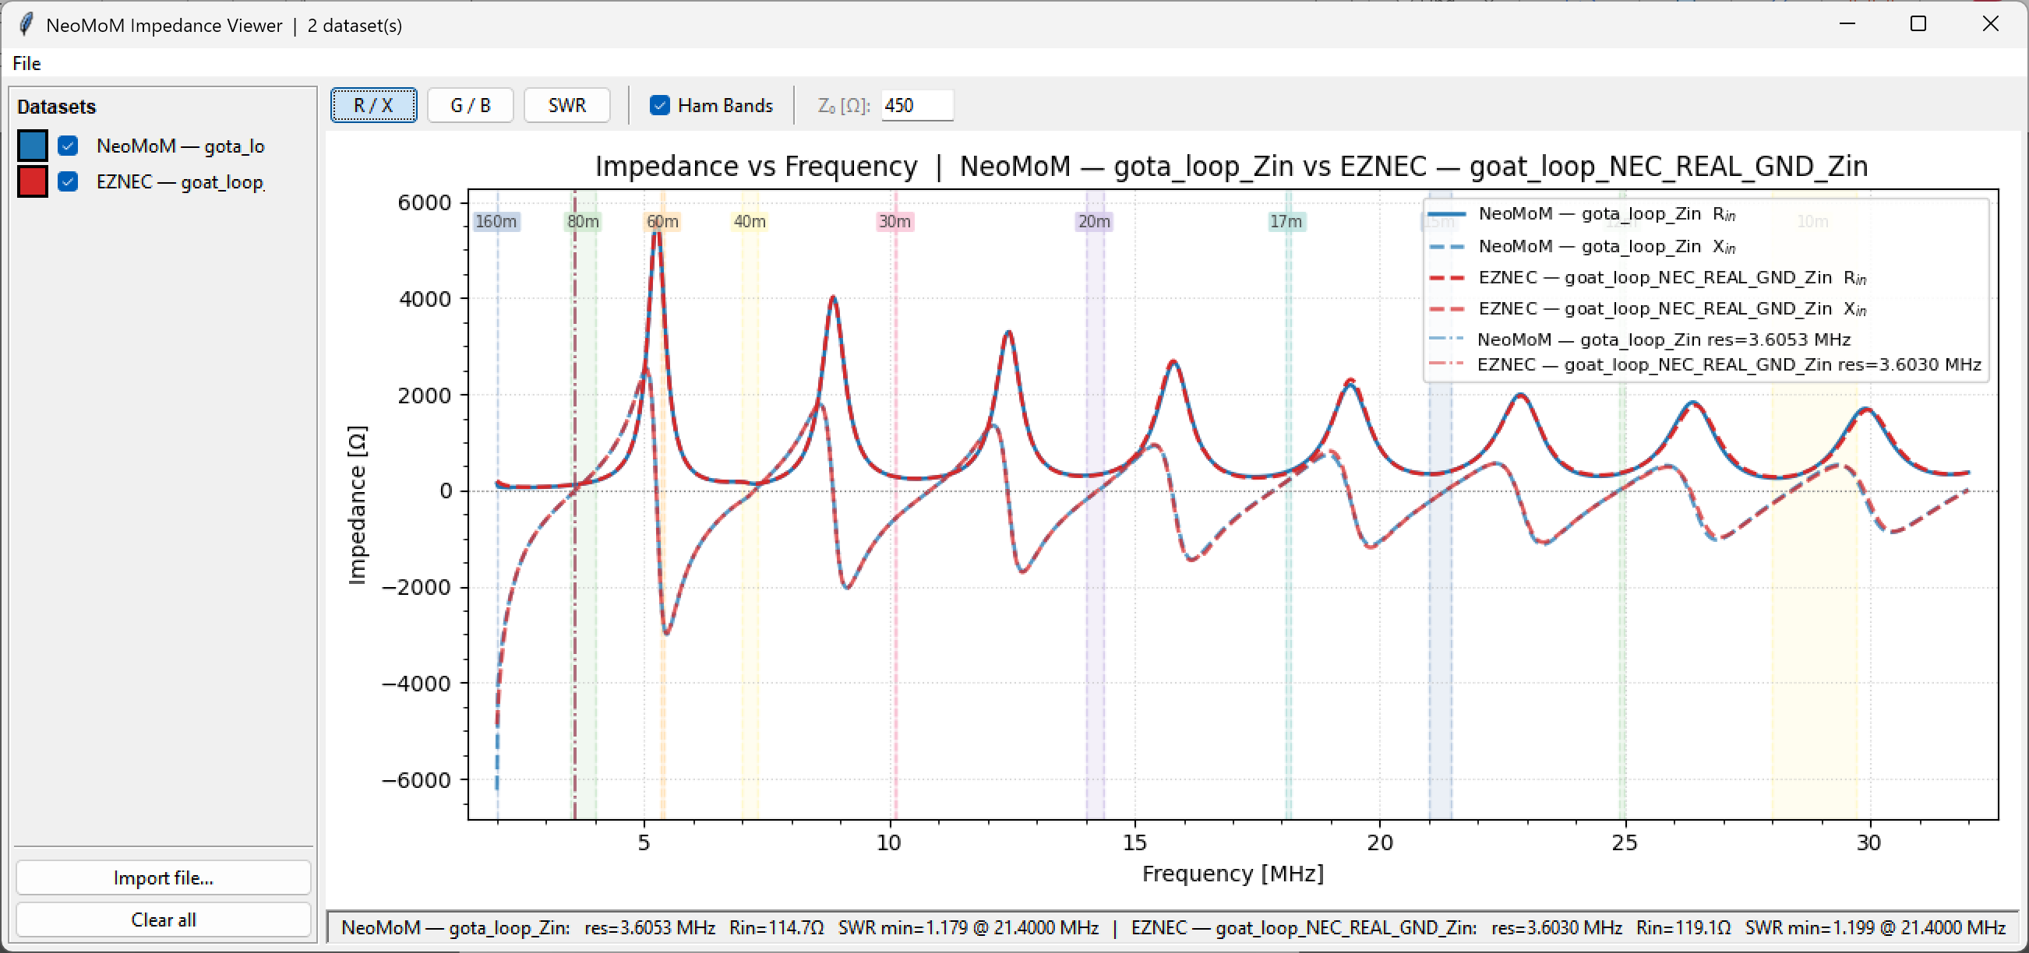Figure 3. Input impedance Rin and Xin vs frequency, 2–32 MHz. NeoMoM (blue) and NEC5 (red dashed).

4.2 Input Admittance — G and B
The input admittance Y = G + jB = 1/Zin is shown in Fig. 4. G is the conductance [mS] and B is the susceptance [mS]. The imaginary part B passes through zero at each resonance — a reliable indicator that is sharper and more precise than the SWR minimum.
Notably, the zero crossings of B fall within or very near all major HF amateur bands: 80, 40, 30, 20, 17, 15, 12, and 10 m. This confirms that the GOTA loop is a genuinely multiband antenna, resonant on each of these bands with appropriate matching via the ladder line and balun.

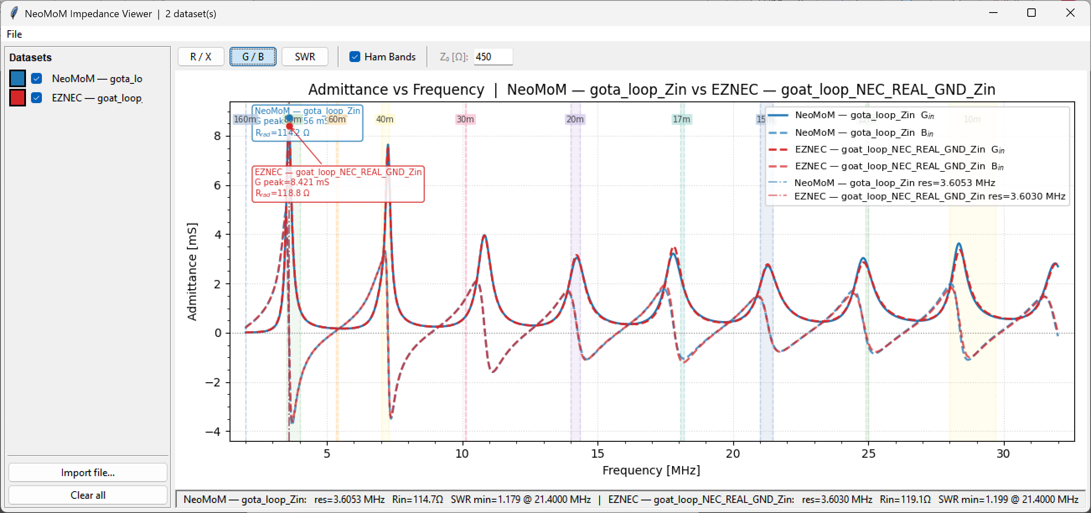
Figure 4. Input admittance Gin and Bin vs frequency, 2–32 MHz. Zero crossings of B mark resonances. NeoMoM (blue) and NEC5 (red dashed).

4.3 SWR vs Frequency
SWR referenced to 450 Ω (ladder line impedance) is shown in Fig. 5. SWR minima occur within each of the major HF amateur bands. Both codes agree closely on the SWR profile.

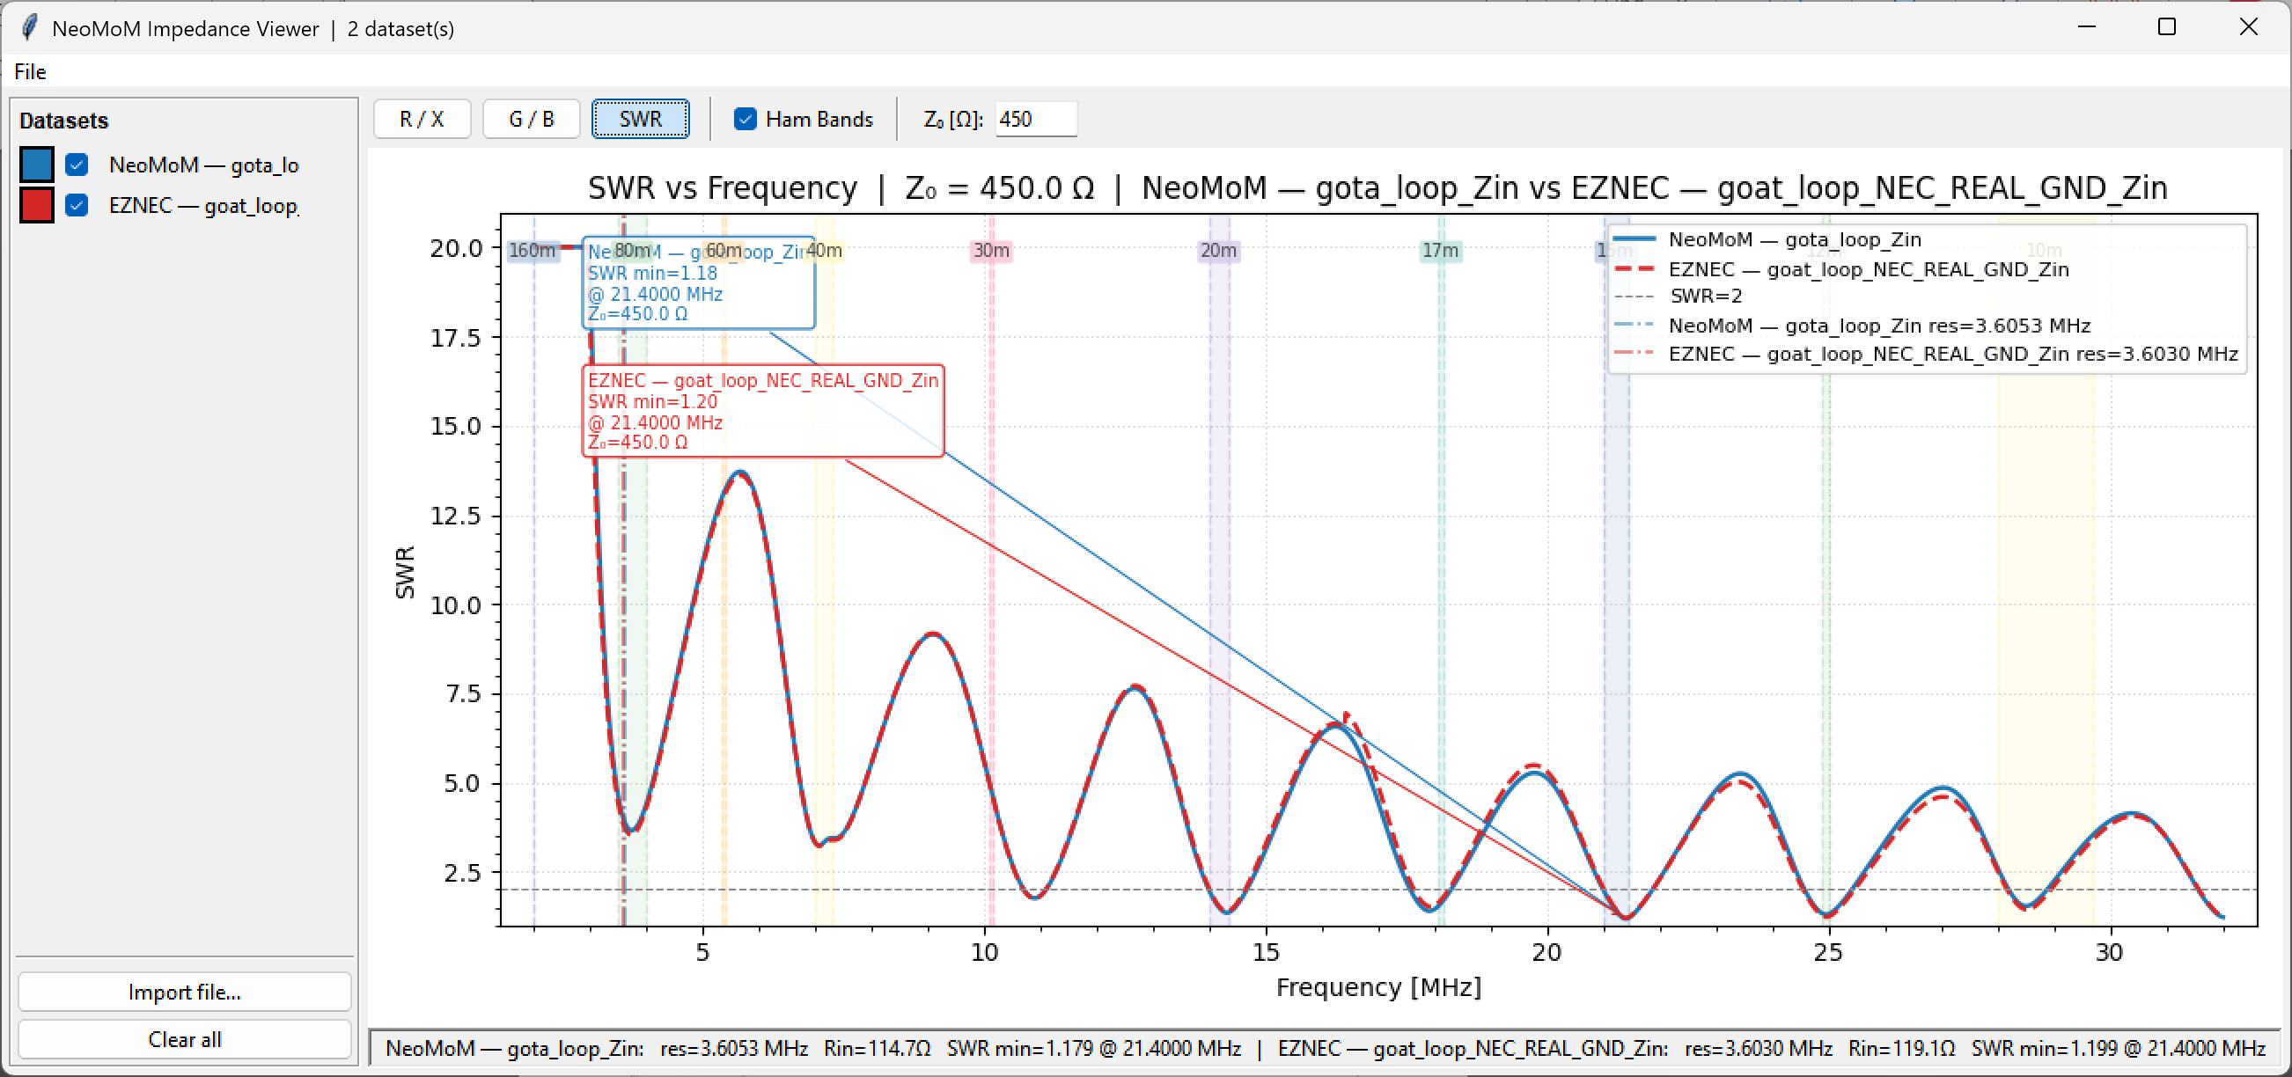
Figure 5. SWR vs frequency referenced to Z₀ = 450 Ω, 2–32 MHz. NeoMoM (blue) and NEC5 (red dashed).

5. Radiation Patterns
Azimuth and elevation radiation patterns are presented for the five principal amateur bands. For each band the total field (Etotal), vertical (Ev), and horizontal (Eh) components are shown. NeoMoM and NEC5 results are overlaid.
As frequency increases the antenna becomes electrically higher above ground, producing progressively lower takeoff angles. This trend is clearly visible in the elevation patterns.

5.1 80 Meters (3.75 MHz)
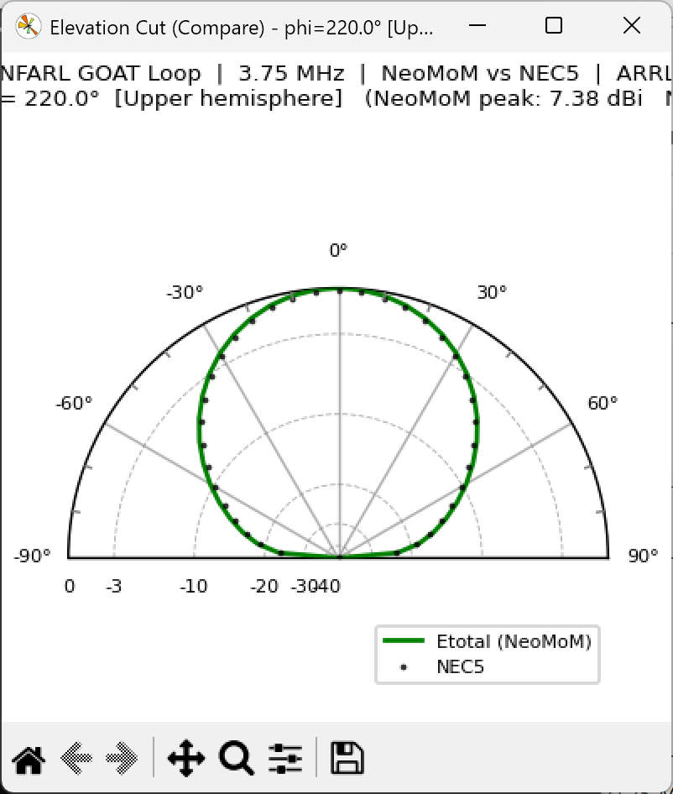
Figure 6. 80 m (3.75 MHz) — elevation pattern. NeoMoM (solid) and NEC5 (dashed).
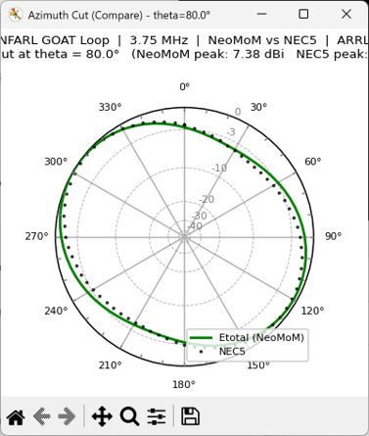
Figure 7. 80 m (3.75 MHz) — azimuth pattern. NeoMoM (solid) and NEC5 (dashed).

5.2 40 Meters (7.2 MHz)
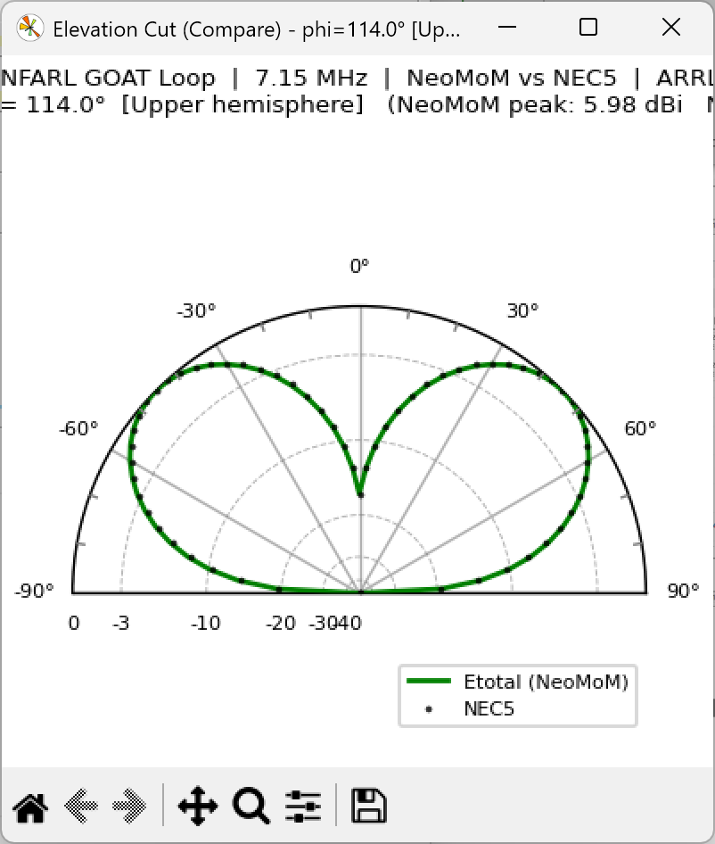
Figure 8. 40 m (7.2 MHz) — elevation pattern. NeoMoM (solid) and NEC5 (dashed).
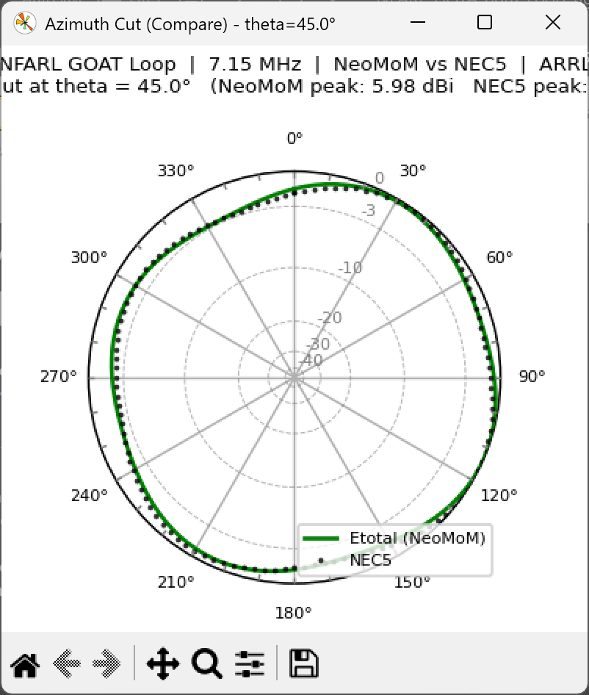
Figure 9. 40 m (7.2 MHz) — azimuth pattern. NeoMoM (solid) and NEC5 (dashed).

5.3 20 Meters (14.2 MHz)
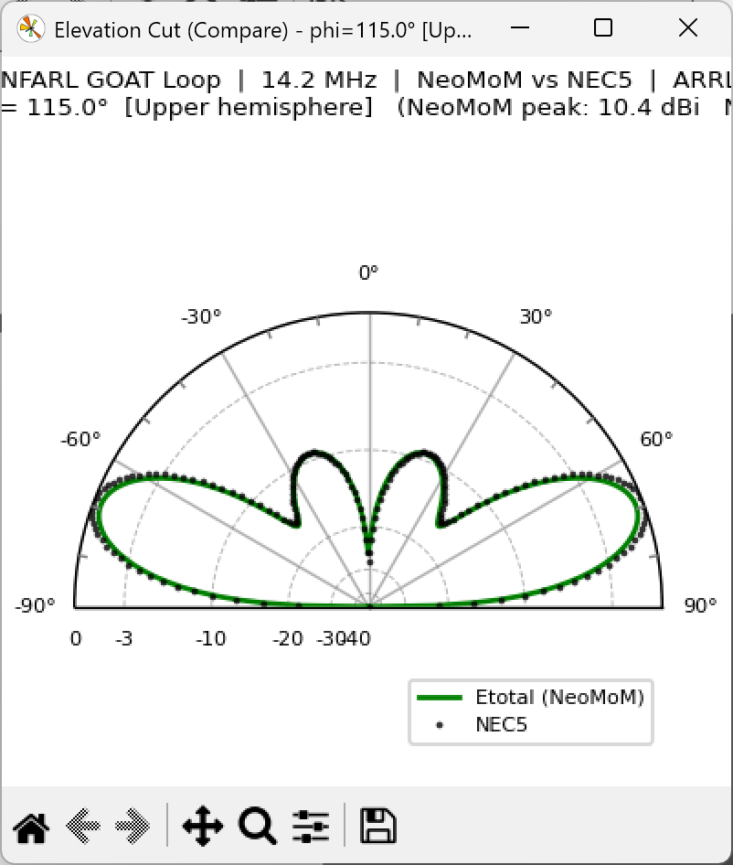
Figure 10. 20 m (14.2 MHz) — elevation pattern. NeoMoM (solid) and NEC5 (dashed).
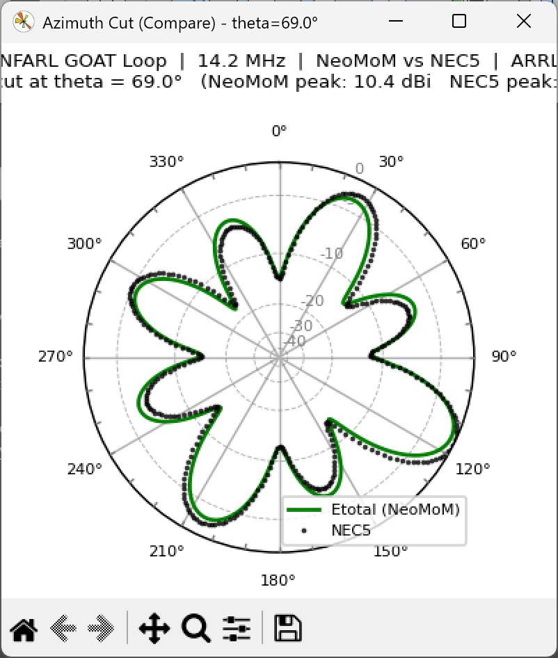
Figure 11. 20 m (14.2 MHz) — azimuth pattern. NeoMoM (solid) and NEC5 (dashed).

5.4 15 Meters (21.25 MHz)
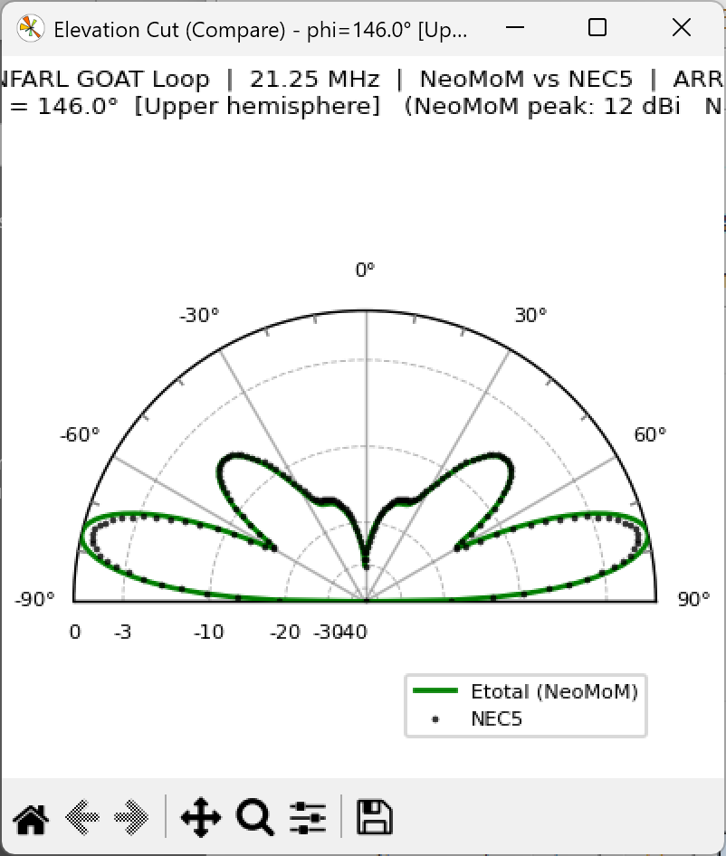
Figure 12. 15 m (21.25 MHz) — elevation pattern. NeoMoM (solid) and NEC5 (dashed).
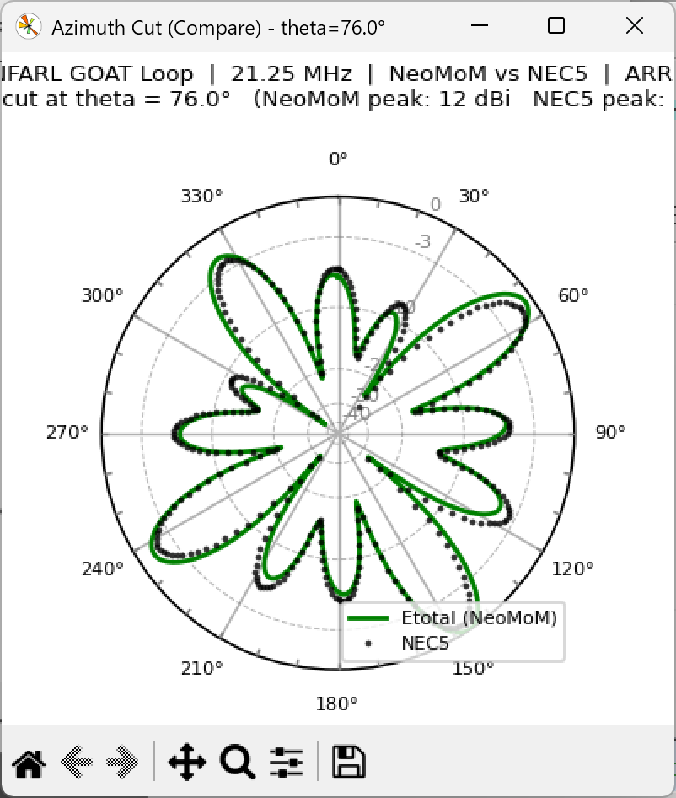
Figure 13. 15 m (21.25 MHz) — azimuth pattern. NeoMoM (solid) and NEC5 (dashed).

5.5 10 Meters (29.0 MHz)
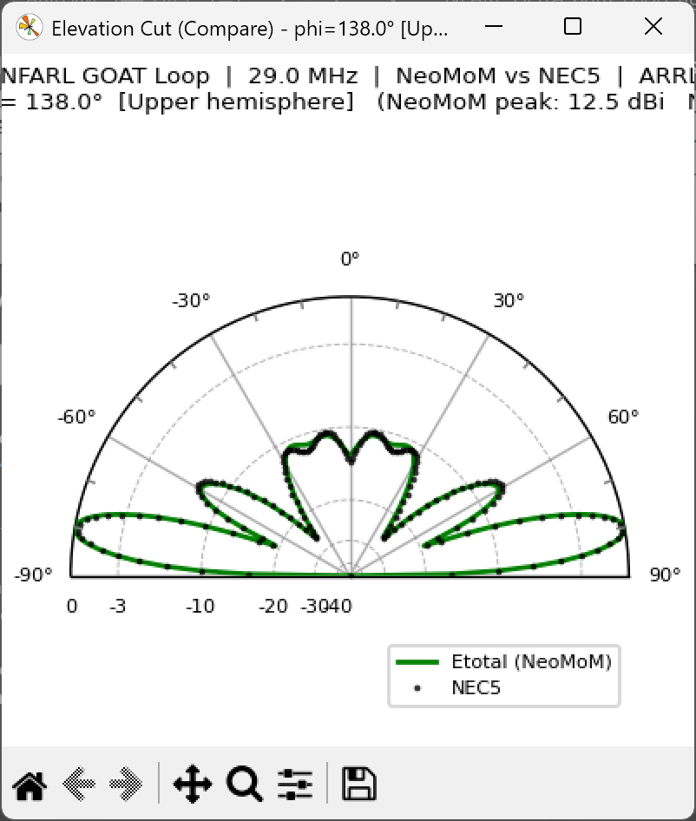
Figure 14. 10 m (29.0 MHz) — elevation pattern. NeoMoM (solid) and NEC5 (dashed).
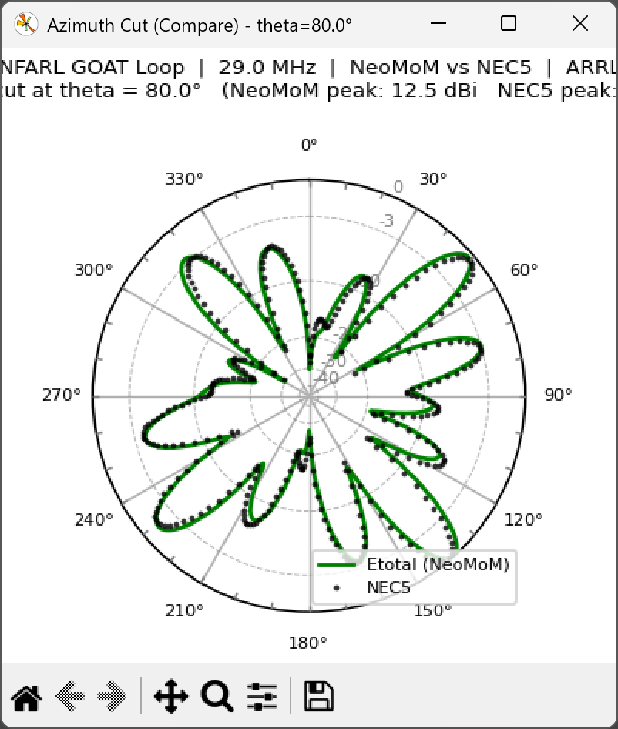
Figure 15. 10 m (29.0 MHz) — azimuth pattern. NeoMoM (solid) and NEC5 (dashed).

6. Geographic Map Overlay
The top-view (azimuth) radiation pattern at 10 m (29.0 MHz) is overlaid on geographic maps in Figs. 16 and 17. The map overlay places the pattern in geographic context, showing which directions are favored for DX propagation from the GOTA station location in Georgia.

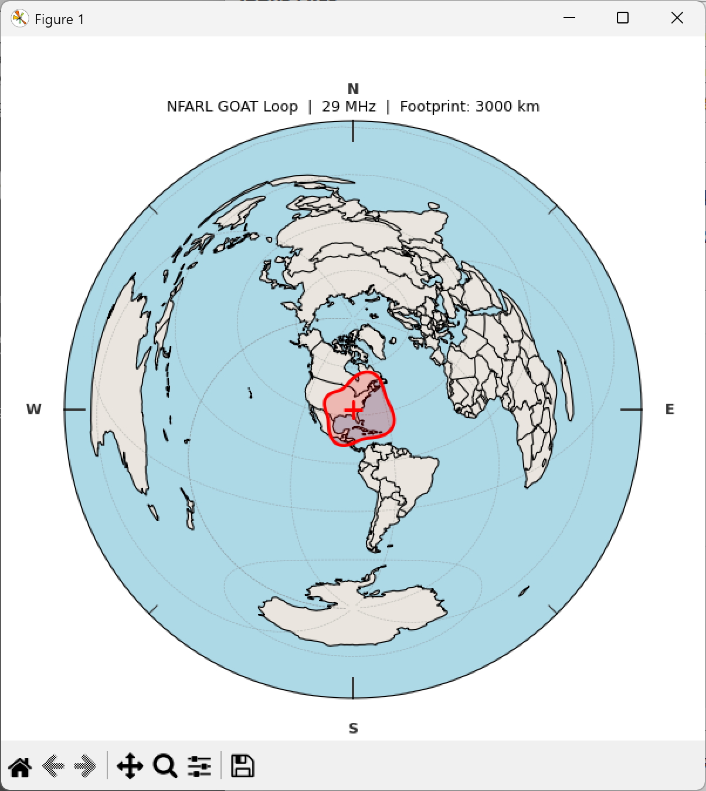
Figure 16. 10 m (29.0 MHz) pattern overlaid on a world map. Station located in Georgia, USA.
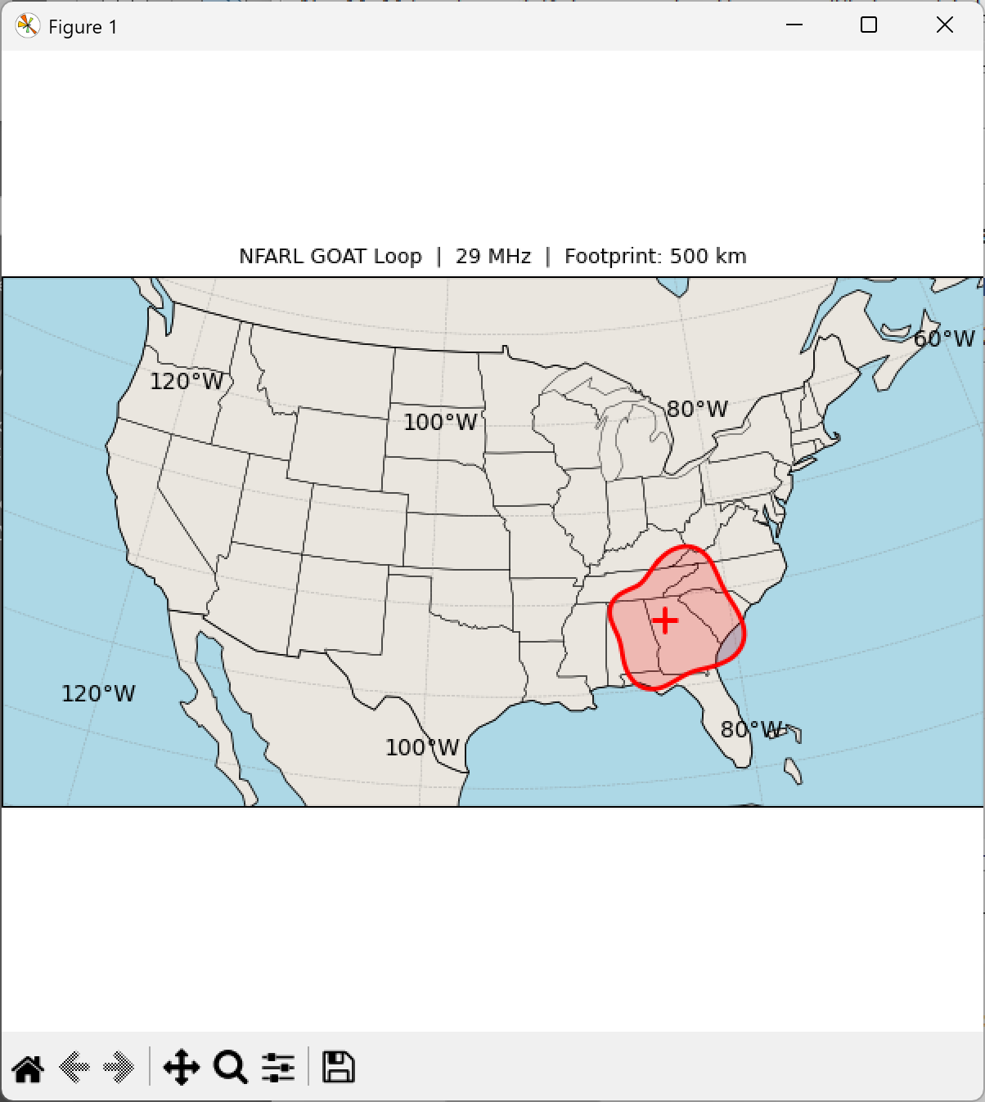
Figure 17. 10 m (29.0 MHz) pattern overlaid on CONUS map.

7. Code Validation
Comparison of two independent MoM codes provides mutual validation of both. The two principal diagnostics are feed impedance and radiation pattern.

7.1 Feed Impedance
The feed impedance Zin = V/I at the excitation point is determined by the computed current at the feed segment and the applied voltage. Agreement in Zin between the two codes confirms that both are computing the current distribution correctly and that the real ground image contribution is consistent between the Fresnel (NeoMoM) and Sommerfeld–Norton (NEC5) ground models.
The observed agreement (Figs. 3–5) is excellent above 10 MHz. At lower frequencies a small frequency shift of approximately 2% is observed, consistent with the known difference between Fresnel and Sommerfeld ground treatments and within expected MoM-to-MoM variation.

7.2 Radiation Patterns
NeoMoM and NEC5 show good pattern agreement across all five bands. The takeoff angle, main lobe direction, and relative Ev/Eh levels are consistent between the two codes. Small differences in sidelobe levels at higher frequencies are attributed to mesh density differences: NeoMoM uses an adaptive mesh (40 segments/λ at each frequency) while the NEC5 mesh is fixed and sized for 32 MHz.

7.3 Summary
The comparison confirms that NeoMoM produces results in good agreement with NEC5. Both codes correctly identify the multiband resonant behavior of the GOTA loop and produce consistent radiation pattern predictions. NeoMoM is suitable for practical antenna analysis and design for amateur radio applications.

8. Conclusions
The NFARL Field Day GOTA 80-meter loop antenna has been analyzed using two independent wire Method of Moments codes. The following conclusions are drawn:
1. The GOTA loop is a genuinely multiband antenna. Susceptance zero crossings occur within or near the 80, 40, 30, 20, 17, 15, 12, and 10 m amateur bands.
2. SWR referenced to 450 Ω shows minima within each major HF band, confirming favorable matching via ladder line and 4:1 balun.
3. Radiation patterns show progressively lower takeoff angles as frequency increases, with the 10 m pattern offering the lowest angle and strongest directivity.
4. NeoMoM and NEC5 results agree well across the full 2–32 MHz sweep. A small frequency shift (~2%) at low frequencies is consistent with differences between the Fresnel and Sommerfeld–Norton ground models.
5. This comparison validates NeoMoM as a reliable tool for practical amateur radio antenna analysis.

9. NeoMoM Software Suite
NeoMoM is composed of five components: neomom_input, neomom (engine), neomom_plot, neomom_Zin, and neomom_current. Together these applications provide a complete workflow from antenna geometry definition through electromagnetic solution to visualization of patterns, impedance, and current distribution.
The NeoMoM suite is currently available for Windows and Linux, with macOS support anticipated. It is intended that NeoMoM executables and source code will be placed in the public domain free of charge. As an open-source tool developed with AI assistance, NeoMoM is expected to remain current as technology and user expectations evolve — other hams will be able to extend and modify it using AI tools as desired. The software is available at github.com/john6080/neomom_v0.

References
[1] Burke, G.J., "Numerical Electromagnetics Code — NEC5," Lawrence Livermore National Laboratory.
[2] Rao, S.M., Wilton, D.R., and Glisson, A.W., "Electromagnetic Scattering by Surfaces of Arbitrary Shape," IEEE Trans. Antennas Propagat., vol. AP-30, May 1982.
[3] Lewallen, R. (W7EL), EZNEC Pro/2+ v7.0, www.eznec.com.
[4] Shaeffer, J. (KZ4TS), NeoMoM Antenna Modeling Suite, github.com/john6080/neomom_v0, 2026.
[5] ARRL Antenna Book, American Radio Relay League, Newington CT.

