NeoMoM Workflow Example
Centre-Fed Half-Wave Dipole on 40 Meters Above REAL Ground
John Shaeffer

KZ4TS, NFARL
john@shaeffer.com, (404) 404.9514

Before You Start
NeoMoM defines antenna geometry using a node-first approach. Spatial nodes are assigned unique tags and entered first. Wire polyline primitives are then defined by referencing those node tags. A single wire tag can describe a complete antenna structure — such as a many-sided loop — as one entity. Feed points are specified by wire tag and node tag.
This contrasts with older formats such as NEC and MMANA-GAL, where every straight wire segment required explicit endpoint coordinates — a tedious process for anything beyond a simple dipole.

Workflow Overview
- Plan the antenna geometry on paper before opening any software.
- Build the geometry input file with the Python GUI neomom_input.
- Run the NeoMoM computational engine.
  - The engine computes complex Eθ and Eφ fields over a sphere (or hemisphere) enclosing the antenna.
- Visualise results with the Python GUI neomom_plot.

Step 1: Plan Your Antenna
Sketch the antenna, its coordinate system, and its location before touching the software. The z-axis is always vertical; the ground plane, when used, lies at z = 0. You are free to orient x and y however you like, but defining +x as North is strongly recommended. With that choice, the spherical azimuth angle φ maps directly to compass bearings:
- +X → North, φ = 0°
- +Y → East, φ = 90°
- −X → South, φ = 180°
- −Y → West, φ = 270°

The example antenna is a centre-fed half-wave dipole for the 40 m band, oriented North–South and mounted 10 m above real ground. Because +x points North, the 20 m wire runs along the x-axis and needs three nodes:
- A (−10, 0, 0) — southern tip
- B (0, 0, 0) — centre feed point
- C (+10, 0, 0) — northern tip

The 10 m height above ground is not included in the node z-coordinates. It is entered separately as zHeight in the Nodes frame of neomom_input.

Step 2: neomom_input
Open neomom_input to create the antenna input file. The file format is a standard Fortran Namelist (*.nml) that can also be created or edited in any text editor. Two windows open: the main application with four tabbed frames (Globals, Nodes, Wires, Excitations) and an empty 3D geometry viewer. Work through each frame in order, then use the File menu to save and run.

Global Parameters
In the Globals frame (Fig. 1), enter 7.25 MHz in the Start and Stop fields and leave Steps at 1. Set Ground Type to Real, and accept the default dielectric constant (εr = 14) and conductivity (σ = 0.005 S/m), or enter local soil values. Leave the remaining solver defaults unchanged.
A yellow warning appears because zHeight defaults to zero, which is invalid with a real or PEC ground. This is resolved in the next frame.

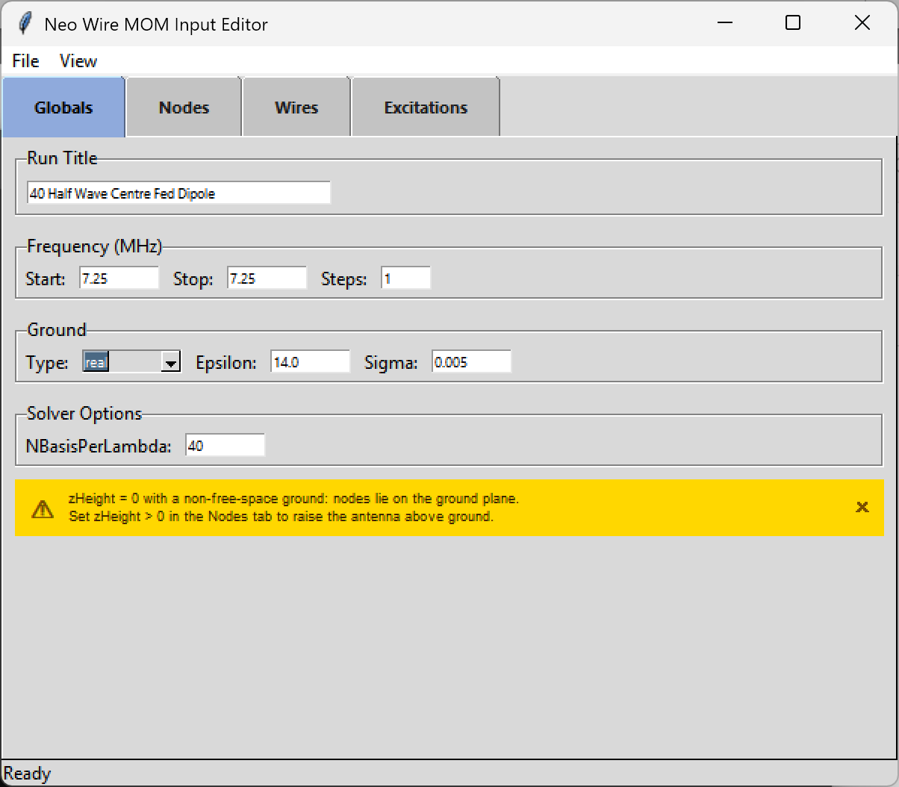
Fig. 1 — Globals frame. Frequency, ground type, and solver options. The yellow warning clears once zHeight is set in the Nodes frame.

Nodes
In the Nodes frame, set Units to Metres and enter zHeight = 10. The interface shows the height in wavelengths at the run frequency (0.242 λ at 7.25 MHz). Add the three nodes using the entry fields at the bottom of the frame:
- Tag A, X = −10, Y = 0, Z = 0
- Tag B, X = 0, Y = 0, Z = 0
- Tag C, X = +10, Y = 0, Z = 0

Node tags default to A, B, C… and increment automatically starting with A, but any mnemonic label may be used. The geometry viewer updates immediately to show the three nodes (Fig. 2).

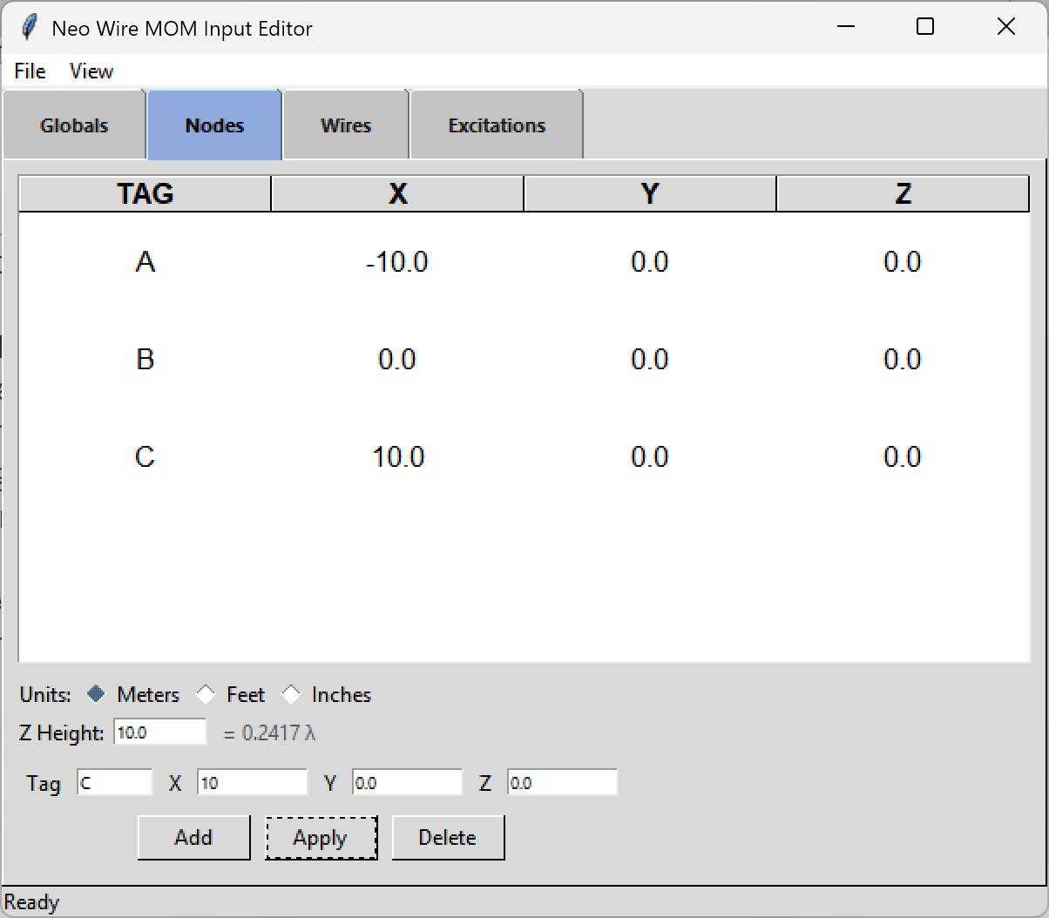  Fig. 2a — Nodes frame with three nodes entered and zHeight = 10 m. | 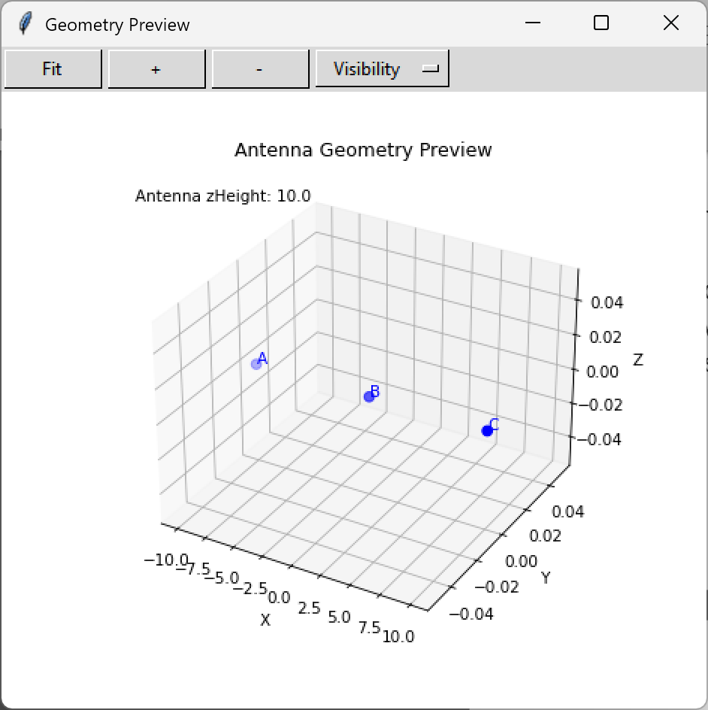  Fig. 2b — Geometry viewer after node entry: nodes A, B, C at zHeight 10 m.

Wire Primitives
In the Wires frame, define the antenna conductor. Wire tags start at W1. Enter the node sequence A B C and set the wire radius to 0.001 m (1 mm radius, 2 mm diameter). NeoMoM reports the total length in the selected units and in wavelengths. The 20 m wire is 0.467 λ at 7.25 MHz — close to the half-wave resonance of 0.5 λ (Fig. 3).

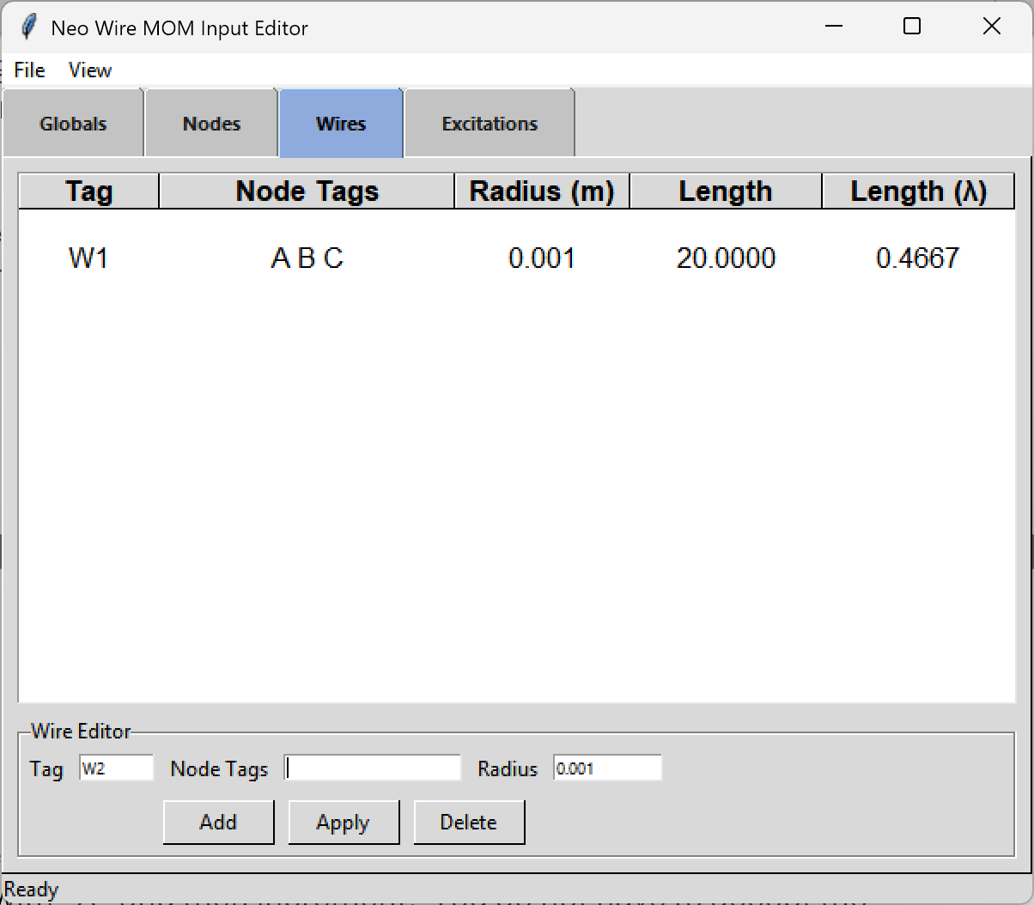  Fig. 3a — Wires frame: W1 spans nodes A–B–C, radius 0.001 m, total length 20 m (0.467 λ). | 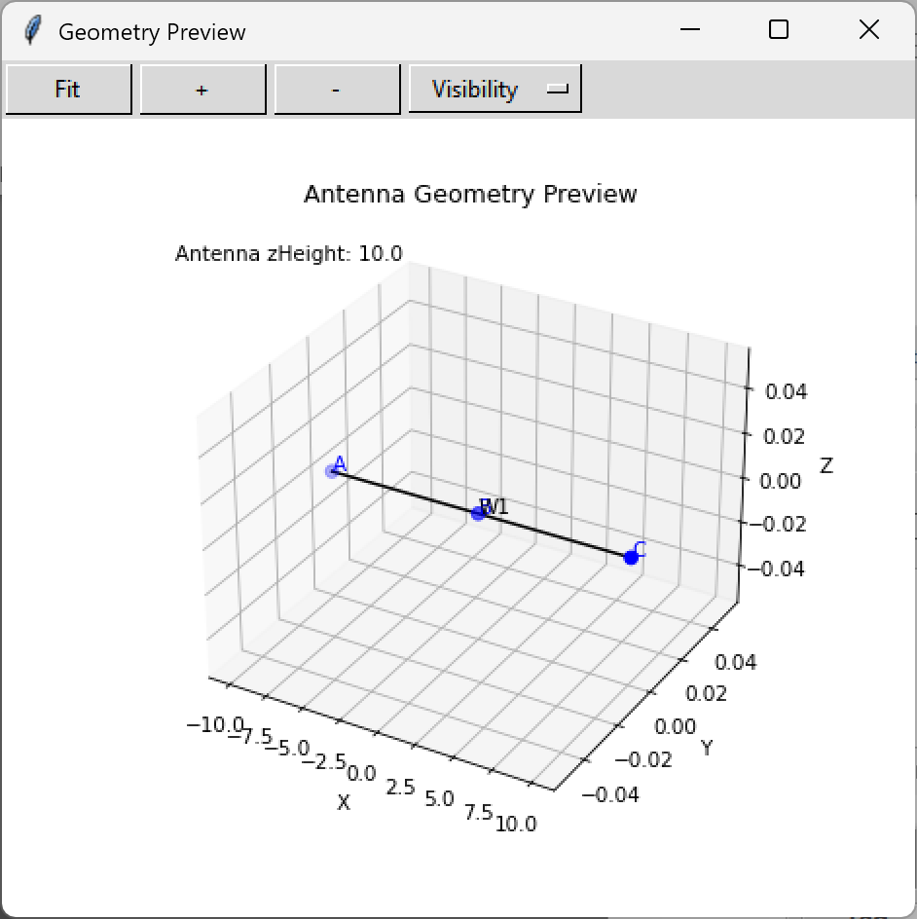  Fig. 3b — Geometry viewer after wire entry: W1 drawn through all three nodes.

Feed-Point Excitation
In the Excitations frame, specify the feed point. Select wire W1 and node B, then accept the default voltage (1.0 V) and phase (0°). The geometry viewer marks the excitation in red (Fig. 4). This example uses a single feed port; multi-port arrays are supported by adding additional excitation entries. This approach to feed point definition requires a specific node. This is in contrast to to NEC 5 where a specific segment (out of the segs specified for a wire) is needed or in MMANA-GAL where the options are wire begin, end, or percent length.

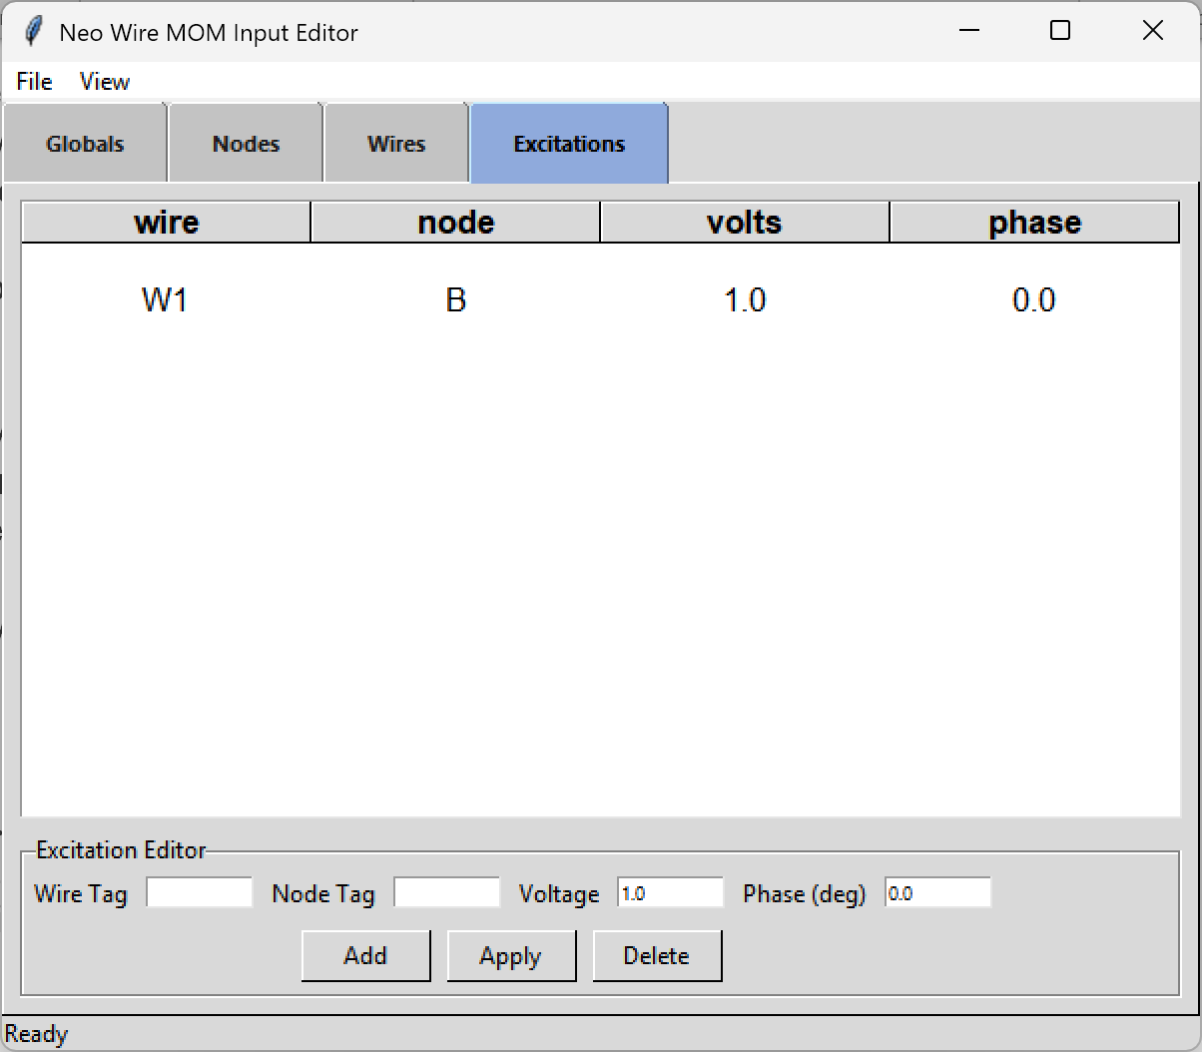  Fig. 4a — Excitations frame: feed on W1 at node B, 1.0 V, 0°. | 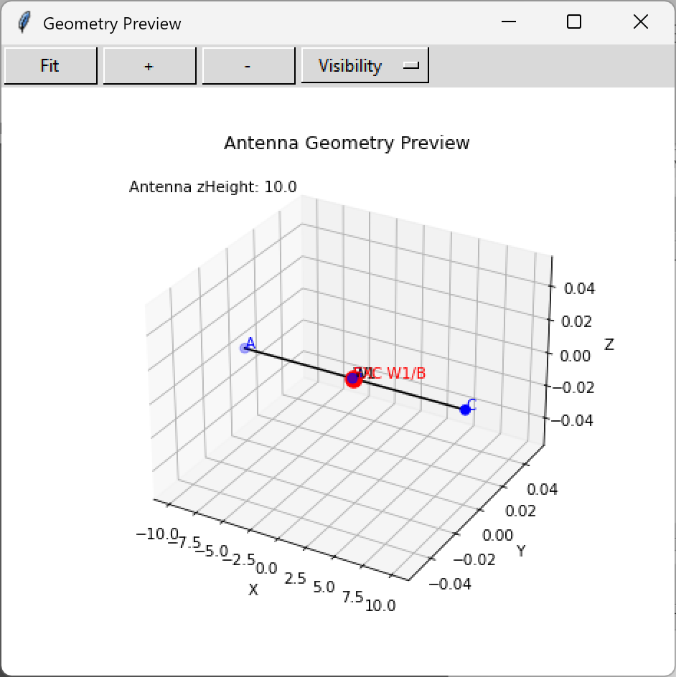  Fig. 4b — Geometry viewer with the W1/B excitation marked in red.

File Menu
After checking the geometry viewer, save the input file from the File menu using option 3, Save as *.nml. The full menu:
- New
- Open existing *.nml file
- Save as *.nml file
- Export as *.nec — NEC5 / EZNEC input deck (adjust segmentation, ground, and pattern settings before running)
- Export as *.maa — MMANA-GAL format
- Import MMANA *.maa — imports most geometry; the excitation node may need to be added manually
- Validate
- Run solver
- Quit

Step 3: Run NeoMoM
The NeoMoM engine can be launched from the File menu (option 8), from a terminal, or by drag-and-drop on Windows. When the run completes, two output files are written: a *.txt summary and a *.csv pattern file. Review the text summary for the key results shown below.

NeoMoM does not require the user to specify pattern cuts in advance. It computes the full set of complex Eθ and Eφ values over the sphere (free space) or upper hemisphere (PEC or real ground), and the plotting GUI generates any cut on demand from that data.

HEADER
================================================================================
NeoMom v0 2026-06-19 16:22:37
================================================================================
Run : Center Fed Half Wave Dipole, 40 m
File : E:\AntennaModeling_AI\models\dipoles\Center_fed_40m_dipole.nml
================================================================================

FREQUENCY & MESH
================================================================================
Frequency : 7.2500 MHz
Wavelength : 41.350681 m
Segments : 20
Basis functions: 19
Segment length : 1.03377 m (lambda / 40.0)
Antenna size : 0.6840 lambda (kD = 4.2978)
================================================================================
Note: kD gives the electrical size of the antenna including its image when a ground plane is used. kD = 2πD/λ, where D is the diagonal of the bounding box enclosing the antenna and its image.
GROUND
================================================================================
Type : REAL
Epsilon_r : 14.0000
Sigma : 5.0000E-03 S/m
zHeight : 10.0000 m
================================================================================

PORT DATA
================================================================================
PORT 1 of 1 W1 / B Z0_ref = 50.00 Ohm
--------------------------------------------------------------------------------
Zin : 81.089 +j 6.984 Ohm
|Zin| / angle : 81.389 Ohm / 4.92 deg
Gamma : 0.24273 angle = 9.61 deg
SWR : 1.641
P_in : 6.1206E-03 W (6.121 mW)
================================================================================
P_accepted : 6.1206E-03 W
================================================================================

PATTERN POINTS AND GAIN
================================================================================
Theta : 0.0 to 90.0 deg step 5.0 deg ( 19 pts)
Phi : 0.0 to 360.0 deg step 5.0 deg ( 73 pts) nAng = 1387
--------------------------------------------------------------------------------
Peak G_total : 6.006 dBi at theta = 25.00 deg phi = 90.00 deg
Peak G_theta : 5.917 dBi at theta = 0.00 deg phi = 0.00 deg
Peak G_phi : 6.006 dBi at theta = 25.00 deg phi = 90.00 deg
================================================================================
Note: Peak gain angles initialise the default cut positions in neomom_plot. Peak G_phi at θ = 25°, φ = 90° indicates the main lobe is broadside to the dipole (East, as expected) and elevated 25° above the horizon.
POWER BALANCE (REAL GROUND)
================================================================================
P_radiated : 4.6850E-03 W
P_accepted : 6.1206E-03 W
Radiation efficiency : 0.7654 (76.5%)
================================================================================
Note: Radiated power is lower than accepted power because real ground introduces loss. For FREE_SPACE and PEC cases a healthy run should show P_radiated ≈ P_accepted within 1%.
OUTPUT FILES
================================================================================
Text summary : ...\dipoles\Center_fed_40m_dipole.txt
Pattern CSV : ...\dipoles\Center_fed_40m_dipole.csv
================================================================================

Step 4: View Results with neomom_plot
neomom_plot reads the *.csv file produced by the engine. If neomom_plot is on the system path, the engine attempts to launch it automatically at the end of the run; otherwise start it from the command line, drag-and-drop, or open-with, passing the *.csv file as the argument.

Main Interface
The main window (Fig. 5) has three sections:
- Top — run metadata: antenna title, frequency, peak gain, ground type, and zHeight in metres and wavelengths.
- Middle — five visualisation modes: 2D Azimuth, 2D Elevation, 3D Standard, 3D Top-Down, Map Overlay.
- Bottom — options for the selected mode (components, scale, cut angle, hemisphere).

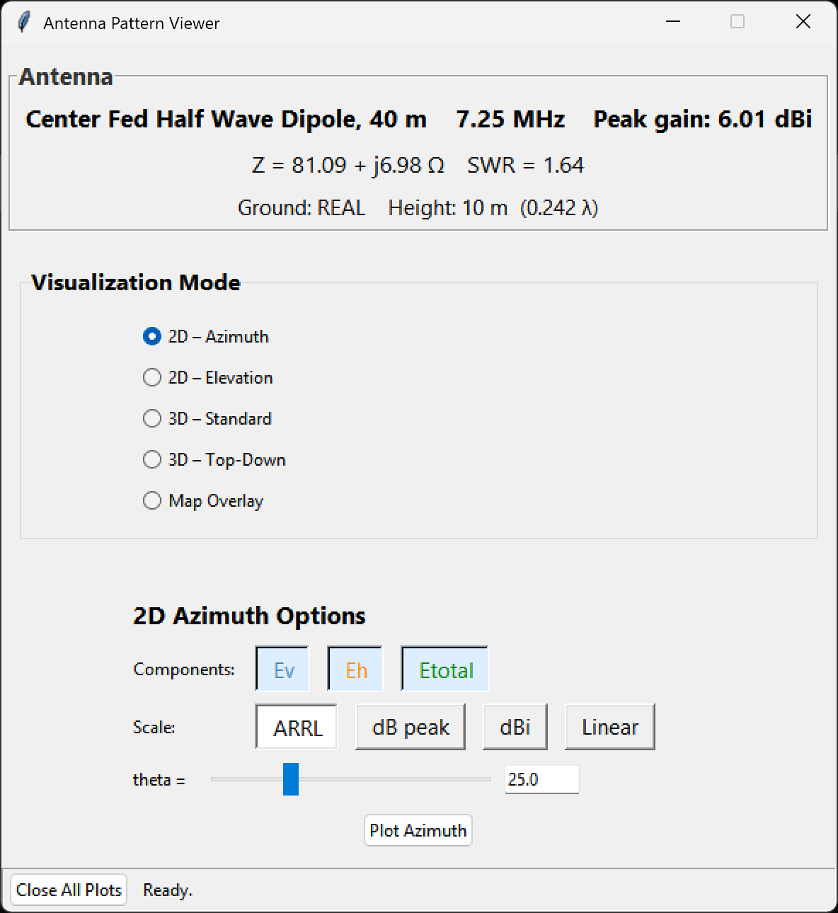
Fig. 5 — neomom_plot main interface for the 40 m dipole. Zin, SWR, peak gain, ground type, and height are displayed in the top panel. The 2D Azimuth mode is selected.

3D Views
A good first view is 3D Top-Down (Fig. 6a). This projects the pattern onto a horizontal plane with +x (North) up and +y (East) to the right, matching standard map orientation. For this North–South dipole the expected East–West figure-of-eight is immediately visible.
The 3D Standard view (Fig. 6b) shows an isometric perspective with the ground plane in the xy-plane. The peak gain annotation is labelled on the main lobe. The ARRL compressed-dB scale is used in both views.

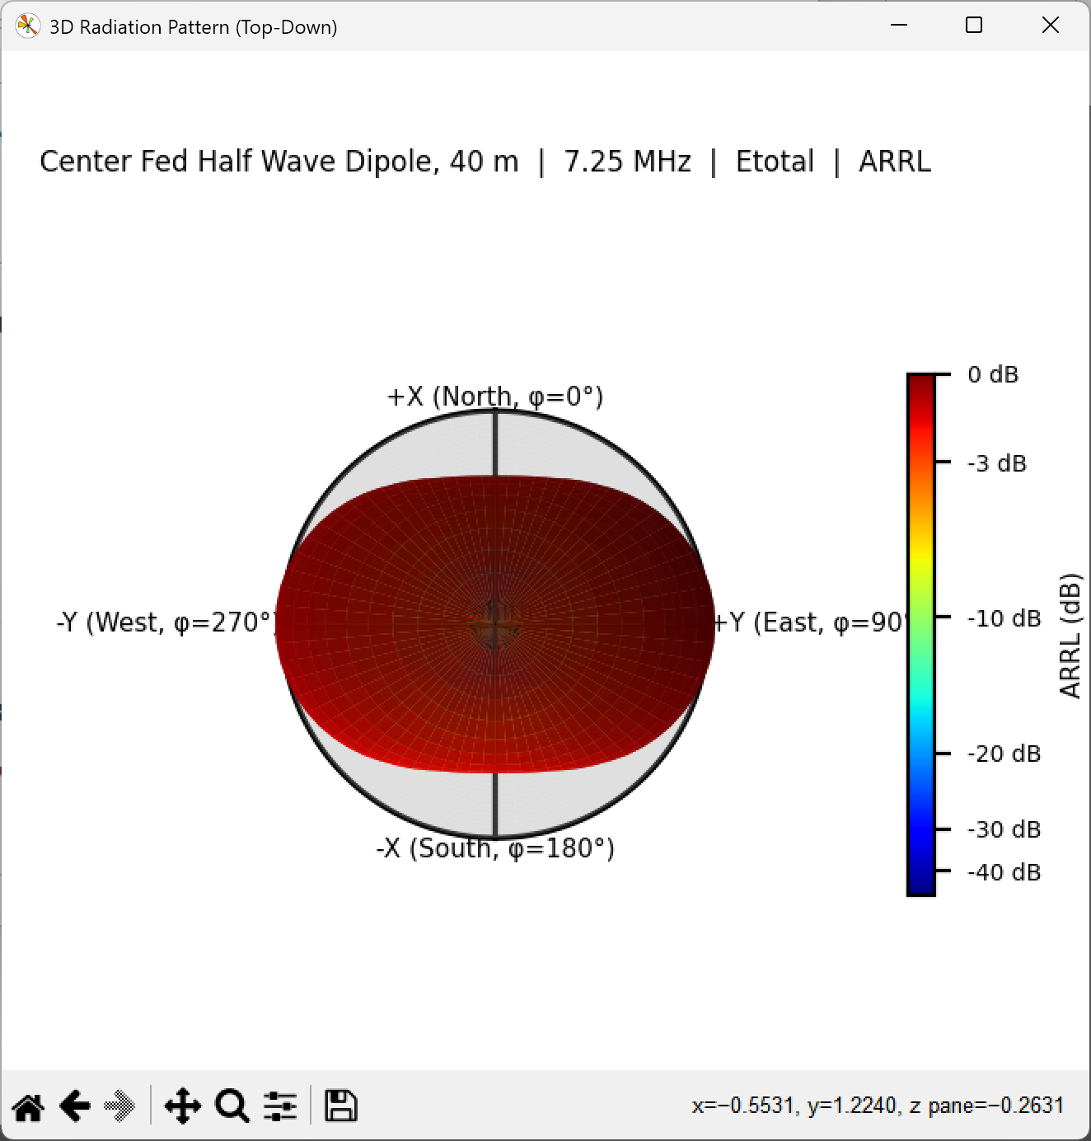  Fig. 6a — 3D Top-Down view. Broadside lobes point East (φ = 90°) and West (φ = 270°). | 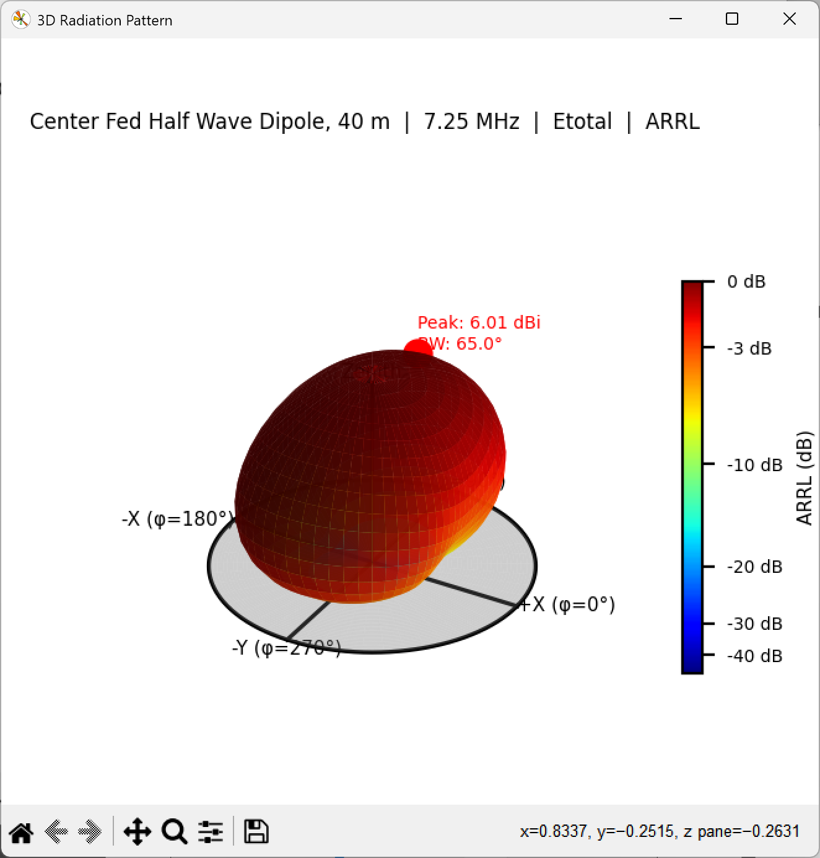  Fig. 6b — 3D Standard view. Peak gain 6.01 dBi at θ = 25°, φ = 90°; −3 dB beamwidth 65°.

2D Pattern Cuts
Select 2D Elevation for a polar plot in the vertical plane. The slider sets the azimuth (φ) for the cut. Fig. 7a shows the broadside elevation cut at φ = 90° (East): the pattern is dominated by the horizontal (Eφ) component with a single main lobe peaking at 25° elevation. The vertical component (Eθ) is negligible in this cut.
Select 2D Azimuth for a polar plot in a horizontal plane. The slider sets θ for the cut. Fig. 7b shows the cut at θ = 35° (close to the peak elevation angle): the expected figure-of-eight appears, with broadside lobes East and West and deep nulls North and South along the wire axis.

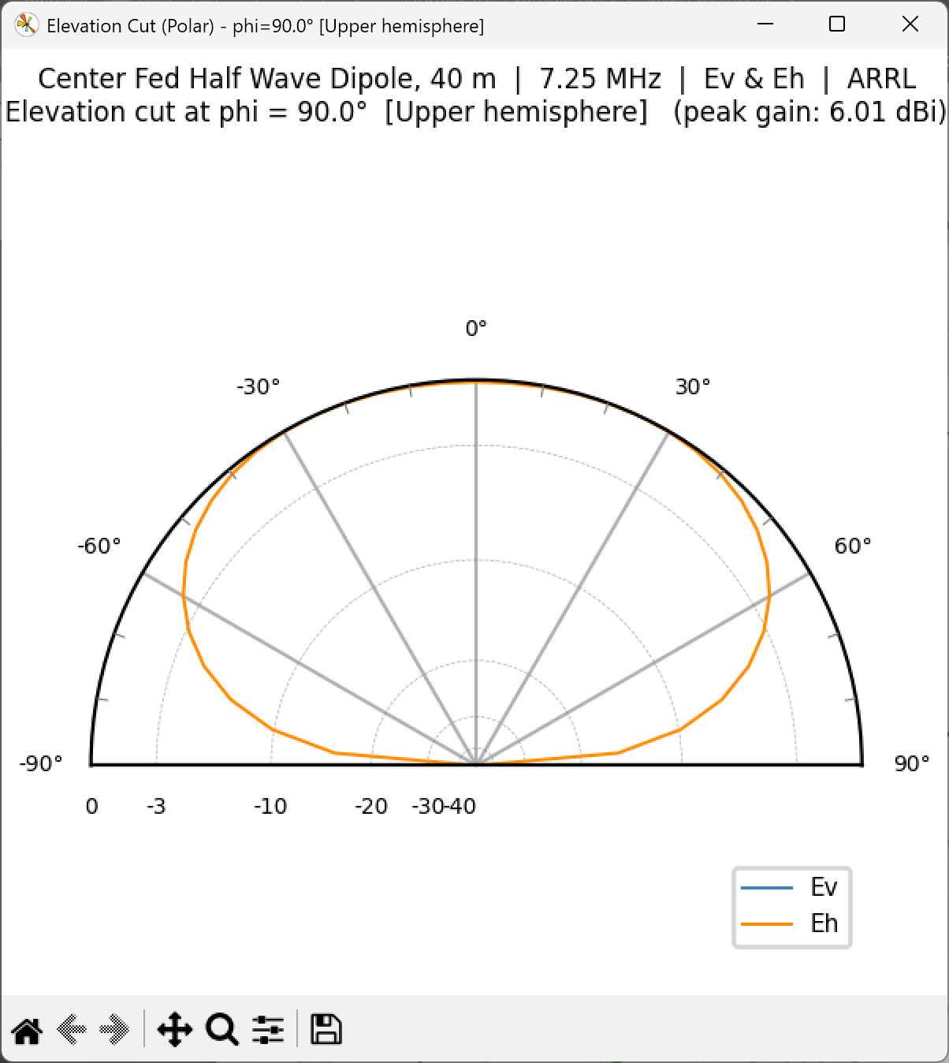  Fig. 7a — Elevation cut at φ = 90° (broadside). Eh dominates; peak at 25° elevation. | 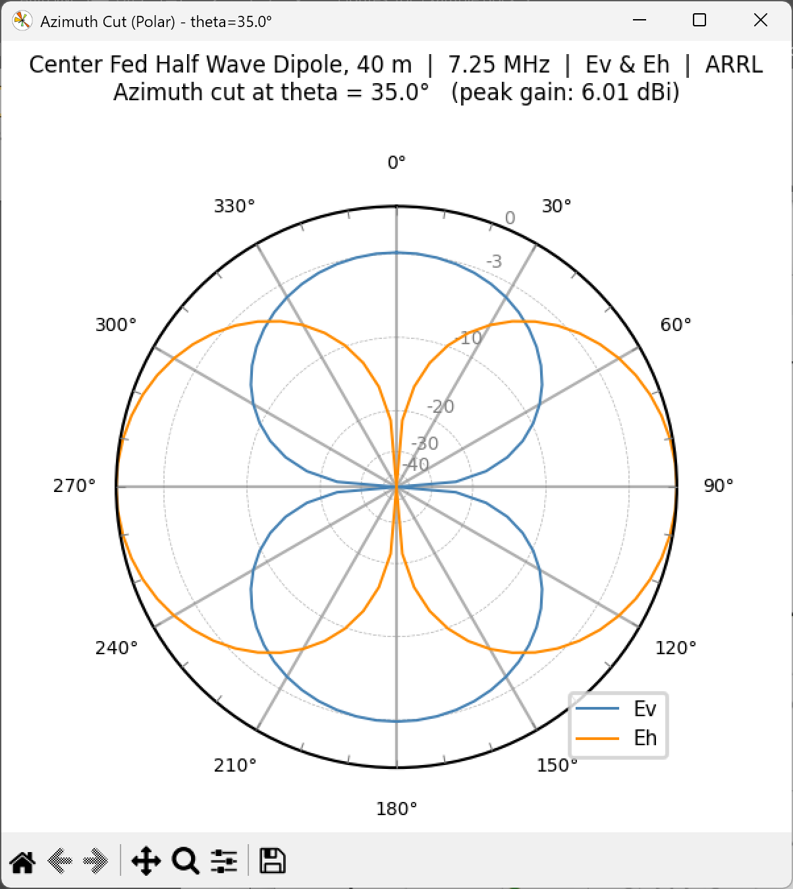  Fig. 7b — Azimuth cut at θ = 35°. Figure-of-eight pattern, broadside East–West.

Map Overlay
The Map Overlay mode projects the antenna footprint onto a geographic map centred on the user’s coordinates (default: Atlanta, GA). Map projections available are World, CONUS, and Local. The footprint radius, in kilometres, sets how far the selected dB contour reaches on the ground. Rotation adjusts for cases where +x is not aligned to true North.

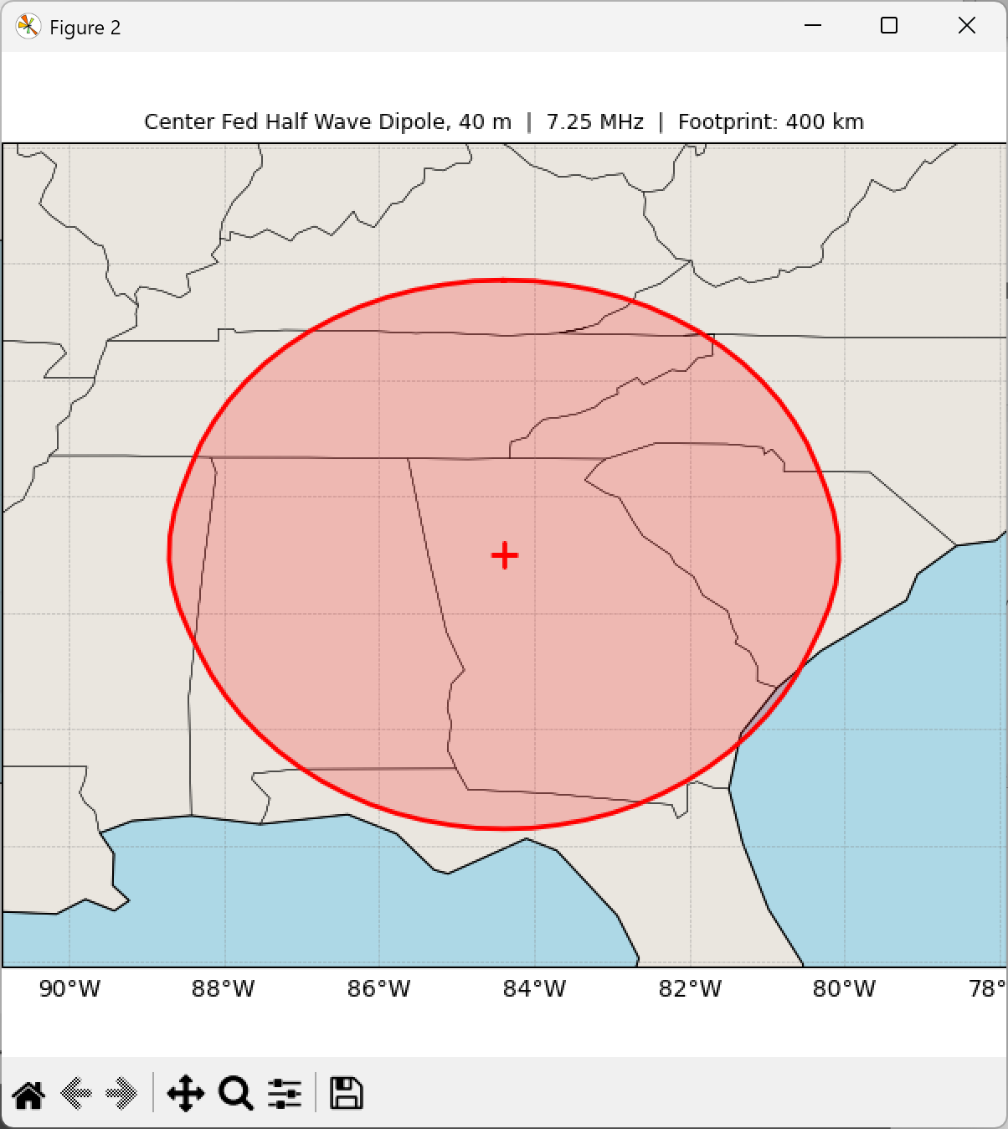
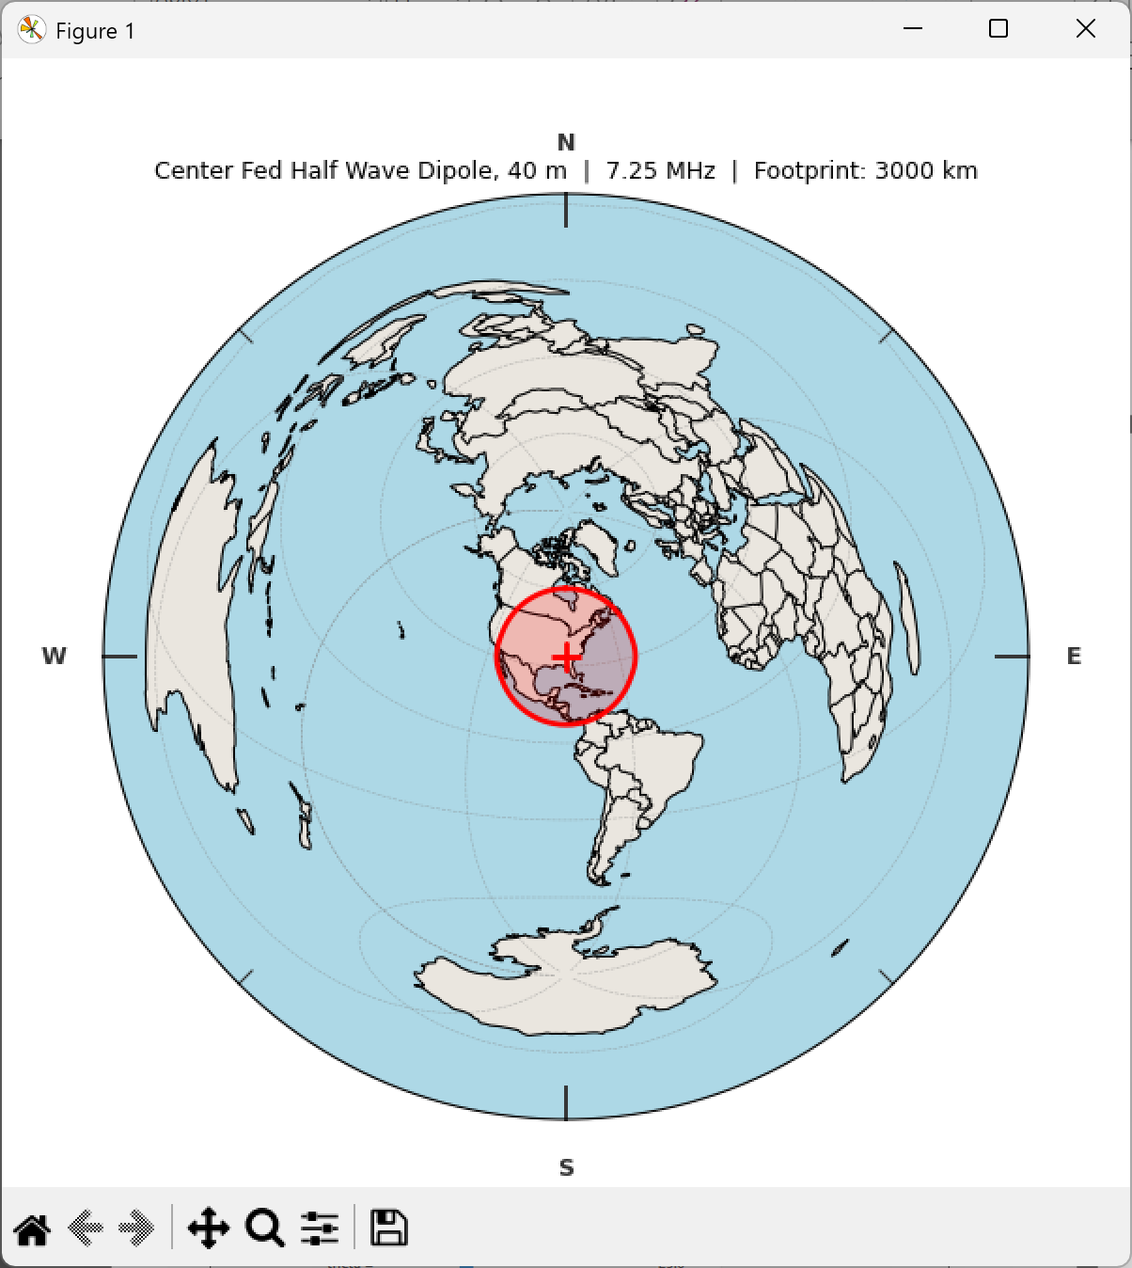  Fig. 8a — World projection, 3000 km footprint. The East–West pattern preference is clear on a hemispheric scale. | 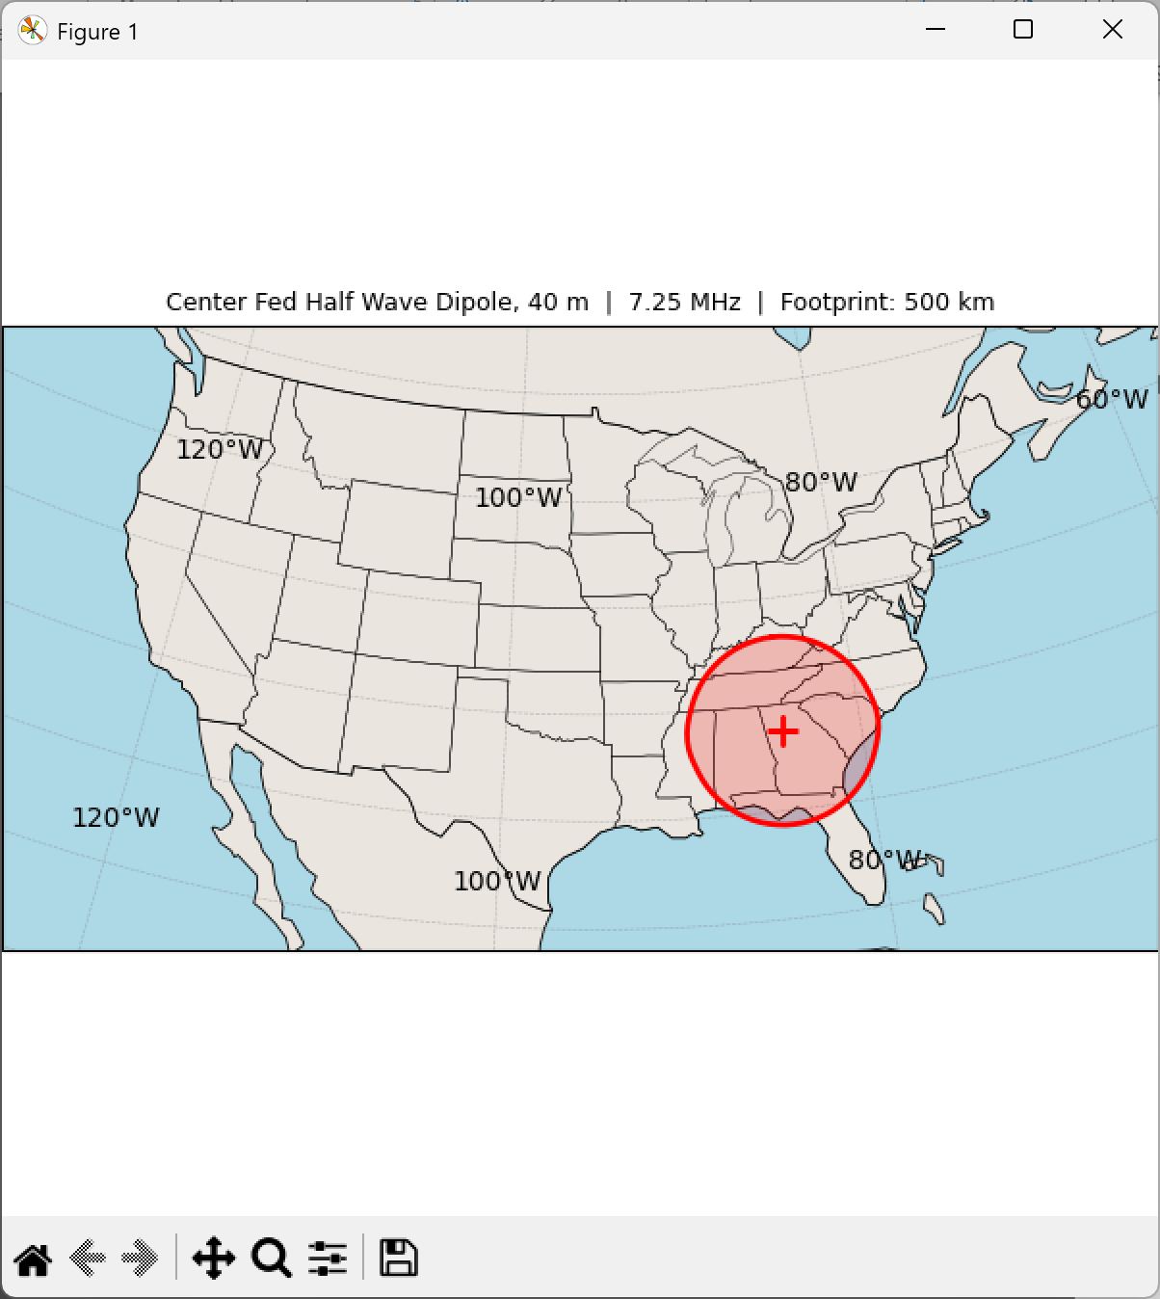  Fig. 8b — CONUS projection, 500 km footprint. Coverage extends to the Gulf Coast and Tennessee Valley.
Fig. 8c — Local projection, 400 km footprint, zoomed to the Southeast US. The elliptical footprint is elongated East–West consistent with the dipole orientation.

