NeoMoM
“An amateur radio antenna prediction code”
John Shaeffer
KZ4TS, NFARL
john@shaeffer.com
404.403.9414

2026

Abstract
NeoMoM is a wire-antenna modeling suite designed for amateur radio operators and antenna engineers. It predicts input impedances, radiation patterns, and gain figures for arbitrary wire structures in free space, over perfect ground, or over real ground. The suite combines a rigorous Method of Moments engine with modern Python graphical interfaces for geometry creation and pattern visualization.

System Overview
NeoMoM consists of three integrated applications that together support the complete antenna modeling workflow:
- neomom_input — Antenna geometry creation and editing
- neomom — Computational Method of Moments (MoM) engine
- neomom_plot — Visualization and interactive pattern analysis with geographic map overlay

Key Features
- Open-source design intended for community use, extension, and experimentation
- Modern Python-based graphical user interfaces for input and visualization
- Direct import of MMANA-GAL (*.maa) files with minor editing for excitation
- Export capability for NEC5 and MMANA-GAL input formats ready for further editing

Design Foundations
NeoMoM builds on the legacy of tools such as NEC, EZNEC, MiniNEC, and MMANA-GAL while introducing:
- A more rigorous computational framework
- A modern object-oriented architecture
- Improved usability through graphical interfaces
- Modern data input approaches

Advances in computing—such as increased memory, multi-core processors, and modern programming techniques—enable higher-performance simulations that were impractical in earlier generations of tools.

Core Concepts

Node-Based Geometry Definition
Antenna structures are defined using a list of tagged spatial nodes (x, y, z coordinates). From these nodes:
- Wire elements are constructed as tagged polylines
- Excitation is defined at a specific wire and node
- Geometry can be created either via GUI or text-based input

Full-Sphere Radiation Modeling
NeoMoM computes radiation fields (Eθ and Eφ) over the entire sphere. This global dataset enables:
- Arbitrary azimuth and elevation pattern cuts
- Full 3D radiation visualization
- Geographic map-based pattern overlays

Extensible GUI Framework
The input and visualization interfaces are implemented in Python using AI-assisted development. This approach encourages:
- Custom GUI development by users
- Experimentation and adaptation within the amateur radio community

System Components

neomom_input
Creates and edits *.nml input files and provides real-time 3D visualization of antenna geometry as nodes, wires, and excitations are defined. Supports:
- Global parameters (frequency, ground type, title)
- Node coordinate input (user-defined units)
- Wire and excitation definitions
- Reading existing .nml and MMANA-GAL (.maa) files
- Exporting NEC and MMANA-GAL *.nec and *.maa files which, after editing, can be used in NEC5 (EZ-NEC) and MMANA-GAL

neomom (Computational Engine)
Full-wave Maxwell solver using the Method of Moments:
- Triangular basis functions with Galerkin formulation
- Complex symmetric system matrix (Z = Zᵀ, not Hermitian)
- Input: Fortran namelist (*.nml)
- Output: Full-sphere complex Eθ and Eφ fields in *.csv format

neomom_plot
Visualizes the radiation fields produced by neomom. Input is the sphere-coverage Eθ and Eφ data. Visualization options include:
- 2D azimuth cuts (user-selected elevation)
- 2D elevation cuts (user-selected azimuth)
- 3D radiation patterns with ground plane
- Top-down geographic view aligned to compass directions

Advanced features:
- Radiation pattern overlay on world, CONUS, or regional maps
- Multiple map projections (azimuthal equidistant, Lambert conformal, plate carrée)
- Adjustable orientation relative to geographic north
- Scaling options: ARRL, dBi, dBpeak, or linear gain (Eθ, Eφ, total)

neomom_input
neomom_input is the graphical input editor for NeoMoM. It presents several panels covering global parameters, node entry, wire primitives, and excitation. As data is entered the geometry viewer updates in real time, allowing immediate visual feedback on node placement and wire connectivity.

Globals Tab
The Globals tab sets the simulation title, frequency range, ground type, and meshing density (basis functions per wavelength). Figure 1 shows the Globals tab configured for the disk cone antenna at 145 MHz with FREE (free space) ground.

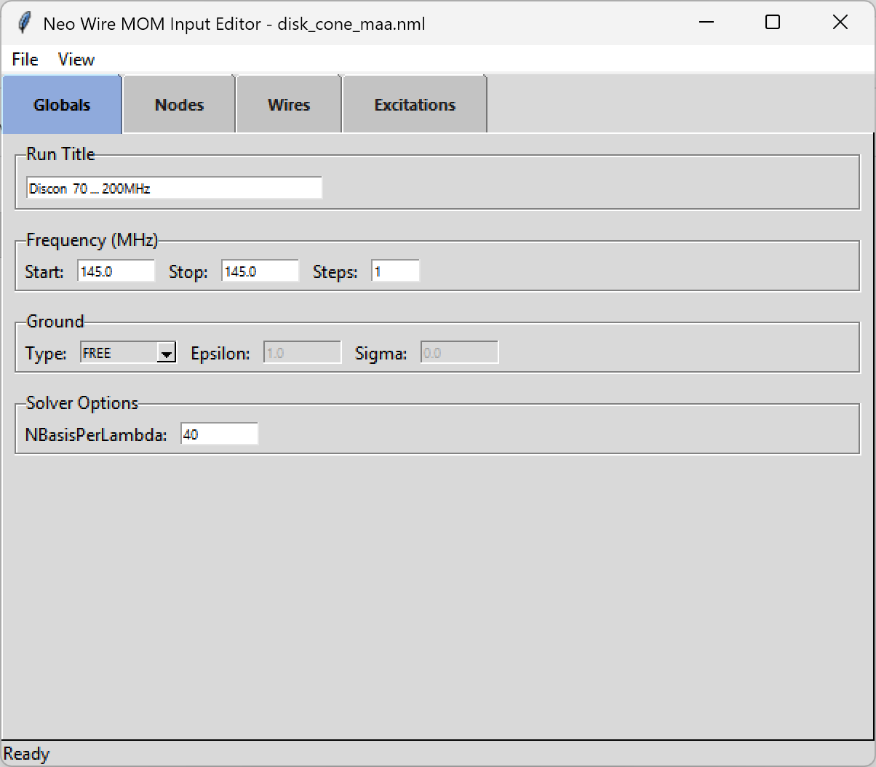
Figure 1 — neomom_input Globals tab: disk cone at 145 MHz, FREE ground, 40 basis functions per wavelength.

Geometry Preview
The geometry viewer renders nodes (blue dots), wires (black lines), and the excitation point (red dot) in an interactive 3D view. Controls allow rotation, zoom, and toggling visibility of element labels. Figure 2 shows the disk cone antenna structure with 8 top-hat radials and 8 cone slopers. The Fit button centers the view on the antenna bounding box.

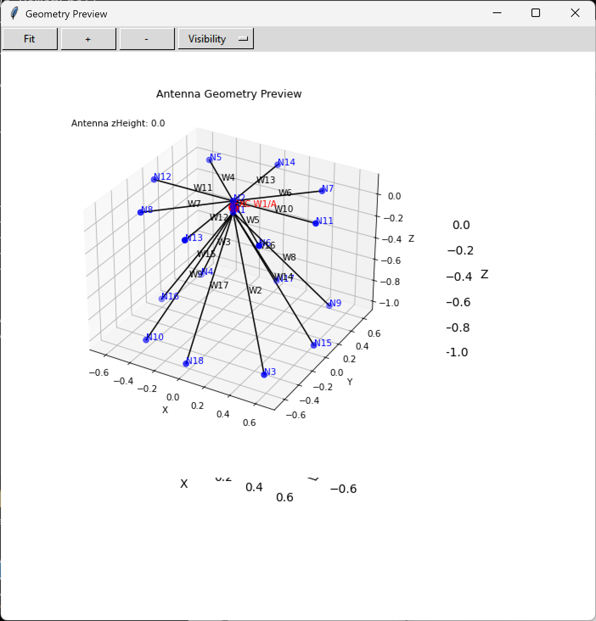  Figure 2a — Disk cone geometry: 8 top-hat radials and 8 cone slopers, W1/A feed point (red). | 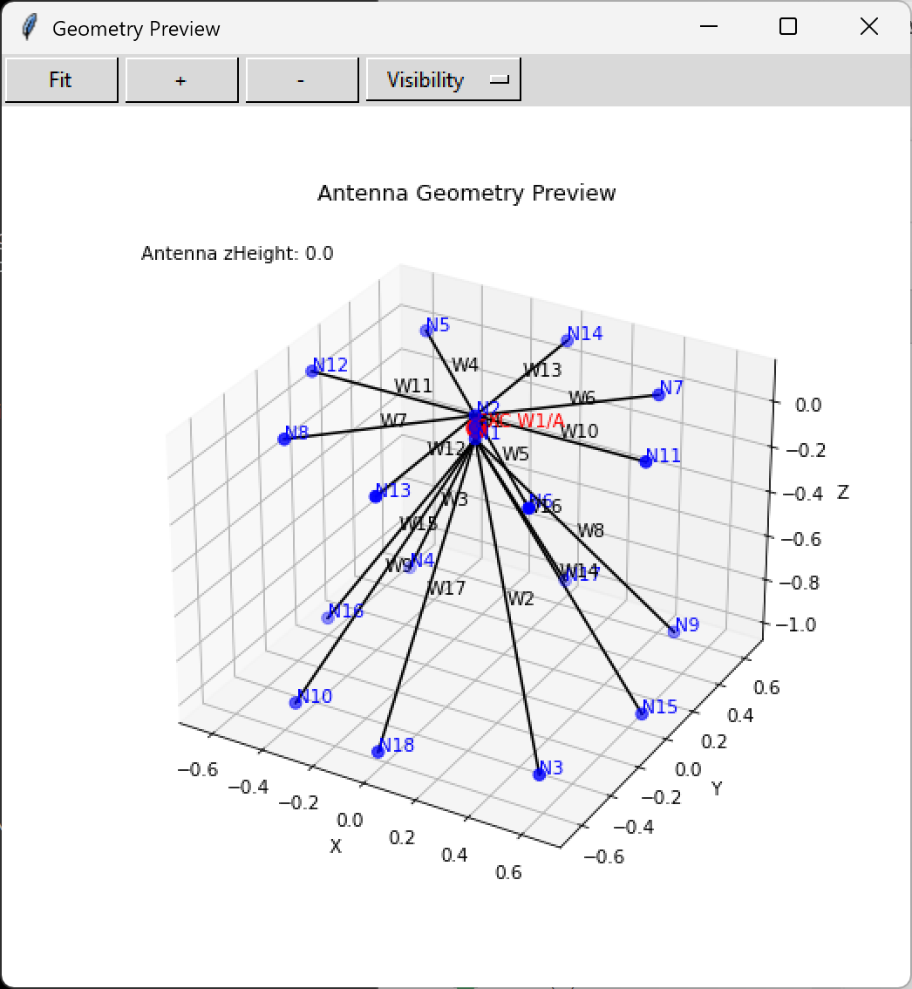  Figure 2b — Alternate view of the disk cone showing the sloped radiator arrangement.

neomom_plot
neomom_plot reads the *.csv output file produced by neomom and presents radiation data in multiple formats. The main panel (Figure 3) shows the title, frequency, and peak gain alongside controls for pattern cuts, scaling, and geographic orientation.

Main Panel and 2D Pattern Cuts
The main GUI provides controls to select the display mode (azimuth cut, elevation cut, 3D, or geographic map), the frequency, and the field component (Etotal, Ev, Eh, or ARRL composite). Pattern scaling options are ARRL (normalized 0–40 dB range), dBi, dBpeak, or linear.

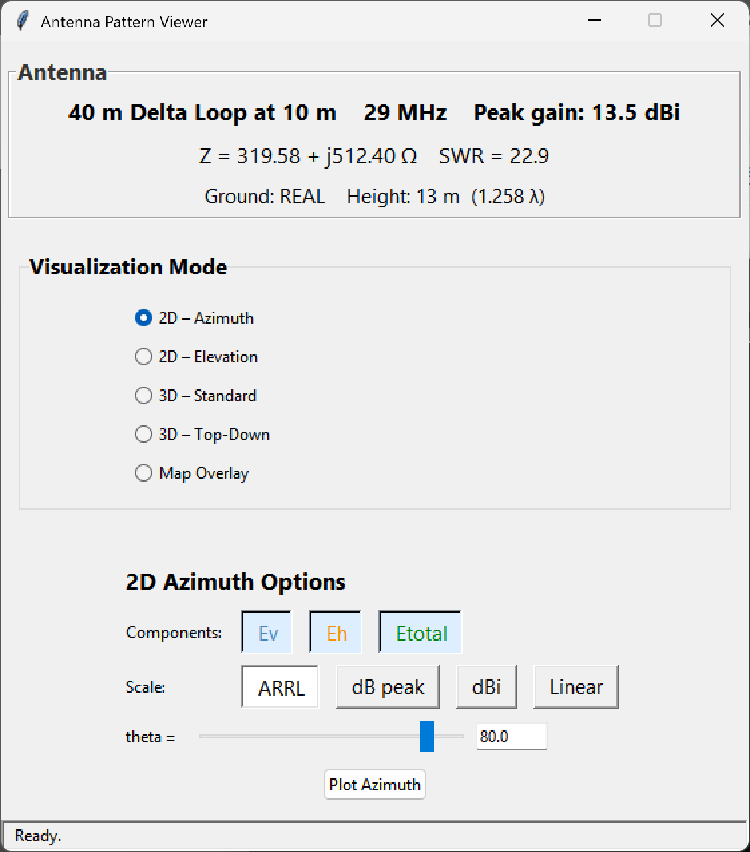
Figure 3 — neomom_plot main GUI showing the 40 m Delta Loop at 10 m height, 29 MHz. Peak gain 13.5 dBi on the ARRL scale.

3D Radiation Pattern
The 3D view projects the full-sphere or hemi-sphere (depends on ground type) radiation data onto a coloured surface with the ground plane shown as a reference disc. Colour indicates relative gain (0 dB = red, −40 dB = blue). Figure 4 shows the 10-metre-high delta loop at the 10 m harmonic (29 MHz), displaying multiple lobes at 13.49 dBi peak.

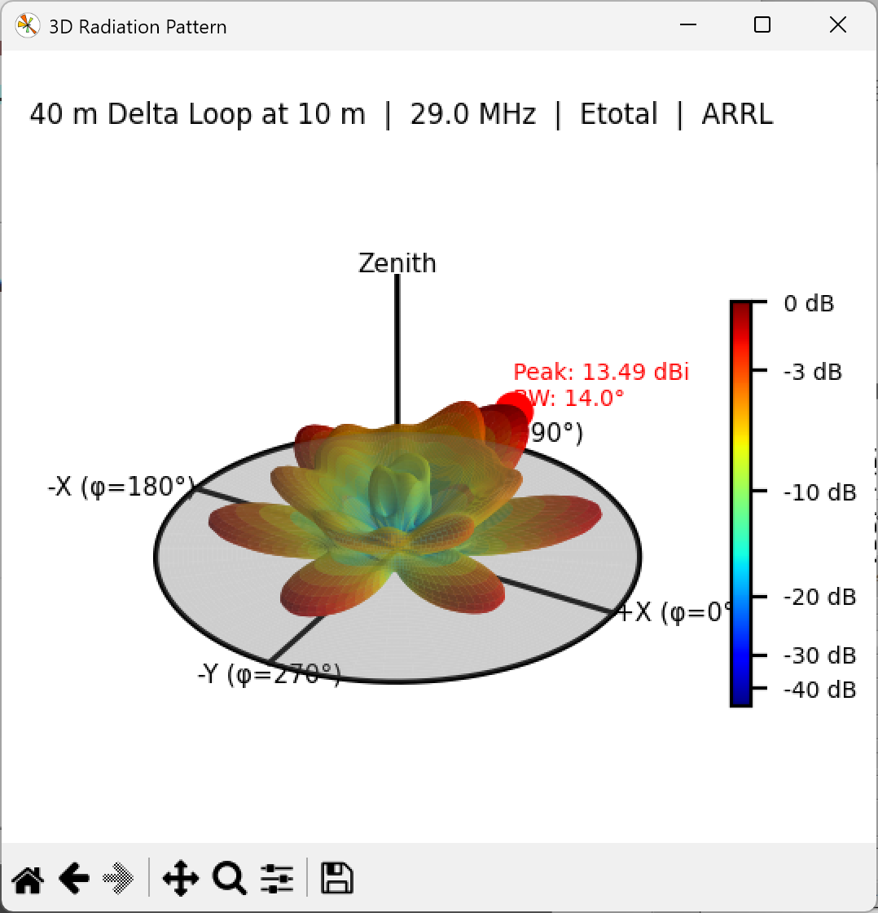
Figure 4 — 3D radiation pattern for the 40 m Delta Loop at 10 m height, 29.0 MHz. Peak: 13.49 dBi, beamwidth 14.0°.

Geographic Map Overlay
neomom_plot can overlay the antenna radiation pattern on a world map using azimuthal equidistant, Lambert conformal conic, or plate carrée projections. The operator selects their grid square or lat/lon location and the map rotates so that the antenna pattern is aligned to geographic north. Figure 5 shows the azimuthal equidistant projection centred on the operator location.

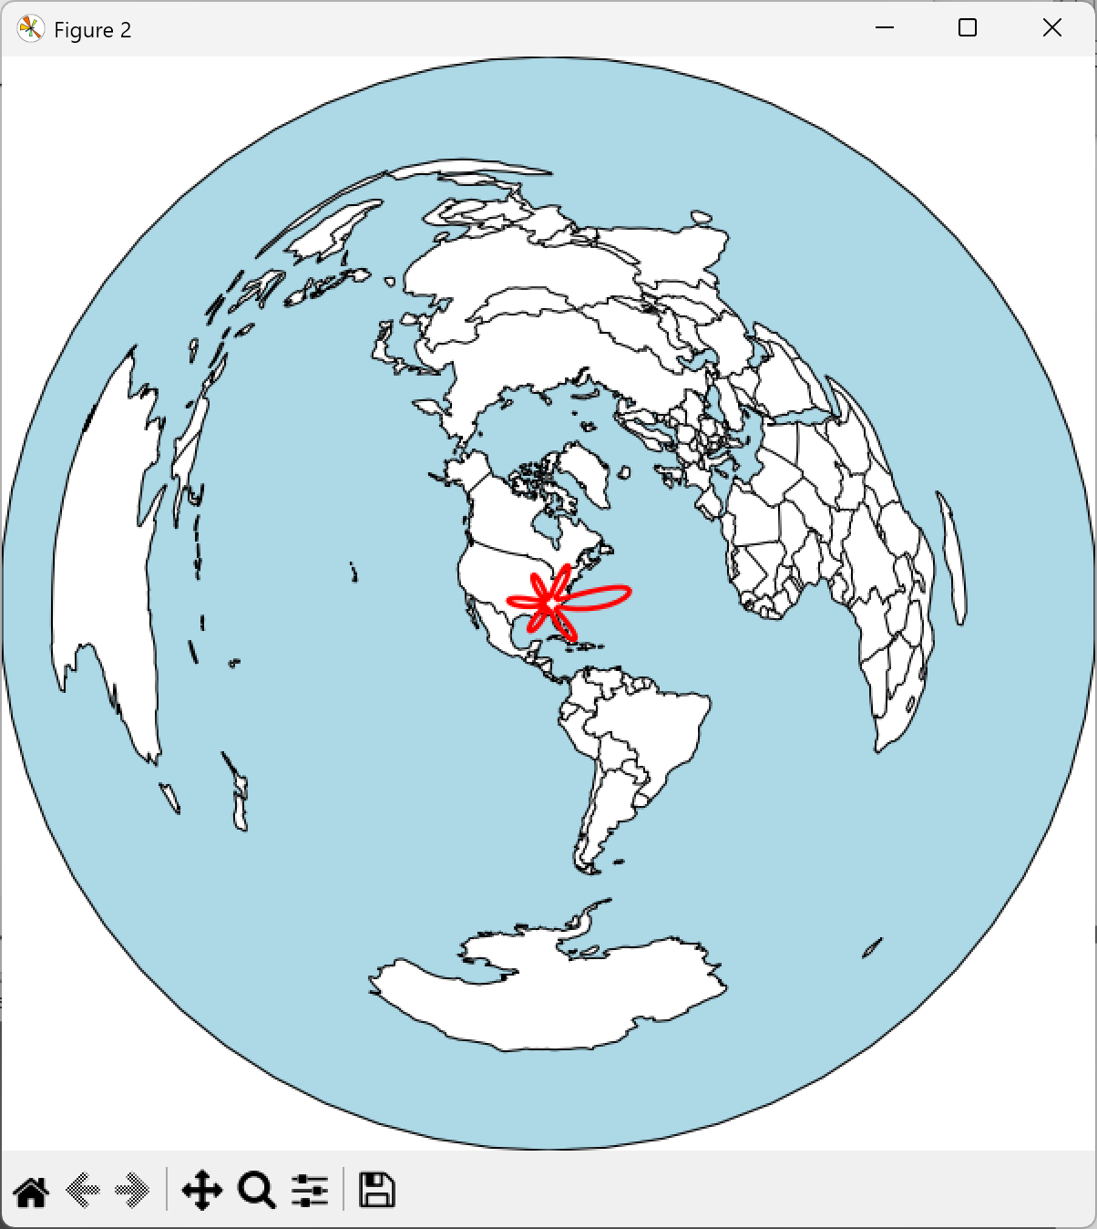
Figure 5 — Azimuthal equidistant map projection centred on operator location (red star). Pattern overlay is aligned to true north.

Validation
The following tables compare input impedances and gain computed with NeoMoM, NEC5, and MMANA-GAL for a representative set of antenna types. NEC5 is the definitive full-wave reference. MMANA-GAL uses the MiniNEC engine and is included for context.
- Half-wave dipole, centre fed
- Folded dipole, centre fed
- End-fed half-wave (EFHW) dipole
- Quarter-wave vertical at and near ground (z = 0)
- Disk cone VHF — array of top-hat radials and sloped cone radials
- Yagi, 6 m, six-element array
- Delta loop sized for 40 m; computed at 40 m and 10 m bands
- J-pole, 2 m, above real ground, two feed approaches

Dipole, folded dipole, and EFHW results include free-space, perfect PEC ground, and real ground cases.

Half-Wave Dipole, Centre Fed
L = 20 m, f = 7.3 MHz, wire radius = 1 mm

Free Space (GE = 0, GN = −1)
Code | Zin (Ω) | Gain (dBi)
NeoMoM | 71.9 – j 0.12 | 2.14
NEC5 | 71.6 − j 5.41 | 2.14
MMANA-GAL | 74.5 + j 2.05 | 1.99
10 m above PEC (GE = 1, GN = 1)
Code | Zin (Ω) | Gain (dBi)
NeoMoM | 84.5 + j 30.5 | 7.58
NEC5 | 84.2 + j 25.0 | 7.58
MMANA-GAL | 74.1 + j 14.7 | 8.02
5 m above PEC (GE = 1, GN = 1)
Code | Zin (Ω) | Gain (dBi)
NeoMoM | 31.1 + j 29.3 | 8.72
NEC5 | 31.6 + j 23.7 | 8.72
MMANA-GAL | 59.6 + j 2.6 | 5.0
10 m above real ground ε = 14, σ = 0.005 (GE = 1, GN = 2)
Code | Zin (Ω) | Gain (dBi)
NeoMoM | 83.1 + j 17.9 | 6.0
NEC5 | 82.5 + j 10.9 | 5.92
MMANA-GAL | 84.7 + j 32.6 | 5.87
5 m above real ground ε = 14, σ = 0.005 (GE = 1, GN = 2)
Code | Zin (Ω) | Gain (dBi)
NeoMoM | 48.4 + j 23.2 | 5.86
NEC5 | 55.6 + j 14.2 | 5.31
MMANA-GAL | 31.2 + j 31.3 | 7.88

Folded Dipole, Centre Fed
L = 10.05 m, f = 14.05 MHz, wire radius = 1.5 mm, spacing d = 0.2 m. File: fd20.maa from the MMANA-GAL antenna library.

Free Space (GE = 0, GN = −1)
Code | Zin (Ω) | Gain (dBi)
NeoMoM | 285 – j 0.74 | 2.19
NEC5 | 286 – j 10.4 | 2.14
MMANA-GAL | 286 + j 4.00 | 2.13
5 m above PEC (GE = 1, GN = 1)
Code | Zin (Ω) | Gain (dBi)
NeoMoM | 328 + j 131 | 7.71
NEC5 | 333 + j 121 | 7.71
MMANA-GAL | 327 + j 136 | 7.7
5 m above real ground ε = 14, σ = 0.005 (GE = 1, GN = 2)
Code | Zin (Ω) | Gain (dBi)
NeoMoM | 320 + j 74.2 | 5.87
NEC5 | 321 + j 56.8 | 5.85
MMANA-GAL | 327 + j 136 | 5.83

EFHW: End-Fed Half-Wave Dipole
L = 20 m, f = 7.3 MHz, wire radius = 1 mm.
Free Space (GE = 0, GN = −1)
Code | Zin (Ω) | Gain (dBi)
NeoMoM | 1453 – j 1109 | 2.15
NEC5 | 1484 – j 1296 | 2.15
MMANA-GAL | 2036 – j 17481 | 2.17
10 m above PEC (GE = 1, GN = 1)
Code | Zin (Ω) | Gain (dBi)
NeoMoM | 2143 – j 1400 | 7.6
NEC5 | 2196 – j 1578 | 7.6
MMANA-GAL | 1612 − j 18123 | 7.6
10 m above real ground ε = 14, σ = 0.005 (GE = 1, GN = 2)
Code | Zin (Ω) | Gain (dBi)
NeoMoM | 1853 – j 1315 | 6.0
NEC5 | 1862 – j 1486 | 5.9
MMANA-GAL | 1612 − j 18123 | 5.9

Quarter-Wave Vertical
L = 10 m, f = 7.3 MHz, wire radius = 1 mm.

PEC Ground — zH = 0.0 m (GE = 1, GN = 1)
Code | Zin (Ω) | Gain (dBi)
NeoMoM | 27.2 – j 2334 | 5.18
NEC5 | 36.7 – j 2.5 | 5.15
MMANA-GAL | 10.5 – j 17379 | 8.05
PEC Ground — zH = 0.1 m (GE = 1, GN = 1)
Code | Zin (Ω) | Gain (dBi)
NeoMoM | 26.9 − j 2421 | 5.19
NEC5 | 28.0 − j 2781 | 5.19
MMANA-GAL | 10.5 – j 17379 | 8.04
Real Ground — zH = 0.0 m (GE = 1, GN = 2)
Code | Zin (Ω) | Gain (dBi)
NeoMoM | 47.0 – j 2429 | −2.5
NEC5 | 48.6 − j 0.701 | −1.25
MMANA-GAL | 10.5 − j 17379 | 1.6
Real Ground — zH = 0.1 m (GE = 1, GN = 2)
Code | Zin (Ω) | Gain (dBi)
NeoMoM | 38.4 – j 2478 | −1.67
NEC5 | 44.6 – j 2794 | −2.08
MMANA-GAL | 10.5 − j 17379 | 1.62

Note: NeoMoM’s large reactive impedance (j 2334 Ω) at zH = 0 reflects the fact that the base node touches ground and is classified as a wire end, forcing I = 0 at that node. NEC5 handles this correctly. A future fix will add an image wire below z = 0 for the PEC ground case, converting the base node from an end to an interior node.

Disk Cone
8 top-hat radials, 8 cone slopers. File: Discon55-200.maa from the MMANA-GAL library. f = 145 MHz, wire radius = 5 mm. Free-space case only.

Free Space (GE = 0)
Code | Zin (Ω) | Gain (dBi)
NeoMoM | 137.5 + j 35 | 1.92
NEC5 | 135.6 + j 31.3 | 1.89
MMANA-GAL | 134 + j 33.8 | 1.95

Note: θmax = 120° for NeoMoM disk cone result.

Yagi, Six Element
File: 6elYag.maa from the MMANA-GAL library. f = 50.5 MHz, wire radius = 7 mm. Free-space case.

Free Space (GE = 0)
Code | Zin (Ω) | Gain (dBi)
NeoMoM | 34.5 – j 2.71 | 11
NEC5 | 35.3 – j 5.39 | 11
MMANA-GAL | 34.3 – j 2.32 | 11

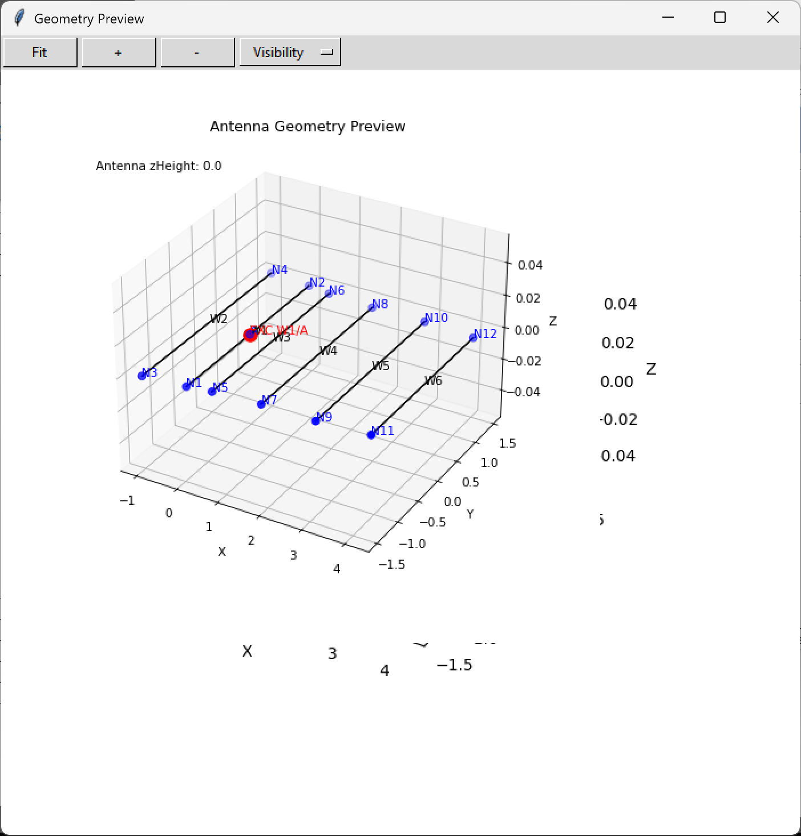
Figure 6 — Six-element Yagi geometry preview. W1–W6 elements with N1–N12 nodes, W1/A feed (red).

Delta Loop
f = 7.25 MHz and f = 29 MHz, wire radius = 1 mm, 13 m above real ground (ε = 14, σ = 0.005).

13 m above Real Ground — 7.25 MHz (fundamental)
Code | Zin (Ω) | Gain (dBi)
NeoMoM | 1749 − j 1582 | 5.77
NEC5 | 1945 – j 1563 | 5.79
MMANA-GAL | 1532 – j 1457 | 5.06
13 m above Real Ground — 29 MHz (10 m harmonic)
Code | Zin (Ω) | Gain (dBi)
NeoMoM | 347 + j 614 | 13.4
NEC5 | 316 + j 568 | 13.5
MMANA-GAL | 367 + j 637 | 6.88

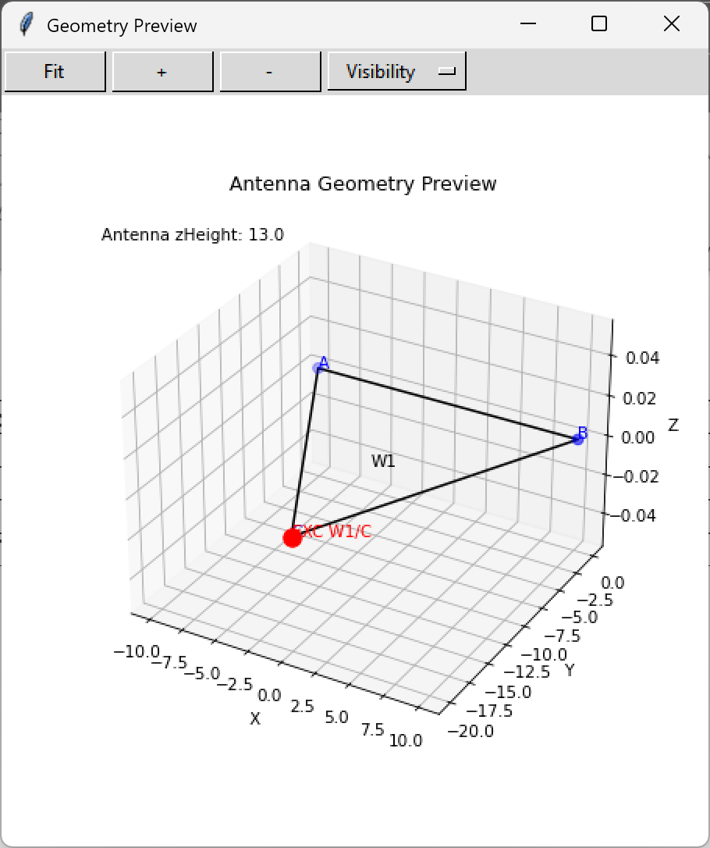  Figure 7a — Delta loop geometry: W1 loop through nodes A, B, C with W1/C feed point (red) at 13 m height. | Figure 7b — 3D radiation pattern at 29 MHz. Peak gain 13.49 dBi, BW 14.0°. ARRL scale.

J-Pole, 2 m, no stub
f = 145 MHz, wire radius = 1 mm, 10 m above real ground (ε = 14, σ = 0.005). J-ant144.maa MMANA-GAL library antenna. Note feed location.

10 m above Real Ground
Code | Zin (Ω) | Gain (dBi)
NeoMoM | 70.2 + j 86.7 | 6.38
NEC5 | 75.1 + j 89.0 | 6.56
MMANA-GAL | 72.7 + j 92.2 | 6.66

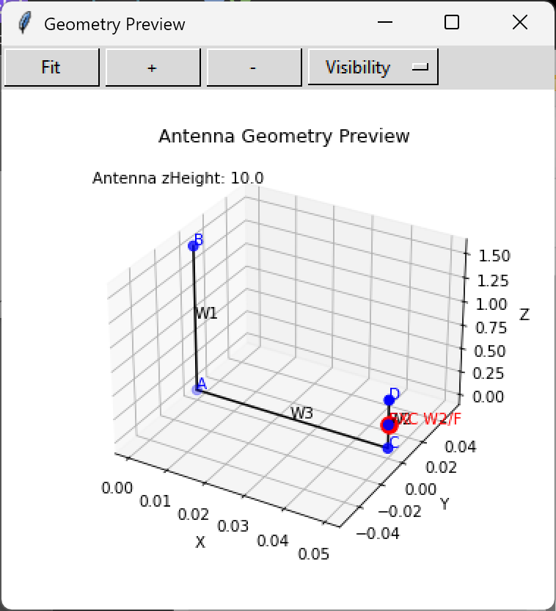  Figure 8a — J-pole geometry: W1 (vertical element), W3 (matching stub), W2/F feed, zHeight 10 m. | 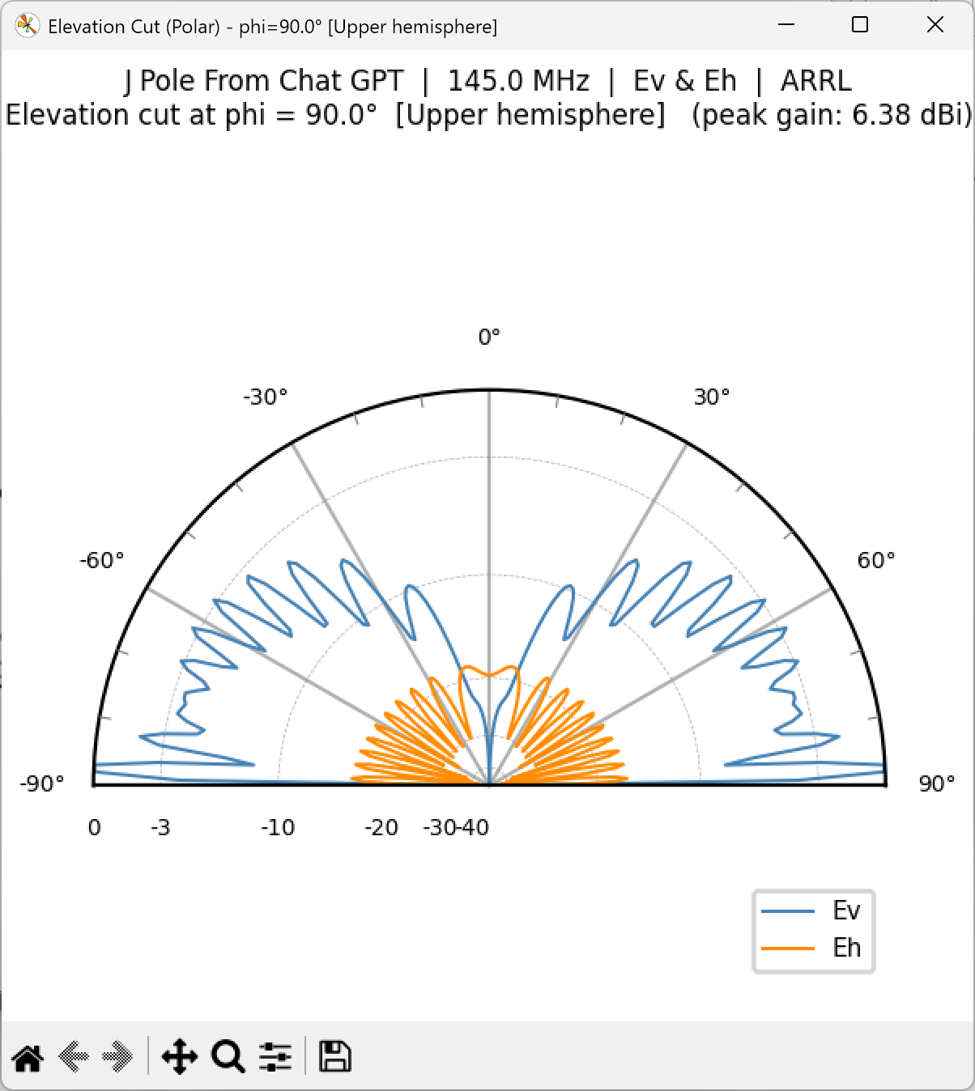  Figure 8b — Elevation pattern at 145 MHz, φ = 90°. Peak gain 6.38 dBi. Ev (blue) and Eh (orange).

J-Pole, 2 m — Stub Feed (0.049 λ Above Ground)
This version uses correct stub feed. Different geometry and frequency than the version above. f = 146 MHz, wire radius = 1 mm, 0.1 m (0.049 λ) above real ground. Dimensions were adjusted to produce resonance and stub height adjusted to give appropriate Zin.

0.1 m above Real Ground
Code | Zin (Ω) | Gain (dBi)
NeoMoM | 57.6 – j 3.14 | 1.3
NEC5 | 60.3 – j 8.30 | 1.12
MMANA-GAL | 64.4 – j 3.18 | 0.8

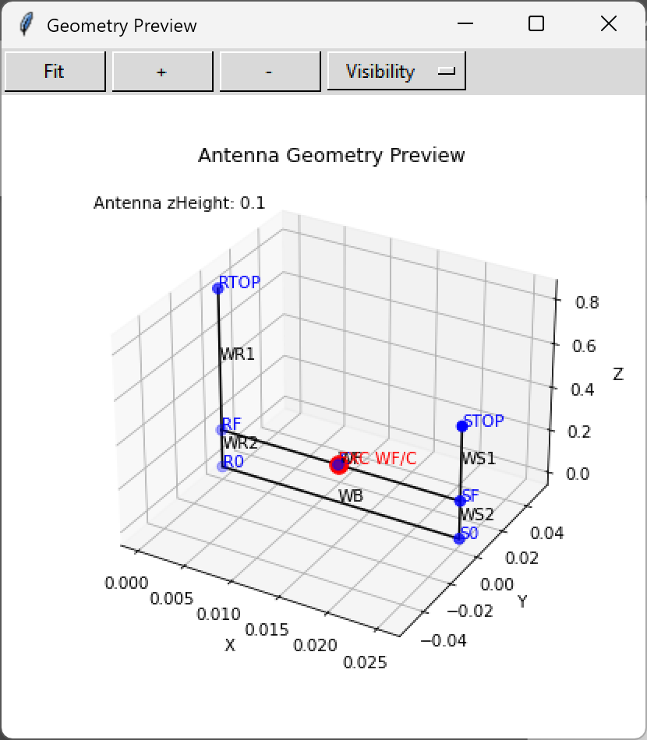  Figure 9a — J-pole stub feed geometry: WR1/WR2 (radiator), WS1/WS2 (stub), WB (base), WF/C feed (red). zHeight 0.1 m. | 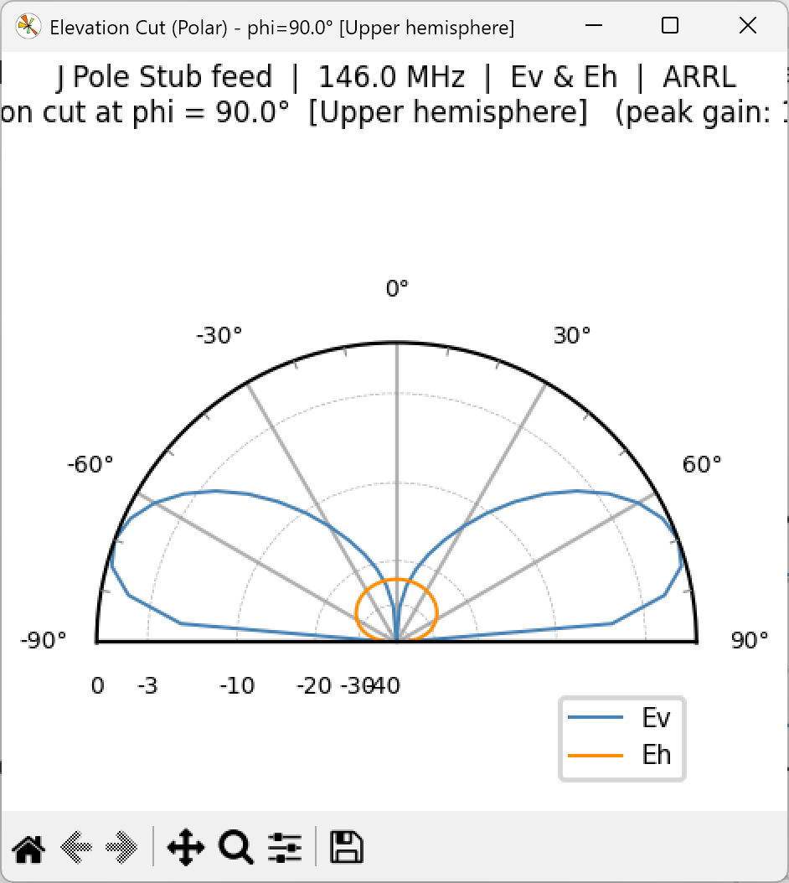  Figure 9b — Elevation pattern at 146 MHz, φ = 90°. Clean low-angle lobe with good Ev/Eh ratio. ARRL scale.
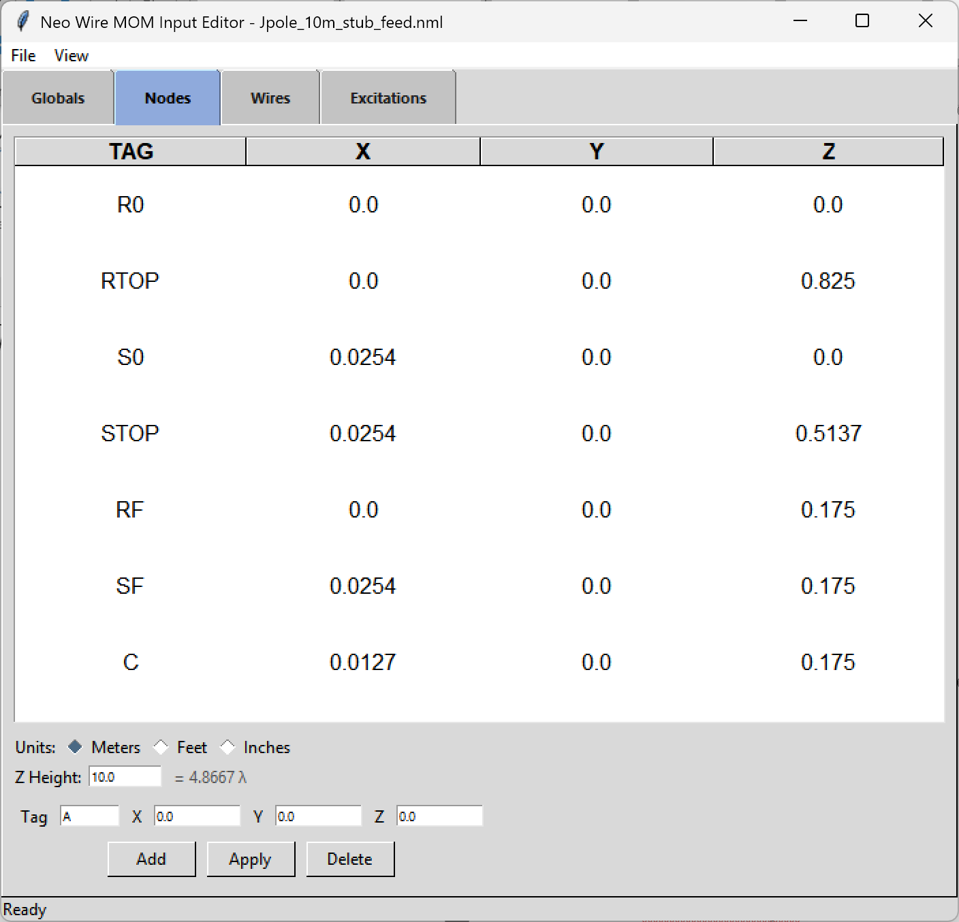

NeoMoM *.nml Input File Example
The *.nml file uses Fortran namelist syntax. It can be created or edited by hand or produced by neomom_input. The example below is for the 40 m Delta Loop at 29 MHz over real ground.

&RunTitle
title = '40 m Delta Loop at 10 m'
/

&Frequency_MHz
fmin = 29.0
fmax = 29.0
nFreq = 1
/

&GROUND
Ground_Plane = real
epsilon = 14.0
sigma = 0.005
/

&OPTONS
NBASISPERLAMBDA = 40
/

&node_input
zHeight = 13.0
nNodes = 3
units = meters
node_list(1) = A, -10.0, 0.0, 0.0
node_list(2) = B, 10.0, 0.0, 0.0
node_list(3) = C, 0.0, -20.0, 0.0
/

&wire_primitive
tag = W1
nNodes = 4
nodeTags = C B A C
radius = 0.001
/

&excitation_input
wireTag = W1
nodeTag = C
voltage = 1.0
phase_deg = 0.0
/

NeoMoM *.toml Input File Example
TOML is a possible modern alternative to Fortran namelist format. It is widely supported, human-readable, and has native parsers in most languages. The same 40 m delta loop case:

[RunTitle] title = "40 m Delta Loop at 10 m"

[Frequency_MHz] fmin = 29.0 fmax = 29.0 nFreq = 1

[GROUND] Ground_Plane = "real" epsilon = 14.0 sigma = 0.005

[OPTIONS]
NBASISPERLAMBDA = 40

[node_input] zHeight = 13.0 nNodes = 3 units = "meters"

[[node_input.node_list]] tag = "A" x = -10.0 y = 0.0 z = 0.0
[[node_input.node_list]] tag = "B" x = 10.0 y = 0.0 z = 0.0
[[node_input.node_list]] tag = "C" x = 0.0 y = -20.0 z = 0.0

[[wire_primitive]]
tag = "W1"
nNodes = 4
nodeTags = ["C", "B", "A", "C"]
radius = 0.001

[excitation_input]
wireTag = "W1"
nodeTag = "C"
voltage = 1.0
phase_deg = 0.0

