NeoMOM

  - “An amateur radio antenna prediction code”

John Shaeffer

KZ4TS, NFARL

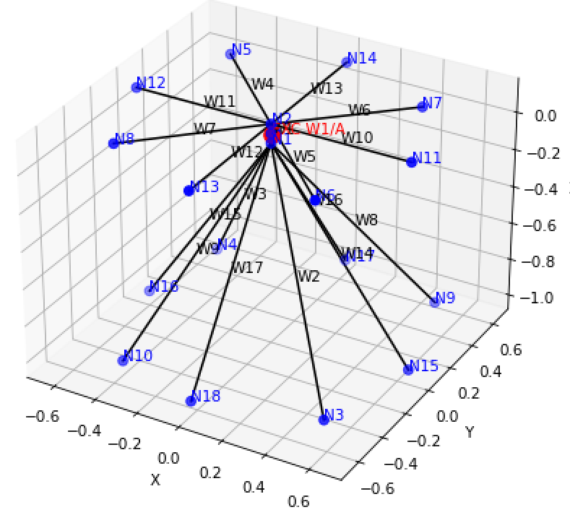

2026
Comments on modeling. From Lee

Abstract
NeoMoM is a wire-antenna modeling suite designed for amateur radio operators and antenna engineers. It predicts input impedances, SWR, gain and radiation patterns using a full-wave electromagnetic solver based on Maxwell’s equations.

System Overview
The suite consists of three integrated applications that together support the complete antenna modeling workflow:
- neomom_input — Antenna geometry creation and editing
- neomom — Computational Method of Moments (MoM) engine
- neomom_plot — Visualization and interactive pattern analysis with geographic map overlay

Key Features
- Open-source design intended for community use, extension, and experimentation
- Modern Python-based graphical user interfaces for input and visualization
- Direct import of MMANA-GAL (*.maa) files with minor editing for excitation
- Export capability for NEC5 and MMANA-GAL input formats ready for further editing

Design Foundations
NeoMoM builds on the legacy of tools such as NEC, EZNEC, MiniNEC, and MMANA-GAL while introducing:
- A more rigorous computational framework
- A modern object-oriented architecture
- Improved usability through graphical interfaces
Advances in computing—such as increased memory, multi-core processors, and modern programming techniques—enable higher-performance simulations using object-oriented Fortran and optimized numerical libraries. AI now allows development of modern GUI applications.

Core Concepts
Node-Based Geometry Definition
Antenna structures are defined using a list of tagged spatial nodes (x, y, z coordinates). From these nodes:
- Wire elements are constructed as tagged polylines
- Excitation is defined at a specific wire and node
- Geometry can be created either via GUI or text-based input

Full-Sphere Radiation Modeling
Neomom computes radiation fields (Eθ and Eφ) over the entire sphere. This global dataset enables:
- Arbitrary azimuth and elevation pattern cuts
- Full 3D radiation visualization
- Geographic map-based pattern overlays

Extensible GUI Framework
The input and visualization interfaces are implemented in Python using AI-assisted development. This approach encourages:
- Custom GUI development by users
- Experimentation and adaptation within the amateur radio community

System Components
Neomom_input
- Creates and edits *.nml input files
- Provides real-time 3D visualization of antenna geometry as nodes, wires, and excitations are defined.
- Supports:
  - Global parameters (frequency, ground type, title)
  - Node coordinate input (user-defined units)
  - Wire and excitation definitions
- Reads existing .nml and MMANA-GAL (.maa) files
- Exports NEC and MMANA-GAL *.nec and *.maa files which, after editing, can be used in NEC5 (EZ-NEC) and MMANA-GAL.
Neomom (Computational Engine)
- Full-wave Maxwell solver using the Method of Moments
- Triangle basis functions with Galerkin formulation
- Symmetric system matrix
- Input: Fortran namelist (*.nml)
- Output: Full-sphere complex Eθ and Eφ fields in *.csv format
Neomom_plot
- Input: Sphere values of E_{θ} and E_{φ} over full or half sphere, [θ,φ], data as output by neomom
- Visualization options:
  - 2D azimuth cuts (user-selected elevation)
  - 2D elevation cuts (user-selected azimuth)
  - 3D radiation patterns with ground plane
  - Top-down geographic view aligned to compass directions
- Advanced features:
  - Radiation pattern overlay on world, CONUS, or regional maps
  - Multiple map projections (azimuthal equidistant, Lambert conformal, plate carrée)
  - Adjustable orientation relative to geographic north
  - Scaling options: ARRL, dBi, dBpeak, or linear gain (Eθ, Eφ, total)

neomom_input
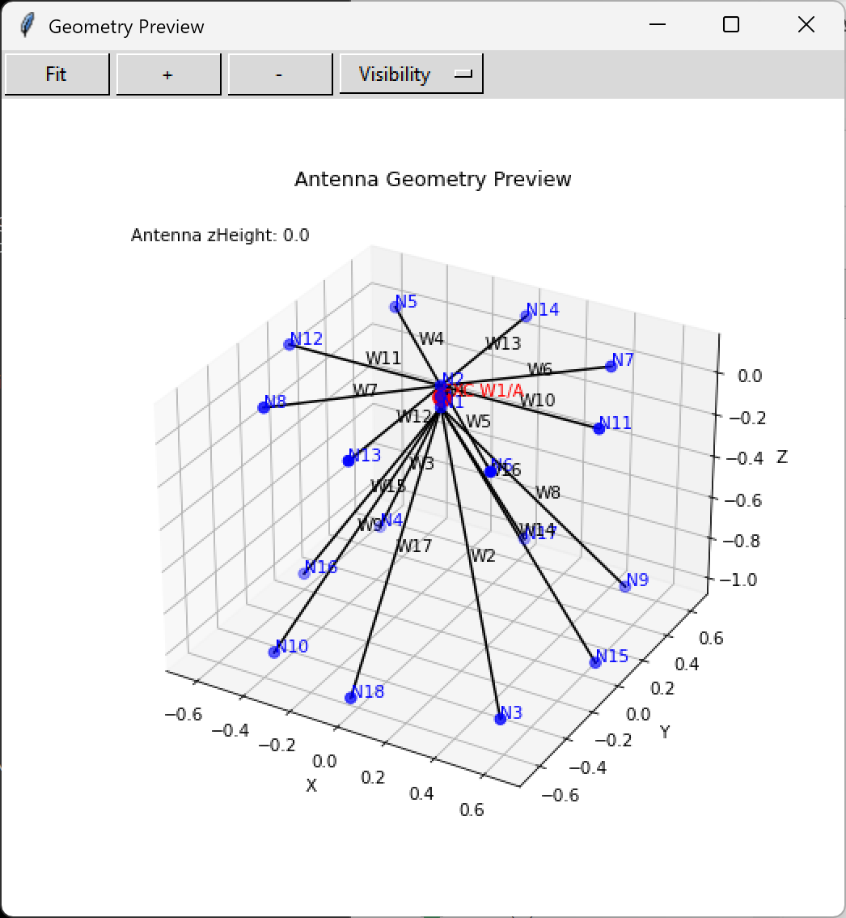
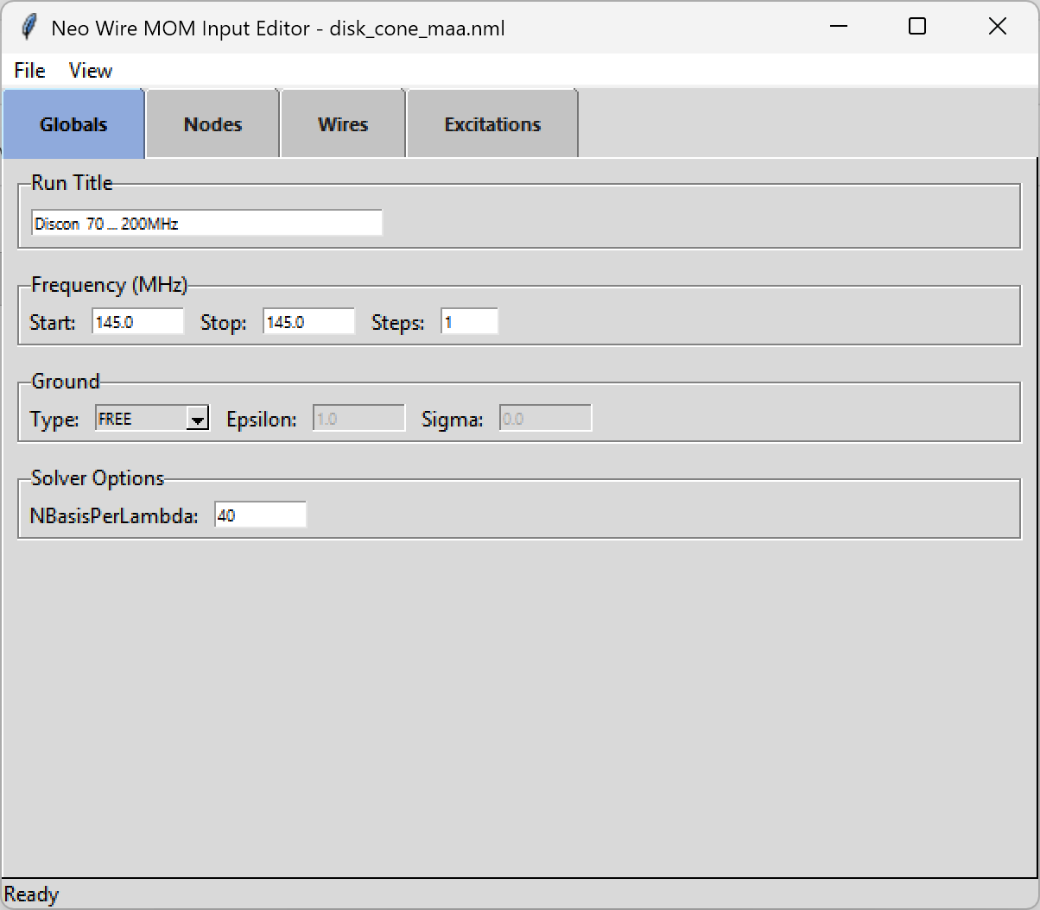

neomom_plot

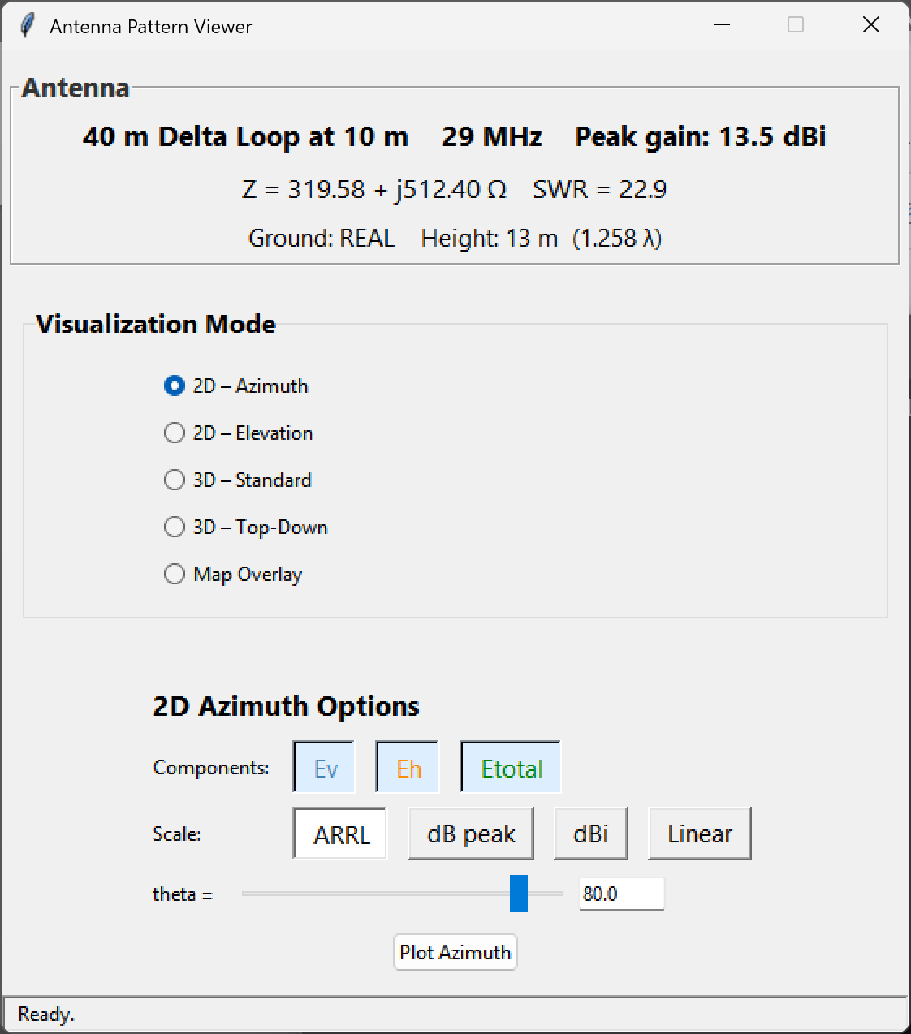

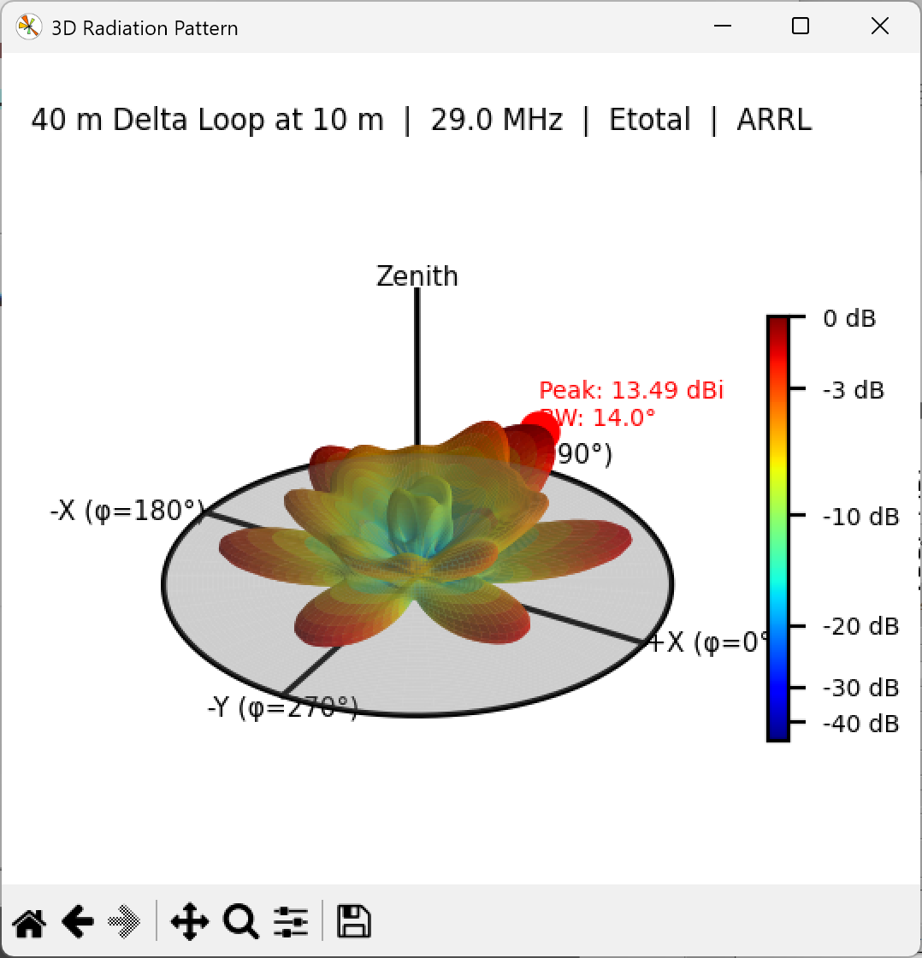

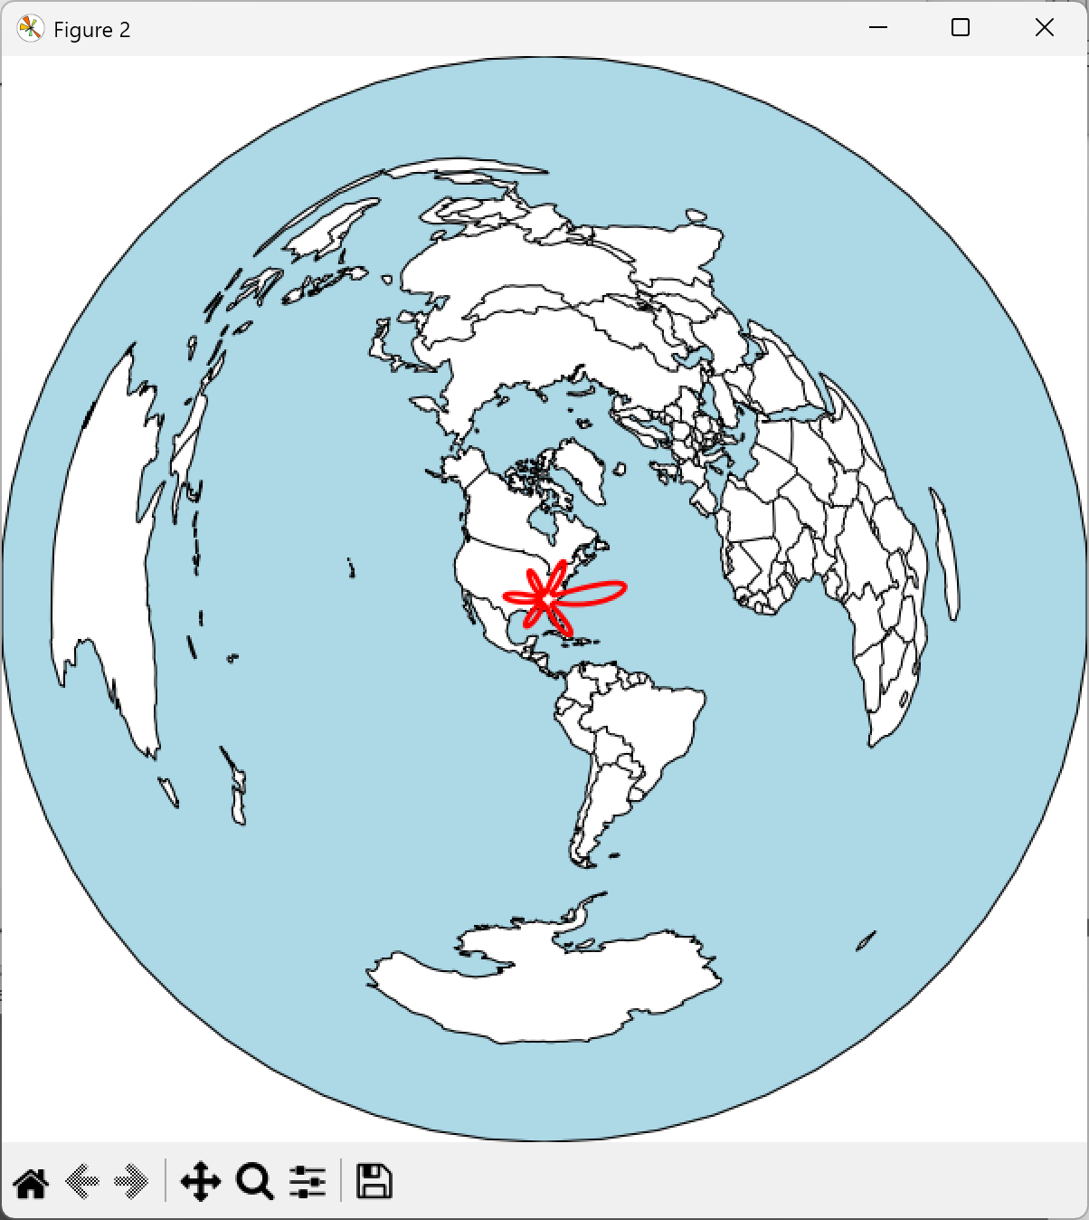

Validation

The following tables show input impedances and gain computed with neomom, NEC5, and mmana-gal for:
- Half wave dipole, center fed
- Folded dipole, center fed
- End fed half wave dipole
- Quarter wave vertical at and near ground, z = 0
- Disk cone VHF array of top hat radials and sloped cone radials
- Yagi, 6m, six element array
- Delta loop sized for 40 m. Computed results for 40 and 10 m
- J Pole, 2m, above real ground

Dipole, folded dipole, and EFHW results are for free-space, perfect PEC ground, and real ground.

Half wave dipole, centre fed

L = 20 m, f = 7.3 MHz, wire radius = 1 mm
Free Space, Perfect Ground, Real Ground
FREE SPACE
 | Zin (ohms) | Gain (max) dB
Neomom | 71.9 – j 0.12 | 2.14
Nec 5 | 71.6 - j 5.41 | 2.14 | GE = 0, GN = -1
Mmana-gal | 74.5 + j 2.05 | 1.99

10 m above perfect ground
 | Zin (ohms) | Gain (max) dB
Neomom | 84.5 + j 30.5 | 7.58
Nec 5 | 84.2 + j 25.0 | 7.58 | GE = 1, GN = 1
Mmana-gal | 74.1 + j 14.7 | 8.02

5 m above perfect ground
 | Zin (ohms) | Gain (max) dB
Neomom | 31.1 + j 29.3 | 8.72
Nec 5 | 31.6 + j 23.7 | 8.72 | GE = 1, GN = 1
Mmana-gal | 59.6 + j 2.6 | 5.0

10 m above real ground (14.0,0.005)
 | Zin (ohms) | Gain (max) dB
Neomom | 83.1 + j 17.9 | 6.0
Nec 5 | 82.5 + j 10.9 | 5.92 | GE = 1, GN = 2
Mmana-gal | 84.7 + j 32.6 | 5.87

5 m above real ground (14.0,0.005)
 | Zin (ohms) | Gain (max) dB
Neomom | 48.4 + j 23.2 | 5.86
Nec 5 | 55.6 + j 14.2 | 5.31 | GE = 1, GN = 2
Mmana-gal | 31.2 + j 31.3 | 7.88

Folded dipole, centre fed

L = 10.05 m, f = 14.05 MHz, wire radius = 1.5 mm, d = 0.2 m
fd20.maa file in the MMANA-GAL antenna library
Free Space, Perfect Ground, Real Ground

FREE SPACE
 | Zin (ohms) | Gain (max) dB
Neomom | 285 – j 0.74 | 2.19
Nec 5 | 286 – j 10.4 | 2.14 | GE = 0, GN = -1
Mmana-gal | 286 + j 4.00 | 2.13

5 m above PEC
 | Zin (ohms) | Gain (max) dB
Neomom | 328 + j 131 | 7.71
Nec 5 | 333 + j 121 | 7.71 | GE = 1, GN = 1
Mmana-gal | 327 + j 136 | 7.7

5 m above real gnd
 | Zin (ohms) | Gain (max) dB
Neomom | 320 + j 74.2 | 5.87
Nec 5 | 321 + j 56.8 | 5.85 | GE = 1, GN = 2
Mmana-gal | 327 + j 136 | 5.83

EFHF: End Fed Half Wave Dipole

L = 20 m, f = 7.3 MHz, wire radius = 1 mm
Free Space, Perfect Ground, Real Ground

FREE SPACE
 | Zin (ohms) | Gain (max) dB
Neomom | 1453 – j 1109 | 2.15
Nec 5 | 1484 – j 1296 | 2.15 | GE = 0, GN = -1
Mmana-gal | 2036 – j 17481 | 2.17

10 m above PEC
 | Zin (ohms) | Gain (max) dB
Neomom | 2143 – j 1400 | 7.6
Nec 5 | 2196 – j 1578 | 7.6 | GE = 1, GN = 1
Mmana-gal | 1612 - j 18123 | 7.6

10 m above real gnd
 | Zin (ohms) | Gain (max) dB
Neomom | 1853 – j 1315 | 6.0
Nec 5 | 1862 – j 1486 | 5.9 | GE = 1, GN = 2
Mmana-gal | 1612 - j 18123 | 5.9

Quarter Wave Vertical

L = 10 m, f = 7.3 MHz, wire radius = 1 mm
Perfect Ground, Real Ground
zH = 0.0 and 0.1 m

PEC Ground
0.0 m above PEC
 | Zin (ohms) | Gain (max) dB
Neomom | 27.2 – j 2334 | 5.18
Nec 5 | 36.7 – j 2.5 | 5.15 | GE = 1, GN = 1
Mmana-gal | 10.5 – j 17379 | 8.05

0.1 m above PEC
 | Zin (ohms) | Gain (max) dB
Neomom | 26.9 - j 2421 | 5.19
Nec 5 | 28.0 - j 2781 | 5.19 | GE = 1, GN = 1
Mmana-gal | 10.5 – j 17379 | 8.04

Real Ground
0.0 m above real gnd
 | Zin (ohms) | Gain (max) dB
Neomom | 47.0 – j 2429 | -2.5
Nec 5 | 48.6 - j 0.701 | -1.25 | GE = 1, GN = 2
Mmana-gal | 10.5 - j 17379 | 1.6

0.1 m above real gnd
 | Zin (ohms) | Gain (max) dB
Neomom | 38.4 – j 2478 | -1.67
Nec 5 | 44.6 – j 2794 | -2.08 | GE = 1, GN = 2
Mmana-gal | 10.5 - j 17379 | 1.62

Disk Cone

8 Top Hat Radials, 8 Cone Slopers
Discon55-200.maa file in the MMANA-GAL antenna library
f = 145 MHz, wire radius = 5 mm
Free Space

Free Space
 | Zin (ohms) | Gain (max) dB
Neomom | 137.5 + j 35 | 1.92 | θmax = 120 deg
Nec 5 | 135.6 + j 31.3 | 1.89 | GE = 0
Mmana-gal | 134 + j 33.8 | 1.95

Yagi, Six Element

6elYag.maa file in the MMANA-GAL antenna library
f = 50.5 MHz, wire radius = 7 mm
Free Space

Free Space
 | Zin (ohms) | Gain (max) dB
Neomom | 34.5 – j 2.71 | 11
Nec 5 | 35.3 – j 5.39 | 11 | GE = 0
Mmana-gal | 34.3 – j 2.32 | 11

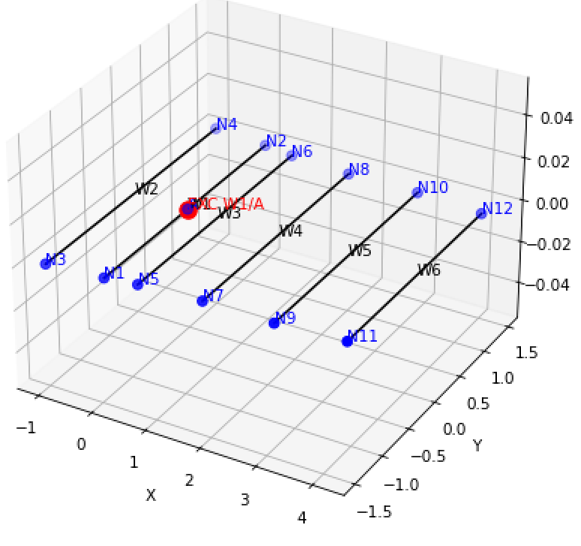

Delta Loop

f = 7.25 MHz, wire radius = 1 mm
13 m above Real Ground
13m above gnd
7.25 MHz | Zin (ohms) | Gain (max) dB
Neomom | 1749 - j 1582 | 5.77
Nec 5 | 1945 – j 1563 | 5.79
Mmana-gal | 1532 – j 1457 | 5.06

f = 29 MHz, wire radius = 1 mm
13 m above Real Ground
13m above gnd
29 MHz | Zin (ohms) | Gain (max) dB
Neomom | 347 + j 614 | 13.4
Nec 5 | 316 + j 568 | 13.5
Mmana-gal | 367 + j 637 | 6.88
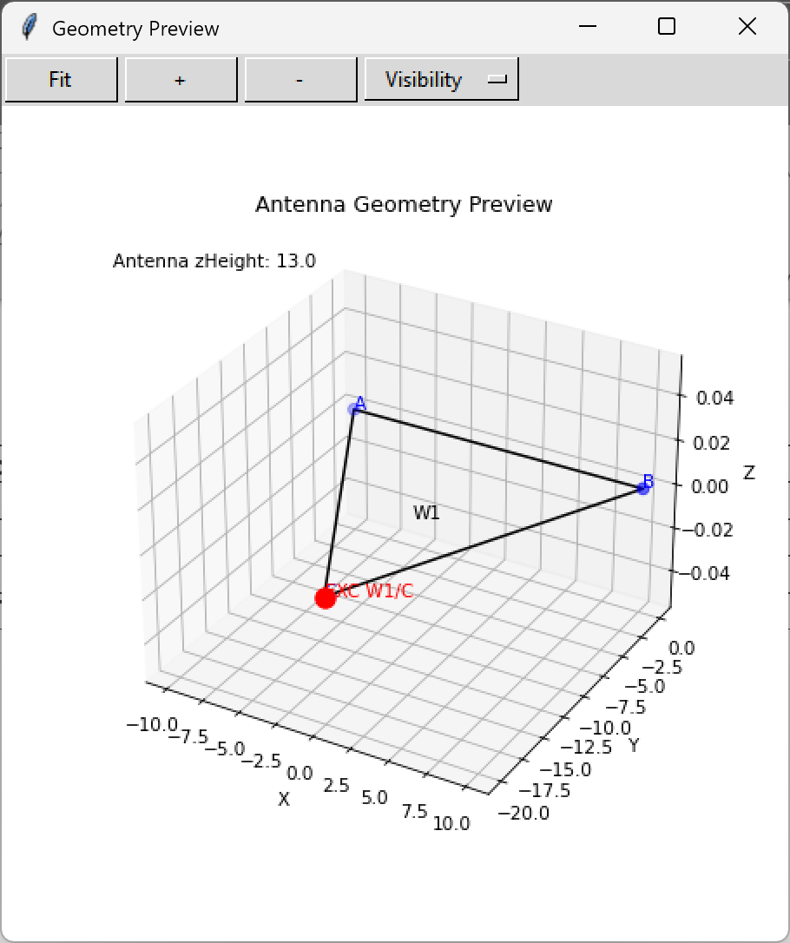

J Pole, 2m

f = 145 MHz, wire radius = 1 mm
10 m above Real Ground
10m above gnd
145 MHz | Zin (ohms) | Gain (max) dB
Neomom | 70.2 + j 86.7 | 6.38
Nec 5 | 75.1 + j 89.0 | 6.56
Mmana-gal | 72.7 + j 92.2 | 6.66
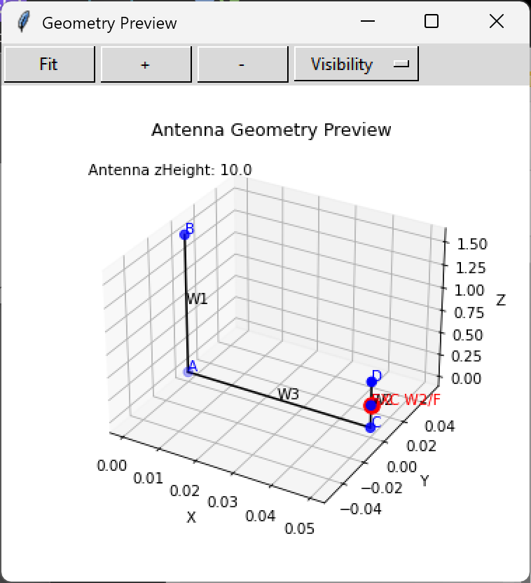
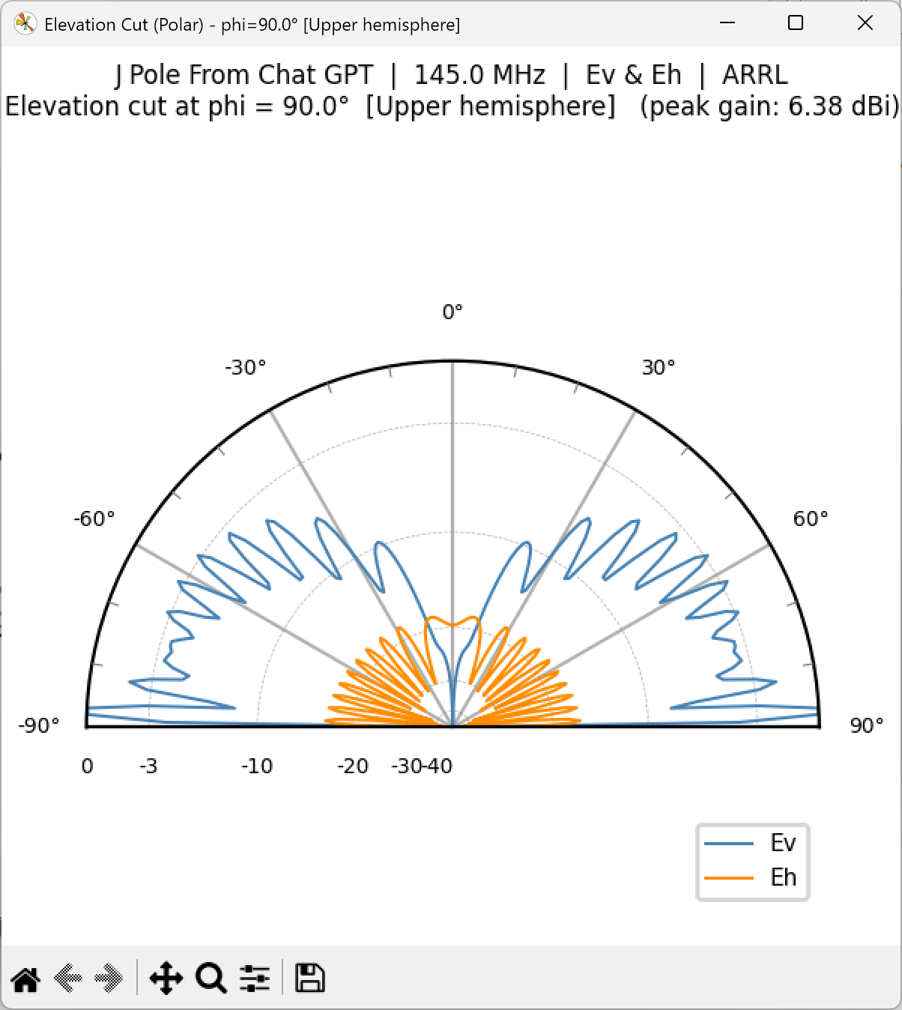

J Pole, 2m, 0.05 λ Above Ground

This J Pole version is the correct gamma match feed
Different size and frequency than the version above
f = 146 MHz, wire radius = 1 mm
0.1 m (0.049 λ) above Real Ground
0.1 m above gnd
146 MHz | Zin (ohms) | Gain (max) dB
Neomom | 57.6 – j 3.14 | 1.3
Nec 5 | 60.3 – j 8.30 | 1.12
Mmana-gal | 64.4 – j 3.18 | 0.8

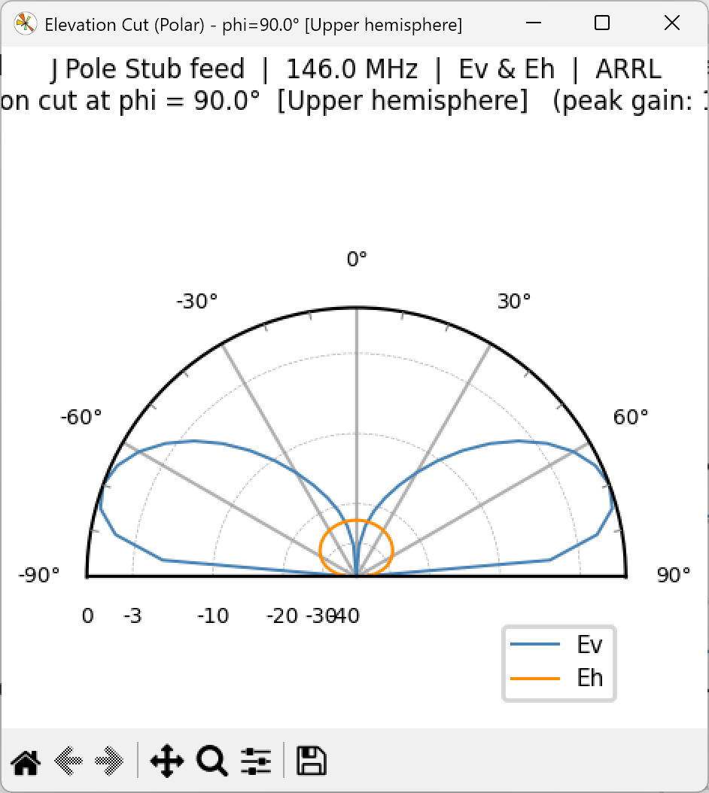
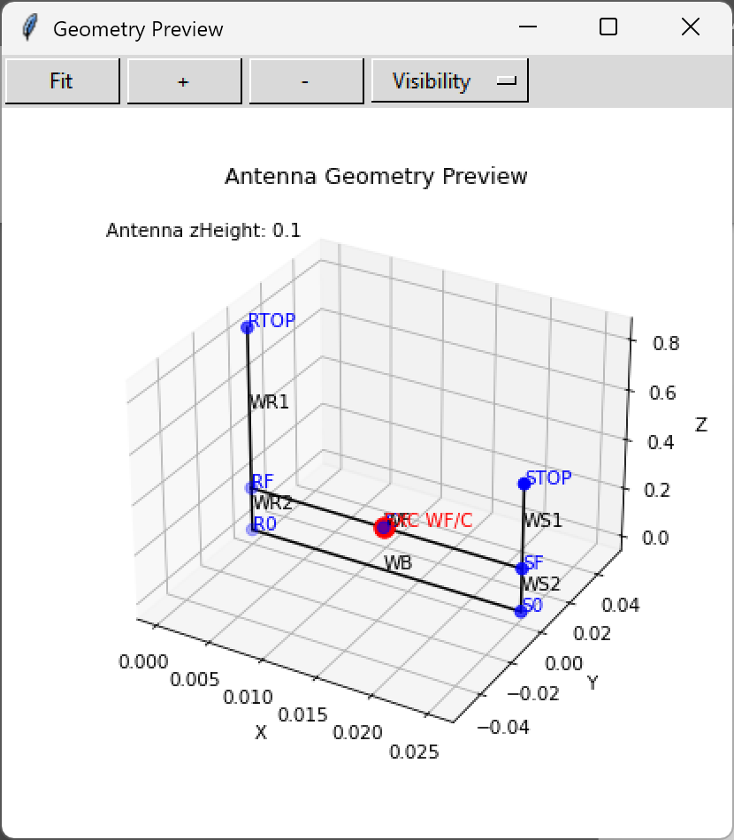

Neomom *.nml input file example

Hand edit or use neomom_input gui

&RunTitle title = '40 m Delta Loop at 10 m' /

&Frequency_MHz fmin = 29.0 fmax = 29.0 nFreq = 1/

&GROUND Ground_Plane = real epsilon = 14.0 sigma = 0.005/

&OPTONS NBASISPERLAMBDA = 40/

&node_input zHeight = 13.0 nNodes = 3 units = meters
node_list(1) = A, -10.0, 0.0, 0.0
node_list(2) = B, 10.0, 0.0, 0.0
node_list(3) = C, 0.0, -20.0, 0.0
/

&wire_primitive
tag = W1,
nNodes = 4,
nodeTags = C B A C
radius = 0.001
/

&excitation_input
wireTag = W1
nodeTag = C
voltage = 1.0
phase_deg = 0.0
/

Neomom *.toml input file example

Possible alternative to namelist input. Modern form for *.ini formats. Widely supported.

[RunTitle] title = "40 m Delta Loop at 10 m"

[Frequency_MHz] fmin = 29.0 fmax = 29.0 nFreq = 1

[GROUND] Ground_Plane = "real" epsilon = 14.0 sigma = 0.005

[OPTIONS] NBASISPERLAMBDA = 40

[node_input] zHeight = 13.0 nNodes = 3 units = "meters"

[[node_input.node_list]] tag = "A" x = -10.0 y = 0.0 z = 0.0
[[node_input.node_list]] tag = "B" x = 10.0 y = 0.0 z = 0.0
[[node_input.node_list]] tag = "C" x = 0.0 y = -20.0 z = 0.0

[[wire_primitive]] tag = "W1" nNodes = 4 nodeTags = ["C", "B", "A", "C"] radius = 0.001

[excitation_input] wireTag = "W1" nodeTag = "C" voltage = 1.0 phase_deg = 0.0

