Technical Report – Week 2: Deployment Automation for FarmaciaKB

# 1. Introduction

This report documents the improvements made in the deployment process of the GeneXus application 'FarmaciaKB' as part of the technical internship at CEDIA. The goal of Week 2 was to analyze the existing manual deployment workflow and replace it with a fully automated PowerShell script to increase reliability, reproducibility, and developer efficiency.

# 2. Manual Deployment Process (Previous State)

The original deployment process involved several manual steps:

- Manually copying files from the Genexus build output directory to the IIS web directory.

- Backing up the current site files manually to a backup location.

- Restarting the IIS Application Pool through the IIS Manager GUI.

- No log was generated to track changes or actions.

This approach was error-prone, time-consuming, and lacked traceability.

# 3. Automated Deployment Process (Proposed Improvement)

A PowerShell script was developed to automate the following tasks:

- Create a timestamped backup of the current deployed application.

- Copy the latest GeneXus-generated build files to the IIS directory.

- Restart the associated Application Pool in IIS.

- Append a timestamped log entry confirming the success of the deployment.

This script reduces human error, ensures consistency, and adds visibility to deployment activities.

# 4. Comparison Table

|  |  |  |
| --- | --- | --- |
| Task | Manual Process | Automated Script |
| Backup | Manual copy-paste | Automatically created with timestamp |
| File Copy | Manual drag-and-drop | Scripted copy from build to IIS |
| App Pool Restart | Manually via IIS Manager | Scripted using Restart-WebAppPool |
| Logging | Not performed | Log file entry created with timestamp |

# 5. Deployment Flow Diagram

The following is a simplified flow diagram representing the automated deployment process:

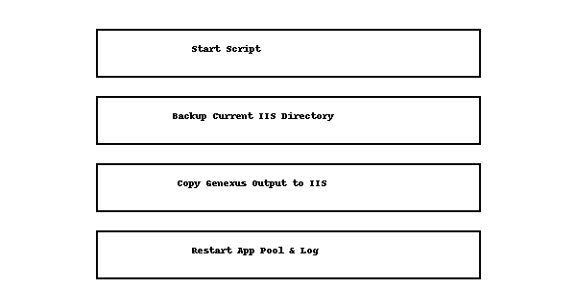

# 6. Conclusion

Automating the deployment process improved the consistency and speed of the operation, while reducing human error. This change is part of a broader effort to modernize the software development lifecycle within CEDIA’s infrastructure. Future improvements could include CI/CD integration or email notifications upon completion.