B Active in store checkout guide
Use after manager release approval. Screens show the implemented local training system with synthetic sales; they do not establish live payment readiness.

Choose and review the items
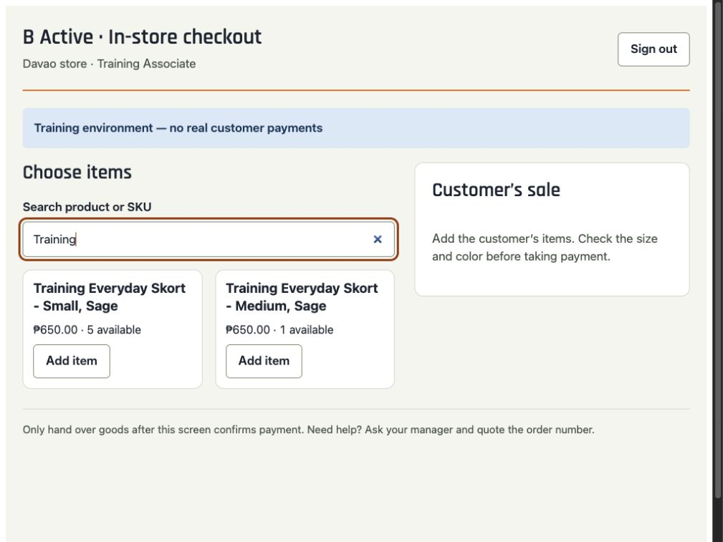
Training example — synthetic items and payments.

1 Sign in
Use your own account. Open B Active cashier, then Open tablet checkout. Check your name. Keep the tablet online.

2 Add exact items
Search the product or SKU. Check size, color and quantity against the items in your hand. Tap Add item. Use + or − in the basket to adjust quantity.

3 Review the sale
Enter an email only if the customer wants a confirmation. Tap Review sale & payment, then read the final total to the customer.
Missing item, incorrect stock or wrong price? Stop and ask your manager.

Take cash
Training example — synthetic sale on the implemented cashier screen.
1 Count the money  Enter the cash you actually counted under Amount received (PHP). Check the change shown.  2 Confirm once  Tap Confirm cash received once. Wait for Payment received on the cashier screen.  3 Return the change  Return the displayed change. Continue to the invoice and handover steps on page 4.  An error does not mean the sale failed. Refresh the same sale before collecting again. | 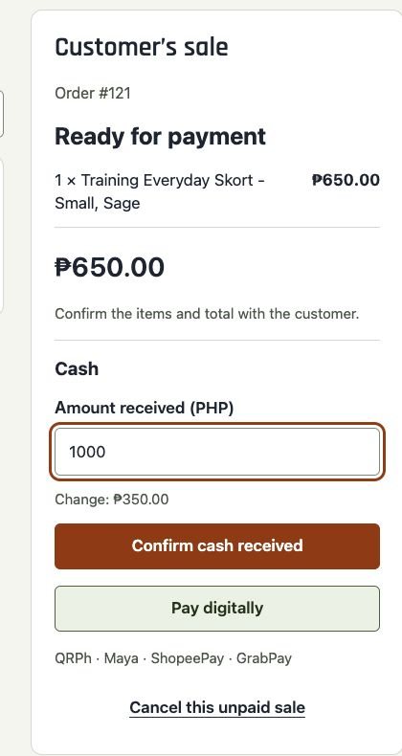

Take a digital payment
Training example — synthetic sale on the implemented cashier screen.
1 Open the payment page  Tap Pay digitally. Ask the customer to scan the code with their phone camera. They choose QRPh, Maya, ShopeePay or GrabPay on the secure payment page.  2 Wait for confirmation  Keep this screen open. It checks automatically; you can also tap Refresh payment status. Wait for Payment received before continuing to page 4.  3 Keep the same sale  If payment remains pending, keep the goods and ask a manager. Do not switch to cash or create a replacement sale.  The displayed code opens a website. It is not the bank-app QRPh code. Never use a customer screenshot as proof of payment. | 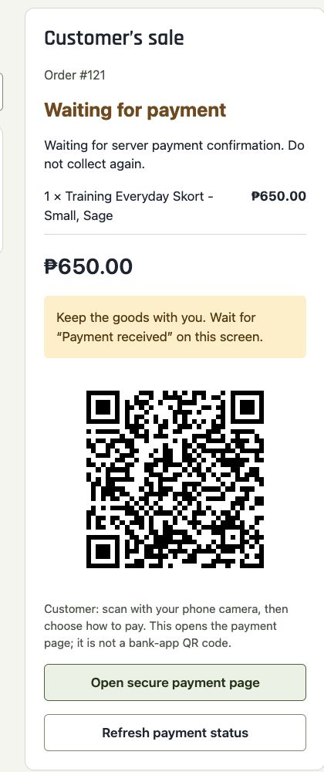

Write the invoice and hand over
Training example — synthetic sale on the implemented cashier screen.
1 Check payment  The cashier screen must say Payment received. Recheck the items, sizes, colors and any change.  2 Write the invoice  Issue a registered handwritten invoice for every sale. Enter its serial number under Handwritten invoice number.  3 Give the customer their purchase  Give the invoice, goods and any change. Tap Confirm invoice & hand over goods as you hand them over.  Only the manager may resolve payment or stock exceptions. Never bypass a pending or review message. | 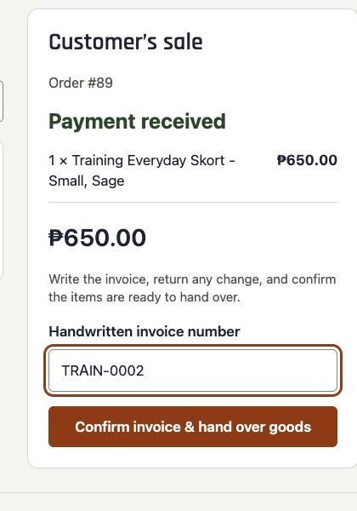

Finish the sale
Training example — synthetic sale on the implemented cashier screen.
1 Check completion  Confirm Sale complete and the invoice number, then tap Start next sale.  2 Handle email requests  Submitted to email service means accepted for sending, not delivered. Use Resend email confirmation if needed. Resending does not collect payment again.  3 Sign out  Use Sign out when finished. An unfinished sale remains linked to your account; sign back in with the same account to resume it.  The email is an order/payment confirmation, not a BIR tax invoice. Always give the handwritten invoice. | 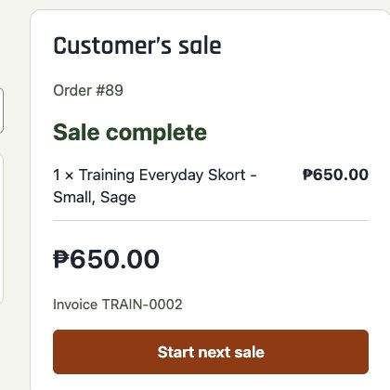

Dos and donts

Do
Use your own account. Check exact variations. Count cash. Read the final total. Wait for the cashier’s payment confirmation. Issue a registered handwritten invoice for every sale.

Do not
Accept payment screenshots. Hand over while pending. Change a pending digital sale to cash. Create a replacement sale after an error. Use a separate QR or payment link. Share accounts or adjust inventory yourself.

When to stop and ask for help

Waiting for payment
Keep the goods. Refresh this sale. Ask a manager if unresolved.

Manager help needed
Stop. Quote the order number. Do not collect again or hand over goods.

Connection lost
Keep the page open. Reconnect and refresh the same sale.

Check the previous request
Tap Resume this sale. Retry this same sale, if shown, repeats the original reference and items without taking payment.

Sale cannot be found
Ask a manager to check your active sale. Do not create a replacement.

Wrong basket after review
Use Cancel this unpaid sale only if available. Wait for cancellation before starting the corrected sale. Otherwise ask a manager.

Refund exchange or discount
Ask a manager. These actions are not available at the cashier.

Email sending failed
Resend the email confirmation. Do not repeat checkout.
Always quote the order number when asking your manager for help.

