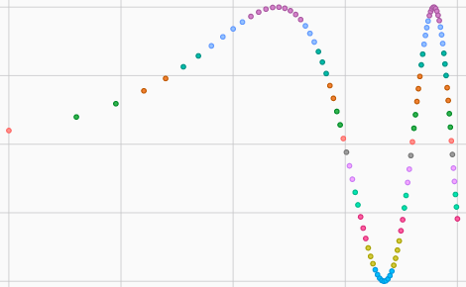
ggplot Reference Card v0.1
(c) 2014 John Lynch – john.lynch@iname.com
Information taken liberally from the ggplot documentation and various
other sources. You may freely modify and distribute this document.

1 Introduction
ggplot was developed by Yhat to provide a system for plotting and visualization based on ggplot2 and the book "The Grammar of Graphics"
Details and examples can be found in the manual. https://github.com/yhat/ggplot/
Grammar represents an abstraction of objects aiming to shorten the distance from mind to page by mapping data to aesthetic attributes and geometric objects. Think of looking at how y changes with x across levels of z.
pip install ggplot to install
Load with import ggplot or from ggplot import *
2 Invoking Plot .
This form is the standard "grammar of graphics" method of plotting. Data is supplied in the form of a dataframe, columns of the data are bound to aesthetics, and plot elements including scales, coordinates, statistics, guides, and geometries are added to the plot.
ggplot(data::AbstractDataFrame, elements::Element...; mapping...)
p = ggplot(dfname, aes('c1','c2')) | generates plot object of c2 vs c1
p = ggplot(aes(x="c1", y="c2"), data=name) | same
p + geom_line(color='red') + ... | add geom to plot as a red line
p = (ggplot(df2, aes('x', 'diffs')) +  geom_point(color='blue') + | plot df2[diffs] with blue points  and also df[dy] as red lines
geom_line(df, aes('x', 'dy'), color='red') | without using pandas melt
3 Modifying Aesthetics
plot(..., color ="c3", ...) | color based on categories in c3
plot('x', 'value', color = 'variable') | color based on melted dataframe
4 Geometries do the actual drawing
geom_point(color='blue') | use points and optionally specify color
geom_point(alpha=0.05, color='red') | change transparency and color
geom_lines() geom_step() | use lines
geom_bar() geom_histogram(binwidth=x)
geom_density(color=, fill=True, alpha=0.5)
geom_jitter() geom_text(label='this')
geom_tile(fill=x)
geom_area(ymin=l, ymax=h)
geom_abline()
geom_hline(y=y1) + geom_vline(x=x1)
geom_now_its_art()
4 Statistics transform one or more aesthetics and draw
stat_smooth() | add loess smoothing of chart points
stat_smooth(span=.15, se=True) | adjust smoothing (.66 default)  and turn standard error shading on
5 Guides draw graphics to support the visualization such as axis ticks, labels and keys
xlab("Time") ylab("Info") | set x label or y label
labs('Time', 'Ratio') | set x and y labels
ggtitle('Amazing ggplot Example')
6 Scales transform the data to aid visualization
scale_x_continuous()  scale_x_discrete  scale_x_log scale_y_log | log10 axis
scale_x_reverse scale_y_reverse | reverse axis
scale_color_manual(values=[color1,...])
scale_color_gradient(low=co1, high=co2) | with aes color set to values
scale_color_brewer() | coming
scale_x_date
7 Showing Facets and Layers
facet_wrap('col_for_facetting')
facet_grid(col1, col2, scales='free_y')
8 Output to other Formats
ggsave(plotname, "filename.png") | Coming: PDF
9 Themes
Many parameters controlling the appearance of plots can be overridden by passing a Theme object to the plot function.
theme_gray() | default theme
theme()
theme_bw()
theme_seaborn()
theme_xkcd()
theme_matplotlib()
10 Pandas
stack on c1 vals: df2 = pd.melt(df[['c1', 'c2', 'c3', 'c5']], id_vars='c1')
ggplot(df2, aes(x='c1', y='value', colour='variable'))

