CS 207 : Minor-Project

Title: Ministry of Human Resource and Development

-150001014, 150001012

Users:

* Public
* HRD Ministers
* Dean/Staff members.

List of features:

* Homepage
* Display list of ministers.
* Display list of schools and Colleges.
* Login page for ministers.
* Login page for Dean/principal.
* Report/ Lodge a complaint.
* View Grievances.
* Delete Grievances that have been rectified.
* Online application to setup a School.
* See land allocation details.
* Display details of funds sanctioned.
* Request for funds on behalf of an educational institution.
* Display fund requests.
* Add new Schemes and Scholarships.
* Display Schemes and Scholarships.
* Approve/Reject applications to setup a school.
* Approve/Reject request for funds.
* Update details of scholarships.
* Search by name/id.
* Dean- Login page.
* Minister-Login page.
* Administrator-Login Page.

Privileges:

Public:

(read only)

* View list of Ministers, Schools, Colleges
* View Grievances.
* View Schemes and Scholarships.

(write)

* Issue application to setup a school.

Dean/Staff members:

( read and write)

* Issue a complaint.
* Delete a grievance.
* Apply for funds.
* Privileges of Public are also valid for Dean/Staff.

Minister:

(read and write)

* View Funds sanctioned.
* View and approve funds.
* View applications to setup a school and approve/reject.
* Shut down a school if required.
* Update details of Schemes and Scholarships.
* Privileges of public are valid for Ministers as well.

Administrator:

* Read, alter or delete data.
* Direct access to the entire database.

# Final list of tables:

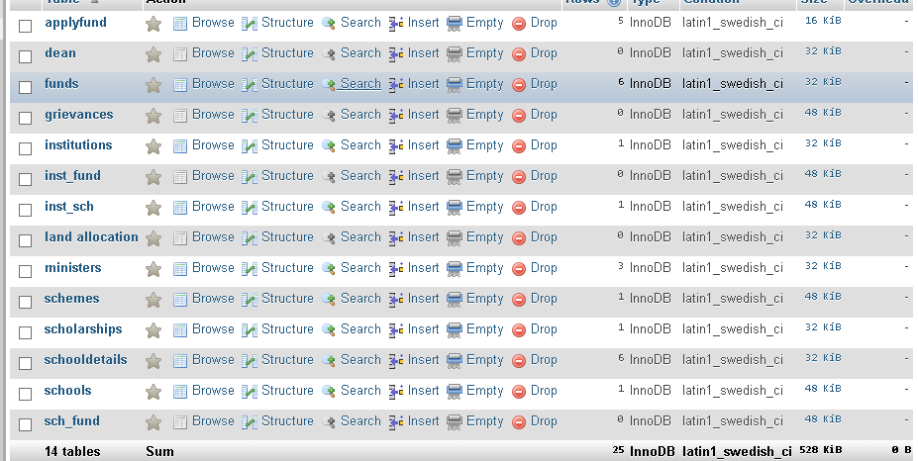

Triggers used:

