MACHAKOS UNIVERSITY
MATHEMATICS AND COMPUTER SCIENCE
GRACE NGIGE
SO9-9183-2021
SC0 113
FOUNDATION OF ARTIFICIAL INTELLIGENCE

1. choose(c) :-career path(c),not (choose(c))
career path A
career path (B)
choose (A)
Then
?-choose(A)
yes
?-choose(B)
no
?-choose (which)
which=A;
no
?-not(choose(which))
no
2.
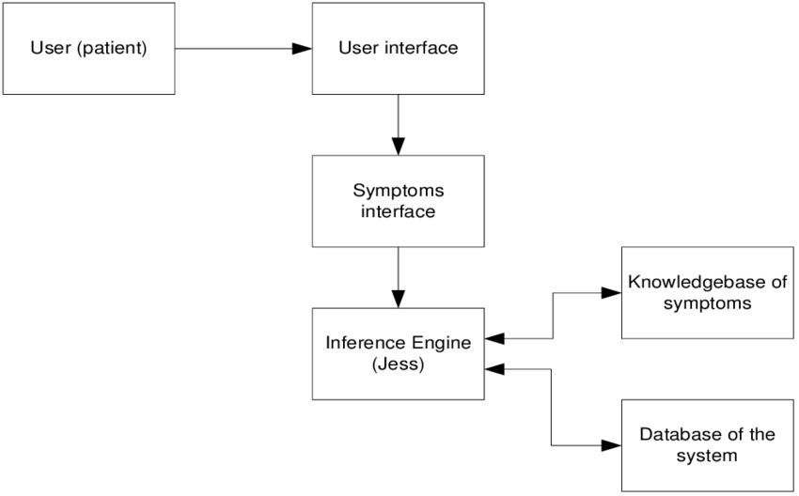
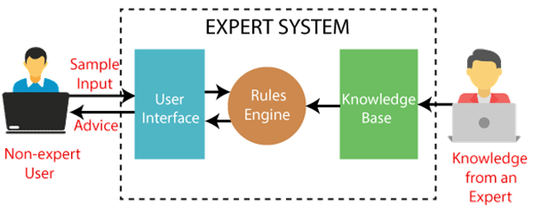

knowledge base
The knowledge base is a collection of rules or other information structure derived from the human expert. Rules are typically structured as if then statements form ;IF<antecedent>THEN<consequent>
The antecedent is the condition that must be satisfied when the antecedent is the action that is performed when the rules fire.

Inference engine
it is the main element of the expert system .the inference engine chooses rules from the agenda to fire. it if there are no rules on the agenda the inference engine must obtain information from the user to add more rules to the agenda. It makes use of the knowledge base to conclude situations. It is responsible for gathering information from the user by asking various questions and applying it whenever necessary .it seeks information and relationship from the knowledge base and answers predictions and suggestions the way a human expert would.

User interface
it is a method by which the expert system interacts with the user. These can be through dialog boxes, commands prompts,forms or other input methods. some expert system will have interaction mechanism for methods. Some expert system will have interaction mechanism for transactions with other application and will not have a user interface.

Mini-Max Algorithm

Mini-max algorithm is a recursive or backtracking algorithm that is used in decision-making and game theory. It provides an optimal move for the player assuming that the opponent is also playing optimally. Mini-Max algorithm uses recursion to search through the game tree. Min-Max algorithm is mostly used for game playing in AI. Such as Chess, Checkers, tic-tac-toe, go, and various tow-players game. This Algorithm computes the minimax decision for the current state. In this algorithm two players play the game; one is called MAX and the other is called MIN. Both the players fight it as the opposing player gets the minimum benefit while they get the maximum benefit. Both Players of the game are opponents of each other, where MAX will select the maximized value and MIN will select the minimized value. The minimax algorithm performs a depth-first search algorithm for the exploration of the complete game tree.

The working of the minimax algorithm can be easily described using an example.
I have taken an example of a game tree which is representing a two-player game.
- In this example, there are two players: Maximizer and the other is called Minimizer.
- Maximizer will try to get the maximum possible score, and Minimizer will try to get the minimum possible score.
This algorithm applies DFS, so in this game tree, we have to go all the way through the leaves to reach the terminal nodes.
At the terminal node, the terminal values are given so we will compare those values and backtrack the tree until the initial state occurs. Following are the main steps involved in solving the two-player game tree:

In the first step, the algorithm generates the entire game tree and applies the utility function to get the utility values for the terminal states. In the below tree diagram, let's take A as the initial state of the tree. Suppose the maximizer takes the first turn which has a worst-case initial value =- infinity, and the minimizer will take the next turn which has a worst-case initial value = +infinity.

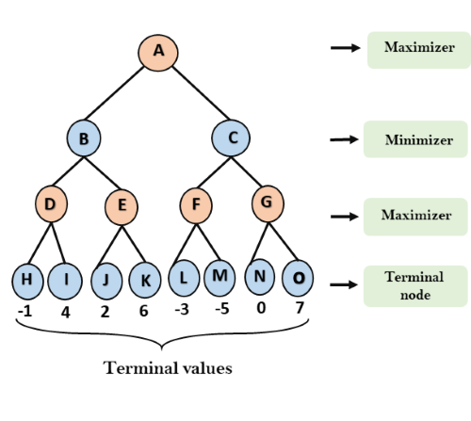

The alpha prunning standard algorithm
the alpha prunning standard algorithm returns the same more as the starndard algorithm does but if removes all the nodes which are not really attracting the final decision but making algorithm slow.
The max player will only update the value of the alpha .
The min player will only update the value of beta.
While backtracking the tree the node values will be passed to upper nodes instead of values of alpha and beta.
We will only pass the alpha and beta values to the child nodes.

