The process model introduced in Chapter 3 assumed that a process was an
executing program with a single thread of control. Virtually all modern operat-
ing systems, however, provide features enabling a process to contain multiple
threads of control. Identifying opportunities for parallelism through the use of
threads is becoming increasingly important for modern multicore systems that
provide multiple CPUs.

A thread is a basic unit of CPU utilization; it comprises a thread ID , a program
counter ( PC ), a register set, and a stack. It shares with other threads belonging
to the same process its code section, data section, and other operating-system
resources, such as open files and signals. A traditional process has a single
thread of control. If a process has multiple threads of control, it can perform
more than one task at a time. Figure 4.1 illustrates the difference between a
traditional single-threaded process and a multithreaded process.

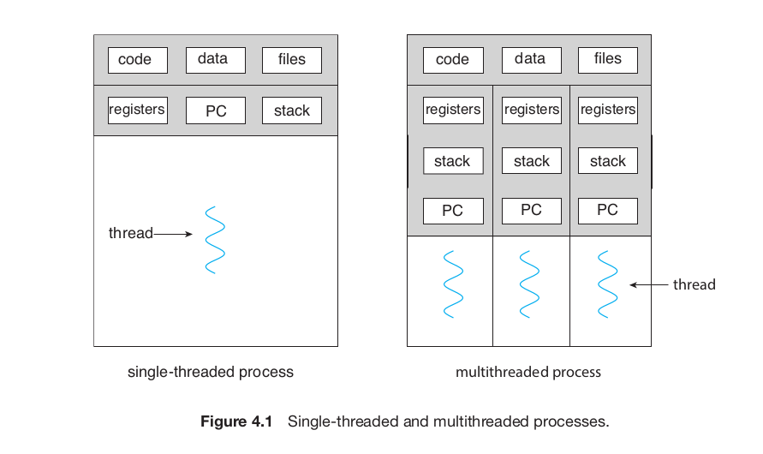

Process creation is time consuming and
resource intensive, however. If the new process will perform the same tasks as
the existing process, why incur all that overhead? It is generally more efficient
to use one process that contains multiple threads.

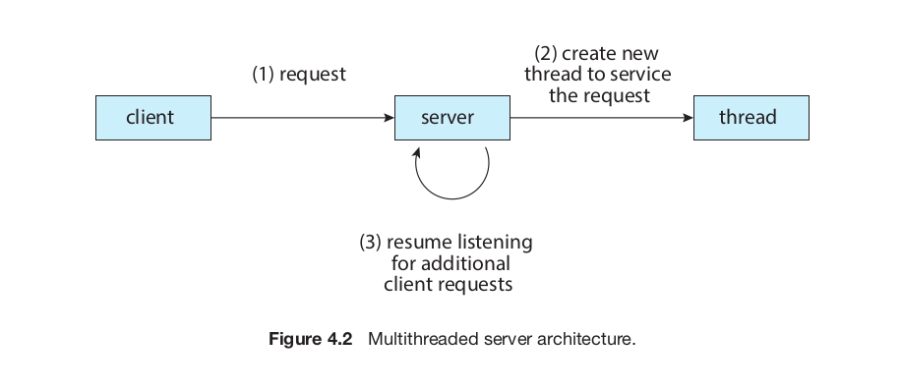

Benefits
1. Responsiveness. Multithreading an interactive application may allow a
program to continue running even if part of it is blocked or is perform-
ing a lengthy operation, thereby increasing responsiveness to the user.
This quality is especially useful in designing user interfaces. For instance,
consider what happens when a user clicks a button that results in the
performance of a time-consuming operation. A single-threaded appli-
cation would be unresponsive to the user until the operation had been
completed. In contrast, if the time-consuming operation is performed in
a separate, asynchronous thread, the application remains responsive to
the user.
2. Resource sharing. Processes can share resources only through techniques
such as shared memory and message passing. Such techniques must
be explicitly arranged by the programmer. However, threads share the
memory and the resources of the process to which they belong by default.
The benefit of sharing code and data is that it allows an application to
have several different threads of activity within the same address space.
3. Economy. Allocating memory and resources for process creation is
costly. Because threads share the resources of the process to which they
belong, it is more economical to create and context-switch threads.
Empirically gauging the difference in overhead can be difficult, but in
general thread creation consumes less time and memory than process
creation. Additionally, context switching is typically faster between
threads than between processes.
4. Scalability. The benefits of multithreading can be even greater in a mul-
tiprocessor architecture, where threads may be running in parallel on
different processing cores. A single-threaded process can run on only
one processor, regardless how many are available. We explore this issue
further in the following section.

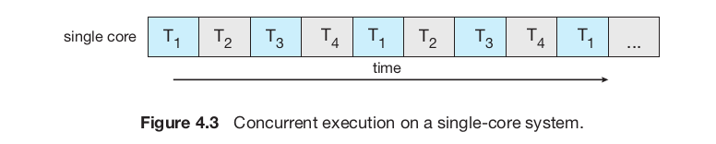

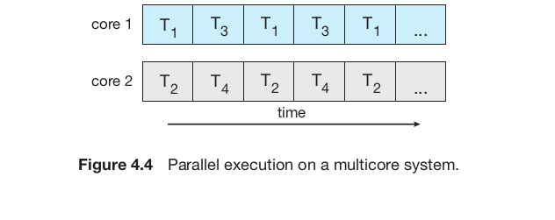

In general, five areas present challenges in programming for multicore
systems:
1. Identifying tasks. This involves examining applications to find areas
that can be divided into separate, concurrent tasks. Ideally, tasks are
independent of one another and thus can run in parallel on individual
cores.
2. Balance. While identifying tasks that can run in parallel, programmers
must also ensure that the tasks perform equal work of equal value. In
some instances, a certain task may not contribute as much value to the
overall process as other tasks. Using a separate execution core to run that
task may not be worth the cost.
3. Data splitting. Just as applications are divided into separate tasks, the
data accessed and manipulated by the tasks must be divided to run on
separate cores.
4. Data dependency. The data accessed by the tasks must be examined for
dependencies between two or more tasks. When one task depends on
data from another, programmers must ensure that the execution of the
tasks is synchronized to accommodate the data dependency. We examine
such strategies in Chapter 6.
5. Testing and debugging. When a program is running in parallel on multi-
ple cores, many different execution paths are possible. Testing and debug-
ging such concurrent programs is inherently more difficult than testing
and debugging single-threaded applications.
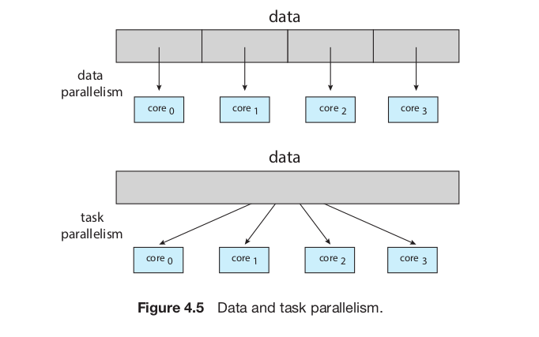

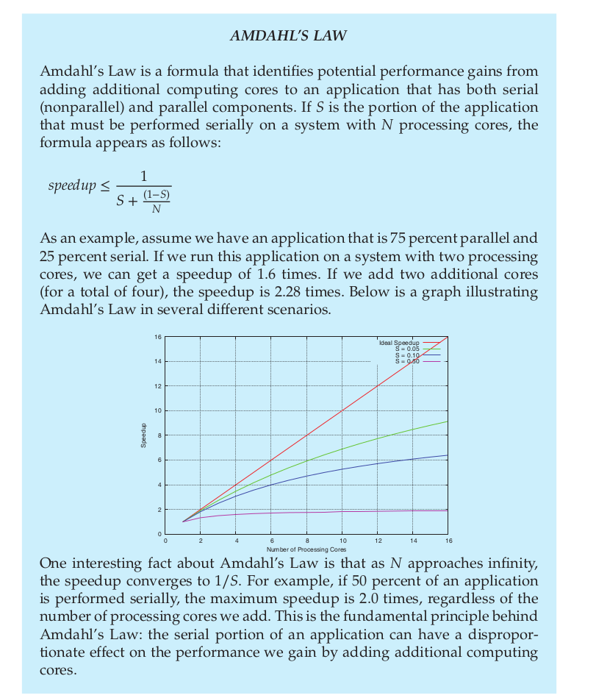

Multithreading Models
Our discussion so far has treated threads in a generic sense. However, support
for threads may be provided either at the user level, for user threads, or by the
kernel, for kernel threads. User threads are supported above the kernel and
are managed without kernel support, whereas kernel threads are supported
and managed directly by the operating system. Virtually all contemporary
operating systems—including Windows, Linux, and mac OS — support kernel
threads.

Many-to-One Model
The many-to-one model (Figure 4.7) maps many user-level threads to one
kernel thread. Thread management is done by the thread library in user space,
so it is efficient (we discuss thread libraries in Section 4.4). However, the entire
process will block if a thread makes a blocking system call. Also, because only
one thread can access the kernel at a time, multiple threads are unable to run
in parallel on multicore systems. Green threads—a thread library available
for Solaris systems and adopted in early versions of Java—used the many-to-
one model. However, very few systems continue to use the model because of
its inability to take advantage of multiple processing cores, which have now
become standard on most computer systems.

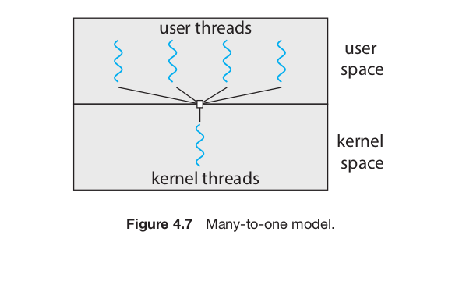

One-to-One Model
The one-to-one model (Figure 4.8) maps each user thread to a kernel thread. It
provides more concurrency than the many-to-one model by allowing another
thread to run when a thread makes a blocking system call. It also allows mul-
tiple threads to run in parallel on multiprocessors. The only drawback to this
model is that creating a user thread requires creating the corresponding kernel
thread, and a large number of kernel threads may burden the performance of
a system. Linux, along with the family of Windows operating systems, imple-
ment the one-to-one model.
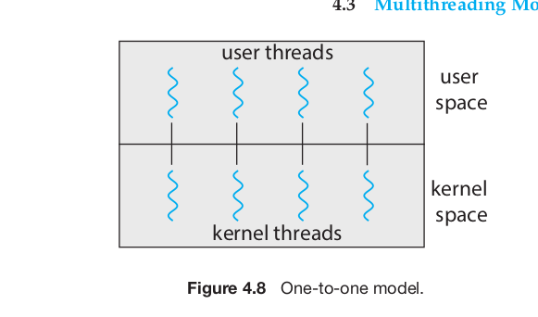

Many-to-Many Model
The many-to-many model (Figure 4.9) multiplexes many user-level threads to
a smaller or equal number of kernel threads. The number of kernel threads
may be specific to either a particular application or a particular machine (an
application may be allocated more kernel threads on a system with eight
processing cores than a system with four cores).

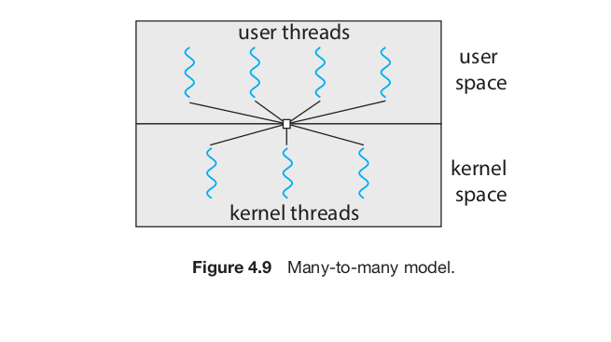
Let’s consider the effect of this design on concurrency. Whereas the many-
to-one model allows the developer to create as many user threads as she
wishes, it does not result in parallelism, because the kernel can schedule only
one kernel thread at a time. The one-to-one model allows greater concurrency,
but the developer has to be careful not to create too many threads within an
application. (In fact, on some systems, she may be limited in the number of
threads she can create.) The many-to-many model suffers from neither of these
shortcomings: developers can create as many user threads as necessary, and
the corresponding kernel threads can run in parallel on a multiprocessor. Also,
when a thread performs a blocking system call, the kernel can schedule another
thread for execution.
One variation on the many-to-many model still multiplexes many user-
level threads to a smaller or equal number of kernel threads but also allows a
user-level thread to be bound to a kernel thread. This variation is sometimes
referred to as the two-level model (Figure 4.10).
Although the many-to-many model appears to be the most flexible of the
models discussed, in practice it is difficult to implement. In addition, with an
increasing number of processing cores appearing on most systems, limiting
the number of kernel threads has become less important. As a result, most
operating systems now use the one-to-one model. However, as we shall see in
Section 4.5, some contemporary concurrency libraries have developers identify
tasks that are then mapped to threads using the many-to-many model.
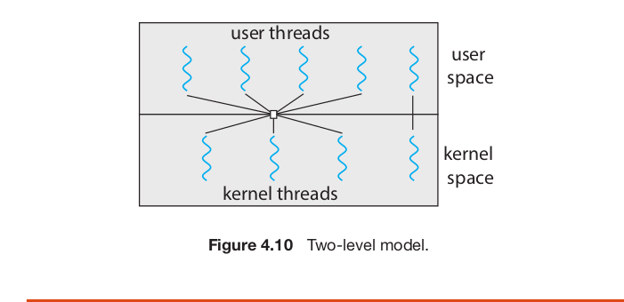

Thread Libraries
A thread library provides the programmer with an API for creating and man-
aging threads. There are two primary ways of implementing a thread library.
The first approach is to provide a library entirely in user space with no kernel
support. All code and data structures for the library exist in user space. This
means that invoking a function in the library results in a local function call in
user space and not a system call.
The second approach is to implement a kernel-level library supported
directly by the operating system. In this case, code and data structures for
the library exist in kernel space. Invoking a function in the API for the library
typically results in a system call to the kernel.

two general strategies for creating multiple threads: asynchronous threading
and synchronous threading. With asynchronous threading, once the parent
creates a child thread, the parent resumes its execution, so that the parent
and child execute concurrently and independently of one another. Because
the threads are independent, there is typically little data sharing between
them. Asynchronous threading is the strategy used in the multithreaded server
illustrated in Figure 4.2 and is also commonly used for designing responsive
user interfaces.
Synchronous threading occurs when the parent thread creates one or more
children and then must wait for all of its children to terminate before it resumes.
Here, the threads created by the parent perform work concurrently, but the
parent cannot continue until this work has been completed. Once each thread
has finished its work, it terminates and joins with its parent. Only after all of the
children have joined can the parent resume execution. Typically, synchronous
threading involves significant data sharing among threads. For example, the
parent thread may combine the results calculated by its various children. All
of the following examples use synchronous threading.

Pthreads
Pthreads refers to the POSIX standard ( IEEE 1003.1c) defining an API for thread
creation and synchronization. This is a specification for thread behavior, not an
implementation. Operating-system designers may implement the specification
in any way they wish. Numerous systems implement the Pthreads specifica-
tion; most are UNIX -type systems, including Linux and mac OS . Although Win-
dows doesn’t support Pthreads natively, some third-party implementations for
Windows are available.

